Atomic Delocalization in Solar Flare Heavy-Ion Tracks and Its Impact on the Plastic Deformation of CE-5 Lunar Soil
Yujie Chen^{1,#}, Yan Fang^{1,#}, Xiaoqian Fu^{1,2,#}, Jiangang Guo³, Tianping Ying³, Jun Ding⁴, Suya Liu⁵, Guang Yang⁵, Lin Gu⁶*, Zheng Bo⁷, Ze Zhang^{1,8}, Xiaolong Chen³*, Jinhua Li⁹*, Qian Yu¹*
¹Center of Electron Microscopy and State Key Laboratory of Silicon Materials, Department of Materials Science and Engineering, Zhejiang University, Hangzhou 310027, China
²Pico Electron Microscopy Center, College of Materials Science and Engineering, Hainan University, Haikou, 570228, China
³Research & Development Center for Functional Crystals, Beijing National Laboratory for Condensed Matter Physics, Institute of Physics, Chinese Academy of Sciences, Beijing 100190, China
⁴Center for Alloy Innovation and Design, State Key Laboratory for Mechanical, Xi’an Jiaotong University, Xi’an 710049, China
⁵Thermo Fisher Scientific, Building A, No.2537, Jinke Road. Pudong District, Shanghai 201210, China
⁶Beijing National Center for Electron Microscopy and Laboratory of Advanced Materials, School of Materials Science and Engineering, Tsinghua University, Beijing 100084, China
⁷State Key Laboratory of Clean Energy Utilization, College of Energy Engineering, Zhejiang University, Hangzhou 310027, China
⁸Institute for Superalloy Science and Technology, School of Materials Science and Engineering, Zhejiang University, Hangzhou, 310027, China
⁹Key Laboratory of Earth and Planetary Physics, Institute of Geology and Geophysics, Chinese Academy of Sciences, Beijing 100029, China
#These authors contributed equally: Yujie Chen, Yan Fang, Xiaoqian Fu
Correspondence should be addressed to: yu_qian@zju.edu.cn; lijinhua@mail.iggcas.ac.cn; xlchen@iphy.ac.cn, lingu@mail.tsinghua.edu.cn.
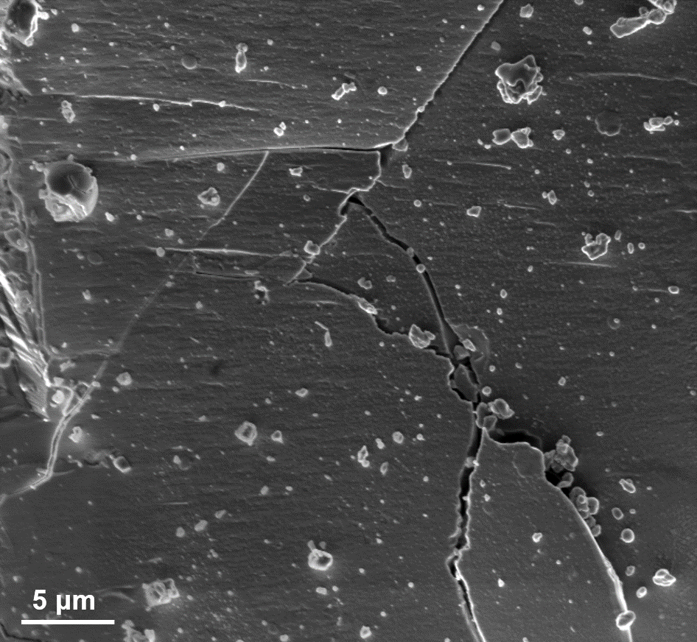
Fig. S1. Scanning electron microscopy image of the surface of the lunar particle.

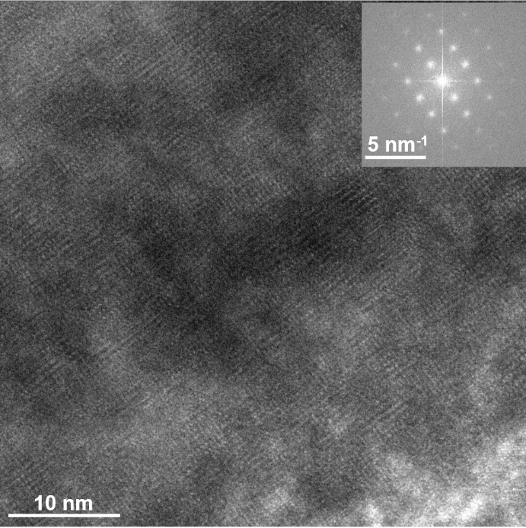
Fig. S2. High-resolution TEM analysis of the amorphous structure in Part Ⅱ.

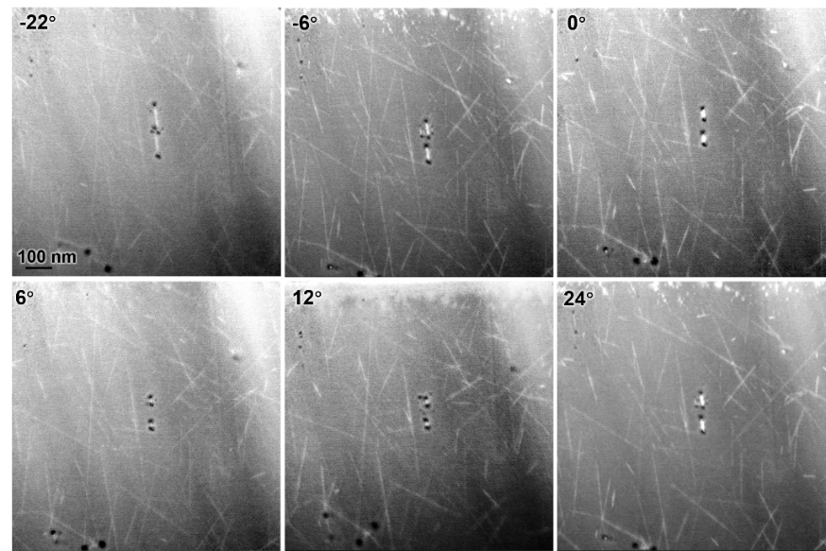
Fig. S3. The HAADF-STEM image of the solar flare tracks in different titling angles.

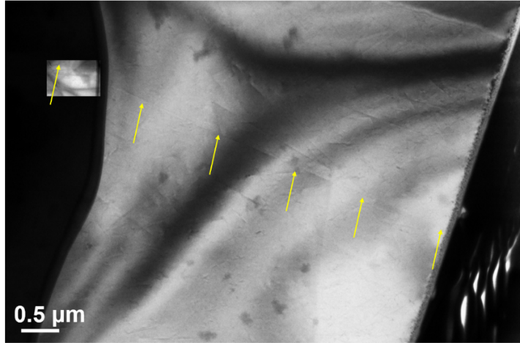
Fig. S4. The TEM images showing the depth of the solar flare tracks. The yellow arrows indicate the most depth of penetration of solar flare tacks in olivine without ending up at the surface.

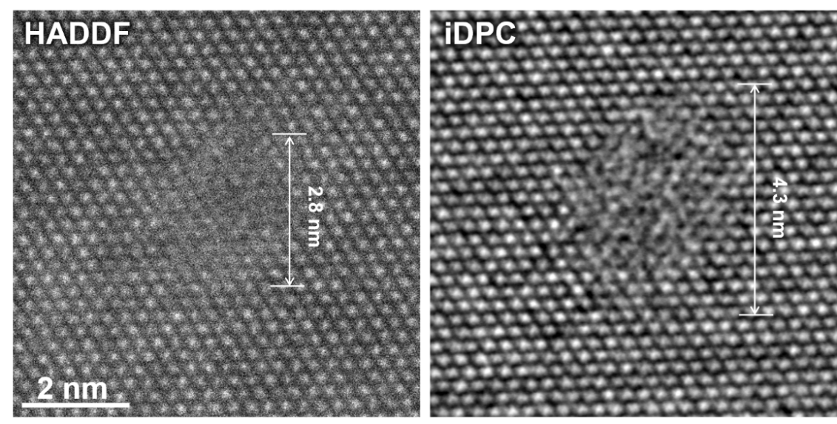
Fig. S5. The cross-sectional atomic structure of a typical solar flare track in which the incidence direction of solar energetic particles was almost along the [100] zone axis of the olivine matrix.
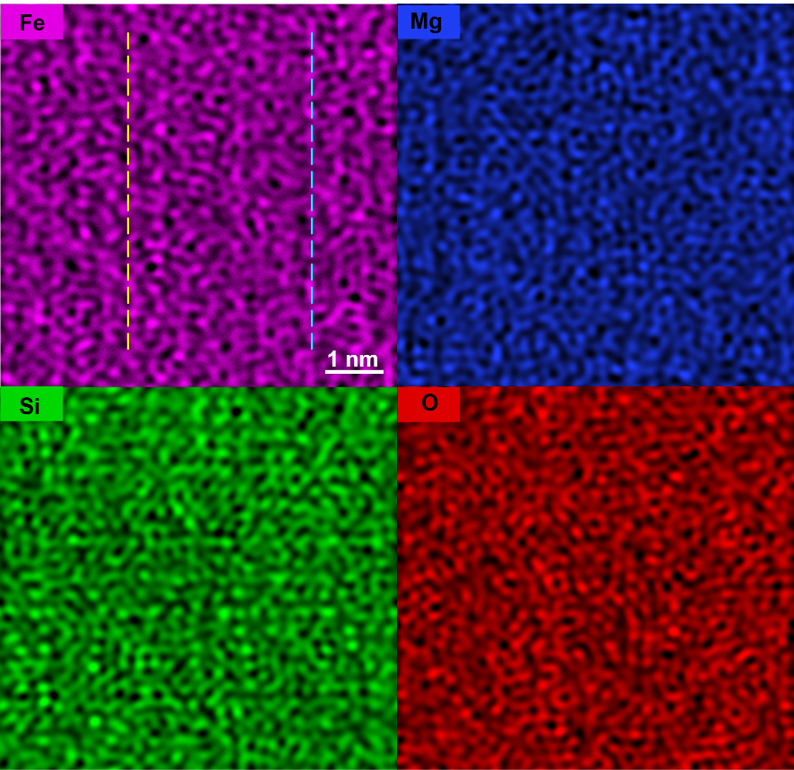
Fig. S6. The HAADF-STEM and iDPC images and the corresponding eds mapping of the defect. The line profile of Fig. 3c and Fig.3d are the distribution of elements in the position of the blue line (matrix) and the yellow line (the defect)
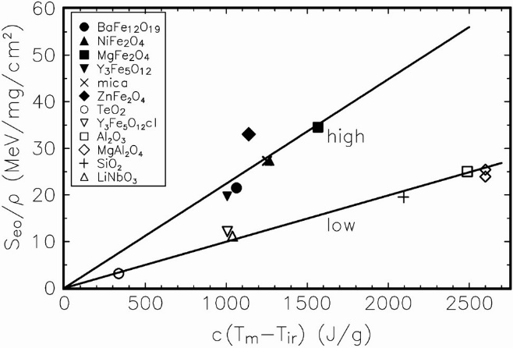
Fig. S7. Dependence of the threshold electronic stopping power S_{et} on the material parameters ρ, c, T_{m}, and T_{ir} denoting the density, the specific heat, the melting point, and the irradiation temperature, respectively. The lines at high (E > 8 MeV nucleon⁻¹) and low (E < 2 MeV nucleon⁻¹) specific ion energies demonstrate the velocity effect.

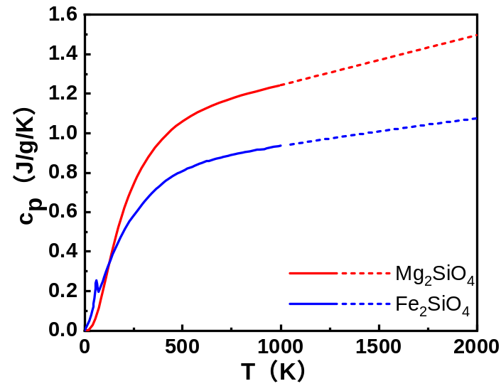
Fig. S8. The heat capacity of fayalite and forsterite.

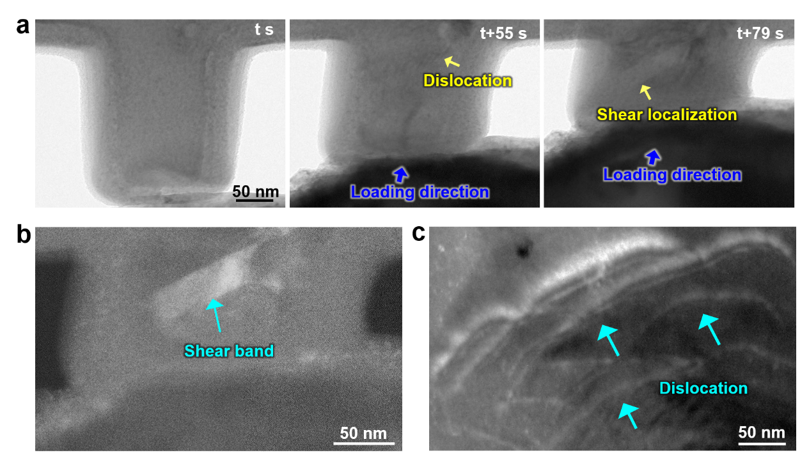
Fig. S9 The dislocation activities in the earth olivine. a, The snapshots captured in the in situ TEM compression testing showing the shear localization and deformation instability. b, The dark-field TEM image of the shear bands. c, The dark-field TEM image of the surface nucleation of dislocations in a single slip system.

Supporting Video 1 The three-dimensional TEM tomography analysis along X and Z axis, respectively, demonstrating that the solar flare tracks commonly exist in random planes with random incidence directions.

Supporting Video 2 In situ TEM nano-compression test, suggesting that the solar flare tracks can act as the effective dislocation source.

Supporting Video 3 In situ TEM nano-compression test, showing that the solar flare tracks can significantly hinder the motion of dislocations and make changes on dislocations’ gliding directions.

