Supplement figure legends
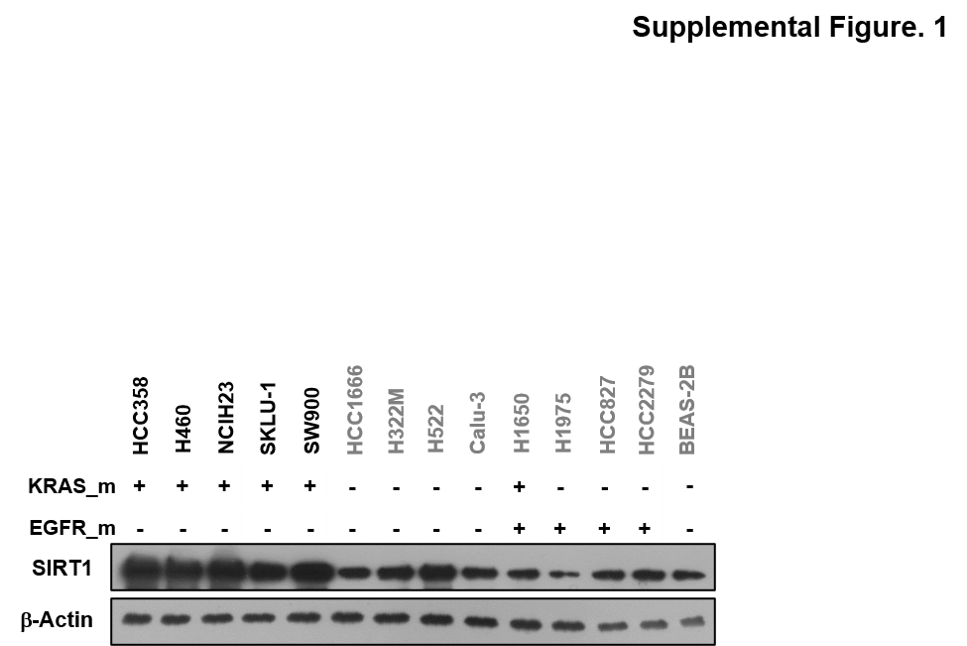

Supplemental Fig. 1 Measure SIRT1 protein expression in NSCLCs
SIRT1 protein expression in non-tumorigenic lung epithelial cells, KRAS^{Mut} positive/negative cell lines, and EGFR^{Mut} positive/negative cell lines.

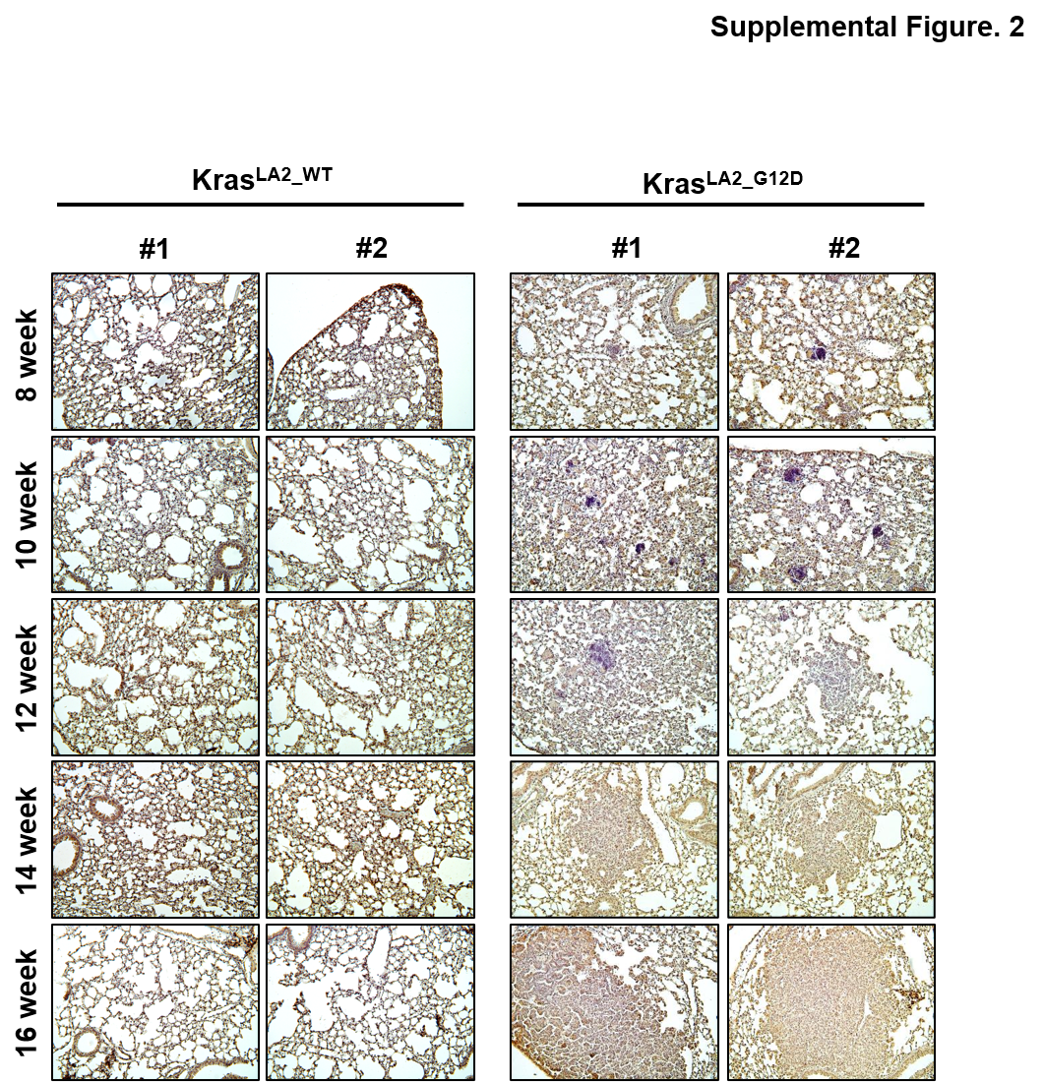

Supplemental Fig. 2 KRAS^{LA2_G12D}-driven lung cancer identification
H&E staining of lungs between 8 and 16 weeks after birth from KRAS^{LA2_WT} and KRAS^{LA2_G12D} mice.

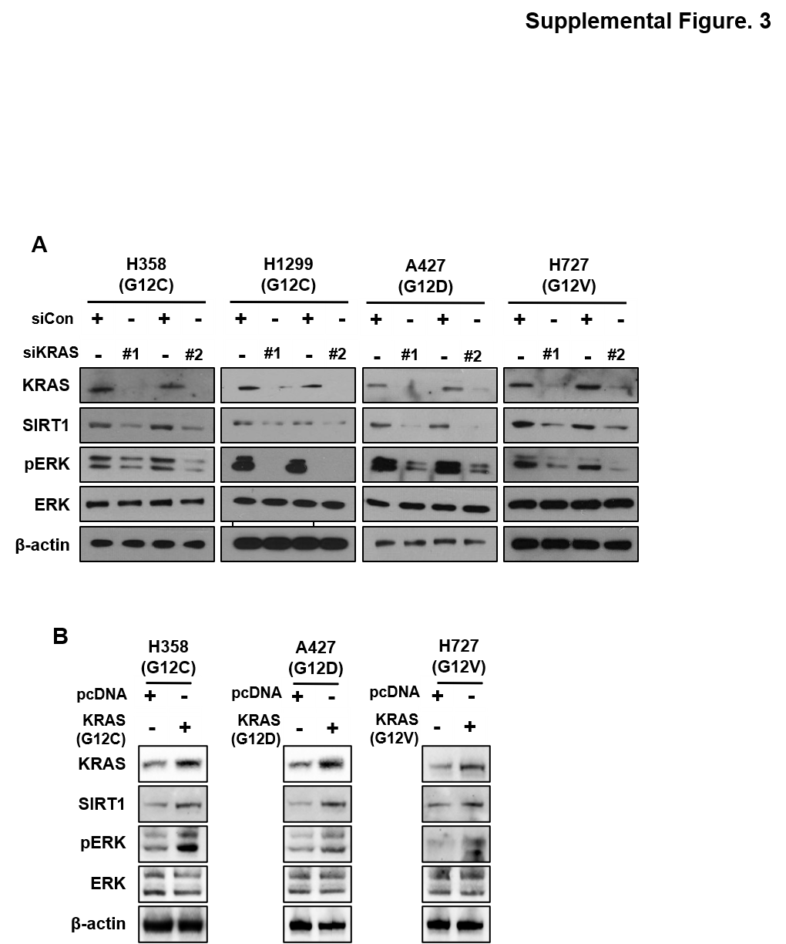
Supplemental Fig. 3 SIRT1 expression is associated with KRAS expression
A, B HCC358, H1299 (KRAS^{G12C} stable cell line), A427 (KRAS^{G12D}), and H727 (KRAS^{G12V}) cells were transfected with siCon, siKRAS (80 nM), pcDNA, KRAS^{G12C}, KRAS^{G12D}, and KRAS^{G12V} (2 μg) plasmids. Cell lysates were immunoblotted with anti-KRAS, anti-SIRT1, anti-pERK, anti-ERK, and anti-β-actin antibodies after 72 h after transfection.
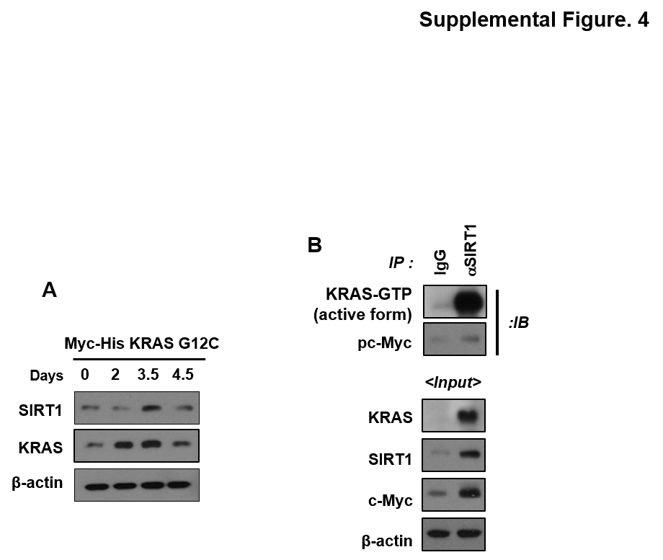
Supplemental Fig. 4 KRAS^{Mut}-induced SIRT1 more binds to KRAS^{Mut} than to c-Myc
A HEK293T cells were expressing Myc-His-KRAS^{G12C}, and then the cells were harvested with lysis buffer on the indicated day and subjected to western blotting. B Cell lysates at 3.5 day under the same conditions as (A) were immunoprecipitated with anti-KRAS-GTP and p-c-Myc antibodies.

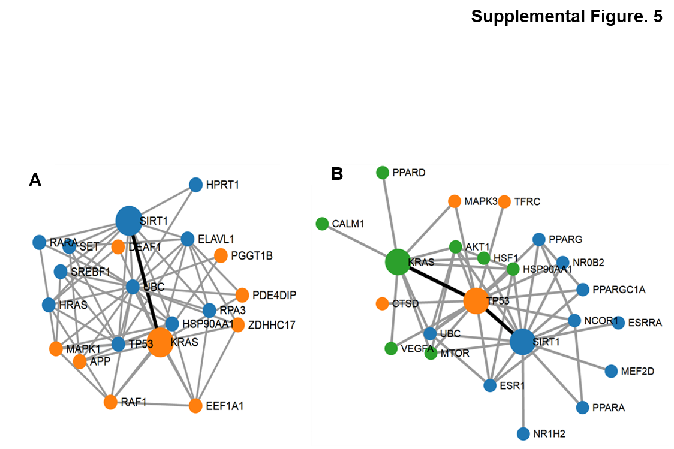
Supplemental Fig. 5 Shortest path between KRAS^{WT} and SIRT1 was analyzed using PINA and STRING in ASEB
A, B Interactive relationships of two proteins KRAS^{WT} and SIRT1, were analyzed using PINA (A) and STRING (B) analysis provided by ASEB.

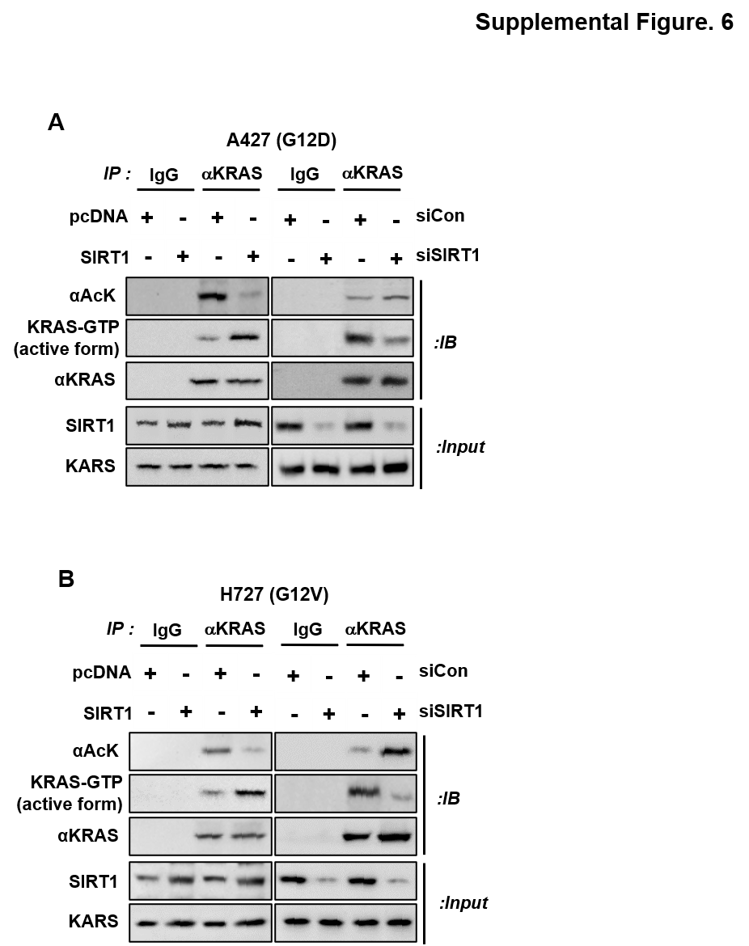
Supplemental Fig. 6 SIRT1 deacetylated and increased the activity of KRAS^{G12D} and KRAS^{G12V}
as well as KRAS^{G12V}.
A, B A427 (KRAS^{G12D}) and H727 (KRAS^{G12V}) cells were transfected with siCon, siSIRT1 (80 nM), pcDNA, SIRT1 plasmids (4 μg). Cell lysates were subjected to immunoprecipitation with anti-KRAS and then analyzed using anti-acetyl lysin, anti-KRAS-GTP, anti-KRAS, and anti-SIRT1 antibodies after 72 h after transfection.
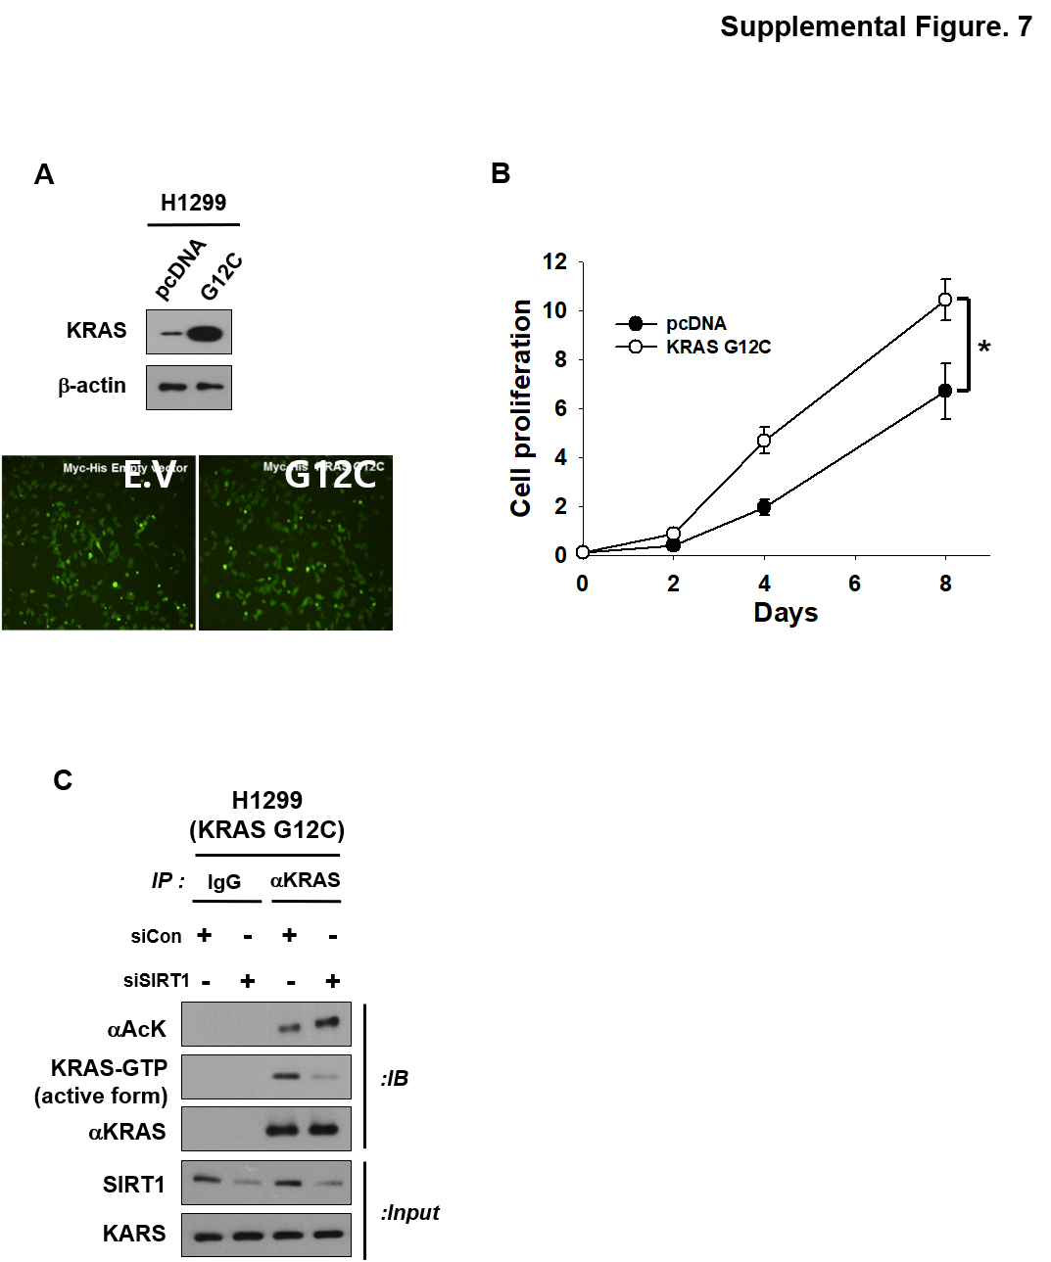
Supplemental Fig.7 Established H1299 KRAS^{G12C} stable cell line validated SIRT1 regulation of KRAS^{G12C} acetylation and cell proliferation
A H1299 (KRAS^{WT}) cells were transformed by stably expressing KRAS^{G12C}. Selected stable cells treated with G418 (400 μg/ml) for two weeks were identified by GFP fluorescence. B The growth rates of H1299 KRAS^{G12C} stable cells were measured using MTS assay. Student’s t-test, mean ± SD; n = 6, *, p < 0.05. C H1299 KRAS^{G12C} stable cell lines were transfected with siCon and siSIRT1 (80 nM) for 72 h. Anti-IgG and anti-KRAS antibodies were immunoprecipitated and immunoblotted with anti-acetyl lysine, anti-KRAS-GTP, anti-KRAS, and anti-SIRT1 antibodies.
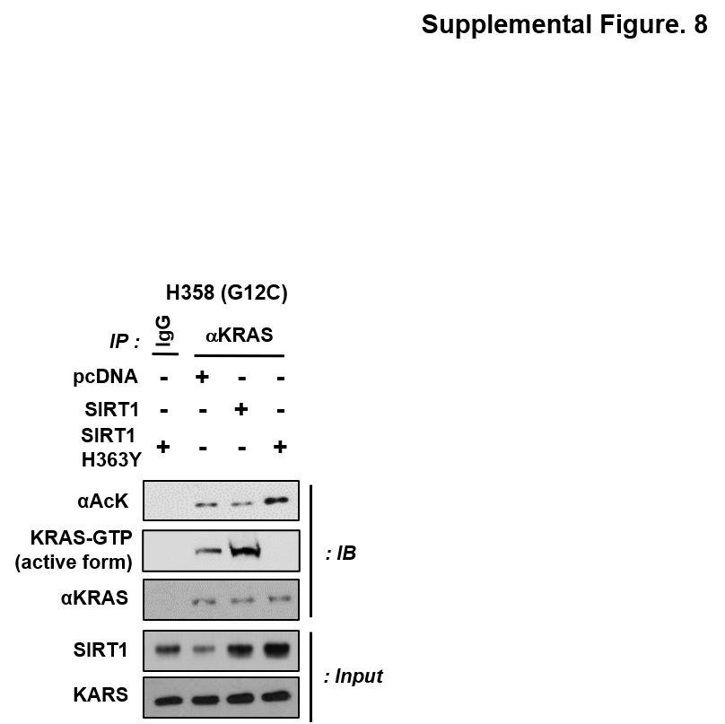
Supplemental Fig.8 SIRT1 deacetylases KRAS^{Mut}
H358 cells were transfected with the following plasmids: pcDNA, SIRT1, and SIRT1^{H363Y} (a catalytically impaired inactive SIRT1 mutant) (4 μg). Cell lysates were subjected to immunoprecipitation with anti-KRAS and, then analyzed using anti-acetyl lysin and anti-KRAS antibodies.

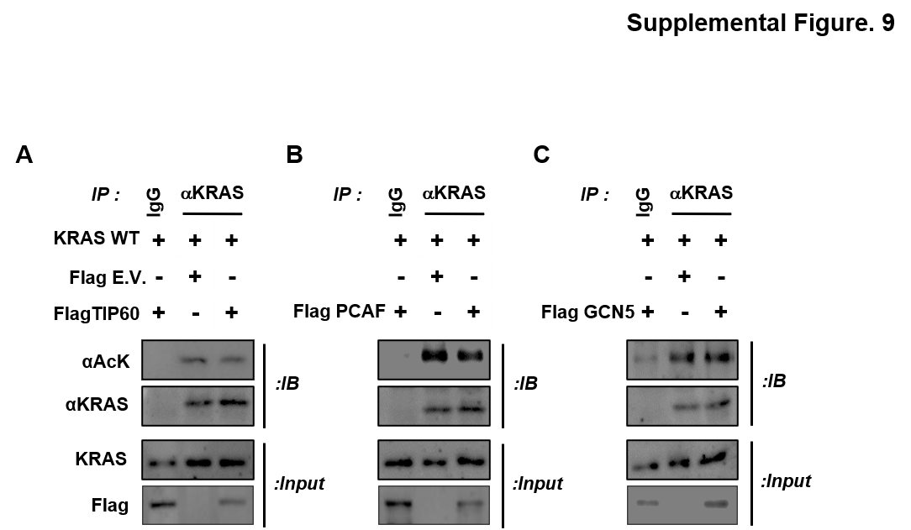
Supplemental Fig.9 Identification of KRAS acetylase enzyme
A-C 93T cells were transfected with KRAS^{G12C}, Flag-E.V., and Flag-TIP60/PCAF/GCN5 plasmids. Cell lysates were immunoprecipitated with anti-IgG and anti-KRAS antibodies and then immunoblotted with anti-acetyl lysine, anti-Flag, and anti-KRAS antibodies.

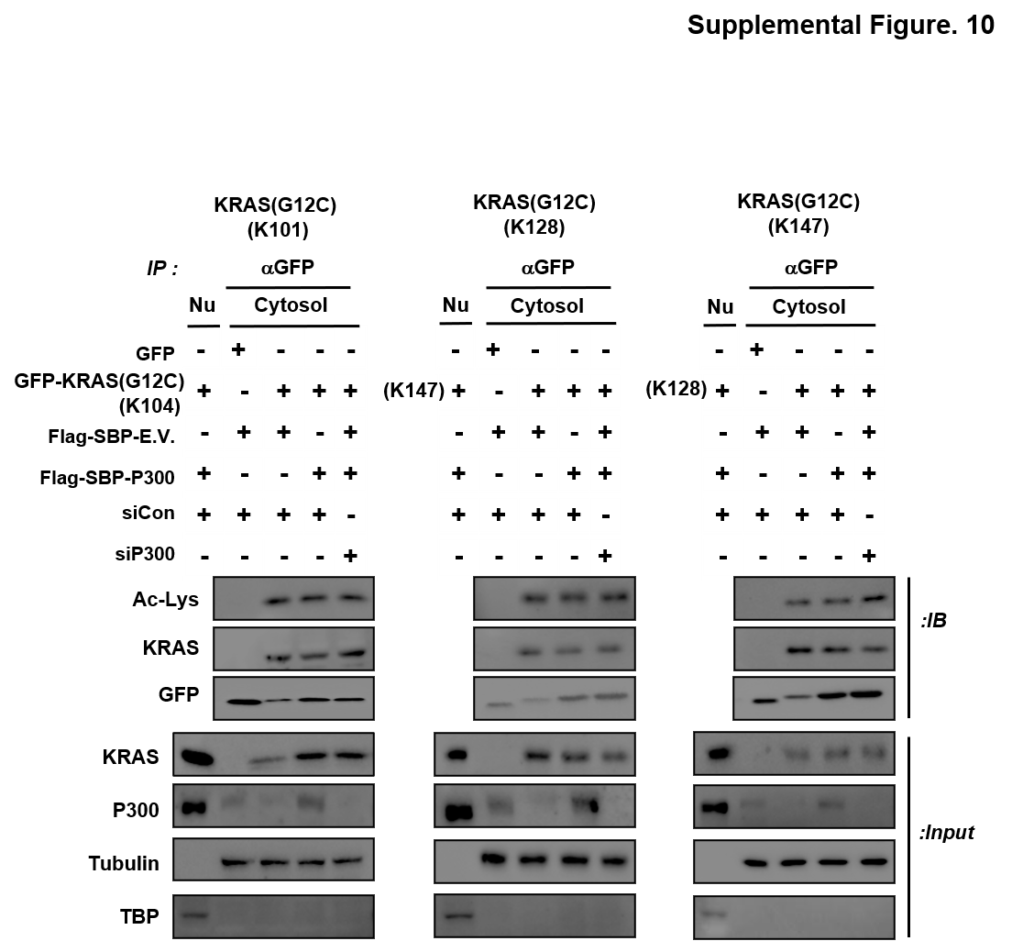
Supplemental Fig.10 KRAS-K101, K128, and K147 are not acetylation sites for the p300 acetylase enzyme
HEK293T cells were transfected with GFP-E.V., GFP-KRAS (lysin residue[101-147a.a.] is changed by arginine except for each K101, K128, and K147), Flag-SBP-E.V., Flag-SBP-p300, siCon, and sip300. Cell lysates were immunoprecipitated with an anti-GFP antibody and then analyzed using anti-acetyl lysine, anti-KRAS, and anti-GFP antibodies.

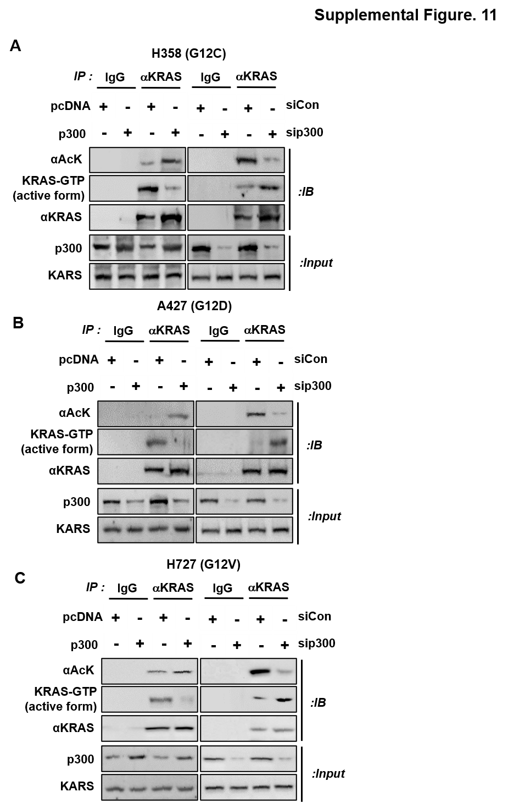
Supplemental Fig.11 Acetyltransferase p300 acetylated and decreased the activity of KRAS^{G12C}, KRAS^{G12D}, and KRAS^{G12V}.
A-C A358 (KRAS^{G12D}), A427 (KRAS^{G12D}), and H727 (KRAS^{G12V}) cells were transfected with siCon, sip300 (80 nM), pcDNA, p300 plasmids (4 μg). Cell lysates were subjected to immunoprecipitation with anti-KRAS and then analyzed by immunoblotting using anti-acetyl lysin, anti-KRAS-GTP, anti-KRAS, and anti-p300 antibodies after 72 h after transfection.
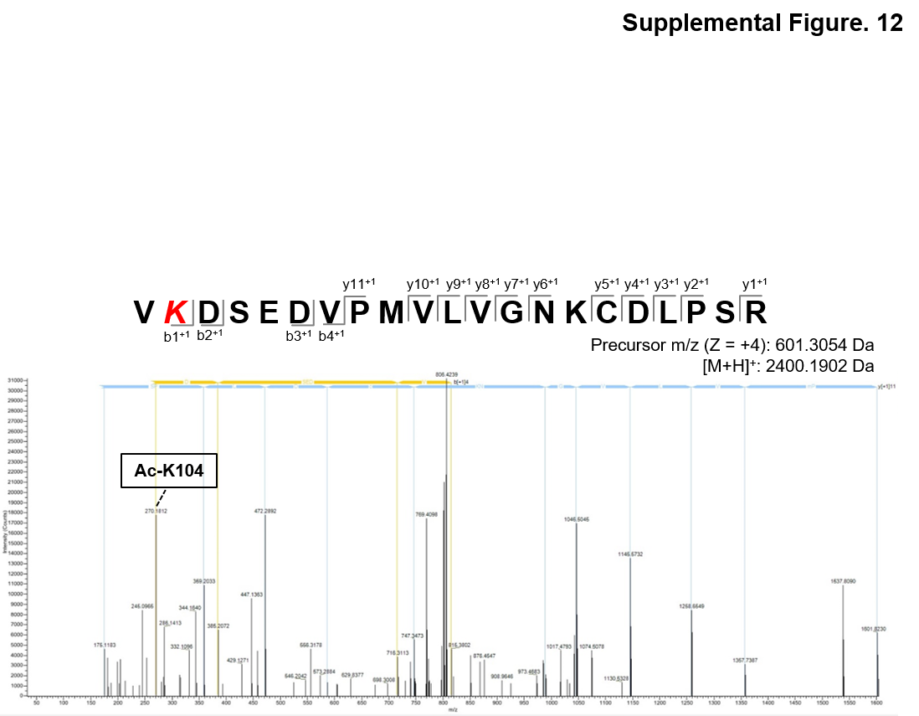
Supplemental Fig.12 LC-MS/MS data from the in vitro acetylation and deacetylation assay
The MS/MS spectrum of the KRAS^{G12C} peptide a.a. 103-VKDSEDVPMVLVGNKCDLPSR-123 is shown Fig. 6E (3) sample. The mass spectrum composed of fragmentation of the ion at m/z 2400.1902 refers to the acetylation of the KRAS^{G12C} peptide a.a. 103-123. A novel lysine acetylation site for residue K104 in the KRAS^{G12C} peptide is indicated. A series of fragments extending from the N-terminus are b ions, and a series of fragments extending from the C terminus are y ions.

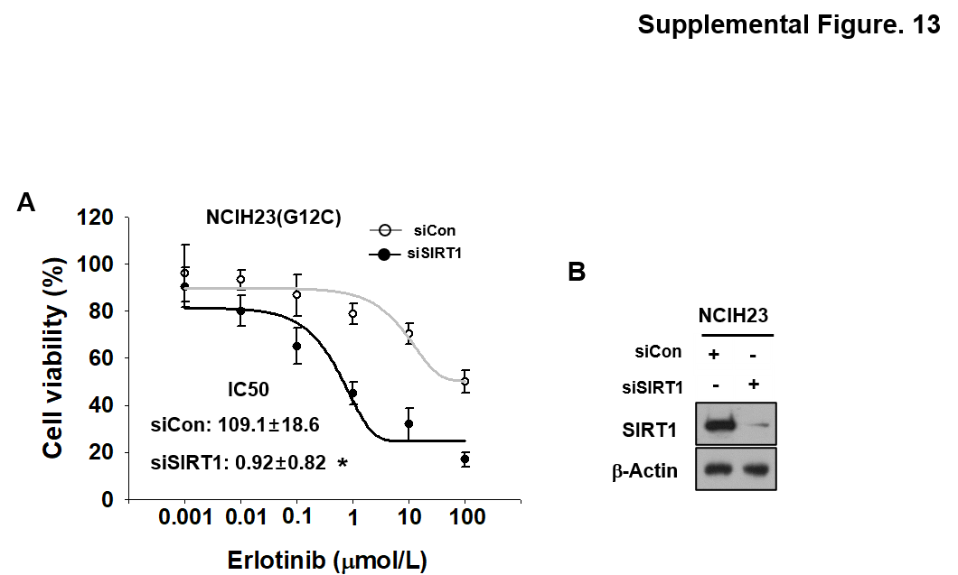

Supplemental Fig.13 Check the synergistic anti-proliferative effect between SIRT1 inhibition and erlotinib in NCIH23 cells
A NICH23 cells were transfected with siCon and siSIRT1 (80 nM) and then seeded 96 well contained with erlotinib at concentrations between 0.001 and 100 μM. Cell viability was measured using MTS assay. Student’s t-test, mean ± SD; n = 6, *, p < 0.05. B SIRT1 K/D expression in transfected cells was measured by western blotting.

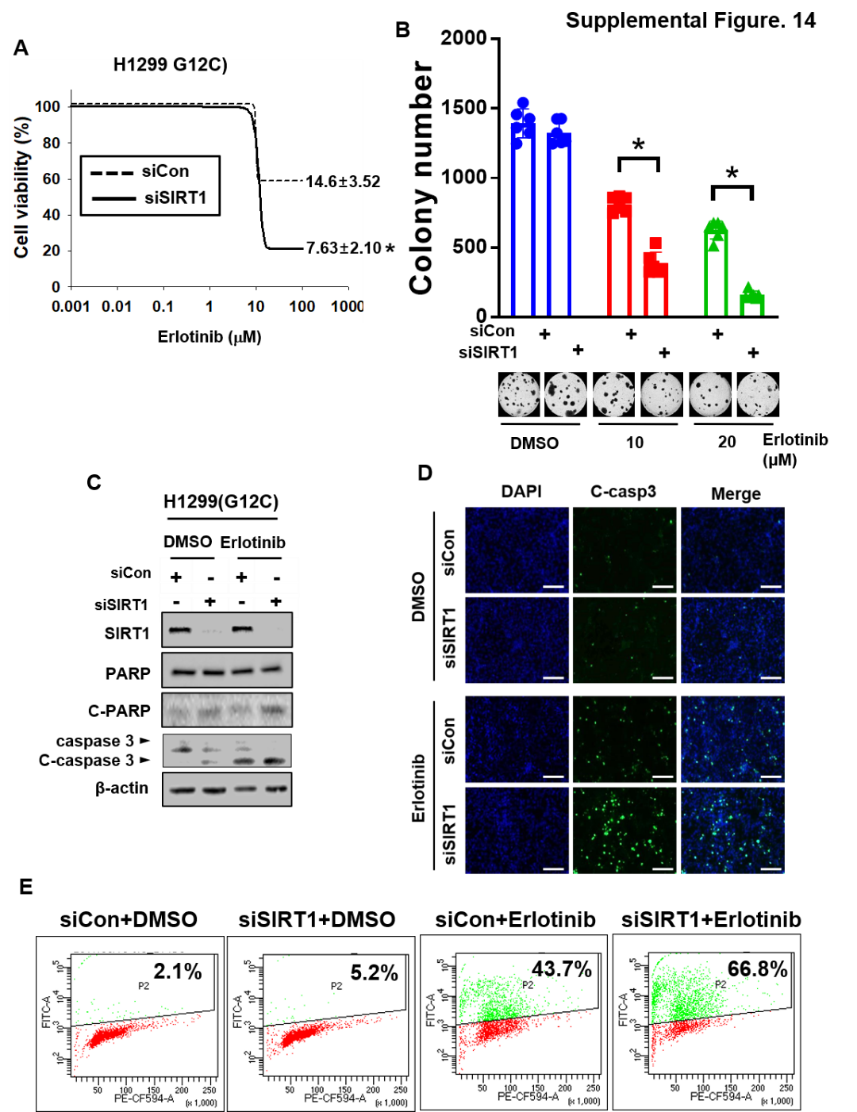
Supplemental Fig.14 SIRT1 K/D supported the synergistic anti-cancer effects of erlotinib on the KRAS^{G12C} stable cell line
A, B 1299 KRAS^{G12C} stable cells, as shown in Supplemental Fig. S7 were transfected with siCon and siSIRT1 (80 nM) and then seeded 96 well (A) for growth curve and 12 wells into agarose (B) for colony formation assay with dose dependent treatment with erlotinib. Student’s t-test, mean ± SD; n = 6, *, p < 0.05. C-E, H1299 KRAS^{G12C} stable cells were transfected with siCon and siSIRT1 (80 nM), and then treated with erlotinib (10 μM). C Western blotting was performed by anti-PARP and caspase-3 antibody. D Cells treated with erlotinib were subjected to immunofluorescence staining, and E DNA damage analysis using the APO-BrdU TUNEL assay.
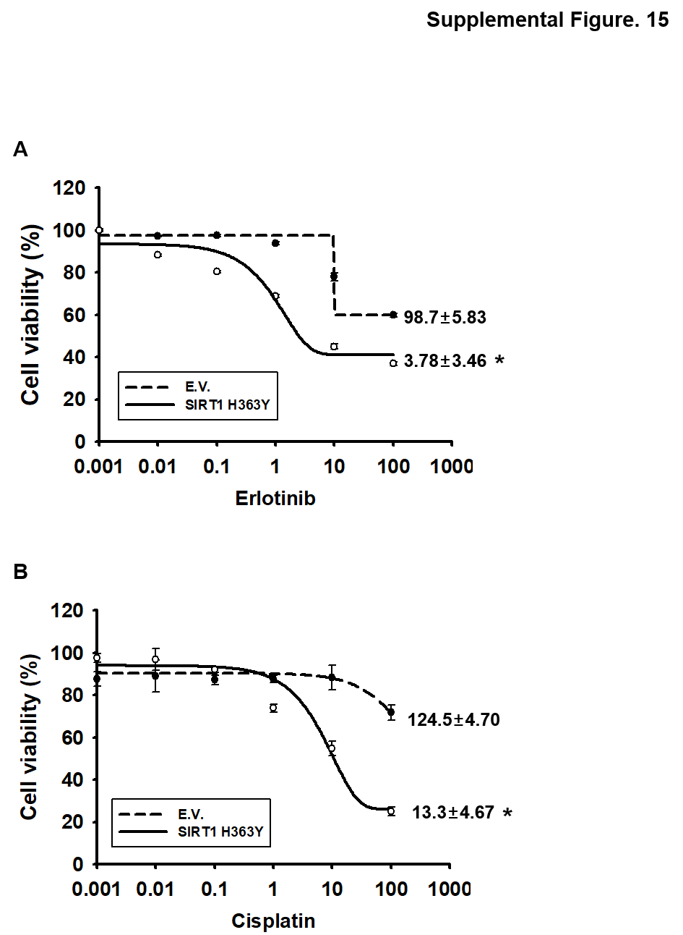
Supplemental Fig. 15 Check the synergistic anti-cancer viability effect of cisplatin and erlotinib on the H358^{H363Y} stable cell line.
A, B H358^{H363Y} stable cells were treated with DMSO and cisplatin (A) and erlotinib (B) in a dose-dependent manner, and cell viability was measured using the MTS assay.
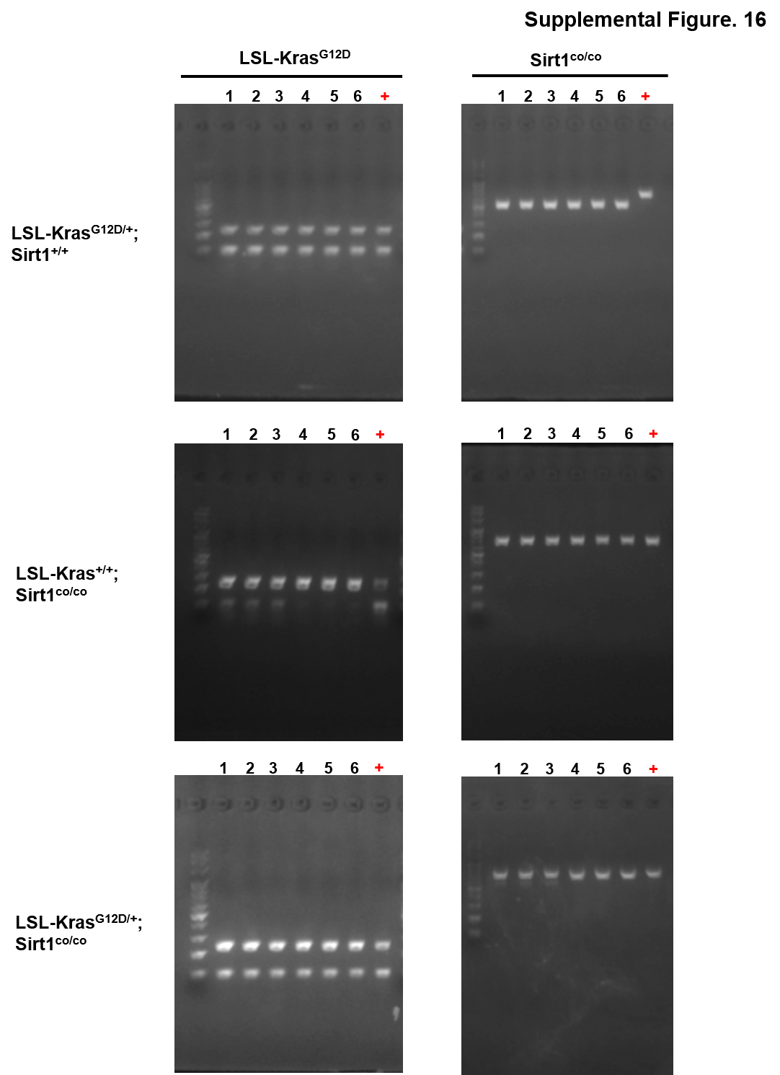
Supplemental Fig. 16 Genotyping PCR analysis
The identification of LSL-Kras^{G12D/+};Sirt1^{+/+} and LSL-Kras^{G12D/+};Sirt1^{co/co} mice aia Genotyping PCR analysis
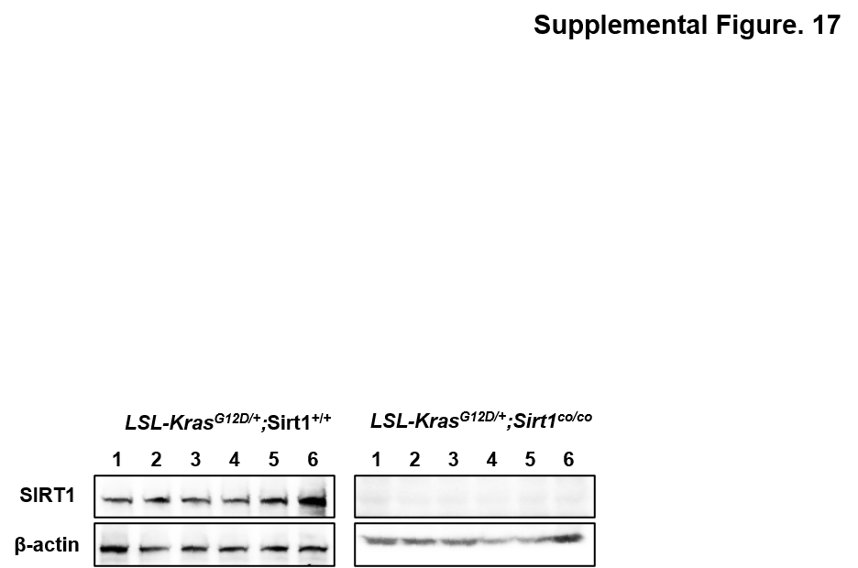
Supplemental Fig. 17 SIRT1 K/D identification from LSL-Kras^{G12D/+};Sirt1^{+/+} and LSL-Kras^{G12D/+}; Sirt1^{co/co} mouse lungs
Immunoblotting analysis of SIRT1 and β-actin (loading control) expression in lung lysates from LSL-Kras^{G12D/+};Sirt1^{+/+} and LSL-Kras^{G12D/+};Sirt1^{co/co} mice.

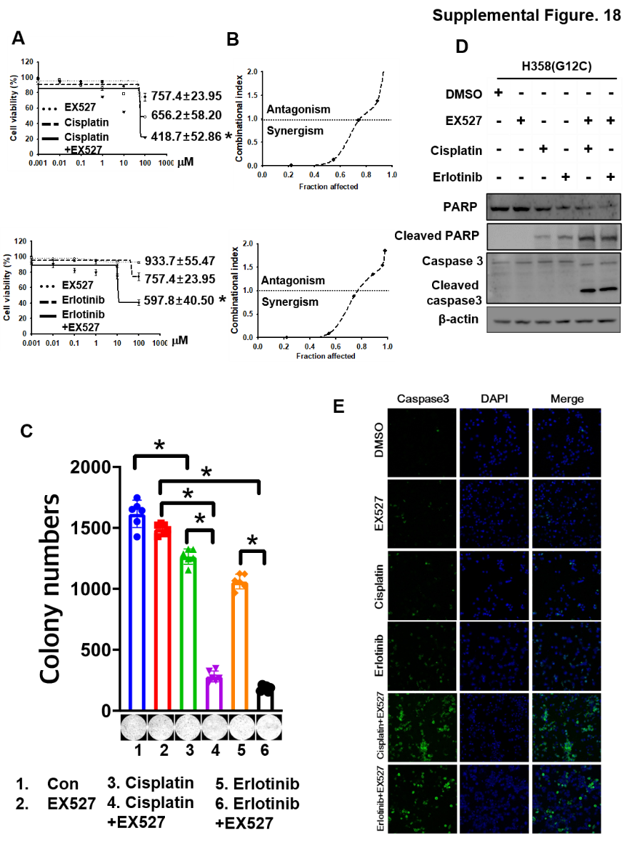

Supplemental Fig. 18 SIRT1 inhibitor is required for the synergistic therapeutic efficacy of EGFR TKI in KRAS^{G12C} lung tumor cells
A, B SIRT1 inhibitor augments the inhibitory effects of cisplatin and erlotinib on KRAS^{Mut} cell (H358 cells), as indicated by (A) growth curves and (B) analysis of combined drug effects. Drug synergy was determined by the combination index (CI) analysis according to the median-effect method of Chou and Talalay using the CalcuSyn software. The CI is a quantitative representation of the degree of drug Interaction. C-E, H358 cells were treated with EX527 (10 μM) in combination with cisplatin (10 μM) or erlotinib (10 μM), as indicated by (C) measured colony-forming capabilities. Data shown are representative images of soft agar assays and relative colony numbers in cells treated with the indicated drugs after 14 days of incubation. Student’s t-test, mean ± SD; n = 6, *, p < 0.05. cell contained with drugs were measured apoptosis markers by using western blotting (D) and immunofluorescence staining (E) after 72 h of drugs’ treatment.

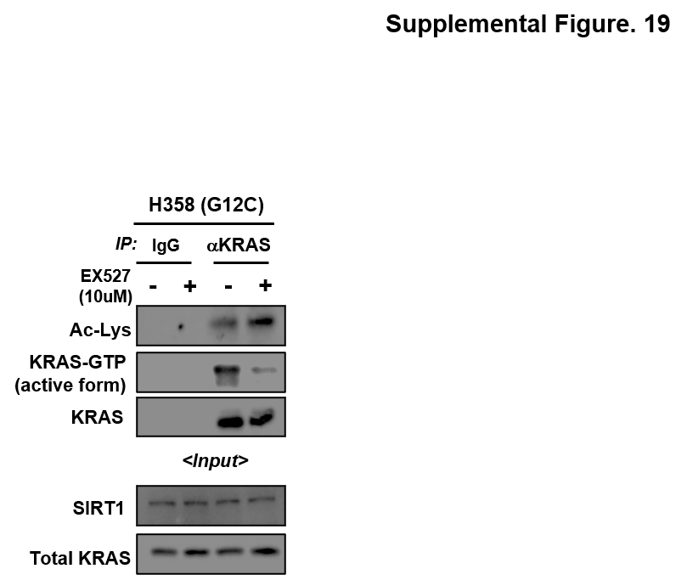
Supplemental Fig. 19 SIRT1 inhibitor, EX527 increased an acetylation of KRAS^{Mut}
H358 cells were treated with EX527 10 μM and then the cell lysates were immunoprecipitated with anti-IgG and anti-KRAS antibodies and then immunoblotted with anti-acetyl lysine, anti-KRAS-GTP, and anti-KRAS antibodies.

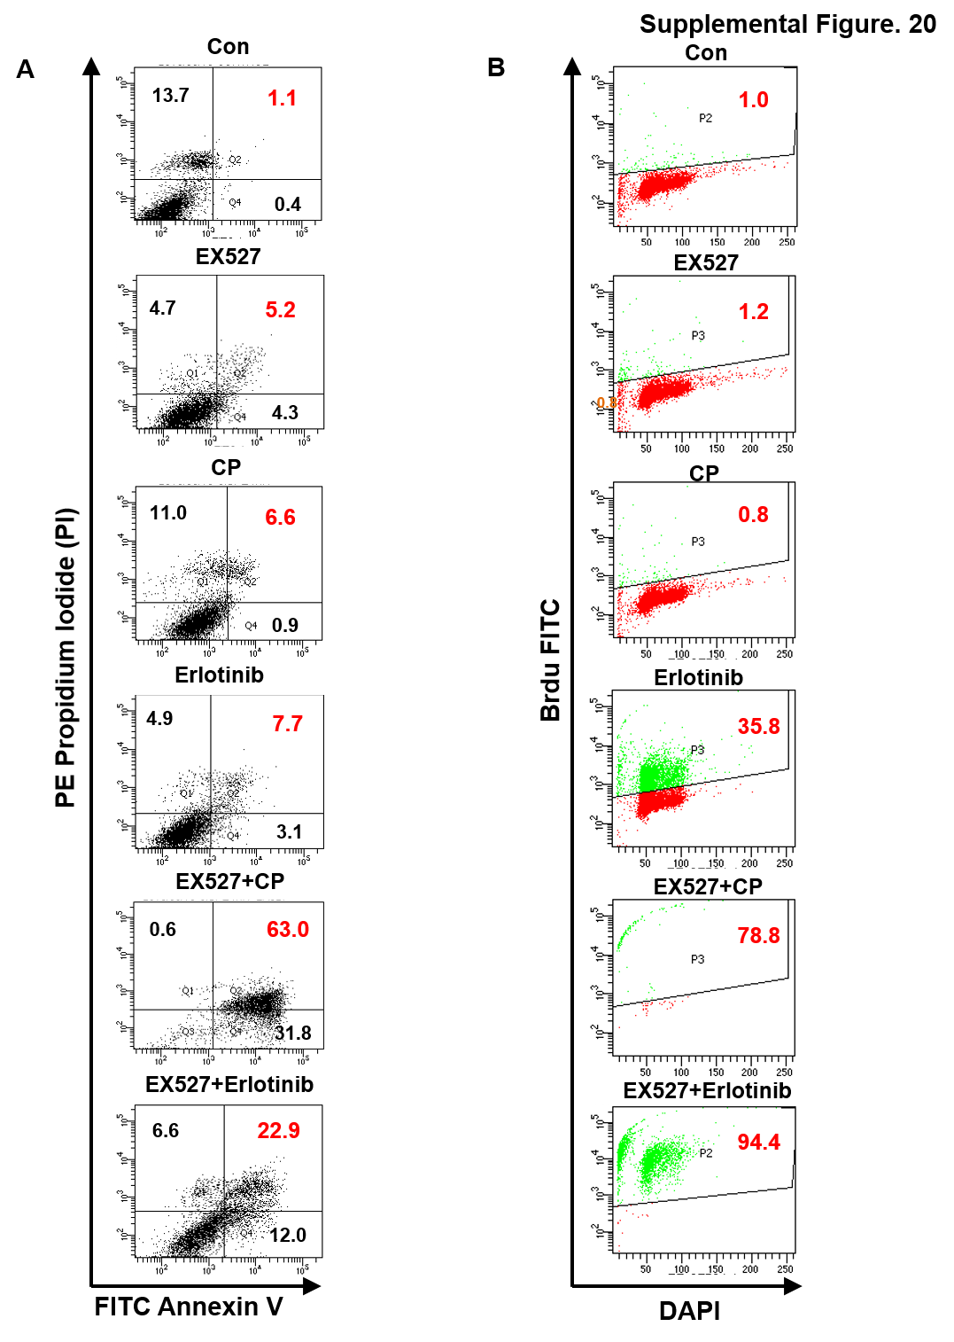
Supplemental Fig. 20 The SIRT1 inhibitor, EX527 augmented apoptosis of KRAS mutant cells treated with cisplatin or erlotinib
A, B H358 cells were treated with DMSO, EX527 (10 μM), cisplatin (10 μM), erlotinib, and combined EX527 with cisplatin or erlotinib, and then FACS analysis was performed for PI & Annexin V staining (A) and Apo-BrdU TUNEL staining (B).
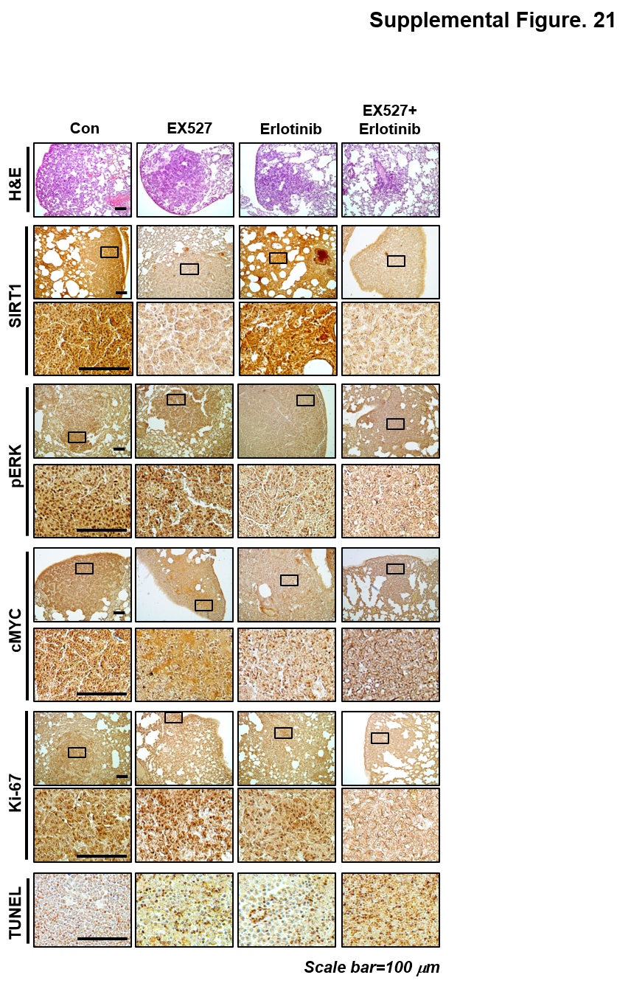
Supplemental Fig. 21 Identification of the synergistic anti-cancer effect of erlotinib in the KRAS^{Mut} lung orthotopic model
Immunohistochemical staining of mouse lung tumor tissues was performed using anti-SRIT1, anti-pERK, anti-c-Myc, and anti-Ki-67 antibodies. Representative images are shown. Scale bar, 100 μm. High-magnification images correspond to areas marked by the black box.
Supplement table legends
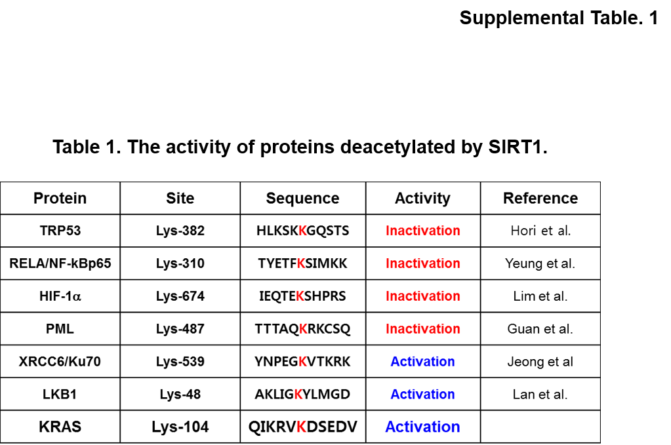
Supplemental Table. 1 Activity of proteins deacetylated by SIRT1
The proteins, TRP53, NF-κBp65, HIF-1α, PML, XRCC6/ku70, and LKB1 are deacetylated by SIRT1, and changes in their activity are described.

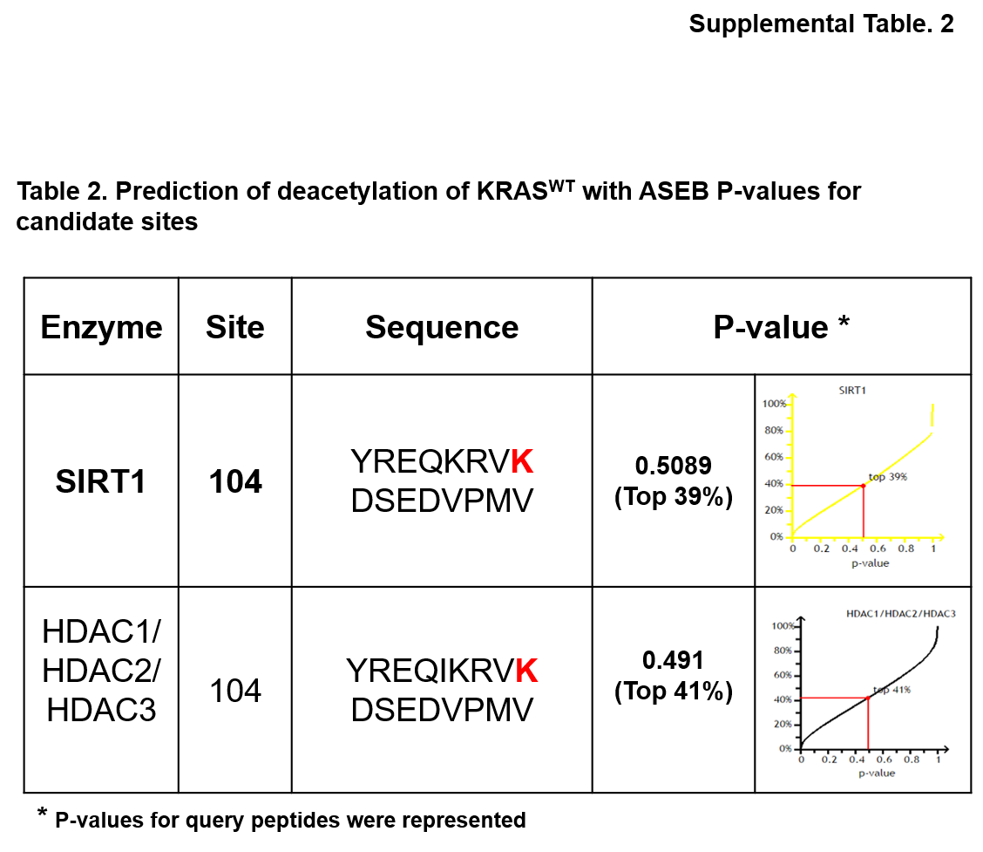
Supplemental Table. 2 Prediction of deacetylation of KRAS^{WT} with ASEB P-values for candidate sites
Deacetylation sites of KRAS^{WT} were explored K104 lysine by SIRT1 (p-value 0.5089, top 39%) and by HDAC1/HDAC2/HDAC3 (p-value 0.4941, top 41%).

