Multiple-function eco-friendly bacterial with high efficiency and widely environmental adaptability on phenol degradation

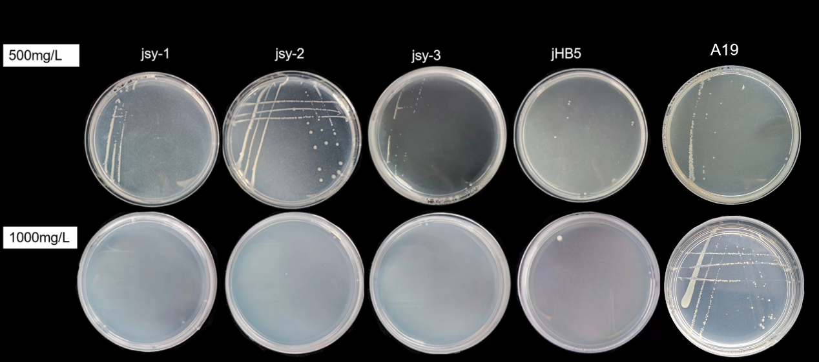
S1.Screening isolated and purified phenol degradation colonies with 500 mg/L and 1000 mg/L phenol as the only carbon source, respectively
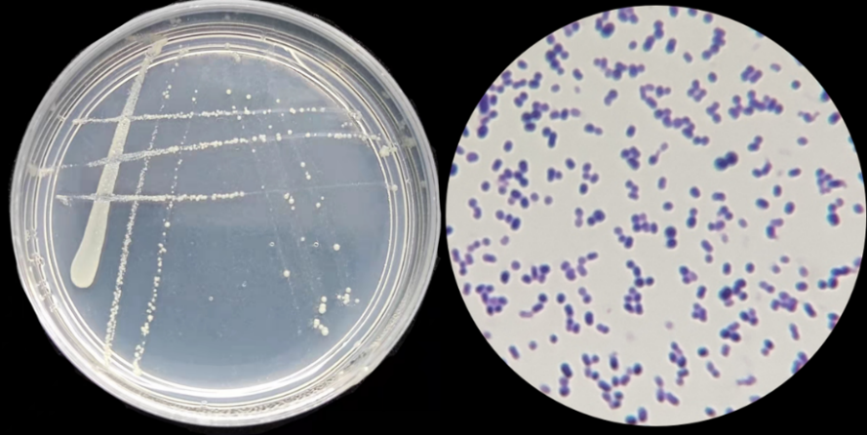
S2. Colony morphological characteristics and body shape characteristics of A19

Table S3 Physiological and biochemical identification results of A19
project | result | projec | result
Gram staining | + | M.R | +
Glucose | + | V.P | +
Mannitose | + | Indole | +
Xylose | + | Amylase | +
Lactose | — | Catalase | +
Note: "+" indicates that the strain can be used; "-" indicates that the strain cannot be used

