Supplementary Figure 1. Kaplan-Meier analysis of primary outcome and secondary outcome according to stroke severity
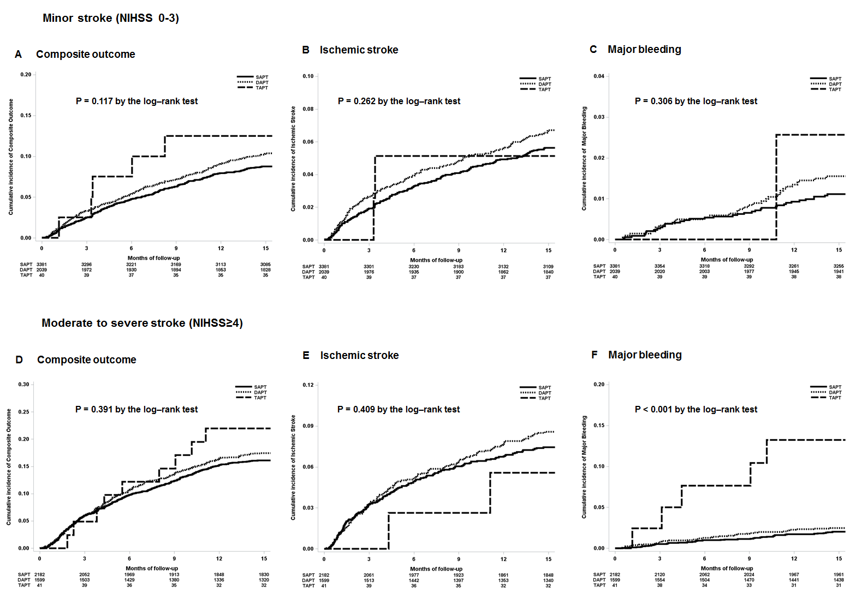

(A) Cumulative incidence of the composite outcome in minor stroke patients
(B) Cumulative incidence of the ischemic stroke in minor stroke patients
(C) Cumulative incidence of major bleeding in minor stroke patients
(D) Cumulative incidence of the composite outcome in moderate to severe stroke patients
(E) Cumulative incidence of the ischemic stroke in moderate to severe stroke patients
(F) Cumulative incidence of major bleeding in moderate to severe stroke patients
SAPT: single antiplatelet therapy; DAPT: dual antiplatelet therapy; TAPT: triple antiplatelet therapy

Supplementary Figure 2. Hazard Ratio for primary outcome and secondary outcome according to stroke severity
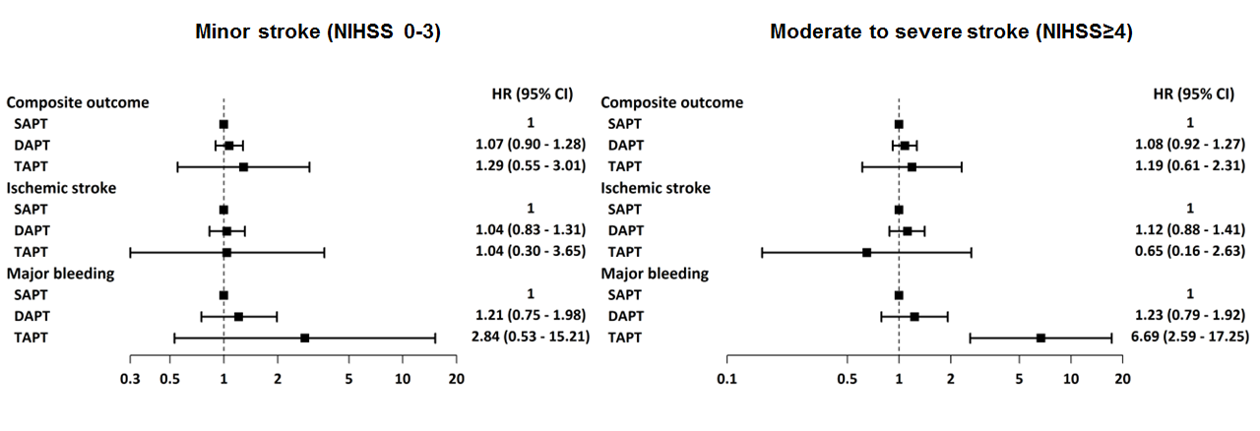
In minor stroke patients, the incidence of composite outcomes, ischemic stroke and major bleeding events at 1 year after stroke were not significantly different within three groups. In moderate to severe stroke patients, no significant difference was observed among the DAPT and TAPT groups in the overall risks of composite outcomes and recurrent ischemic stroke at 1 year after acute ischemic stroke. However, DAPT and TAPT increased the risk of major bleeding events than the SAPT.
SAPT: single antiplatelet therapy; DAPT: dual antiplatelet therapy; TAPT: triple antiplatelet therapy

Supplementary Figure 3. Kaplan-Meier analysis of primary outcome and secondary outcome according to stroke subtypes
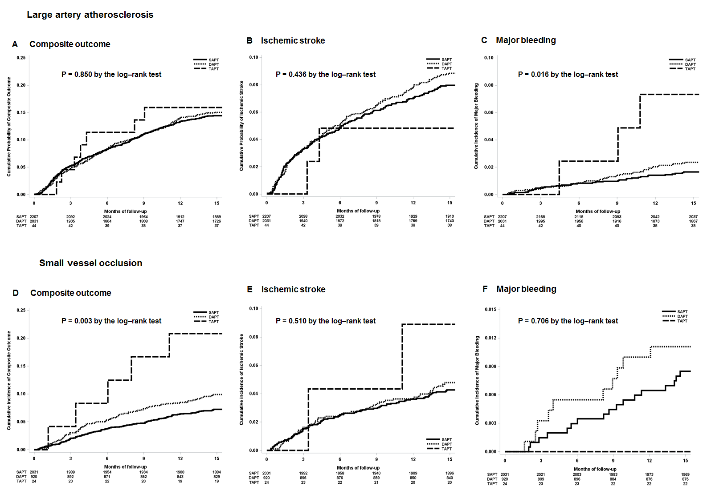
(A) Cumulative incidence of the composite outcome in LAA patients
(B) Cumulative incidence of the ischemic stroke in LAA patients
(C) Cumulative incidence of major bleeding in LAA patients
(D) Cumulative incidence of the composite outcome in SVO patients
(E) Cumulative incidence of the ischemic stroke in SVO patients
(F) Cumulative incidence of major bleeding in SVO patients
LAA: large artery atherosclerosis; SVO: small vessel occlusion; SAPT: single antiplatelet therapy; DAPT: dual antiplatelet therapy; TAPT: triple antiplatelet therapy

Supplementary Figure 4. Hazard Ratio for primary outcome and secondary outcome according to stroke severity
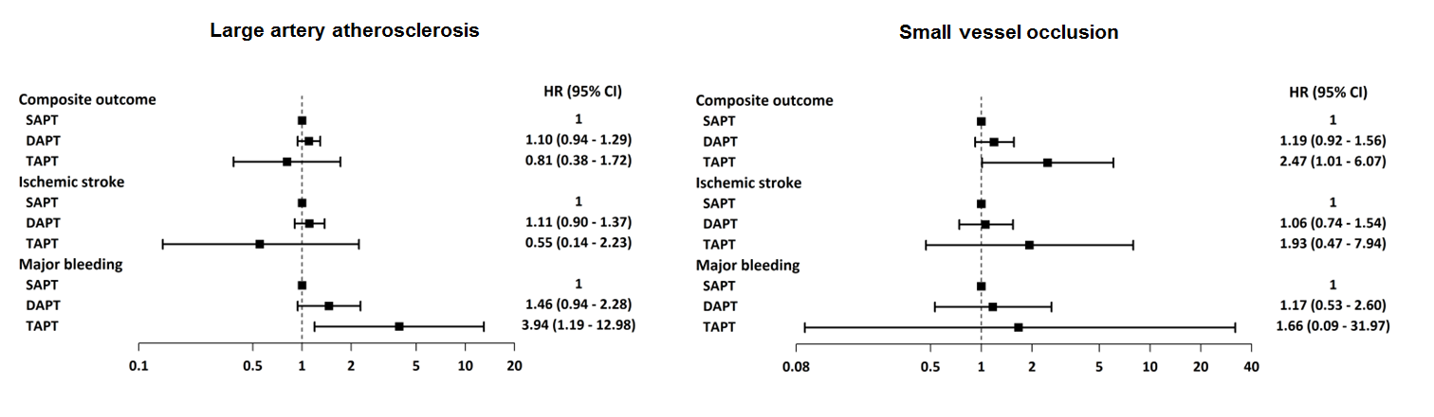
In the LAA group, DAPT and TAPT did not reduce the incidence of recurrent ischemic stroke or composite outcome, but they increased the risk of major bleeding events. In the SVO group, no significant differences in composite outcome, ischemic stroke and major bleeding events were observed among the three groups.
SAPT: single antiplatelet therapy; DAPT: dual antiplatelet therapy; TAPT: triple antiplatelet therapy

