Table S1 Monthly dominance of phytoplankton species in Donggang sea area
Species name | Mar | Apr | May | Jun | Jul | Aug | Sep | Oct
*Chaetoceros calcitrans | 0.01 | 0.04 | 0.08 | 0.13 | 0.03 | 0.02 | 0.001 | 0.002
*Cryptomonadales sp. | 0.01 | 0.02 | 0.13 | 0.02 | 0.03 | 0.05 | 0.004 | 0.03
*eukaryote marine clone | 0.01 | 0.05 | 0.003 | 0.003 | 0.004 | 0.00 | 0.001 | 0.004
*Mamiella gilva | 0.002 | 0.04 | 0.01 | 0.08 | 0.03 | 0.02 | 0.01 | 0.07
*Micromonas pusilla | 0.003 | 0.05 | 0.03 | 0.01 | 0.06 | 0.10 | 0.00 | 0.07
*Picochlorum atomus | 0.001 | 0.05 | 0.001 | 0.001 | 0.001 | 0.002 | 0 | 0
**Actinoptychus sp. | 0 | 0 | 0 | 0 | 0 | 0 | 0.00 | 0.02
**Arcocellulus cornucervis | 0.001 | 0.009 | 0.001 | 0.001 | 0.002 | 0.005 | 0.17 | 0.07
**Brockmanniella brockmannii | 0.01 | 0.03 | 0.10 | 0.004 | 0.01 | 0.01 | 0 | 0
**Cyclotella choctawhatcheeana | 0.01 | 0.02 | 0.004 | 0.02 | 0.06 | 0.03 | 0.06 | 0.02
**Chaetoceros sp1. | 0.56 | 0.02 | 0.01 | 0.004 | 0.005 | 0.010 | 0.0005 | 0.0017
**Chaetoceros sp2. | 0.004 | 0.02 | 0.005 | 0.11 | 0.01 | 0.02 | 0.004 | 0.004
**Chaetoceros muellerii | 0.004 | 0.01 | 0.00 | 0.15 | 0.00 | 0.01 | 0 | 0
**Geminigera cryophila | 0.001 | 0.002 | 0.004 | 0.003 | 0.04 | 0.02 | 0.00 | 0.02
**Heterosigma akashiwo | 0.003 | 0.01 | 0.005 | 0.01 | 0.06 | 0.01 | 0.01 | 0.01
**Karlodinium veneficum | 0.003 | 0.02 | 0.23 | 0.00 | 0.01 | 0.01 | 0.00 | 0.02
**Skeletonema menzellii | 0.01 | 0.04 | 0.01 | 0.01 | 0.15 | 0.05 | 0.02 | 0.02
**Teleaulax amphioxeia | 0.01 | 0.03 | 0.17 | 0.01 | 0.02 | 0.07 | 0.003 | 0.02
**Pyramimonas australis | 0.001 | 0.01 | 0.005 | 0.01 | 0.01 | 0.01 | 0.00 | 0.00
**Pyramimonas sp. | 0.000 | 0.02 | 0.004 | 0.001 | 0.001 | 0.001 | 0 | 0
***Akashiwo sanguinea | 0.0001 | 0 | 0.0001 | 0.0001 | 0.00003 | 0.001 | 0.54 | 0.14
***Alexandrium hiranoi | 0.003 | 0.02 | 0.01 | 0.12 | 0.25 | 0.02 | 0 | 0
***Alexandrium ostenfeldii | 0.002 | 0.02 | 0.01 | 0.07 | 0.01 | 0.01 | 0.00 | 0.00
***Asterionellopsis glacialis | 0.002 | 0.01 | 0.002 | 0.001 | 0.002 | 0.05 | 0.00 | 0.00
***Conticribra weissflogii | 0.03 | 0.01 | 0.002 | 0.002 | 0.003 | 0.004 | 0.00 | 0.00
***Ditylum brightwellii | 0.03 | 0.03 | 0.004 | 0.002 | 0.003 | 0.01 | 0.002 | 0.005
***Dissodinium pseudolunula | 0.004 | 0.04 | 0.01 | 0.04 | 0.004 | 0.01 | 0 | 0
***Fibrocapsa japonica | 0.001 | 0.004 | 0.001 | 0.001 | 0.001 | 0.02 | 0.02 | 0.04
***Guinardia striata | 0.003 | 0.01 | 0.001 | 0.001 | 0.002 | 0.05 | 0 | 0
***Polykrikos kofoidii | 0.002 | 0.01 | 0.01 | 0.003 | 0.005 | 0.08 | 0.00 | 0.03
***Proterythropsis sp. | 0.002 | 0.01 | 0.008 | 0.03 | 0.00 | 0.05 | 0.00 | 0.00
***Rhizosolenia setigera | 0.21 | 0.09 | 0.03 | 0.01 | 0.01 | 0.03 | 0.02 | 0.04
***Rhizosolenia similoides | 0.002 | 0.02 | 0.003 | 0.0003 | 0.001 | 0.004 | 0 | 0
***Polykrikos schwartzii | 0.001 | 0.01 | 0.002 | 0.001 | 0.002 | 0.04 | 0 | 0
***Thalassiosira curviseriata | 0 | 0 | 0 | 0 | 0 | 0 | 0.01 | 0.09
***Thalassiosira lundiana | 0 | 0 | 0 | 0 | 0 | 0 | 0.01 | 0.03
***Thalassiosira pseudonana | 0.005 | 0.01 | 0.004 | 0.01 | 0.12 | 0.01 | 0 | 0
***Thalassiosira punctigera | 0 | 0 | 0 | 0 | 0 | 0 | 0.01 | 0.04
*: picophytoplankton; **: nanophytoplankton; ***:microphytoplankton. The numbers in bold are the dominance of local phytoplankton in the month Y> 0.02.the first column is filled with red for picophytoplankton, yellow for nanophytoplankton and green for microphytoplankton, the same below.

Table S2 The dominance of phytoplankton in Changhai Sea
Species name | Mar | Apr | May | Jun | Jul | Aug | Sep | Oct
*Amoebophrya sp. | 0.002 | 0.004 | 0.09 | 0.01 | 0.002 | 0.004 | 0.01 | 0.19
*Aureococcus anophagefferens | 0.002 | 0.03 | 0.01 | 0.001 | 0.0005 | 0.002 | 0.0001 | 0.0008
*Chaetoceros calcitrans | 0.001 | 0.001 | 0.02 | 0.02 | 0.002 | 0.001 | 0 | 0
*Micromonas pusilla | 0.01 | 0.09 | 0.07 | 0.02 | 0.01 | 0.39 | 0.37 | 0.08
*Syndiniales sp. | 0.002 | 0.02 | 0.07 | 0.003 | 0.001 | 0.003 | 0.001 | 0.003
**Arcocellulus cornucervis | 0.01 | 0.01 | 0.01 | 0.00 | 0.001 | 0.02 | 0.02 | 0.03
**Brockmanniella brockmannii | 0.01 | 0.02 | 0.07 | 0.01 | 0.001 | 0.01 | 0 | 0
**Chaetoceros sp. | 0.03 | 0.0003 | 0.0001 | 0.0001 | 0.00004 | 0.0002 | 0.0001 | 0.0002
**Cyclotella choctawhatcheeana | 0.004 | 0.003 | 0.002 | 0.005 | 0.003 | 0.04 | 0.0007 | 0.0006
**Eucampia antarctica | 0 | 0 | 0 | 0 | 0 | 0 | 0.23 | 0.01
**Heterosigma akashiwo | 0.001 | 0.003 | 0.002 | 0.03 | 0.004 | 0.005 | 0.0003 | 0.0005
**Karlodinium veneficum | 0.002 | 0.01 | 0.10 | 0.004 | 0.001 | 0.004 | 0.11 | 0.37
**Phaeocystis globosa | 0.0001 | 0.001 | 0.0002 | 0.0005 | 0.0003 | 0.002 | 0.01 | 0.05
**Phaeocystis pouchetii | 0.002 | 0.24 | 0.03 | 0.002 | 0.001 | 0.003 | 0 | 0
**Pyramimonas australis | 0.0005 | 0.002 | 0.003 | 0.02 | 0.001 | 0.002 | 0.003 | 0.02
**Skeletonema menzellii | 0.01 | 0.01 | 0.01 | 0.01 | 0.05 | 0.03 | 0.0025 | 0.0012
**Teleaulax amphioxeia | 0.004 | 0.005 | 0.02 | 0.01 | 0.00 | 0.01 | 0.01 | 0.05
**Telonema subtile | 0.002 | 0.03 | 0.01 | 0.003 | 0.002 | 0.01 | 0.005 | 0.04
***Alexandrium affine | 0.003 | 0.01 | 0.01 | 0.01 | 0.004 | 0.10 | 0 | 0
***Alexandrium hiranoi | 0.04 | 0.07 | 0.07 | 0.64 | 0.87 | 0.08 | 0 | 0
***Alexandrium ostenfeldii | 0.001 | 0.001 | 0.002 | 0.03 | 0.001 | 0.004 | 0.004 | 0.002
***Cerataulina pelagica | 0.001 | 0.0005 | 0.0005 | 0.0003 | 0.0002 | 0.01 | 0.04 | 0.01
***Pseudo-nitzschia pungens | 0.002 | 0.003 | 0.002 | 0.001 | 0.0004 | 0.03 | 0.0028 | 0.0011
***Pyrophacus steinii | 0.00002 | 0.0002 | 0.0003 | 0.02 | 0.001 | 0.001 | 0.03 | 0.0002
***Rhizosolenia setigera | 0.76 | 0.25 | 0.26 | 0.03 | 0.01 | 0.05 | 0.0042 | 0.0029
***Thalassiosira curviseriata | 0.003 | 0.01 | 0.01 | 0.002 | 0.0005 | 0.004 | 0.01 | 0.04
***Thalassiosira gravida | 0.004 | 0.02 | 0.01 | 0.005 | 0.001 | 0.01 | 0 | 0
***Thalassiosira hendeyi | 0.01 | 0.01 | 0.01 | 0.01 | 0.001 | 0.02 | 0.0008 | 0.01

Table S3 The abbreviation codes of phytoplankton species
Pico |  | Nano |  | Micro
Species name | Abbreviated code | Species name | Abbreviated code | Species name | Abbreviated code
Amoebophrya sp. | Amo sp. | Amoebophrya sp. | Amo sp. | Akashiwo sanguinea | Aka san
Aureococcus anophagefferens | Aur ano | Arcocellulus cornucervis | Arc cor | Alexandrium affine | Ale aff
Chaetoceros calcitrans | Cha cal | Brockmanniella brockmannii | Bro bro | Alexandrium hiranoi | Ale hir
Cryptomonadales sp. | Cry sp. | Chaetoceros cf. lorenzianus | Cha sp4. | Alexandrium ostenfeldii | Ale ost
Euduboscquella crenulata | Eud cre | Chaetoceros cf. wighamii | Cha cf. | Asterionellopsis glacialis | Ast gla
eukaryote clone OLI11011 | euk clo2 | Chaetoceros muellerii | Cha mue | Asteroplanus karianus | Ast kar
eukaryote clone OLI11115 | euk clo3 | Chaetoceros sp. | Cha sp2. | Cerataulina pelagica | Cer pel
eukaryote marine clone ME1-24 | euk clo1 | Chaetoceros sp. NIES-3971 | Cha sp1. | Conticribra weissflogii | Con wei
Mamiella gilva | Mam gil | Chaetoceros sp. RCC2564 | Cha sp3. | Dissodinium pseudolunula | Dis pse
Micromonas commoda | Mic com | Chattonella subsalsa | Cha sub | Ditylum brightwellii | Dit bri
Micromonas pusilla | Mic pus | Chrysophyceae sp. | Chr sp. | Fibrocapsa japonica | Fib jap
phytoplankton environmental sample 1 | phy env1 | Cyclotella choctawhatcheeana | Cyc cho | Guinardia striata | Gui str
phytoplankton environmental sample 2 | phy env2 | Geminigera cryophila | Gem cry | Impagidinium pallidum | Imp pal
phytoplankton environmental sample 3 | phy env3 | Hemiselmis cryptochromatica | Hem cry | Licmophora paradoxa | Lic par
phytoplankton environmental sample 4 | phy env4 | Heterosigma akashiwo | Het aka | Polykrikos kofoidii | Pol kof
Picochlorum atomus | Pic ato | Karlodinium veneficum | Kar ven | Polykrikos schwartzii | Pol sch
Pycnococcus provasolii | Pyc pro | Leucocryptos marina | Leu mar | Proterythropsis sp. BSL-2009a | Pro sp.
Syndiniales Group I | Syn sp1. | Levanderina fissa | Lev fis | Pseudo-nitzschia pungens | Pse pun
Syndiniales Group II | Syn sp2. | Pelagophyceae sp. | Pel sp. | Pyrophacus steinii | Pyr ste
Syndiniales sp. | Syn sp3. | Phaeocystis pouchetii | Pha pou | Rhizosolenia setigera | Rhi set
Triparma strigata | Tri str | Pyramimonas australis | Pyr aus | Rhizosolenia similoides | Rhi sim
 |  | Rhodomonas sp. RCC2516 | Rho sp. | Storeatula major | Sto maj
 |  | Skeletonema menzellii | Ske men | Thalassiosira curviseriata | Tha cur
 |  | Spiniferites ramosus | Spi ram | Thalassiosira gravida | Tha gra
 |  | Spumella sp. | Spu sp. | Thalassiosira hendeyi | Tha hen
 |  | Teleaulax amphioxeia | Tel amp | Thalassiosira lundiana | Tha lun
 |  | Telonema subtile | Tel sub | Thalassiosira minima | Tha min
 |  |  |  | Thalassiosira pseudonana | Tha pse

Table S4 Explanatory quantity and significance test of environmental factors
Area | Grain size community | Environmental factors | Interpretation quantity | pseudo-F | P
DG | Pico- | SST | 30.2 | 12.6 | 0.002
DG | Pico- | NO₂ | 9.9 | 4.4 | 0.008
DG | Pico- | pH | 9.5 | 4.9 | 0.008
DG | Pico- | DO | 8.5 | 4.1 | 0.020
DG | Pico- | DO(N/P) | 6.5 | 3.6 | 0.032
DG | Nano- | DO | 36.2 | 18.9 | 0.002
DG | Nano- | NO₃ | 12.3 | 7.3 | 0.002
DG | Nano- | SiO₃ | 8.8 | 5.8 | 0.002
DG | Nano- | NO₃/DIN | 7.2 | 5.2 | 0.002
DG | Nano- | DIP | 6.9 | 5.5 | 0.004
DG | Nano- | NO₂ | 5.7 | 5.0 | 0.006
DG | Nano- | NH₄/DIN | 3.5 | 3.2 | 0.018
DG | Micro- | SiO₃/DIN | 24.6 | 12.8 | 0.002
DG | Micro- | NO₃ | 23.7 | 16.4 | 0.002
DG | Micro- | T | 10.3 | 9.9 | 0.002
DG | Micro- | COD | 9.8 | 7.8 | 0.002
DG | Micro- | NH₄/DIN | 5.3 | 5.6 | 0.002
DG | Micro- | NH₄ | 4.5 | 5.2 | 0.008
DG | Micro- | DIP | 6.4 | 9.0 | 0.002
DG | Micro- | SiO₃ | 3.0 | 4.5 | 0.010
DG | Micro- | DIN/DON | 2.4 | 4.0 | 0.014
DG | Total | DO | 25.6 | 12.5 | 0.002
DG | Total | NO₃ | 18.9 | 11.3 | 0.002
DG | Total | SiO₃ | 12.8 | 9.1 | 0.002
DG | Total | DIP | 9.3 | 7.6 | 0.002
DG | Total | NO₃/DIN | 7.0 | 6.4 | 0.002
DG | Total | NO₂ | 3.8 | 3.7 | 0.004
DG | Total | DIN | 2.9 | 3.0 | 0.010
DG | Total | COD | 2.7 | 2.9 | 0.008
DG | Total | pH | 2.3 | 2.6 | 0.016
CH | Pico- | SiO₃ | 36.6 | 20.3 | 0.002
CH | Pico- | NO₃ | 20.4 | 14.7 | 0.002
CH | Pico- | TN/TP | 10.7 | 9.1 | 0.002
CH | Pico- | NO₂ | 7.5 | 7.3 | 0.002
CH | Pico- | DIP | 7.6 | 8.7 | 0.002
CH | Pico- | pH | 2.8 | 3.4 | 0.036
CH | Nano- | TN/TP | 29.3 | 14.7 | 0.002
CH | Nano- | pH | 17.4 | 10.5 | 0.002
CH | Nano- | NO₂/DIN | 10.3 | 7.1 | 0.002
CH | Nano- | SiO₃ | 7.1 | 5.4 | 0.002
CH | Nano- | SST | 4.0 | 3.1 | 0.034
CH | Nano- | DO | 3.8 | 3.2 | 0.050
CH | Micro- | SST | 53.4 | 48.5 | 0.002
CH | Micro- | DO | 31.5 | 74.0 | 0.002
CH | Micro- | NH₄ | 6.0 | 20.2 | 0.002
CH | Micro- | TN/TP | 3.3 | 14.5 | 0.002
CH | Micro- | DIP | 1.9 | 10.3 | 0.002
CH | Micro- | DIN/DON | 1.0 | 5.8 | 0.010
CH | Micro- | NH₄/DIN | 0.6 | 3.6 | 0.032
CH | Micro- | NO₂ | 0.5 | 3.1 | 0.048
CH | Micro- | DIP/DOP | 0.4 | 3.1 | 0.046
CH | Total | SST | 46.6 | 35.6 | 0.002
CH | Total | DO | 30.9 | 47.5 | 0.002
CH | Total | NH₄ | 5.8 | 10.8 | 0.002
CH | Total | TN/TP | 4.1 | 9.2 | 0.002
CH | Total | NO₂ | 3.4 | 8.8 | 0.002
CH | Total | DIP | 3.3 | 10.8 | 0.002
CH | Total | T | 1.2 | 4.3 | 0.004
CH | Total | pH | 1.0 | 3.6 | 0.006
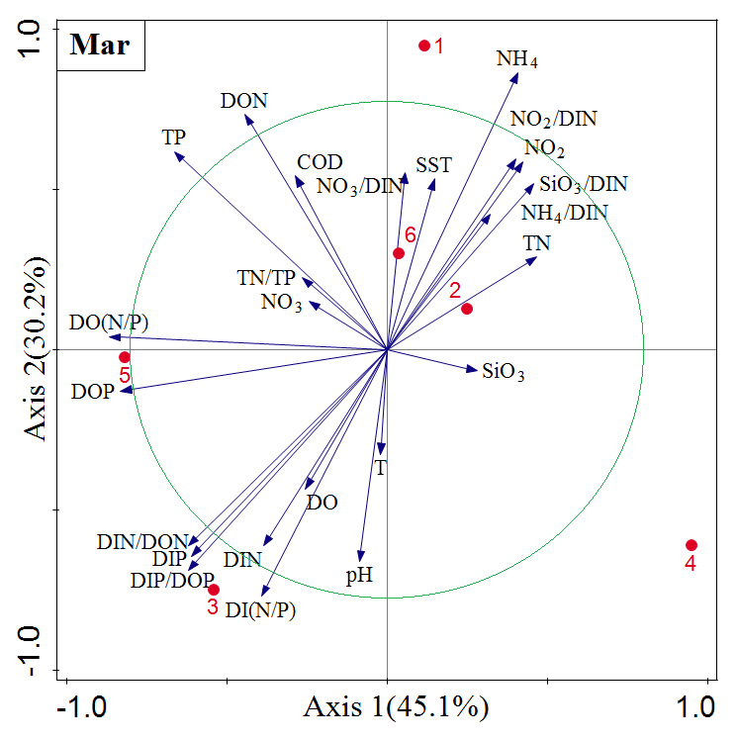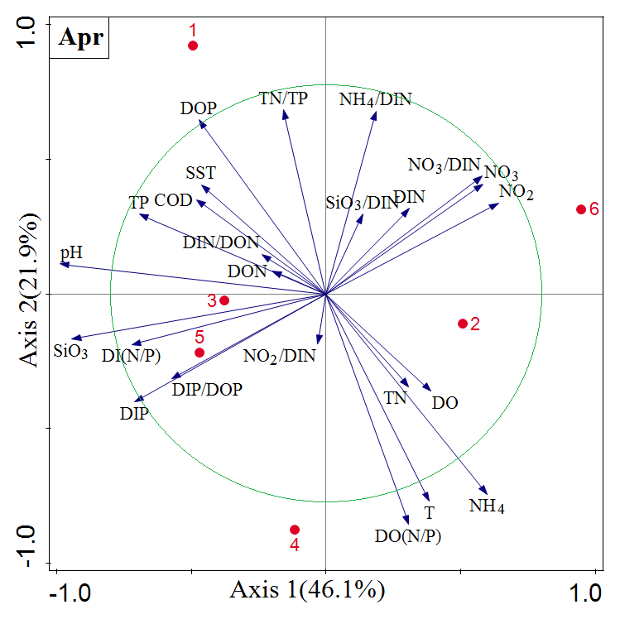
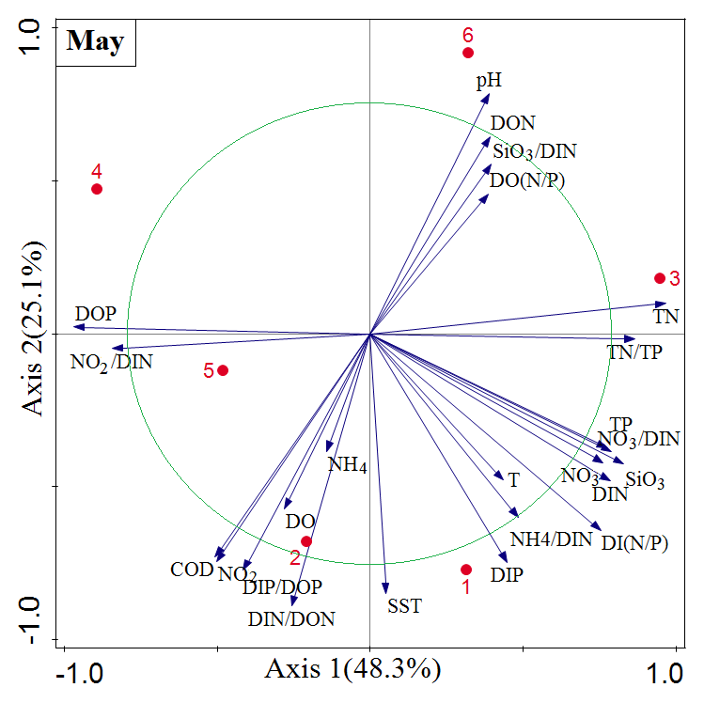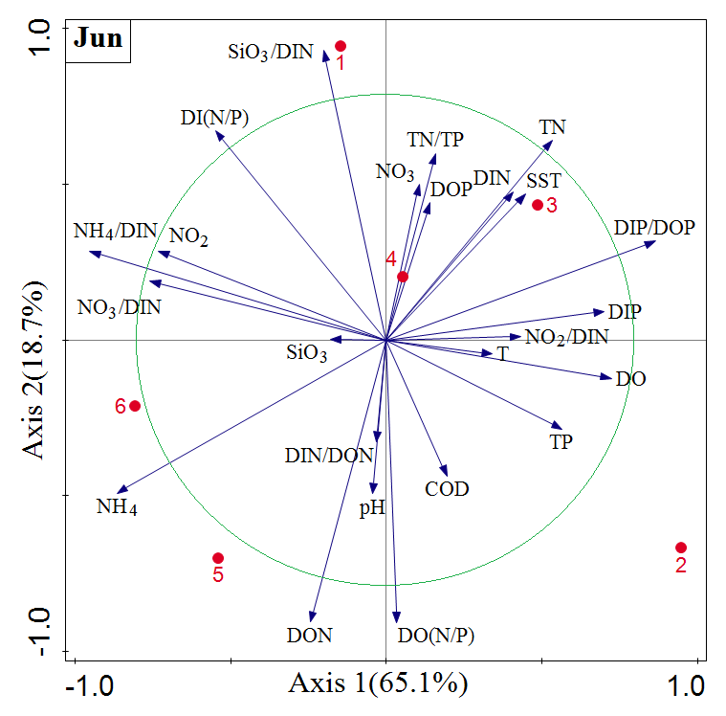
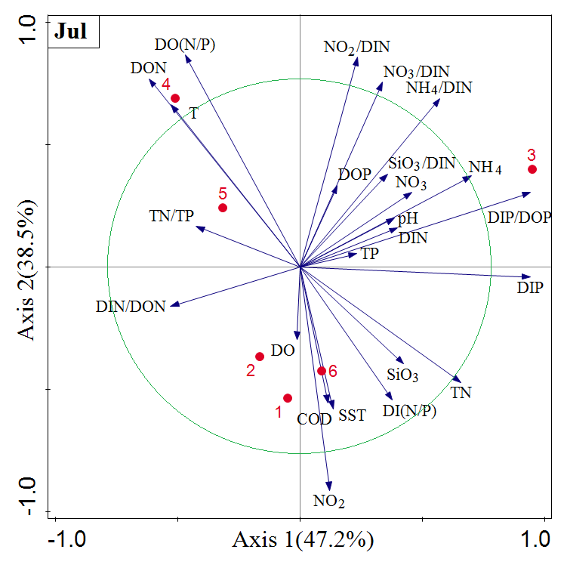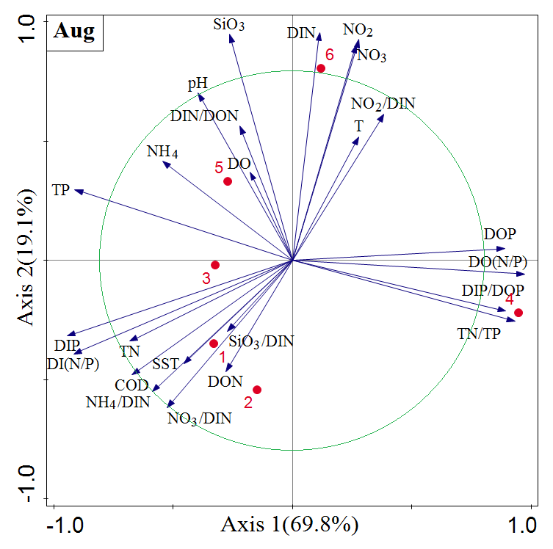
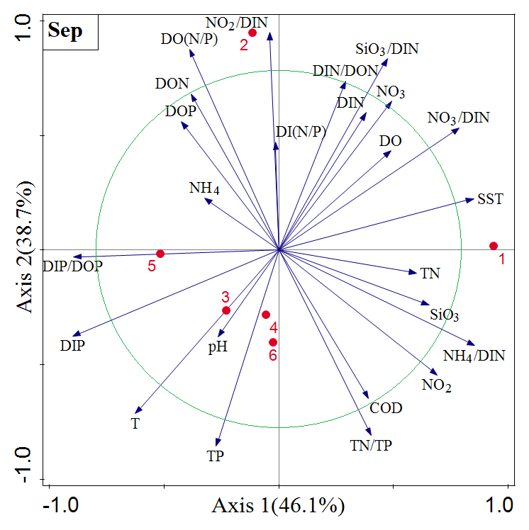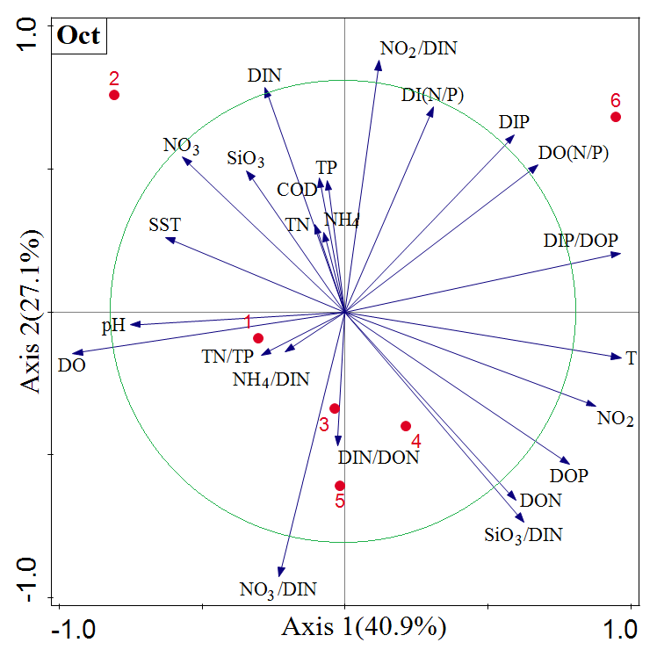
Fig.S1 PCA plots of difference rates of environmental variables at Donggang and Changhai. Red numbers 1–6 indicate corresponding stations. Blue arrows indicate environmental variables.

Fig.S2 Inter-month variation of the main differential environmental indicators in the two study areas (10-fold expansion of NO₂ in figure)

