Supplementary information for
Blue Quantum Emitters in hexagonal Boron Nitride
Haidong Liang^{1,2,#,*}, Yuan Chen^{3,#}, Leyi Loh^{2,4}, Nicholas Lin Quan Cheng², Yifeng Chen^{2,5}, Chengyuan Yang^{1,2}, Zhepeng Zhang², Kenji Watanabe⁶, Takashi Taniguchi⁷, Su Ying Quek^{2,4,5,8}, Michel Bosman⁴, Goki Eda^{2,3,5, *}, Andrew A. Bettiol^{1,2,*}
¹ Centre for Ion Beam Applications (CIBA), Department of Physics, National University of Singapore, Singapore 117542, Singapore
² Department of Physics, National University of Singapore, Singapore 117551, Singapore
³Department of Chemistry, National University of Singapore, 117543, Singapore
⁴Department of Materials Science and Engineering, National University of Singapore, 117575, Singapore
⁵Centre for Advanced 2D Materials, National University of Singapore, 117542, Singapore
⁶Research Centre for Functional Materials, National Institute for Materials Science, Tsukuba 305-0044, Japan;
⁷International Centre for Materials Nanoarchitectonics, National Institute for Materials Science, Tsukuba 305-0044, Japan
⁸NUS Graduate School Integrative Sciences and Engineering Programme, National University of Singapore, 117456, Singapore
# These authors contributed equally. * Authors to whom correspondence should be addressed. Electronic mail: haidong@nus.edu.sg, g.eda@nus.edu.sg, a.bettiol@nus.edu.sg

Fig. S1. PL spectra of some other ensembles of emitters in hBN powders.
Spectra obtained from several ensembles of blue emitters exhibit similar properties as the spectrum shown in Fig. 1. The PL emissions cover all the visible range when excited using a 405 nm laser. However, the blue emissions dominate in most cases. Usually, there are two main peaks at around 427 nm and 452 nm. Similar blue emissions was also observed in hBN as reported by Hayee, F. et al.¹
Fig. S2. Nearby SPEs have similar emissions. a, PL mapping of four emitters located nearby. b, PL spectra from four emitters selected in a. c, $g^{2}(τ)$ measurements of the four selected emissions.
Most of the blue emitters that are close to each other have similar PL spectra. It is difficult to distinguish them with the objective lens. Fig. S2 shows an example.

Fig. S3. More blue SPEs, with PL spectra (left) and $g^{2}(τ)$ (right) results confirming their single photon emission properties. The blue highlighted part indicates the selected wavelength range for the $g^{2}(τ)$ measurements. SPEs measured with a, 462 nm peak emission, b, 489 nm peak emission. c, 427 nm peak emission, d, 506 nm peak emission, e, 446 nm peak emission, f, 492 nm peak emission.
There are three main types of blue quantum emitters that have been observed. The first has a ZPL peak at around 430 nm, examples include SPE3, SPE8. The second has a peak at around 450-460 nm, examples include SPE1, SPE2, SPE4, SPE5, SPE6, SPE7, SPE9. The third has a peak at around 490 nm, examples are SPE10, SPE11, SPE12.
Fig. S4. SPEs with longer wavelengths. a, PL spectrum of a quantum emitter in hBN powder. b, g⁽²⁾ measurements with different wavelength range. The top is for the blue wavelength range, highlighted with blue colour in the spectrum, the bottom is for the red wavelength range, highlighted with a red colour in the spectrum.
Unlike blue SPEs, for emissions in hBN powders with longer wavelength, once a sharp PL peaks observed, it is probably a SPE, and it can be accompanied with the blue emissions. Fig. S4 is such an example.

Fig. S5. Details of the irradiation conditions in Fig. 3d-f. The schematic of the irradiation points. The overall scan size is 36×36 µm, with 2048×2048 pixels. The patterned points have three different sizes: 53 nm×53 nm (3×3 pixels), 106 nm×106 nm (6×6 pixels) and 159 nm×159 nm (9×9 pixels), as marked in different columns in the figure. Each two rows are irradiated with different dwell times: from 1 s/pixel to 1 ms pixel (top to bottom), as marked in the figure. The irradiation current is 0.9 pA, and the highest fluence for the spots is ~5.6×10⁶ ions/pixel, and 4.5×10⁷ ions/spot (9× 9 pixels).
Fig. S6. PL spectra of hBN flakes on different substrates irradiated using different energies and ions.
Both proton and helium ion beam irradiation can create the blue emissions in hBN on different substrates. This might suggest that the blue emissions is from the an internal vacancy or intercalant defects.
Fig. S7. PL data from additional high temperature annealed hBN. a, Microscope image of two annealed hBN flakes. b, PL map of the two hBN flakes in a. c, PL spectra of different emissions marked in b. d, Microscope image of another annealed hBN flake. e, PL map of the sample in d. All scale bars are 5µm. f, PL spectra of the emissions marked in e.
Fig. S8. Blue emitters and $V_{B}^{-}$. a, Microscope image of a patterned irradiated hBN flake using 1.6MeV He⁺. There are squares and points. The top square and two rows of points have been irradiated with a fluence of 6E16. The top second squares and next two rows of points have been irradiated with a fluence of 3E16, and then 1E16, 5E15, 3E15, 1E15, 3E14 to the bottom square and two rows of points. b, Blue emission PL map of the irradiated hBN flake in a. c, PL spectra of the pristine and irradiated squares with different fluences, excited by 405 nm laser. d, PL spectra of 4 points marked in a and b, excited by 405 nm laser. They are labelled as ‘point1’: an irradiated point in the first row, with a fluence of 6E16, ‘centre1’ an unirradiated point in centre of four irradiated points, close to ‘point1’, ‘point6’: an irradiated point in the 11th row, with a fluence of 1E15, ‘centre6’: an unirradiated point close to ‘point6’. e, ODMR spectrum of the $V_{B}^{-}$ spin defects in the 3E16 square. f, $V_{B}^{-}$ PL map of the same hBN flake, excited by 532 nm laser. g, PL spectra of the pristine and irradiated squares, excited by 532 nm laser. h, PL spectra of 4 points marked in a and b, excited by 532 nm laser. All fluences are in units of ions/cm².
Both the blue emissions and the $V_{B}^{-}$ spin defects^{2,3} are created by high energy He⁺ irradiation. However, the distributions of the two emissions are a slightly different. For the $V_{B}^{-}$ spin defects, the PL intensity increases up to the highest irradiation fluence 6E16, as shown in Fig. S8g. It means in this fluence range, the He⁺ irradiation can continue to create more $V_{B}^{-}$ spin defects without significant damage the overall crystal lattice. However, for the blue emissions, the PL intensity increases with fluence up to 3E15 ions/cm², and then decreases with increasing fluence, as shown in Fig. S8c. When the fluence is over 1E16 ions/cm², the blue emissions spread beyond the irradiation area. For example, the unirradiated point ‘centre1’ marked in Fig. S8a is giving the same blue emissions as the irradiated points and squares, as shown in Fig. S8d. However, if it is excited by 532 nm laser, the same point is not giving any emission from $V_{B}^{-}$ spin defects as shown in Fig. S8h. This is consistent with our assumption that the blue emissions are from B_{int} and N_{int}. While for $V_{B}^{-}$ spin defects, the boron vacancies are confined to the irradiate region only. The knocked out boron and nitrogen atoms can propagate through the crystal, and the B_{int} and N_{int} would spread out of the irradiated region, when the irradiation fluence is high.

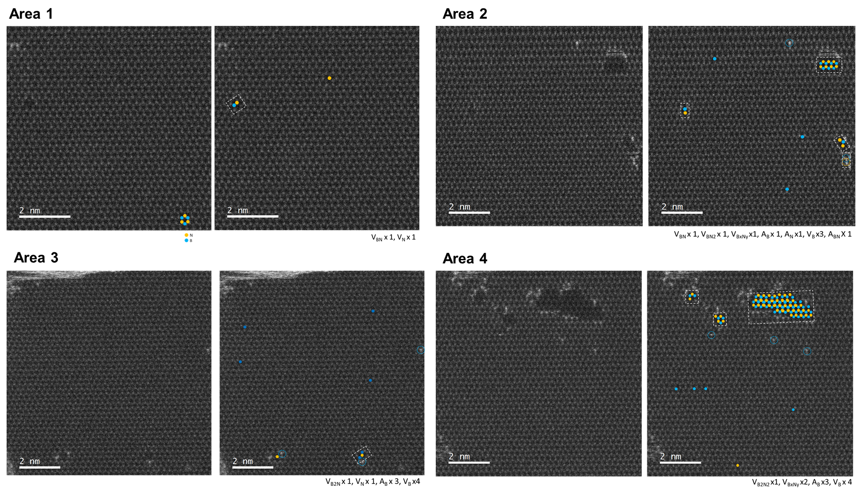
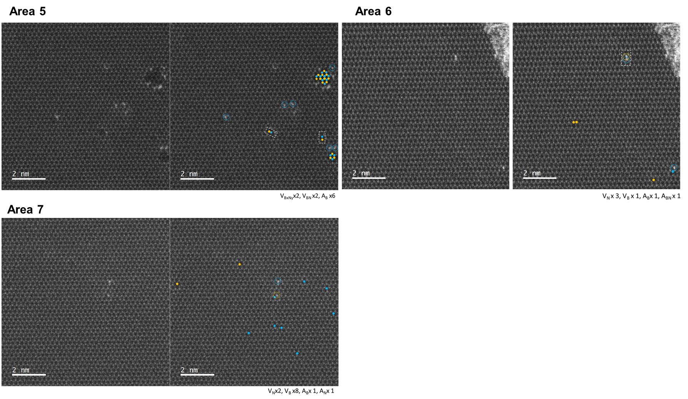
Figure S9. HAADF-STEM images of 7 areas across the proton-irradiated hBN multilayer. For each area, as-imaged (left panel) and the same image with defects denoted (right panel) of a large-area HAADF-STEM image. Blue circle represents B atoms and yellow circle represents N atoms. In the right panels, filled circles denote missing atoms and dashed unfilled circles denote additional atoms (e.g., adatoms and intercalants).

References
1. Hayee, F. et al. Revealing multiple classes of stable quantum emitters in hexagonal boron nitride with correlated optical and electron microscopy. Nat. Mater. 19, 534–539 (2020).
2. Gottscholl, A. et al. Initialization and read-out of intrinsic spin defects in a van der Waals crystal at room temperature. Nat. Mater. 19, 540–545 (2020).
3. Liang, H. et al. High Sensitivity Spin Defects in hBN Created by High-Energy He Beam Irradiation. Adv. Opt. Mater. 2201941, 1–7 (2022).

