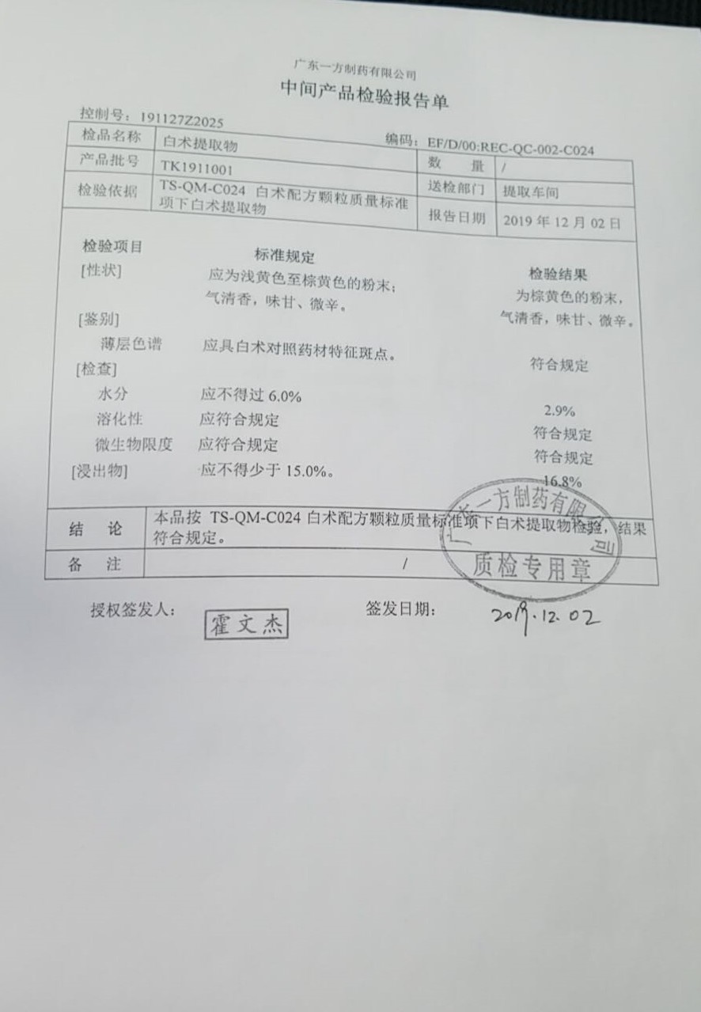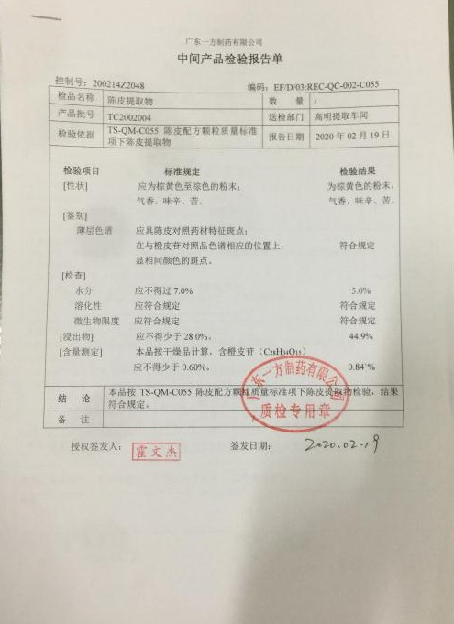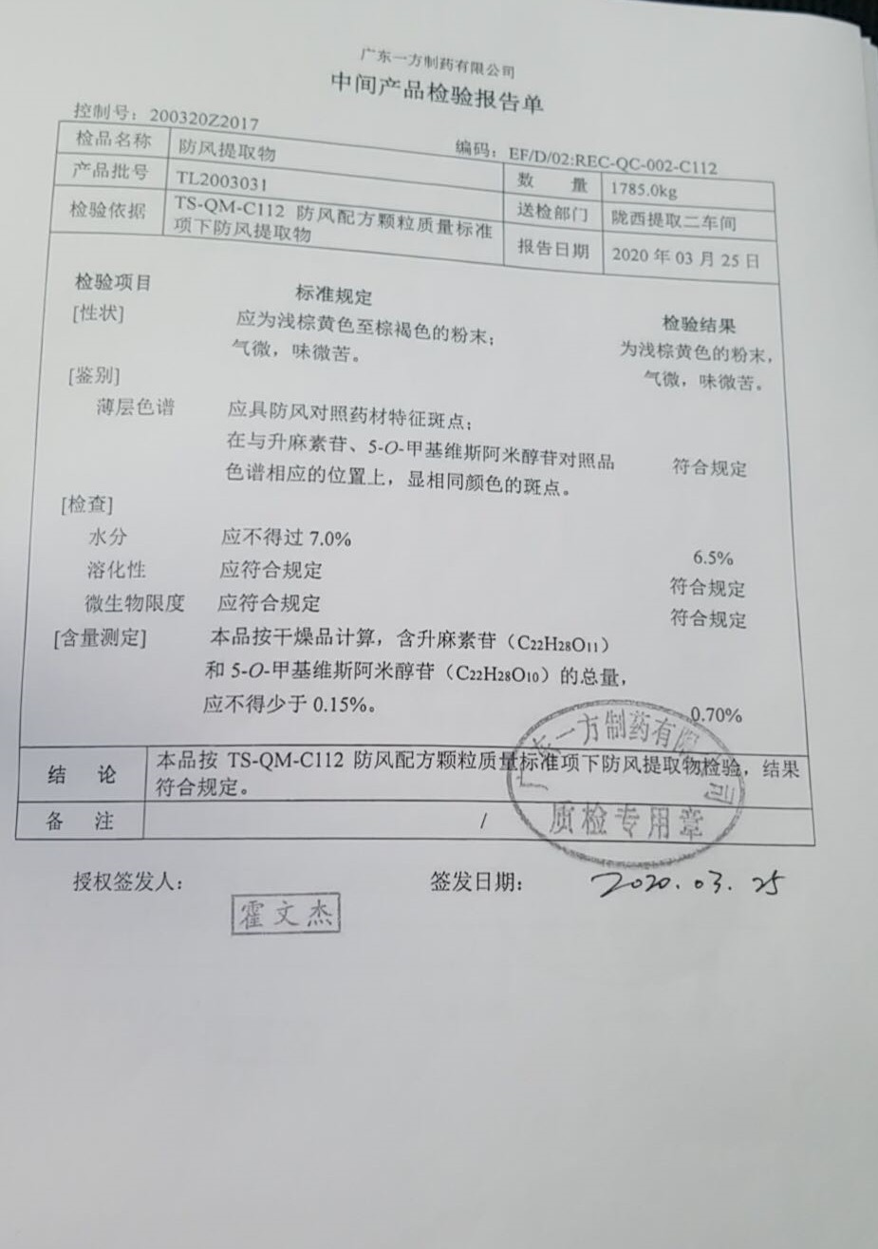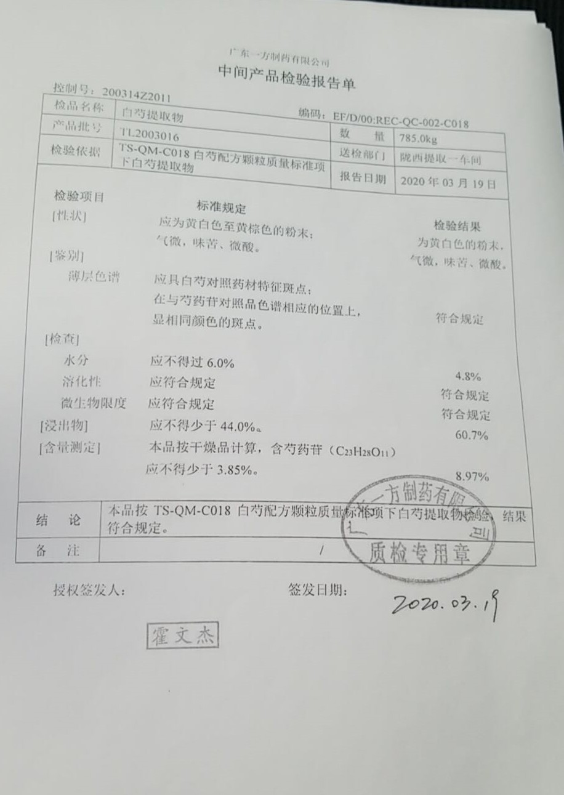

Rhizoma Atractylodis Macrocephalae extract

Citri Reticulatae Pericarpium extract

Saposhnikoviae Radix extract

Paeoniae Radix Alba etract

