Box 1. Outlining the quantification equations, approaches, and data sources of five cookstove methodologies on the voluntary carbon market: Gold Standard (GS)’s Technologies and Practices to Displace Decentralized Thermal Energy Consumption (GS-TPDDTEC), GS Simplified Methodology (GS-Simplified), GS Methodology for Metered & Measured Energy Cooking Devices (GS-Metered), and the Clean Development Mechanism (CDM)’s small scale methodologies: AMS-II-G, and AMS-I-E. We include the exact equations in supplemental materials, but here outline the approaches using the language defined in the main text (e.g., our definition of adoption rate)
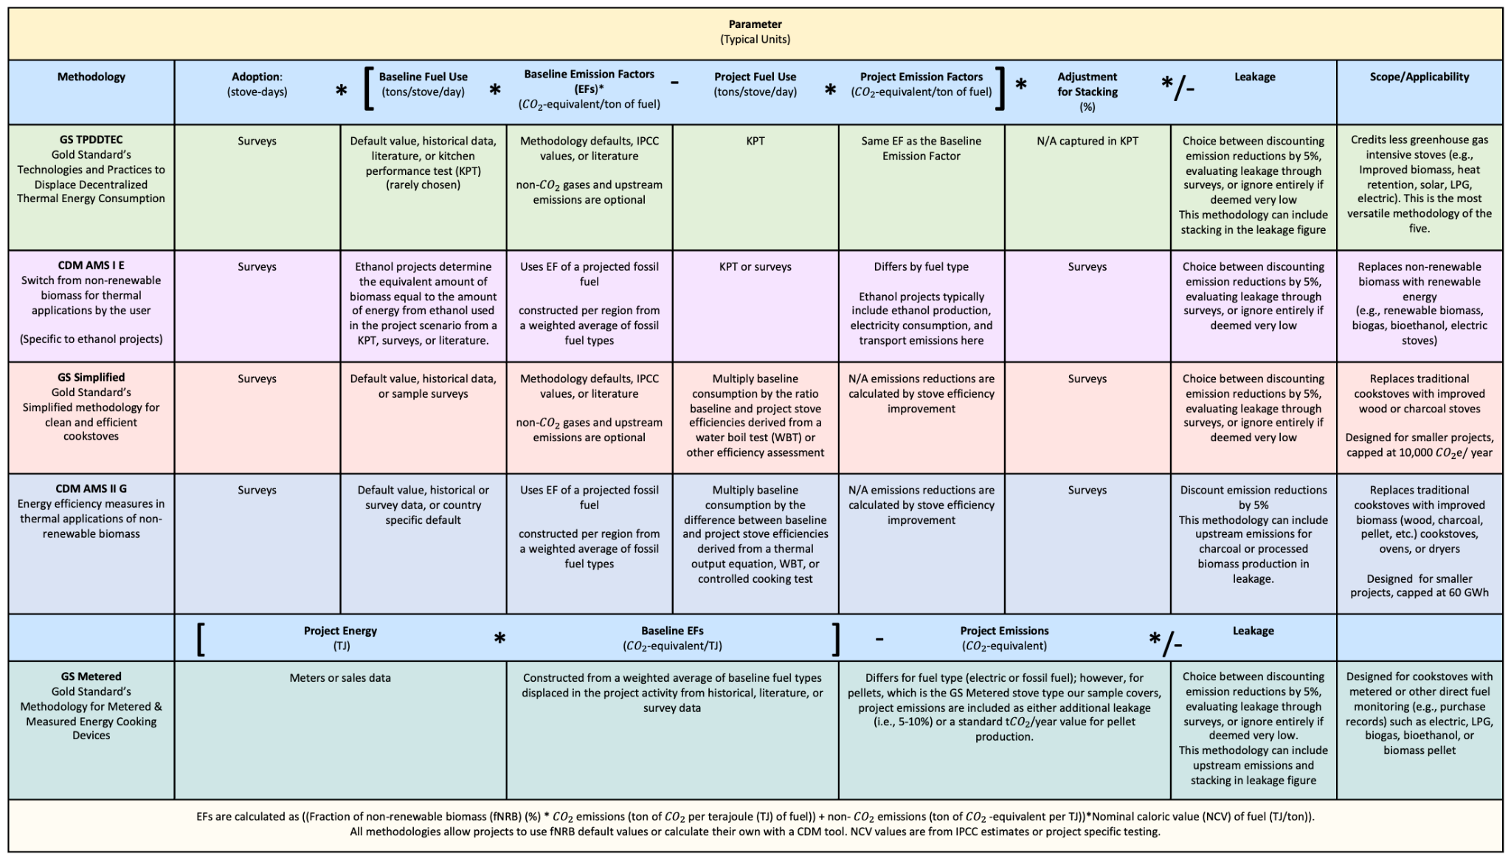

Box 2. Outlining the factors and adjustments to each methodology based on published literature and our own analysis (see online methods) and then the amount of over or under-crediting from each individual factor across our sample of projects. A check mark means that the approach outlined in the “Adjusted with” row was applied; a blank cell means no adjustment was made; text describes the change that was made.

