Supplementary Material
Incidence and Potential Risk Factors of Human Cytomegalovirus Infection in Patients with Severe and Critical COVID-19: A retrospective cohort study
Waki Imoto^{a,b,c}, Takumi Imai^{d}, Ryota Kawai^{d}, Yasutaka Ihara^{d}, Yuta Nonomiya^{d}, Hiroki Namikawa^{e}, Koichi Yamada^{a,b,c}, Hisako Yoshida^{d}, Yukihiro Kaneko^{f,g}, Ayumi Shintani^{d}, Hiroshi Kakeya^{a,b,c,g}

ª Department of Infection Control Science, Osaka Metropolitan University Graduate School of Medicine, 1-4-3, Asahi-machi, Abeno-ku, Osaka 545-8585, Japan
^{b} Department of Infectious Disease Medicine, Osaka Metropolitan University Hospital, 1-5-7 Asahi-machi, Abeno-ku, Osaka 545-8586, Japan
^{c} Department of Infection Control and Prevention, Osaka Metropolitan University Hospital, 1-5-7 Asahi-machi, Abeno-ku, Osaka 545-8586, Japan
^{d} Department of Medical Statistics, Osaka Metropolitan University Graduate School of Medicine, 1-4-3, Asahi-machi, Abeno-ku, Osaka 545-8585, Japan
^{e} Department of Medical Education and General Practice, Osaka Metropolitan University Graduate School of Medicine, 1-4-3, Asahi-machi, Abeno-ku, Osaka 545-8585, Japan
^{f} Department of Bacteriology, Osaka Metropolitan University Graduate School of Medicine, 1-4-3, Asahi-machi, Abeno-ku, Osaka 545-8585, Japan
^{g} Research Center for Infectious Disease Sciences (RCIDs), Osaka Metropolitan University Graduate School of Medicine, 1-4-3, Asahi-machi, Abeno-ku, Osaka 545-8585, Japan

Table of contents

Supplementary Methods 1. Details for time-dependent propensity score sequential matching

Supplementary Table 1. Code lists for treatment and disease definitions
Supplementary Table 1-1. ICD-10 codes for COVID-19
Supplementary Table 1-2. Code list for medical procedures for COVID-19
Supplementary Table 1-3. ICD-10 codes for human cytomegalovirus infections
Supplementary Table 1-4. Agents for human cytomegalovirus infections (Definition 2)
Supplementary Table 1-5. ICD-10 codes for comorbidities
Supplementary Table 1-6. Code list for therapeutic medications for COVID-19
Supplementary Table 1-7. Code list for other medical procedures

Supplementary Table 2. Characteristics of the population created by time-dependent propensity score sequential matching
Supplementary Table 2-1. Source population: Severe or critical COVID-19 population
Supplementary Table 2-2. Source population: Critical COVID-19 subgroup

Supplementary Figure 1. Demographic characteristics of COVID-19 patients from MDV data compared with those from publicly available data for COVID-19 by the Japanese Ministry of Health, Labour and Welfare
Supplementary Figure 1-1. Distribution of patients with COVID-19 by calendar date
Supplementary Figure 1-2. Proportions of age groups in COVID-19 patients

Supplementary Figure 2. Relationships between age and BMI and HCMV infection
Supplementary Figure 2-1. Relationships between age and incidents of HCMV infection
Supplementary Figure 2-2. Relationships between BMI and incidents of HCMV infection

Abbreviations: ICD-10, International Statistical Classification of Diseases and Related Health Problems, Tenth Revision; COVID-19, coronavirus disease 2019

Supplementary Methods 1. Details for time-dependent propensity score sequential matching
To examine the relationship between human cytomegalovirus (HCMV) infection and increased mortality, while adjusting for the effects of measured potential confounders and avoiding the risk of “immortal time bias” [1, 2], time-dependent propensity score sequential matching [3] was applied in a 1:5 ratio to create groups with comparable observed characteristics other than HCMV infection status. The propensity score for each day was estimated by Cox proportional hazard regression for the incidence of HCMV infection. The following potential confounders between HCMV infection and death were included in the models: time-fixed (age, body mass index, sex, Charlson Comorbidity Index score, hypertension, dyslipidemia, calendar dates) and time-dependent covariates (steroid use, immunosuppressants use, intensive care unit admission, blood transfusion, dialysis, respiratory care procedure). The matching process, similar to that adopted in the observational cohort study [4] of the coronavirus disease 2019 vaccine by Dagan et al., was performed as follows. For every patient with a new incidence of HCMV infection, the population at risk for HCMV infection on the same day, who were not yet selected as a matched group, was identified. Among this population, the top five patients with the nearest propensity scores to that of the patient with a new incidence of HCMV infection were selected. Matching proceeded in the order of data entry, and optical matching [3,5] was not performed. If a selected patient without HCMV infection had HCMV infection on a later day, survival times of members in the same matched group were censored, and a new matched group using a patient with a new incidence of HCMV infection was created. The balance of the characteristics on the day of the matching between patients with and without HCMV infection were evaluated by absolute standardized differences (shown in Supplementary Table 2-1, 2-2). The hazard ratios for death between patients with (numerator) and without (denominator) HCMV infection and their 95% confidence intervals were estimated by simple Cox proportional hazard regressions with the matching day as the time 0 and accounting for the matched nature of the data. Hazard ratios above 1 indicate the association between HCMV infection and increased mortality.

References

1. Wolkewitz M, Allignol A, Harbarth S, de Angelis G, Schumacher M and Beyersmann J. Time-dependent study entries and exposures in cohort studies can easily be sources of different and avoidable types of bias. J Clin Epidemiol 2012; 65: 1171-1180.
2. Schumacher M, Allignol A, Beyersmann J, Binder N and Wolkewitz M. Hospital-acquired infections—appropriate statistical treatment is urgently needed! Int J Epidemiol 2013; 42: 1502-1508.
3. Lu B. Propensity score matching with time-dependent covariates. Biometrics 2005; 61: 721-728.
4. Dagan N, Barda N, Kepten E, Miron O, Perchik S, Katz MA et al. BNT162b2 mRNA Covid-19 vaccine in a nationwide mass vaccination setting. N Engl J Med 2021; 384: 1412-1423.
5. Li YP, Propert KJ and Rosenbaum PR. Balanced risk set matching. J Am Stat Assoc 2001; 96: 870-882.
Supplementary Table 1-1. ICD-10 codes for COVID-19
 | ICD-10 codes
COVID-19 | U071, U072, B342

Supplementary Table 1-2. Code lists for medical procedures for COVID-19
Treatment | Procedure codes
Oxygen therapy | J024
Intensive care unit admission | A3002, A3004, A301-41, A301-42, A301-43, A3011, A3012, A3013, A3014, A3015, A3018
High-care unit admission | A3001, A3003, A301-21, A301-22
Invasive mechanical ventilation/  Non-invasive Positive Pressure Ventilation (NPPV) | 114009610, 114006810, 140006050, 140009310, 140009550, 140009750, 140009950, 140010150, 140023510, 140023750, 140023950, 140024150, 140024350, 140030830, 140030930, 140031030, 140031130, 140031230, 140031330, 140031430, 140031530, 140031630, 140031730, 140037810,  140039550, 140039650, 140039850, 140039950
Extracorporeal membrane oxygenation (ECMO) | 710010015, 710010014, 710010662, 710010661, 738960000, 710010663
High-flow oxygen therapy | 140057410, 140057310, 140055810

Supplementary Table 1-3. ICD-10 codes for human cytomegalovirus infections
 | ICD-10 codes
HCMV | B202, B250, B251, B258, B259, B271

Supplementary Table 1-4. Agents for human cytomegalovirus infections (Definition 2)
Brand name
Ganciclovir
Valganciclovir Hydrochloride
Foscarnet Sodium Hydrate

Supplementary Table 1-5. ICD-10 codes for comorbidities
 | ICD-10 codes
Dyslipidemia | E785
Organ transplantation | Z94
Myocardial Infarction | I21.x, I22.x, I25.2
Congestive heart failure | I09.9, I11.0, I13.0, I13.2, I25.5, I42.0, I42.5–I42.9, I43.x, I50.x, P29.0
Peripheral vascular disease | I70.x, I71.x, I73.1, I73.8, I73.9, I77.1, I79.0, I79.2, K55.1, K55.8, K55.9, Z95.8, Z95.9
Cerebrovascular disease | G45.x, G46.x, H34.0, I60.x–I69.x
Dementia | F00.x–F03.x, F05.1, G30.x, G31.1
Chronic pulmonary disease | I27.8, I27.9, J40.x–J47.x, J60.x–J67.x, J68.4, J70.1, J70.3
Rheumatologic disease | M05.x, M06.x, M31.5, M32.x–M34.x, M35.1, M35.3, M36.0
Peptic ulcer | K25.x–K28.x
Mild liver disease | B18.x, K70.0–K70.3, K70.9, K71.3–K71.5, K71.7, K73.x, K74.x, K76.0, K76.2–K76.4, K76.8, K76.9, Z94.4
Moderate-to-severe renal disease | I12.0, I13.1, N03.2–N03.7, N05.2–N05.7, N18.x, N19.x, N25.0, Z49.0– Z49.2, Z94.0, Z99.2
Any malignancy | C00.x–C26.x, C30.x–C34.x, C37.x–C41.x, C43.x, C45.x–C58.x, C60.x–C76.x, C97.x
Leukemia | C91.x-C95.x
lymphoma | C81.x-C90.x, C96.x
Moderate-to-severe liver disease | I85.0, I85.9, I86.4, I98.2, K70.4, K71.1, K72.1, K72.9, K76.5, K76.6, K76.7
Metastatic solid tumor | C77.x–C80.x
Acquired immunodeficiency syndrome | B20.x–B22.x, B24.x

Supplementary Table 1-6. List of codes for therapeutic medication for COVID-19
Therapeutic medication | Procedure codes
Steroid | 642450081, 620007336, 620525001, 620525101, 620525201, 620525301, 620525401, 620525601, 620525701, 620525801, 620525901, 640422045,  640422046, 640422047, 642450007, 642450008, 642450054, 642450055, 642450056, 620007332, 620007333, 620007334, 620007335, 620008816,  620008818, 620008819, 620518605, 620518905, 620519005, 640454009, 642450029, 642450044, 642450046, 620002208, 620002209, 620005162,  620005163, 620519503, 620519603, 622756200, 622756300, 620006613, 620006614, 620530402, 620530502, 642450115, 642450116, 642450169,  642450170, 642450171, 620002613, 620002614, 620002615, 620002616, 620002617, 620003829, 620003830, 620003831, 620006275, 620006276,  621977200, 620001310, 620003758, 620003759, 620007356, 620007357, 620007358, 620007359, 620528103, 620528502, 620528505, 620528901,  620528905, 620529204, 622100401, 622100501, 622329500, 622329600, 622329700, 622756400, 622756500, 622756600, 622756700, 640454024,  640454025, 640454026, 642450049, 642450050, 642450139, 642450140, 642450141, 642450142, 620007381, 620007382, 642450067, 620002513,  612450017, 612450121, 620006985, 620006986, 620008651, 620521302, 621997701, 622359901, 612450070, 612450007, 620006903, 620007078,  610408661, 610422253, 610431117, 610454071, 612450051, 612450096, 612450100, 612450118, 620000125, 620000694, 620000695, 620000696,  620000697, 620000698, 620001894, 620001895, 620001896, 620003272, 620004294, 620004387, 620005848, 620527133, 620527205, 621559301, 620004578, 620004620, 620005133, 620005134, 620006161, 620006162, 620521501, 620005125, 620005126
Immunosuppressant | 616210018, 620006949, 620008624, 620008997, 620009119, 621133002, 622023001, 622746800, 666210001, 610409338, 620008070, 620008106, 620008107, 620008509, 620008510, 620008511, 620008512, 620008513, 620008514, 620009440, 620009441, 620506801, 621867201, 621884302, 621884303, 621890601, 621965201, 621969902, 622011801, 622026201, 622053401, 622065002, 622102901, 622102902, 622102903, 622109401, 622646301, 614210169, 620005941, 622181601, 640453101, 644210037, 614210098, 620007515, 622221301, 644210048, 644210049, 620006808, 622093601, 622509701, 622509801, 622608801, 622608901, 622609001, 629911301, 629911401, 629913601, 629913701, 640462006, 622378801, 622577001, 622590801, 622596901, 622651501, 620002479, 620007231, 621934101, 622003901, 622242701, 622624701, 622635001, 622635101, 622635201, 629906301, 622676001, 622676101, 622676201, 622676301, 629900301, 629900501, 622070002, 622675801, 622224501, 622654701, 622508101, 622508201, 622046501, 622554701, 622123701, 622639401, 622403701, 622518901, 622608101, 629911101, 620006184, 620006804, 620006805, 620008445, 620008829, 622510201, 613990075, 613990088, 620004279, 620006560, 629916101, 622533801, 622533901, 622534001, 622793801, 622793901, 621984301, 620004854, 620004855, 620004856, 620008850, 610443018, 610443019, 610443020, 610443021, 613990074, 613990085, 613990086, 620002641, 620002728, 620002729, 620009313, 620009314, 620882601, 620894001, 621326201, 621483603, 621483703, 621637802, 621674701, 621674801, 621677601, 621677701, 621685602, 621732201, 621738001, 621743306, 621743406, 622043804, 622056201, 622056301, 622056401, 622741800, 622741900, 622742000, 622363701, 610409342, 610443059, 610451009, 610451010, 613990096, 620008437, 620008438, 620008439, 622047401, 622232201, 622232301, 622270501, 622270601, 622280901, 622281001, 622281101, 622281201, 622281301, 622370001, 622370101, 622384301, 622384303, 622384401, 622384403, 622384501, 622384503, 622384601, 622384603, 622384703, 622437901, 622438001, 622438101, 622438601, 622438701, 622580901, 622590901, 643990141, 622242601, 622573701, 622573801, 622440601, 622587101, 622587201, 622587301, 622587401, 622678101, 622678201, 610432045, 622272501, 622283901, 622440801, 613990069, 613990070, 621993201, 621993301, 622008902, 622009001, 622009002, 622518701, 622518801, 611140861, 611140862, 620003877, 620003878, 620003879, 620003880, 622002901, 622265701, 622491601, 622183501, 622184501, 620006160, 620006895, 620007135, 620942001, 610453008, 610453065, 610463004, 620004897, 621442802, 621442905, 621443001, 621443002, 622039002, 622103601, 622103602, 622161402, 622173801, 622173901, 622746900, 622747000, 622833801, 622596601, 622596701, 622662001, 622662101, 622242201, 622242301, 622830601, 622830701, 610422247, 610433106, 610433156, 620000180, 620000181, 620006092, 620008052, 620942203, 620942401, 620943101, 622108401, 622108402, 622743000, 622743100, 620005116, 620005117, 610432016, 620002151, 620004005, 620004082, 620004083, 620004084, 620006686, 621622602, 621642203, 621734801, 622581501, 622630501, 622634501, 622642401, 622742200, 622742300, 622841001, 622869601, 620000416, 620000417, 620000418

Supplementary Table 1-7. Code list for other medical procedures
 | Procedure codes
Blood transfusion | 150327910, 150366570, 150286310, 150224910, 150328010, 150366670, 150390610, 150225770, 710010664, 150247010, 724230000, 150380070, 150254810, 150286210, 643330019
Dialysis | 140051010, 140052970, 140057910, 140058970, 620823201, 113002510, 620004188, 140057810, 620008808, 140058010, 140060310, 620005699, 620009138, 620009139, 710010654, 738110000, 622299701, 622299801, 622299501, 622300001, 732670000, 622299401, 622299601, 622300101, 622300201, 734010000, 734000000, 732690000, 622300301, 738100000, 734020000, 622471001, 620822301, 140059170, 140036710, 620004183, 621653101, 620007544, 622533301, 622837401, 620005155, 140052810, 622533201, 622181701, 621317501, 622396601, 621318501, 732680000, 140052570, 622530601, 622083901, 621728201, 620822901, 622131401, 622605801, 622605601, 622131301, 621989301, 621989401, 621989202,  621989402, 621989302, 620009140, 622301301, 622301501, 620009141, 622301201, 622300701, 622300801, 622300601, 622301101, 622054701, 621315901, 622471101, 621561701, 620007212, 621561801, 620004186, 620005157, 140051110, 622837301, 622456001, 622456101, 140058410, 140058510, 620009151, 620006312, 190167970, 620008806, 621653201,  620007213, 620005156, 620004187, 622420401, 622054501, 622836201, 621728101, 140060210, 620005701, 620007543, 622083701, 620822001, 622396801, 621317701, 621317601, 620008809, 622300501, 622301001, 140058210, 620823001, 620009175, 620009176, 620009180, 620009177, 620009186, 622605901, 622836301, 622836101, 622533401, 622300401,  620009168, 140060410, 622811101, 622083801, 622458601, 622458501, 721018000, 622471201, 620009159, 620009158, 620009187, 620009189, 620005154, 621989201, 620009166, 620009157, 140061010, 620009162, 620009171, 737890000, 737910000, 737900000, 621728001, 622837501, 622300901, 620822101, 621515201, 622606001, 621480901, 622466701,  622605701, 622466801, 620004184, 620004185, 621956701, 621317301, 620007546, 622606101, 140058610, 622514201, 620830301, 620829901, 621628201, 620830901, 621318301, 140058110, 621633401, 620009184, 620009178, 622456201, 621318001, 621319201, 621317201, 622396501, 621318401, 621318101, 621318901, 620009183, 620009181, 620009172,  620009174, 620009188, 620009173, 140059410, 140060910, 622396701, 621503101, 621503401, 621502001, 140060810

Supplementary Table 2-1. Characteristics of the population created by time-dependent propensity score sequential matching (source population: severe or critical COVID-19 population)
 |  | With HCMV (Definition 2) N=93 | Without HCMV (Definition 2) N=465
Variables |  | Mean (SD) or N (%) | Mean (SD) or N (%) | ASD
Age |  | 68.97 (11.16) | 68.87 (12.86) | 0.008
BMI |  | 25.12 (5.23) | 24.86 (5.03) | 0.051
Sex | Male | 71 (76.3%) | 357 (76.8%) | 0.010
 | Female | 22 (23.7%) | 108 (23.2)
Charlson Comorbidity Index score |  | 4.53 (2.70) | 4.41 (2.73) | 0.042
Hypertension |  | 72 (77.4%) | 359 (77.2%) | 0.005
Dyslipidemia |  | 23 (24.7%) | 115 (24.7%) | <0.001
Organ transplantation history |  | 2 (2.2%) | 7 (1.5%) | 0.048
Calendar dates of COVID-19
 | 01/01/2020-05/31/2020 | 5 (5.4%) | 23 (4.9%) | 0.019
 | 06/01/2020-10/31/2020 | 9 (9.7%) | 38 (8.2%) | 0.053
 | 11/01/2020-03-31/2021 | 23 (24.7%) | 119 (25.6%) | 0.020
 | 04/01/2021-06/30/2021 | 31 (33.3%) | 165 (35.5%) | 0.045
 | 07/01/2021-12/31/2021 | 25 (26.9%) | 120 (25.8%) | 0.024
Medication
 | Steroid | 89 (95.7%) | 448 (96.3%) | 0.033
 | Immunosuppressants | 40 (43.0%) | 193 (41.5%) | 0.030
Medical procedures
 | ICU admission | 73 (78.5%) | 364 (78.3%) | 0.005
 | Blood transfusion | 53 (57.0%) | 254 (54.6%) | 0.048
 | Dialysis | 7 (7.5%) | 35 (7.5%) | <0.001
 | Respiratory care procedure* | 73 (78.5%) | 381 (81.9%) | 0.086
*Respiratory care procedure includes the use of at least one of the following procedures: invasive mechanical ventilation/non-invasive positive pressure ventilation (NPPV), extracorporeal membrane oxygenation (ECMO), and high flow oxygen therapy.
Abbreviations; COVID-19, coronavirus disease 2019; HCMV, human cytomegalovirus; SD, standard deviation; ASD, absolute standardized difference; BMI, body mass index; ICU, intensive care unit

Among multiple datasets from multiple imputation methods for missing BMI, a result from one dataset was shown. The results of the characteristics balance were similar across all multiply imputed datasets.
Supplementary Table 2-2. Characteristics of the population created by time-dependent propensity score sequential matching (source population: critical COVID-19 subgroup)
 |  | With HCMV (Definition 2) N=78 | Without HCMV (Definition 2) N=390
Variables |  | Mean (SD) or N (%) | Mean (SD) or N (%) | ASD
Age |  | 68.50 (10.86) | 69.53 (12.01) | 0.090
BMI |  | 25.93 (5.46) | 25.56 (4.93) | 0.072
Sex | Male | 58 (74.4%) | 285 (73.1%) | 0.029
 | Female | 20 (25.6%) | 105 (26.9%)
Charlson Comorbidity Index score |  | 4.14 (2.41) | 4.03 (2.25) | 0.046
Hypertension |  | 57 (73.1%) | 286 (73.3%) | 0.006
Dyslipidemia |  | 19 (24.4%) | 98 (25.1%) | 0.018
Organ transplantation history |  | 1 (1.3%) | 9 (2.3%) | 0.077
Calendar dates of COVID-19
 | 01/01/2020-05/31/2020 | 4 (5.1%) | 17 (4.4%) | 0.036
 | 06/01/2020-10/31/2020 | 8 (10.3%) | 33 (8.5%) | 0.062
 | 11/01/2020-03-31/2021 | 18 (23.1%) | 101 (25.9%) | 0.066
 | 04/01/2021-06/30/2021 | 27 (34.6%) | 146 (37.4%) | 0.059
 | 07/01/2021-12/31/2021 | 21 (26.9%) | 93 (23.8%) | 0.071
Medication
 | Steroid | 76 (97.4%) | 382 (97.9%) | 0.034
 | Immunosuppressants | 35 (44.9%) | 166 (42.6%) | 0.047
Medical procedures
 | ICU admission | 72 (92.3%) | 366 (93.8%) | 0.061
 | Blood transfusion | 47 (60.3%) | 229 (58.7%) | 0.031
 | Dialysis | 7 (9.0%) | 26 (6.7%) | 0.086
 | Respiratory care procedure* | 71 (91.0%) | 356 (91.3%) | 0.009
*Respiratory care procedure includes the use of at least one of the following procedures: invasive mechanical ventilation/non-invasive positive pressure ventilation (NPPV), extracorporeal membrane oxygenation (ECMO), and high flow oxygen therapy.
Abbreviations; COVID-19, coronavirus disease 2019; HCMV, human cytomegalovirus; SD, standard deviation; ASD, absolute standardized difference; BMI, body mass index; ICU, intensive care unit

Among multiple datasets from multiple imputation methods for missing BMI, a result from one dataset was shown. The results of the characteristics balance were similar across all multiply imputed datasets.

Supplementary Figure 1-1. Distribution of patients with COVID-19 by calendar date
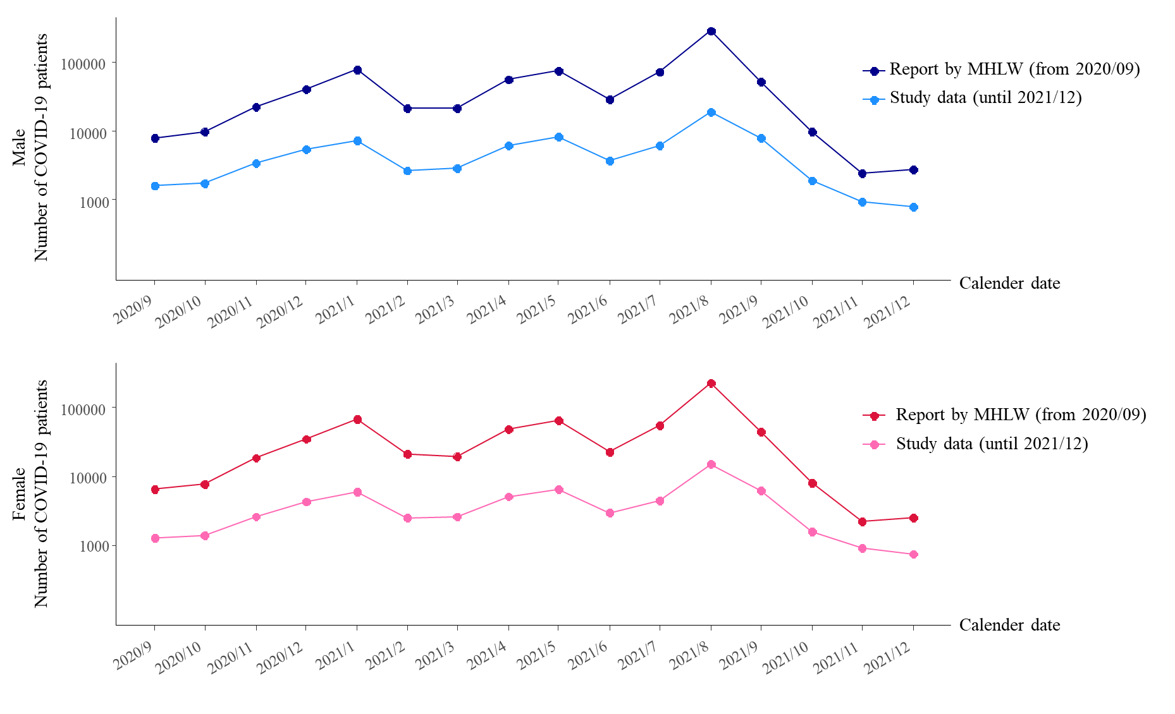

Abbreviations; COVID-19, coronavirus disease 2019; MHLW, Ministry of Health, Labour and Welfare
Supplementary Figure 1-2. Proportions of age groups in COVID-19 patients
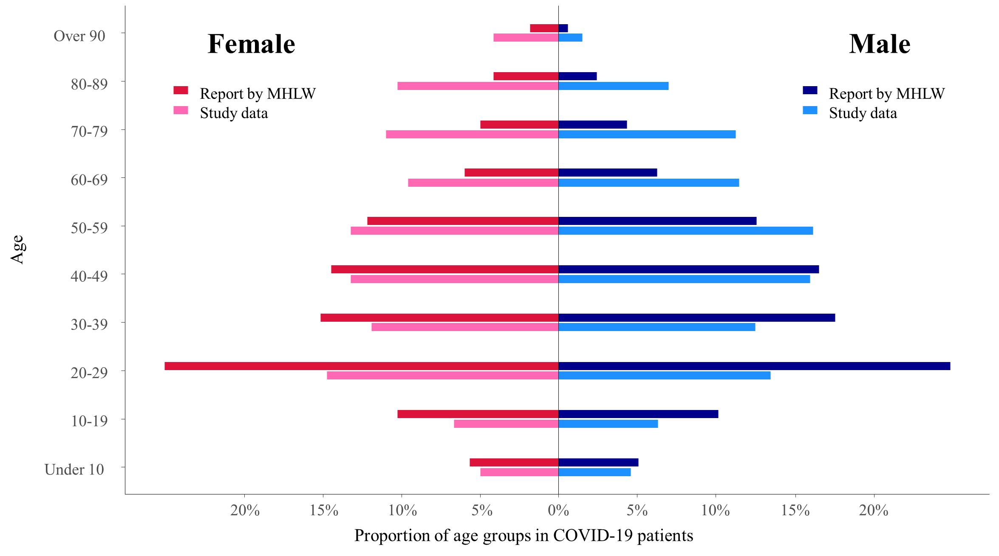

Abbreviations: COVID-19, coronavirus disease 2019; MHLW, Ministry of Health, Labour and Welfare
Supplementary Figure 2-1. Relationships between HCMV infection and age
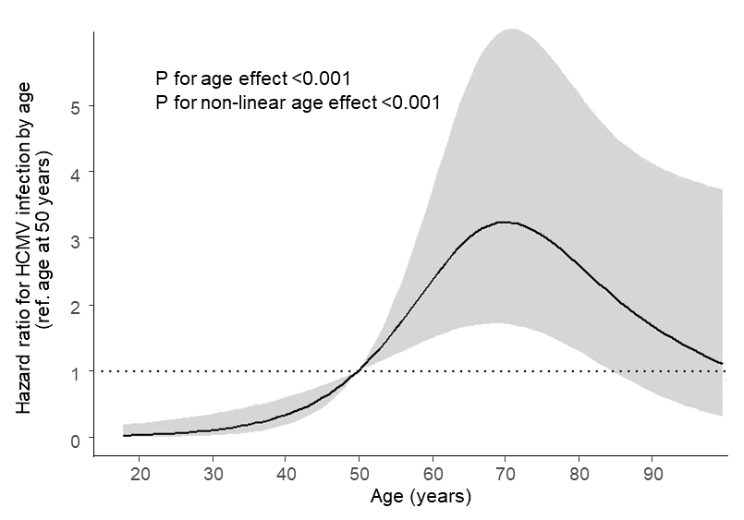

Abbreviation: HCMV, human cytomegalovirus

Supplementary Figure 2-2. Relationships between HCMV infection and BMI
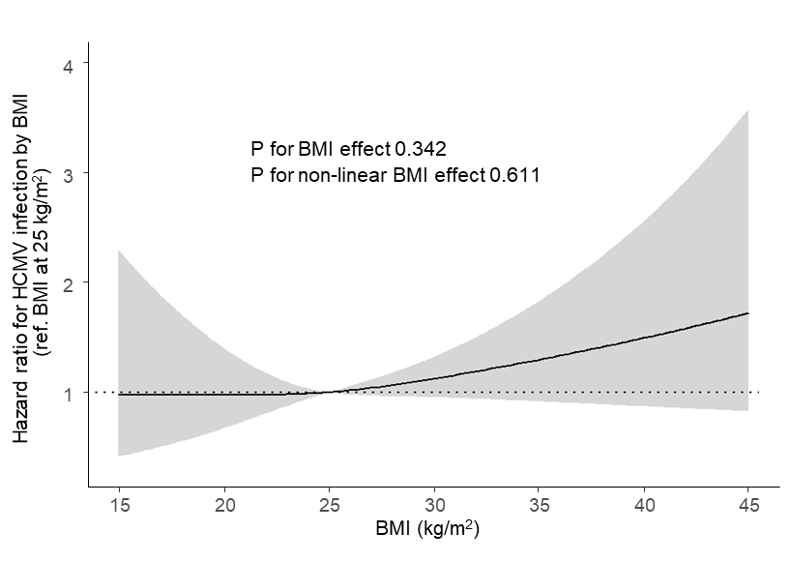

Abbreviations: HCMV, human cytomegalovirus; BMI, body mass index

