Supplementary materials and methods for the manuscript entitled Evaluating the performance of a plasma dual-target test developed based on sense-antisense and dual-MGB probe technique for colorectal cancer detection

Supplementary methods

Tissue and plasma DNA extraction
Genomic DNA of tissue samples and plasma cfDNA was isolated using FFPE DNA rapid extraction kit (TianGen, Beijing) and plasma/serum cfDNA extraction kit (Ammunition Life-tech, Wuhan), respectively, according to the protocols. Briefly, cfDNA extraction was divided into two steps. First, approximately 10 ml of blood was drawn from participants at room temperature and then centrifuged twice with 1300g and 14000g for 10 min at 4°C within 2 hours. Then, about 2~3 ml of plasma was retained for cfDNA purification. The purified cfDNA was eluted in 40 ul TE buffer and then treated with bisulfite using a DNA bisulfite modification kit (Ammunition Life-tech, Wuhan) according to the instructions described in the previous study, or stored at -80 °C until used.

Primer designing
According to the annotation information of 450k BeadChip, we obtained the two candidate probes genomic coordinates, which were located in NTMT1 (METTL11A) and MAP3K14-AS1 (LOC100133991) genes, respectively (Table 1). Their coordinates were then confirmed on the NCBI gene database (https://www.ncbi.nlm.nih.gov/gene/). With the aid of UCSC Genome Brower tool (https://genome.ucsc.edu/cgi-bin/hgGateway), we retrieved 150 bp of 5’- and 3’- flanking sequences of each probe as templates to design methylation-specific PCR (MSP) primers and MGB probes. For NTMT1, the sense and antisense strands of target region were used as templates for primers and MGB probe designing. For MAP3K14-AS1, one pair of primers and two MGB probes were designed for the antisense strand of target region. It should be noted that the first MGB probe of MAP3K14-AS1 was designed according to the Bisulfite-converted antisense strand (BS-strand) sequence, while the second was based on the complementary sequence of the BS-strand. All the primers used in this study were conducted on Primer 5.0 software. The final primers and MGB probes are shown in Table 2. The Actin gene (ACTB) was selected as an internal control.

Table 1. The details of two candidate probes.
Probe ID | Position (hg19) | Symbol | Strand
cg14015706 | chr9:132382433-132382434 | NTMT1 | reverse
cg08247376 | chr17:43339358-43339359 | MAP3K14-AS1 | forward

Table 2. The information of primers and MGB probes used in this study.
Target | Primers | Seqeunce | Amplification region | Length
ACTB | forward | 5'-CGCAATAAATCTAAACAAACTCC-3' |  | 99 bp
ACTB | reverse | 5'-GGGTTAGATGGGGGATATGT-3' |  | 99 bp
ACTB | MGB probe | 5'-TCCCAAAACCCCAACAC-3' |  | 99 bp
NTMT1 | sense forward | 5'-TAATTTTGGGGGTTGTTGTGAC-3' | chr9: 129620796-129620897 | 101 bp
NTMT1 | sense reverse | 5'-CGGCATATAAACTTAACCAACG-3' | chr9: 129620796-129620897 | 101 bp
NTMT1 | sense MGB probe | 5'-ACTATACCGAACTTACT-3' | chr9: 129620796-129620897 | 101 bp
NTMT1 | antisense forward | 5'-GGGAGTTATTCGTTGTTCGTC-3' | chr9: 129620441-129620505 | 64 bp
NTMT1 | antisense reverse | 5'-TCCCGAACGAAACAACGAGA-3' | chr9: 129620441-129620505 | 64 bp
NTMT1 | antisense MGB probe | 5'-CGAAATAAACGCCACCGACC-3' | chr9: 129620441-129620505 | 64 bp
MAP3K14-AS1 | antisense forward | 5'-CGATTTGTAGTGGGGGGTTC-3'* | chr17: 45246849-45246926 | 77 bp
MAP3K14-AS1 | antisense reverse | 5'-AAACCAACCCTACATCCGGG-3' | chr17: 45246849-45246926 | 77 bp
MAP3K14-AS1 | MGB probe 1 | 5'-CCCGTCGACGTCCC-3' | chr17: 45246849-45246926 | 77 bp
MAP3K14-AS1 | MGB probe 2 | 5'-TATTGCGGCGGTTTGTG-3' | chr17: 45246849-45246926 | 77 bp
*The bases highlighted in red color were introduced mutations: T->C; C->G. The introduced mutations aimed to adjust Tm values and avoid primer dimers.

Methylation-specific PCR
The amplification system of methylation-specific PCR is showing in Table 3. The fixed test was a triplex PCR system with FAM channel for internal reference gene ACTB, ROX channel for NTMT1 (dual-strands), and VIC channel for MAP3K14-AS1 (dual-MGB probes). The PCR procedure was pre-denaturation at 95°C for 5 min, denaturation at 95°C for 15s, and annealing at 60°C for 30s. For the 7500 Fast Real-Time PCR System (Applied Biosystems, USA), the cycle threshold (Ct) was assigned to 50 for the target without amplification curve because the maximum cycle of this instrument is 50.
Table 3. The amplification system of the MethyDT test.
Components | Volume (ul)
20*HA buffer (Ammunition Life-tech, Wuhan) | 2.50
25mM dNTP Mixture (yisheng, Wuhan) | 0.40
High Affinity HotStart Taq(5U/μL) (TianGen, Beijing) | 0.6
TE (Sangon Biotech, Shanghai) | 5.16
Forward primer of ACTB (100μM) | 0.1
Reverse primer of ACTB (100μM) | 0.1
Probe of ACTB (100μM) | 0.1
Forward primer of NTMT1 sense (100μM) | 0.1
Reverse primer of NTMT1 sense (100μM) | 0.1
Probe of NTMT1 sense (100μM) | 0.1
Forward primer of NTMT1 antisense (100μM) | 0.1
Reverse primer of NTMT1 antisense (100μM) | 0.1
Probe of NTMT1 antisense (100μM) | 0.1
Forward primer of MAP3K14-AS1 (100μM) | 0.1
Reverse primer of MAP3K14-AS1 (100μM) | 0.1
Probe 1 of MAP3K14-AS1 (100μM) | 0.12
Probe 2 MAP3K14-AS1 (100μM) | 0.12
Template DNA | 40
Total | 50

Assay parameters evaluation
Standard curve experiments were carried out to assess the amplification efficiency of each pair of primers. The experiments consisted of five ten-fold dilutions of fully methylated plasmid DNA templates with five replicates at each dilution (1, 10, 100, 1000, and 10000 copies per run). Primer tolerance experiments were designed to assess the specific amplification ability of methylated primers against methylated templates. Eight concentration dilutions of fully methylated DNA templates (0, 1, 5, 10, 50, 100, 200, and 400 copies/ul) mixed with a high concentration of unmethylated DNA (10⁷ copies/ul) were prepared to evaluate the ability of methylated primers selectively amplifying methylated templates under the background of unmethylated templates. Each concentration experiment was repeated five times. The lowest detection limit (LDL) of each target was then estimated according to the amplification results of all treatments. We defined the concentration that targets showed normal amplification cures and Ct values in all five repeated treatments as the assay’s LDL (also known as technical sensitivity).

Sanger sequencing
Sanger sequencing (ABI 3730XL, GENEWIZ, Suzhou) was performed for the target regions of NTMT1 and MAP3K14-AS1 after BS-treatment to confirm their methylation status on 30 CRC tissue samples and normal intestinal mucosa samples. The cytosine in methylated CpG sites remained cytosine, while the unmethylated cytosine was converted to thymine after BS-treated. Therefore, sanger sequencing results allowed us to determine the methylation status of target regions directly.

The dual-strand and dual-MGB probe technique
For NTMT1, two pairs of methylation primers targeted sense and antisense strands, and their corresponding MGB-probes were designed (Figure 1A). In the two-fold serially diluted experiment, the detected copy numbers by sense and antisense strand assays were slightly less than half of the theoretical copy numbers with slopes of 0.39 and 0.31, respectively. The detected copy numbers by dual-strand assay were about 0.73 times of theoretical copy numbers (Figure 1B), which was approximately two-fold increase compared to any single-strand assay (average fold change of 2.35 for all diluted concentrations, Figure 1C), as expected. Meanwhile, Ct value of dual-strand assay was almost one cycle earlier than that of any single-strand assay (average △Ct=1.21, Figure 1D), which was in line with theoretical △Ct value (should be one).
For MAP3K14-AS1, the MGB-probe1 and MGB-porbe2 were designed according to the antisense strand sequence and the reverse complementary sequence of antisense strand (Figure 1E). Theoretically, the copy numbers detected by any single MGB-probe assay should be half of the diluted copy numbers, and that of dual-MGB probe assay should be equal to the diluted copy numbers. We observed slopes of 0.48, 0.43 and 1.01 for MGB-probe1, MGB-probe2 and dual-MGB probe assays, respectively (Figure 1F). Similarly, the dual-MGB probe assay was able to detect about 2.06-fold higher copy numbers than single MGB probe assays (Figure 1G), and the Ct values were shifted forward by 0.99 cycles (Figure 1H).
Additionally, in the serially diluted experiment, no amplification cures for both targets were observed when a high proportion of unmethylated DNA was used as templates (the methylated DNA copies were 0), and accordingly, no Ct values were obtained. These results suggested that the developed assays were explicitly targeted for methylated DNAs even at the background numerous unmethylated DNAs. We also found that the dual-strand assay was able to robustly detect methylated DNAs at a concentration of 10 copies/ul, while it was 5 copies/ul for the dual-MGB probe assay (Supplemental figure 2), indicating that their technical sensitives were as low as 10 and 5 copies per microliter. Besides, the standard curve experiment was carried out to evaluate the two assays’ amplification efficiencies. When incorporated into a single multiplex MSP system, the estimated amplification efficiencies of MTNT1 and MAP3K14-AS1 were 98.14% and 110.08%, respectively (Supplemental figure 3). The standard curve experiment also revealed no apparent interference between the two markers in the multiplex MSP system.
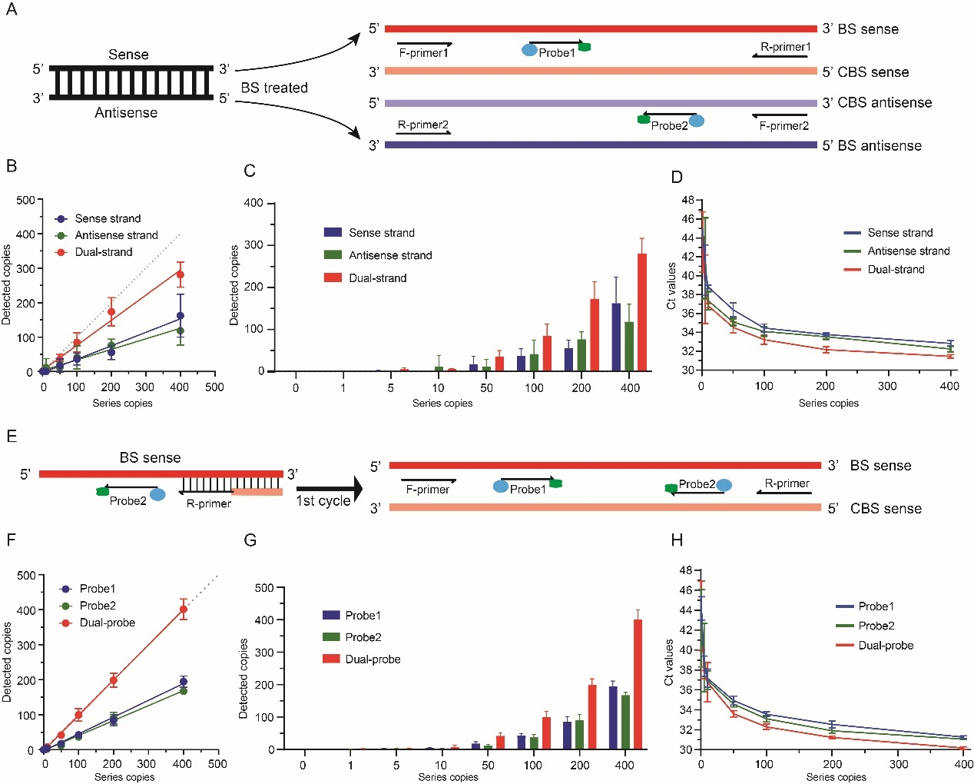
Figure 1. The development of sense-antisense strand and dual-MGB probe technique. A: The strategy of sense-antisense strand technique. Two pairs of primers were designed according to the sense and antisense BS-strand sequences. CBS indicated the complementary sequence of sense and antisense BS-strands. B: The agreement between detected copies by dual-strand and single-strand assays and diluted template DNA copies (theoretical copies). The solid lines were fitted by a simple linear model. C-D: The detected copies (C) and Ct values (D) of dual-strand and single-strand assays for different diluted concentrations. E: The strategy of dual-MGB probe technique. Two MGB probes were designed. Probe 1 is located downstream of the forward primer, targeting the BS-strand template. Probe 2 is located downstream of the reverse primer, targeting the complementary sequence of BS-strand. F: The agreement between detected copies by dual-MGB probe and single MGB probe assays and diluted template DNA copies (theoretical copies). The solid lines were fitted by a simple linear model. G-H: The detected copies (G) and Ct values (H) of dual-MGP probe and single MGB probe assays for diluted concentrations. Error bars in panel B, C, D, F, G, and H represented mean ± standard deviation.

Supplementary Tables
Supplemental table 1. The public datasets used in this study.
Data set | Normal (n) | Cancer (n) | Platform | Sample type
TCGA CRC | 45 | 394 | 450k | tissue
GSE48684 | 41 | 64 | 450k | tissue
GSE40279 | 656 |  | 450k | whole blood
GSE122126 | 12 | 3 | 850k | cfDNA

Supplemental table 2. The clinical features of TCGA cohort.
 |  | Normal | CRC
Sex (n, %)
 | male | 24 (53.33) | 211 (53.96)
 | female | 21 (46.67) | 180 (46.04)
 | Na |  | 3
Age (median [Q25-Q75]) |  | 70 [64-77] | 66 (55-74)
Stage (n, %)
 | I |  | 55 (13.96)
 | II |  | 143 (36.29)
 | III |  | 120 (30.46)
 | IV |  | 54 (13.71)
 | Na |  | 22 (5.58%)

Supplemental table 3. The clinical features of GSE48684 cohort.
 |  | Normal | CRC
Sex (n, %)
 | male | 22 (53.66) | 23 (35.94)
 | female | 19 (46.34) | 41 (64.06)
Age (median [Q25-Q75]) |  | Na | Na
Stage (n, %)
 | I |  | 3 (4.69)
 | II |  | 18 (28.13)
 | III |  | 19 (29.69)
 | IV |  | 24 (37.50)

Supplemental table 4. The clinical features of GSE40279 cohort.
 |  | Healthy
Sex (n, %)
 | male | 318 (48.48)
 | female | 338 (51.52)
Age (median [Q25-Q75]) |  | 65 (54-75)

Supplemental table 5. The clinical features of training and validation cohorts used in this study.
 | Training set |  |  |  | Validation set
Sex (n, %) |  | Healthy | Other disease | CRC | Healthy | Interfering disease | Other intestinal disease | Adenoma/Polyps | CRC
 | male | 32 (58.18) | 46 (61.33) | 38 (53.52) | 58 (49.57) | 27 (43.54) | 87 (57.24) | 34 (56.67) | 69 (57.50)
 | female | 23 (41.82) | 29 (38.67) | 33 (46.48) | 59 (54.43) | 35 (56.4) | 65 (42.76) | 26 (43.33) | 51 (42.50)
Age (median [Q25-Q75]) |  | 42 [39-43] | 62 [50-70] | 64 [52-73] | 39 [35-41] | 59 [54-69] | 55 [44-55] | 61 [52-70] | 64 [54-71]
TNM Stage (n, %)
 | I |  |  | 20 (28.17) |  |  |  |  | 17 (14.17)
 | II |  |  | 28 (39.44) |  |  |  |  | 29 (24.17)
 | III |  |  | 21 (29.58) |  |  |  |  | 43 (35.83)
 | IV |  |  | 2 (2.82) |  |  |  |  | 1 (0.83)
 | Na |  |  |  |  |  |  |  | 30 (25.00)

Supplemental table 6. The methylated and unmethylated events of all CpG sites in the amplicons of NTMT1 and MAP3K14-AS1 between normal and CRC samples.
 | NTMT1 antisense |  | NTMT1 sense |  | MAP3K14-AS1 antisense
 | normal | cancer | normal | cancer | normal | cancer
Unmethylated | 165 | 9 | 41 | 8 | 149 | 4
Methylated | 75 | 266 | 8 | 82 | 15 | 176

Supplemental table 7. The methylation frequencies of each CpG sites in the amplicons of NTMT1 and MAP3K14-AS1 between normal and CRC samples.
Target |  | normal |  | cancer |  | P value
Target |  | Um | Me | Um | Me | P value
NTMT1 antisense | CpG1 | 9 | 9 | 0 | 25 | < 0.001
NTMT1 antisense | CpG2 | 15 | 8 | 0 | 28 | < 0.001
NTMT1 antisense | CpG3 | 17 | 8 | 0 | 28 | < 0.001
NTMT1 antisense | CpG4 | 17 | 8 | 2 | 26 | < 0.001
NTMT1 antisense | CpG5 | 19 | 6 | 2 | 26 | < 0.001
NTMT1 antisense | CpG6 | 18 | 6 | 1 | 26 | < 0.001
NTMT1 antisense | CpG7 | 18 | 7 | 0 | 28 | < 0.001
NTMT1 antisense | CpG8 | 18 | 7 | 0 | 28 | < 0.001
NTMT1 antisense | CpG9 | 16 | 9 | 1 | 27 | < 0.001
NTMT1 antisense | CpG10 | 18 | 7 | 3 | 24 | < 0.001
NTMT1 sense | CpG1 | 22 | 5 | 8 | 22 | < 0.001
NTMT1 sense | CpG2 | 14 | 3 | 0 | 30 | < 0.001
NTMT1 sense | CpG3 | 5 | 0 | 0 | 30 | < 0.001
MAP3K14-AS1 antisense | CpG1 | 25 | 3 | 0 | 30 | < 0.001
MAP3K14-AS1 antisense | CpG2 | 28 | 1 | 2 | 28 | < 0.001
MAP3K14-AS1 antisense | CpG3 | 26 | 4 | 0 | 30 | < 0.001
MAP3K14-AS1 antisense | CpG4 | 27 | 2 | 1 | 29 | < 0.001
MAP3K14-AS1 antisense | CpG5 | 21 | 4 | 0 | 30 | < 0.001
MAP3K14-AS1 antisense | CpG6 | 22 | 1 | 1 | 29 | < 0.001

Supplemental table 8. ROC curve analysis of the Ct values of NTMT1.
Ct values | Specificity | Sensitivity | Youden index
49.73 | 91.54% | 78.87% | 0.70
48.65 | 91.54% | 77.46% | 0.69
48.30 | 91.54% | 76.06% | 0.68
47.93 | 91.54% | 74.65% | 0.66
47.61 | 92.31% | 74.65% | 0.67
47.57 | 93.08% | 74.65% | 0.68
47.49 | 93.08% | 73.24% | 0.66
47.31 | 93.08% | 71.83% | 0.65
47.18 | 93.08% | 70.42% | 0.63
47.06 | 93.85% | 70.42% | 0.64
46.90 | 93.85% | 69.01% | 0.63
46.84 | 93.85% | 67.61% | 0.61
46.82 | 93.85% | 66.20% | 0.60
46.81 | 93.85% | 64.79% | 0.59
46.80 | 93.85% | 63.38% | 0.57
46.78 | 93.85% | 61.97% | 0.56
46.77 | 93.85% | 60.56% | 0.54
46.76 | 94.62% | 60.56% | 0.55
46.76 | 95.38% | 60.56% | 0.56
46.74 | 95.38% | 59.15% | 0.55
46.72 | 96.15% | 59.15% | 0.55
46.71 | 96.92% | 59.15% | 0.56
46.71 | 97.69% | 59.15% | 0.57
46.69 | 98.46% | 59.15% | 0.58
46.67 | 99.23% | 59.15% | 0.58
46.66 | 99.23% | 57.75% | 0.57
46.65 | 99.23% | 56.34% | 0.56
46.65 | 99.23% | 54.93% | 0.54
46.64 | 99.23% | 53.52% | 0.53
46.63 | 99.23% | 52.11% | 0.51
46.62 | 99.23% | 50.70% | 0.50
46.61 | 99.23% | 49.30% | 0.49
46.61 | 99.23% | 47.89% | 0.47
46.59 | 99.23% | 46.48% | 0.46
46.56 | 99.23% | 45.07% | 0.44
46.55 | 99.23% | 43.66% | 0.43
46.55 | 99.23% | 42.25% | 0.41
46.54 | 99.23% | 40.85% | 0.40
46.54 | 99.23% | 39.44% | 0.39
46.53 | 99.23% | 38.03% | 0.37
46.52 | 99.23% | 36.62% | 0.36
46.51 | 99.23% | 35.21% | 0.34
46.51 | 99.23% | 33.80% | 0.33
46.50 | 99.23% | 32.39% | 0.32
46.49 | 99.23% | 30.99% | 0.30
46.49 | 99.23% | 29.58% | 0.29
46.48 | 99.23% | 28.17% | 0.27
46.48 | 100.00% | 28.17% | 0.28
46.47 | 100.00% | 26.76% | 0.27
46.47 | 100.00% | 25.35% | 0.25
46.46 | 100.00% | 23.94% | 0.24
46.46 | 100.00% | 22.54% | 0.23
46.45 | 100.00% | 21.13% | 0.21
46.44 | 100.00% | 18.31% | 0.18
46.44 | 100.00% | 16.90% | 0.17
46.43 | 100.00% | 15.49% | 0.15
46.43 | 100.00% | 14.08% | 0.14
46.43 | 100.00% | 12.68% | 0.13
46.42 | 100.00% | 11.27% | 0.11
46.41 | 100.00% | 9.86% | 0.10
46.40 | 100.00% | 8.45% | 0.08
46.40 | 100.00% | 7.04% | 0.07
46.40 | 100.00% | 5.63% | 0.06
46.40 | 100.00% | 4.23% | 0.04
46.39 | 100.00% | 2.82% | 0.03
46.38 | 100.00% | 1.41% | 0.01

Supplemental table 9. ROC curve analysis of the Ct values of MAP3K14-AS1.
Ct values | Specificity | Sensitivity | Youden index
49.34 | 97.69% | 54.93% | 0.53
48.46 | 98.46% | 54.93% | 0.53
48.36 | 99.23% | 54.93% | 0.54
48.33 | 99.23% | 53.52% | 0.53
48.27 | 99.23% | 52.11% | 0.51
48.24 | 99.23% | 50.70% | 0.50
48.24 | 99.23% | 49.30% | 0.49
48.24 | 99.23% | 47.89% | 0.47
48.23 | 99.23% | 46.48% | 0.46
48.23 | 99.23% | 45.07% | 0.44
48.22 | 99.23% | 43.66% | 0.43
48.21 | 99.23% | 42.25% | 0.41
48.21 | 99.23% | 40.85% | 0.40
48.20 | 99.23% | 39.44% | 0.39
48.19 | 99.23% | 38.03% | 0.37
48.18 | 99.23% | 36.62% | 0.36
48.18 | 99.23% | 35.21% | 0.34
48.18 | 99.23% | 33.80% | 0.33
48.17 | 99.23% | 32.39% | 0.32
48.17 | 99.23% | 29.58% | 0.29
48.16 | 99.23% | 28.17% | 0.27
48.16 | 99.23% | 26.76% | 0.26
48.16 | 99.23% | 25.35% | 0.25
48.16 | 99.23% | 23.94% | 0.23
48.16 | 100.00% | 23.94% | 0.24
48.15 | 100.00% | 22.54% | 0.23
48.14 | 100.00% | 21.13% | 0.21
48.14 | 100.00% | 19.72% | 0.20
48.13 | 100.00% | 18.31% | 0.18
48.13 | 100.00% | 16.90% | 0.17
48.13 | 100.00% | 15.49% | 0.15
48.12 | 100.00% | 14.08% | 0.14
48.12 | 100.00% | 12.68% | 0.13
48.12 | 100.00% | 11.27% | 0.11
48.12 | 100.00% | 9.86% | 0.10
48.11 | 100.00% | 8.45% | 0.08
48.11 | 100.00% | 7.04% | 0.07
48.11 | 100.00% | 5.63% | 0.06
48.10 | 100.00% | 4.23% | 0.04
48.10 | 100.00% | 2.82% | 0.03
48.09 | 100.00% | 1.41% | 0.01

Supplemental table 10. The sensitivity and specificity of MethyDT test evaluated by the 1/2 algorithm.
Target | Non-cancer |  | Cancer |  | Sensitivity | Specificity
Target | negative | positive | negative | positive | Sensitivity | Specificity
NTMT1 | 119 | 11 | 15 | 56 | 78.87% | 91.54%
MAP3K14-AS1 | 127 | 3 | 32 | 39 | 54.93% | 97.69%
1/2 algorithm | 116 | 14 | 12 | 59 | 83.10% | 89.23%

Supplemental table 11. Sensitivities of MethyDT test for the detection of CRC patients stratified by different clinical features.
 | TNM stage | Sensitivity (%, n) | X² test P value
 | CRC (I-IV) | 83.10 (n=59)
Stage | I-II | 79.17 (n=38) | 0.35
Stage | III-IV | 91.30 (n=21)
Age | CRC (age <60) | 82.89 (n=24) | 0.49
Age | CRC (age >60) | 85.55 (n=35)
Sex | Male | 81.85 (n=31) | 0.96
Sex | Female | 84.85 (n=28)

Supplemental table 12. Sensitivities of MethyDT test for the detection of CRC patients stratified by different clinical features in validation set.
 | TNM stage | Sensitivity (%, n) | X² test P value
Stage | I-II | 82.61 (38) | 0.97
Stage | III-IV | 88.64 (39) | 0.97
Stage | Not available | 86.67 (26) | 0.97
Age | CRC (age <60) | 87.50 (n=41) | 0.87
Age | CRC (age >60) | 84.72 (n=61) | 0.87
Sex | Male | 85.51 (n=59) | 0.99
 | Female | 86.27 (n=44) | 0.99

Supplementary table 13. The positive detection rates and specificities of MethyDT test for non-CRC samples.
Group | Participant (%, n) | Positive detection rate (%, n) | Specificity (%, n)
Adenoma | 7.83 (40) | 30.00 (12) | 70.00 (28)
Polyps | 3.91 (20) | 10.00 (2) | 90.00 (18)
Benign bowel disease | 10.57 (54) | 14.81 (8) | 85.19 (46)
Other disease | 29.75 (152) | 7.24 (11) | 92.76 (141)
Other cancers | 1.57 (8) | 0 (0) | 100 (8)
Healthy | 22.9 (117) | 4.27 (5) | 95.73 (112)

Supplemental table 14. The numbers of single-positive, double-positive and double-negative samples measured by MethyDT test in the training set.
Target | Healthy | Other disease | CRC
me NTMT1 | 2 | 9 | 20
me MAP3K14-AS1 | 0 | 3 | 3
both me | 0 | 0 | 36
both ume | 53 | 63 | 12
Total | 55 | 75 | 71

Supplemental table 15. The numbers of single-positive, double-positive and double-negative samples measured by MethyDT test in the validation set.
Target | Healthy | Adenoma | Polyps | Benign bowel disease | Other disease | Other cancers | CRC
me NTMT1 | 3 | 6 | 2 | 5 | 7 | 0 | 26
me MAP3K14-AS1 | 1 | 3 | 0 | 3 | 0 | 0 | 12
both me | 1 | 3 | 0 | 0 | 4 | 0 | 65
both ume | 112 | 28 | 18 | 46 | 141 | 8 | 17
Total | 117 | 40 | 20 | 54 | 152 | 8 | 120

Supplementary Figures
Supplemental figure 1. Relationship between patient age and methylation levels of cg14015706 (A) and cg08247376 (B). cg14015706 and cg08247376 are located in the first exon of NTMT1 and 200 bp of the upstream MAP3K14-AS1 transcription start site, respectively. The figure shows the Pearson’s correlation coefficient. The solid black line is fitted by linear regression model. The upper and lower bounds correspond to 95% confidence intervals.
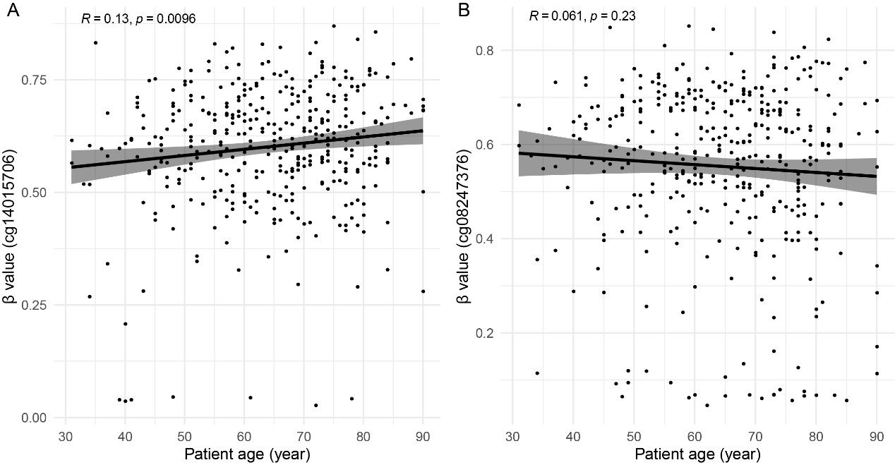

Supplemental figure 2. Ct values of the sense-antisense and dual-MGB probe technique in diluted experiments. A: Boxplot showing the Ct values of sense-, antisense- and sense/antisense strand assays for the detection of different copies of methylated NTMT1 templates. B: Boxplot showing the Ct values of probe1, probe2 and probe1/probe2 assay for the detection of different copies of methylated MAP3K14-AS templates. The error bar of the boxplot indicated the 5%-95% interval of Ct values.
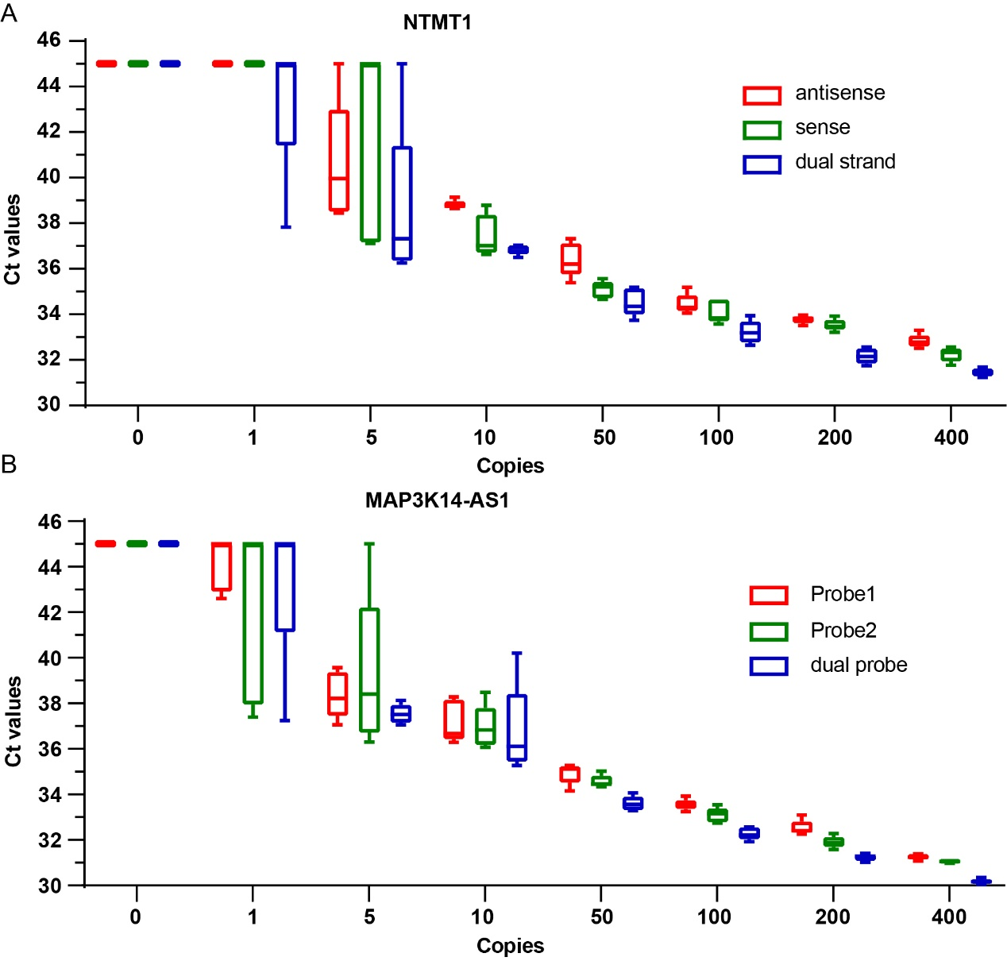

Supplemental figure 3. Standard curves and amplification curves of NTMT1 and MAP3K14-AS1 assays. A and C correspond to the standard curves of the 10-fold dilution experiment of NTMT1 and MAP3K14-AS1 assays, and B and D correspond to the amplification curves of these experiments.
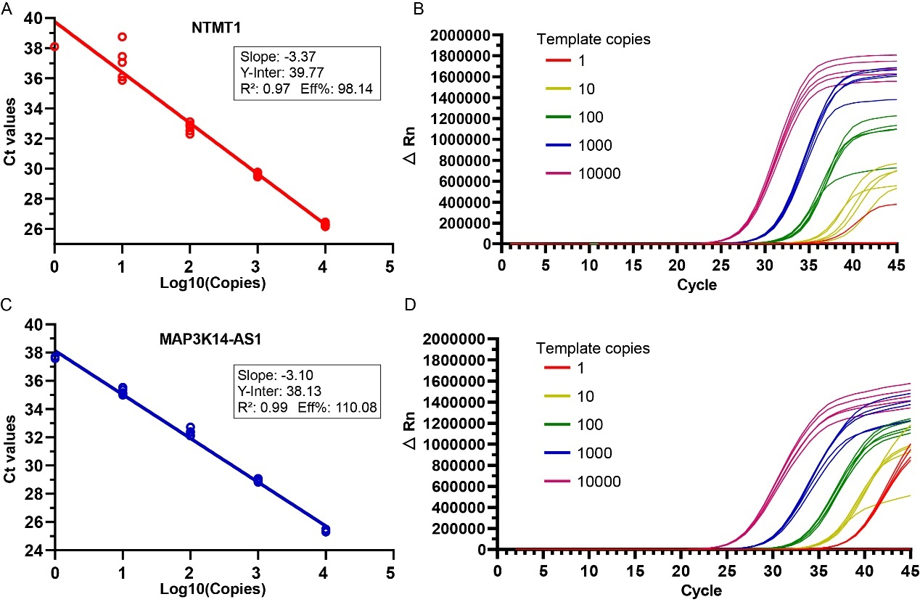

Supplemental figure 4. Standard curves of ACTB, NTMT1 and MAP3K14-AS1 assays in clinical trials. We carried out 6-diluted concentration experiments with each concentration repeated 16 times to assess the cfDNA copies of target genes in clinical samples. A model of Ct~copy number was fitted based on the Ct values and the cfDNA inputs. Using this model, we estimated the copies of each target gene in clinical samples.
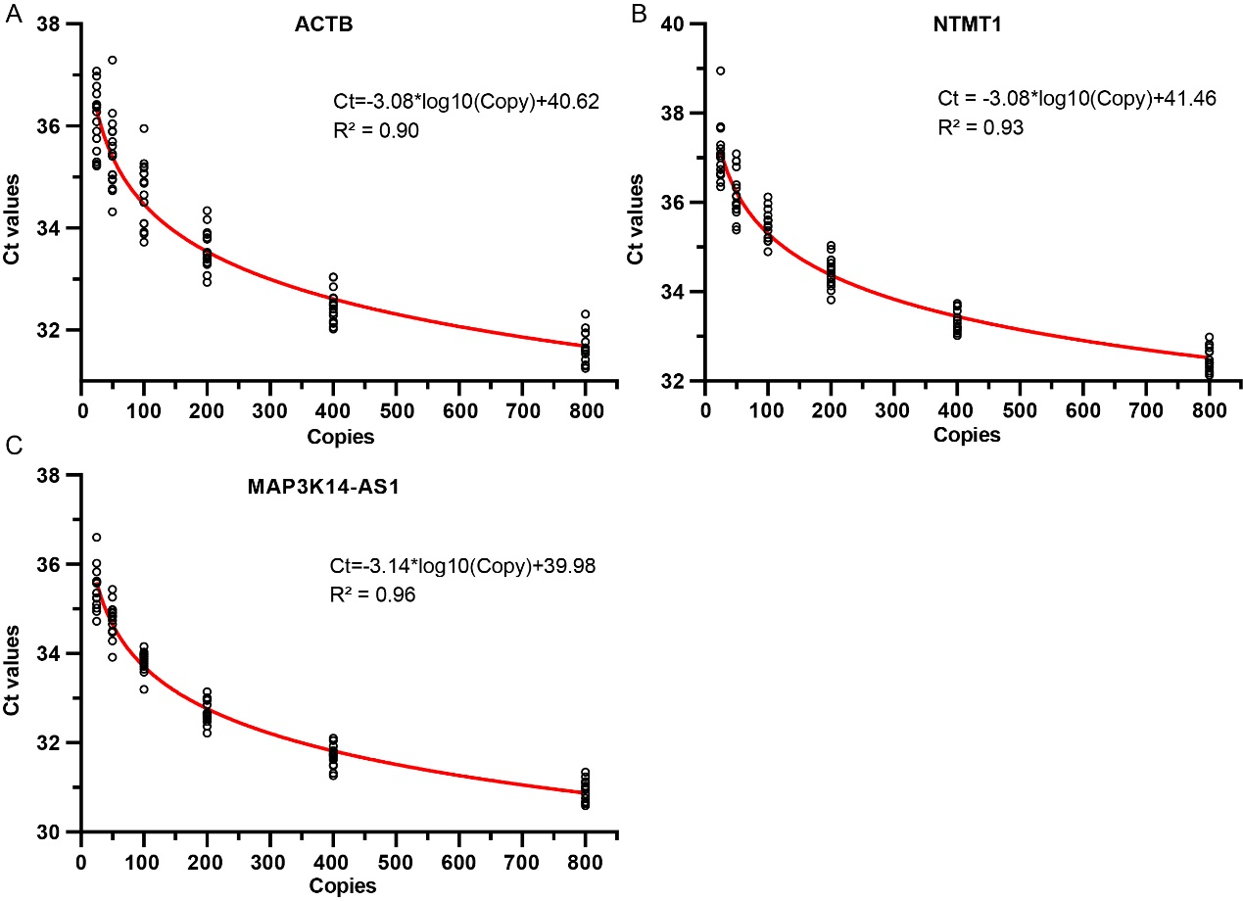

Supplemental figure 5. The cfDNA copies of NTMT1 (A) and MAP3K14-AS1 (B) in non-cancer samples and different stages of CRC samples in training set. Kruskal-Wallis rank sum test was performed for the comparison between four CRC stages. Two-sample Wilcoxon tests was performed for the comparison of non-cancer and stage I groups.
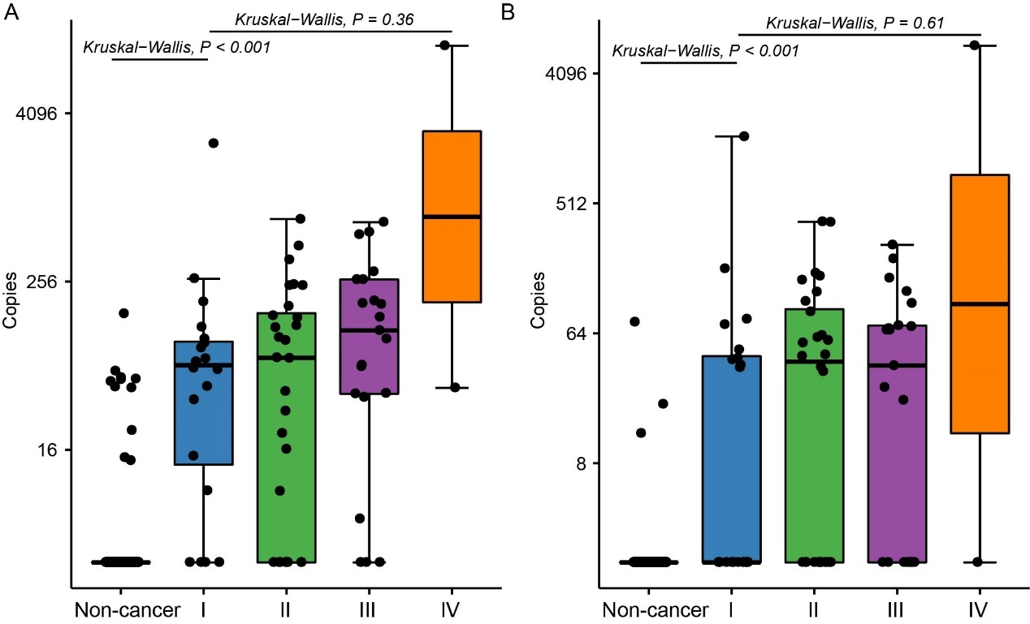

Supplemental figure 6. The cfDNA copies of NTMT1 (A) and MAP3K14-AS1 (B) in different categories of CRC samples in validation set. Boxplot in panel A and B indicated the cfDNA copies of NTMT1 and MAP3K14-AS1 in healthy, CRC and other diseases. Boxplot in panel C and D indicated the cfDNA copies of NTMT1 (C) and MAP3K14-AS1 (D) in non-cancer samples and different stages of CRC samples. Kruskal-Wallis rank sum test was performed for the comparison between four CRC stages. Two-sample Wilcoxon tests was performed for the comparison of non-cancer and stage I groups.
