Supplementary Information
Unravelling the effects of active site density and energetics on the water oxidation activity of iridium oxides
Caiwu Liangª, Reshma R Rao*^{a,b}, Katrine L. Svane^{c}, Joseph H.L. Haddenª, Benjamin Moss ^{b},Soren B. Scott ª, Michael Sachs^{d}, James Murawskiª, Adrian Malthe Frandsen^{c}, Jason Riley ^{a,} Mary P. Ryanª, Jan Rossmeisl*^{c}, James R. Durrant*^{b}, Ifan E.L. Stephens*ª
a) Department of Materials, Imperial College London, Exhibition Road, SW72AZ, London, United Kingdom
b) Department of Chemistry, Imperial College London, White city campus, W12 0BZ, London, United Kingdom
c) Department of Chemistry, University of Copenhagen, 2100, København Ø, Denmark
d) PULSE Institute, Stanford University, Menlo Park CA 95024, USA
Supplemetary method
Synthesis of amorphous IrO_{x} and crystalline IrO₂.
The amorphous IrO_{x} was prepared using an electrodeposition method analogous to previous reports.^{1, 2} Typically, a solution with iridium source was prepared by dissolving 0.2 mmol of IrCl₃ hydrate (Fluorochem) and 1 mmol of oxalic acid dehydrate (Sigma Aldrich) in 30 mL of water. The pH was adjusted to 10 with 5 mmol of K₂CO₃ (Sigma Aldrich, ≥99.0%). The volume of the solution was then increased to 50 mL by adding another 20 mL of water. The solution was left to rest for 4 days at 35ºC and then stored in the refrigerator at 4ºC. The electrodeposition of IrO_{x} was conducted in a typical three-electrode set up in this solution. A clean FTO glass substrate was using as working electrode, and a Pt mesh, and an Ag/AgCl as counter and reference electrode, respectively. Polyimide tape was attached to the FTO surface to limit the conductive surface to ~1$×$1 cm. The electrodeposition was done by applying an anodic current density of 35 µA/cm² for ~1000s. The mass loading of the obtained IrO_{x} was around 80 μg/cm². For TOF-SIMS and XPS measurement, IrO_{x} was deposited on a Ti substrate for a longer deposition time of 12000s to get a thicker layer sample. The rutile IrO₂ is obtained by thermal annealing the IrO_{x} sample in the atmosphere at 550 degrees for 8 hours, at a heating rate of 10 degrees per minute. Thus, the rutile IrO₂ has the same Ir mass loading as the amorphous IrO_{x}.
Materials Characterization
Scanning electron microscopy (SEM) images which were measured by a LEO 1525 scanning electron microscope (FESEM, 5 kV). X-ray diffraction measurements were used to determine the phase composition of each catalyst is obtained by a Bruker-Axs diffractometer equipped with a PSD LinxEye detector. The X-ray diffraction patterns were collected between 10 ≤ 2θ ≤ 70 with a step size of 0.05°. X-ray photoemission spectroscopy (XPS) were obtained from a Thermo Scientific K-Alpha spectrometer equipped with an Al Kα X-ray source (1486.6 eV) coupled with a 180° double focusing hemispherical analyzer with a 2s detector at an operating pressure of 1 × 10⁻⁸ mbar and a flood gun to minimize charging effects from photoemission. X-ray absorption spectroscopy data of Ir L₃ edge were collected at the B18 beamline at the Diamond light source in UK. The beamline has an energy range of 2.05 keV – 35 keV for spectroscopy. The energy of the incident X-ray beam was selected using a Si (111) monochromator, λ/Δλ ~ 5,000. The XAS measurements for amorphous IrO_{x} and rutile IrO₂ were performed in fluorescence. The XAS measurement for standard sample Ir powder, IrCl₃, and IrO₂ (Alfa Sigma) were perform in transmission mode.

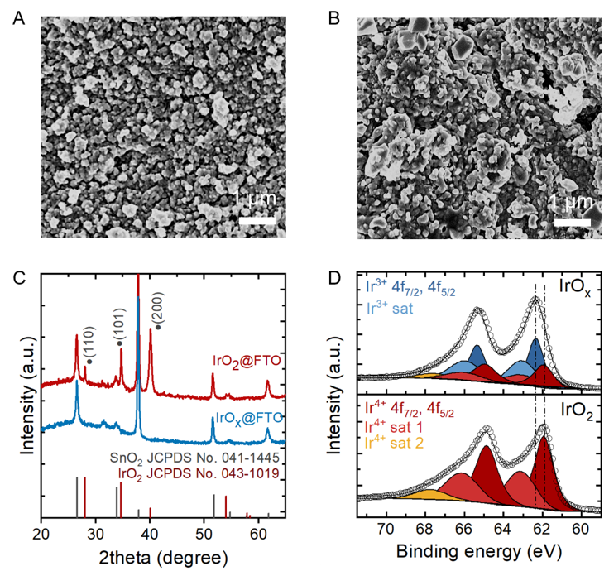
Supplementary Figure 1. Morphology, structure and composition of amorphous IrO_{x} and rutile IrO₂. (A) and (B) SEM images of amorphous IrO_{x} and rutile IrO₂ on FTO, respectively. (B) XRD patterns of amorphous IrO_{x} and rutile IrO₂ on FTO. The rutile sample was obtained by annealing amorphous sample at 550 ℃ for 8 hours in the air. (C) Ir 4f XPS spectra for the amorphous IrO_{x} and rutile IrO₂.
Supplementary Figure 1A and 1B shows that the obtained IrO_{x} films consist of uniform nanoparticles of around 200 nm. After annealing, the nanoparticle size slightly increases. Supplementary Figure 1C shows a comparison of the XRD pattern for IrO_{x} and IrO₂ on FTO substrates. The diffraction peaks observed in the IrO_{x} sample are from the FTO layer, while the new emerging peaks at around 2θ of 28.1, 34.7 and 40.1 degrees after annealing match well with the typical diffraction peaks (110), (101) and (200) of rutile IrO₂, respectively. A complete transformation of amorphous IrO_{x} to rutile IrO₂ after thermally treating the IrO_{x} at around 550 ℃ for 5 h was also reported by Geiger et al.³ From XPS result, the IrO_{x} shows a combination of Ir³⁺ (62.4 eV) and Ir⁴⁺ (61.9 eV), while the IrO₂ is dominated by Ir⁴⁺ (Supplementary Figure 1D). Similar XPS results for IrO_{x} and IrO₂ have also been reported by Geiger et al.³

XANES and EXAFS analysis
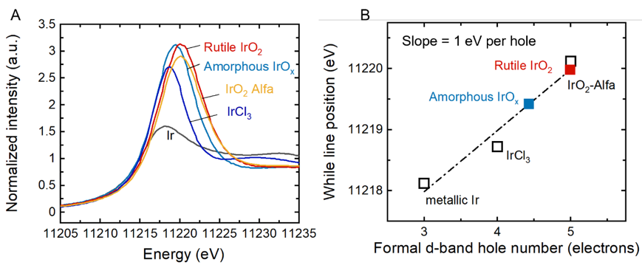
Supplementary Figure 2. Oxidation state of amorphous IrO_{x} and rutile IrO₂. (A) Ir L₃-edge XANES region of IrO_{x} and IrO₂ and the reference standard samples (B) White line position of IrO_{x} and IrO₂ as a function of the formal d-band hole number. The formal d-band hole number for metallic iridium (5d⁷), IrCl₃ (5d⁶) and IrO₂ (5d⁵) were 3, 4 and 5 respectively. The white line shift per d-band hole (slope) was fitted to be around 1 eV per d-band hole.

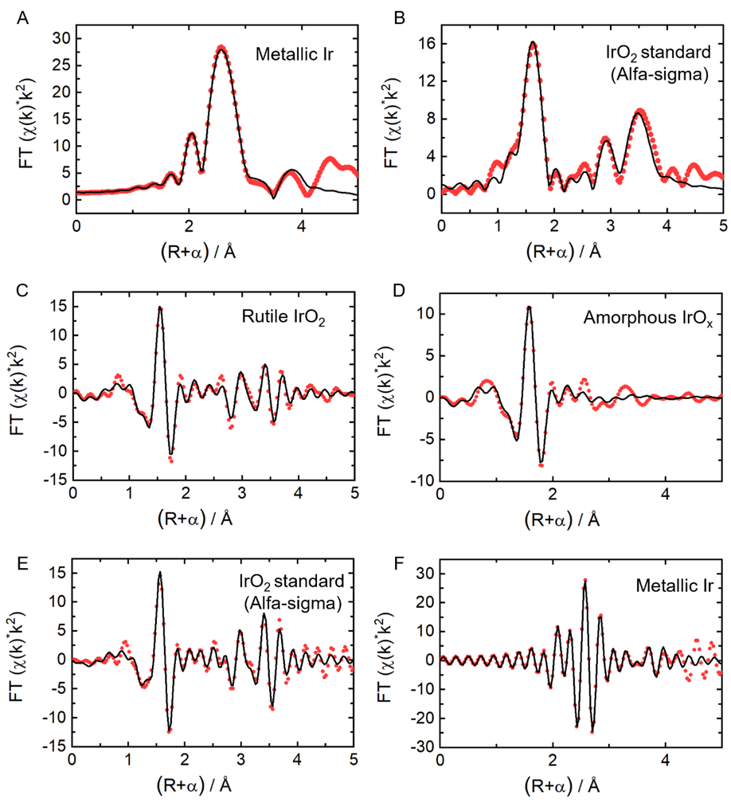
Supplementary Figure 3. k²-weighted Fourier transforms of EXAFS spectra collected at the Ir L₃ edge of the metallic Ir (A) and IrO₂ standard (Alfa-Sigma) (B). k² -weighted EXAFS oscillations collected at Ir L₃ edge of C) rutile IrO_{2,} D) amorphous IrOx, E) IrO₂ standard (Alfa-Sigma) and F) with metallic Ir standards. The experimental (red symbols) and fits (black solid lines) are shown.

Supplementary Table 1. Ir L₃ edge EXAFS simulation parameters of amorphous IrO_{x}, rutile IrO₂ and the standards. k = 3 – 13 Å⁻¹
Sample | Shell | N | σ² / Å² | R / Å | ΔE₀ / eV | R-factor (%)
Amorphous IrO_{x} | Ir-O | 5.84 (± 0.45) | 0.0048 (± 0.0011) | 2.023 (±0.008) | 9.22 (± 0.87) | 0.6
Rutile IrO₂ | Ir-O | 6.0 (± 0.73) | 0.0034 (± 0.0015) | 1.971 (±0.012) | 7.40 (± 1.56) | 4.1
Rutile IrO₂ | Ir-Ir₁ | 2 (± 0.00) | 0.0027 (± 0.0024) | 3.121 (±0.027) | 7.40 (± 1.56) | 4.1
Rutile IrO₂ | Ir-Ir₂ | 8 (± 0.00) | 0.0052 (± 0.0016) | 3.559 (±0.018) | 7.40 (± 1.56) | 4.1
IrO₂ standard | Ir-O | 6 (± 0.00) | 0.0023 (± 0.0009) | 1.977 (±0.008) | 8.34 (± 1.09) | 3.1
IrO₂ standard | Ir-Ir₁ | 2 (± 0.00) | 0.0025 (± 0.0013) | 3.147 (±0.014) | 8.34 (± 1.09) | 3.1
IrO₂ standard | Ir-Ir₂ | 8 (± 0.00) | 0.0041 (± 0.0008) | 3.552 (±0.009) | 8.34 (± 1.09) | 3.1
Ir standard | Ir-Ir₁ | 12 (± 0.00) | 0.0028 (± 0.0002) | 2.709 (± 0.002) | 6.19 (± 0.53) | 0.8
Ir standard | Ir-Ir₂ | 6 (± 0.00) | 0.0038 (± 0.0007) | 3.821 (± 0.008) | 6.19 (± 0.53) | 0.8
Debye-Waller parameters (σ), coordination distances (R) and energy shift (ΔE₀) were kept unrestricted. Coordination numbers (N) was kept unrestricted for amorphous IrO_{x} and rutile IrO₂ but keep the same as formal crystal structure for IrO₂ standard and metallic standard. The passive electron reduction factor S₀ ² for both amorphous IrO_{x} and rutile IrO₂ was set to 1 to fit the coordination number.

Electrochemical measurement
All the electrochemical measurements were carried out in 0.1 M HClO4 prepared by dilution of concentrated acid (Suprapur 70% HClO₄, Merck, Germany) in ultrapure water (>18.2 MΩ cm, Sartorius). Iridium oxides samples were deposited on ~1cm x 1cm area of FTO substrates. The electrochemical test was conducted in a typical three-electrode setup using an SP-150 Biologic potentiostat. The catalysts on FTO substrate were used directly as working electrode and test in 0.1 M perchloric acid. A Pt mesh and an Ag/AgCl electrode (KCl-saturated) were used as counter and reference electrodes, respectively. The potential of Ag/AgCl were calibrated to convert versus reversible hydrogen electrode (RHE). Potentials were iR compensated by manually subtracting I$×$R_{u}. The resistance R_{u} (~25Ω) was obtained from high-frequency intercept of the real resistance in electrochemical impedance spectroscopy (EIS).

Time-of-flight secondary ion mass spectrometry (TOF-SIMS) measuemnet
TOF-SIMS was used to detect the isotope labeling proton signal deuterium (D⁺) as a function of sputter depth. The sample was performed using an IONTOF TOF-SIMS V, with a sputter current of 75 nA. Bi⁺ was used as the primary analysis ion and 1 keV Cs⁺ was used as the sputter beam. The sputter beam was set to create a crater of length and width of 300 µm. A square analysis area, with sides of 100 µm, was then set around the centre of the crater. Data were taken over a mass range from m/z = 0 to 200 for negative secondary ions. Calibration was performed using C⁻, CH⁻, CH₂⁻ CH₃⁻ O⁻, OH⁻, F⁻, and 35Cl⁻. The differences between the expected and observed masses after calibration were less than 50 ppm. The samples were first electrochemically cycled in deuterated 0.1 M HClO₄ electrolyte and then subjected to TOF-SIMS to record D signal over sputtering time. To note, the electrodeposition film of IrO_{x} and IrO₂ are porous, which makes it challenging to distinguish the depth of the whole film between the real detected ‘depth’ of the catalysts. To avoid the porosity, we used a paraffin wax to fill the pores in the film, using a method developed by Hadden, Ryan and Riley. Briefly, the film is filled and covered with thick paraffin wax to make sure the surface is entirely blocked with the wax.⁴ After the wax covering, no IrO_{x} is presented on the surface. A following ‘grinding’ process was introduced to deform the wax cover layer and expose IrO_{x} islands on the surface. After grinding the sample, two different processes were introduced, (1) soaking the sample into a deuterated HClO₄ solution for 10 minutes and (2) performing 3 CV cycles between 0.66 V-1.46 V vs RHE at a scan rate of 10 mV/s (around 10 minutes). These two samples, named as before cycling IrO_{x} and after cycling IrO_{x}, were subjected to TOF-SIMS for measurement and comparison. The sputter rate for IrO_{x} and IrO₂ sample during the TOF-SIMS measurement was calibrated by measuring the depth of the crater after long time sputtering on IrO_{x} and IrO₂ film without wax coating (Supplementary Figure 6 and 7 and Table 2). A higher sputter current of 150 nA was used to increase the depth of crater within a certain amount of sputter time for better crater distance mapping. The sputter rate for the measurement is then calculated as the measured depth of crater divided by the total amount of sputter time and normalized by the sputter current, which is shown in supplementary Table 2.

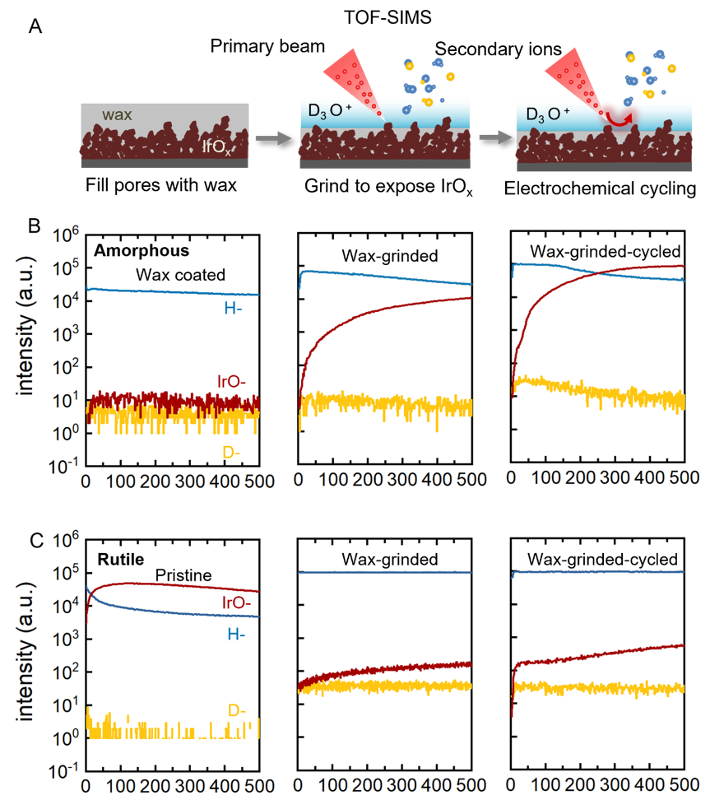
Supplementary Figure 4. TOF-SIMS analysis (A) schematic of the wax cover process for samples measured in TOF-SIMS. TOF-SIMS plots of hydrogen ion, deuterium ion and IrO- cluster intensity over sputter time for (B) amorphous IrO_{x} and (C) rutile IrO₂ samples at a different stage of the wax cover process.

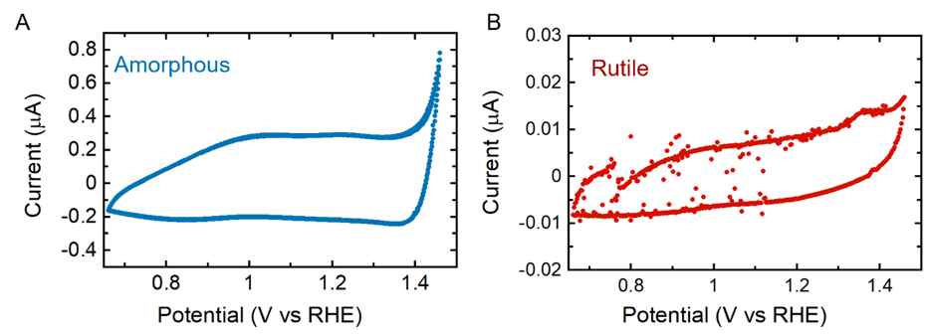
Supplementary Figure 5. Cyclic voltammogram results for wax-coated amorphous IrO_{x} and rutile IrO₂ samples.

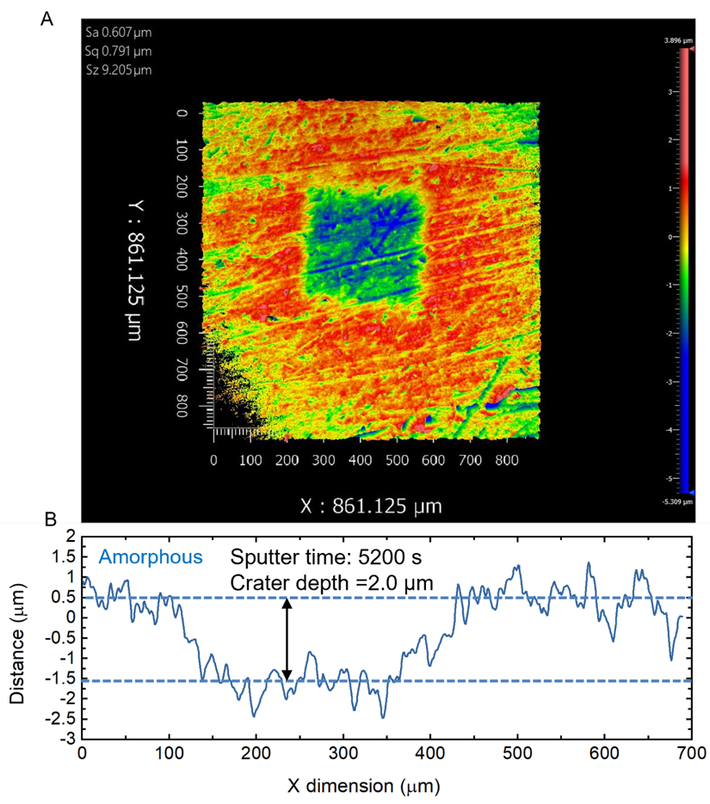
Supplementary Figure 6. (A) Mapping of crater after sputter for 5200 s with 150 nA sputter current for IrO_{x} (B) Corresponding line trace of depth for the crater.

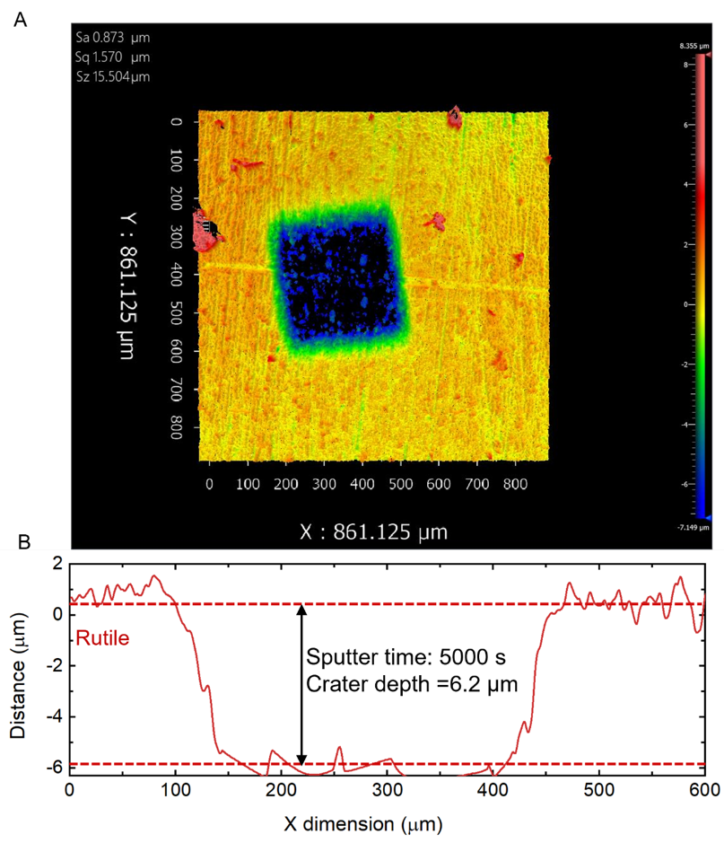
Supplementary Figure 7. (A) Mapping of crater after sputter for 5000 s with 150 nA sputter current for IrO_{x} (B) Corresponding line trace of depth for the crater.

Supplementary Table 2. Sputter rate for TOF-SIMS measurement on IrO_{x} and IrO₂
Sample | Sputter current (nA) | Sputter time (s) | Sputter depth (nm) | Sputter rate  (nm/s) | Sputter rate at standard 75 nA (nm/s)
Amorphous IrO_{x} | 150 | 5200 | 2000 | 0.384 | 0.192
Rutile IrO₂ | 150 | 5000 | 6200 | 1.24 | 0.62

Operando Uv-vis absorption spectroscopy
For spectroelectrochemistry meaurementsmeasurements, samples were deposited on ~1cm x 1cm area of FTO substrates. Measurements were made in a three-electrode cell using a home-built optical spectroscopy setup. A stabilized 10mW tungsten-halogen light source from Thorlabs (SLS201L) was used with a collimating add on (SLS201C). The light emitted from the lamp was transmitted through the sample and collected using a 1 cm diameter liquid light guide (Edmund optics). Light transmitted to the spectrograph was first columnated and refocused using two 5 cm planoconvex lenses (Edmund) in order to optimally match the optical components of the spectroscope (Kymera 193i, Andor), CCD camera (iDus Du420A-BEX2-DD, Andor). The detector was maintained at -80ºC during the measurements to ensure high signal-to-noise ratio. An Ivium Vertex potentiostat was used. Data acquisition was facilitated by a custom-built LabView software. Measurements were made in potentiostatic mode. The equilibration time at each potential was 10 seconds. This was followed by measurement of the optical spectra. At each potential, 30 averages of the spectra were taken (each spectral acquisition takes ~30 ms), before moving to the next potential. Simultaneously, the current was measured at each potential using the Ivium Vertex potentiostat.

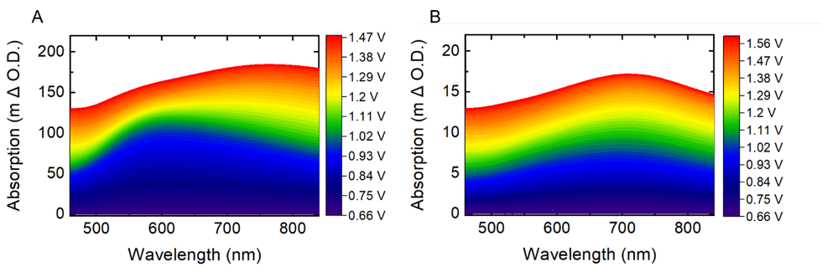

Supplementary Figure 8. Differential absorption spectra of amorphous IrO_{x} (A) and crystalline IrO₂ (B) during a linear sweep scan from 0.66 V to 1.48 V vs. RHE and 1.6 V vs. RHE in 0.1M HClO4 at a scan rate of 1 mV/s (iR corrected). Absorption changes were recorded at every 1 mV. The absorption changes are calculated with respect to the absorption at 0.66 V vs. RHE. The absorption spectra is smooth by Savitzky-Golay filter with an order of 3.

Deconvolution of Uv-vis Absorption spectra
To quantitatively understand and compare the redox states for IrO_{x} and IrO₂, we now deconvolute the absorption signal in Figure 2A and 2B to figure out the individual contribution from each redox at each potential. The deconvolution was based on the assumption that the detected absorption difference at each potential (ΔA(E,λ)) is a linear sum of absorption from three different redox transitions. The absorption changes for each redox (𝐴_{real_𝑖} (𝜆)) can be obtained from the differential absorption change in Figure 2A and 2B, where a change in amplitude as a function of potential arises from a single redox transition, while a change in spectral shape indicates a mix of different redox species, the ratio of which is changing. The differential absorption spectra for amorphous IrO_{x} with interval of 20 mV are shown in Supplementary Figure 9, where three distinguished features constantly present at 0.66-0.9 V, 1.1-1.3 V and 1.4-1.46 V can be obtained as redox1, redox2 and redox3, respectively. A similar process was performed to obtain the redox transition features for rutile IrO₂. Since the absorption amplitude for rutile IrO₂ is much smaller than amorphous IrO_{x}, the differential absorption with 20 mV interval has very low signal and the noise is too high to distinguish the absorption feature for each redox. We increased the differential signal by increasing the interval, using absorption at 0.9 V as reference and analysis the differential absorption between 0.9V and potential below 0.9 V. A constant increase of absorption at around 700 nm were obtained as redox1(Supplementary Figure 10A). Similarly, the absorption feature for redox2 and 3 can be obtained from Supplementary Figure 10B and 10C.
The total absorption is a linear combination of the absorption of individual redox species. According to the Lambert-Beer law, the absorption change of individual redox are considered linearly proportional to the population of the redox states formed at each transition. Thus, the calculated absorption can be written as:
$ΔAfit(E,λ) = N_{i}(E)×A_{real_i }(λ)$ (Equation 1)

$A_{real_i }(λ)=P_{i}×ε_{i}(λ)$ (Equation 2)
where $N_{i}(E)$ is the number of 𝐴_{real_𝑖}(𝜆) that contribute to the total absorption change at each potential, $P_{i}$ is the population of different redox states in 𝐴_{real_𝑖}(𝜆), and $ε_{i}(λ)$ is the absorption change per one-electron oxidation during each redox transition. Thus, the population of each redox state at each potential is the product of $N_{i}(E)$ and $P_{i}$. The model data 𝛥𝐴𝑓𝑖𝑡(𝐸, 𝜆) was fit to the experimental data by adjusting the $N_{i}\left(E\right)$ at each potential, corresponding to the contribution weight of each redox state. The fitting process sought to minimise the square difference between the experimental and the model data (|ΔA_{real}(E,λ)-ΔA_{fit}(E,λ)|)² across all the wavelengths and separately for each potential. As a result, this procedure allowed separating the contributions to the absorption of the three different redox transitions at each potential with a minimal error. The comparison of calculated absorption and real data as well as fitting residuals are shown in Supplementary Figure 11 and 12. The calculated spectra at each potential match excellently with the experimentally observed absorption spectra. The fitting residuals acrossing the wavelength and the whole investigated potential range are below 3 m ΔO.D., corresponding to fitting errors as low as < 2% of the total signal.
To obtain $P_{i}$, the $ε_{i}(λ)$ value at certain wavelengths was experimentally measured by correlating the amount of charge transferred for each redox to their corresponding absorption intensity change at the same wavelength. To obtain the redox charge and absorption simultaneously, we combine pulse voltammetry and transient absorption measurements at potential ranges where only one redox transition takes place (Supplementary Figure 13 and 14). Specifically, two different potentials were applied as square waves, applying lower potential for 10 s, ramping up to higher potential for 10 s and then reduced back to the lower value. When changing the potential, the current detected is expected from the oxidation or reduction of the redox states of species. For redox 3, which occurs in parallel to OER, the current from redox can be obtained by subtracting the steady-state current of OER. We integrated the current over time to obtain the number of redox states generation at each potential jump. The absorption changes were evaluated at the maximum absorption wavelength (600 nm, 800 nm and 500 nm) for redox 1, 2 and 3, respectively. The slope of the linear regression for the deconvoluted absorption change against the integrated charge was taken as the differential absorption coefficient 𝜀1(600 nm), 𝜀2(800 nm), and 𝜀3(500 nm). Thus, the $P_{i}$ can be calculated using these values and Equation 2.

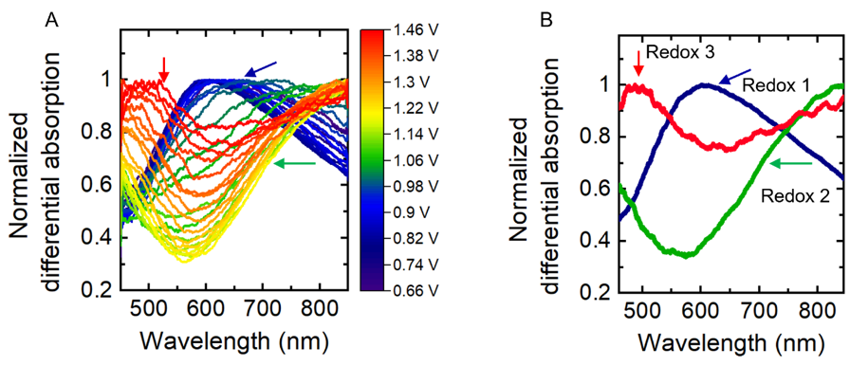
Supplementary Figure 9. Differential analysis of absorption spectra for amorphous IrO_{x} (A) Differential absorption at every 20 mV. The absorption was obtained by subtraction of adjacent 20 mV spectra and normalized the maximum absorption to 1. (B) extracted spectra for individual redoxes. The spectra are obtained from the constant changing area where it is expected to be only one component is changing its amount in this potential regime. The absorption of redox 1 (blue), 2 (green) and 3 (red) were calculated by the differential absorption between 0.84-0.82, 1.18-1.16 and 1.46-1.44 V, respectively.

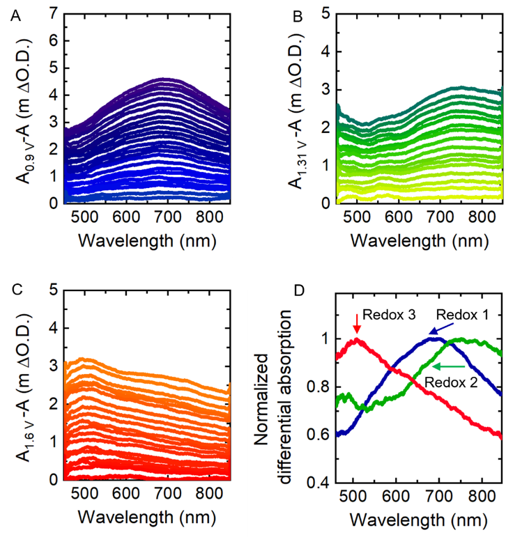
Supplementary Figure 10. Differential analysis of absorption spectra for rutile IrO₂ (A) Differential absorption at every 10 mV in potential range of 0.66 V to 0.9 V, taking adsorption at 0.9 V as reference spectra. (B) Differential absorption in potential range of 1.15 to 1.31 V, taking adsorption at 1.31 V as reference spectra. (C) Differential absorption in potential range of 1.40 to 1.60 V, taking adsorption at 1.60 V as reference spectra. The spectra at these three potential regions shows different features and the absorption of redox 1 (blue), 2 (green) and 3 (red) obtained from the constant changing area in these three regions, respectively. (D) The normalized absorption of individual redox 1, 2 and 3, corresponding to the differential adsorption at 0.73-0.9V, 1.22-1.31 V and 1.48-1.6 V, respectively.

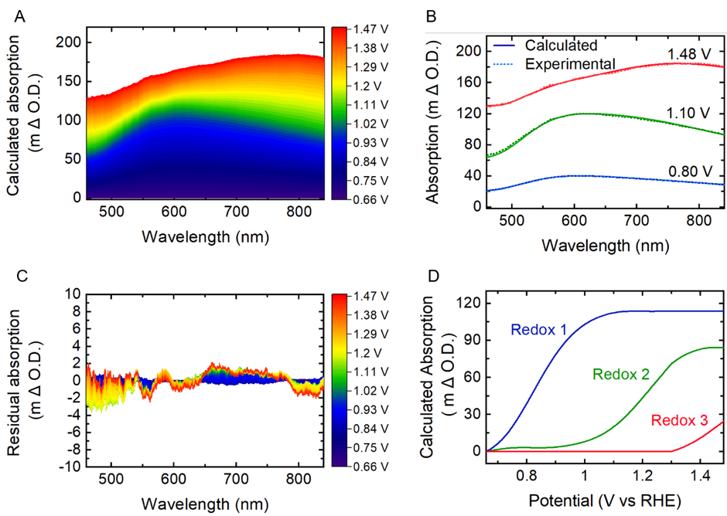
Supplementary Figure 11. Deconvolution result for amorphous IrO_{x}. (A) Calculated differential absorption spectra of amorphous IrO_{x} at every 1 mV during a linear sweep scan from 0.66 V to 1.48 V vs. RHE. (B) Comparison of calculated differential spectra and experimental observed spectra. (C) Fitting residuals between calculated spectra and experimental spectra at each potential. (D) Calculated absorption at its peak wavelength of each redox as a function of potential.

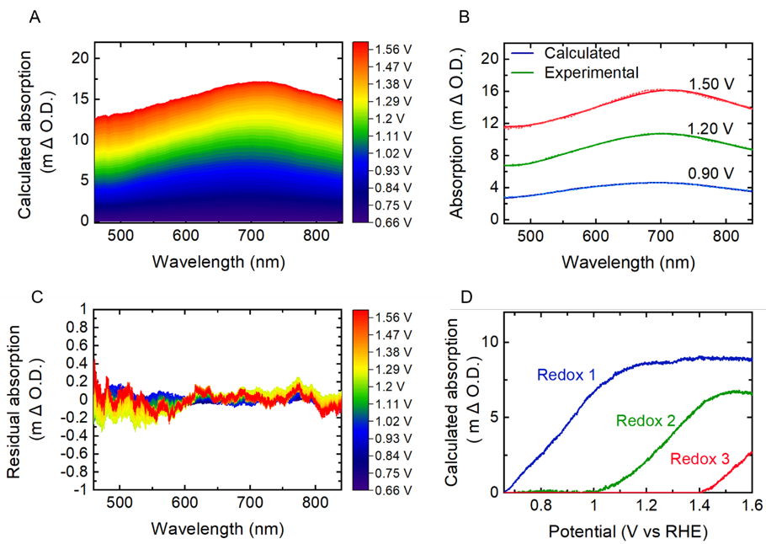

Supplementary Figure 12. Deconvolution result for rutile IrO₂. (A) Calculated differential absorption spectra of amorphous IrO_{x} at every 1 mV during a linear sweep scan from 0.66 V to 1.48 V vs. RHE. (B) Comparison of calculated differential spectra and experimental observed spectra. (C) Fitting residuals between calculated spectra and experimental spectra at each potential. (D) Calculated absorption at its peak wavelength of each redox as a function of potential.

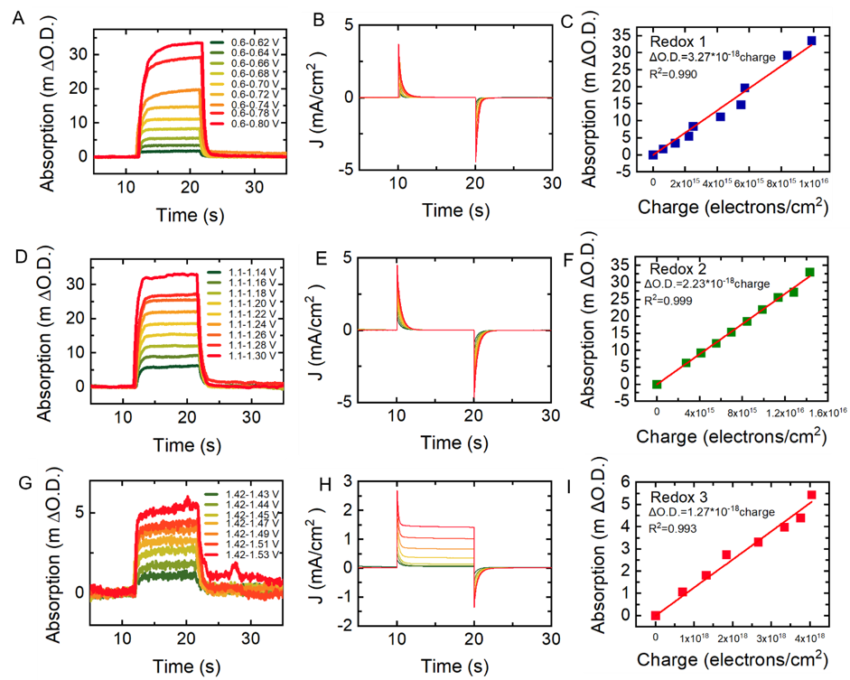
Supplementary Figure 13. Measurement of extinction coefficient $ε_{i}(λ)$ for each redox in amorphous IrO_{x}. (A) Absorption change at 600 nm during potential steps between two different applied potentials. (B) the corresponding transient currents measured during potential (C) The relation between deconvoluted absorption change and the extracted charge for redox 1. The charges are calculated by integrating the reductive peak in B. The slope of the linear regression is the differential absorption coefficient of the redox 1. (D-E) Absorption change at 800 nm, current and charge vs absorption relationship for redox 2. (F-G) Absorption change at 500 nm, current and charge vs absorption relationship for redox 3.

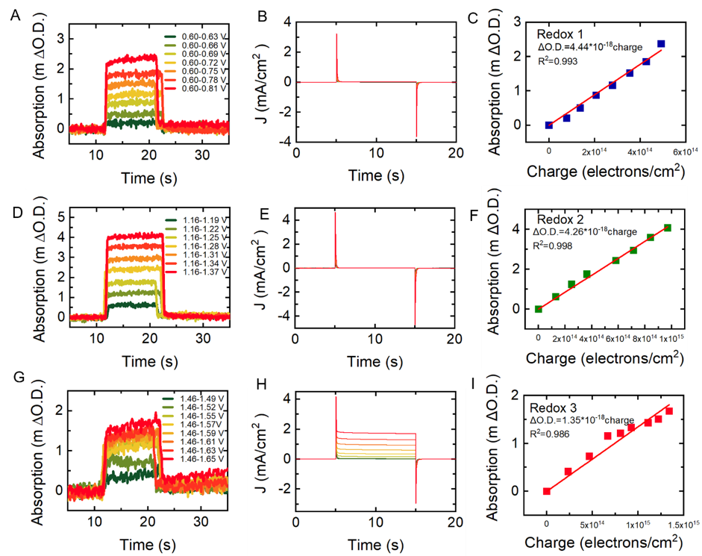

Supplementary Figure 14. Measurement of extinction coefficient $ε_{i}(λ)$ for each redox in Rutile IrO_{x}. (A) Absorption change at 700 nm during potential steps between two different applied potentials. (B) the corresponding transient currents measured during potential (C) The relation between deconvoluted absorption change and the extracted charge for redox 1. The charges are calculated by integrating the reductive peak in B. The slope of the linear regression is the differential absorption coefficient of the redox 1. (D-E) Absorption change at 800 nm, current and charge vs absorption relationship for redox 2. (F-G) Absorption change at 500 nm, current and charge vs absorption relationship for redox 3.

Supplementary Table 3. Redox centers for amorphous and rutile iridium oxides determined from spectroelectrochemistry
Spectroelectrochemical redox centers (V vs RHE) | Amorphous IrO_{x} | Rutile IrO₂
Redox 1 | 0.82 | 0.9
Redox 2 | 1.22 | 1.26
Redox 3 | 1.47 | 1.57

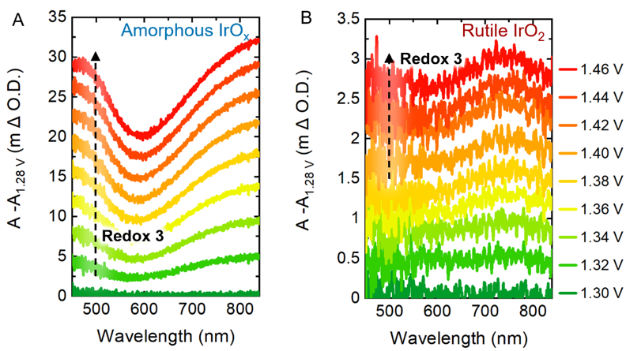
Supplementary Figure 15. Change of absorption with regard to the absorption at 1.28V for amorphous IrO_{x} (A) and rutile IrO₂ (B). The absorption at 500 nm increase can be observed from around 1.3-1.32 V for amorphous IrO_{x}, while can only be observed from around 1.4-1.42 V for rutile IrO₂.

Frumkin isotherm fitting
The free energies of absorbates on the surface during redox transition can be written as:
Δ𝐺=Δ𝐺⁰+𝑅𝑇ln(𝜃/1−𝜃) (Equation 3)
where θ is the coverage, T is the temperature, F is the faradaic constant, and R is the universal gas constant. ΔG⁰ is the chemical potential intrinsic to the individual redox transition. In this work, we assume the maximum concentrations observed in our spectroelectrochemical analyses is the full coverage. Thus, the coverage can be calculated as θ=P/P_{max.} For redox 1 and 2, the maximum concentration can be directly obtained in the saturated regime, while for redox 3, the maximum concentration is assumed to be the same as redox 2. At equilibrium, the free energy of redox states can be established as FU_{RHE} = −ΔG, thus redox potential vs coverage follows
-Δ𝐺⁰ = 𝑅𝑇ln(𝜃/1−𝜃) (Equation 4)
Δ𝐺⁰ con be correlated to its redox potential using Nernst equation
-zFU = 𝑅𝑇ln(𝜃/1−𝜃) (Equation 5)
Where E is the redox potential and z is the electron number transfer during redox, i.e. z =1 in this case. To obtain insights on the interaction between adsorbates, we fit the Langmuir and Frumkin isotherm models to the coverage vs U data obtained by spectroelectrochemistry. Supplementary figure 16 shows the fit based on the Langmuir isotherm, which assumes a constant ΔG₀ value in Equation 3. It is clear that the Langmuir isotherm provides an inadequate fit for all the redox in both amorphous and rutile iridium oxides, giving R² from 0.3 to 0.8. The inadequate fit of Langmuir isotherm indicates that there are on-negligible adsorbate interactions. To account for the interaction between adsorbates, we switch to the Frumkin isotherm, which uses a mean-field approximation to capture the adsorbate–adsorbate interaction,
Δ𝐺⁰_{(𝜃)} = Δ𝐺⁰_{(𝜃=0)} + r ⋅𝜃 (Equation 6)
where r is the lateral interaction parameter represent the interaction strength between the adsorbates. Positive value of r corresponding to repulsive interactions, while negative corresponding to attractive interactions. Supplementary figure 17 shows the fit based on the Frumkin isotherm. We do not include very initial or final regime coverage <0.05 or >0.95 as it is relative less confident in the deconvolution procedure due to the noise in optical signal. The Frumkin isotherm fit match well with the experiment, giving R² up to 0.99 in each redox on both amorphous and rutile iridium oxides.

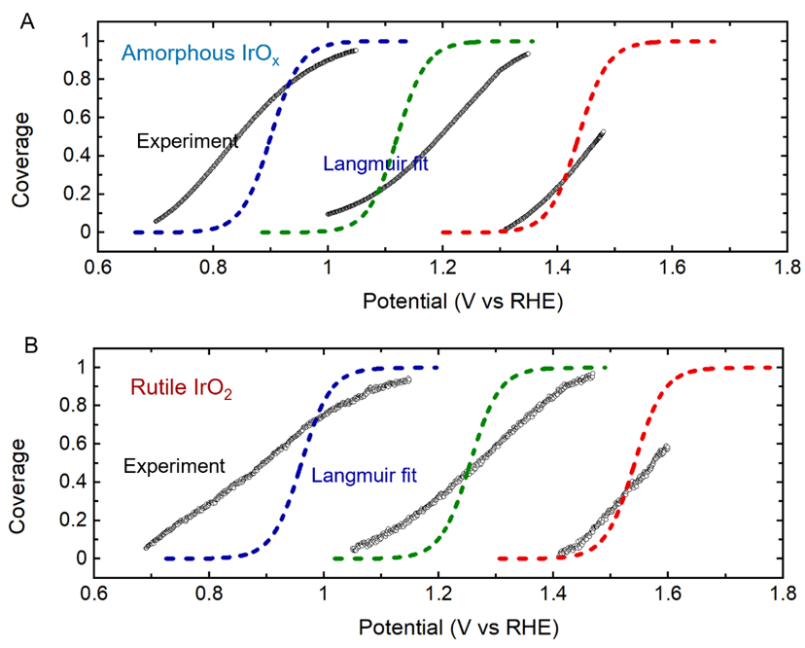
Supplementary Figure 16. Langmuir isotherm fitting for each redox in amorphous IrO_{x} (A) and rutile IrO₂ (B). Clearly, Langmuir isotherm doesn’t fit our experiment data.

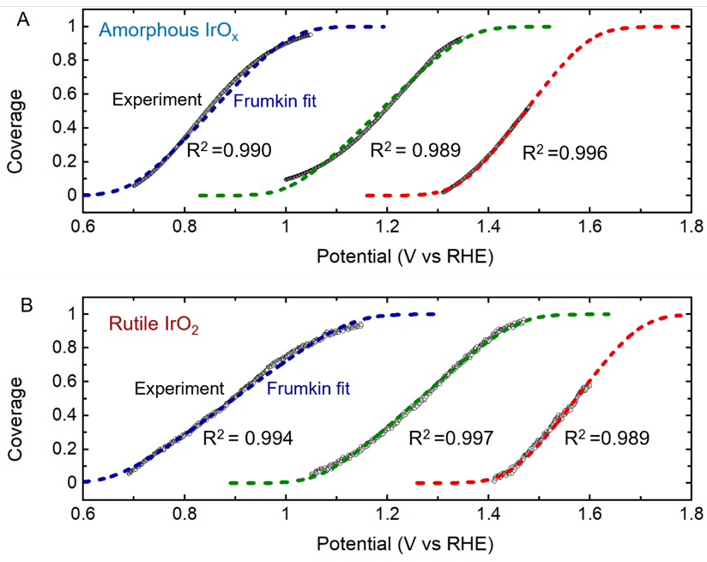
Supplementary Figure 17. Frumkin isotherm fitting for each redox in amorphous IrO_{x} (A) and rutile IrO₂ (B). This fitting gives R² as high as 0.989-0.996.

Computational methods
All DFT calculations were performed with the grid-based projector augmented wave (GPAW) software package.^{5, 6}. The atomic simulation environment (ASE) was used to set up and control the calculations.⁷ The calculations were performed with a plane-wave basis with an energy cutoff of 500 eV. The RPBE functional was used to describe the effects of exchange and correlation. ⁸
The (110) surface of rutile IrO₂ was modeled by a 3x1 slab with four atomic layers, of which 2 were fixed in the bulk geometry at the computationally optimized lattice constants (a=4.59Å, c=3.19 Å, comparing well with experimental values of a=4.50 Å, c=3.15 Å)⁹. 20 Å of vacuum separated periodic images of the slab and a dipole correction was used to decouple the electrostatic interactions on either side of the slab. The brillouin zone was sampled by 4x4 k-points.
The surface of amorphous IrO₂ cannot be modeled by periodic DFT calculations, however to get an understanding of the differences between rutile and amorphous IrO₂ we model the (001) surface of IrO₂ in the hollandite structure. This surface bears similarity with the rutile 110 surface, however adsorbates are further separated (in the x-direction) and the bulk is more open, as would be expected for an amorphous structure (see supplementary figure 18 for a comparison of the two surfaces). This surface is modeled by a 3x1 slab with 6 atomic layers (3 frozen) corresponding to 1.5 repeats of the unit cell, and sampled by 3x4 k-points. The calculated lattice constants are a=10.13 Å, c=3.18 Å, comparing well with experimental data on hollandite K_{x}IrO₂ (a=10.02Å,b=3.15Å, c=10.05Å, beta=90.11)¹⁰

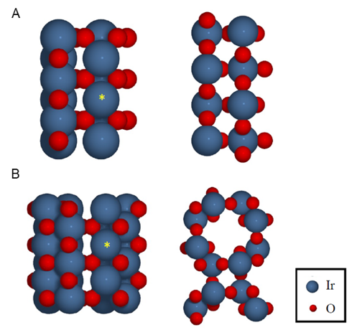
Supplementary Figure 18. Structure of a) the rutile (110) surface and b) the hollandite surface in top (left) and side view (right). The size of the surfaces are the size used for the computational unit cell and the cus adsorption site is marked by a yellow star.

Adsorption energies calculated by DFT (E_{ads,DFT}) are corrected for changes in zero point energy and entropy (∆ZPE - T∆S , given in Supplementary Table 4) and the computational hydrogen electrode is used to include the effects of an applied potential (U),¹¹ i.e. the free energy of adsorption is calculated as:
∆G_{ads}(U) = E_{ads,DFT} + ∆ZPE – T∆S – neU (Equation 7)
Where n is the number of electrons involved in the reaction. We consider the full coverage adsorption of *H, *H₂O, *OH and *O on the coordinatively unsaturated (CUS) site and *H on the bridging oxygen (*H_{b}). The calculated adsorption energies are used to construct a pourbaix diagram for the rutile IrO₂ surface (Figure S20a). Based on this diagram we determine the transitions that match the experimentally observed redox transitions, and calculate the energy required for each redox step necessary to transform the three adsorbates in our 3x1 unit cell (Figure S19b-d for rutile and Figure S21b-c for hollandite). Taking redox 2 as an example (Figure S19c), the first *H_{b} to be removed will have two neighbouring *H_{b}, the second will only have one *H_{b} and the final will have none. This gives rise to three different energies which, when incorporated in a mean field model where adsorbates are not able to move on the surface, gives rise to a Frumkin isotherm rather than three distinct Langmuir isotherms (see note on the Frumkin isotherm below). The values of the parameters for the Frumkin isotherm, determined from our DFT calculations, are given in Supplementary Table 5.
We furthermore calculate the overpotential for OER on the rutile and hollandite surfaces, considering both the conventional reaction pathway going through the *OH, *O and *OOH intermediates, and an alternative pathway where the proton of *OH and *OOH is transferred to a neighbouring bridging oxygen atom (Figure S21a). The results show that the overpotentials (0.40 and 0.41V for hollandite and rutile, respectively) and preferred reaction pathways (*OH, *O and *O₂+H_{b} intermediates) are very similar. A more detailed study of the reaction pathways on rutile IrO₂, starting from different surface adsorbate structures, is shown in Figure S20. Here, a different pathway involving the coupling of neighbouring *O₂ species, is calculated to be the most favourable (grey arrows in Figure S20). This pathway has an overpotential of just 0.14 eV, however, to initiate this pathway, some *O must be present at the surface, and in practice the required potential is therefore higher.

Supplementary Table 4: Free energy corrections used to account for the changes in entropy (-T∆S) and zero point energy (∆ZPE) based on values from ref. 11.
Adsorbate | ZPE | ∆ZPE | TS | T∆S | ∆ZPE - T∆S
H₂O (l) | 0.56 | 0 | 0.67 | 0 | 0
H₂ (g) | 0.27 |  | 0.41
H₂O_{cus} | 0.56 | 0 | 0 | -0.67 | 0.67
OH_{cus} + ½ H₂ | 0.44 | -0.12 | 0.20 | -0.47 | 0.35
O_{cus} + H₂ | 0.34 | -0.22 | 0.41 | -0.27 | 0.05
H_{b}/H_{cus} - 1/2 H₂ | 0.17 | 0.04 | 0 | -0.21 | 0.17
OH_{cus} + H_{b} | 0.47 | -0.09 | 0 | -0.67 | 0.58
OOH_{cus} + 3/2 H₂ | Taken as the sum of *OH + *O + 1.5 H₂ |  |  |  | 0.40
O_{cus} + H_{b} + 1/2 H₂ | Considered equivalent to OH_{cus} |  |  |  | 0.35
O_{2cus} + H_{b} | Considered equivalent to OOH_{cus} |  |  |  | 0.40
O_{2cus} | Taken as the sum of 2 *O + 2 H₂ |  |  |  | 0.10

Supplementary Figure 19: a) Pourbaix diagram of the IrO₂ surface. Only structures with all sites occupied by the same species are shown. The stepwise transition from one surface to the next and the corresponding energy is shown in b) for *H_{b}+*H to *H_{b}+*OH, c) for *H_{b}+*OH to *OH and d) for *OH to *O.
Supplementary Figure 20. Possible reactions on the rutile IrO₂ (110) surface considering a 3x1 unit cell. Crossing a black dashed line indicate an electrochemical reaction step whereas purely chemical steps are marked by horisontal white arrows. Coloured arrows indicate closed OER cycles, with the corresponding ∆G values listed in the top right corner (maximum value underlined).

Supplementary Figure 21 a) Comparison of the OER energy diagrams on rutile and hollandite IrO₂. The diagrams are drawn for a *O covered surface, following the pathway with the *OH and *O₂+H_{b} intermediates. Stepwise transition from b) *OH+*H_{b} to *OH and c) *OH to *O on the hollandite (001) surface.

Supplementary Table 5: Parameters for the Frumkin isotherm determined from calculated transition energies at different coverages. ∆G_{ads}(θ=1/2) is calculated as the average energy of the smallest and the largest reaction step (see supplementary figure 19 and 21 for values), and the r value is calculated as the difference between those two.
 | Extracted ∆G_{ads} (θ=1/2) | r (eV/monolayer)
Redox 1 (*H₂O + Hb →*OH + Hb) | 0.19 | 0.46
Redox 2 (*OH + Hb → *OH) | 1.05 | 0.31
Redox 3 (*OH → *O) (rutile) | 1.52 | 0.02
Redox 2 (*OH + Hb → *OH) (hollandite) | 0.97 | 0.33
Redox 3 (*OH → *O) (hollandite) | 1.34 | 0.08

Note on the origin of the Frumkin isotherm and the magnitude of the interaction parameter
In our calculation model, there is a limit to the range of values that the interaction parameter can take on before it will no longer give rise to a Frumkin isotherm. To see this, we consider two different scenarios for a surface with adsorbates interacting along one dimension (as on the rutile (110) surface). In the first scenario the adsorbates land in a random place and stick immediately without the possibility to move, and in the second scenario the adsorbates are free to move to assume the distribution on the surface that minimizes the energy.
In the first situation, the adsorption energy (E) as a function of the coverage (θ) can be written as:
$E(θ)= E_{0}+ 0∙(1-θ)^{2} + J_{1}(1-q )∙q + (J_{1} + J_{2})∙θ^{2}$ (Equation8)
Where E₀ is the adsorption energy when an adsorbate has 0 neighbours, J₁ is e interaction energy when there is one neighbour and J₁+J₂ is the interaction energy when there are two neighbours. The terms (1-θ)², (1-θ)θ and θ² represent the probability of an adsorbate landing in a place with 0, 1 or 2 neighbouring sites occupied, respectively. If we assume the interaction to be linear in the number of adsorbates J₁ = J₂ and the expression is reduced to:
$E(θ)= E_{0}+ 2∙θ∙ J_{1}$ (Equation9)
Which we recognize as the expression giving rise to the Frumkin isotherm, with r = 2J₁.
In the second situation, assuming a repulsive interaction, the adsorbates will distribute to have 0 neighbours for any coverage below θ=1/2 and the adsorption energy will be E₀. For θ>1/2, the adsorbates will distribute such that n adsorbates are distributed across n + 1 sites (see Supplementary Figure 22a). The average adsorption energy of an adsorbate when the unit cell contains n+1 sites becomes:
$E_{av}\left(n\right)= {(n∙E}_{0}+(n-1) J_{1})/n$ (Equation 10)
The size of the unit cell is related to θ as: θ = n/(n+1)
Therefore, rewritten as a function of θ:
$E_{av}\left(q\right)= E_{0}+(2q-1) J_{1}/q$ (Equation 11)
We multiply by θ to get the total energy as a function of coverage:
$E_{tot}\left(θ\right)= {θ∙E}_{0}+(2θ-1) J_{1}$ (Equation 12)
Then differentiate to get the adsorption energy for new adsorbates as a function of coverage:
$E(θ)= E_{0}+ 2 J_{1}$ (Equation13)
Thus, this scenario results in two different adsorption energies that are both independent of θ. Below a coverage of θ=½ all adsorbates will have an adsorption energy of E₀ and above a coverage of θ=½ all adsorbates will have an adsorption energy of E₀ + 2J₁. The resulting isotherm will then be composed of two Langmuir isotherms (Supplementary Figure 22b).
The scenario that best describes the situation on a real surface depends on the relative magnitude of the interaction parameter and the barrier for moving to a different site on the surface. If the repulsive interaction between neighbouring adsorbates is large, the barrier for an adsorbate to move when a neighbouring site becomes occupied is reduced (see supplementary figure 23). The isotherm will resemble a double Langmuir more closely than the Frumkin isotherm. However, if the interaction remains relatively small, the barrier to move will only be slightly reduced and the adsorbates will mostly remain on their initial site, giving rise to the Frumkin isotherm.
Supplementary Figure 22: a) Scematic drawing of a one-dimensional surface where adsorbates are distributed to avoid neighbours with n=1 (top) and n=2 (bottom) and b) schematic drawing of the resulting adsorption isotherm.

Supplementary Figure 23: Schematic of the potential energy surface for an adsorbate (Ads1) a) when the neighbouring sites are vacant (*) and b) when an adsorbate is present on one of the neighbouring sites (Ads2). The energy barrier for moving to the neighbouring site is marked as ∆E.

Open circuit decay measurement
Open circuit decay measurement is performed as follow: For the first 10 seconds, a potential prior to the oxygen evolution potential was applied. Between 10 and 20 seconds, a higher potential in the regime where oxygen evolution current can be observed was After 20 seconds, the potential was switch to open circuit and the decay in optical signal across the whole wavelength was recorded. The decay at the wavelength of 500 nm and 800 nm was shown in Supplementary figure 24A. The absorption at 500 nm change rapidly within the first several tens of seconds but decay slowly in the rest of time of 1000 s, while absorption at 800 nm decrease slower at the initial time period but quicker than that at 500 nm in the rest of time. Using absorption just before switching to open circuit potential as reference, the signal decay spectra can be obtained as a function of time (Supplementary Figure 24B). The decay of absorption within the initial 10 s has a maximum absorption decay peak at around 500 nm, while the absorption decay spectra from 200 s to 1000s shows maximum signal at around 800 nm. Thus, the time constant for the fast decay part of 500 nm signal provides insight into the lifetime of the active species redox 3, while the slow part of the decay comes from the decay of redox 2.
Supplementary Figure 26 shows the signal decay at a different applied potential. With potential increasing, the absorption signal increase and the time constant for the signal decay decrease. Assuming all the active species decay within the first 100 seconds, the total number of active states can be extracted by the difference of signal at 100 s and 20 s. The signal was then normalized with this total decay signal (Supplementary Figure 26 D). The activity of the species can be represented by initial decay rate of the normalized optical signal.
The kinetics decays were smoothed with a Robust Local Regression (rlowess) filter using a span of 2%. To derive the lifetimes τ, the optical signal decays were normalized and fit with an initial slope linear regression between 0 and 25% intensity decay, following Equations
$ΔA= m∙t+c$ (Equation13)
$τ =1/m$ (Equation14)
Where $ΔA$ is the experimental differential absorption, t is time, m and c are fit constants, and τ is the lifetime calculated from m. The intrinsic rate of the rate-determining step, i.e. the O₂ evolving rate per active state TOF(1/4τ) can be calculated as
$TOF(1/4τ) = 1/(4∙τ)$ (Equation15)

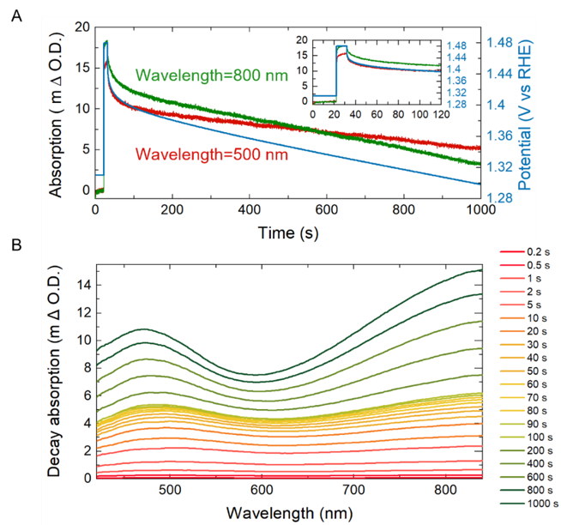
Supplementary Figure 24. Absorption decay analysis after switching potential to open circuit potential. (A) The absorption at around 500 nm and 800 nm change with time after switching to open circuit potential from 1.48 V. The absorption is the average of the absorption at the wavelength range of 490-510 nm and 790-810, respectively. The right Y axis is the corresponding potential change with time (B) The absorption decay across the whole detected wavelength using the absorption just before switching to open circuit potential as reference. The signal is smoothed with an average of adjacent 20 nm region. Two distinct spectral shape can be seen across the decay time. Within the first 1s of decay, the spectra show broad band at around 500 nm, while the at longer decay regime (100-1000s), the spectra show another dominant band at around 800 nm.

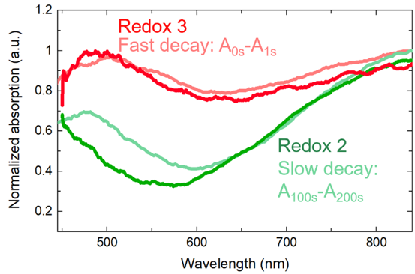
Supplementary Figure 25. Comparison of the differential spectrum during decay and spectra obtained in step potential measurement. The differential spectra during decay within the first 1 seconds (light red) and from 100 seconds to 200 seconds (light green) were obtained from Supplementary Figure 24 B. The spectra shape of redox 3 (dark red) and redox 2 (dark green) is obtained from Supplementary Figure 9 B. All the spectra were normalized by its maximum absorption for comparison.

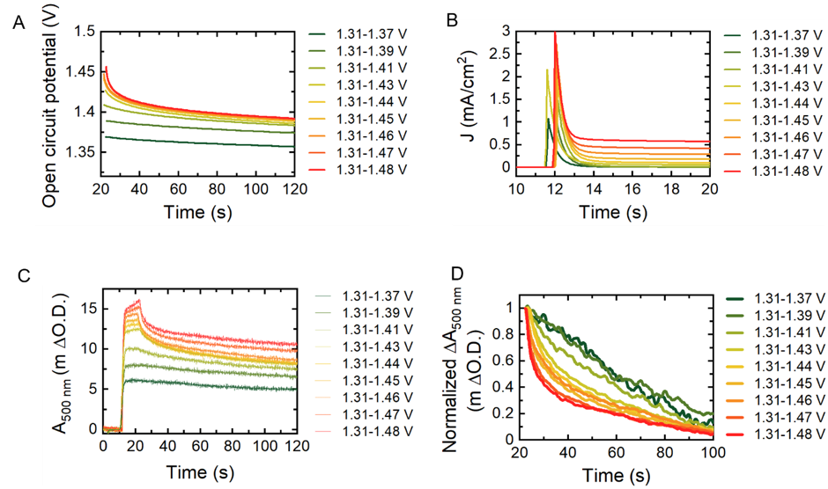

Supplementary Figure 26. Measurement showing the optical signal decay as a function of time for amorphous IrO_{x} at the wavelength of 500 nm (A) Open circuit potential decay after switching off from different applied potential. (B) Current response during the ramping up of potential. (C) Optical signal decay (D) Normalized optical signal decay.

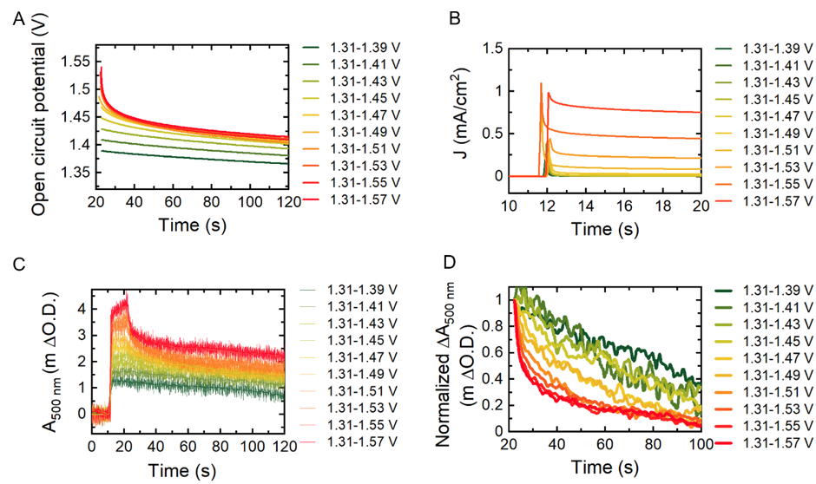
Supplementary Figure 27. Measurement showing the optical signal decay as a function of time for rutile IrO₂ at the wavelength of 500 nm (A) Open circuit potential decay after switching off from different applied potential. (B) Current response during the ramping up of potential. (C) Optical signal decay (D) Normalized optical signal decay from the smooth signal in C.

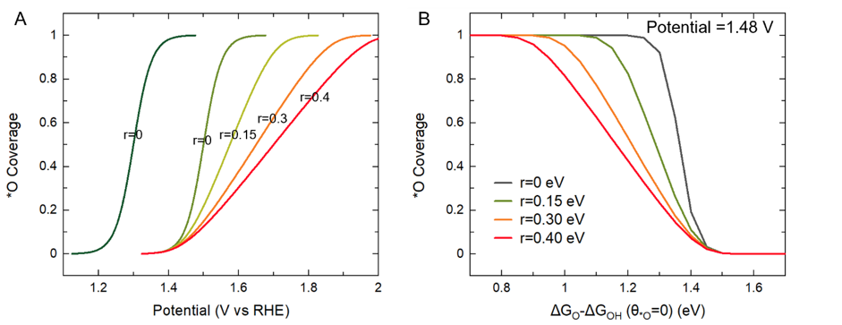
Supplementary Figure 28. (A) Effect of ∆G_{*O} - ∆G_{*OH} (θ_{*O} =0) and interaction strength r on potential dependent *O coverage. The lower the ∆G_{*O} - ∆G_{*OH} (θ_{*O} =0) (the stronger binding of *O), the higher the coverage of *O at a given potential. The larger the r, the slower the *O will increase with potential and thus the lower the coverage at the given overpotential. (B) The *O coverage at overpotential of 250 mV on catalysts with different r and ∆G_{*O} - ∆G_{*OH} (θ_{*O} =0) value. The coverage is obtained by numerically solving the Frumkin isotherm equation at a given r and ∆G_{*O} - ∆G_{*OH} (θ_{*O} =0) The higher the r and ∆G_{*O} - ∆G_{*OH} (θ_{*O} =0) value, the lower the coverage of *O can form at this overpotential. Catalysts with ∆G_{*O} - ∆G_{*OH} (θ_{*O} =0) larger than 1.48 V (overpotential 250 mV) will not form *O on the surface at this overpotential. The start point and end point of Frumkin was defined as 1% coverage and 99% coverage in the numerical solving function.

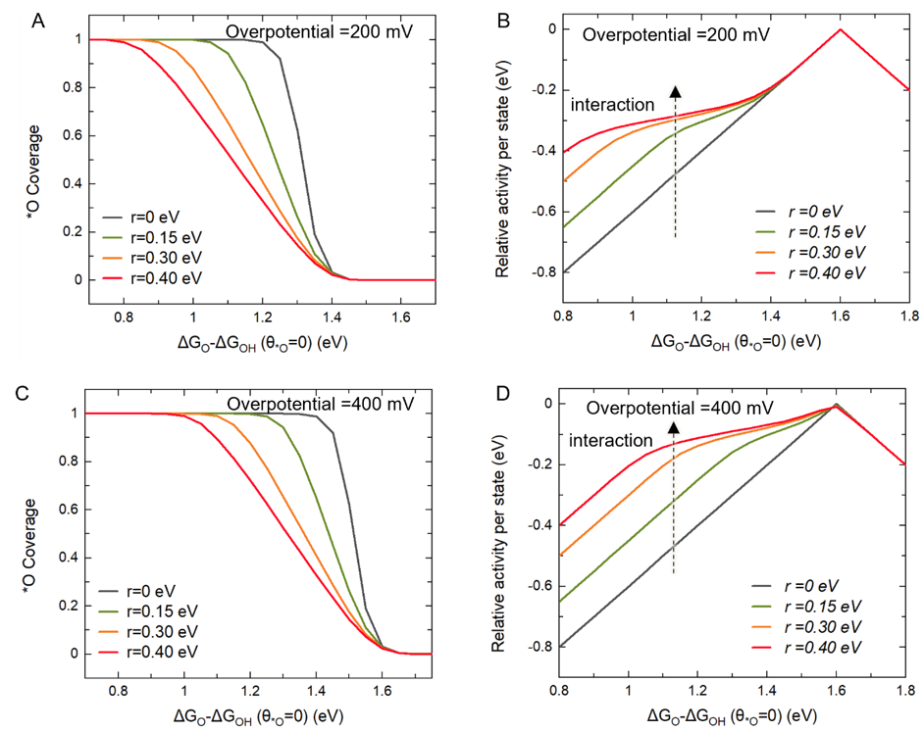

Supplementary Figure 29. (A) Coverage of *O for catalysts with different ∆G_{O} - ∆G_{OH}(θ_{*O}=0) and r values at a constant overpotential of 200 mV. The coverage is obtained by numerically solving the Frumkin isotherm equation at a given r and ∆G_{*O} - ∆G_{*OH} (θ_{*O} =0). (B) The corresponding relative activity per state at the same r and ∆G_{*O} - ∆G_{*OH} (θ_{*O} =0). (C) Coverage of *O at an overpotential of 400 mV (D) The corresponding relative activity per state. The higher the overpotential, the higher the coverage that can form and thus more significant improvement of relative activity by the adsorbate-adsorbate effect.

References
1. Bozal-Ginesta, C.; Rao, R. R.; Mesa, C. A.; Liu, X.; Hillman, S. A. J.; Stephens, I. E. L.; Durrant, J. R., Redox-State Kinetics in Water-Oxidation IrOx Electrocatalysts Measured by Operando Spectroelectrochemistry. ACS Catalysis 2021, 11 (24), 15013-15025.
2. Petit, M. A.; Plichon, V., Anodic electrodeposition of iridium oxide films. Journal of Electroanalytical Chemistry 1998, 444 (2), 247-252.
3. Geiger, S.; Kasian, O.; Shrestha, B. R.; Mingers, A. M.; Mayrhofer, K. J. J.; Cherevko, S., Activity and Stability of Electrochemically and Thermally Treated Iridium for the Oxygen Evolution Reaction. Journal of The Electrochemical Society 2016, 163 (11), F3132-F3138.
4. Hadden, J. H. L.; Ryan, M. P.; Riley, D. J., Is Nickel Hydroxide Charging Only Skin-Deep? ACS Applied Energy Materials 2020, 3 (3), 2803-2810.
5. Enkovaara, J.; Rostgaard, C.; Mortensen, J. J.; Chen, J.; Dułak, M.; Ferrighi, L.; Gavnholt, J.; Glinsvad, C.; Haikola, V.; Hansen, H., Electronic structure calculations with GPAW: a real-space implementation of the projector augmented-wave method. Journal of physics: Condensed matter 2010, 22 (25), 253202.
6. Mortensen, J. J.; Hansen, L. B.; Jacobsen, K. W., Real-space grid implementation of the projector augmented wave method. Physical Review B 2005, 71 (3), 035109.
7. Larsen, A. H.; Mortensen, J. J.; Blomqvist, J.; Castelli, I. E.; Christensen, R.; Dułak, M.; Friis, J.; Groves, M. N.; Hammer, B.; Hargus, C., The atomic simulation environment—a Python library for working with atoms. Journal of Physics: Condensed Matter 2017, 29 (27), 273002.
8. Hammer, B.; Hansen, L. B.; Nørskov, J. K., Improved adsorption energetics within density-functional theory using revised Perdew-Burke-Ernzerhof functionals. Physical review B 1999, 59 (11), 7413.
9. Rogers, D. B.; Shannon, R. D.; Sleight, A. W.; Gillson, J. L., Crystal chemistry of metal dioxides with rutile-related structures. Inorganic chemistry 1969, 8 (4), 841-849.
10. Bestaoui, N.; Deniard, P.; Brec, R., Structural study of a hollandite-type KxIrO2. Journal of Solid State Chemistry 1995, 118 (2), 372-377.
11. Nørskov, J. K.; Rossmeisl, J.; Logadottir, A.; Lindqvist, L.; Kitchin, J. R.; Bligaard, T.; Jonsson, H., Origin of the overpotential for oxygen reduction at a fuel-cell cathode. The Journal of Physical Chemistry B 2004, 108 (46), 17886-17892.

