Table 6 ： Overview of common mutations in three groups except NC
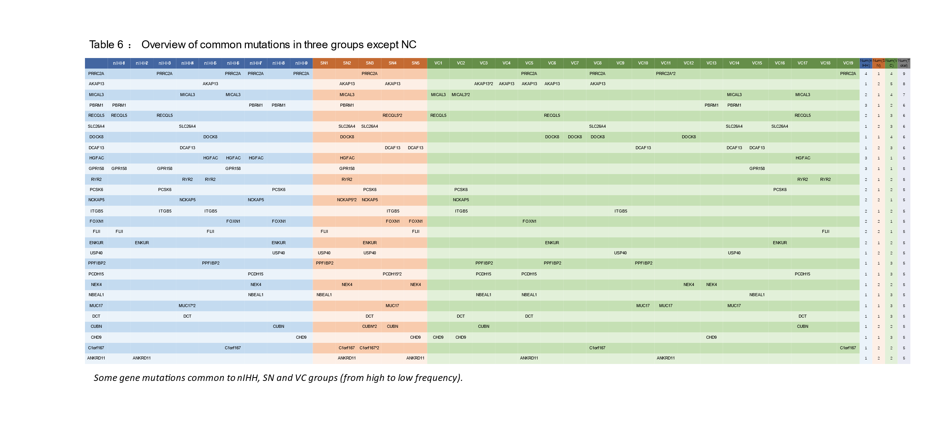
Table 7 ： Overview of common enrichment pathways in three groups except NC

