Supplementary File (Appendices)

Appendix Table 1: Comparison of age, treatment duration, ANB and GoGn-SN of sample sets in both groups（±SD）
 | Extraction (n=11) | Non-extraction (n=12) | t | P值
Age | 22.909±2.508 | 23.667±4.638 | -0.481 | 0.636
Treatment period | 26.909±7.436 | 19.667±5.630 | 2.648 | 0.015*
ANB | 3.758±0.959 | 2.8275±1.266 | 1.973 | 0.059
GoGn-SN | 33.160±3.012 | 34.249±2.714 | -0.912 | 0.372
Note: * means p<0.05, the difference is statistically significant; ** means p<0.001, the difference is statistically significant.

Appendix Table 2 Definition of facial soft tissue line distance, angle landmarks
Landmarks | Definition
Nasion (N’) | The intersection of the fronto-nasal suture and the midsagittal plane is located slightly above the most concave point of the root of the nose
Pronasale (Prn) | The most prominent point on the tip of the nose
Columella (C) | Crest between the nostrils
Subnasale (Sn) | Located at the junction of the lowest point of the columella and the upper lip soft tissue skin
Labiale superius (Ls) | Upper lip red and skin junction
Stomion (Sto) | Midpoint of transverse fissure between upper and lower lips
Labiale inferius (Li) | Lower lip red and skin junction
Sublabiale (Sl) | Horizontal depression between lower lip and chin
Pogonion (Pg’) | The foremost point in the middle of the chin
Menton (Me’) | The lowest point in the middle of the chin
Cheek right (Chk_R) | Midpoint of Right cheek
Cheek left (Chk_L) | Midpoint of left cheek
Tragion right (Tra_R) | Nodular protrusion in front of right external auditory canal
Tragion left (Tra_L) | Nodular protrusion in front of left external auditory canal
Cheilion right (Ch_R) | Right end of mouth
Cheilion left (Ch_L) | Left end of mouth cleft
Gonion right (Go_R) | The most prominent point of the right mandibular angle
Gonion left (Go_L) | The most prominent point of the left mandibular angle

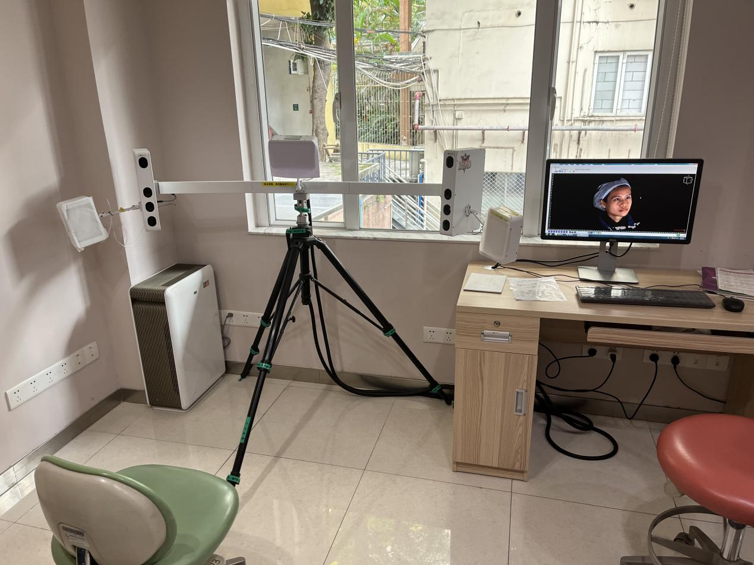
Appendix Figure 1: 3dMD® facial three-dimensional imaging system and capturing environment

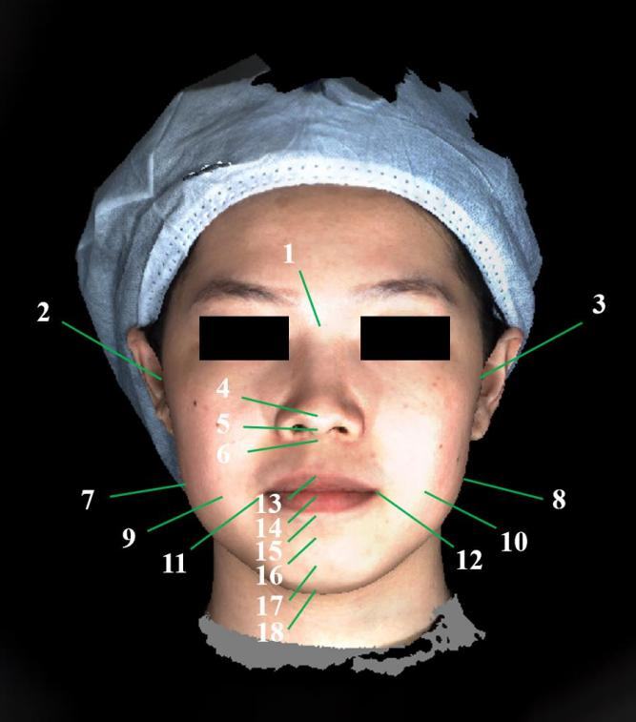
Appendix Figure 2: 18 soft tissue line distance and angle measurement landmarks on 3D images

