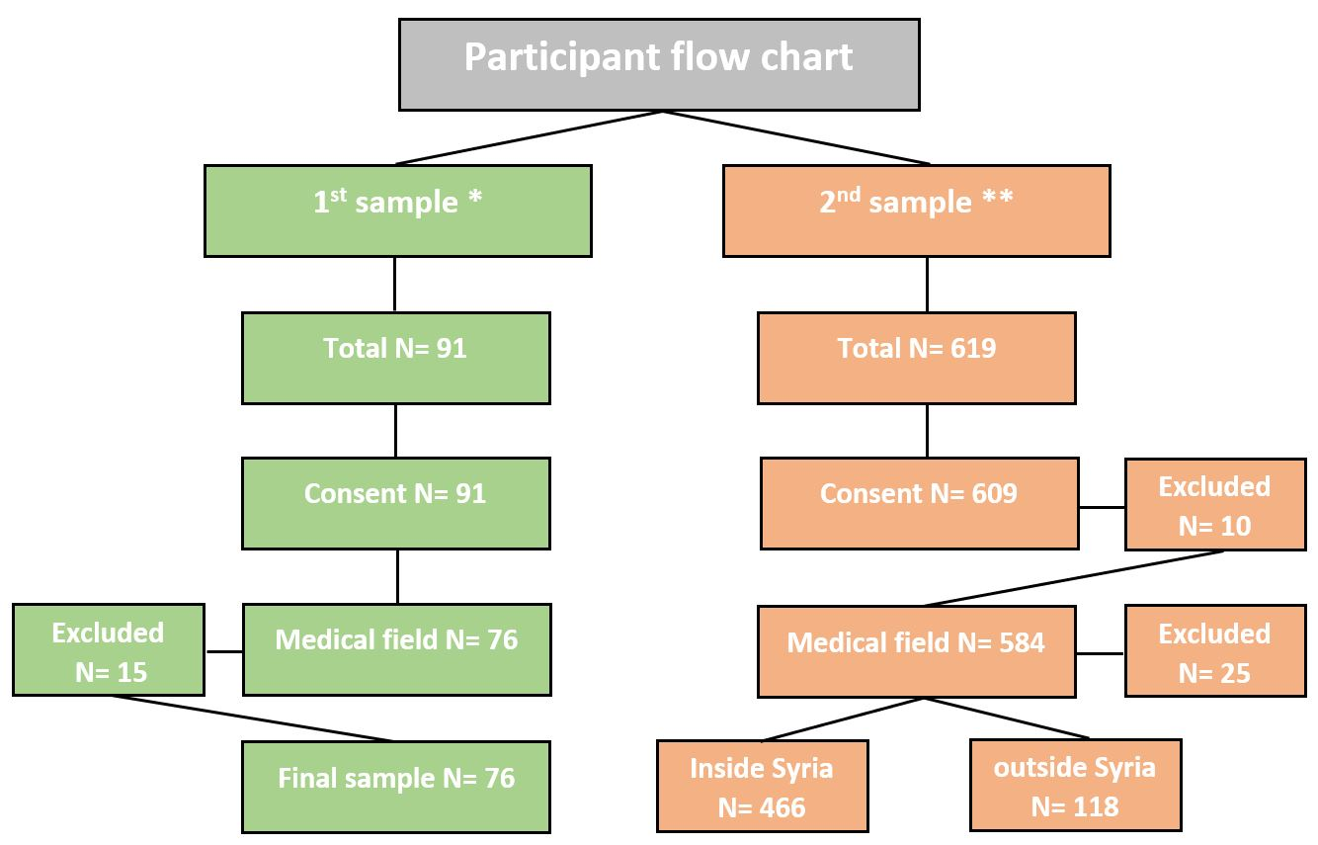
* 1st sample: first stage of data collecting
** 2nd sample: second stage of data collecting
Chart N.1: participant flow chart

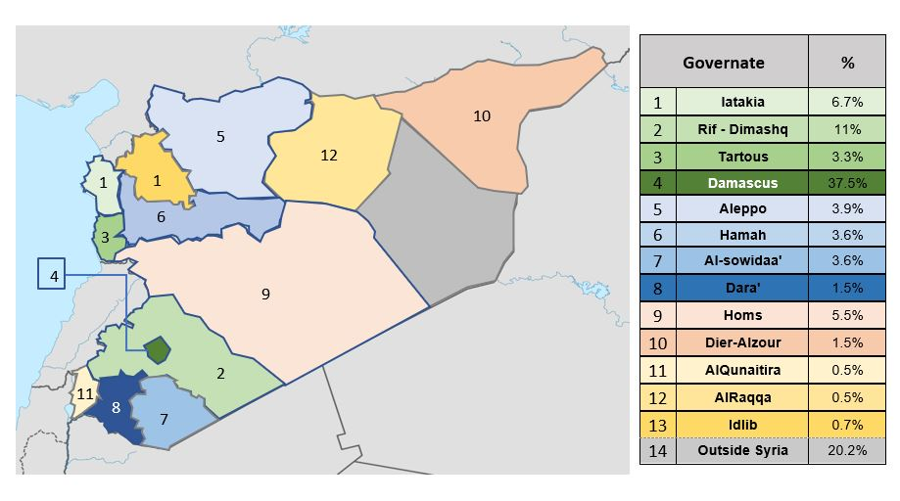
Distribution of the sample (inside Syria) according to the governates

comparing between the three indices between participant from inside Syria and outside Syria:

comparing between the three indices between 1st and 2nd sample:

Specialty for the 2nd sample:

