Supplementary material: Fig. 1 Seismic line from figure 2b (inline 12398) with the interpreted (part a) and modelled position of BHSZ during the LGM and BHSZ_{M} (part b).

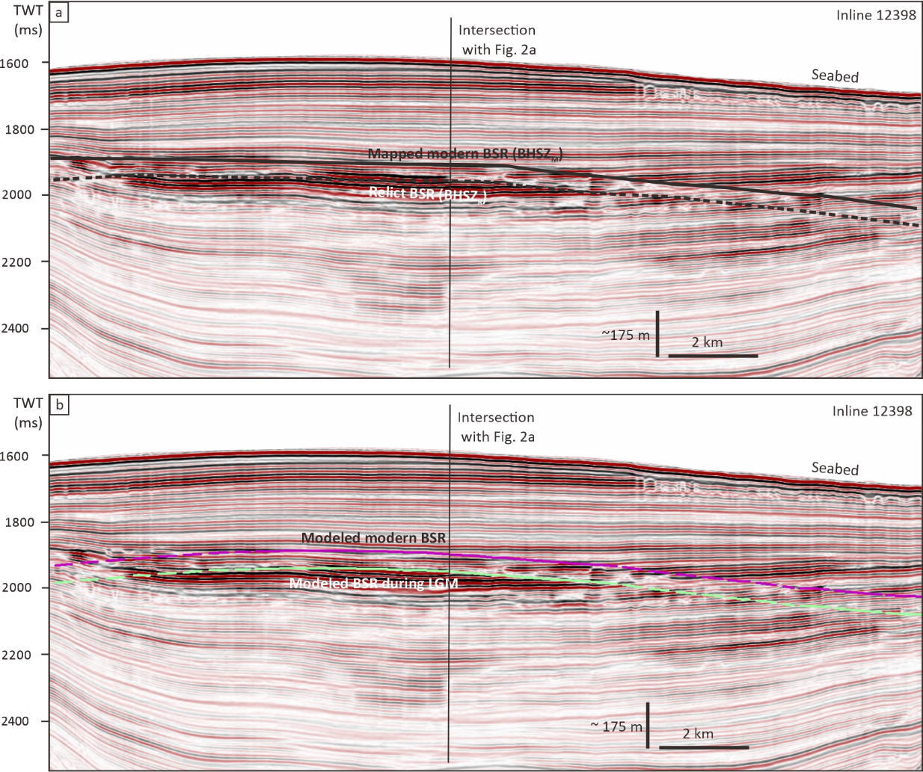
Supplementary material: Fig. 2 a) Seabed map showing the location of one of the 23 giant pockmarks. b) Representative seismic line across the pockmark.
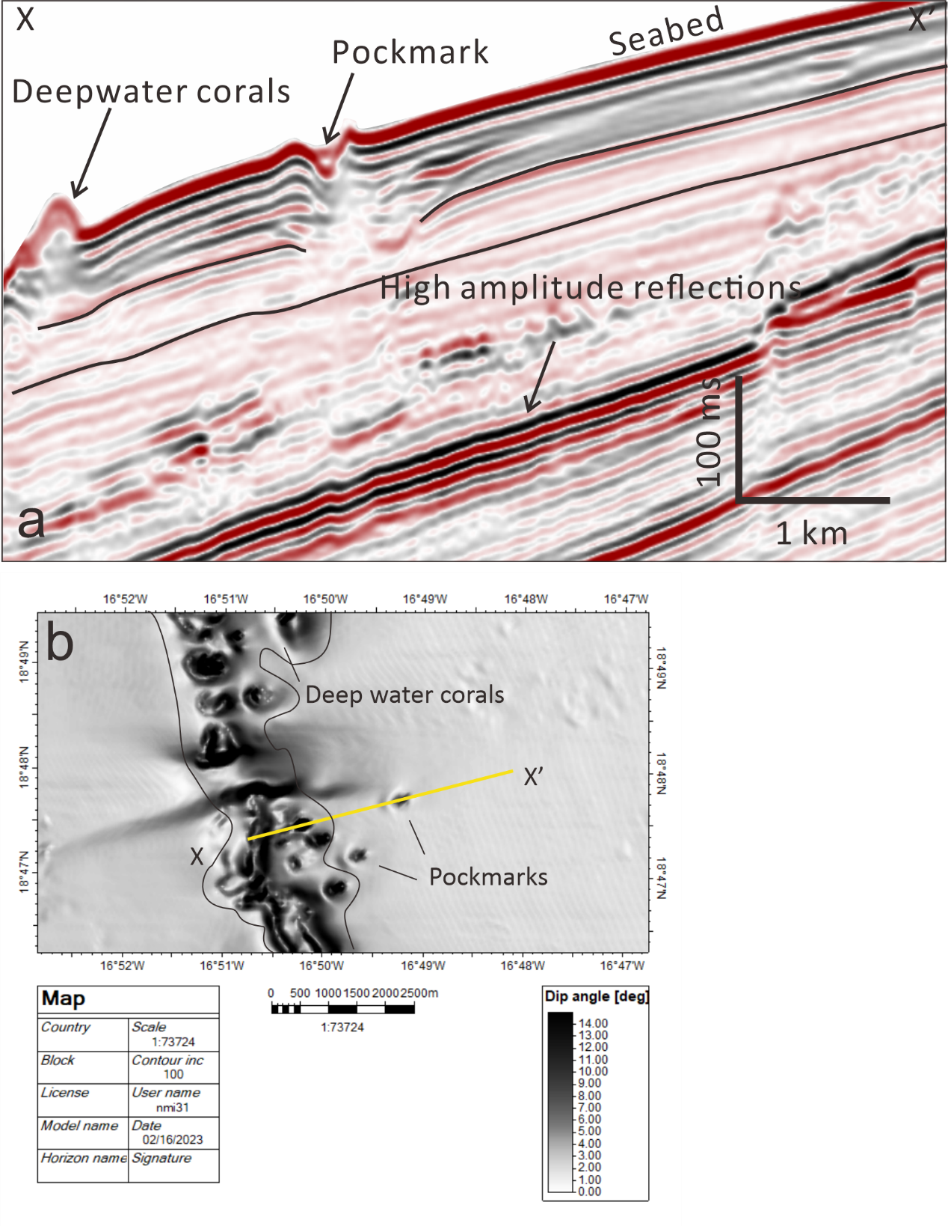

Supplementary material: Fig. 3 Calculated thickness of the theoretical gas hydrate stability zone (GHSZ)¹ with the locations of studies documenting similar features to those described here. Green dots – seismic evidence for existence of simple graded margins^{2–10}; red dots – seismic evidence for the landward limit of marine hydrate where the dip of the BHSZ > the dip of stratal^{4,6–9,11–17}; blue dots – BHSZ is approximately concordant with strata on the continental slope^{4,6–8,10–12,14,15,18}; black dots – pockmarks significantly (up to10s of km) beyond the landward limit of marine hydrate^{6,15,16}.
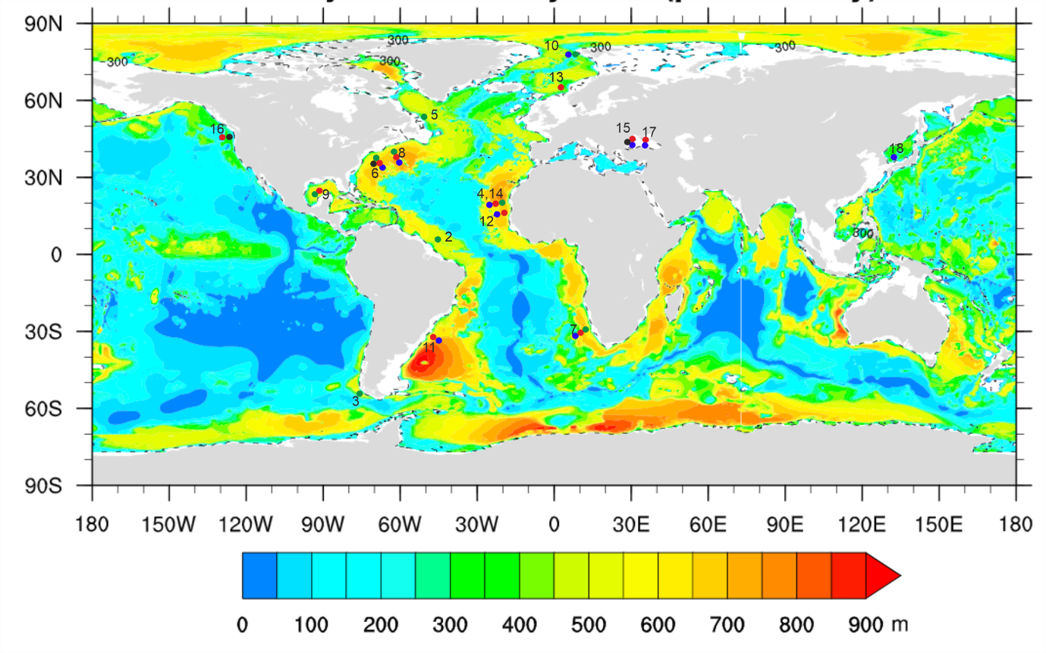
References
1. Kretschmer, K., Biastoch, A., Rüpke, L. & Burwicz, E. Modeling the fate of methane hydrates under global warming. Global Biogeochem Cycles 29, 610–625 (2015).
2. Pirmez, C. & Imran, J. Reconstruction of turbidity currents in Amazon Channel. Mar Pet Geol 20, 823–849 (2003).
3. Sylvester, Z., Pirmez, C. & Cantelli, A. A model of submarine channel-levee evolution based on channel trajectories: Implications for stratigraphic architecture. Mar Pet Geol 28, 716–727 (2011).
4. Li, A., Davies, R. J. & Mathias, S. Methane hydrate recycling offshore of Mauritania probably after the last glacial maximum. Mar Pet Geol 84, 323–331 (2017).
5. PIPER, D. J. W., DEPTUCK, M. E., MOSHER, D. C., HUGHES CLARKE, J. E. & MIGEON, S. Erosional and Depositional Features of Glacial Meltwater Discharges on the Eastern Canadian Continental Margin. in Application of the Principles of Seismic Geomorphology to Continental-Slope and Base-of-Slope Systems: Case Studies from Seafloor and Near-Seafloor Analogues 61–80 (SEPM (Society for Sedimentary Geology), 2012). doi:10.2110/pec.12.99.0061.
6. Brothers, D. S. et al. Seabed fluid expulsion along the upper slope and outer shelf of the U.S. Atlantic continental margin. Geophys Res Lett 41, 96–101 (2014).
7. Wenau, S., Spiess, V. & Zabel, M. Giant Seafloor Depressions Caused by Slope Failures and Bottom Currents on the Namibia Continental Margin. Geochemistry, Geophysics, Geosystems 22, (2021).
8. Ruppel, C. D. et al. US Atlantic Margin Gas Hydrates. in World Atlas of Submarine Gas Hydrates in Continental Margins 287–302 (Springer International Publishing, 2022). doi:10.1007/978-3-030-81186-0_24.
9. Prather, B. E. Calibration and visualization of depositional process models for above-grade slopes: a case study from the Gulf of Mexico. Mar Pet Geol 17, 619–638 (2000).
10. Osti, G., Waghorn, K. A., Waage, M., Plaza-Faverola, A. & Ferré, B. Evolution of contourite drifts in regions of slope failures at eastern Fram Strait. arktos 5, 105–120 (2019).
11. Ketzer, M. et al. Gas hydrate dissociation linked to contemporary ocean warming in the southern hemisphere. Nat Commun 11, 3788 (2020).
12. Davies, R. J. & Clarke, A. L. Methane recycling between hydrate and critically pressured stratigraphic traps, offshore Mauritania. Geology 38, 963–966 (2010).
13. Bünz, S. & Mienert, J. Acoustic imaging of gas hydrate and free gas at the Storegga Slide. J Geophys Res Solid Earth 109, (2004).
14. Ang Li. Three-dimensional Seismic Analysis and Modelling of Marine Hydrate Systems Offshore of Mauritania. PhD Thesis. (2017).
15. Riboulot, V. et al. Control of the geomorphology and gas hydrate extent on widespread gas emissions offshore Romania. Bulletin de la Société géologique de France 188, 26 (2017).
16. Merle, S. G. et al. Distribution of Methane Plumes on Cascadia Margin and Implications for the Landward Limit of Methane Hydrate Stability. Front Earth Sci (Lausanne) 9, (2021).
17. Riedel, M. et al. Controls on Gas Emission Distribution on the Continental Slope of the Western Black Sea. Front Earth Sci (Lausanne) 8, (2021).
18. Yoo, D. G. et al. Occurrence and seismic characteristics of gas hydrate in the Ulleung Basin, East Sea. Mar Pet Geol 47, 236–247 (2013).

