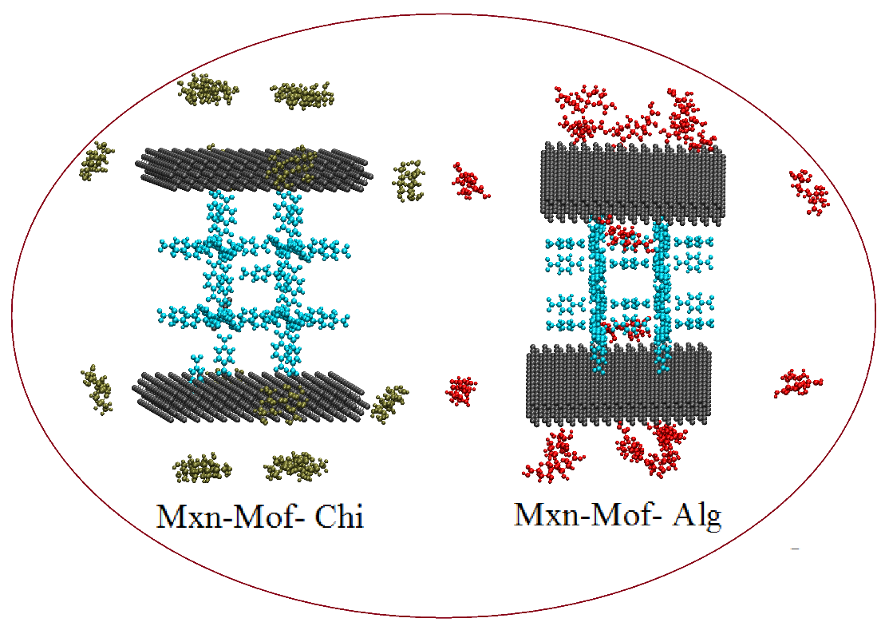
Figure S1. Initial photos of the Mxn-MOF-p (p: Chi, Alg) simulation box, 16 polymers of Chitosan and Alginate are placed around the substrate at ~2nm distance.

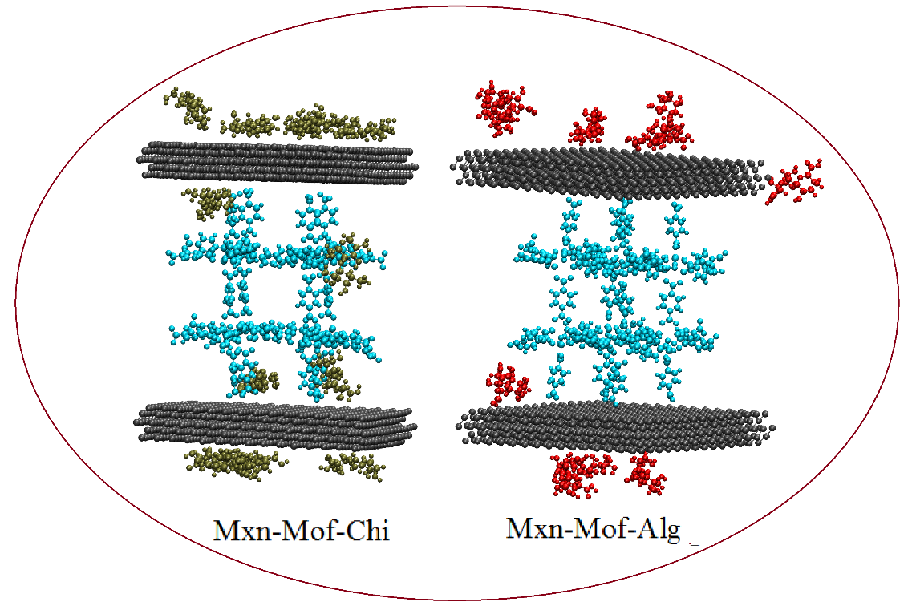
Figure S2. Final snapshots of simulation systems Mxn-MOF-Chi and Mxn-MOF-Alg

Table S1. Details of the designed simulation boxes.
Name System | carrier | Cur | DOX | No. Water molecules | Box Size (nm3)
Mxn-Mof-Dox | MOF-5/ MXene | - | 3 | 31372 | 10.00×10.00×10.00
Mxn-Mof-Cur | MOF-5/ MXene | 3 | - | 31389 | 10.00×10.00×10.00
Mxn-Mof-Alg | MOF-5/ MXene | - | - | 31364 | 10.00×10.00×10.00
Mxn-Mof-Chi | MOF-5/ MXene | - | - | 31371 | 10.00×10.00×10.00
MM-Alg-Dox | MOF-5/ MXene | 3 | - | 31194 | 10.00×10.00×10.00
MM-Chi-Dox | MOF-5/ MXene | 3 | - | 31147 | 10.00×10.00×10.00
MM-Alg-Cur | MOF-5/ MXene | 3 | - | 31211 | 10.00×10.00×10.00
MM-Chi-Cur | MOF-5/ MXene | 3 | - | 31166 | 10.00×10.00×10.00
MM-Dox/Cur | MOF-5/ MXene | 3 | 3 | 31326 | 10.00×10.00×10.00
MM-chi-Dox/Cur | MOF-5/ MXene | 3 | 3 | 31100 | 10.00×10.00×10.00
MM-Alg-Dox/Cur | MOF-5/ MXene | 3 | 3 | 31136 | 10.00×10.00×10.00

Table S2. A summary of MD simulation’s states.
 |  |  | Stage | Time(ns) | Time step (fs)
Mxn-Mof-p | Chi | - | NVT | 0.2 | 0.0002
Mxn-Mof-p | Chi | - | NpT | 0.2 | 0.0002
Mxn-Mof-p | Alg | - | MD | 30 | 0.0015
All | Mxn-Mof | Dox or Cur | NVT  NpT  MD | 0.2  0.2  75 | 0.0002  0.0002  0.0015
All | MM-Alg | Dox or Cur | NVT  NpT  MD | 0.2  0.2  75 | 0.0002  0.0002  0.0015
All | MM-Chi | Dox or Cur | NVT  NpT  MD | 0.2  0.2  75 | 0.0002  0.0002  0.0015
All | MM-Alg- | Dox/Cur | NVT  NpT  MD | 0.2  0.2  75 | 0.0002  0.0002  0.0015
All | MM-Chi- | Dox/Cur | NVT  NpT  MD | 0.2  0.2  75 | 0.0002  0.0002  0.0015

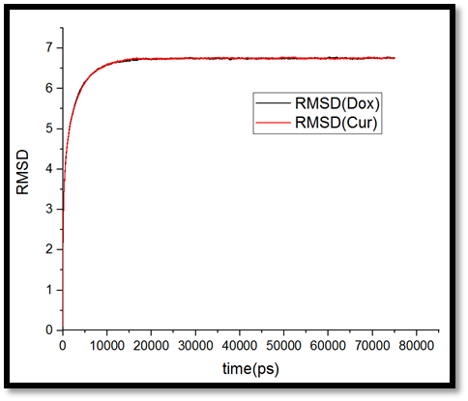

Figure S3. RMSD curves for simulated systems Mxn-MOF-Dox and Mxn-MOF-Cur

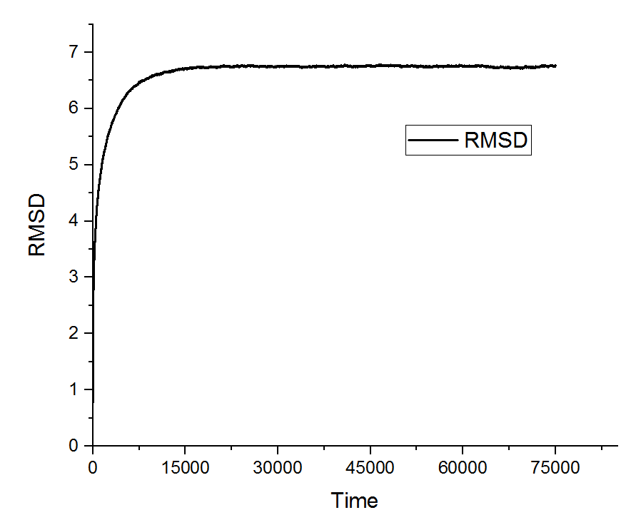
Figure S4. The RMSD curve for the simulated system MM-Dox/Cur.

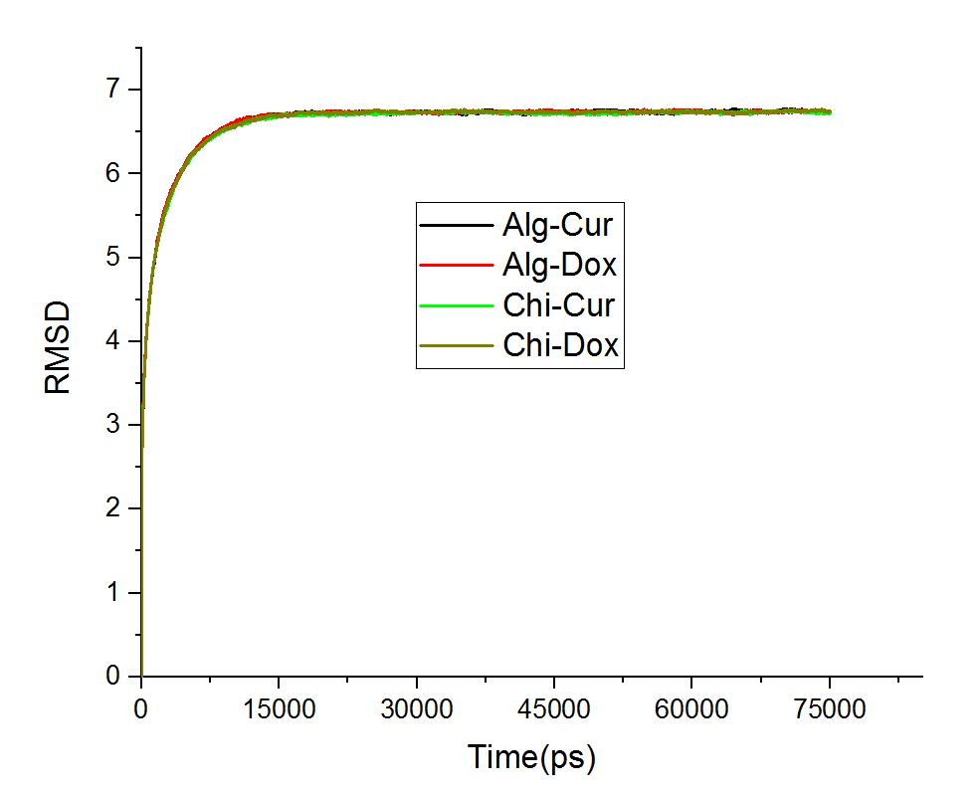

Figure S5. The RMSD curves for simulated systems MM-p-drug.

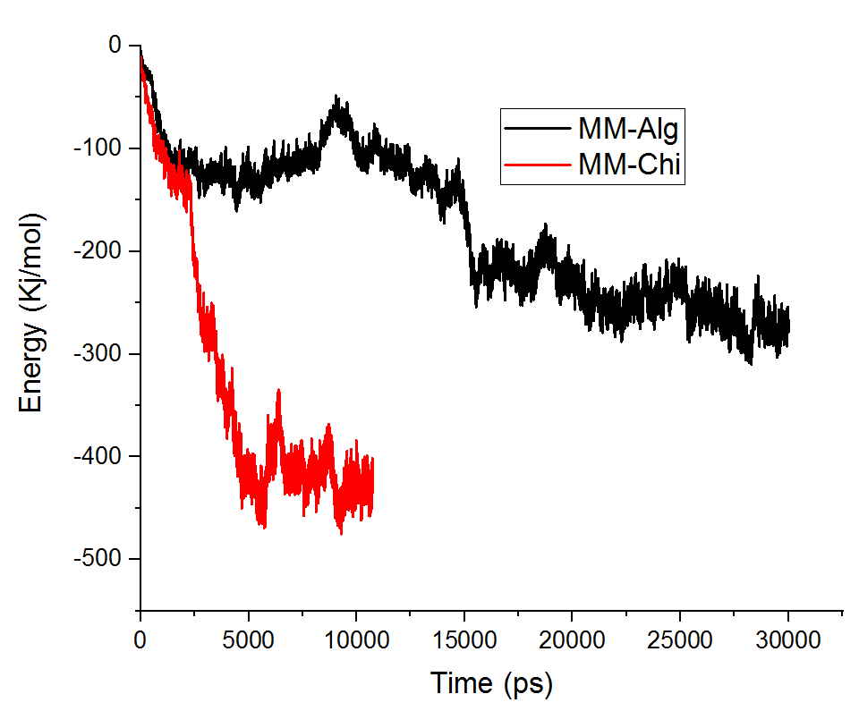
Figure S6. The LJ interaction energy of Chitosan and Alginate polymers with MM substrate.

