Supplement Figure

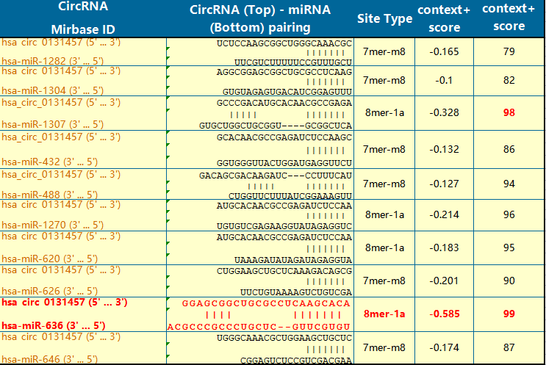

Sup figure 1 | The target miRNA combined with hsa_circ_0131457 were predicted by StarBase database, and a total of 10 mirnas were found. The 10 mirnas were hsa-miR-636、hsa-miR-1307、hsa-miR-1270、hsa-miR-1304、hsa-miR-432、hsa-miR-488、hsa-miR-620、hsa-miR-626、hsa-miR-646 and hsa-miR-1282.The analysis showed that hsa-miR-636 had the highest score (99). hsa_circ_0131457 combined with hsa-miR-636 had the best matching value.

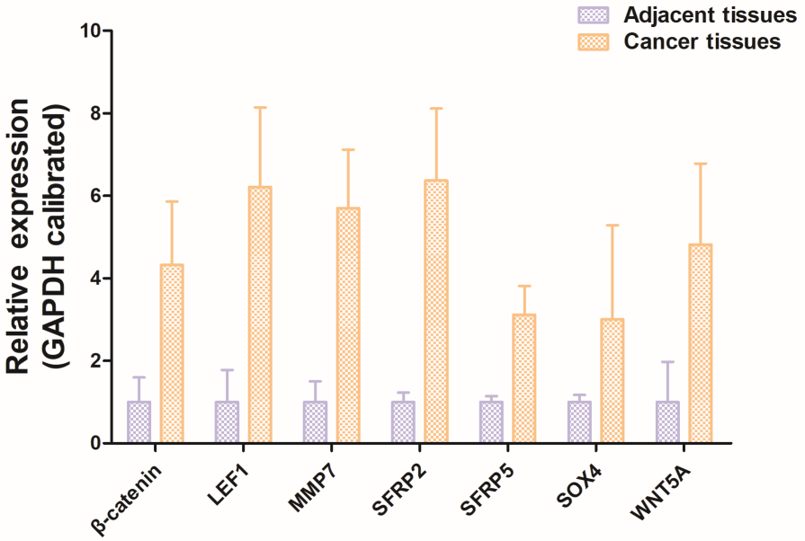
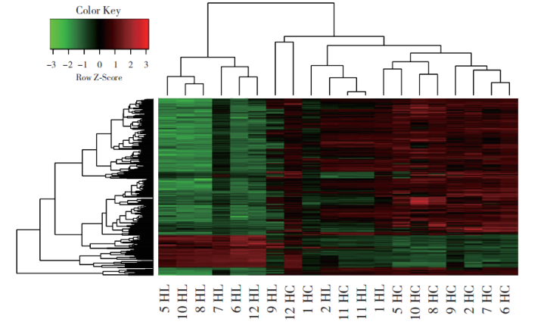
A
B

Sup figure 2 | Cluster analysis heat map of differential gene expression in pancreatic and paracancer tissues. (A) The Affymetrix gene expression profile microarray was used to detect pancreatic and paracancer tissues. According to the screening criteria of significantly differentially expressed genes, 512 differentially expressed genes were screened between pancreatic cancer tissues and adjacent tissues, accounting for 1.34% of the total detected genes. Among them, 419 genes with up-regulated expression accounted for 1.10% of the total effective detected genes, and 93 genes with down-regulated expression accounted for 0.24% of the total effective detected genes. (B) The information of all Wnt signaling pathway members was retrieved from BioCarta Pathways database and compared with the chip analysis results to screen out the members of Wnt signaling pathway with differential expression. The analysis results showed that compared with the adjacent tissues, the Wnt signaling pathway members β-catenin, LEF1, MMP7, SFRP2, SFRP5, SOX4 and WNT5A were differentially expressed in pancreatic cancer tissues. Their differentially expressed multiples were 4.32, 6.21, 5.70, 6.37, 3.12, 3.00 and 4.83, respectively. The difference of SFRP2 expression was the most significant.

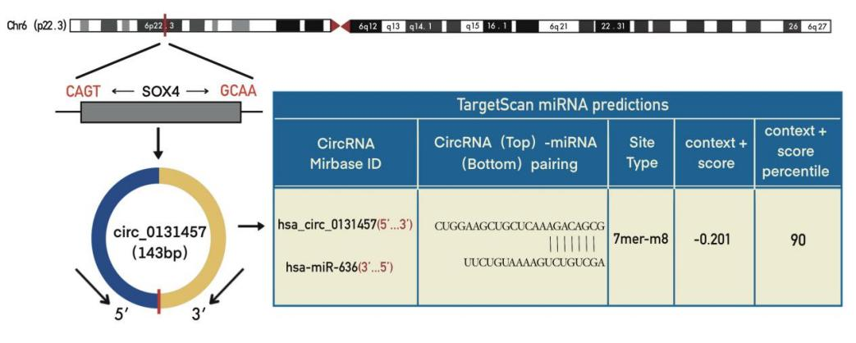
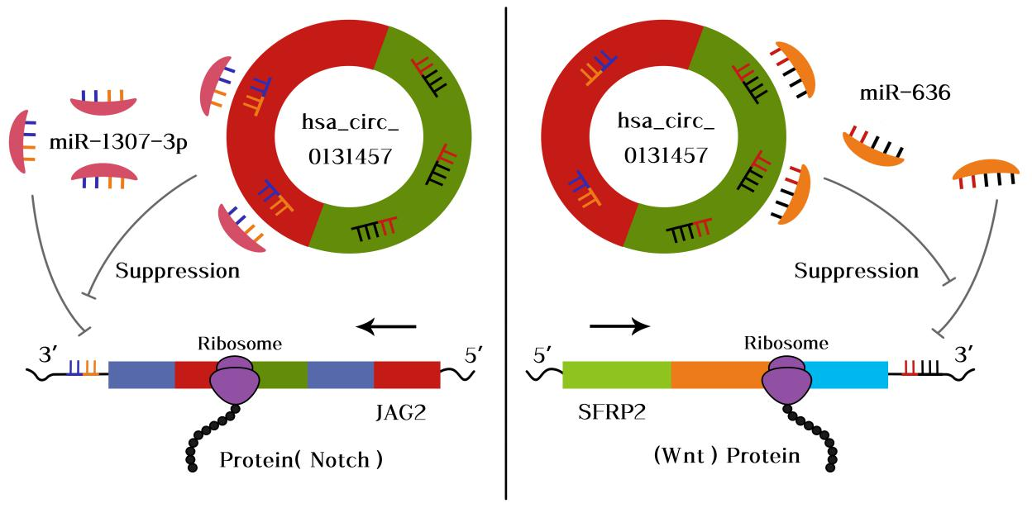

Sup figure 3 | The diagram of hsa_circ_0131457/miR-636/SFRP2 regulatory mechanism hypothesis in pancreatic cancer. (A) hsa_circ_0131457 Map of genomic localization and splicing mode. (B) hsa_ circ_ 0131457 regulates SFRP2 through sponge adsorption of miRNA.

