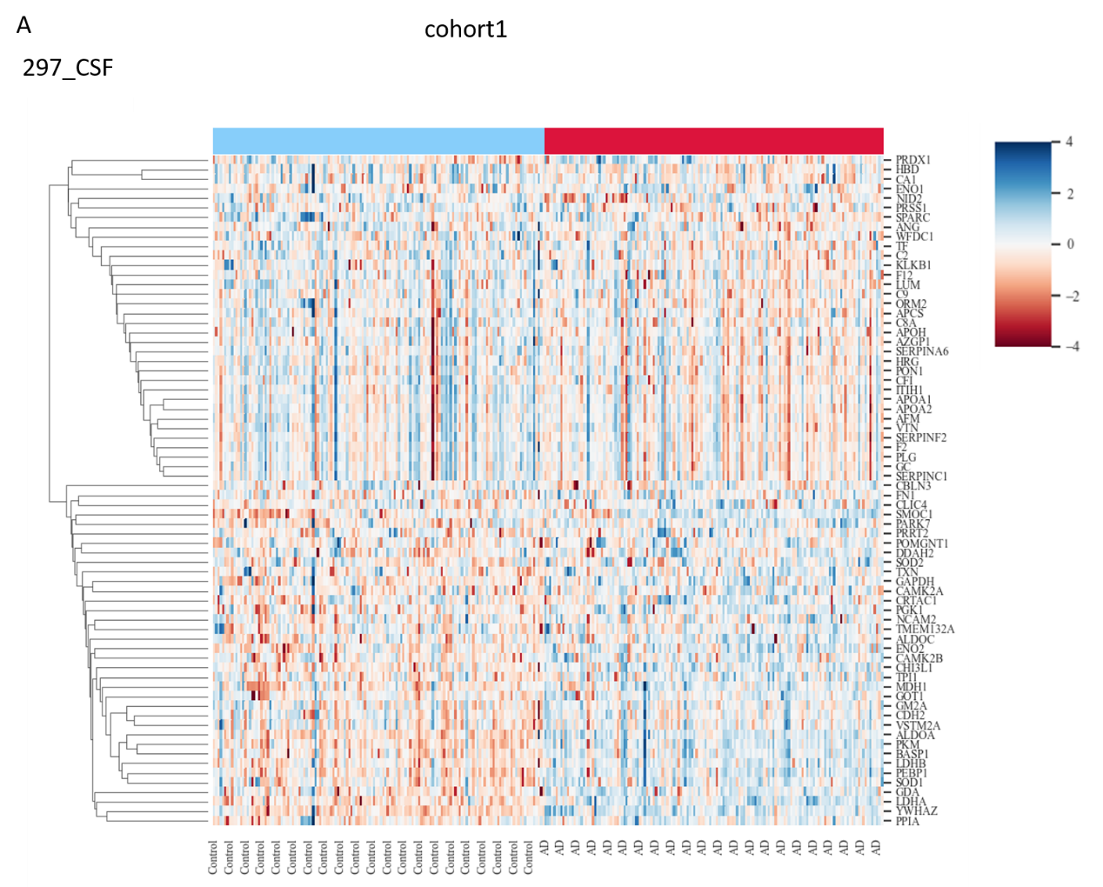

Supplementary Figure 1: Consistent DEP heatmap chart in cohort 1
A: The heatmap representation of the up- and downregulated- proteins in AD. The blue color shows upregulated proteins, and the red color shows downregulated proteins.

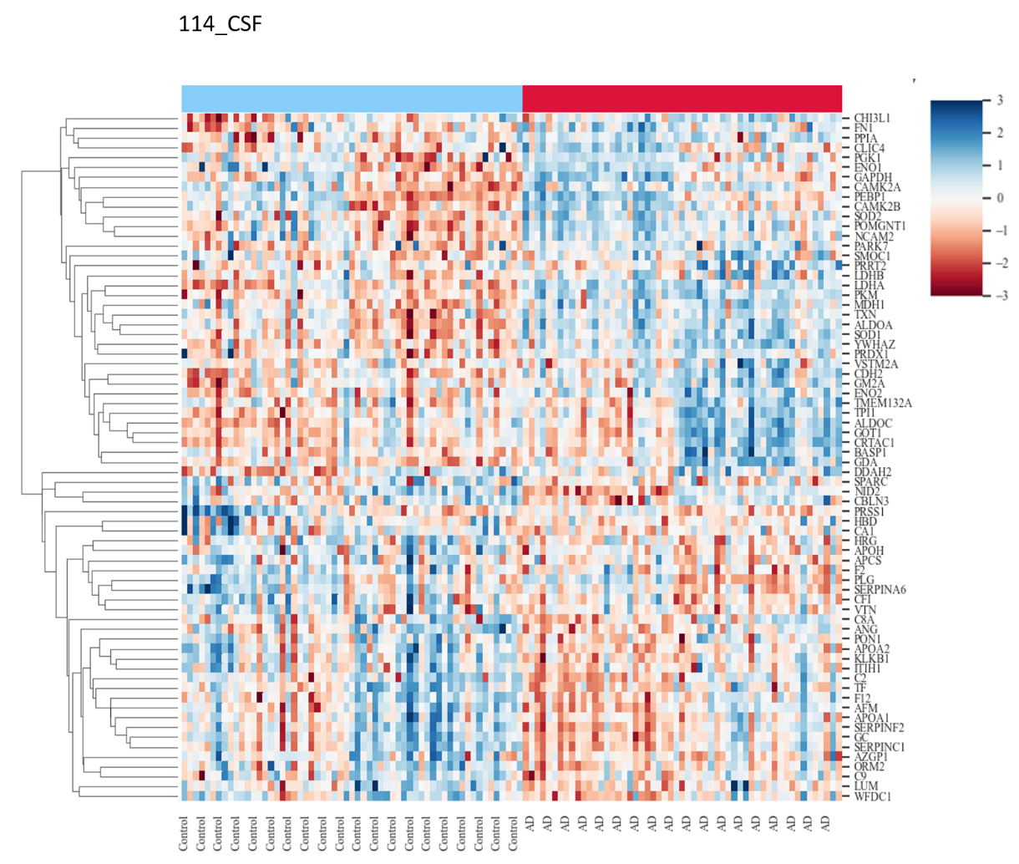
Supplementary Figure 2: Consistent DEP heatmap chart in cohort 2
A: The heatmap representation of the up- and downregulated- proteins in AD. The blue color shows upregulated proteins, and the red color shows downregulated proteins.

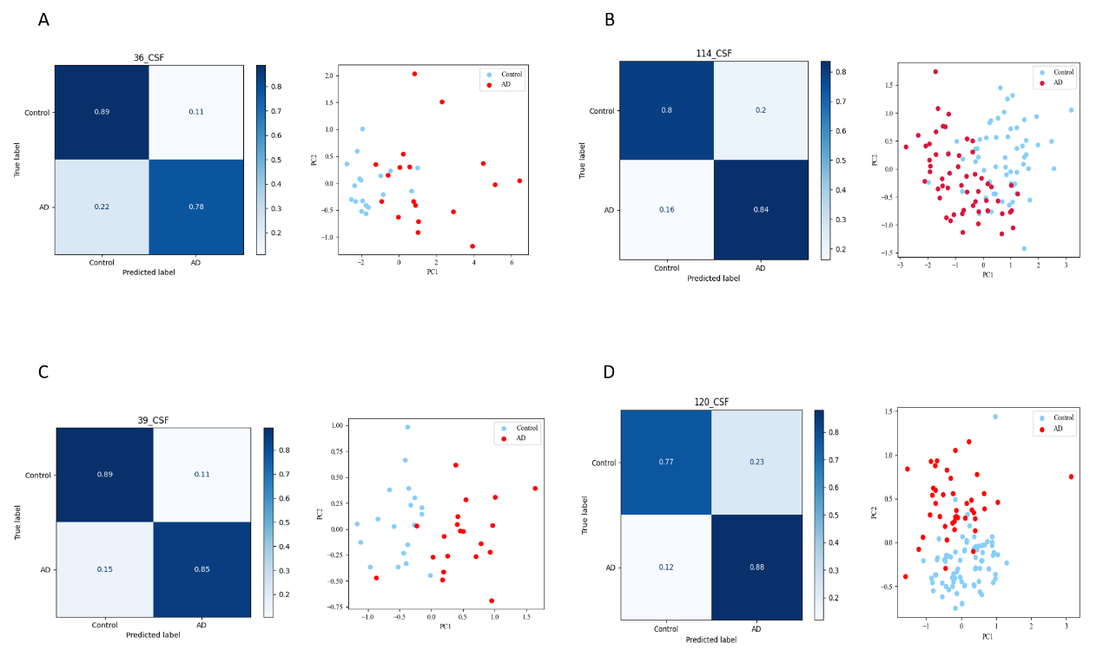

Supplementary Figure 3: The 12-protein panel shows good performance in validation cohorts
A: The confusion matrix of the 12-protein panel. The PCA plot using 12-protein panel showed a good distinguish performance in 36_CSF dataset. B: The confusion matrix of the 12-protein panel. The PCA plot using 12-protein panel showed a good distinguish performance in 114_CSF dataset. C: The confusion matrix of the 12-protein panel. The PCA plot using 12-protein panel showed a good distinguish performance in 39_CSF dataset. D: The confusion matrix of the 12-protein panel. The PCA plot using 12-protein panel showed a good distinguish performance in 120_CSF dataset.

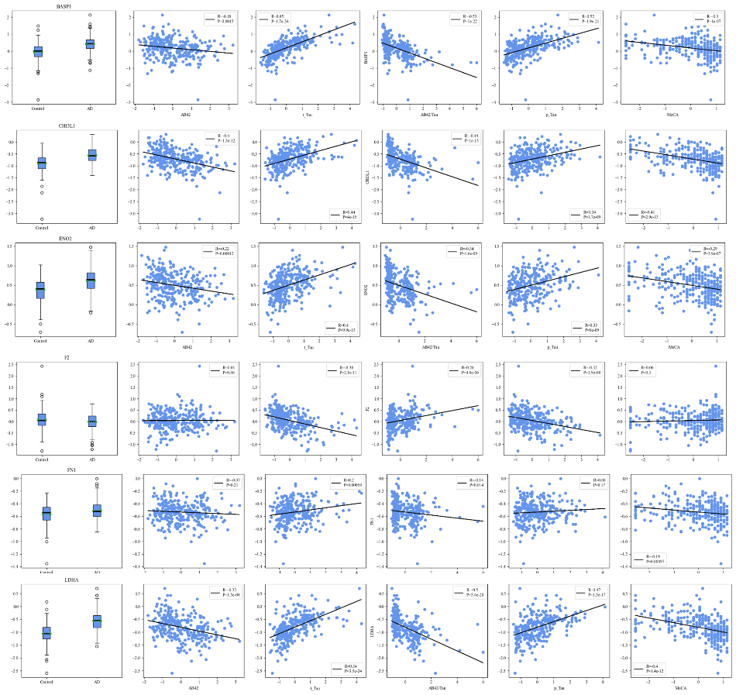
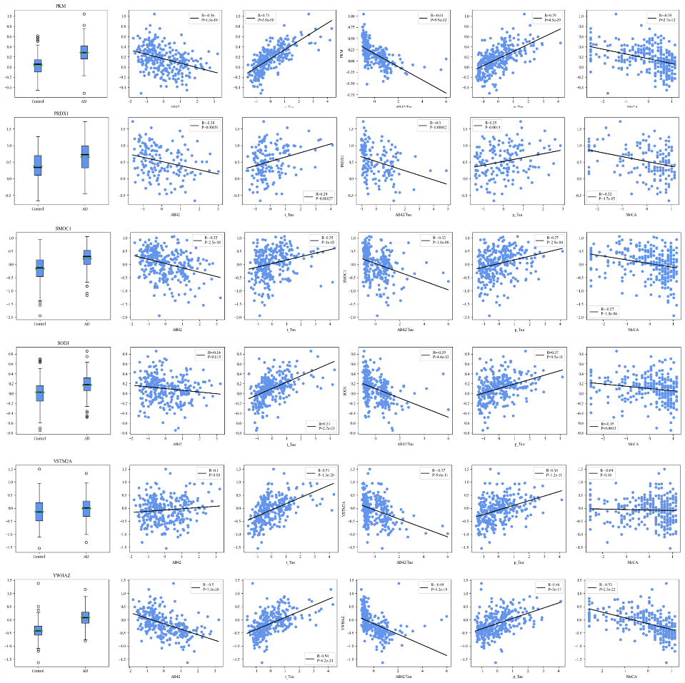
Supplementary Figure 4: The 12 proteins in the panel are correlated to AD classical biomarkers
The boxplot showed the relative expression levels of the 12 proteins in control and AD in 297_CSF dataset. The scatter plot showed the correlation of the AD pathogenic molecule and 12-proteins in the panel.

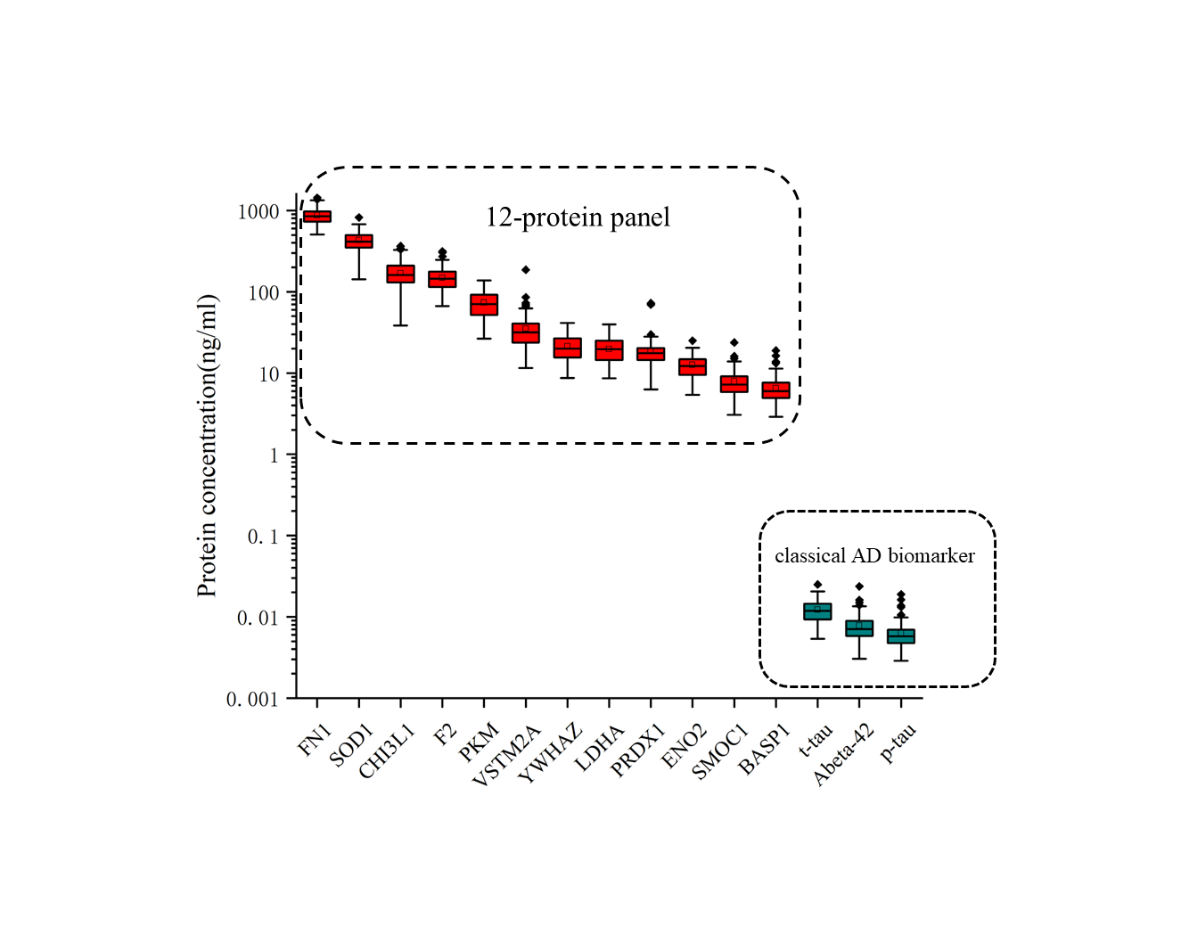
Supplementary Figure 5: The protein concentrations in CSF show that 12 proteins in panel are all significantly higher than classical AD biomarker
The boxplot showed the protein concentrations in 114_CSF dataset. 12 proteins in panel are estimated via DIA intensity. Classical AD biomarker are measured by ELISA and offered in 114_CSF dataset.

