Supplementary Information

Systemic risks from climate-related disruptions at ports

Jasper Verschuur^{1,*}, Elco E. Koks^{1,2} and Jim W. Hall¹

¹ Oxford Programme for Sustainable Infrastructure Systems (OPSIS), Environmental Change Institute, University of Oxford, Oxford, United Kingdom
² Institute for Environmental Studies, Vrije Universiteit Amsterdam, Amsterdam, Netherlands

*corresponding author: jasper.verschuur@keble.ox.ac.uk
Oxford Programme for Sustainable Infrastructure Systems (OPSIS), Environmental Change Institute, University of Oxford, 3 South Parks Road, Oxford OX1 3QY, United Kingdom

Contains:
Supplementary Methods
Supplementary Figures 1-6
Supplementary Tables 1-3
Supplementary References

Supplementary Methods

Relationship trading partners and port-to-port downtime risk
We test whether the number of port trading partners (that is the number of ports that are the last port of call of the incoming vessels at the port of interest, see ‘Port-to-port downtime risk’ below) has effect on the indirect downtime risk. To do this, we count the number of port partners (NP) of incoming vessels, and account for the direct downtime risk at ports. The latter is to account for the fact that ports (p) with a high direct downtime risk (DR) have a high likelihood of downtime risk at their geographically near trading partners.

In short, we formulate the regression:

$$PtPDR_{p}=β_{0}+β_{1}DR_{p}+β_{2}LN(NP_{p})+ϵ$$

Both coefficients are statistically significant (p < 0.01) with a model fit with R² of 0.21. A high direct downtime risk is associated with a higher port-to-port downtime risk ($β_{1} = 0.24)$, while a higher number of trading partners is associated with a lower port-to-port downtime risk ($β_{2} =-0.07)$.

Port-to-port downtime risk
To construct the port-to-port network, we constructed a database of vessel movements between 1320 ports in our subsample, covering around 98,000 trade-carrying vessels in total. Based on the order of visits between 2019 and 2020, we can construct the connections between ports (which we call routes). Details of this dataset are included in previous work^{1,2}. On every route, a vessel carries an amount of goods (the loaded capacity), which we approximate by multiplying the payload (or utilisation rate) on the route with the carrying capacity of the vessel (its DWT). When then aggregate across all vessels and divide by two to get the average loaded capacity on transport route for the year 2019-2020. This results in a dataset of 150,000 routes between the 1320 ports.

For every port of interest, we look at the loaded capacity on the route from all origin ports in our sample. We then combine this with the downtime risk at these ports (Extended Figure 1) to derive the loaded capacity at-risk. Supplementary Figure 3 shows examples of the loaded capacity at-risk for six ports; Rotterdam (Netherlands), Los Angeles-Long Beach (United States), Jeddah (Saudi Arabia), Durban (South Africa), Suva (Fiji) and Santos (Brazil). To estimate the port-to-port downtime risk, we take a weighted mean of the loaded capacity at-risk across all the origin ports.

Maritime trade at-risk
To estimate the maritime trade at-risk, we utilize the output of the Oxford Maritime Transport (OxMarTrans) model, a global maritime transport model that can simulate the route allocation of bilateral maritime trade flows. A detailed overview of the OxMarTrans model is provided in ref². The base year for the trade flows is 2015, as this dataset is linked to a global multi-regional input-output table (see below), for which 2015 was the latest available year at the time of performing the analysis.

For every country’s maritime trade exports, we look which ports are being used to export goods (often at a domestic port of the exporting country if a country is not a landlocked country), tranship goods (often a foreign port), and import goods (often at a trading partner’s domestic port if the trading partner is not a landlocked country). We can do a similar exercise for a country’s maritime imports, looking at the ports used to export goods (often a trading partner’s domestic port if the trading partner is not a landlocked country), tranship goods, and import goods (often at a domestic port of the importing country if a country is not a landlocked country). This results in a network of >2.1 million unique port-country pair combinations across >25,000 unique country pairs and 11 economic sectors. For the results reported, we only look at the aggregate flows across the 11 sectors.

By combining the amount of trade flowing through each port (either in volume or value terms) with the annually expected downtime at this port, we can construct an overview of a country’s trade-dependent ports and the trade at-risk at the port-level. Supplementary Figure 5 shows the top 200 ports with the highest trade at-risk for six example countries (Netherlands, Brazil, United States, Fiji, South Africa and Brazil). We can construct a country’s downtime risk by taking doing a weighted mean (weighted with the amount of a country’s trade flows going through a port) across all ports in a country’s “port portfolio”, and multiply this with the total trade flow to estimate the total trade at-risk. We can do this for both a country’s imports as well as exports, the total of which is similar on a global scale, but different on a country scale.

Economic activity at-risk
The estimates of economic activity at-risk builds upon the maritime trade network described in ‘Maritime trade at-risk’, but goes one step further. This metric does not only intend to estimate how a supply-chain is exposed to downtime because you trade through a certain port, but also because you rely on firms upstream in your supply-chain (the firms you depend on, 1st order suppliers, or firms that the firms that you depend on depend on, 2nd order suppliers, etc). In other words, as a supply-chain, you may be indirectly exposed to port disruptions without your direct input or consumption going through a port (e.g. you are exposed to closure of a raw materials exporting port without you directly using raw materials in your production process).

To estimate this, we expand the methodology described in Verschuur et al.², who evaluated the criticality of ports for global and domestic supply-chains by hypothetically extracting the trade through this port from a global multiregional input-output table (MRIO). This is done by removing the sector-specific trade flows through a port (which connect industries across countries) and re-evaluating the industry output and consumption in the MRIO tables. Only forward dependencies are included in this metric (supply dependencies) and no backward dependencies (demand dependencies). Based on this, one could evaluate, per country and per sector, which percentage of its consumption or industry output is directly (because of a firm’s input coming through a port) or indirectly (because of a firm’s 1st, 2nd or higher order suppliers input or output coming through a port) influenced by the trade flowing through the port of interest. To illustrate this, Supplementary Figure 5 shows the percentage of a country’s total industry output influenced by six example ports, namely Rotterdam, Los Angeles-Long Beach, Jeddah, Santos, Port Hedland and Durban.

This analysis is done for all 1320 ports in our dataset. To find the industry output and consumption at-risk of a given supply-chain in a given country, we reserve the perspective and look at what fraction of the industry output and consumption is at-risk every year because of expected annual downtime at all the ports that this supply-chain depends upon. Similar as with the maritime trade at-risk, one can evaluate the top ports in terms of industry output or consumption at-risk, as for instance show for six countries in Supplementary Figure 6 (top 200 ports). This can be done at both the sector-country level as well as the aggregate country-level.

Supplementary Figures
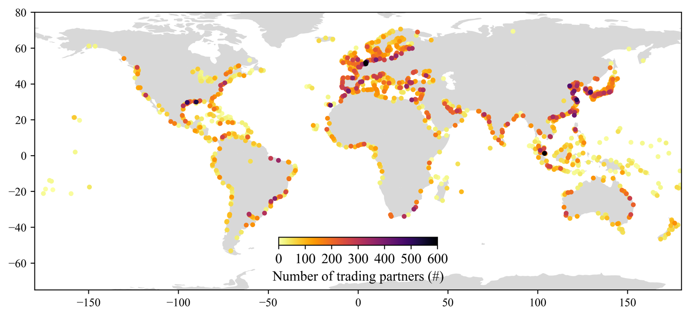
Supplementary Figure 1. Number of port trading partners. The number of ports that a port directly depends upon in the maritime transport network. These trading ports are ports that vessels have last visited before calling at the port of interest.

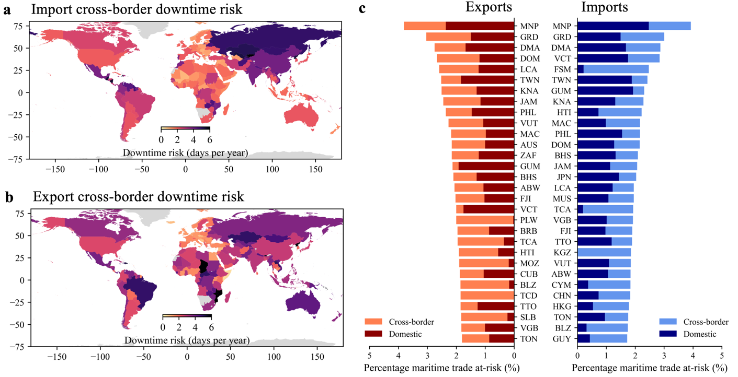
Supplementary Figure 2. Maritime trade volume at-risk. (a) Cross-border downtime risk for country’s import flows, (b) same as (a) but for exports. (c) Top-30 countries in terms of maritime trade at-risk (in volume terms), including a breakdown between domestic and cross-border downtime risk.

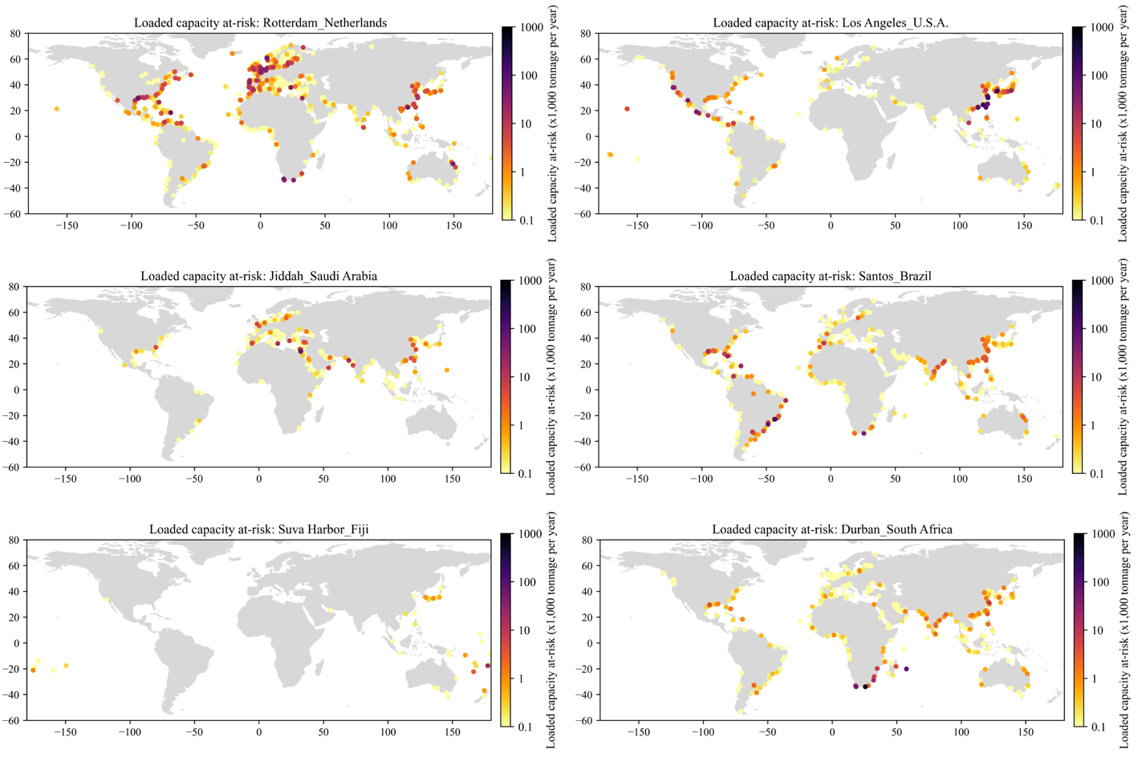
Supplementary Figure 3. Loaded capacity at risk for six example ports. The loaded capacity at-risk in transport-dependent ports in maritime transport network (i.e. trading ports). The loaded capacity quantifies the expected annual amount of loaded capacity (volume of goods carried) on a route service the port of interest times the expected annual downtime at the trading port.

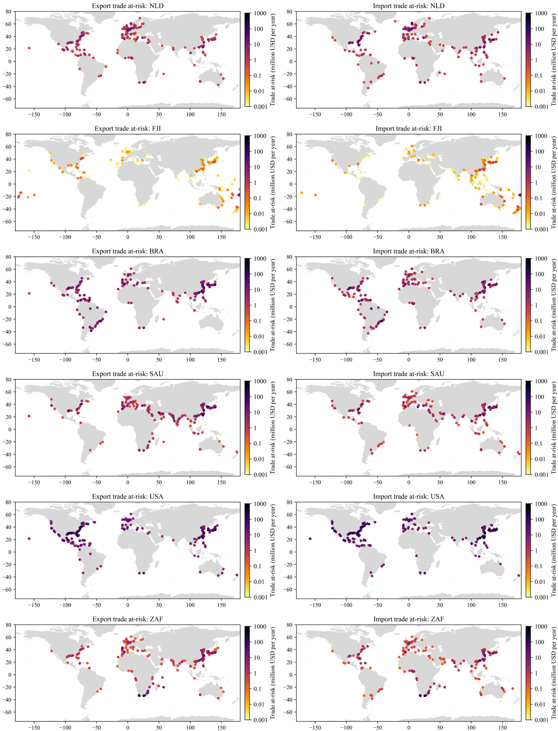
Supplementary Figure 4. Top 200 most critical ports for maritime trade. The top-200 most critical ports for maritime trade (in value terms) for six example countries. The import or export trade at-risk is estimated by combining the country’s absolute amount of import of exports flowing through a port with the expected annual downtime at this port.

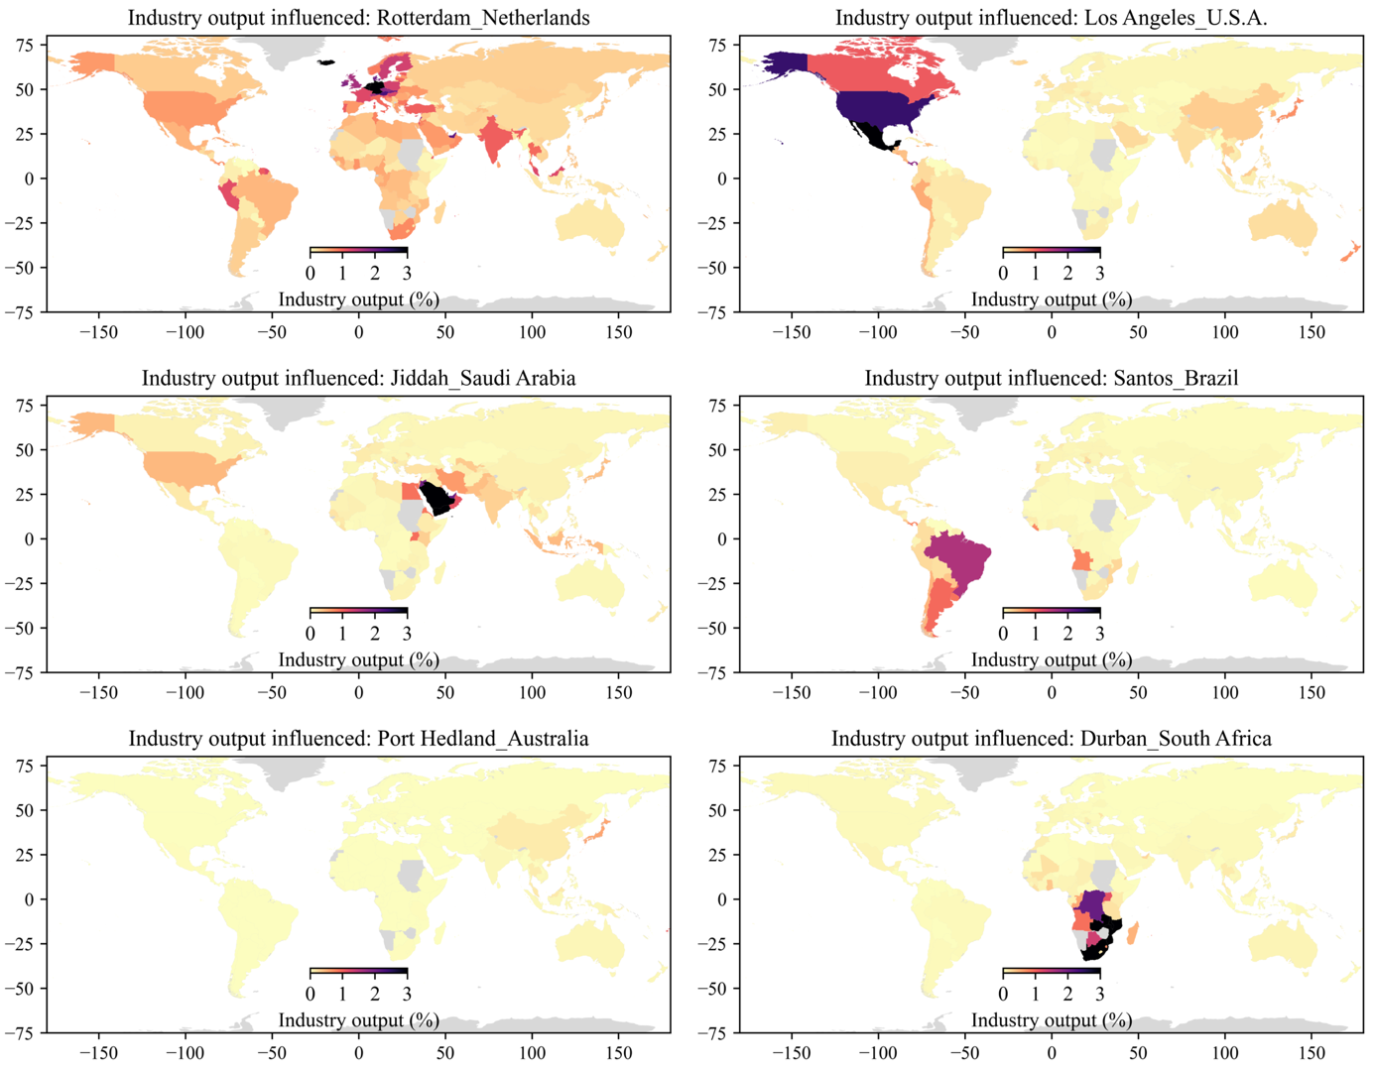
Supplementary Figure 5. Industry output influenced by trade through ports. The aggregate industry output of country’s supply-chains influenced by trade through a port of interest. The industry output influenced is derived by hypothetically removing the port’s trade flows from a multiregional input-output table and re-evaluating the industry output of supply-chains globally. This therefore captures all forward dependencies of a country’s industry output on trade through a given port.

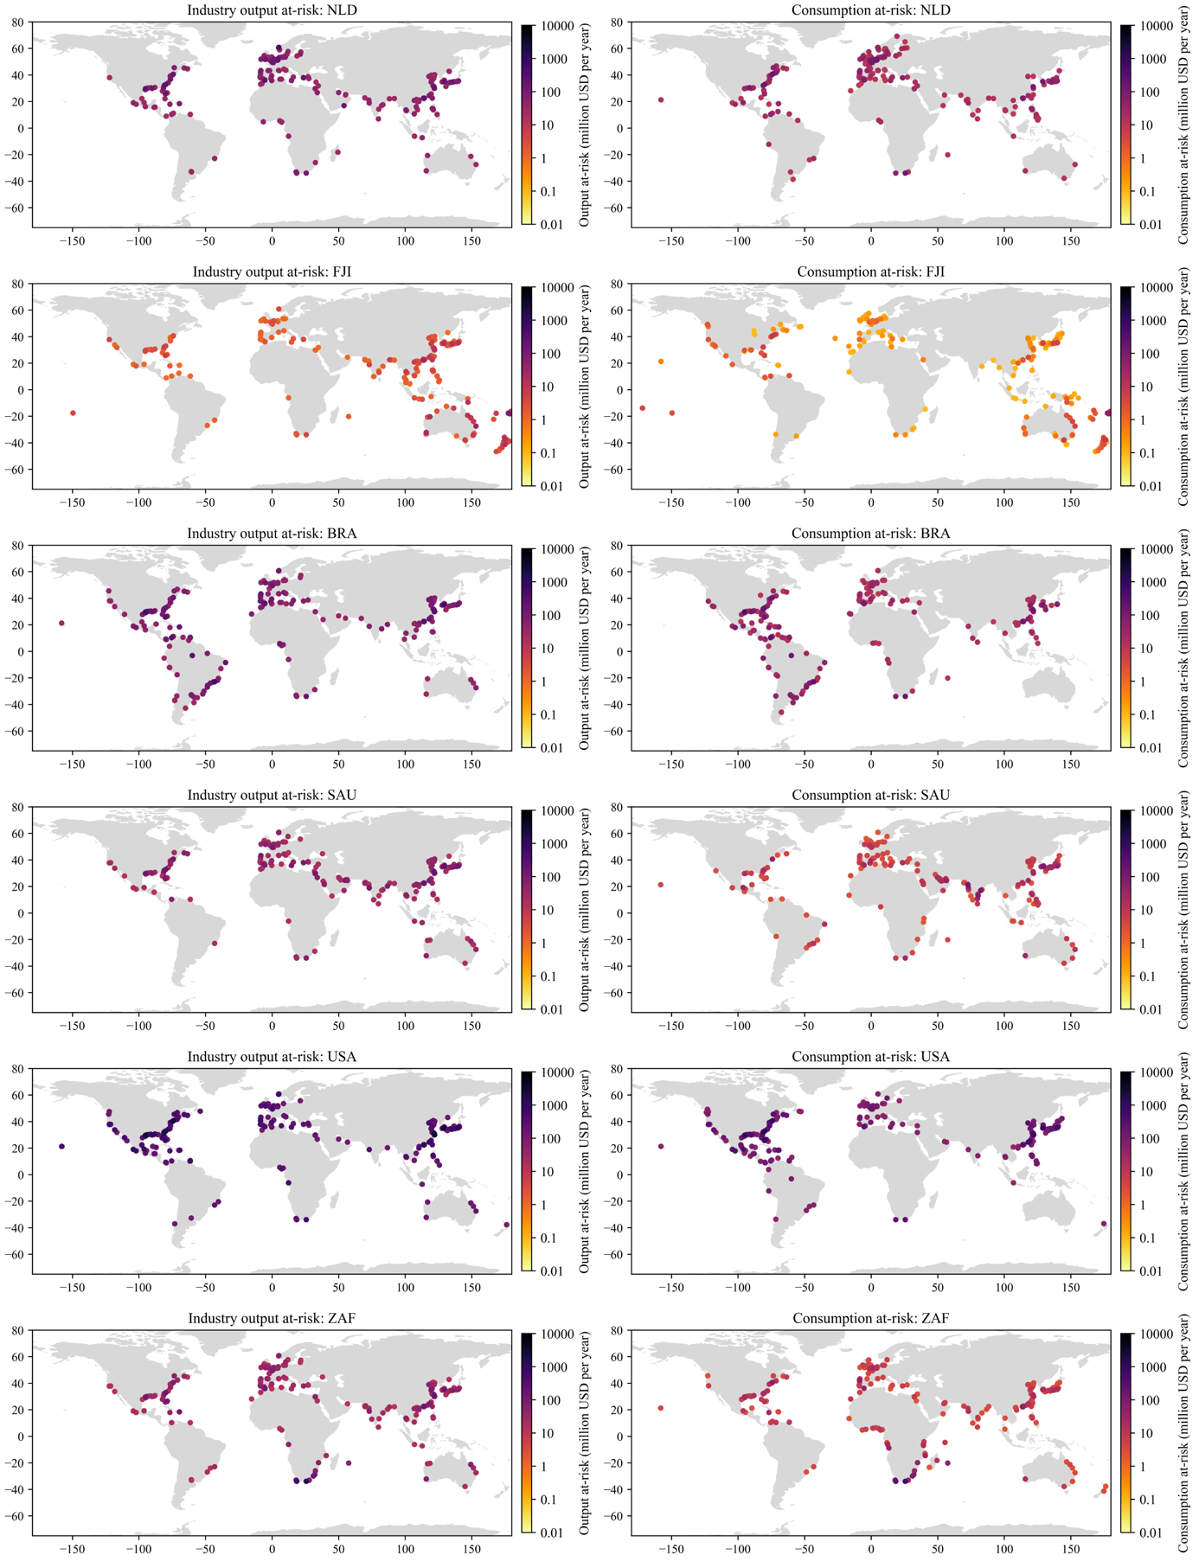
Supplementary Figure 6. Top 200 most critical ports for supply-chains. The top-200 most critical ports for country’s supply-chains (in terms of industry output and consumption) for six example countries. The industry output and consumption at-risk is estimated by combining the country’s absolute amount of industry output or consumption influenced by trade through a port with the expected annual downtime at this port.

Supplementary Tables

Supplementary Table 1. Sector specific trade at-risk in volume terms, including the fraction of cross-border risk.

Sector | Trade at-risk (million tonnes) | Fraction import cross-border (%) | Fraction export cross-border (%)
Agriculture | 2.8 | 61.4 | 75.6
Electrical and Machinery | 22.4 | 69.2 | 48.7
Fishing | 0.3 | 60.1 | 74.4
Food & Beverages | 4.3 | 59.1 | 74.0
Metal Products | 7.2 | 66.5 | 57.1
Mining and Quarrying | 8.1 | 50.0 | 77.2
Other Manufacturing | 8.3 | 69.2 | 48.8
Petroleum, Chemical and Non-Metallic Mineral Products | 19.7 | 58.5 | 60.4
Textiles and Wearing Apparel | 4.1 | 70.1 | 55.9
Transport Equipment | 2.0 | 69.4 | 53.1
Wood and Paper | 1.7 | 58.8 | 66.1

Supplementary Table 2. Sector specific trade at-risk in value terms, including the fraction of cross-border risk.

Sector | Trade at-risk (million tonnes) | Fraction import cross-border (%) | Fraction export cross-border (%)
Agriculture | 7.5 | 58.0 | 78.8
Electrical and Machinery | 1.6 | 67.1 | 51.2
Fishing | 0.1 | 62.8 | 67.7
Food & Beverages | 5.7 | 59.4 | 67.9
Metal Products | 5.1 | 71.5 | 55.3
Mining and Quarrying | 48.4 | 58.5 | 69.4
Other Manufacturing | 0.9 | 72.7 | 45.5
Petroleum, Chemical and Non-Metallic Mineral Products | 45.5 | 58.9 | 64.5
Textiles and Wearing Apparel | 0.4 | 70.2 | 55.6
Transport Equipment | 0.4 | 66.6 | 55.2
Wood and Paper | 2.0 | 57.4 | 72.7

Supplementary Table 3. Sector specific industry output and consumption at-risk, including the fraction of cross-border risk.

Sector | Industry output at-risk (USD billion) | Fraction cross-border (%) | Consumption at-risk (USD billion) | Fraction cross-border (%)
Agriculture | 2.71 | 67.59 | 0.58 | 74.11
Electrical and Machinery | 25.39 | 66.90 | 9.72 | 56.81
Fishing | 0.32 | 63.30 | 0.05 | 71.25
Food & Beverages | 6.95 | 65.90 | 2.28 | 74.43
Metal Products | 11.43 | 62.37 | 0.39 | 58.62
Mining and Quarrying | 1.99 | 59.59 | 0.06 | 63.22
Other Manufacturing | 2.67 | 67.28 | 1.69 | 59.16
Petroleum, Chemical and Non-Metallic Mineral Products | 23.58 | 58.34 | 2.85 | 65.38
Textiles and Wearing Apparel | 5.02 | 65.59 | 3.73 | 58.71
Transport Equipment | 9.55 | 68.50 | 4.25 | 51.10
Wood and Paper | 3.74 | 63.27 | 0.42 | 61.14

Supplementary References

1. Verschuur, J., Koks, E. E. & Hall, J. W. Global economic impacts of COVID-19 lockdown measures stand out in high-frequency shipping data. PLoS One 16, e0248818 (2021).
2. Verschuur, J., Koks, E. E. & Hall, J. W. Ports’ criticality in international trade and global supply-chains. Nat. Commun. 13, 4351 (2022).

