Polymer-based dual drug delivery system for targeted treatment of fluoroquinolone-resistant Staphylococcus aureus mediated infections.
Gopalakrishnan Thamilselvan¹, Helma David¹, Anusree Sajeevan¹, Shobana Rajaramon¹, Adline Princy Solomon^{1*}, Ramya Devi^{3*} and N. Vedha Hari³
Supplementary Data
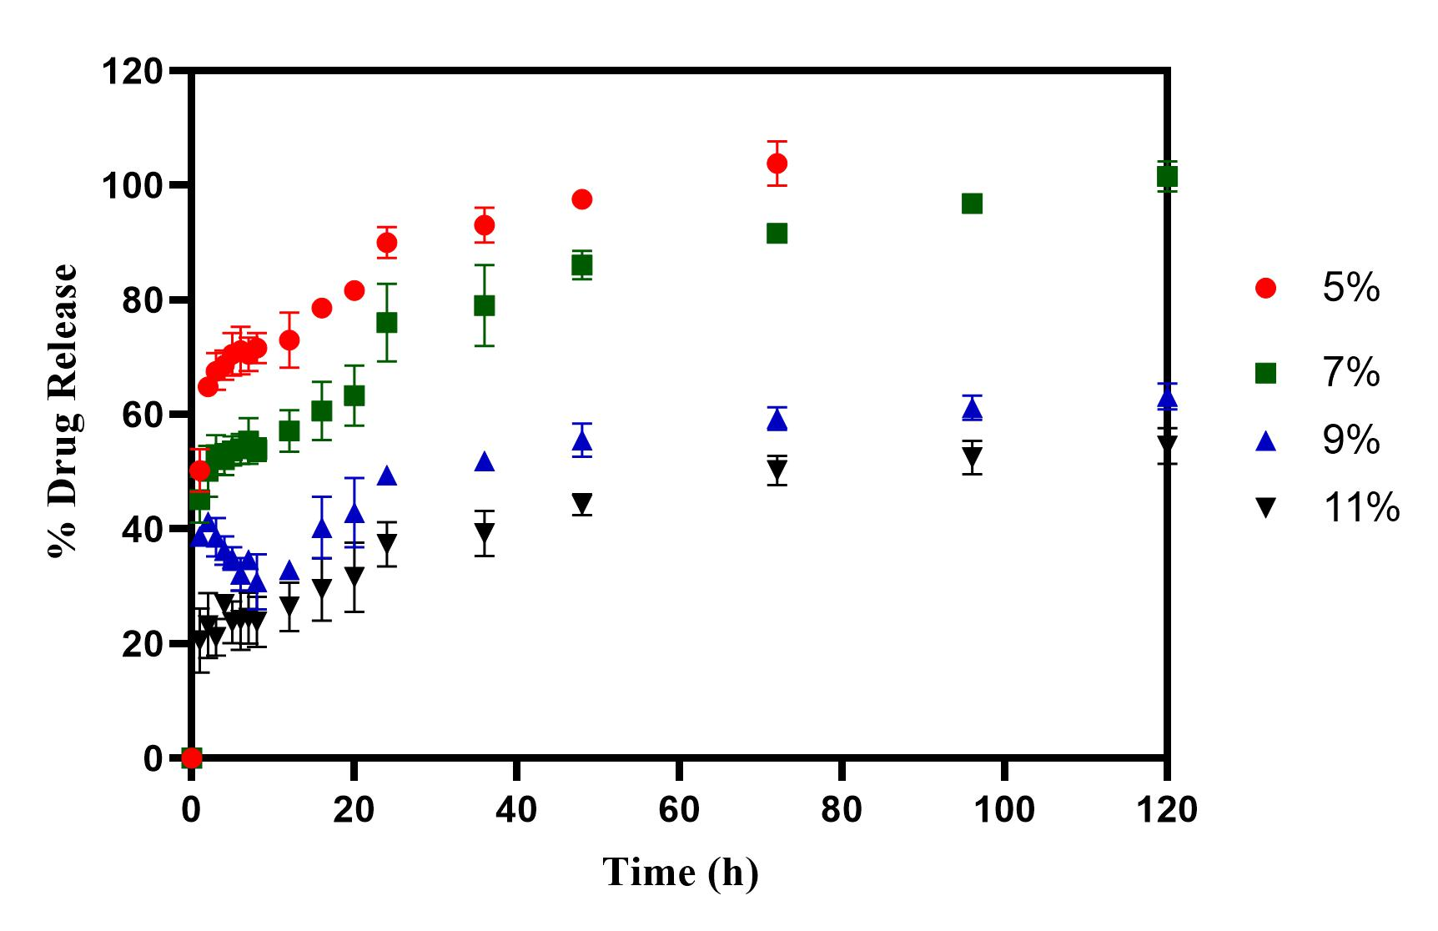
Supplementary Figure 1: Cumulative Drug Release profile of ciprofloxacin hydrochloride from ciprofloxacin hydrochloride loaded hydrogels at pH 5.8
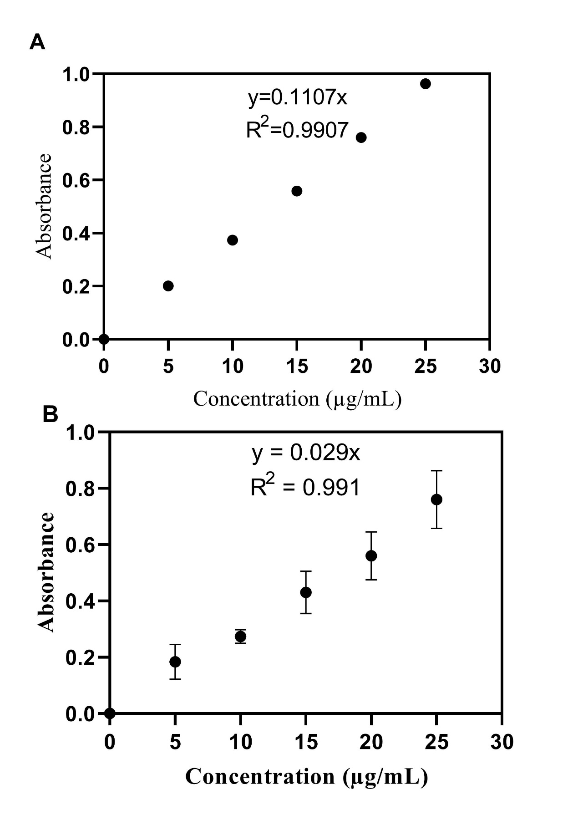

Supplementary Figure 2: Standard Calibration of A) Ciprofloxacin Hcl
B) 5-NPPP in phosphate buffer pH 7.4 using UV-Visible Spectroscopy

Supplementary Table 1: In-vitro drug release kinetics of hydrogels and nanoparticles
Kinetics Model | Parameters | Ciprofloxacin 7% Hydrogel | 5-NPPP Nanoparticles 7% hydrogels | 1:1 ratio 5-NPPP nanoparticles
Zero order | K₀ | 1.157 | 1.113 | 2.915
 | R² | 0.3712 | 0.4839 | 0.4074
 | SS | 16497.6983 | 15788.8500 | 7656.1141
First order | K₁ | 0.061 | 0.057 | 0.089
 | R² | 0.8070 | 0.7328 | 0.9826
 | SS | 2313.3364 | 2843.4176 | 221.7613
Higuchi | K_{H} | 11.102 | 10.718 | 16.257
 | R² | 0.7732 | 0.7405 | 0.9577
 | SS | 2718.6407 | 2760.7587 | 537.8492
Korsemeyer-Peppas | K_{KP} | 23.872 | 23.926 | 19.441
 | R² | 0.9941 | 0.9960 | 0.9684
 | n | 0.303 | 0.293 | 0.441
 | SS | 70.6484 | 42.4220 | 402.6827
Hixson-Crowell | K_{HC} | 0.013 | 0.012 | 0.025
 | R² | 0.6545 | 0.5754 | 0.9504
 | SS | 4140.9272 | 4517.5689 | 630.5531
Hopfenberg | K_{HB} | 0.0001 | 0.0001 | 0.0001
 | R² | 0.8070 | 0.7327 | 0.9826
 | SS | 2313.8863 | 2844.1062 | 221.8595
Baker-Lonsdale | K_{BL} | 0.004 | 0.004 | 0.007
 | R² | 0.9682 | 0.9487 | 0.9702
 | SS | 380.7404 | 546.2778 | 379.1157
Makoid-Banakar | K_{MB} | 22.143 | 23.211 | 14.106
 | R² | 0.9967 | 0.9965 | 0.9911
 | SS | 39.6956 | 37.5513 | 113.6269
Weibull | R² | 0.9890 | 0.9868 | 0.9943
 | SS | 131.9703 | 139.9933 | 72.1845
Gompertz | R² | 0.9487 | 0.9436 | 0.9745
 | SS | 615.4648 | 599.6645 | 324.5155

Supplementary Table 2: In-vivo behavioral patterns, dermal signs, feed intake and mortality rate of mice from acute dermal toxicity studies – 5-NPPP loaded hydrogels

Animal Number | Gender | Abnormal Signs (Skin and fur, eyes, mucous membrane, behavioral patterns, internal organs after necropsy) | Feed Intake for 14 days | Weekly body weight (gm)  n=5 |  |  | Mortality rate* (%)
 |  |  |  | Day 0 | Day 7 | Day 14
1 | Female | No change | Good | 29.79 | 30.14 | 30.98 | 0
2 | Female | No change | Good | 30.14 | 32.31 | 33.33 | 0
3 | Female | No change | Good | 25.02 | 25.36 | 26.1 | 0
4 | Female | No change | Good | 24.5 | 26.09 | 27.08 | 0
5 | Female | No change | Good | 27 | 27.54 | 28 | 0

*Mortality rate is the number of dead mice divided by total number of mice

Supplementary Table 3: In-vivo behavioral patterns, dermal signs, feed intake and mortality rate of mice from acute dermal toxicity studies – 5-NPPP nanoparticle and CIP loaded hydrogels

Animal Number | Gender | Abnormal Signs (Skin and fur, eyes, mucous membrane, behavioral patterns, internal organs after necropsy) | Feed Intake for 14 days | Weekly body weight (gm)  n=5 |  |  | Mortality rate* (%)
 |  |  |  | Day 0 | Day 7 | Day 14
1 | Female | No change | Good | 25.61 | 26.61 | 28.42 | 0
2 | Female | No change | Good | 25.82 | 27.42 | 28.56 | 0
3 | Female | No change | Good | 27.24 | 28.36 | 30.12 | 0
4 | Female | No change | Good | 29.3 | 31.26 | 32.42 | 0
5 | Female | No change | Good | 28.5 | 29.2 | 29.5 | 0

*Mortality rate is the number of dead mice divided by total number of mice

