Supplementary Material: Smallholder Farmer Resilience to Extreme Weather Events in Global Food Value Chains

SM1: Proportion of farmers utilising different strategies to enhance their resilience to a flooding event. Flooded farmers (green) and non-flooded farmers (blue) are segregated, with significant differences (Chi-squared test) shown (p<0.01= **)
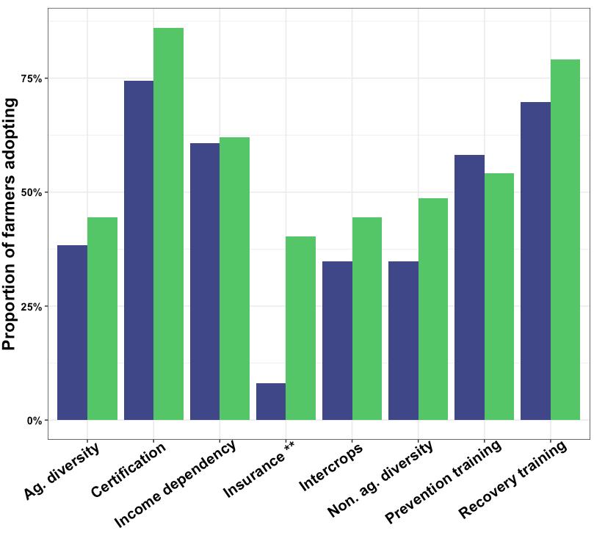
Flooded farmers
Non-Flooded farmers

SM2: a) Fraction of flooded farmers experiencing different types of damage (infrastructure is proportion of farmers reporting incident, production is mean proportion of land of production destroyed. b) Extent of flood waters on banana farm in Valverde province 2017. c) Damage to banana plants after flood water receded
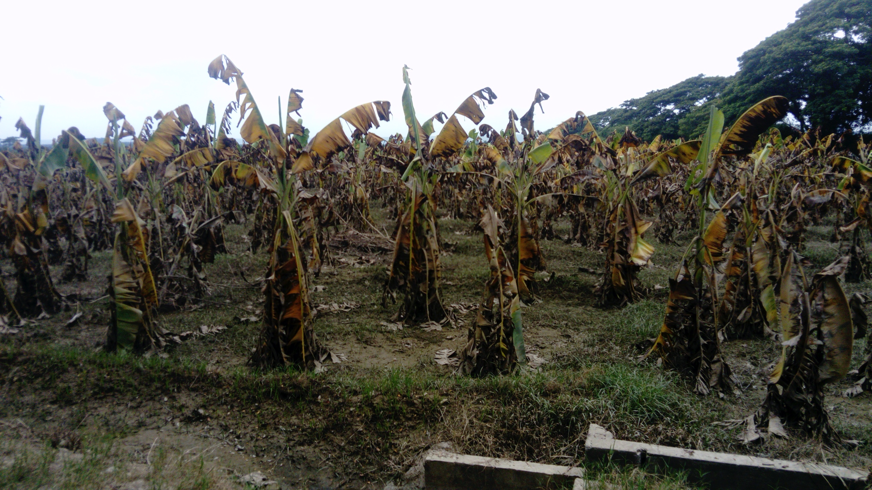
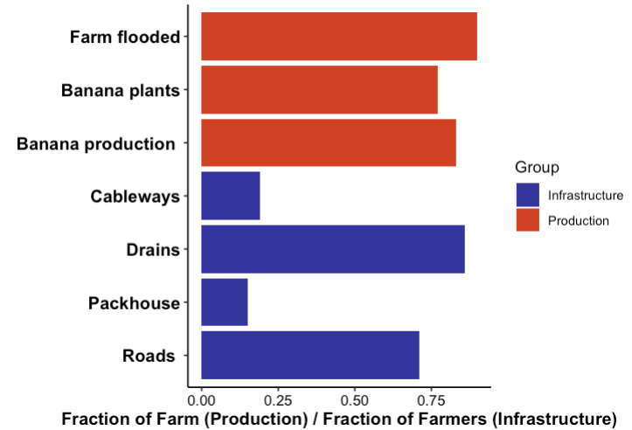
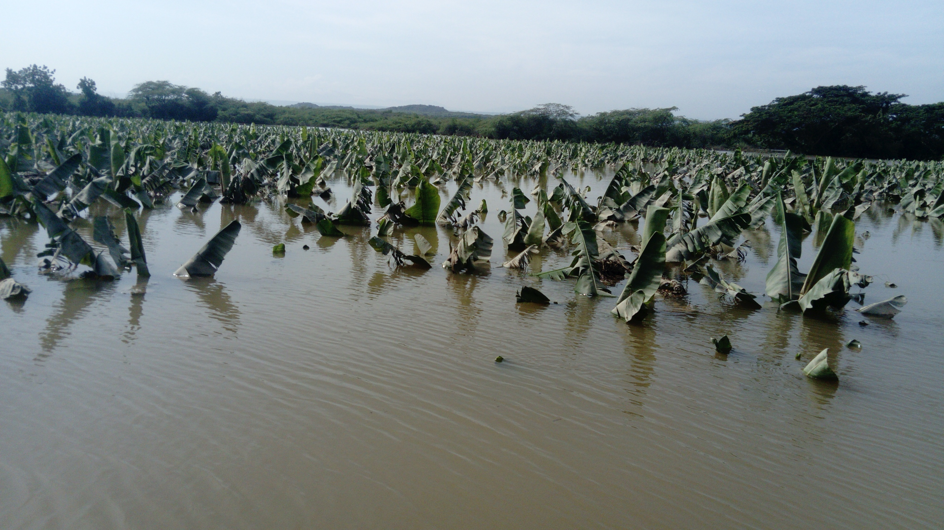
a) Damage
b) Flood waters in 2017
c) Damage to banana plants

SM3: Agricultural recovery process for smallholder banana farmers after flooding

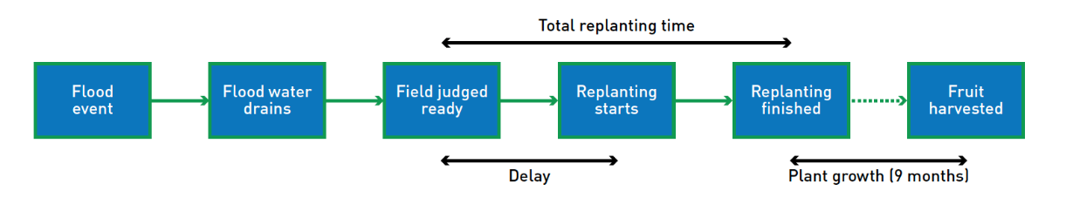
SM4: Variables hypothesised to determine farmers recovery from flooding event:

Name | Description | Expected influence on recovery time (RT) | Literature supporting variables role in climate resilience of smallholders
Gender | Female household head | Positive (i.e increased RT) | (Jost et al. 2016)
Age | Age of household head | Negative | (Tazeze, Haji, and Ketema 2012)
Education | Number of years education | Negative | (Menike and Arachchi 2016)
Banana income dependency | Proportion of income form bananas | Positive
Non-agricultural income streams | Number of non-agricultural income sources | Negative | (Bellon et al. 2020)
Diversity of all income streams | Number of different income sources (ag./non-ag.) | Negative | (Antwi-Agyei, Stringer, and Dougill 2014)
Farmer owned | Household owns the farm | Negative | (Antwi-Agyei, Dougill, and Stringer 2015)
Banana farm size | Area of banana farms in hectares | Negative | (Harvey et al. 2014)
Distance from river | Distance from the river in metres | Negative | (Philpott et al. 2008)
Intercrops | Number of different crops integrated in banana production | Negative | (Lasco, Delfino, and Espaldon 2014)
Farm diversity | Diversity of crops produced on the farm | Negative | (Lin 2011)
Flooded area | Size of area flooded in September 2017 | Positive
Area replanted | Area of banana farm that was replanted after flooding | Positive
Agricultural network size | Number of other farmers that the farmer discusses banana production strategy with every month | Negative | (Saint Ville et al. 2016)
Flood training | Farmer has received specific training on flood damage prevention | Negative | (Nor Diana et al. 2019)
Recovery training | Farmer has received specific training on replanting the farm after flooding | Negative | (Stewart et al. 2015)
Agricultural group memberships | No. of agricultural groups the farmer is engaged in | Negative | (Kangogo, Dentoni, and Bijman 2020)
Certification | Farm is certified under Organic, RA or FT | Negative
Financial sources | Number of financial sources the farmer has access to e.g. bank loans, credit groups | Negative | (Li et al. 2020)
Savings | Does the farmer have savings | Negative | (Oostendorp et al. 2019)
Insurance | Does the farmer have flood insurance | Negative | (Collier, Skees, and Barnett 2009)
Drainage time | Days after initial flood water drained from farm | Positive

SM5: Characteristics of sampled banana farmers Means are presented with standard deviation in brackets for continuous and count variables. Differences are assessed using t-tests for continuous variables and Chi-squared for binary and count). Farmers were categorised based on whether they were flooded as a result of the 2017 hurricanes.

Characteristic | Total sample, n = 158 | Non-flooded, n = 78 |  | Flooded in 2017 n = 80 |  | P value
Female | 11% |  | 8.10% |  | 15% |  | 0.248
Age | 50 (13) |  | 50 (14) |  | 51 (12) |  | 0.286
Number of farms | 1 (1) |  | 1 (1) |  | 1 (1) |  | 0.072
Farm size (ha) | 5.2 (4.8) |  | 5.1 (5.2) |  | 5.2 (4.3) |  | 0.176
Organic | 78% |  | 74% |  | 83% |  | 0.245
Fairtrade | 95% |  | 94% |  | 96% |  | 0.915
RA | 47% |  | 48% |  | 46% |  | 0.943
Intercrops | 1 (1) |  | 1 (1) |  | 1 (1) |  | 0.822
Crop types | 2 (2) |  | 2 (1) |  | 2 (2) |  | 0.725
Non ag. income diversity | 0 (1) |  | 0 (1) |  | 0 (1) |  | 0.600
Distance to river (m) | 1698 (2263) |  | 2232 (2570) |  | 1164 (1772) |  | 0.007
Banana income proportion | 0.61 (0.31) |  | 0.61 (0.31) |  | 0.62 (0.32) |  | 0.821

SM6: Standardized regression coefficients of the four determinants of the dependent variable recovery time (Significance: p<0.01 ’**’, P<0.05 ‘*’) The model has an adjusted R squared value of 0.241, showing it explains 24% of the variation in recovery time. Recovery time= β₀+ β₁ Scale of damage + β₂ Farm and livelihood diversity+ β₃ Flood training+ β₄ Drainage+ ε

Variables | Standardised regression coefficients | Standard Error
(Intercept) | 1.233 ** | 0.0997
Scale of damage | 0.262* | 0.0999
Farm and livelihood diversity | 0.240* | 0.0998
Flood training | -0.256* | 0.0998
Drainage | 0.298** | 0.1000
Multiple R-squared: 0.2807, Adjusted R-squared: 0.241
F-statistic: 7.026 on 4 and 72 DF. P <0.0001

SM7: Correlation matrix of the explanatory and dependant variables. Only significant correlations (p<0.05) are displayed. Circle size and colour intensity are proportional to the correlation coefficients (Pearson's) Blue circles indicate positive correlation and red circles indicate negative correlation. Recovery time (dependent variable) and its sub-components are on the right-hand side of the matrix.

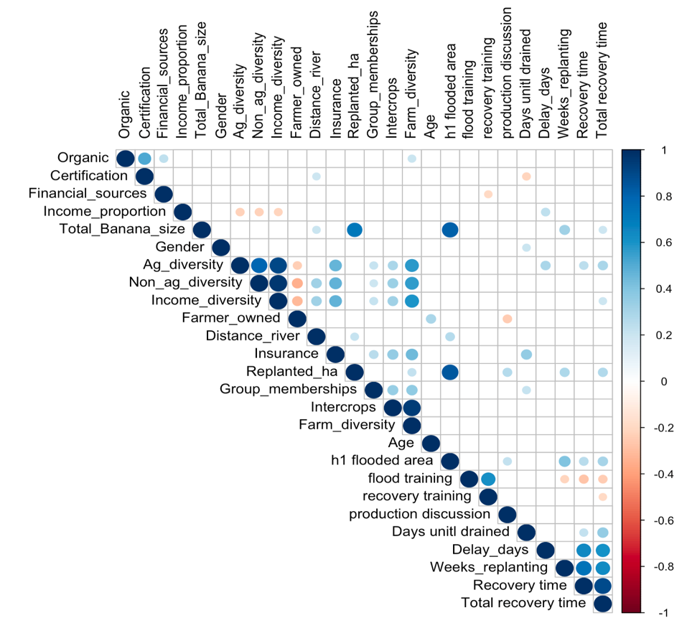

SM8: Factor loadings after rotation. Loadings greater than 0.3 are considered in the interpretation of the factors and highlighted in bold.
 | Scale of damage |  | Farm and livelihood diversity | Flood Training | Drainage
Flooded area |  | 0.94 | 0.01 | -0.01 | 0.10
Replanted area |  | 0.87 | 0.13 | -0.01 | -0.05
Total banana farm size |  | 0.91 | -0.05 | -0.03 | 0.11
Agricultural crop diversity |  | 0.05 | 0.93 | 0.09 | 0.04
Non. ag. income diversity |  | 0.02 | 0.92 | -0.05 | -0.03
Flood training |  | -0.08 | -0.02 | 0.90 | -0.10
Recovery training |  | 0.04 | 0.05 | 0.88 | 0.18
Drainage time |  | 0.14 | 0.19 | 0.01 | 0.82
Banana income dependency |  | -0.03 | -0.40 | 0.08 | 0.57
Eigen values | 2.49 |  | 1.93 | 1.60 | 1.07

SM9 Banana plantation areas in 2019 that overlap with locations that saw storm-related damage due to hurricanes Irma and Maria in 2017. The highlighted regions (red) are considered at high risk should similar extreme weather events reoccur.

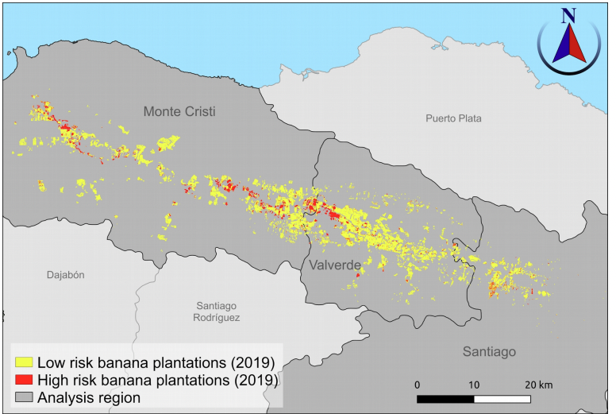

SM10 Study site and sample

The DR is the Caribbean’s largest banana exporter⁵⁰ and the world’s largest organic banana exporter⁵¹. In addition, the DR faces several severe climate threats, including reoccurring droughts and tropical cyclones that cause significant damage through: heavy rainfall, flooding, strong winds, as well as sea surges⁵².

Export banana production in the DR is concentrated in the North West Line regions of Valverde and Monte Cristi (Suppl. Mat. 5). The provinces are dominated by the drainage basin of the Yaque del Norte River which runs through the Cibao valley. The river’s flood plains are a key agricultural area for the DR. The river provides water for irrigation for key export crops, including rice and banana. The drainage basin has suffered from severe deforestation over the past decades³⁵. This has affected the hydrological regime, further exacerbating the scale of floods at time of heavy rain and reducing water availability during times of drought⁵³.

Sampling
In the Yaque del Norte drainage basin we sampled the farmers from four farmer cooperatives that supply two major exporters in the region, making up 28% of DR banana exports⁵⁴. To understand the impact of the shock, we preferentially sampled farmers with farms in proximity to rivers. We did this using GPS data shared by farmer cooperatives. Using a zone generated from a rivers layer on GIS software, we included farms within 1.5 km of a waterway to make up 60% of the sample⁵⁵. Using the lists generated from this analysis of farmer cooperative data, we randomly sampled farmers from the list of farmers in the buffer zone and a list of farmers whose farms are outside the buffer zone (40%).

The sample consisted of 158 smallholder banana farmers engaged in the international export value chain (Suppl. Mat. 6). According to their responses, farmers were subsequently categorised based on whether they were flooded or not flooded as a result of the 2017 hurricanes.

SM11 Exploratory factor analysis
Using these variables, we conducted an exploratory factor analysis, following Field⁵⁶. First, to test issues with multiple collinearity in the explanatory variables, we conducted a correlation analysis using Pearson’s correlation coefficient on the 80 flooded households. Variables related to recovery time (and its subcomponents delay and replanting time) were selected based on significant correlation coefficients. Bartlett’s test of sphericity was conducted to determine whether factor analysis was suitable with regards to the relatedness of the variables (see in Field⁵⁶). The Kaiser-Meyer Olkin (KMO) approach was used to determine sampling adequacy, based on common variance. Variables not meeting this criterion were discarded. Following this, an initial un-rotated principal component analysis (PCA) was conducted with these variables. The Kaiser criterion (> 1) was used to determine the number of factors to extract based on the eigenvalues of the unrotated components⁵⁷. These components were thus extracted and their axis rotated using VARIMAX technique. We then used multiple linear regression to assess the influence of these factors on recovery time. The analysis was carried out using the psych package with R statistical software⁵⁸.

For the exploratory factor analysis, the correlation analysis revealed nine potential explanatory variables significantly correlated with recovery time (including subcomponents replanting time and delay time) from the 22 tested (Suppl. Mat. 7). Income diversity was replaced by non-agricultural diversity (income diversity – ag. diversity) as its correlation with ag. diversity was above 0.9. These nine variables met the KMO measure of sampling adequacy to be included in the factor analysis (>=0.5, SM2). The overall KMO with these nine variables was 0.58. A Bartlett’s test of sphericity on these variables (Chi squared = 329.97, p<0.01) indicated that there was sufficient correlation between the variables to conduct a factor analysis. The initial PCA generated four components with eigenvalues greater than one. Therefore, four components, explaining 79% of the variation, were extracted and rotated (Suppl. Mat. 8).

SM12 Multiple linear regression
These four components were explored as drivers of recovery time with multiple linear regression using the factor scores of the four derived components. The following model was therefore formulated using the PCA components:
$$Recoverytime=β_{0}+β_{1}Scaleofdamage+β_{2}Farm∧livelihooddiversity+β_{3}Floodtraining+β_{4}Drainage+ε$$

SM13 Mapping banana production area and impact of hurricanes

In brief, banana plantations for 2019 were mapped at a resolution of 10 m x 10 m by building a random forest classifier using a fusion of Synthetic Aperture Radar (SAR) data from the European Space Agency (ESA) Sentinel-1 satellite platform, multi-spectral data from ESA’s Sentinel-2 platform, and terrain information from the 90m resolution Shuttle Radar Telemetry Mission (SRTM) Digital Elevation Model (DEM). Specifically, classification was run on a stack of rasters comprising the median VV polarisation backscatter for 2019 (i.e. January 2019 to December 2019), the standard deviation in VV backscatter for the same time period, the median red, green, blue and NDVI values for 2019, and slope derived from the DEM. The random forest classifier was trained using ground truth data from 100 banana plantation polygons, and a set of other land-cover classes that were manually digitised using imagery available from Google Earth. The classifier was used to produce a map of banana plantation area for 2019 (representing the post-hurricane recovered production area). Using a confusion matrix⁶⁰ and a random sample of 500 test pixels generated from the banana plantation ground truth data, accuracy of classified banana plantations was estimated at 99.8%. The trained classifier was then used to produce a map for pre-hurricane banana plantations using one year’s worth of Sentinel-1 and Sentinel-2 data immediately preceding hurricane Irma (i.e. from September 2016 to August 2017).
The area affected by the hurricanes was mapped using ESA’s Sentinel-1 data. Affected areas consisted of the spatial union of three components. First, the immediate impact of the hurricanes was identified as pixels with large reductions in VV polarisation backscatter immediately after the hurricane events, as reduced backscatter can be used as a signal for flooded pixels⁶¹. The second component comprised a 100 meter buffer around the pixels identified in the first component. This accounted for areas that are likely to have experienced open water flooding (or at the very least, inundated soils) but which may have been obscured by vegetation features (e.g. banana plants, large trees, etc.). The third component, a legacy effect, was identified as pixels which during the three months after the hurricane events showed large negative deviations in average VV polarisation backscatter values relative to the distribution of values observed for the year preceding the hurricanes. This third component accounts for more protracted impacts of the hurricane, for example, banana plantation pixels that do not see immediate loss of plants after the hurricane. Spatially overlaying the pre-hurricane banana plantation area map (for 2017), the post-hurricane plantation map (for 2019) and the map of areas affected by hurricanes in the region, we identified (1) the location and spatial extent of banana plantation area in 2017 affected by the hurricane events, (2) the turnover in plantation area between 2017 and 2019, and (3) plantations area in 2019 that would be at risk if a similar extreme weather event were to occur again. A detailed description of the remote sensing methods can be found in Varma et al.⁵⁹.

SM14 Quantifying recovery of banana plantations

The rationale for this analysis is that for non-flooded pixels, by definition, 75% of pixel values should be greater than or equal to Q1 of all non-flooded pixel values. Prior to the hurricanes 75% of subsequently flooded pixels should also show values greater than or equal to Q1 of non-flooded pixels (i.e. Q1 of flooded pixels ≈ Q1 of non-flooded pixels). A loss of structural complexity following the hurricanes (through direct hurricane damage, or clearing of affected plants after the hurricanes) leads to lower backscatter values in flooded pixels, which in turn results in less than 75% of pixels with values greater than or equal to Q1 of non-flooded pixels. The deviation in the fraction of flooded pixels which meet this criterion can be used as a proxy for the fraction of affected pixels that are not in a ‘productive state’. As post-hurricane recovery of production area progresses, and more affected area returns to a productive state, the fraction of flooded pixels with values greater than or equal to Q1 of non-flooded pixels will increase. This will continue until, once again, Q1 of flooded pixels ≈ Q1 of non-flooded pixels, and recovery is said to be completed. The PFI was obtained by first subsetting the sampled flooded pixels, such that only pixels whose VV backscatter values were greater than or equal to Q1 of non-flooded pixels for a minimum of eight out of the 15 image dates prior to the hurricane events were retained. This subsetting step minimised large fluctuations in backscatter values between consecutive images from having a disproportionate influence on the analysis, and is primarily observed in pixels at plantation edges. In total, 3365 flooded pixels were retained for this analysis. Then, for each date, the proportion of flooded pixels with a backscatter value greater than or equal to Q1 of non-flooded pixels for the corresponding date were calculated. Recovery time was calculated from the onset of the first hurricane event till the date when at least 75% of flooded pixels first showed a backscatter value greater than or equal to Q1 of non-flooded pixels.

A set of 6500 random sampling points were generated within each group, such that minimum spacing between points was 50m. Sentinel-1 VV polarisation backscatter values, averaged within a 50m x 50m window, were extracted at each sampling point from every Sentinel-1 image available from March 2017 to April 2018 (68 images). The spatial averaging in a 50m window was conducted to eliminate speckling artefacts that SAR data suffers from when working at fine spatial resolutions. Separately for the flooded and non-flooded pixels, we calculated the first quartile (Q1), median (Q2) and third quartile (Q3) of the VV backscatter values across the study region for every date that Sentinel-1 data were available for. These data (i.e. Q1, Q2 and Q3) were visualised as a function of date of image capture to illustrate the deviation in backscatter values in flooded pixels after the hurricane events relative to non-flooded pixels.

SM References:

Antwi-Agyei, Philip, Andrew J. Dougill, and Lindsay C. Stringer. 2015. “Impacts of Land Tenure Arrangements on the Adaptive Capacity of Marginalized Groups: The Case of Ghana’s Ejura Sekyedumase and Bongo Districts.” Land Use Policy 49 (December): 203–12. https://doi.org/10.1016/j.landusepol.2015.08.007.
Antwi-Agyei, Philip, Lindsay C. Stringer, and Andrew J. Dougill. 2014. “Livelihood Adaptations to Climate Variability: Insights from Farming Households in Ghana.” Regional Environmental Change 14 (4): 1615–26. https://doi.org/10.1007/s10113-014-0597-9.
Bellon, Mauricio R., Bekele Hundie Kotu, Carlo Azzarri, and Francesco Caracciolo. 2020. “To Diversify or Not to Diversify, That Is the Question. Pursuing Agricultural Development for Smallholder Farmers in Marginal Areas of Ghana.” World Development 125 (January): 104682. https://doi.org/10.1016/j.worlddev.2019.104682.
Collier, Benjamin, Jerry Skees, and Barry Barnett. 2009. “Weather Index Insurance and Climate Change: Opportunities and Challenges in Lower Income Countries.” Geneva Papers on Risk and Insurance: Issues and Practice 34 (3): 401–24. https://doi.org/10.1057/gpp.2009.11.
Harvey, Celia A., Zo Lalaina Rakotobe, Nalini S. Rao, Radhika Dave, Hery Razafimahatratra, Rivo Hasinandrianina Rabarijohn, Haingo Rajaofara, and James L. MacKinnon. 2014. “Extreme Vulnerability of Smallholder Farmers to Agricultural Risks and Climate Change in Madagascar.” Philosophical Transactions of the Royal Society B: Biological Sciences 369 (1639): 20130089. https://doi.org/10.1098/rstb.2013.0089.
Jost, Christine, Florence Kyazze, Jesse Naab, Sharmind Neelormi, James Kinyangi, Robert Zougmore, Pramod Aggarwal, et al. 2016. “Understanding Gender Dimensions of Agriculture and Climate Change in Smallholder Farming Communities.” Climate and Development 8 (2): 133–44. https://doi.org/10.1080/17565529.2015.1050978.
Kangogo, Daniel, Domenico Dentoni, and Jos Bijman. 2020. “Determinants of Farm Resilience to Climate Change: The Role of Farmer Entrepreneurship and Value Chain Collaborations.” Sustainability 12 (3): 868. https://doi.org/10.3390/su12030868.
Lasco, Rodel D., Rafaela Jane P. Delfino, and Marya Laya O. Espaldon. 2014. “Agroforestry Systems: Helping Smallholders Adapt to Climate Risks While Mitigating Climate Change.” Wiley Interdisciplinary Reviews: Climate Change 5 (6): 825–33. https://doi.org/10.1002/wcc.301.
Li, Wenjing, Chuanmin Shuai, Yu Shuai, Xin Cheng, Yue Liu, and Fubin Huang. 2020. “How Livelihood Assets Contribute to Sustainable Development of Smallholder Farmers.” Journal of International Development 32 (3): 408–29. https://doi.org/10.1002/jid.3461.
Lin, Brenda B. 2011. “Articles Www.” BioScience 61 (3). https://doi.org/10.1525/bio.2011.61.3.4.
Menike, L.M.C.S., and K.A.G.P. Keeragala Arachchi. 2016. “Adaptation to Climate Change by Smallholder Farmers in Rural Communities: Evidence from Sri Lanka.” Procedia Food Science 6 (January): 288–92. https://doi.org/10.1016/j.profoo.2016.02.057.
Nor Diana, M. I., S. Chamburi, T. Mohd Raihan, and A. Nurul Ashikin. 2019. “Assessing Local Vulnerability to Climate Change by Using Livelihood Vulnerability Index: Case Study in Pahang Region, Malaysia.” In IOP Conference Series: Materials Science and Engineering, 506:012059. Institute of Physics Publishing. https://doi.org/10.1088/1757-899X/506/1/012059.
Oostendorp, Remco, Marcel van Asseldonk, John Gathiaka, Richard Mulwa, Maren Radeny, John Recha, Cor Wattel, and Lia van Wesenbeeck. 2019. “Inclusive Agribusiness under Climate Change: A Brief Review of the Role of Finance.” Current Opinion in Environmental Sustainability. Elsevier B.V. https://doi.org/10.1016/j.cosust.2019.09.014.
Philpott, Stacy M., Brenda B. Lin, Shalene Jha, and Shannon J. Brines. 2008. “A Multi-Scale Assessment of Hurricane Impacts on Agricultural Landscapes Based on Land Use and Topographic Features.” Agriculture, Ecosystems and Environment 128 (1–2): 12–20. https://doi.org/10.1016/j.agee.2008.04.016.
Stewart, Ruth, Laurenz Langer, Natalie Rebelo Da Silva, Evans Muchiri, Hazel Zaranyika, Yvonne Erasmus, Nicola Randall, et al. 2015. “The Effects of Training, Innovation and New Technology on African Smallholder Farmers’ Economic Outcomes and Food Security: A Systematic Review.” Campbell Systematic Reviews 11 (1): 1–224. https://doi.org/10.4073/csr.2015.16.
Tazeze, Aemro, Jemma Haji, and Mengistu Ketema. 2012. “Climate Change Adaptation Strategies of Smallholder Farmers: The Case of Babilie District, East Harerghe Zone of Oromia Regional State of Ethiopia.” Journal of Economics and Sustainable Development Www.Iiste.Org ISSN. Vol. 3. Online. www.iiste.org.
Ville, Arlette S. Saint, Gordon M. Hickey, Uli Locher, and Leroy E. Phillip. 2016. “Exploring the Role of Social Capital in Influencing Knowledge Flows and Innovation in Smallholder Farming Communities in the Caribbean.” Food Security 8 (3): 535–49. https://doi.org/10.1007/s12571-016-0581-y.

