- 3-acetyl-2H-chromen-2-one (1):
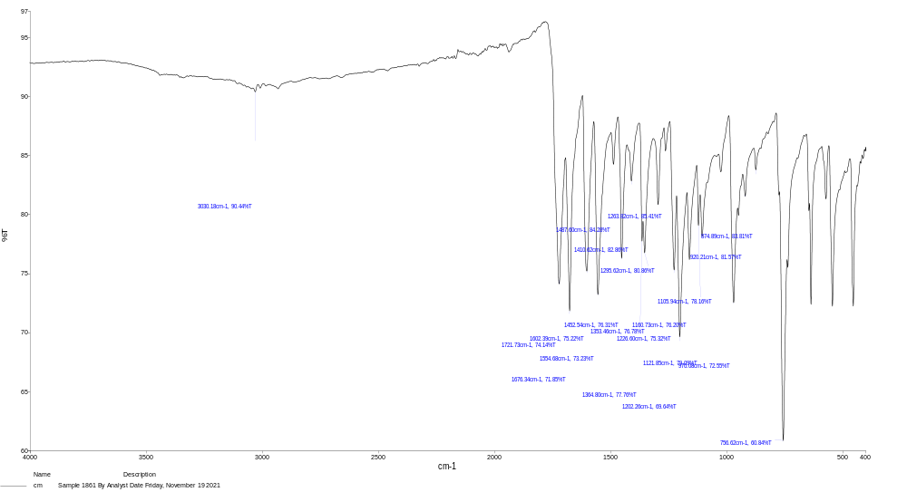

- 3-(2-bromoacetyl)-2H-chromen-2-one (2)
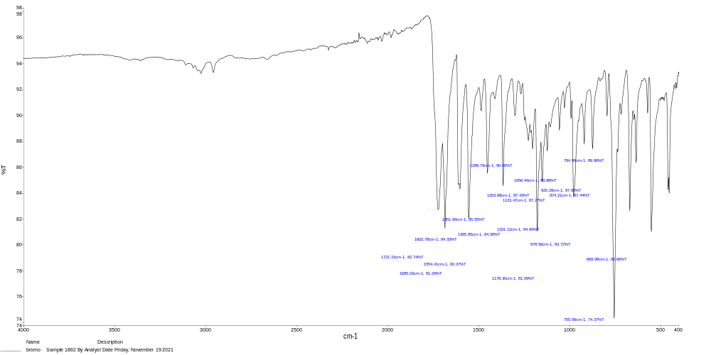

- 3-(2-aminothiazol-4-yl)-2H-chromen-2-one (3)
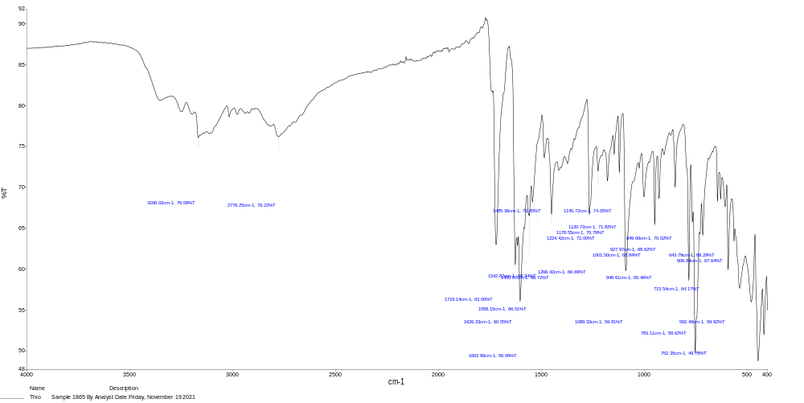

- 2-chloro-N-(4-(2-oxo-2H-chromen-3-yl)thiazol-2-yl)acetamide (4)

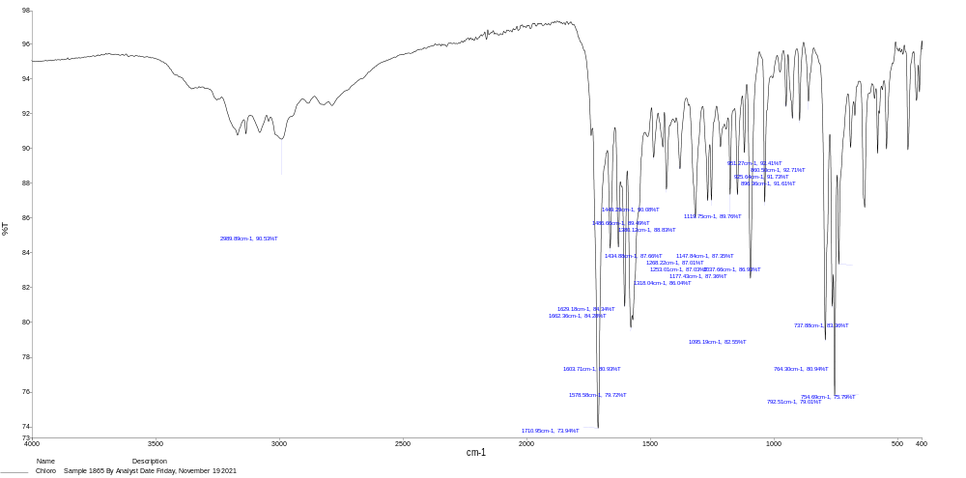

- N-(4-(2-oxo-2H-chromen-3-yl)thiazol-2-yl)-2-(phenylamino)acetamide (5)
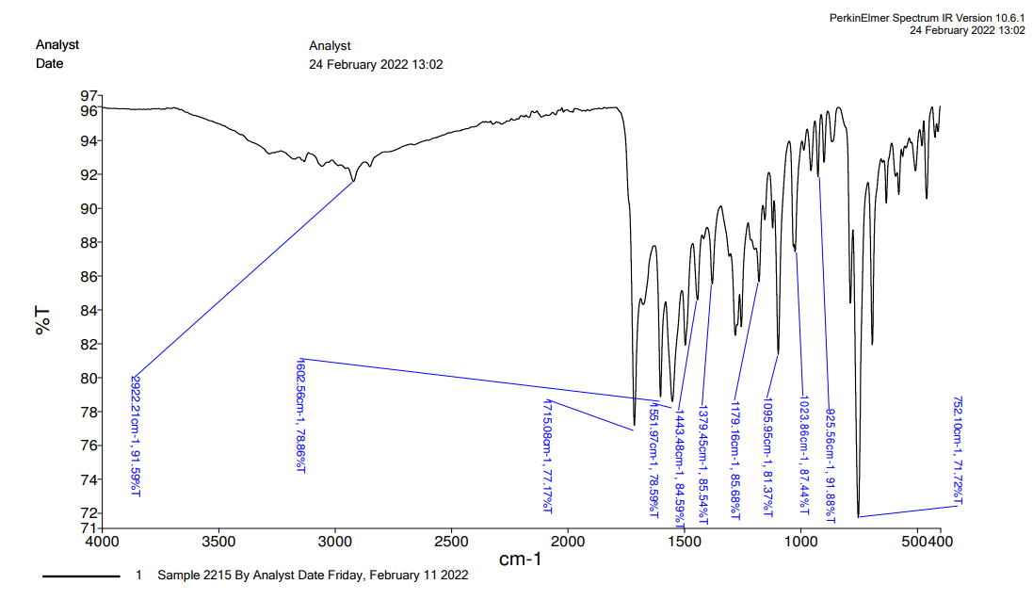

- 2-((4-chlorophenyl)amino)-N-(4-(2-oxo-2H-chromen-3-yl)thiazol-2-yl)acetamide (6)

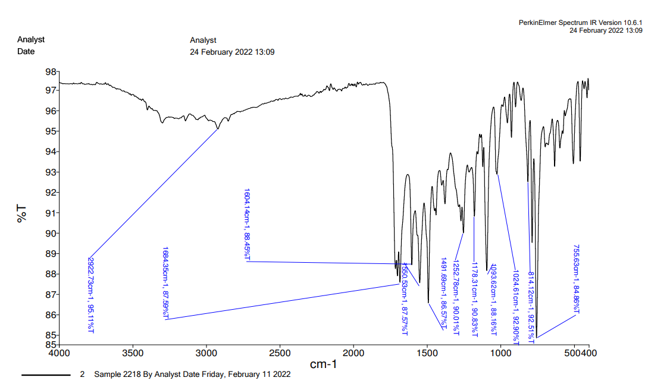

- 2-((4-fluorophenyl)amino)-N-(4-(2-oxo-2H-chromen-3-yl)thiazol-2-yl)acetamide (7)

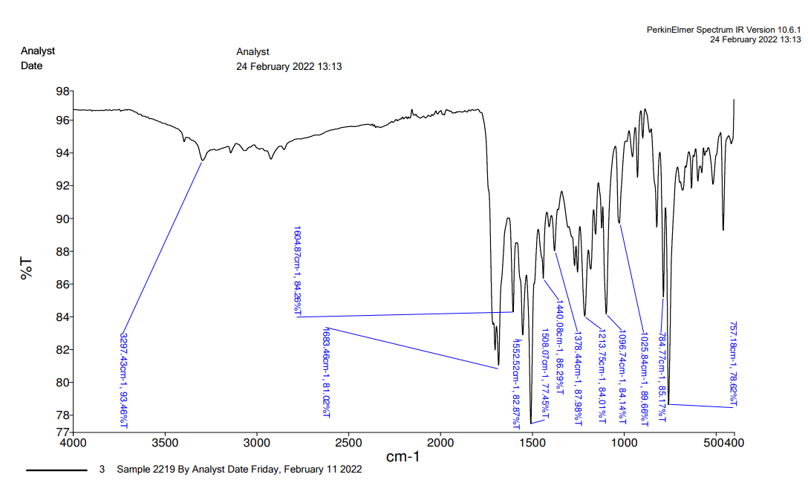

- 2-((3,4-dichlorophenyl)amino)-N-(4-(2-oxo-2H-chromen-3-yl)thiazol-2-yl)acetamide (8)
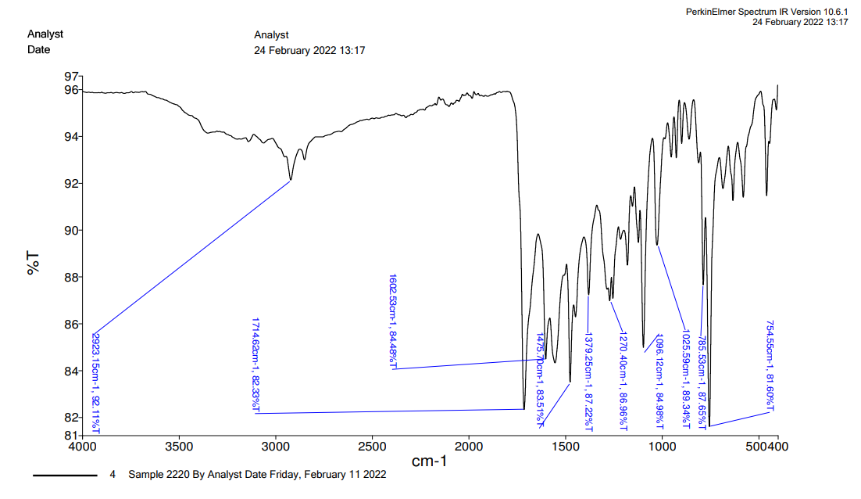

- 2-((4-methoxyphenyl)amino)-N-(4-(2-oxo-2H-chromen-3-yl)thiazol-2-yl)acetamide (9)
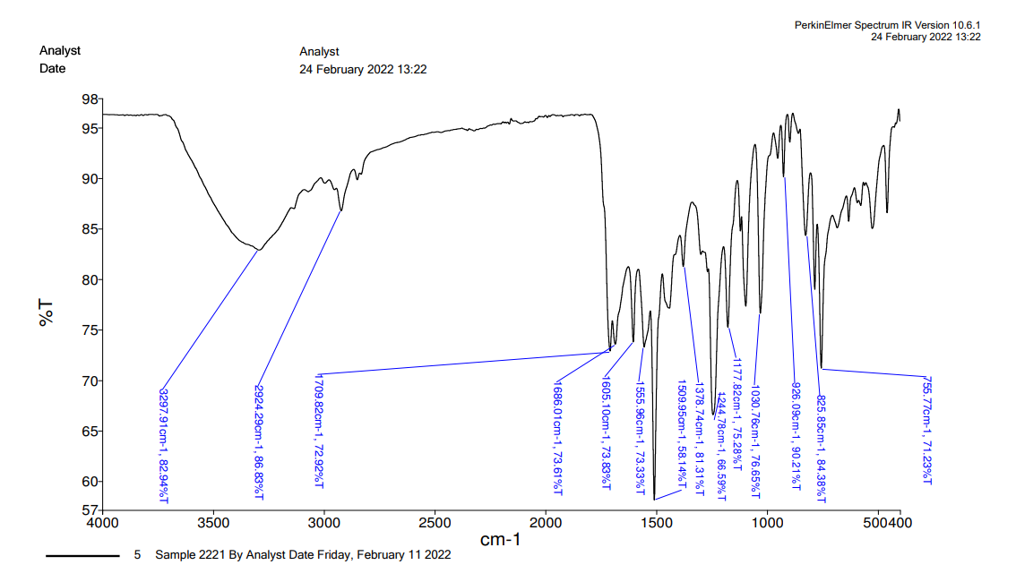

- 2-((3-methoxyphenyl)amino)-N-(4-(2-oxo-2H-chromen-3-yl)thiazol-2-yl)acetamide (10)
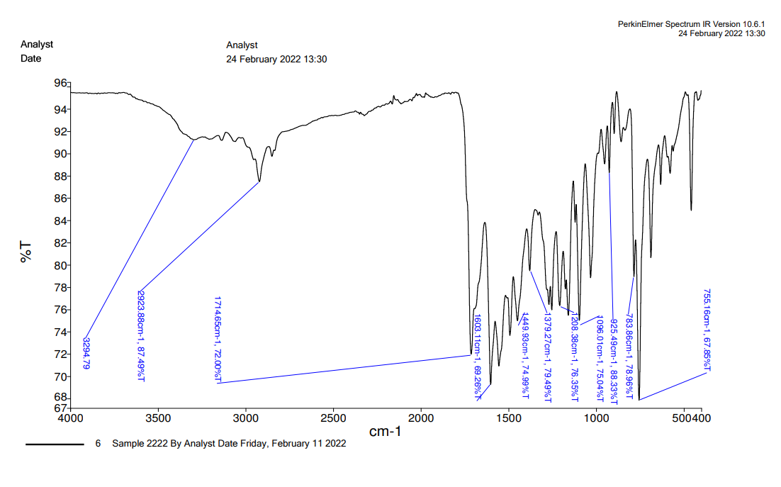

- 2-((2-chlorophenyl)amino)-N-(4-(2-oxo-2H-chromen-3-yl)thiazol-2-yl)acetamide (11)

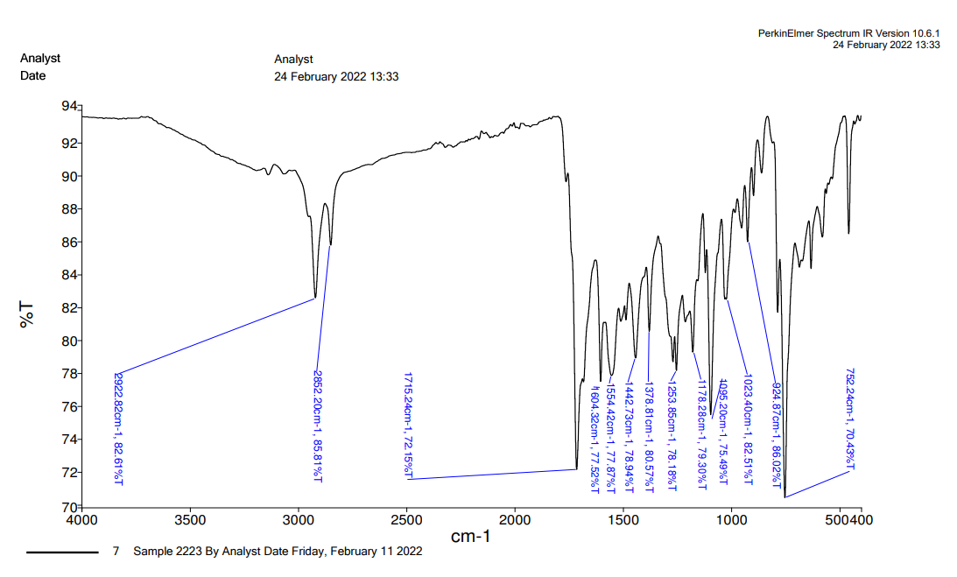

- 2-((3,5-dichlorophenyl)amino)-N-(4-(2-oxo-2H-chromen-3-yl)thiazol-2-yl)acetamide (12)
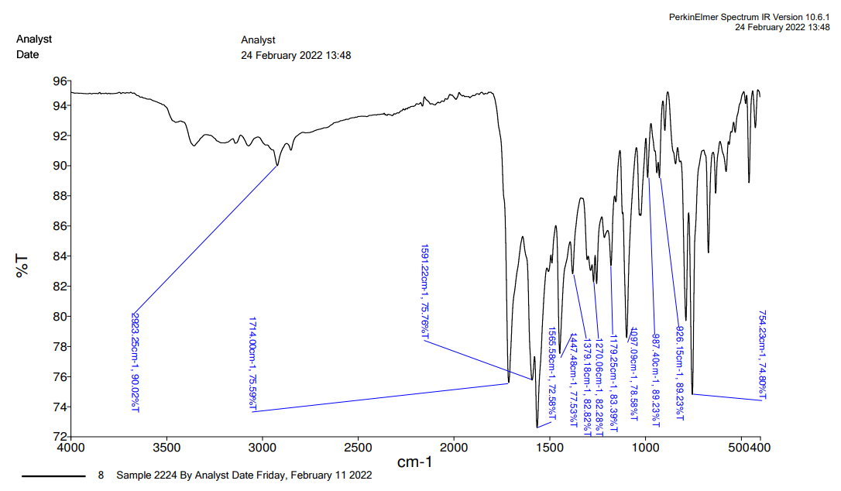

- 2-((2,4-dichlorophenyl)amino)-N-(4-(2-oxo-2H-chromen-3-yl)thiazol-2-yl)acetamide (13)
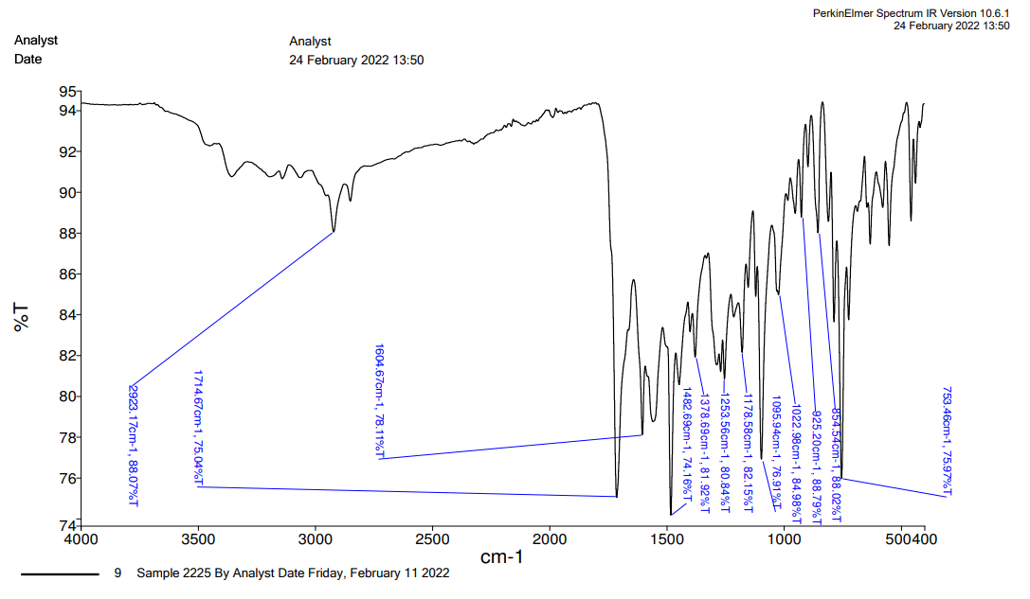

- 2-((2,5-dimethylphenyl)amino)-N-(4-(2-oxo-2H-chromen-3-yl)thiazol-2-yl)acetamide(14)

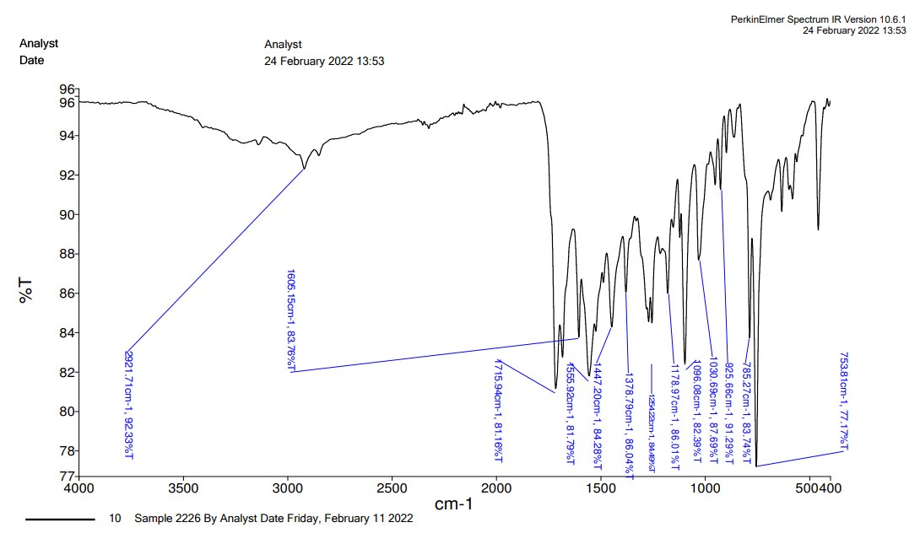

- 2-((2,4-dimethylphenyl)amino)-N-(4-(2-oxo-2H-chromen-3-yl)thiazol-2-yl)acetamide (15)
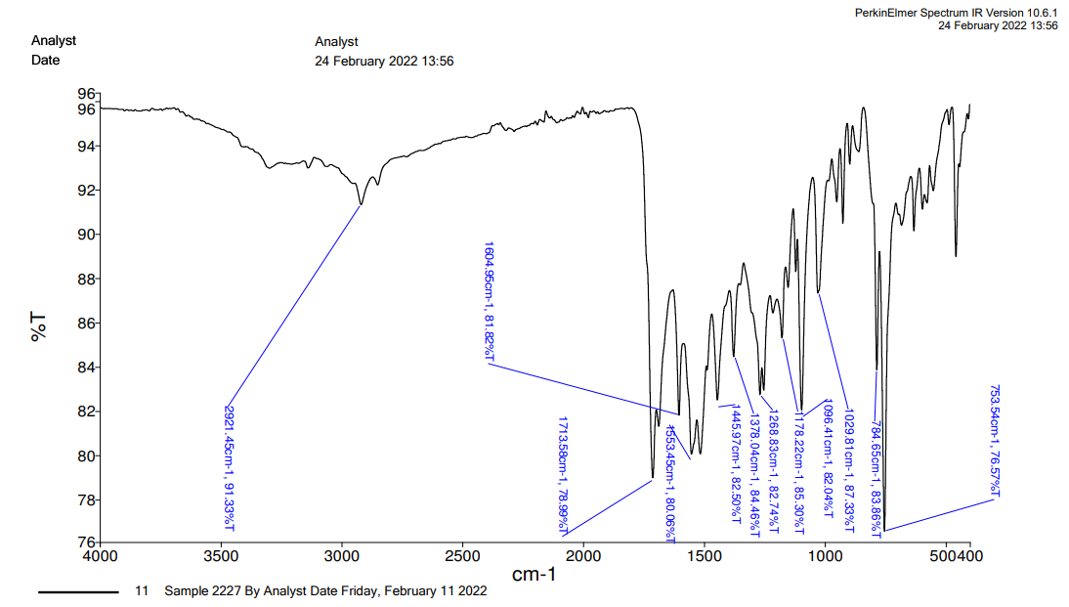

- 2-((2,3-dimethylphenyl)amino)-N-(4-(2-oxo-2H-chromen-3-yl)thiazol-2-yl)acetamide(16)
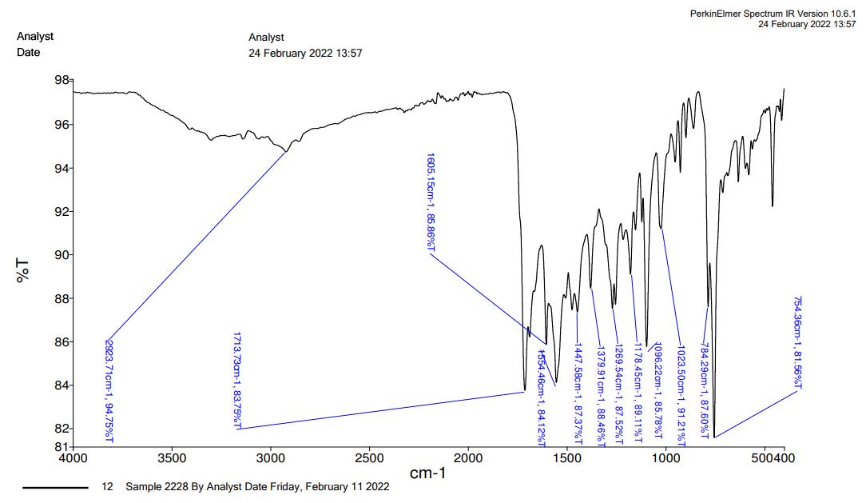

- 2-((2,4-difluorophenyl)amino)-N-(4-(2-oxo-2H-chromen-3-yl)thiazol-2-yl)acetamide (17)
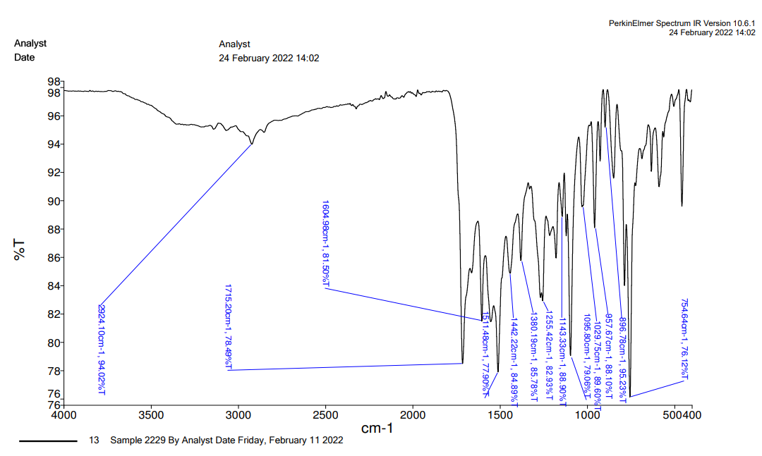

- 2-((4-bromophenyl)amino)-N-(4-(2-oxo-2H-chromen-3-yl)thiazol-2-yl)acetamide (18)
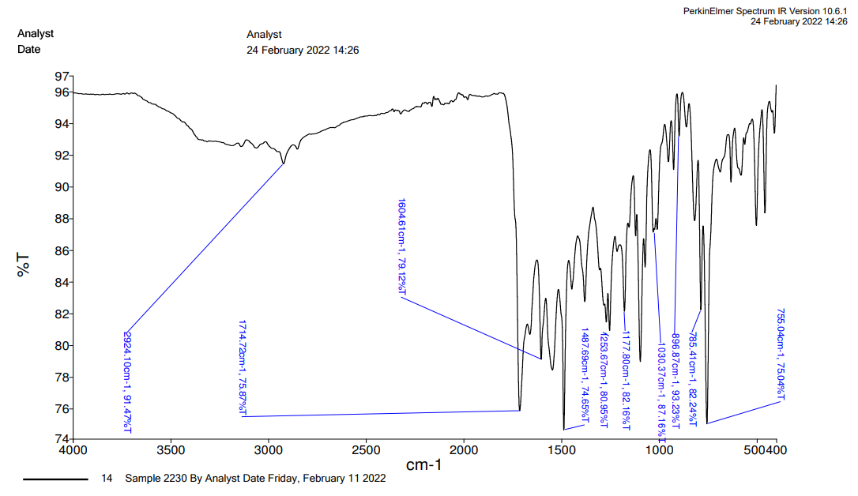

- N-(4-(2-oxo-2H-chromen-3-yl)thiazol-2-yl)-2-((3,4,5-trimethoxyphenyl)amino)acetamide (19)
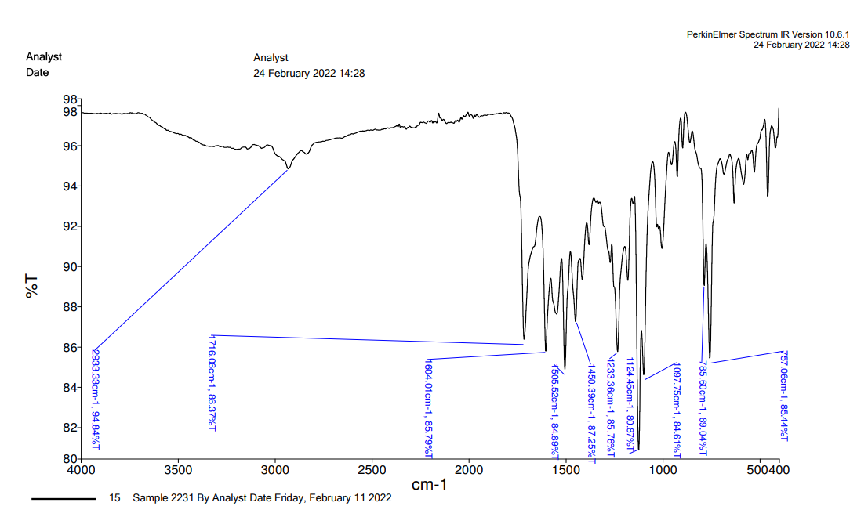

¹H-NMR
N-(4-(2-oxo-2H-chromen-3-yl)thiazol-2-yl)-2-(phenylamino)acetamide (5)
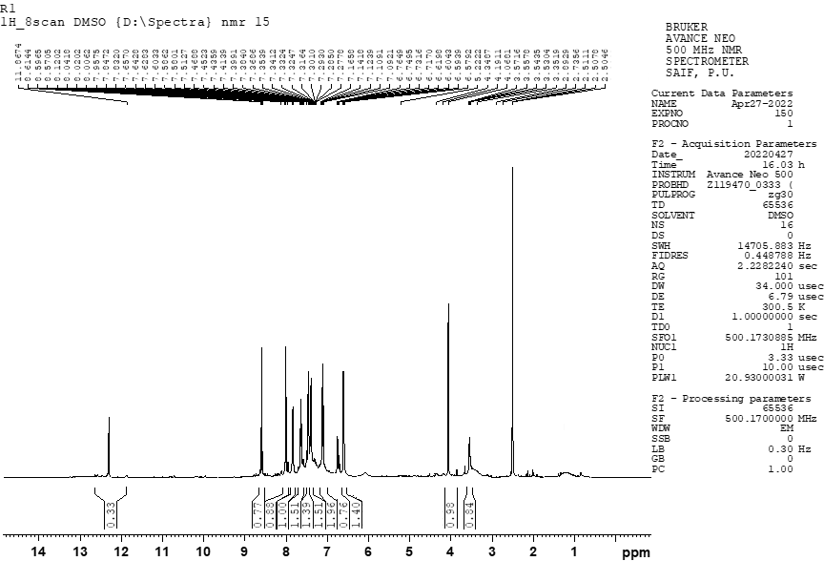
2-((4-chlorophenyl)amino)-N-(4-(2-oxo-2H-chromen-3-yl)thiazol-2-yl)acetamide (6)
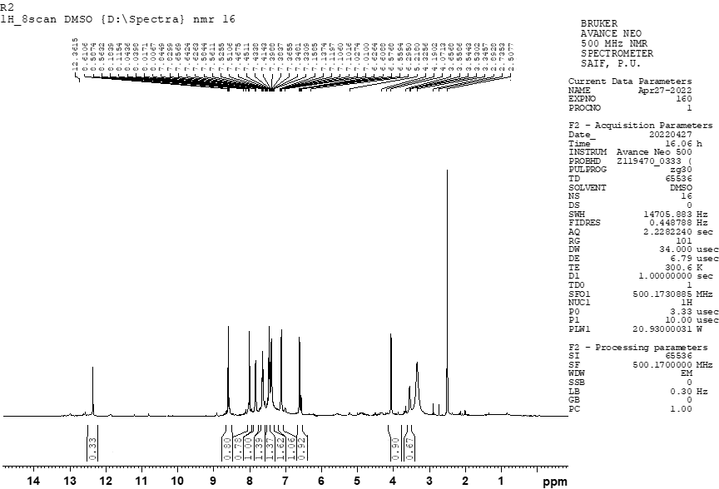
2-((4-fluorophenyl)amino)-N-(4-(2-oxo-2H-chromen-3-yl)thiazol-2-yl)acetamide (7)
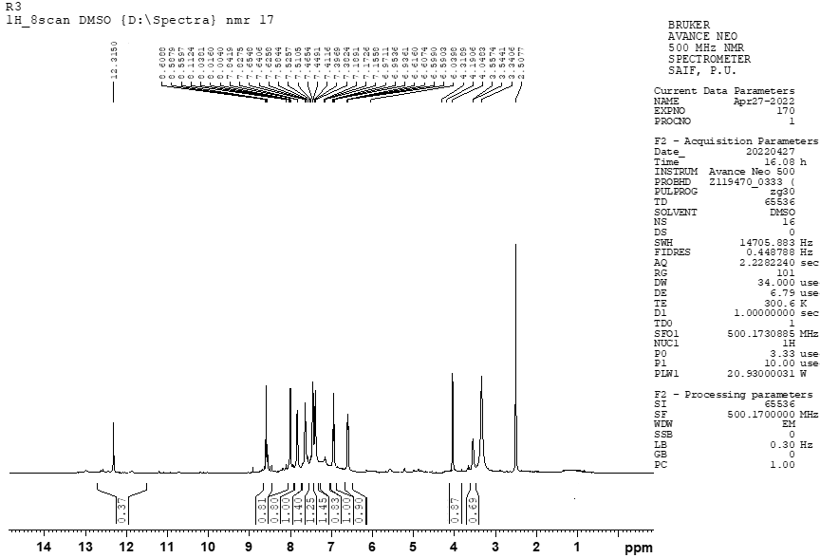
- 2-((3,4-dichlorophenyl)amino)-N-(4-(2-oxo-2H-chromen-3-yl)thiazol-2-yl)acetamide (8)
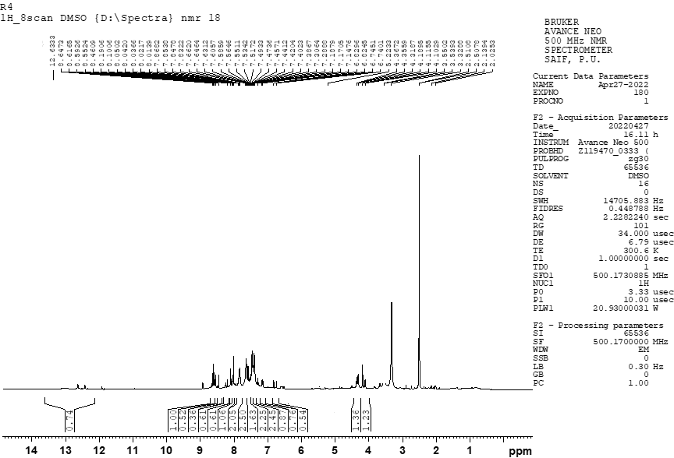
2-((4-methoxyphenyl)amino)-N-(4-(2-oxo-2H-chromen-3-yl)thiazol-2-yl)acetamide (9)
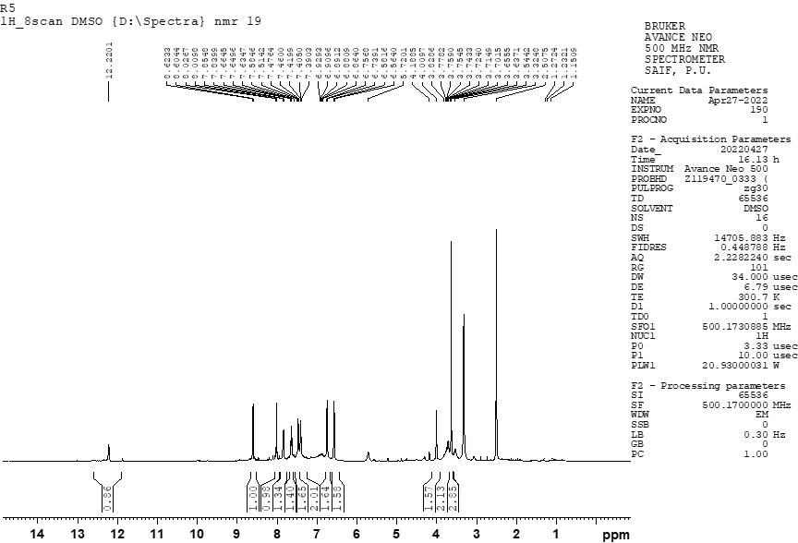2-((3-methoxyphenyl)amino)-N-(4-(2-oxo-2H-chromen-3-yl)thiazol-2-yl)acetamide (10)
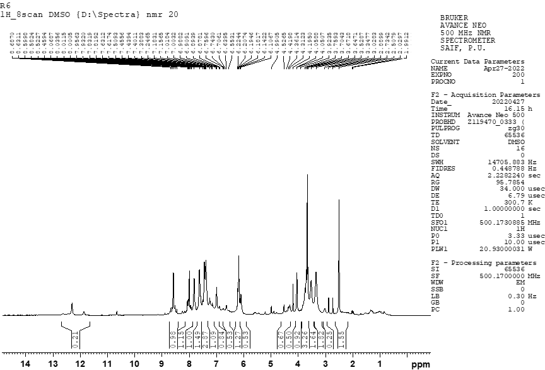

2-((2-chlorophenyl)amino)-N-(4-(2-oxo-2H-chromen-3-yl)thiazol-2-yl)acetamide (11)
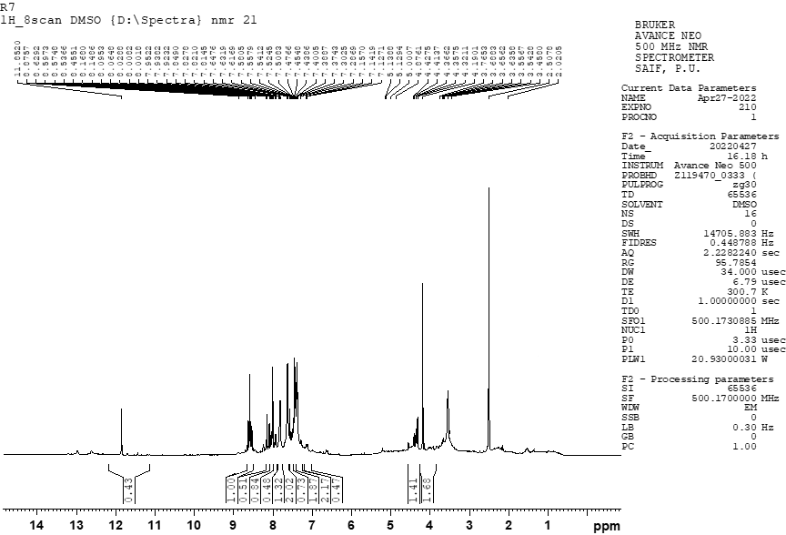
2-((3,5-dichlorophenyl)amino)-N-(4-(2-oxo-2H-chromen-3-yl)thiazol-2-yl)acetamide (12)
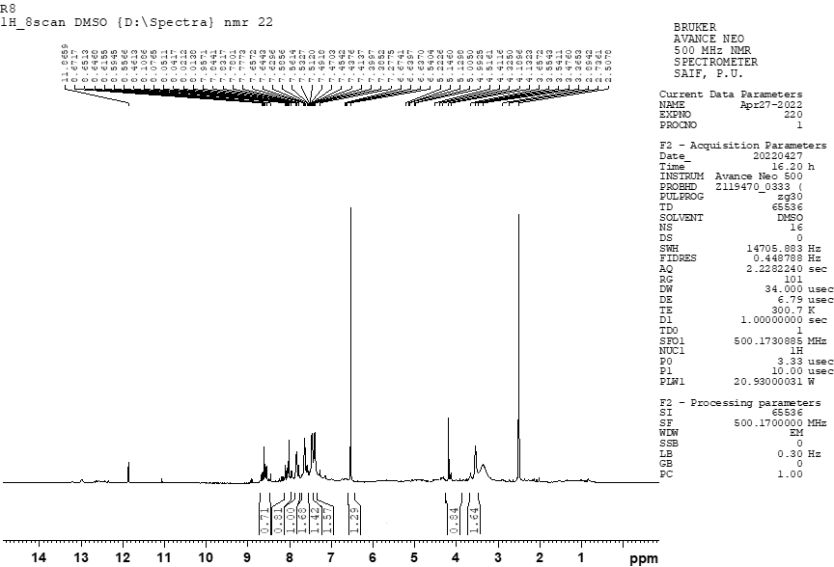

2-((2,4-dichlorophenyl)amino)-N-(4-(2-oxo-2H-chromen-3-yl)thiazol-2-yl)acetamide (13)
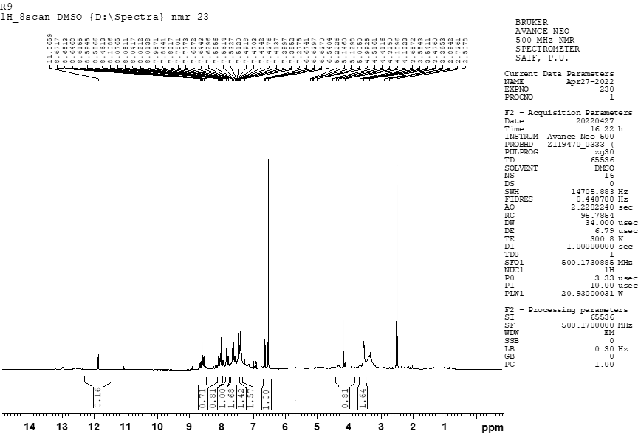
2-((2,5-dimethylphenyl)amino)-N-(4-(2-oxo-2H-chromen-3-yl)thiazol-2-yl)acetamide(14)
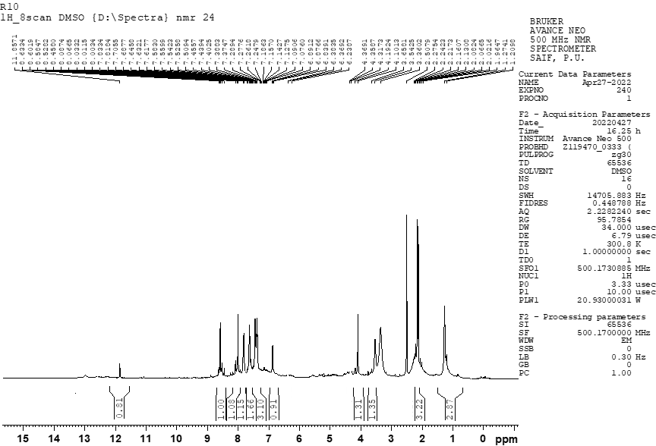
2-((2,4-dimethylphenyl)amino)-N-(4-(2-oxo-2H-chromen-3-yl)thiazol-2-yl)acetamide (15)
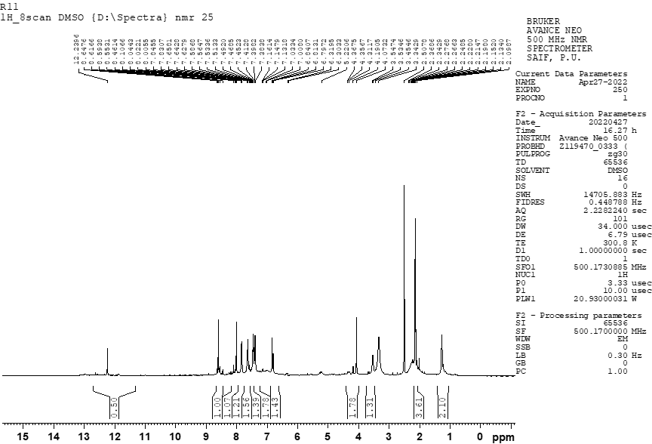
2-((2,3-dimethylphenyl)amino)-N-(4-(2-oxo-2H-chromen-3-yl)thiazol-2-yl)acetamide(16)
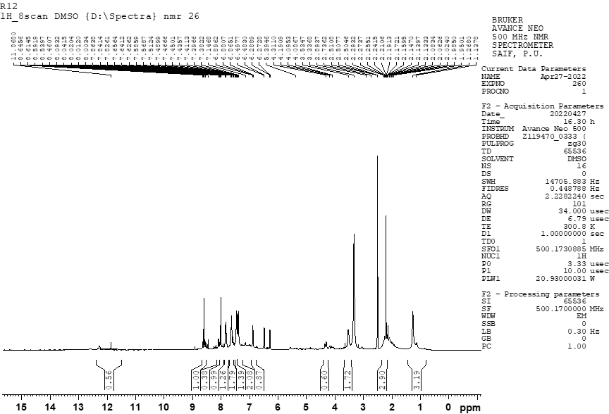
2-((2,4-difluorophenyl)amino)-N-(4-(2-oxo-2H-chromen-3-yl)thiazol-2-yl)acetamide (17)
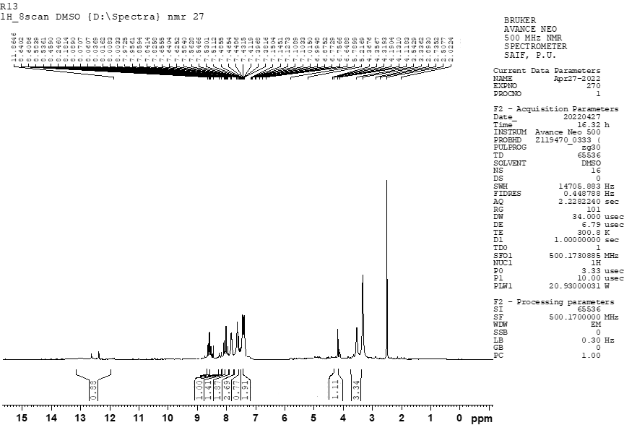
2-((4-bromophenyl)amino)-N-(4-(2-oxo-2H-chromen-3-yl)thiazol-2-yl)acetamide (18)
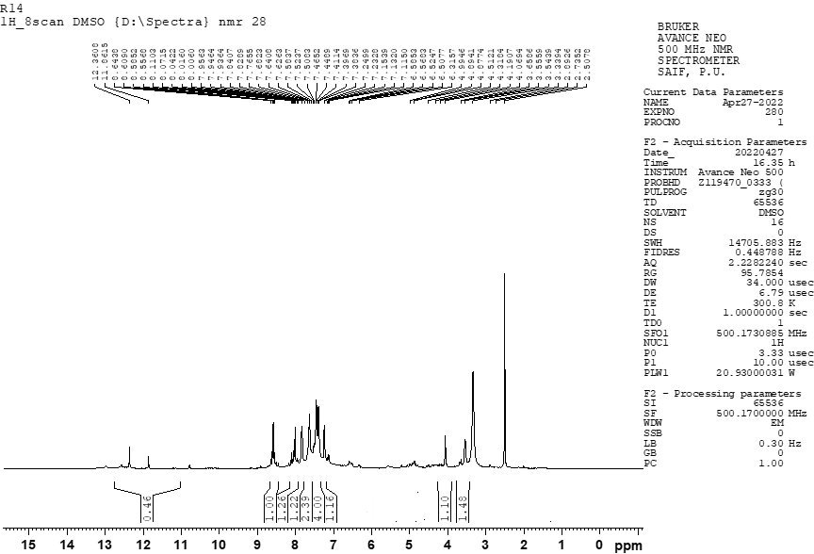
N-(4-(2-oxo-2H-chromen-3-yl)thiazol-2-yl)-2-((3,4,5-trimethoxyphenyl)amino)acetamide (19)
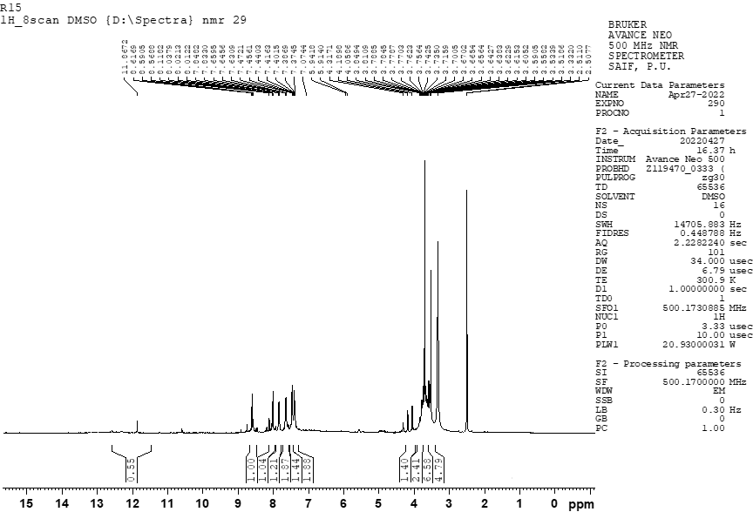

Mass Spectra:
N-(4-(2-oxo-2H-chromen-3-yl)thiazol-2-yl)-2-(phenylamino)acetamide (5)
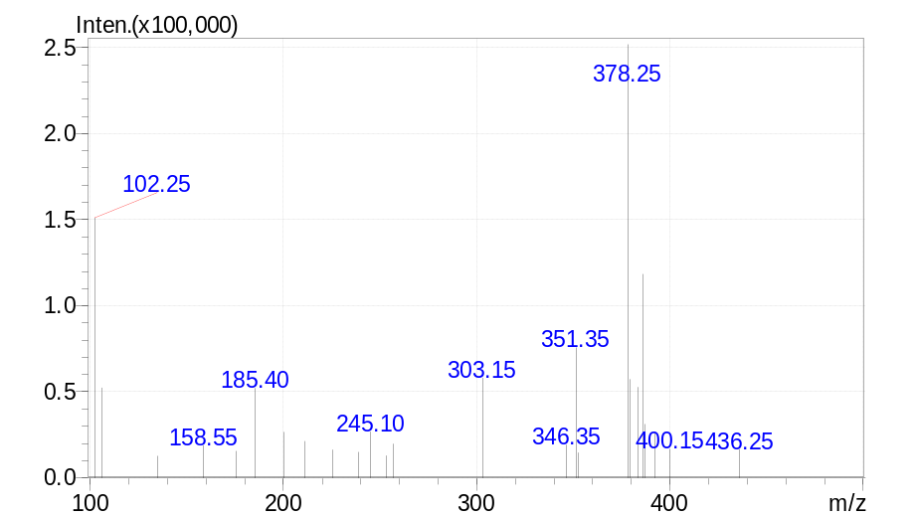

2-((4-chlorophenyl)amino)-N-(4-(2-oxo-2H-chromen-3-yl)thiazol-2-yl)acetamide (6)
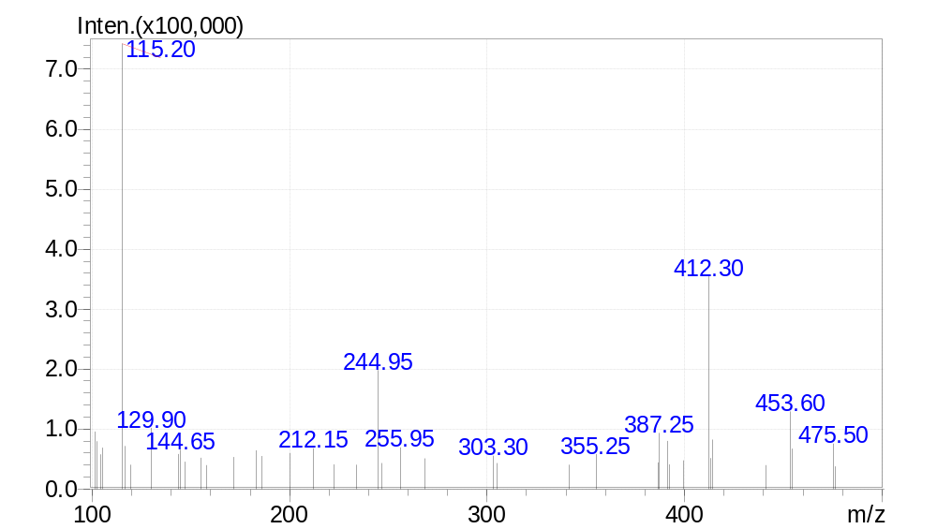

2-((4-fluorophenyl)amino)-N-(4-(2-oxo-2H-chromen-3-yl)thiazol-2-yl)acetamide (7)
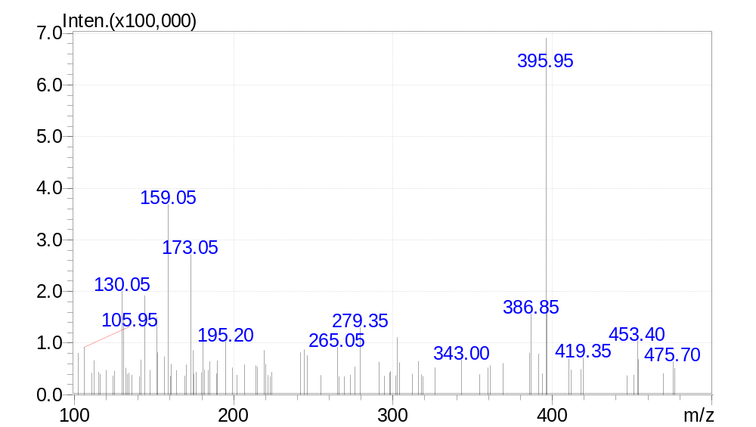

2-((3,4-dichlorophenyl)amino)-N-(4-(2-oxo-2H-chromen-3-yl)thiazol-2-yl)acetamide (8)
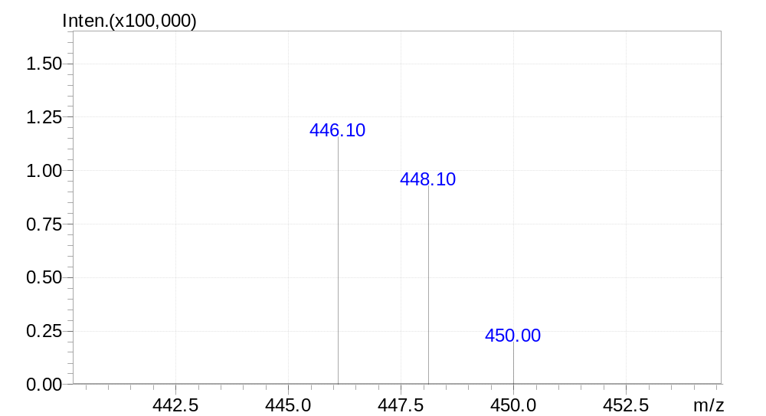

2-((4-methoxyphenyl)amino)-N-(4-(2-oxo-2H-chromen-3-yl)thiazol-2-yl)acetamide (9)
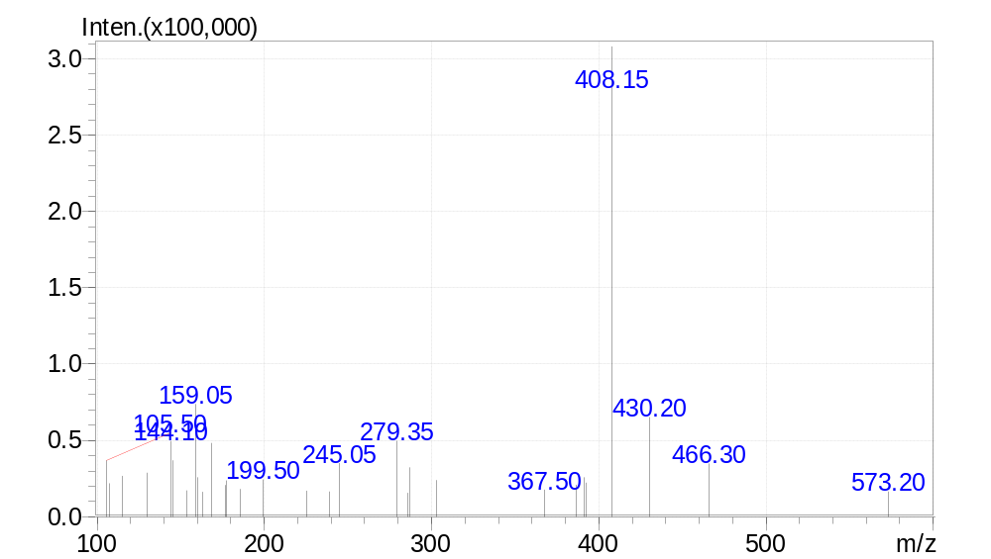

2-((3-methoxyphenyl)amino)-N-(4-(2-oxo-2H-chromen-3-yl)thiazol-2-yl)acetamide (10)
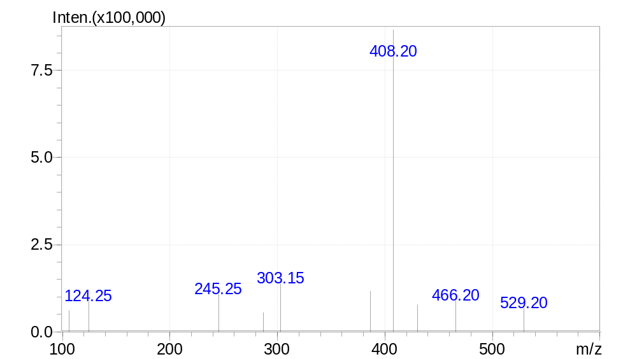

2-((2-chlorophenyl)amino)-N-(4-(2-oxo-2H-chromen-3-yl)thiazol-2-yl)acetamide (11)
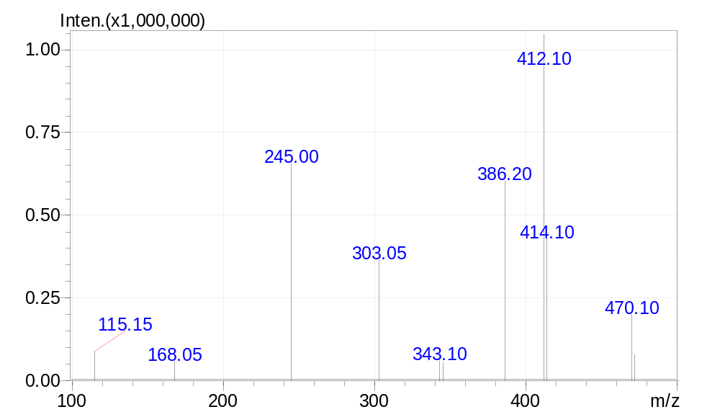

2-((3,5-dichlorophenyl)amino)-N-(4-(2-oxo-2H-chromen-3-yl)thiazol-2-yl)acetamide (12)

- 2-((2,5-dimethylphenyl)amino)-N-(4-(2-oxo-2H-chromen-3-yl)thiazol-2-yl)acetamide(14)

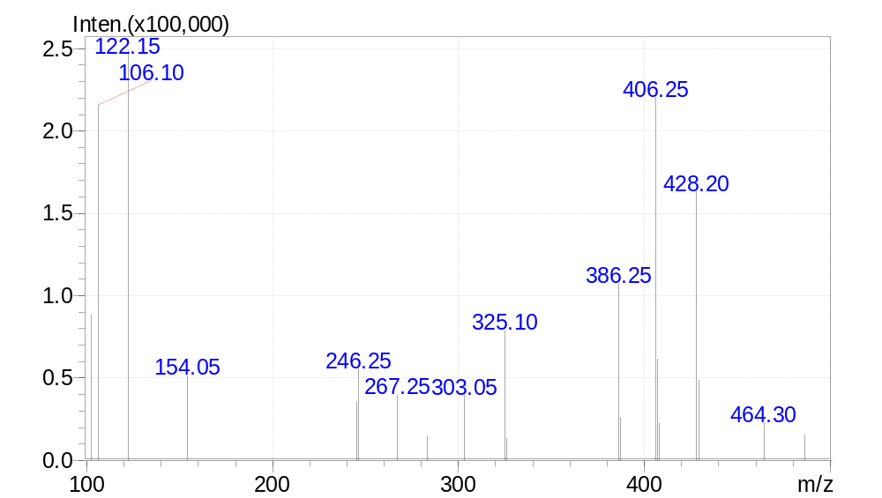

2-((2,4-dimethylphenyl)amino)-N-(4-(2-oxo-2H-chromen-3-yl)thiazol-2-yl)acetamide (15)
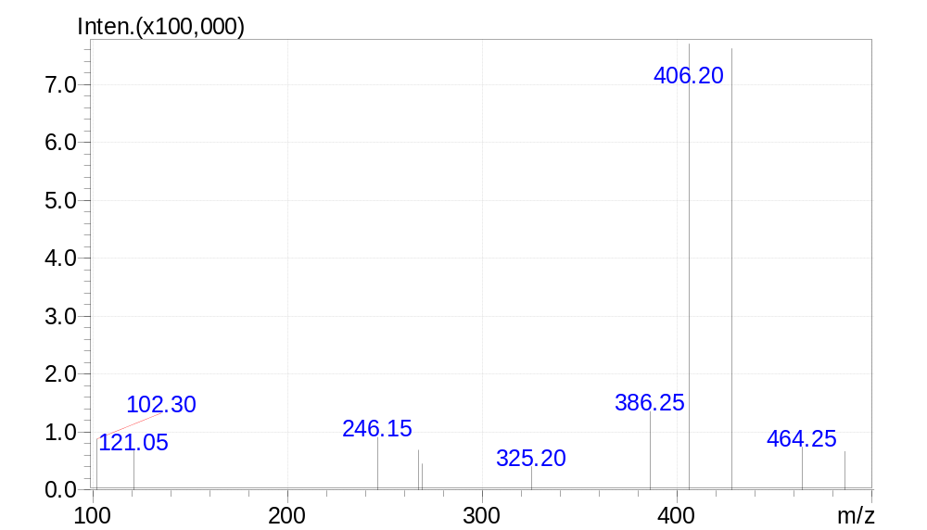

2-((2,3-dimethylphenyl)amino)-N-(4-(2-oxo-2H-chromen-3-yl)thiazol-2-yl)acetamide(16)
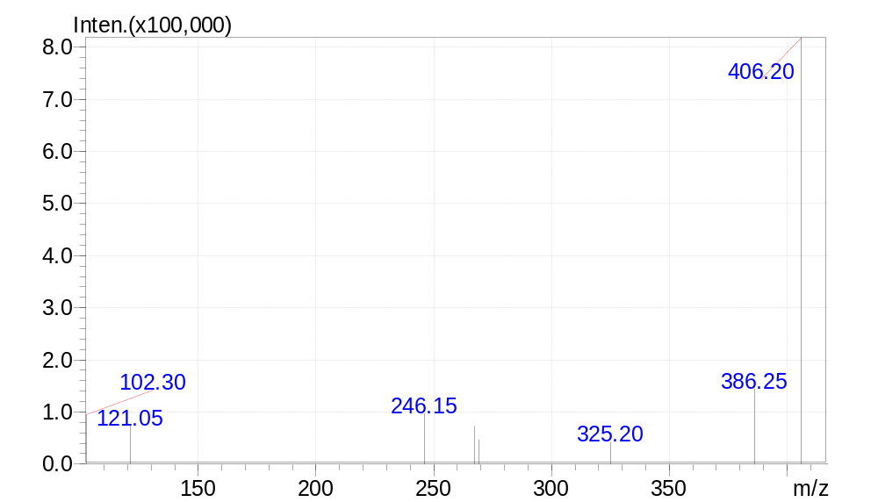

2-((2,4-difluorophenyl)amino)-N-(4-(2-oxo-2H-chromen-3-yl)thiazol-2-yl)acetamide (17)
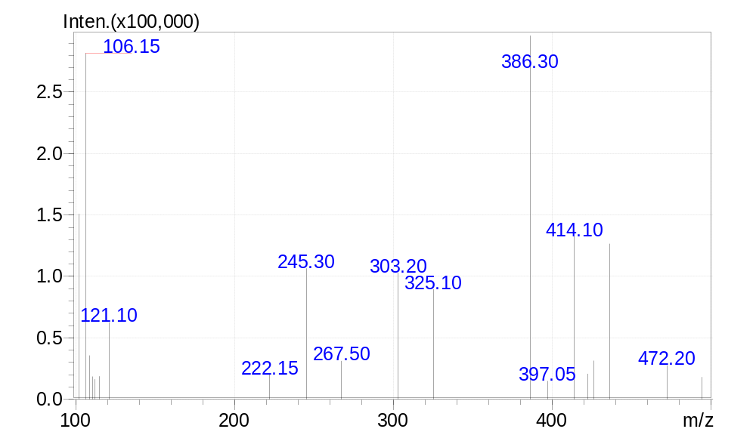
2-((4-bromophenyl)amino)-N-(4-(2-oxo-2H-chromen-3-yl)thiazol-2-yl)acetamide (18)
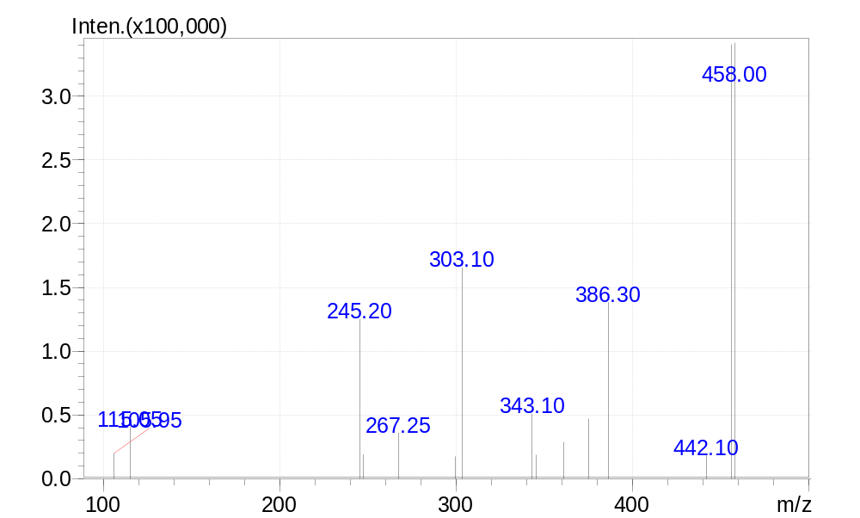

N-(4-(2-oxo-2H-chromen-3-yl)thiazol-2-yl)-2-((3,4,5- trimethoxyphenyl)amino)acetamide (19)
