The supplemental materials for
Exploring influential factors of CO₂ emissions in China’s cities using machine learning techniques
Kun Xiang¹· Haofei Yu¹ ·Hao Du² ·Md Hasibul Hasan¹· Siyi Wei² ·Xiangyun Xiang²

¹Department of Civil, Environmental, and Construction Engineering, University of Central Florida, Orlando 32816, USA
²Research Center of Machine Learning and Environment Science, China Three Gorges University, Yichang 443002, China

Corresponding author: KunXiang. kwanxiang@knights.ucf.edu

List of Tables
S1 The full list of potential variables and importance scores
S2 The top twenty-five combinations according to H-statistic values

List of Figures
S1 The map of sample cities

Table S1 The full list of potential variables and importance scores
Variable Number | Variable Name | Importance Score
1 | Land Area of Urban Built-up Region | 0.0391
2 | Population Density | 0.0088
3 | Total Population | 0.0189
4 | The proportion of the population employed in the primary sector | 0.0088
5 | The proportion of the population employed in the secondary industry | 0.0058
6 | The proportion of the population employed in the tertiary industry | 0.0087
7 | Employed persons in the mining industry | 0.0082
8 | Employed persons in the manufacturing industry | 0.0057
9 | Employees in Electricity, Heat & Gas Industries | 0.0221
10 | Employed persons in the construction industry | 0.0084
11 | Employees in Logistics and Warehousing Industries | 0.0224
12 | Accommodation and catering industry employees | 0.0104
13 | Employed persons in real estate | 0.0087
14 | Employed persons in the public facility industry | 0.0091
15 | Urban construction land area | 0.0079
16 | Proportion of urban construction land to city area | 0.0091
17 | Regional GDP | 0.0051
18 | GDP per capita | 0.0064
19 | Share of primary sector GDP in total GDP | 0.0087
20 | Share of secondary sector GDP in total GDP | 0.0091
21 | Share of tertiary sector GDP in total GDP | 0.0170
22 | Number of industries above designated size | 0.0109
23 | Number of domestic enterprises above the scale | 0.0150
24 | Number of Hong Kong, Taiwan, and Macao-funded industries above the designated size | 0.0085
25 | Number of international industries above the designated size | 0.0131
26 | Total Industry GDP above designated size | 0.0118
27 | Total Domestic Industry GDP above designated size | 0.0139
28 | Hong Kong, Taiwan, and Macao funded Industry GDP above the designated size | 0.0090
29 | International funded Industry GDP above designated size | 0.0081
30 | Investment in Real Estate | 0.0211
31 | Completed residential real estate value | 0.0070
32 | The actual amount of foreign capital used in the year | 0.0105
33 | The actual amount of foreign capital | 0.0077
34 | Local public budget revenue | 0.1493
35 | Local Public Budget Expenditure | 0.0473
36 | Expenditures on Science & Technology | 0.2110
37 | Water sales | 0.0064
38 | Residential Water Consumption | 0.0100
39 | Total Electricity Consumption of Society | 0.0246
40 | Total Industrial Electricity Consumption | 0.0226
41 | Electricity Consumption in the residential building | 0.0176
42 | Total Natural Gas Supply | 0.0135
43 | Total LPG supply | 0.0174
44 | Greenery Coverage Area in Built-up Region | 0.0479
45 | Green Coverage Rate | 0.0066
46 | Greenery Coverage Area in Park | 0.0673
47 | Greenery Coverage Area in Built-up Region | 0.0479
48 | Domestic Waste Recycling Rate | 0.0044
49 | Sewage treatment rate | 0.0079
50 | Industrial Solid Waste Utilization rate | 0.0081
51 | Industrial Dust Emission | 0.0114
52 | Industrial NOx emission | 0.0184
53 | Industrial SO₂ Emissions | 0.0214
54 | Industrial Wastewater Discharge | 0.0247
55 | Actual number of buses at the end of the year | 0.0045
56 | Total annual bus passenger traffic | 0.0071
57 | Number of operating Taxis | 0.0443

Table S1 reported all potential variables that were inputted for feature selection. These fifty-seven potential variables covered almost all aspects of urban society and the economy. The importance scores were calculated by the ‘feature-importance’ function in XGBoost model and distributed between 0.0011 to 0.1493. In terms of those scores, this research finally selected fourteen variables, whose importance score exceeded 0.02, to train the benchmark model.

Table S2 The top twenty-five feature combinations according to H-statistic values
Feature Combination | Value
('Urban Built-up Land Area', 'Expenditures on Science & Technology') | 0.9173
('Investment on Real Estate', 'Expenditures on Science & Technology') | 0.8908
('Total Electricity Consumption of Society', 'Expenditures on Science & Technology') | 0.8301
('Park Green Area', 'Expenditures on Science &Technology') | 0.6806
('Urban Built-up Land Area', 'Investment on Real Estate') | 0.4122
('Total Industrial Electricity Consumption', 'Investment on Real Estate') | 0.3402
('Greenery Coverage on Built-up Area', 'Investment on Real Estate') | 0.3223
('Greenery Coverage on Built-up Area', 'Expenditures on Science & Technology') | 0.2891
('Local Public Budget Revenue', 'Total Electricity Consumption of Society') | 0.2816
('Local Public Budget Revenue', 'Expenditures on Science & Technology') | 0.2647
('Employees in Electricity, Heat & Gas Industry', 'Investment on Real Estate') | 0.2354
('Employees in Transportation & Warehousing Industry', 'Expenditures on Science & Technology') | 0.2323
('Employees in Electricity , Heat & Gas Industry', 'Expenditures on Science & Technology') | 0.2318
('Park Green Area', 'Industrial SO₂ emissions') | 0.2134
('Local Public Budget Expenditure', 'Industrial SO₂ emissions') | 0.2133
('Local Public Budget Expenditure', 'Total Electricity Consumption of Society') | 0.2035
('Park Green Area', 'Employees in Transportation &Warehousing Industry') | 0.2014
('Park Green Area', 'Industrial Wastewater Discharge') | 0.2009
('Local Public Budget Revenue', 'Number of Operating Taxis') | 0.1974
('Park Green Area', 'Total Electricity Consumption of Society') | 0.1949
('Number of Operating Taxis', 'Industrial SO₂ emissions') | 0.1935
('Industrial Wastewater Discharge', 'Employees in Transportation & Warehousing Industry') | 0.1900
('Park Green Area', 'Greenery Coverage on Built-up Area') | 0.1831
('Total Electricity Consumption of Society', 'Employees in Electricity, Heat & Gas Industry') | 0.1705
('Park Green Area', 'Total Industrial Electricity Consumption') | 0.1667

Table S2 reported the top twenty-five feature combinations according to H-statistic values. H-statistic value is a metric that is used to measure the magnitude of interactions between input features. Because of the huge number of feature combinations, this research selected four combinations to investigate the strong interactive effects on urban CO₂ emissions.
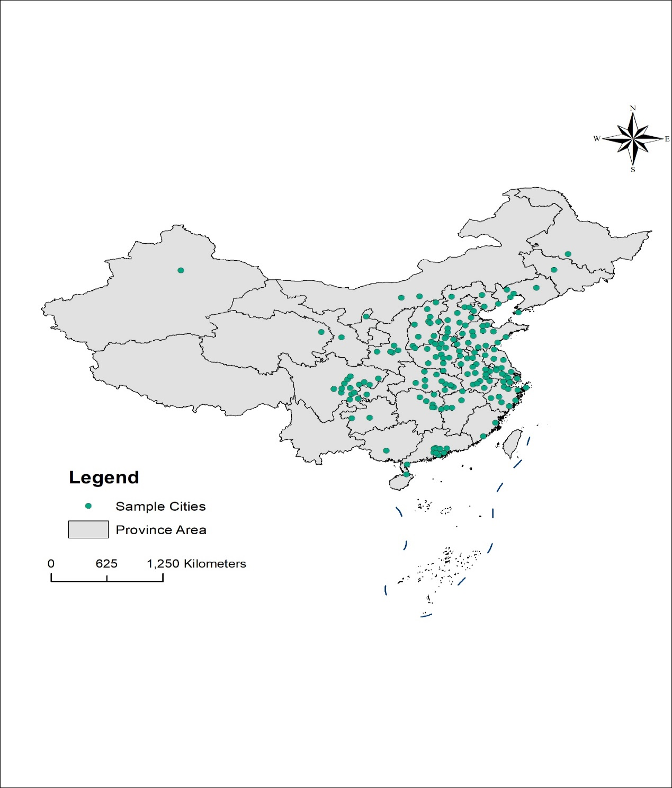
Figure S1 The map of sample cities

Figure S1 mapped all sample cities investigated for CO₂ emissions. These sample cities are almost located in every Chinese province, and therefore provide a reliable representation of the characteristics of urban development in different regions.

