Supplementary Figures

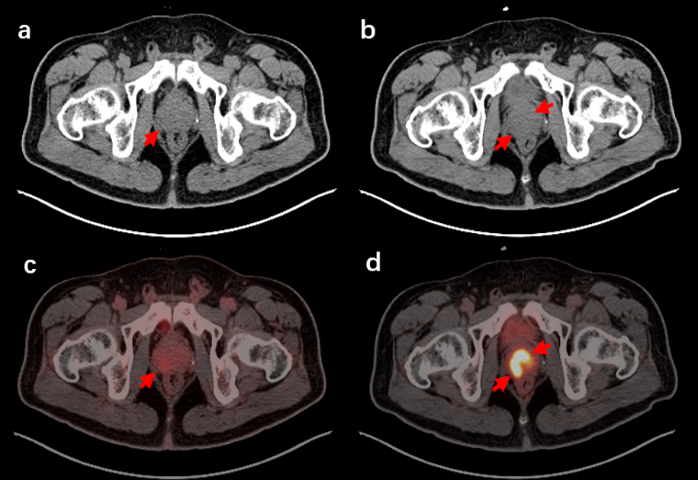
Suppl Fig. 1 Patient 17 (age 65, Gleason score 9, PSA: 8.49 ng/mL). Axial CT image and PET/CT fusion image of ¹⁸F-FDG PET/CT (a, c) and ¹⁸F-PSMA-1007 (b, d). ¹⁸F-PSMA-1007 PET/CT showed multifocal prostate primary lesions (d), while ¹⁸F-FDG PET/CT did not (c).

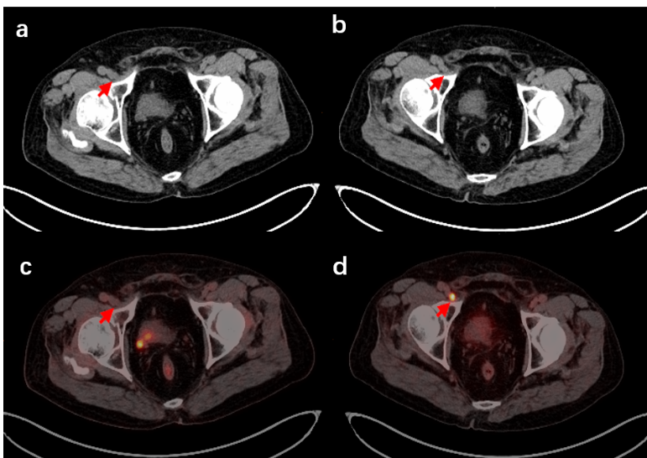
Suppl Fig. 2 Patient 25 (age 78, Gleason score 9, PSA: 5.17 ng/mL). Axial CT image and PET/CT fusion image of ¹⁸F-FDG PET/CT (a, c) and ¹⁸F-PSMA-1007 (b, d). Abnormal increased uptake of ¹⁸F-PSMA-1007 was found in small lymph nodes in the right inguinal region (d), while no increased uptake of ¹⁸F-FDG was found (c).

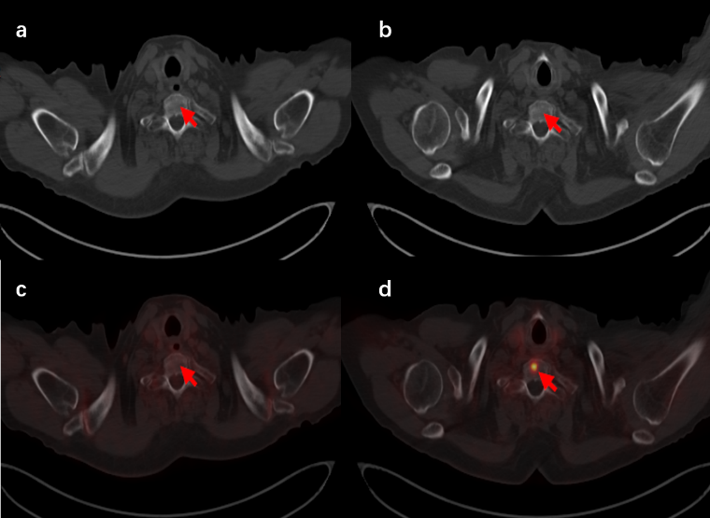
Suppl Fig. 3 Patient 25 (age 78, Gleason score 9, PSA: 5.17 ng/mL). Axial CT image and PET/CT fusion image of ¹⁸F-FDG PET/CT (a, c) and ¹⁸F-PSMA-1007 (b, d). Abnormal increased uptake of ¹⁸F-PSMA-1007 was found in thoracic vertebrae 1 (d), while no increased uptake of ¹⁸F-FDG was found (c).

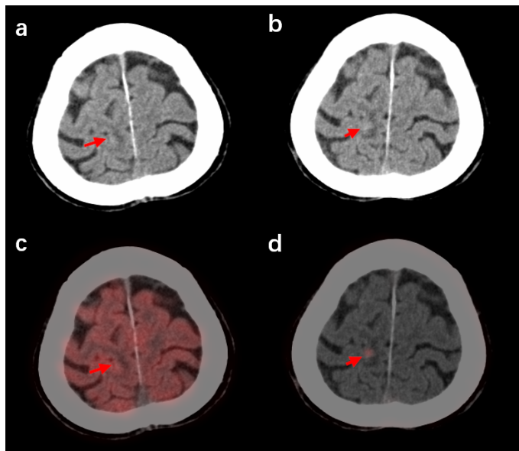
Suppl Fig. 4 Patient 16 (age 83, Gleason score 9, PSA: 972.76 ng/mL). Axial CT image and PET/CT fusion image of ¹⁸F-FDG PET/CT (a, c) and ¹⁸F-PSMA-1007 (b, d). Abnormal focal increased uptake of ¹⁸F-PSMA-1007 was found in the right parietal lobe (d), while no abnormal focal increased uptake of ¹⁸F-FDG was found (c).

