Appendix 1

This appendix collects, for each National Park, a table indicating the species observed in the park as well as the date of the first (first occ.) and last (last occ.) sighting. Moreover, the time series graphs produced by PETS analysis on the butterfly data of all Italian National Parks are also provided. In these graphs each species is represented in a row with the same order as in the table. Literature records are represented by dark gray dots, while data from iNaturalist are represented by red dots. The years with both kinds of records for any given species are reported in blue. Green and pink segments represent persistence and absence of a species as defined in Fig. 2. The Parks are ordered in terms of contribution of iNaturalist in reducing the perception of local extinction as envisaged by difference between PETS0 and PETS1 (Δ (PETS0 - PETS1)) reported in Table 1.

Parco Nazionale delle Cinque Terre
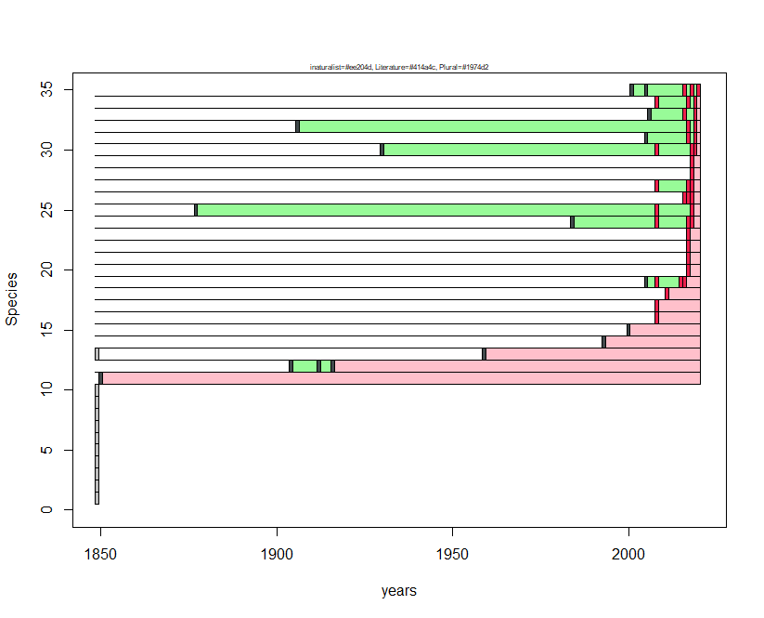
Species N | Species name | first occ. | last occ.
1 | Polygonia egea | NA | NA
2 | Hipparchia fagi | NA | NA
3 | Pyrgus malvoides | NA | NA
4 | Leptidea sinapis | NA | NA
5 | Cupido alcetas | NA | NA
6 | Coenonympha pamphilus | NA | NA
7 | Hesperia comma | NA | NA
8 | Lasiommata maera | NA | NA
9 | Euchloe crameri | NA | NA
10 | Plebejus argus | NA | NA
11 | Zerynthia cassandra | 1851 | 1851
12 | Hipparchia statilinus | 1905 | 1917
13 | Lysandra hispana | 1960 | 1960
14 | Gonepteryx rhamni | 1994 | 1994
15 | Aporia crataegi | 2001 | 2001
16 | Limenitis reducta | 2009 | 2009
17 | Maniola jurtina | 2009 | 2009
18 | Pontia edusa | 2012 | 2012
19 | Gonepteryx cleopatra | 2006 | 2017
20 | Melanargia galathea | 2018 | 2018
21 | Pieris rapae | 2018 | 2018
22 | Pieris brassicae | 2018 | 2018
23 | Lycaena phlaeas | 2018 | 2018
24 | Vanessa cardui | 1985 | 2019
25 | Pararge aegeria | 1878 | 2019
26 | Vanessa atalanta | 2017 | 2019
27 | Lasiommata megera | 2009 | 2019
28 | Glaucopsyche alexis | 2019 | 2019
29 | Melitaea didyma | 2019 | 2019
30 | Charaxes jasius | 1931 | 2020
31 | Colias crocea | 2006 | 2020
32 | Leptotes pirithous | 1907 | 2020
33 | Cacyreus marshalli | 2007 | 2020
34 | Iphiclides podalirius | 2009 | 2020
35 | Papilio machaon | 2002 | 2021

Parco Nazionale dell'Arcipelago di La Maddalena
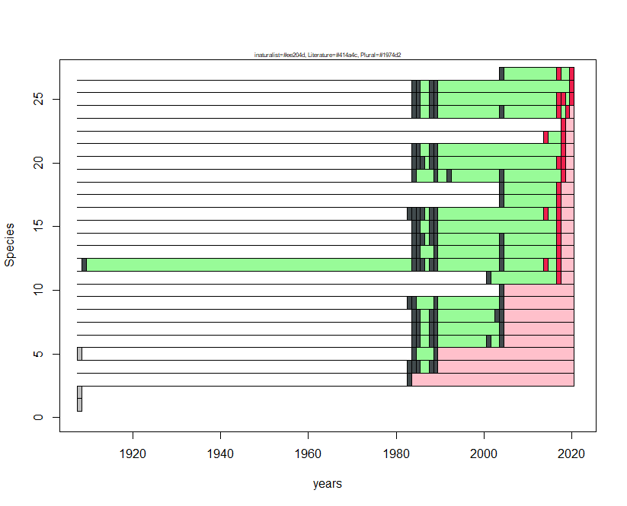
Species N | Species name | first occ. | last occ.
1 | Coenonympha pamphilus | NA | NA
2 | Carcharodus alceae | NA | NA
3 | Euchloe insularis | 1984 | 1984
4 | Maniola jurtina | 1984 | 1990
5 | Pieris brassicae | 1985 | 1990
6 | Plebejus bellieri | 1985 | 2005
7 | Aricia cramera | 1985 | 2005
8 | Polyommatus celina | 1985 | 2005
9 | Pararge aegeria | 1984 | 2005
10 | Celastrina argiolus | 2005 | 2005
11 | Cacyreus marshalli | 2002 | 2018
12 | Lasiommata paramegaera | 1910 | 2018
13 | Pieris rapae | 1985 | 2018
14 | Lycaena phlaeas | 1985 | 2018
15 | Vanessa atalanta | 1985 | 2018
16 | Coenonympha corinna | 1984 | 2018
17 | Pontia daplidice | 2005 | 2018
18 | Lampides boeticus | 2005 | 2018
19 | Papilio machaon | 1985 | 2019
20 | Vanessa cardui | 1985 | 2019
21 | Hipparchia aristaeus | 1985 | 2019
22 | Danaus chrysippus | 2015 | 2019
23 | Leptotes pirithous | 2019 | 2019
24 | Colias crocea | 1985 | 2020
25 | Charaxes jasius | 1985 | 2021
26 | Pyronia cecilia | 1985 | 2021
27 | Gonepteryx cleopatra | 2005 | 2021

Parco Nazionale delle Foreste Casentinesi, Monte Falterona e Campigna
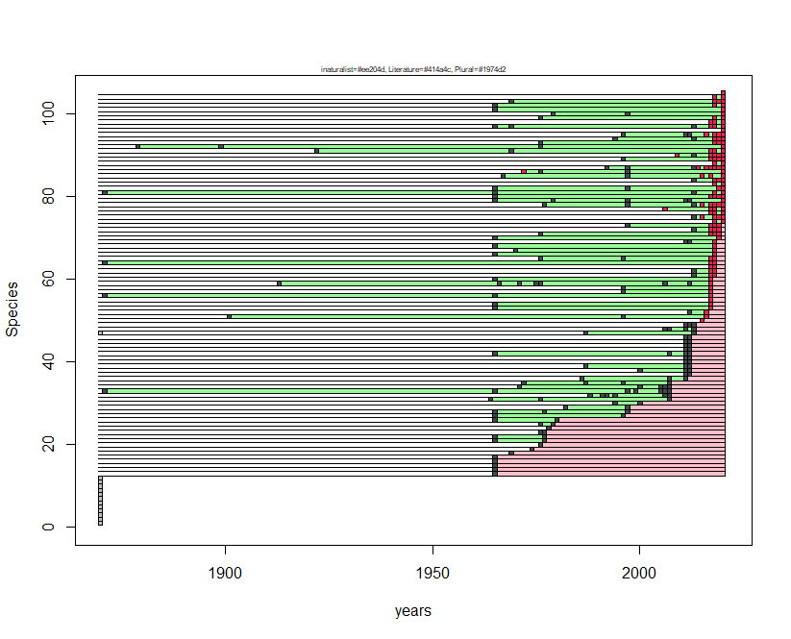
Species N | Species name | first occ. | last occ.
1 | Plebejus argyrognomon | NA | NA
2 | Brenthis daphne | NA | NA
3 | Nymphalis polychloros | NA | NA
4 | Papilio machaon | NA | NA
5 | Thymelicus sylvestris | NA | NA
6 | Thymelicus acteon | NA | NA
7 | Hesperia comma | NA | NA
8 | Fabriciana niobe | NA | NA
9 | Chazara briseis | NA | NA
10 | Polyommatus dorylas | NA | NA
11 | Hyponephele lycaon | NA | NA
12 | Thecla betulae | NA | NA
13 | Satyrium w-album | 1966 | 1966
14 | Plebejus argus | 1966 | 1966
15 | Plebejus idas | 1966 | 1966
16 | Cupido osiris | 1966 | 1966
17 | Satyrium acaciae | 1966 | 1966
18 | Anthocharis cardamines | 1970 | 1970
19 | Hyponephele lupina | 1975 | 1975
20 | Hipparchia fagi | 1977 | 1977
21 | Glaucopsyche alexis | 1966 | 1978
22 | Aricia agestis | 1966 | 1978
23 | Hipparchia hermione | 1977 | 1978
24 | Pyrgus onopordi | 1979 | 1979
25 | Erynnis tages | 1977 | 1980
26 | Cupido minimus | 1966 | 1981
27 | Polyommatus daphnis | 1966 | 1997
28 | Cupido alcetas | 1966 | 1998
29 | Nymphalis antiopa | 1983 | 1998
30 | Heteropterus morpheus | 1995 | 2001
31 | Hamearis lucina | 1965 | 2008
32 | Limenitis camilla | 1989 | 2008
33 | Lycaena virgaureae | 1872 | 2008
34 | Boloria dia | 1972 | 2008
35 | Iolana iolas | 1973 | 2008
36 | Zerynthia cassandra | 1987 | 2012
37 | Hipparchia semele | 2012 | 2013
38 | Favonius quercus | 2001 | 2013
39 | Melitaea trivia | 1988 | 2013
40 | Carcharodus floccifera | 2012 | 2013
41 | Thymelicus lineola | 2012 | 2013
42 | Phengaris arion | 1966 | 2013
43 | Pontia edusa | 2012 | 2013
44 | Pyrgus armoricanus | 2012 | 2013
45 | Carcharodus alceae | 2012 | 2013
46 | Pieris mannii | 2012 | 2013
47 | Cupido argiades | 1988 | 2014
48 | Euphydryas aurinia | 2007 | 2014
49 | Melitaea aurelia | 2012 | 2014
50 | Pieris rapae | 2016 | 2016
51 | Callophrys rubi | 1902 | 2017
52 | Apatura ilia | 2013 | 2017
53 | Cyaniris semiargus | 1966 | 2018
54 | Polyommatus amandus | 1966 | 2018
55 | Coenonympha arcania | 2018 | 2018
56 | Lycaena alciphron | 1872 | 2018
57 | Aglais urticae | 1997 | 2018
58 | Pyrgus malvoides | 1997 | 2018
59 | Parnassius mnemosyne | 1914 | 2018
60 | Lycaena phlaeas | 1966 | 2018
61 | Polygonia c-album | 2014 | 2019
62 | Vanessa atalanta | 2014 | 2019
63 | Melitaea celadussa | 2018 | 2019
64 | Coenonympha pamphilus | 1872 | 2019
65 | Aporia crataegi | 1977 | 2019
66 | Leptotes pirithous | 1966 | 2019
67 | Melitaea cinxia | 1971 | 2019
68 | Lycaena tityrus | 1966 | 2019
69 | Hipparchia statilinus | 2012 | 2019
70 | Polyommatus escheri | 1966 | 2020
71 | Boloria euphrosyne | 1977 | 2020
72 | Pararge aegeria | 2014 | 2020
73 | Lasiommata megera | 1998 | 2020
74 | Brintesia circe | 2019 | 2021
75 | Argynnis paphia | 2014 | 2021
76 | Speyeria aglaja | 2018 | 2021
77 | Issoria lathonia | 2007 | 2021
78 | Lasiommata maera | 1978 | 2021
79 | Pseudophilotes baton | 1966 | 2021
80 | Lysandra coridon | 1966 | 2021
81 | Polyommatus icarus | 1872 | 2021
82 | Lysandra bellargus | 1966 | 2021
83 | Limenitis reducta | 2019 | 2021
84 | Pyronia tithonus | 2014 | 2021
85 | Maniola jurtina | 1968 | 2021
86 | Erebia ligea | 1973 | 2021
87 | Melanargia galathea | 1993 | 2021
88 | Leptidea sinapis | 2019 | 2021
89 | Pieris brassicae | 1997 | 2021
90 | Pieris napi | 2010 | 2021
91 | Colias crocea | 1923 | 2021
92 | Colias alfacariensis | 1880 | 2021
93 | Gonepteryx rhamni | 1977 | 2021
94 | Ochlodes sylvanus | 1995 | 2021
95 | Iphiclides podalirius | 1997 | 2021
96 | Lampides boeticus | 2021 | 2021
97 | Celastrina argiolus | 1966 | 2021
98 | Aglais io | 2018 | 2021
99 | Fabriciana adippe | 1977 | 2021
100 | Spialia sertorius | 1980 | 2021
101 | Satyrium ilicis | 1966 | 2021
102 | Polyommatus thersites | 1966 | 2021
103 | Vanessa cardui | 1970 | 2021
104 | Melitaea didyma | 2019 | 2021
105 | Melitaea phoebe | 2021 | 2021

Parco Nazionale del Gargano
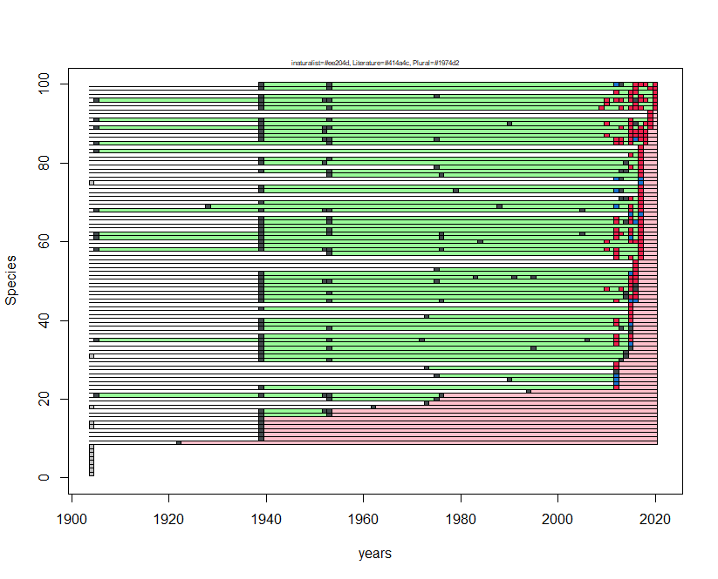
Species N | Species name | first occ. | last occ.
1 | Hamearis lucina | NA | NA
2 | Phengaris arion | NA | NA
3 | Cyaniris semiargus | NA | NA
4 | Hipparchia hermione | NA | NA
5 | Carcharodus floccifera | NA | NA
6 | Satyrium w-album | NA | NA
7 | Libythea celtis | NA | NA
8 | Satyrium acaciae | NA | NA
9 | Muschampia proto | 1923 | 1923
10 | Polygonia egea | 1940 | 1940
11 | Polyommatus amandus | 1940 | 1940
12 | Lasiommata maera | 1940 | 1940
13 | Plebejus argyrognomon | 1940 | 1940
14 | Boloria euphrosyne | 1940 | 1940
15 | Thymelicus lineola | 1940 | 1940
16 | Hipparchia semele | 1940 | 1954
17 | Lycaena thersamon | 1940 | 1954
18 | Gegenes nostrodamus | 1963 | 1963
19 | Gegenes pumilio | 1974 | 1974
20 | Pyronia tithonus | 1954 | 1976
21 | Pieris rapae | 1906 | 1977
22 | Polyommatus dorylas | 1995 | 1995
23 | Melitaea phoebe | 1940 | 2013
24 | Hyponephele lupina | 2013 | 2013
25 | Fabriciana adippe | 1991 | 2013
26 | Speyeria aglaja | 1976 | 2013
27 | Pieris ergane | 2013 | 2013
28 | Lysandra coridon | 1974 | 2013
29 | Brintesia circe | 2013 | 2013
30 | Leptidea sinapis | 1940 | 2014
31 | Euchloe ausonia | 1940 | 2015
32 | Pyrgus sidae | 1940 | 2015
33 | Pieris mannii | 1940 | 2016
34 | Melitaea didyma | 1940 | 2016
35 | Colias crocea | 1906 | 2016
36 | Pieris napi | 1940 | 2016
37 | Pyrgus onopordi | 2016 | 2016
38 | Hipparchia fagi | 1940 | 2016
39 | Colias alfacariensis | 1940 | 2016
40 | Satyrium spini | 1940 | 2016
41 | Charaxes jasius | 1974 | 2016
42 | Thymelicus acteon | 2016 | 2016
43 | Aporia crataegi | 1940 | 2016
44 | Spialia sertorius | 2016 | 2016
45 | Iphiclides podalirius | 1940 | 2017
46 | Callophrys rubi | 1940 | 2017
47 | Celastrina argiolus | 1940 | 2017
48 | Anthocharis cardamines | 1940 | 2017
49 | Gonepteryx rhamni | 1940 | 2017
50 | Pyrgus malvoides | 1940 | 2017
51 | Melanargia arge | 1940 | 2017
52 | Glaucopsyche alexis | 1940 | 2017
53 | Erynnis tages | 1976 | 2017
54 | Aglais io | 2017 | 2017
55 | Polygonia c-album | 2017 | 2017
56 | Polyommatus thersites | 2013 | 2018
57 | Vanessa atalanta | 1954 | 2018
58 | Pieris brassicae | 1906 | 2018
59 | Pseudophilotes baton | 1940 | 2018
60 | Zerynthia cassandra | 1940 | 2018
61 | Lycaena phlaeas | 1906 | 2018
62 | Polyommatus icarus | 1906 | 2018
63 | Hipparchia statilinus | 1940 | 2018
64 | Lycaena tityrus | 1940 | 2018
65 | Issoria lathonia | 1940 | 2018
66 | Maniola jurtina | 1940 | 2018
67 | Polyommatus dolus | 2016 | 2018
68 | Aricia agestis | 1906 | 2018
69 | Polyommatus daphnis | 1929 | 2018
70 | Lycaena alciphron | 1940 | 2018
71 | Plebejus argus | 2014 | 2018
72 | Polyommatus escheri | 2018 | 2018
73 | Argynnis pandora | 1940 | 2018
74 | Melanargia russiae | 1940 | 2018
75 | Thymelicus sylvestris | 2018 | 2018
76 | Pyrgus armoricanus | 2013 | 2018
77 | Ochlodes sylvanus | 1954 | 2018
78 | Brenthis daphne | 1940 | 2018
79 | Melanargia galathea | 1976 | 2018
80 | Melitaea celadussa | 1940 | 2018
81 | Coenonympha arcania | 1940 | 2018
82 | Satyrium ilicis | 2016 | 2018
83 | Nymphalis polychloros | 1906 | 2018
84 | Euphydryas aurinia | 2018 | 2018
85 | Vanessa cardui | 1906 | 2019
86 | Coenonympha pamphilus | 1940 | 2019
87 | Cupido minimus | 1940 | 2019
88 | Melitaea cinxia | 1940 | 2019
89 | Pontia edusa | 1906 | 2020
90 | Papilio machaon | 1940 | 2020
91 | Pyronia cecilia | 1906 | 2020
92 | Leptotes pirithous | 2020 | 2020
93 | Danaus chrysippus | 2020 | 2020
94 | Pararge aegeria | 1940 | 2021
95 | Gonepteryx cleopatra | 1940 | 2021
96 | Lasiommata megera | 1906 | 2021
97 | Carcharodus alceae | 1940 | 2021
98 | Lysandra bellargus | 2013 | 2021
99 | Limenitis reducta | 1940 | 2021
100 | Argynnis paphia | 1940 | 2021

Parco Nazionale dell'Appennino Tosco-Emiliano
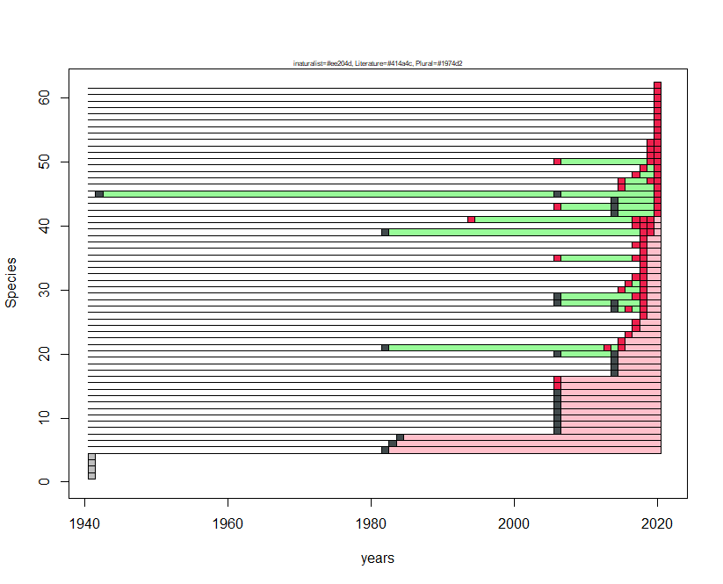
Species N | Species name | first occ. | last occ.
1 | Zerynthia cassandra | NA | NA
2 | Plebejus argyrognomon | NA | NA
3 | Aricia agestis | NA | NA
4 | Parnassius apollo | NA | NA
5 | Parnassius mnemosyne | 1983 | 1983
6 | Erebia epiphron | 1984 | 1984
7 | Erebia cassioides | 1985 | 1985
8 | Vanessa cardui | 2007 | 2007
9 | Satyrus ferula | 2007 | 2007
10 | Hipparchia hermione | 2007 | 2007
11 | Plebejus idas | 2007 | 2007
12 | Pyrgus malvoides | 2007 | 2007
13 | Cupido osiris | 2007 | 2007
14 | Cyaniris semiargus | 2007 | 2007
15 | Erebia euryale | 2007 | 2007
16 | Maniola jurtina | 2007 | 2007
17 | Lasiommata megera | 2015 | 2015
18 | Cupido minimus | 2015 | 2015
19 | Melitaea phoebe | 2015 | 2015
20 | Leptidea sinapis | 2007 | 2015
21 | Gonepteryx rhamni | 1983 | 2016
22 | Polygonia c-album | 2016 | 2016
23 | Arethusana arethusa | 2017 | 2017
24 | Phengaris arion | 2018 | 2018
25 | Lycaena tityrus | 2018 | 2018
26 | Callophrys rubi | 2019 | 2019
27 | Boloria euphrosyne | 2015 | 2019
28 | Erynnis tages | 2007 | 2019
29 | Pararge aegeria | 2007 | 2019
30 | Lasiommata maera | 2016 | 2019
31 | Papilio machaon | 2017 | 2019
32 | Aglais urticae | 2018 | 2019
33 | Vanessa atalanta | 2019 | 2019
34 | Polyommatus amandus | 2019 | 2019
35 | Ochlodes sylvanus | 2007 | 2019
36 | Erebia ligea | 2019 | 2019
37 | Speyeria aglaja | 2018 | 2019
38 | Coenonympha arcania | 2019 | 2019
39 | Aporia crataegi | 1983 | 2020
40 | Argynnis paphia | 2018 | 2020
41 | Erebia medusa | 1995 | 2020
42 | Polyommatus icarus | 2015 | 2021
43 | Pieris napi | 2007 | 2021
44 | Coenonympha pamphilus | 2015 | 2021
45 | Polyommatus escheri | 1943 | 2021
46 | Leptotes pirithous | 2016 | 2021
47 | Issoria lathonia | 2016 | 2021
48 | Hipparchia statilinus | 2018 | 2021
49 | Limenitis reducta | 2019 | 2021
50 | Iphiclides podalirius | 2007 | 2021
51 | Plebejus argus | 2020 | 2021
52 | Melanargia galathea | 2020 | 2021
53 | Aglais io | 2020 | 2021
54 | Aricia artaxerxes | 2021 | 2021
55 | Brintesia circe | 2021 | 2021
56 | Colias crocea | 2021 | 2021
57 | Melitaea celadussa | 2021 | 2021
58 | Pieris ergane | 2021 | 2021
59 | Polygonia egea | 2021 | 2021
60 | Pyronia tithonus | 2021 | 2021
61 | Satyrium ilicis | 2021 | 2021
62 | Thymelicus sylvestris | 2021 | 2021

Parco Nazionale delle Dolomiti Bellunesi
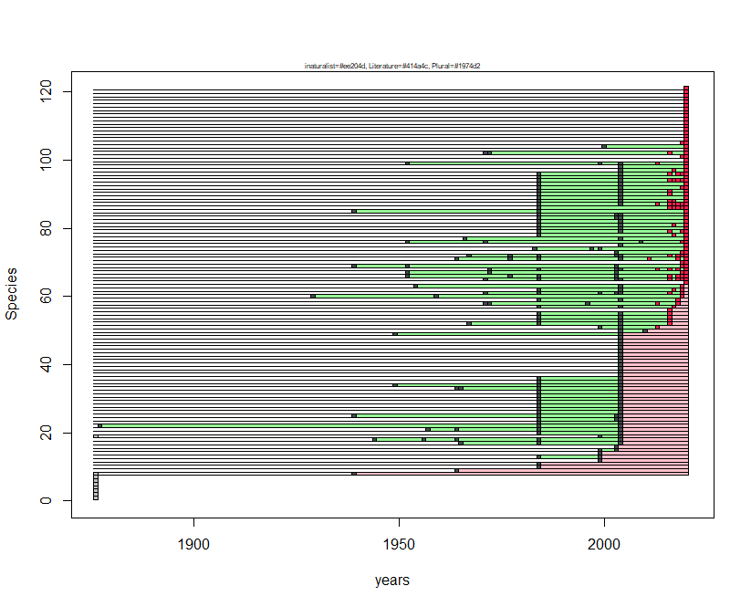
species N | Species name | first occ. | last occ.
1 | Cacyreus marshalli | NA | NA
2 | Pontia callidice | NA | NA
3 | Zerynthia polyxena | NA | NA
4 | Melitaea cinxia | NA | NA
5 | Hipparchia fagi | NA | NA
6 | Hipparchia semele | NA | NA
7 | Pyrgus sidae | NA | NA
8 | Polyommatus dorylas | 1940 | 1940
9 | Pyronia tithonus | 1965 | 1965
10 | Glaucopsyche alexis | 1985 | 1985
11 | Brintesia circe | 1985 | 1985
12 | Boloria thore | 2000 | 2000
13 | Limenitis populi | 1985 | 2000
14 | Colias palaeno | 2000 | 2000
15 | Phengaris arion | 2000 | 2004
16 | Phengaris alcon | 2004 | 2004
17 | Aglais io | 1966 | 2005
18 | Boloria dia | 1945 | 2005
19 | Melitaea aurelia | 2000 | 2005
20 | Leptidea sinapis | 1985 | 2005
21 | Anthocharis cardamines | 1958 | 2005
22 | Pieris brassicae | 1878 | 2005
23 | Pontia edusa | 1985 | 2005
24 | Colias alfacariensis | 1985 | 2005
25 | Hamearis lucina | 1940 | 2005
26 | Satyrium w-album | 1985 | 2005
27 | Limenitis camilla | 1985 | 2005
28 | Limenitis reducta | 1985 | 2005
29 | Nymphalis antiopa | 1985 | 2005
30 | Nymphalis polychloros | 1985 | 2005
31 | Aglais urticae | 1985 | 2005
32 | Vanessa cardui | 1985 | 2005
33 | Melitaea didyma | 1965 | 2005
34 | Melitaea phoebe | 1950 | 2005
35 | Iphiclides podalirius | 1985 | 2005
36 | Thymelicus sylvestris | 1985 | 2005
37 | Hesperia comma | 2005 | 2005
38 | Pyrgus alveus | 2005 | 2005
39 | Spialia sertorius | 2005 | 2005
40 | Pieris mannii | 2005 | 2005
41 | Satyrium spini | 2005 | 2005
42 | Callophrys rubi | 2005 | 2005
43 | Leptotes pirithous | 2005 | 2005
44 | Cupido argiades | 2005 | 2005
45 | Plebejus argus | 2005 | 2005
46 | Plebejus argyrognomon | 2005 | 2005
47 | Aricia agestis | 2005 | 2005
48 | Brenthis daphne | 2005 | 2005
49 | Melitaea athalia | 1950 | 2005
50 | Pyrgus malvoides | 2005 | 2011
51 | Melitaea diamina | 2000 | 2014
52 | Papilio machaon | 1968 | 2017
53 | Celastrina argiolus | 1985 | 2017
54 | Polygonia c-album | 1985 | 2017
55 | Lasiommata megera | 1985 | 2017
56 | Plebejus idas | 2017 | 2017
57 | Apatura ilia | 1985 | 2018
58 | Parnassius apollo | 1972 | 2019
59 | Lycaena phlaeas | 1985 | 2019
60 | Boloria pales | 1930 | 2020
61 | Apatura iris | 1972 | 2020
62 | Vanessa atalanta | 1985 | 2020
63 | Pararge aegeria | 1955 | 2020
64 | Erebia pandrose | 2021 | 2021
65 | Gonepteryx rhamni | 1972 | 2021
66 | Erebia aethiops | 1953 | 2021
67 | Erebia ligea | 1953 | 2021
68 | Melanargia galathea | 1973 | 2021
69 | Lasiommata maera | 1940 | 2021
70 | Coenonympha gardetta | 2020 | 2021
71 | Minois dryas | 1965 | 2021
72 | Maniola jurtina | 1968 | 2021
73 | Erebia pronoe | 2004 | 2021
74 | Parnassius mnemosyne | 1984 | 2021
75 | Euphydryas aurinia | 2005 | 2021
76 | Erebia euryale | 1953 | 2021
77 | Cupido minimus | 1967 | 2021
78 | Aporia crataegi | 1985 | 2021
79 | Pieris rapae | 1985 | 2021
80 | Pieris napi | 1985 | 2021
81 | Colias crocea | 1985 | 2021
82 | Cupido alcetas | 1985 | 2021
83 | Lysandra bellargus | 1985 | 2021
84 | Polyommatus icarus | 1985 | 2021
85 | Lysandra coridon | 1940 | 2021
86 | Neptis rivularis | 1985 | 2021
87 | Argynnis paphia | 1985 | 2021
88 | Fabriciana adippe | 1985 | 2021
89 | Issoria lathonia | 1985 | 2021
90 | Coenonympha arcania | 1985 | 2021
91 | Coenonympha pamphilus | 1985 | 2021
92 | Aphantopus hyperantus | 1985 | 2021
93 | Erynnis tages | 1985 | 2021
94 | Heteropterus morpheus | 1985 | 2021
95 | Carterocephalus palaemon | 1985 | 2021
96 | Ochlodes sylvanus | 1985 | 2021
97 | Thymelicus lineola | 2005 | 2021
98 | Lycaena tityrus | 2005 | 2021
99 | Lopinga achine | 1953 | 2021
100 | Pyrgus andromedae | 2021 | 2021
101 | Speyeria aglaja | 2020 | 2021
102 | Lasiommata petropolitana | 1972 | 2021
103 | Erebia albergana | 2021 | 2021
104 | Pyrgus malvae | 2001 | 2021
105 | Erebia epiphron | 2020 | 2021
106 | Agriades orbitulus | 2021 | 2021
107 | Fabriciana niobe | 2021 | 2021
108 | Aricia artaxerxes | 2021 | 2021
109 | Boloria euphrosyne | 2021 | 2021
110 | Boloria titania | 2021 | 2021
111 | Cyaniris semiargus | 2021 | 2021
112 | Erebia cassioides | 2021 | 2021
113 | Erebia gorge | 2021 | 2021
114 | Erebia manto | 2021 | 2021
115 | Erebia medusa | 2021 | 2021
116 | Erebia stiria | 2021 | 2021
117 | Eumedonia eumedon | 2021 | 2021
118 | Lycaena virgaureae | 2021 | 2021
119 | Pieris bryoniae | 2021 | 2021
120 | Satyrus ferula | 2021 | 2021
121 | Scolitantides orion | 2021 | 2021

Parco Nazionale dell'Asinara
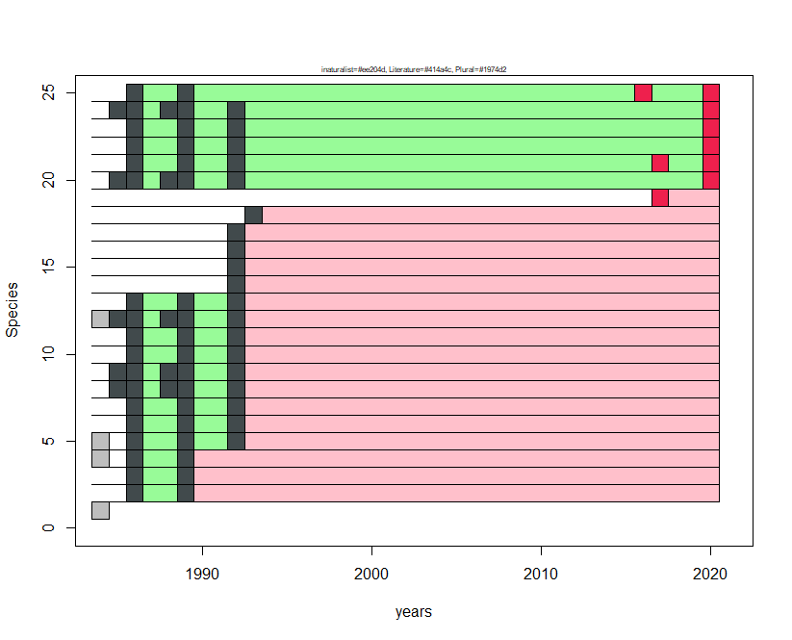
Species N | Species name | first occ. | last occ.
1 | Nymphalis polychloros | NA | NA
2 | Hipparchia aristaeus | 1987 | 1990
3 | Leptidea sinapis | 1987 | 1990
4 | Leptotes pirithous | 1987 | 1990
5 | Carcharodus alceae | 1987 | 1993
6 | Pieris brassicae | 1987 | 1993
7 | Pontia daplidice | 1987 | 1993
8 | Pieris rapae | 1986 | 1993
9 | Colias crocea | 1986 | 1993
10 | Polyommatus celina | 1987 | 1993
11 | Vanessa atalanta | 1987 | 1993
12 | Maniola jurtina | 1986 | 1993
13 | Pararge aegeria | 1987 | 1993
14 | Euchloe insularis | 1993 | 1993
15 | Gonepteryx cleopatra | 1993 | 1993
16 | Lampides boeticus | 1993 | 1993
17 | Celastrina argiolus | 1993 | 1993
18 | Pyrgus armoricanus | 1994 | 1994
19 | Coenonympha corinna | 2018 | 2018
20 | Lasiommata paramegaera | 1986 | 2021
21 | Papilio machaon | 1987 | 2021
22 | Lycaena phlaeas | 1987 | 2021
23 | Aricia cramera | 1987 | 2021
24 | Vanessa cardui | 1986 | 2021
25 | Pyronia cecilia | 1987 | 2021

Parco Nazionale del Gran Sasso e Monti della Laga
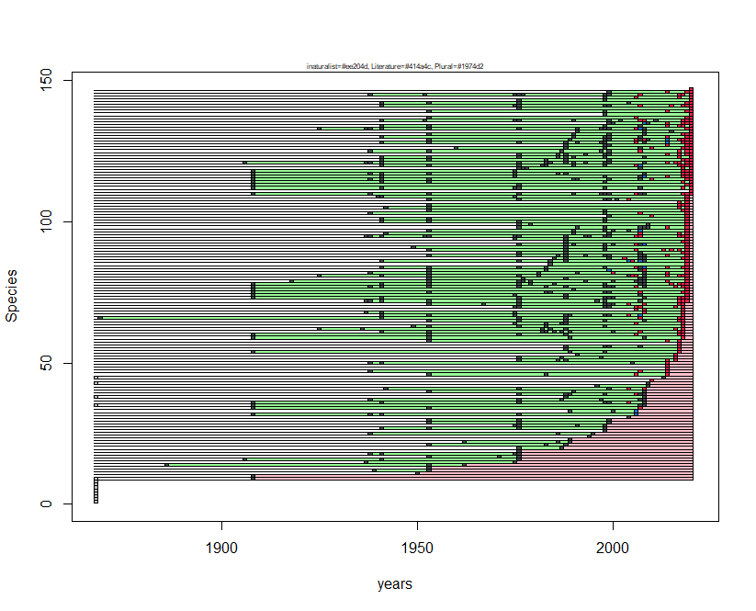
Species N | Species name | first occ. | last occ.
1 | Pyrgus onopordi | NA | NA
2 | Spialia sertorius | NA | NA
3 | Leptotes pirithous | NA | NA
4 | Leptidea reali | NA | NA
5 | Melanargia arge | NA | NA
6 | Hyponephele lupina | NA | NA
7 | Boloria dia | NA | NA
8 | Apatura ilia | NA | NA
9 | Pyronia cecilia | 1909 | 1909
10 | Satyrium w-album | 1909 | 1909
11 | Lycaena thersamon | 1951 | 1951
12 | Carcharodus baeticus | 1940 | 1954
13 | Favonius quercus | 1954 | 1954
14 | Phengaris alcon | 1887 | 1963
15 | Pyrgus foulquieri | 1938 | 1976
16 | Erebia euryale | 1907 | 1977
17 | Erebia pandrose | 1954 | 1977
18 | Erebia gorge | 1939 | 1977
19 | Thecla betulae | 1977 | 1977
20 | Polyommatus daphnis | 1977 | 1988
21 | Brenthis daphne | 1954 | 1989
22 | Coenonympha dorus | 1963 | 1990
23 | Hipparchia fagi | 1990 | 1990
24 | Libythea celtis | 1995 | 1995
25 | Hipparchia statilinus | 1939 | 1996
26 | Carcharodus alceae | 1999 | 1999
27 | Pieris rapae | 1942 | 1999
28 | Hipparchia hermione | 1976 | 1999
29 | Pieris ergane | 1954 | 2000
30 | Euchloe ausonia | 1954 | 2000
31 | Melitaea diamina | 2005 | 2005
32 | Pontia edusa | 1909 | 2007
33 | Brenthis hecate | 1990 | 2007
34 | Carcharodus floccifera | 1909 | 2008
35 | Leptidea sinapis | 1909 | 2009
36 | Pieris napi | 1909 | 2009
37 | Melitaea cinxia | 1939 | 2009
38 | Lampides boeticus | 1989 | 2009
39 | Polyommatus damon | 1977 | 2009
40 | Satyrium acaciae | 1954 | 2009
41 | Erebia montana | 1943 | 2009
42 | Iolana iolas | 1997 | 2010
43 | Hamearis lucina | 2010 | 2010
44 | Pyrgus malvoides | 2011 | 2011
45 | Zerynthia cassandra | 2014 | 2014
46 | Plebejus idas | 1954 | 2015
47 | Ochlodes sylvanus | 1939 | 2015
48 | Heteropterus morpheus | 2015 | 2015
49 | Cupido alcetas | 2015 | 2015
50 | Pyrgus alveus | 1939 | 2015
51 | Erebia ligea | 1977 | 2017
52 | Melitaea phoebe | 1977 | 2017
53 | Glaucopsyche alexis | 1992 | 2017
54 | Lasiommata megera | 1909 | 2018
55 | Nymphalis polychloros | 1989 | 2018
56 | Vanessa atalanta | 1989 | 2018
57 | Limenitis camilla | 2018 | 2018
58 | Satyrium ilicis | 1954 | 2018
59 | Lycaena tityrus | 1909 | 2019
60 | Pseudophilotes baton | 1909 | 2019
61 | Fabriciana niobe | 1942 | 2019
62 | Polyommatus dolus | 1926 | 2019
63 | Papilio machaon | 1950 | 2019
64 | Fabriciana adippe | 1976 | 2019
65 | Melitaea trivia | 1954 | 2019
66 | Satyrus ferula | 1870 | 2019
67 | Hyponephele lycaon | 1942 | 2019
68 | Thymelicus acteon | 1938 | 2019
69 | Thymelicus lineola | 2007 | 2019
70 | Hesperia comma | 1976 | 2019
71 | Colias alfacariensis | 1954 | 2019
72 | Parnassius apollo | 1938 | 2020
73 | Issoria lathonia | 1909 | 2020
74 | Maniola jurtina | 1909 | 2020
75 | Satyrium spini | 1909 | 2020
76 | Polyommatus escheri | 1909 | 2020
77 | Polyommatus dorylas | 1909 | 2020
78 | Polyommatus icarus | 1909 | 2020
79 | Parnassius mnemosyne | 1919 | 2020
80 | Phengaris arion | 1954 | 2020
81 | Lycaena hippothoe | 1926 | 2020
82 | Polyommatus amandus | 1939 | 2020
83 | Eumedonia eumedon | 1954 | 2020
84 | Cyaniris semiargus | 1942 | 2020
85 | Plebejus argyrognomon | 1985 | 2020
86 | Coenonympha rhodopensis | 1942 | 2020
87 | Erebia albergana | 1986 | 2020
88 | Erebia epiphron | 1954 | 2020
89 | Polyommatus thersites | 1977 | 2020
90 | Argynnis paphia | 1954 | 2020
91 | Boloria euphrosyne | 1950 | 2020
92 | Melitaea varia | 1977 | 2020
93 | Brintesia circe | 1989 | 2020
94 | Hipparchia semele | 1976 | 2020
95 | Melanargia russiae | 1938 | 2020
96 | Aricia artaxerxes | 1943 | 2020
97 | Lycaena alciphron | 1954 | 2020
98 | Cupido osiris | 1977 | 2020
99 | Lasiommata petropolitana | 1977 | 2020
100 | Polyommatus eros | 1942 | 2020
101 | Aricia agestis | 1942 | 2020
102 | Callophrys rubi | 2000 | 2020
103 | Thymelicus sylvestris | 1939 | 2020
104 | Aporia crataegi | 1954 | 2020
105 | Nymphalis antiopa | 1943 | 2020
106 | Coenonympha arcania | 1954 | 2020
107 | Pararge aegeria | 2018 | 2020
108 | Argynnis pandora | 1954 | 2020
109 | Erebia pluto | 1941 | 2020
110 | Lysandra bellargus | 1909 | 2021
111 | Pyrgus armoricanus | 2021 | 2021
112 | Vanessa cardui | 1909 | 2021
113 | Polygonia egea | 1909 | 2021
114 | Colias crocea | 1909 | 2021
115 | Cupido minimus | 1909 | 2021
116 | Coenonympha pamphilus | 1909 | 2021
117 | Melanargia galathea | 1909 | 2021
118 | Erynnis tages | 1909 | 2021
119 | Euphydryas aurinia | 1977 | 2021
120 | Lycaena virgaureae | 1942 | 2021
121 | Lysandra coridon | 1907 | 2021
122 | Speyeria aglaja | 1942 | 2021
123 | Pieris brassicae | 1942 | 2021
124 | Erebia neoridas | 1977 | 2021
125 | Melitaea didyma | 1939 | 2021
126 | Aglais io | 1961 | 2021
127 | Melitaea celadussa | 1989 | 2021
128 | Erebia meolans | 1942 | 2021
129 | Coenonympha glycerion | 1954 | 2021
130 | Lycaena phlaeas | 1942 | 2021
131 | Lasiommata maera | 1954 | 2021
132 | Iphiclides podalirius | 1992 | 2021
133 | Plebejus argus | 1926 | 2021
134 | Limenitis reducta | 1942 | 2021
135 | Anthocharis euphenoides | 2000 | 2021
136 | Erebia cassioides | 1942 | 2021
137 | Pyrgus carthami | 1954 | 2021
138 | Anthocharis cardamines | 1999 | 2021
139 | Celastrina argiolus | 1954 | 2021
140 | Pyrgus serratulae | 1977 | 2021
141 | Aglais urticae | 1942 | 2021
142 | Boloria pales | 1942 | 2021
143 | Gonepteryx rhamni | 1977 | 2021
144 | Polygonia c-album | 1999 | 2021
145 | Chazara briseis | 1939 | 2021
146 | Pyronia tithonus | 2000 | 2021
147 | Pyrgus sidae | 2021 | 2021

Parco Nazionale del Circeo
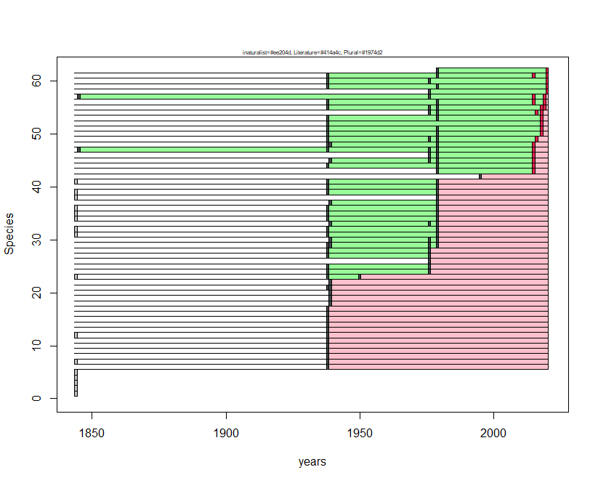
Species N | Species name | first occ. | last occ.
1 | Hesperia comma | NA | NA
2 | Lasiommata maera | NA | NA
3 | Lycaena dispar | NA | NA
4 | Melanargia arge | NA | NA
5 | Hipparchia sbordonii | NA | NA
6 | Glaucopsyche alexis | 1939 | 1939
7 | Pyrgus malvoides | 1939 | 1939
8 | Thymelicus acteon | 1939 | 1939
9 | Pontia edusa | 1939 | 1939
10 | Pieris mannii | 1939 | 1939
11 | Anthocharis cardamines | 1939 | 1939
12 | Callophrys rubi | 1939 | 1939
13 | Polygonia egea | 1939 | 1939
14 | Brenthis daphne | 1939 | 1939
15 | Hipparchia fagi | 1939 | 1939
16 | Melitaea didyma | 1939 | 1939
17 | Issoria lathonia | 1939 | 1939
18 | Carcharodus alceae | 1940 | 1940
19 | Euchloe ausonia | 1940 | 1940
20 | Lysandra bellargus | 1940 | 1940
21 | Limenitis reducta | 1939 | 1940
22 | Hipparchia semele | 1940 | 1940
23 | Speyeria aglaja | 1939 | 1951
24 | Melitaea cinxia | 1939 | 1977
25 | Gegenes pumilio | 1939 | 1977
26 | Lycaena alciphron | 1977 | 1977
27 | Melitaea phoebe | 1939 | 1977
28 | Pyronia cecilia | 1939 | 1977
29 | Papilio machaon | 1939 | 1980
30 | Pieris brassicae | 1940 | 1980
31 | Pieris napi | 1939 | 1980
32 | Leptidea sinapis | 1939 | 1980
33 | Favonius quercus | 1940 | 1980
34 | Celastrina argiolus | 1939 | 1980
35 | Aricia agestis | 1939 | 1980
36 | Polygonia c-album | 1939 | 1980
37 | Argynnis paphia | 1940 | 1980
38 | Hipparchia hermione | 1980 | 1980
39 | Hipparchia statilinus | 1939 | 1980
40 | Melanargia galathea | 1939 | 1980
41 | Coenonympha pamphilus | 1939 | 1980
42 | Cacyreus marshalli | 1996 | 1996
43 | Ochlodes sylvanus | 1980 | 2016
44 | Pieris rapae | 1939 | 2016
45 | Colias crocea | 1940 | 2016
46 | Lampides boeticus | 1977 | 2016
47 | Polyommatus icarus | 1846 | 2016
48 | Pararge aegeria | 1939 | 2016
49 | Lycaena phlaeas | 1939 | 2017
50 | Iphiclides podalirius | 1939 | 2019
51 | Gonepteryx cleopatra | 1939 | 2019
52 | Aglais io | 1939 | 2019
53 | Vanessa cardui | 1939 | 2019
54 | Charaxes jasius | 1977 | 2019
55 | Satyrium ilicis | 1939 | 2020
56 | Vanessa atalanta | 1939 | 2020
57 | Leptotes pirithous | 1846 | 2020
58 | Zerynthia cassandra | 1977 | 2021
59 | Gonepteryx rhamni | 1939 | 2021
60 | Nymphalis polychloros | 1939 | 2021
61 | Maniola jurtina | 1939 | 2021
62 | Lasiommata megera | 1980 | 2021

Parco Nazionale dell'Alta Murgia
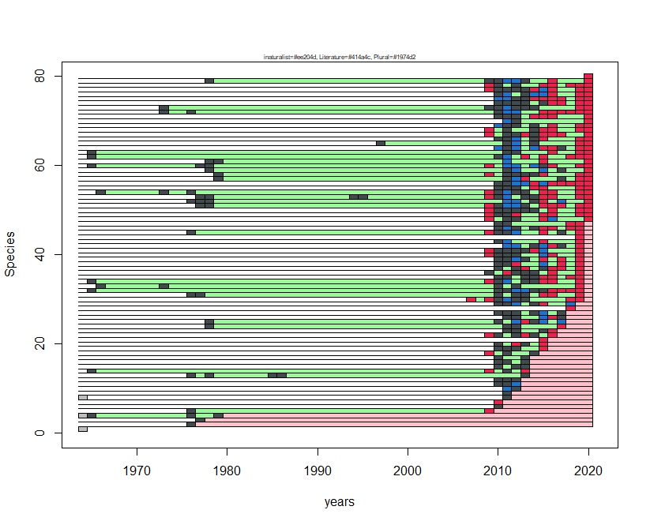
Species N | Species name | first occ. | last occ.
1 | Melitaea cinxia | NA | NA
2 | Brenthis daphne | 1977 | 1977
3 | Hyponephele lycaon | 1978 | 1978
4 | Hyponephele lupina | 1966 | 1980
5 | Lysandra coridon | 1977 | 2010
6 | Argynnis paphia | 2011 | 2011
7 | Melitaea trivia | 2011 | 2011
8 | Pyrgus onopordi | 2012 | 2012
9 | Aglais io | 2012 | 2012
10 | Thymelicus acteon | 2012 | 2013
11 | Satyrium w-album | 2011 | 2013
12 | Favonius quercus | 2011 | 2013
13 | Carcharodus baeticus | 1977 | 2014
14 | Polyommatus thersites | 1966 | 2014
15 | Gegenes nostrodamus | 2011 | 2014
16 | Leptotes pirithous | 2011 | 2014
17 | Gegenes pumilio | 2011 | 2014
18 | Gonepteryx cleopatra | 2010 | 2015
19 | Pieris brassicae | 2011 | 2016
20 | Thymelicus sylvestris | 2011 | 2016
21 | Pyrgus armoricanus | 2016 | 2016
22 | Pyrgus sidae | 2010 | 2017
23 | Lampides boeticus | 2012 | 2017
24 | Polygonia egea | 1979 | 2018
25 | Anthocharis cardamines | 1979 | 2018
26 | Cupido minimus | 2012 | 2018
27 | Nymphalis polychloros | 2011 | 2018
28 | Lycaena thersamon | 2019 | 2019
29 | Zerynthia cassandra | 2011 | 2019
30 | Iphiclides podalirius | 2008 | 2020
31 | Melanargia galathea | 1977 | 2020
32 | Carcharodus floccifera | 1966 | 2020
33 | Thymelicus lineola | 1967 | 2020
34 | Hipparchia semele | 1966 | 2020
35 | Pieris napi | 2011 | 2020
36 | Colias crocea | 2010 | 2020
37 | Colias alfacariensis | 2011 | 2020
38 | Celastrina argiolus | 2011 | 2020
39 | Maniola jurtina | 2011 | 2020
40 | Hipparchia statilinus | 2010 | 2020
41 | Muschampia proto | 2010 | 2020
42 | Libythea celtis | 2012 | 2020
43 | Melitaea phoebe | 2011 | 2020
44 | Polygonia c-album | 2020 | 2020
45 | Aporia crataegi | 1977 | 2020
46 | Gonepteryx rhamni | 2011 | 2020
47 | Lasiommata maera | 2011 | 2020
48 | Glaucopsyche alexis | 2010 | 2021
49 | Issoria lathonia | 2010 | 2021
50 | Pieris rapae | 2010 | 2021
51 | Melanargia russiae | 1978 | 2021
52 | Brenthis hecate | 1977 | 2021
53 | Melanargia arge | 1978 | 2021
54 | Melitaea didyma | 1967 | 2021
55 | Pararge aegeria | 2011 | 2021
56 | Papilio machaon | 2011 | 2021
57 | Pontia edusa | 1980 | 2021
58 | Euchloe ausonia | 1980 | 2021
59 | Satyrium acaciae | 1979 | 2021
60 | Satyrium spini | 1966 | 2021
61 | Lycaena phlaeas | 1979 | 2021
62 | Spialia sertorius | 1966 | 2021
63 | Carcharodus alceae | 1966 | 2021
64 | Satyrium ilicis | 2011 | 2021
65 | Ochlodes sylvanus | 1998 | 2021
66 | Callophrys rubi | 2011 | 2021
67 | Pseudophilotes baton | 2010 | 2021
68 | Aricia agestis | 2010 | 2021
69 | Polyommatus icarus | 2011 | 2021
70 | Vanessa atalanta | 2012 | 2021
71 | Vanessa cardui | 2011 | 2021
72 | Limenitis reducta | 1974 | 2021
73 | Lasiommata megera | 1974 | 2021
74 | Coenonympha pamphilus | 2011 | 2021
75 | Pyronia cecilia | 2011 | 2021
76 | Pyrgus malvoides | 2011 | 2021
77 | Lysandra bellargus | 2010 | 2021
78 | Argynnis pandora | 2010 | 2021
79 | Brintesia circe | 1979 | 2021
80 | Cacyreus marshalli | 2021 | 2021

Parco Nazionale dell'Appennino Lucano - Val d'Agri - Lagonegrese
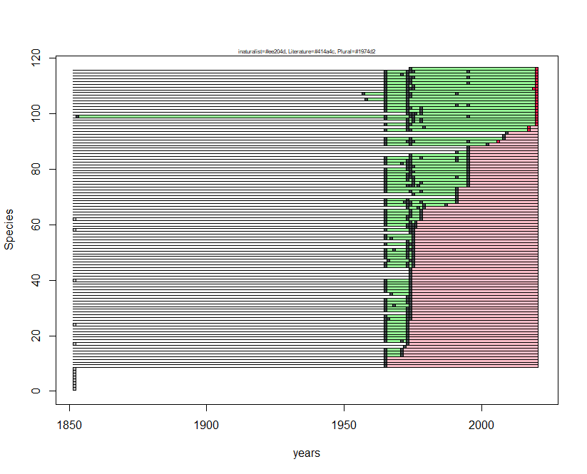
Species N | Species name | first occ. | last occ.
1 | Thymelicus acteon | NA | NA
2 | Parnassius mnemosyne | NA | NA
3 | Lysandra coridon | NA | NA
4 | Iolana iolas | NA | NA
5 | Charaxes jasius | NA | NA
6 | Hipparchia neapolitana | NA | NA
7 | Satyrium spini | NA | NA
8 | Gegenes pumilio | NA | NA
9 | Lampides boeticus | 1966 | 1966
10 | Melitaea trivia | 1966 | 1966
11 | Lysandra bellargus | 1966 | 1966
12 | Polyommatus dorylas | 1966 | 1966
13 | Lasiommata maera | 1966 | 1972
14 | Cupido osiris | 1966 | 1972
15 | Hamearis lucina | 1966 | 1972
16 | Pyrgus onopordi | 1973 | 1973
17 | Gonepteryx cleopatra | 1974 | 1974
18 | Lycaena alciphron | 1966 | 1974
19 | Favonius quercus | 1966 | 1974
20 | Pseudophilotes baton | 1966 | 1974
21 | Vanessa atalanta | 1966 | 1974
22 | Aglais urticae | 1966 | 1974
23 | Hipparchia fagi | 1966 | 1974
24 | Chazara briseis | 1966 | 1974
25 | Hyponephele lycaon | 1966 | 1974
26 | Carcharodus floccifera | 1966 | 1975
27 | Colias alfacariensis | 1966 | 1975
28 | Satyrium acaciae | 1974 | 1975
29 | Cupido minimus | 1966 | 1975
30 | Plebejus idas | 1966 | 1975
31 | Cyaniris semiargus | 1966 | 1975
32 | Polyommatus thersites | 1966 | 1975
33 | Fabriciana adippe | 1966 | 1975
34 | Argynnis paphia | 1974 | 1975
35 | Melanargia arge | 1968 | 1975
36 | Hyponephele lupina | 1966 | 1975
37 | Melitaea phoebe | 1966 | 1975
38 | Euchloe ausonia | 1966 | 1975
39 | Glaucopsyche alexis | 1966 | 1975
40 | Hesperia comma | 1966 | 1975
41 | Lycaena thersamon | 1975 | 1975
42 | Polyommatus daphnis | 1975 | 1975
43 | Polyommatus dolus | 1975 | 1975
44 | Gegenes nostrodamus | 1975 | 1975
45 | Polyommatus amandus | 1966 | 1976
46 | Fabriciana niobe | 1966 | 1976
47 | Argynnis pandora | 1967 | 1976
48 | Satyrus ferula | 1966 | 1976
49 | Hipparchia hermione | 1966 | 1976
50 | Pieris brassicae | 1966 | 1976
51 | Lycaena phlaeas | 1966 | 1976
52 | Nymphalis antiopa | 1974 | 1976
53 | Vanessa cardui | 1966 | 1976
54 | Speyeria aglaja | 1974 | 1976
55 | Boloria euphrosyne | 1966 | 1976
56 | Callophrys rubi | 1966 | 1976
57 | Muschampia proto | 1975 | 1976
58 | Euphydryas aurinia | 1966 | 1976
59 | Gonepteryx rhamni | 1974 | 1977
60 | Aporia crataegi | 1966 | 1977
61 | Pyrgus sidae | 1966 | 1977
62 | Eumedonia eumedon | 1966 | 1979
63 | Coenonympha arcania | 1966 | 1979
64 | Erynnis tages | 1966 | 1979
65 | Pyrgus armoricanus | 1966 | 1979
66 | Celastrina argiolus | 1974 | 1980
67 | Hipparchia semele | 1966 | 1988
68 | Carcharodus alceae | 1966 | 1992
69 | Pararge aegeria | 1966 | 1992
70 | Pyrgus carthami | 1992 | 1992
71 | Pyrgus malvoides | 1976 | 1992
72 | Spialia sertorius | 1966 | 1992
73 | Anthocharis cardamines | 1966 | 1992
74 | Leptidea sinapis | 1966 | 1996
75 | Polygonia c-album | 1966 | 1996
76 | Thymelicus lineola | 1966 | 1996
77 | Pontia edusa | 1966 | 1996
78 | Pieris rapae | 1966 | 1996
79 | Brenthis daphne | 1966 | 1996
80 | Melitaea didyma | 1966 | 1996
81 | Melanargia russiae | 1974 | 1996
82 | Pyronia cecilia | 1966 | 1996
83 | Lasiommata megera | 1966 | 1996
84 | Papilio machaon | 1966 | 1996
85 | Pieris mannii | 1975 | 1996
86 | Cupido alcetas | 1992 | 1996
87 | Brenthis hecate | 1996 | 1996
88 | Cupido argiades | 1996 | 1996
89 | Nymphalis polychloros | 1966 | 2003
90 | Maniola jurtina | 1966 | 2007
91 | Melitaea cinxia | 1966 | 2009
92 | Melitaea ornata | 2009 | 2009
93 | Zerynthia cassandra | 2010 | 2010
94 | Ochlodes sylvanus | 1966 | 2018
95 | Lycaena tityrus | 1974 | 2018
96 | Pieris napi | 1966 | 2021
97 | Plebejus argus | 1974 | 2021
98 | Aglais io | 1966 | 2021
99 | Melitaea celadussa | 1854 | 2021
100 | Pieris ergane | 1974 | 2021
101 | Thymelicus sylvestris | 1966 | 2021
102 | Iphiclides podalirius | 1966 | 2021
103 | Colias crocea | 1966 | 2021
104 | Satyrium ilicis | 1966 | 2021
105 | Aricia agestis | 1959 | 2021
106 | Polyommatus escheri | 1966 | 2021
107 | Polyommatus icarus | 1958 | 2021
108 | Polygonia egea | 1966 | 2021
109 | Issoria lathonia | 1966 | 2021
110 | Limenitis reducta | 1966 | 2021
111 | Brintesia circe | 1966 | 2021
112 | Hipparchia statilinus | 1966 | 2021
113 | Melanargia galathea | 1966 | 2021
114 | Pyronia tithonus | 1966 | 2021
115 | Coenonympha pamphilus | 1966 | 2021
116 | Leptotes pirithous | 1975 | 2021

Parco Nazionale dell'Aspromonte
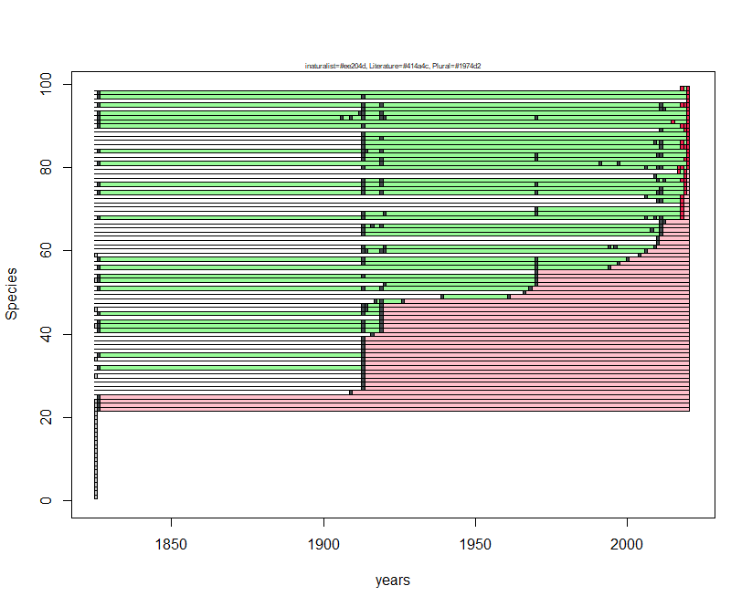
Species N | Species name | first occ. | last occ.
1 | Thymelicus acteon | NA | NA
2 | Pseudophilotes baton | NA | NA
3 | Satyrium w-album | NA | NA
4 | Gonepteryx rhamni | NA | NA
5 | Polyommatus amandus | NA | NA
6 | Speyeria aglaja | NA | NA
7 | Pyrgus onopordi | NA | NA
8 | Eumedonia eumedon | NA | NA
9 | Polyommatus thersites | NA | NA
10 | Brintesia circe | NA | NA
11 | Hyponephele lupina | NA | NA
12 | Gegenes nostrodamus | NA | NA
13 | Erynnis tages | NA | NA
14 | Pyrgus malvoides | NA | NA
15 | Thymelicus lineola | NA | NA
16 | Colias alfacariensis | NA | NA
17 | Nymphalis polychloros | NA | NA
18 | Pieris ergane | NA | NA
19 | Melanargia russiae | NA | NA
20 | Charaxes jasius | NA | NA
21 | Cupido minimus | NA | NA
22 | Favonius quercus | 1827 | 1827
23 | Callophrys rubi | 1827 | 1827
24 | Leptotes pirithous | 1827 | 1827
25 | Chazara briseis | 1827 | 1827
26 | Melanargia arge | 1910 | 1910
27 | Lycaena tityrus | 1914 | 1914
28 | Glaucopsyche alexis | 1914 | 1914
29 | Plebejus argus | 1914 | 1914
30 | Satyrium ilicis | 1914 | 1914
31 | Brenthis daphne | 1914 | 1914
32 | Melitaea phoebe | 1827 | 1914
33 | Pyrgus armoricanus | 1914 | 1914
34 | Carcharodus floccifera | 1914 | 1914
35 | Argynnis pandora | 1827 | 1914
36 | Fabriciana adippe | 1914 | 1914
37 | Aporia crataegi | 1914 | 1914
38 | Satyrium spini | 1914 | 1914
39 | Thymelicus sylvestris | 1914 | 1914
40 | Anthocharis cardamines | 1917 | 1917
41 | Aglais urticae | 1827 | 1920
42 | Hipparchia fagi | 1827 | 1920
43 | Lasiommata maera | 1827 | 1920
44 | Hyponephele lycaon | 1920 | 1920
45 | Nymphalis antiopa | 1827 | 1920
46 | Coenonympha arcania | 1914 | 1920
47 | Fabriciana niobe | 1914 | 1920
48 | Papilio alexanor | 1918 | 1927
49 | Gegenes pumilio | 1940 | 1962
50 | Zerynthia cassandra | 1967 | 1967
51 | Satyrus ferula | 1827 | 1969
52 | Pieris mannii | 1921 | 1971
53 | Polygonia c-album | 1827 | 1971
54 | Polygonia egea | 1827 | 1971
55 | Pyronia tithonus | 1971 | 1971
56 | Hipparchia semele | 1827 | 1995
57 | Leptidea sinapis | 1914 | 1998
58 | Hipparchia hermione | 1827 | 2001
59 | Melitaea cinxia | 2005 | 2005
60 | Melanargia galathea | 1914 | 2007
61 | Hipparchia blachieri | 1914 | 2010
62 | Celastrina argiolus | 2011 | 2011
63 | Gonepteryx cleopatra | 2011 | 2011
64 | Pieris rapae | 1914 | 2012
65 | Aricia agestis | 1914 | 2012
66 | Euchloe ausonia | 1914 | 2012
67 | Carcharodus alceae | 2012 | 2013
68 | Maniola jurtina | 1827 | 2019
69 | Pieris napi | 1914 | 2019
70 | Ochlodes sylvanus | 1971 | 2019
71 | Melitaea trivia | 2019 | 2019
72 | Lampides boeticus | 2011 | 2019
73 | Polyommatus icarus | 2007 | 2019
74 | Pararge aegeria | 1827 | 2020
75 | Pontia edusa | 1914 | 2020
76 | Argynnis paphia | 1827 | 2020
77 | Vanessa cardui | 1914 | 2020
78 | Papilio machaon | 2010 | 2020
79 | Hipparchia statilinus | 2018 | 2020
80 | Lycaena phlaeas | 1914 | 2021
81 | Anthocharis damone | 1827 | 2021
82 | Melitaea celadussa | 1914 | 2021
83 | Pieris brassicae | 1914 | 2021
84 | Melitaea didyma | 1827 | 2021
85 | Coenonympha pamphilus | 1914 | 2021
86 | Colias crocea | 1914 | 2021
87 | Lycaena alciphron | 1914 | 2021
88 | Cyaniris semiargus | 1914 | 2021
89 | Vanessa atalanta | 2012 | 2021
90 | Issoria lathonia | 1827 | 2021
91 | Boloria euphrosyne | 1827 | 2021
92 | Parnassius apollo | 1827 | 2021
93 | Parnassius mnemosyne | 1827 | 2021
94 | Pyronia cecilia | 1914 | 2021
95 | Lasiommata megera | 1827 | 2021
96 | Iphiclides podalirius | 2021 | 2021
97 | Aglais io | 1827 | 2021
98 | Limenitis reducta | 1827 | 2021
99 | Libythea celtis | 2019 | 2021

Parco Nazionale della Maiella
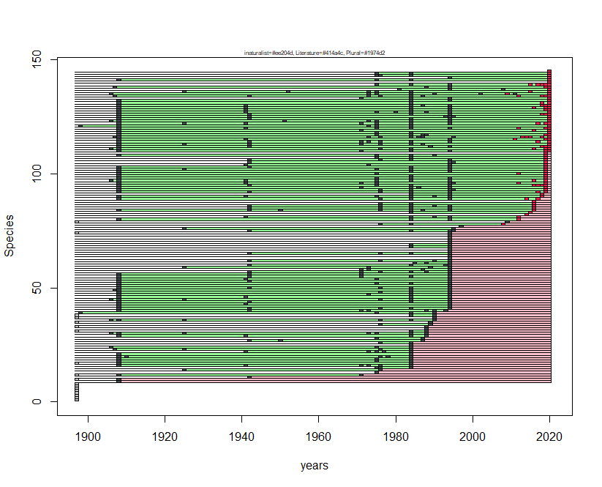
Species N | Species name | first occ. | last occ.
1 | Euchloe ausonia | NA | NA
2 | Erebia aethiops | NA | NA
3 | Erebia neoridas | NA | NA
4 | Hamearis lucina | NA | NA
5 | Coenonympha dorus | NA | NA
6 | Pyrgus malvoides | NA | NA
7 | Pyrgus onopordi | NA | NA
8 | Pyrgus sidae | NA | NA
9 | Eumedonia eumedon | 1909 | 1909
10 | Aricia artaxerxes | 1909 | 1909
11 | Cupido argiades | 1943 | 1943
12 | Pyrgus carthami | 1909 | 1972
13 | Erebia epiphron | 1976 | 1976
14 | Polyommatus escheri | 1926 | 1977
15 | Pyrgus foulquieri | 1976 | 1985
16 | Polyommatus dorylas | 1909 | 1985
17 | Pyrgus serratulae | 1909 | 1985
18 | Pyrgus alveus | 1909 | 1985
19 | Thymelicus lineola | 1909 | 1985
20 | Lycaena alciphron | 1909 | 1985
21 | Satyrium acaciae | 1909 | 1985
22 | Chazara briseis | 1942 | 1985
23 | Polyommatus dolus | 1908 | 1985
24 | Hipparchia hermione | 1907 | 1985
25 | Phengaris alcon | 1985 | 1985
26 | Boloria pales | 1977 | 1985
27 | Lycaena thersamon | 1943 | 1988
28 | Argynnis pandora | 1976 | 1988
29 | Nymphalis antiopa | 1909 | 1989
30 | Hyponephele lycaon | 1907 | 1989
31 | Brenthis hecate | 1985 | 1989
32 | Zerynthia cassandra | 1989 | 1989
33 | Fabriciana adippe | 1989 | 1989
34 | Hyponephele lupina | 1977 | 1990
35 | Cupido osiris | 1990 | 1990
36 | Polyommatus eros | 1907 | 1991
37 | Favonius quercus | 1991 | 1991
38 | Plebejus argyrognomon | 1985 | 1991
39 | Coenonympha rhodopensis | 1899 | 1991
40 | Parnassius mnemosyne | 1909 | 1994
41 | Colias crocea | 1909 | 1995
42 | Polyommatus amandus | 1909 | 1995
43 | Melitaea phoebe | 1909 | 1995
44 | Carcharodus floccifera | 1909 | 1995
45 | Pieris ergane | 1907 | 1995
46 | Gonepteryx cleopatra | 1909 | 1995
47 | Satyrium spini | 1909 | 1995
48 | Pseudophilotes baton | 1909 | 1995
49 | Pyronia cecilia | 1908 | 1995
50 | Leptidea sinapis | 1909 | 1995
51 | Carcharodus lavatherae | 1909 | 1995
52 | Thymelicus acteon | 1909 | 1995
53 | Satyrium ilicis | 1909 | 1995
54 | Polygonia c-album | 1909 | 1995
55 | Aporia crataegi | 1909 | 1995
56 | Thymelicus sylvestris | 1909 | 1995
57 | Lycaena phlaeas | 1943 | 1995
58 | Aricia agestis | 1972 | 1995
59 | Polyommatus damon | 1926 | 1995
60 | Lampides boeticus | 1943 | 1995
61 | Libythea celtis | 1986 | 1995
62 | Pontia edusa | 1943 | 1995
63 | Carcharodus alceae | 1995 | 1995
64 | Nymphalis polychloros | 1995 | 1995
65 | Gonepteryx rhamni | 1943 | 1995
66 | Glaucopsyche alexis | 1995 | 1995
67 | Melitaea cinxia | 1995 | 1995
68 | Melitaea trivia | 1985 | 1995
69 | Hipparchia fagi | 1985 | 1995
70 | Pieris mannii | 1995 | 1995
71 | Spialia sertorius | 1995 | 1995
72 | Carcharodus baeticus | 1995 | 1995
73 | Pyrgus armoricanus | 1995 | 1995
74 | Apatura ilia | 1995 | 1995
75 | Anthocharis cardamines | 1943 | 1996
76 | Anthocharis euphenoides | 1926 | 1996
77 | Thecla betulae | 1998 | 1998
78 | Plebejus idas | 1977 | 2009
79 | Leptidea reali | 2010 | 2010
80 | Cupido alcetas | 1909 | 2013
81 | Aglais io | 1942 | 2013
82 | Cacyreus marshalli | 2015 | 2015
83 | Boloria euphrosyne | 1985 | 2016
84 | Polyommatus daphnis | 1909 | 2017
85 | Leptotes pirithous | 1943 | 2017
86 | Pieris rapae | 1943 | 2017
87 | Lycaena hippothoe | 1977 | 2017
88 | Satyrium w-album | 2017 | 2017
89 | Lycaena tityrus | 1909 | 2018
90 | Vanessa cardui | 1909 | 2019
91 | Brenthis daphne | 1985 | 2019
92 | Pieris brassicae | 1909 | 2020
93 | Colias alfacariensis | 1909 | 2020
94 | Cyaniris semiargus | 1909 | 2020
95 | Argynnis paphia | 1909 | 2020
96 | Coenonympha pamphilus | 1909 | 2020
97 | Maniola jurtina | 1907 | 2020
98 | Hipparchia semele | 1909 | 2020
99 | Phengaris arion | 1909 | 2020
100 | Erynnis tages | 1909 | 2020
101 | Vanessa atalanta | 1909 | 2020
102 | Melitaea didyma | 1909 | 2020
103 | Issoria lathonia | 1909 | 2020
104 | Pyronia tithonus | 1942 | 2020
105 | Callophrys rubi | 1943 | 2020
106 | Polyommatus thersites | 1943 | 2020
107 | Melitaea varia | 1976 | 2020
108 | Erebia gorge | 1909 | 2020
109 | Heteropterus morpheus | 2020 | 2020
110 | Pieris napi | 1909 | 2021
111 | Lycaena virgaureae | 1907 | 2021
112 | Celastrina argiolus | 1909 | 2021
113 | Plebejus argus | 1909 | 2021
114 | Polyommatus icarus | 1909 | 2021
115 | Lysandra bellargus | 1909 | 2021
116 | Lysandra coridon | 1908 | 2021
117 | Speyeria aglaja | 1909 | 2021
118 | Fabriciana niobe | 1909 | 2021
119 | Melitaea celadussa | 1909 | 2021
120 | Lasiommata megera | 1909 | 2021
121 | Erebia meolans | 1899 | 2021
122 | Melanargia galathea | 1909 | 2021
123 | Satyrus ferula | 1907 | 2021
124 | Ochlodes sylvanus | 1909 | 2021
125 | Papilio machaon | 1909 | 2021
126 | Iphiclides podalirius | 1909 | 2021
127 | Aglais urticae | 1909 | 2021
128 | Polygonia egea | 1909 | 2021
129 | Limenitis reducta | 1909 | 2021
130 | Pararge aegeria | 1909 | 2021
131 | Lasiommata maera | 1909 | 2021
132 | Coenonympha arcania | 1909 | 2021
133 | Cupido minimus | 1972 | 2021
134 | Parnassius apollo | 1908 | 2021
135 | Erebia cassioides | 1907 | 2021
136 | Melanargia russiae | 1926 | 2021
137 | Euphydryas aurinia | 1982 | 2021
138 | Hipparchia statilinus | 1908 | 2021
139 | Brintesia circe | 1976 | 2021
140 | Melitaea diamina | 2021 | 2021
141 | Erebia ligea | 1909 | 2021
142 | Melanargia arge | 1995 | 2021
143 | Hesperia comma | 1976 | 2021
144 | Erebia pluto | 1976 | 2021
145 | Erebia albergana | 2021 | 2021

Parco Nazionale dell'Arcipelago Toscano
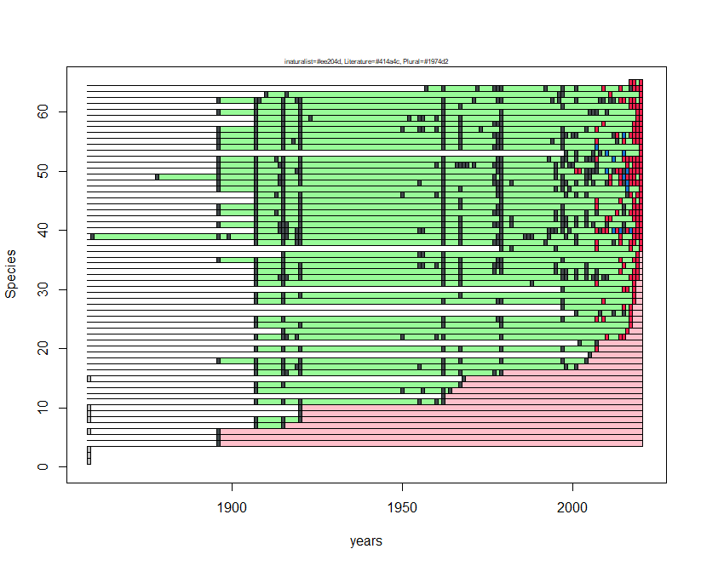
Species N | Species name | first occ. | last occ.
1 | Libythea celtis | NA | NA
2 | Thymelicus sylvestris | NA | NA
3 | Aglais io | NA | NA
4 | Polyommatus escheri | 1897 | 1897
5 | Lysandra bellargus | 1897 | 1897
6 | Carcharodus floccifera | 1897 | 1897
7 | Nymphalis polychloros | 1908 | 1916
8 | Argynnis paphia | 1908 | 1921
9 | Melitaea cinxia | 1921 | 1921
10 | Polygonia c-album | 1921 | 1921
11 | Spialia sertorius | 1908 | 1963
12 | Gegenes nostrodamus | 1963 | 1963
13 | Gegenes pumilio | 1908 | 1965
14 | Aglais urticae | 1908 | 1968
15 | Colias alfacariensis | 1969 | 1969
16 | Leptidea sinapis | 1908 | 1980
17 | Pieris mannii | 1908 | 2002
18 | Pontia edusa | 1897 | 2005
19 | Pyrgus malvoides | 2006 | 2006
20 | Coenonympha pamphilus | 1908 | 2008
21 | Gonepteryx rhamni | 2003 | 2008
22 | Hipparchia statilinus | 1908 | 2016
23 | Glaucopsyche alexis | 1916 | 2017
24 | Favonius quercus | 1908 | 2018
25 | Carcharodus alceae | 1908 | 2018
26 | Danaus chrysippus | 2002 | 2018
27 | Anthocharis cardamines | 1998 | 2018
28 | Pieris napi | 1908 | 2019
29 | Melitaea celadussa | 1908 | 2019
30 | Callophrys rubi | 1998 | 2019
31 | Thymelicus acteon | 1908 | 2019
32 | Pieris brassicae | 1908 | 2020
33 | Lampides boeticus | 1908 | 2020
34 | Pyronia cecilia | 1908 | 2020
35 | Issoria lathonia | 1897 | 2020
36 | Pyrgus armoricanus | 1916 | 2020
37 | Lasiommata paramegaera | 1980 | 2021
38 | Hipparchia neomiris | 1908 | 2021
39 | Hipparchia aristaeus | 1860 | 2021
40 | Coenonympha corinna | 1908 | 2021
41 | Pieris rapae | 1897 | 2021
42 | Colias crocea | 1908 | 2021
43 | Gonepteryx cleopatra | 1897 | 2021
44 | Lycaena phlaeas | 1897 | 2021
45 | Satyrium ilicis | 1908 | 2021
46 | Leptotes pirithous | 1908 | 2021
47 | Celastrina argiolus | 1897 | 2021
48 | Vanessa atalanta | 1897 | 2021
49 | Vanessa cardui | 1879 | 2021
50 | Charaxes jasius | 1897 | 2021
51 | Maniola jurtina | 1897 | 2021
52 | Papilio machaon | 1897 | 2021
53 | Cacyreus marshalli | 1999 | 2021
54 | Polyommatus icarus | 1897 | 2021
55 | Pararge aegeria | 1897 | 2021
56 | Lasiommata megera | 1897 | 2021
57 | Aricia agestis | 1897 | 2021
58 | Pyronia tithonus | 1908 | 2021
59 | Melitaea didyma | 1908 | 2021
60 | Limenitis reducta | 1897 | 2021
61 | Iphiclides podalirius | 1908 | 2021
62 | Argynnis pandora | 1897 | 2021
63 | Euchloe ausonia | 1911 | 2021
64 | Plebejus bellieri | 1958 | 2021
65 | Zerynthia cassandra | 2018 | 2021

Parco Nazionale dei Monti Sibillini
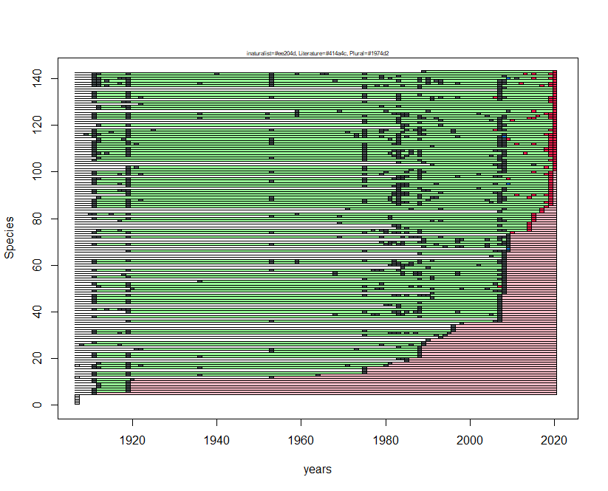
Species N | Species name | first occ. | last occ.
1 | Argynnis pandora | NA | NA
2 | Thecla betulae | NA | NA
3 | Lycaena thersamon | NA | NA
4 | Satyrium w-album | NA | NA
5 | Pieris mannii | 1912 | 1912
6 | Pyrgus onopordi | 1912 | 1920
7 | Spialia sertorius | 1912 | 1920
8 | Carcharodus lavatherae | 1913 | 1920
9 | Pyrgus carthami | 1913 | 1920
10 | Pyrgus malvoides | 1912 | 1920
11 | Cupido alcetas | 1912 | 1921
12 | Carcharodus floccifera | 1954 | 1954
13 | Libythea celtis | 1912 | 1965
14 | Erynnis tages | 1912 | 1976
15 | Thymelicus lineola | 1976 | 1976
16 | Pyrgus alveus | 1912 | 1976
17 | Carcharodus baeticus | 1912 | 1981
18 | Pyrgus serratulae | 1913 | 1982
19 | Polygonia egea | 1986 | 1986
20 | Plebejus argyrognomon | 1984 | 1986
21 | Pseudophilotes baton | 1912 | 1989
22 | Hipparchia fagi | 1912 | 1989
23 | Nymphalis polychloros | 1954 | 1989
24 | Phengaris alcon | 1922 | 1989
25 | Aricia artaxerxes | 1984 | 1989
26 | Coenonympha dorus | 1909 | 1990
27 | Pyronia cecilia | 1912 | 1990
28 | Polyommatus escheri | 1991 | 1991
29 | Melitaea diamina | 1994 | 1994
30 | Hyponephele lupina | 1976 | 1995
31 | Polyommatus daphnis | 1912 | 1996
32 | Thymelicus sylvestris | 1912 | 1997
33 | Iolana iolas | 1997 | 1997
34 | Limenitis camilla | 1997 | 1997
35 | Pyrgus sidae | 1999 | 1999
36 | Aporia crataegi | 1920 | 2008
37 | Callophrys rubi | 2008 | 2008
38 | Boloria euphrosyne | 1912 | 2008
39 | Euphydryas aurinia | 1969 | 2008
40 | Melitaea didyma | 1920 | 2008
41 | Melitaea celadussa | 1912 | 2008
42 | Pararge aegeria | 1984 | 2008
43 | Euchloe ausonia | 1981 | 2008
44 | Favonius quercus | 1912 | 2008
45 | Satyrium ilicis | 1912 | 2008
46 | Celastrina argiolus | 1912 | 2008
47 | Lasiommata megera | 1912 | 2008
48 | Anthocharis cardamines | 1992 | 2009
49 | Pieris rapae | 1912 | 2009
50 | Pieris ergane | 1921 | 2009
51 | Erebia ligea | 1913 | 2009
52 | Colias crocea | 1912 | 2009
53 | Gonepteryx rhamni | 1937 | 2009
54 | Cupido minimus | 1976 | 2009
55 | Glaucopsyche alexis | 1912 | 2009
56 | Melitaea cinxia | 1919 | 2009
57 | Melitaea phoebe | 1969 | 2009
58 | Parnassius mnemosyne | 1912 | 2009
59 | Satyrium acaciae | 1985 | 2009
60 | Hipparchia statilinus | 1982 | 2009
61 | Erebia epiphron | 1912 | 2009
62 | Erebia meolans | 1912 | 2009
63 | Pontia edusa | 2009 | 2009
64 | Apatura ilia | 2006 | 2009
65 | Lampides boeticus | 1989 | 2009
66 | Leptidea sinapis | 1920 | 2010
67 | Nymphalis antiopa | 2010 | 2010
68 | Brenthis hecate | 1990 | 2010
69 | Lycaena hippothoe | 1912 | 2010
70 | Melitaea trivia | 1980 | 2010
71 | Coenonympha glycerion | 1990 | 2010
72 | Coenonympha rhodopensis | 1912 | 2010
73 | Leptidea reali | 2010 | 2010
74 | Fabriciana niobe | 1912 | 2011
75 | Phengaris arion | 1913 | 2015
76 | Plebejus idas | 1984 | 2015
77 | Eumedonia eumedon | 1983 | 2015
78 | Heteropterus morpheus | 1970 | 2015
79 | Cupido osiris | 1918 | 2016
80 | Lycaena phlaeas | 1912 | 2016
81 | Erebia pluto | 1954 | 2016
82 | Erebia gorge | 1911 | 2016
83 | Hamearis lucina | 2008 | 2018
84 | Anthocharis euphenoides | 1972 | 2018
85 | Thymelicus acteon | 1912 | 2019
86 | Fabriciana adippe | 1912 | 2020
87 | Maniola jurtina | 1912 | 2020
88 | Lycaena alciphron | 1912 | 2020
89 | Polyommatus amandus | 1913 | 2020
90 | Argynnis paphia | 1920 | 2020
91 | Limenitis reducta | 1912 | 2020
92 | Lasiommata maera | 1912 | 2020
93 | Brintesia circe | 1984 | 2020
94 | Pyronia tithonus | 1920 | 2020
95 | Satyrium spini | 1912 | 2020
96 | Aricia agestis | 1912 | 2020
97 | Speyeria aglaja | 1912 | 2020
98 | Brenthis daphne | 1984 | 2020
99 | Hipparchia semele | 1912 | 2020
100 | Erebia albergana | 1912 | 2020
101 | Pieris brassicae | 1920 | 2021
102 | Pieris napi | 1920 | 2021
103 | Iphiclides podalirius | 1992 | 2021
104 | Lycaena tityrus | 1984 | 2021
105 | Issoria lathonia | 1912 | 2021
106 | Coenonympha arcania | 1913 | 2021
107 | Coenonympha pamphilus | 1912 | 2021
108 | Erebia neoridas | 1912 | 2021
109 | Melanargia galathea | 1912 | 2021
110 | Ochlodes sylvanus | 1912 | 2021
111 | Colias alfacariensis | 1912 | 2021
112 | Lycaena virgaureae | 1912 | 2021
113 | Cyaniris semiargus | 1912 | 2021
114 | Polyommatus dorylas | 1913 | 2021
115 | Polyommatus icarus | 1912 | 2021
116 | Lysandra coridon | 1910 | 2021
117 | Polyommatus dolus | 1912 | 2021
118 | Polyommatus damon | 1912 | 2021
119 | Vanessa atalanta | 1985 | 2021
120 | Vanessa cardui | 1913 | 2021
121 | Aglais io | 1976 | 2021
122 | Aglais urticae | 1976 | 2021
123 | Hyponephele lycaon | 1912 | 2021
124 | Satyrus ferula | 1912 | 2021
125 | Chazara briseis | 1912 | 2021
126 | Boloria pales | 1960 | 2021
127 | Pyrgus armoricanus | 1913 | 2021
128 | Pyrgus foulquieri | 1913 | 2021
129 | Carcharodus alceae | 1923 | 2021
130 | Hesperia comma | 1912 | 2021
131 | Papilio machaon | 1984 | 2021
132 | Plebejus argus | 1912 | 2021
133 | Polyommatus thersites | 1912 | 2021
134 | Polygonia c-album | 1912 | 2021
135 | Boloria dia | 2008 | 2021
136 | Hipparchia hermione | 1976 | 2021
137 | Melanargia russiae | 1912 | 2021
138 | Lysandra bellargus | 1912 | 2021
139 | Melitaea varia | 1912 | 2021
140 | Erebia cassioides | 1912 | 2021
141 | Polyommatus eros | 1912 | 2021
142 | Parnassius apollo | 1912 | 2021
143 | Leptotes pirithous | 1990 | 2021

Parco Nazionale del Gran Paradiso
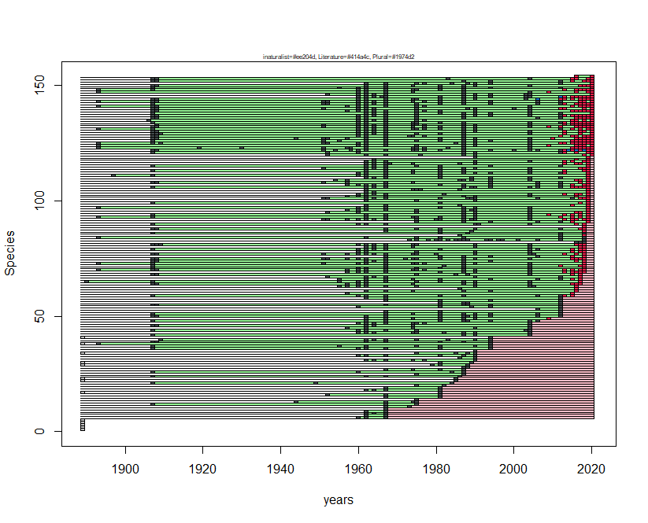
Species N | Species name | first occ. | last occ.
1 | Pyrgus warrenensis | NA | NA
2 | Pontia edusa | NA | NA
3 | Erebia pharte | NA | NA
4 | Pyrgus onopordi | NA | NA
5 | Satyrium ilicis | NA | NA
6 | Pyrgus cacaliae | 1961 | 1968
7 | Lycaena phlaeas | 1963 | 1968
8 | Aglais io | 1963 | 1968
9 | Celastrina argiolus | 1963 | 1968
10 | Boloria dia | 1968 | 1968
11 | Parnassius mnemosyne | 1968 | 1974
12 | Plebejus argyrognomon | 1908 | 1976
13 | Boloria selene | 1945 | 1976
14 | Erebia meolans | 1976 | 1976
15 | Thymelicus acteon | 1968 | 1982
16 | Colias crocea | 1953 | 1982
17 | Favonius quercus | 1982 | 1982
18 | Melitaea deione | 1963 | 1982
19 | Pararge aegeria | 1968 | 1982
20 | Melitaea parthenoides | 1976 | 1983
21 | Pieris mannii | 1908 | 1985
22 | Phengaris alcon | 1986 | 1986
23 | Pyronia tithonus | 1986 | 1986
24 | Cupido osiris | 1908 | 1987
25 | Carcharodus alceae | 1976 | 1988
26 | Pyrgus serratulae | 1908 | 1988
27 | Aphantopus hyperantus | 1968 | 1988
28 | Carcharodus floccifera | 1988 | 1989
29 | Iolana iolas | 1980 | 1989
30 | Nymphalis polychloros | 1982 | 1990
31 | Euchloe simplonia | 1963 | 1991
32 | Pyrgus andromedae | 1987 | 1991
33 | Erynnis tages | 1961 | 1991
34 | Limenitis populi | 1976 | 1991
35 | Libythea celtis | 1991 | 1991
36 | Satyrium spini | 1908 | 1995
37 | Kretania trappi | 1908 | 1995
38 | Argynnis pandora | 1894 | 1995
39 | Brenthis daphne | 1908 | 1995
40 | Melitaea aurelia | 1910 | 1995
41 | Hipparchia hermione | 1995 | 1995
42 | Aricia artaxerxes | 1908 | 2005
43 | Euphydryas aurinia | 1961 | 2005
44 | Pyrgus alveus | 1908 | 2005
45 | Agriades orbitulus | 1958 | 2005
46 | Erebia gorge | 1908 | 2005
47 | Pieris bryoniae | 1961 | 2005
48 | Lysandra bellargus | 1908 | 2007
49 | Plebejus idas | 1963 | 2010
50 | Colias alfacariensis | 1908 | 2013
51 | Leptidea sinapis | 1908 | 2013
52 | Polyommatus thersites | 1968 | 2013
53 | Brintesia circe | 2007 | 2013
54 | Iphiclides podalirius | 1961 | 2013
55 | Hipparchia fagi | 1908 | 2013
56 | Hipparchia statilinus | 1982 | 2013
57 | Lasiommata megera | 1968 | 2013
58 | Aricia agestis | 1963 | 2013
59 | Thymelicus sylvestris | 1908 | 2016
60 | Colias palaeno | 1958 | 2016
61 | Pyrgus carthami | 1963 | 2017
62 | Hamearis lucina | 1987 | 2017
63 | Phengaris arion | 1956 | 2017
64 | Boloria pales | 1908 | 2018
65 | Polyommatus eros | 1891 | 2018
66 | Polyommatus icarus | 1956 | 2018
67 | Pieris rapae | 1953 | 2018
68 | Erebia ligea | 1908 | 2018
69 | Hesperia comma | 1958 | 2019
70 | Colias phicomone | 1894 | 2019
71 | Plebejus argus | 1908 | 2019
72 | Aricia nicias | 1908 | 2019
73 | Boloria napaea | 1894 | 2019
74 | Melitaea diamina | 1908 | 2019
75 | Euphydryas cynthia | 1908 | 2019
76 | Thymelicus lineola | 1968 | 2019
77 | Pontia callidice | 1908 | 2019
78 | Agriades glandon | 1961 | 2019
79 | Fabriciana adippe | 1908 | 2019
80 | Erebia mnestra | 1963 | 2019
81 | Erebia pandrose | 1908 | 2019
82 | Cacyreus marshalli | 2017 | 2019
83 | Polyommatus humedasae | 1974 | 2019
84 | Carcharodus lavatherae | 1894 | 2019
85 | Glaucopsyche alexis | 1987 | 2019
86 | Polyommatus daphnis | 1908 | 2019
87 | Polygonia c-album | 1968 | 2019
88 | Argynnis paphia | 1908 | 2019
89 | Limenitis camilla | 2019 | 2019
90 | Lycaena tityrus | 1908 | 2019
91 | Ochlodes sylvanus | 1976 | 2020
92 | Aglais urticae | 1952 | 2020
93 | Fabriciana niobe | 1894 | 2020
94 | Erebia euryale | 1908 | 2020
95 | Oeneis glacialis | 1953 | 2020
96 | Pyrgus malvoides | 1958 | 2020
97 | Spialia sertorius | 1894 | 2020
98 | Callophrys rubi | 1963 | 2020
99 | Pseudophilotes baton | 1908 | 2020
100 | Agriades optilete | 1963 | 2020
101 | Nymphalis antiopa | 1952 | 2020
102 | Boloria euphrosyne | 1958 | 2020
103 | Melitaea cinxia | 1961 | 2020
104 | Erebia pluto | 1963 | 2020
105 | Erebia triarius | 1963 | 2020
106 | Pieris napi | 1908 | 2020
107 | Coenonympha pamphilus | 1958 | 2020
108 | Maniola jurtina | 1908 | 2020
109 | Anthocharis cardamines | 1955 | 2020
110 | Gonepteryx rhamni | 1963 | 2020
111 | Lycaena alciphron | 1898 | 2020
112 | Cupido minimus | 1961 | 2020
113 | Polyommatus dorylas | 1908 | 2020
114 | Vanessa cardui | 1952 | 2020
115 | Hipparchia semele | 1908 | 2020
116 | Lasiommata petropolitana | 1963 | 2020
117 | Vanessa atalanta | 1963 | 2020
118 | Erebia medusa | 1965 | 2020
119 | Carterocephalus palaemon | 1991 | 2020
120 | Pyrgus carlinae | 1953 | 2021
121 | Papilio machaon | 1908 | 2021
122 | Parnassius apollo | 1908 | 2021
123 | Parnassius phoebus | 1894 | 2021
124 | Lycaena hippothoe | 1894 | 2021
125 | Lycaena virgaureae | 1894 | 2021
126 | Cyaniris semiargus | 1908 | 2021
127 | Speyeria aglaja | 1908 | 2021
128 | Boloria titania | 1908 | 2021
129 | Melitaea varia | 1908 | 2021
130 | Erebia melampus | 1908 | 2021
131 | Hyponephele lycaon | 1894 | 2021
132 | Erebia albergana | 1908 | 2021
133 | Coenonympha gardetta | 1909 | 2021
134 | Lysandra coridon | 1908 | 2021
135 | Brenthis ino | 1907 | 2021
136 | Melitaea didyma | 1908 | 2021
137 | Melitaea phoebe | 1908 | 2021
138 | Melitaea celadussa | 1908 | 2021
139 | Erebia cassioides | 1908 | 2021
140 | Erebia epiphron | 1908 | 2021
141 | Erebia montana | 1894 | 2021
142 | Melanargia galathea | 1908 | 2021
143 | Satyrus ferula | 1894 | 2021
144 | Lasiommata maera | 1908 | 2021
145 | Aporia crataegi | 1961 | 2021
146 | Pieris brassicae | 1953 | 2021
147 | Eumedonia eumedon | 1894 | 2021
148 | Polyommatus damon | 1894 | 2021
149 | Polyommatus escheri | 1908 | 2021
150 | Issoria lathonia | 1908 | 2021
151 | Limenitis reducta | 1963 | 2021
152 | Coenonympha arcania | 1908 | 2021
153 | Erebia aethiops | 1908 | 2021
154 | Apatura iris | 2017 | 2021

Parco Nazionale del Cilento e Vallo di Diano
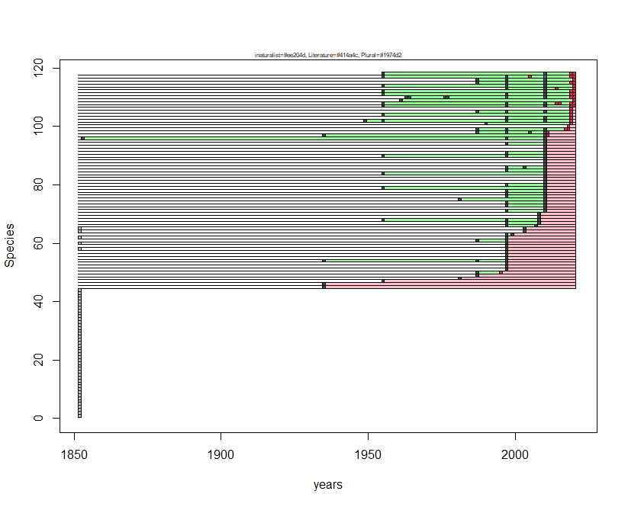
Species N | Species name | first occ. | last occ.
1 | Spialia sertorius | NA | NA
2 | Carcharodus lavatherae | NA | NA
3 | Erynnis tages | NA | NA
4 | Hesperia comma | NA | NA
5 | Anthocharis cardamines | NA | NA
6 | Lycaena alciphron | NA | NA
7 | Cupido minimus | NA | NA
8 | Polyommatus thersites | NA | NA
9 | Aglais urticae | NA | NA
10 | Fabriciana niobe | NA | NA
11 | Coenonympha arcania | NA | NA
12 | Pieris ergane | NA | NA
13 | Colias alfacariensis | NA | NA
14 | Lycaena tityrus | NA | NA
15 | Eumedonia eumedon | NA | NA
16 | Melitaea trivia | NA | NA
17 | Satyrus ferula | NA | NA
18 | Melanargia russiae | NA | NA
19 | Iolana iolas | NA | NA
20 | Aricia artaxerxes | NA | NA
21 | Boloria euphrosyne | NA | NA
22 | Carcharodus floccifera | NA | NA
23 | Nymphalis antiopa | NA | NA
24 | Polyommatus daphnis | NA | NA
25 | Brenthis hecate | NA | NA
26 | Hipparchia neapolitana | NA | NA
27 | Polygonia egea | NA | NA
28 | Pyrgus onopordi | NA | NA
29 | Pyrgus sidae | NA | NA
30 | Hamearis lucina | NA | NA
31 | Favonius quercus | NA | NA
32 | Phengaris arion | NA | NA
33 | Lysandra coridon | NA | NA
34 | Polyommatus dorylas | NA | NA
35 | Polyommatus dolus | NA | NA
36 | Euphydryas aurinia | NA | NA
37 | Parnassius mnemosyne | NA | NA
38 | Satyrium spini | NA | NA
39 | Cupido argiades | NA | NA
40 | Pseudophilotes baton | NA | NA
41 | Plebejus argyrognomon | NA | NA
42 | Libythea celtis | NA | NA
43 | Cupido osiris | NA | NA
44 | Hyponephele lycaon | NA | NA
45 | Speyeria aglaja | 1936 | 1936
46 | Plebejus argus | 1936 | 1936
47 | Fabriciana adippe | 1956 | 1956
48 | Hipparchia blachieri | 1982 | 1982
49 | Nymphalis polychloros | 1988 | 1988
50 | Argynnis pandora | 1988 | 1996
51 | Hipparchia fagi | 1998 | 1998
52 | Aporia crataegi | 1998 | 1998
53 | Aglais io | 1998 | 1998
54 | Brenthis daphne | 1936 | 1998
55 | Brintesia circe | 1998 | 1998
56 | Lysandra bellargus | 1998 | 1998
57 | Gegenes pumilio | 1998 | 1998
58 | Pyrgus armoricanus | 1998 | 1998
59 | Thymelicus lineola | 1998 | 1998
60 | Polyommatus amandus | 1998 | 1998
61 | Polygonia c-album | 1988 | 1998
62 | Pyronia tithonus | 1998 | 1998
63 | Hipparchia hermione | 1998 | 2000
64 | Satyrium acaciae | 2004 | 2004
65 | Satyrium w-album | 2004 | 2004
66 | Cyaniris semiargus | 1998 | 2008
67 | Melitaea cinxia | 1998 | 2009
68 | Melitaea phoebe | 1956 | 2009
69 | Cacyreus marshalli | 2009 | 2009
70 | Melitaea ornata | 2009 | 2009
71 | Melanargia arge | 1998 | 2011
72 | Pyrgus malvoides | 2011 | 2011
73 | Carcharodus alceae | 1998 | 2011
74 | Thymelicus acteon | 1998 | 2011
75 | Thymelicus sylvestris | 1982 | 2011
76 | Ochlodes sylvanus | 1998 | 2011
77 | Pontia edusa | 1998 | 2011
78 | Pieris mannii | 1998 | 2011
79 | Pieris napi | 1956 | 2011
80 | Pieris rapae | 1998 | 2011
81 | Euchloe ausonia | 2011 | 2011
82 | Gonepteryx cleopatra | 2011 | 2011
83 | Gonepteryx rhamni | 2011 | 2011
84 | Leptidea sinapis | 1956 | 2011
85 | Lycaena phlaeas | 1998 | 2011
86 | Satyrium ilicis | 1998 | 2011
87 | Callophrys rubi | 2011 | 2011
88 | Leptotes pirithous | 2011 | 2011
89 | Glaucopsyche alexis | 2011 | 2011
90 | Aricia agestis | 1956 | 2011
91 | Vanessa cardui | 1998 | 2011
92 | Charaxes jasius | 2011 | 2011
93 | Hipparchia semele | 2011 | 2011
94 | Maniola jurtina | 1998 | 2011
95 | Celastrina argiolus | 2011 | 2011
96 | Melitaea celadussa | 1854 | 2011
97 | Issoria lathonia | 1936 | 2012
98 | Melanargia galathea | 1988 | 2012
99 | Vanessa atalanta | 1988 | 2019
100 | Apatura ilia | 2019 | 2019
101 | Danaus chrysippus | 1991 | 2020
102 | Pieris brassicae | 1950 | 2020
103 | Lampides boeticus | 1998 | 2020
104 | Argynnis paphia | 1956 | 2020
105 | Melitaea didyma | 1988 | 2020
106 | Cupido alcetas | 2020 | 2020
107 | Papilio machaon | 1956 | 2021
108 | Iphiclides podalirius | 1956 | 2021
109 | Zerynthia cassandra | 1962 | 2021
110 | Colias crocea | 1964 | 2021
111 | Polyommatus icarus | 1956 | 2021
112 | Limenitis reducta | 1956 | 2021
113 | Pyronia cecilia | 1998 | 2021
114 | Coenonympha pamphilus | 1956 | 2021
115 | Pararge aegeria | 1988 | 2021
116 | Lasiommata maera | 1988 | 2021
117 | Lasiommata megera | 1956 | 2021
118 | Hipparchia statilinus | 1956 | 2021

Parco Nazionale dell'Abruzzo, Lazio e Molise
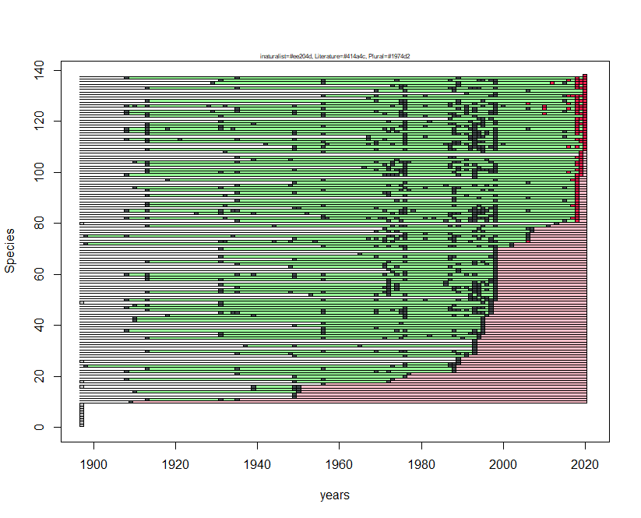
Species N | Species name | first occ. | last occ.
1 | Lasiommata petropolitana | NA | NA
2 | Pyrgus serratulae | NA | NA
3 | Satyrium w-album | NA | NA
4 | Erebia epiphron | NA | NA
5 | Favonius quercus | NA | NA
6 | Carcharodus floccifera | NA | NA
7 | Iolana iolas | NA | NA
8 | Aricia artaxerxes | NA | NA
9 | Melanargia arge | NA | NA
10 | Limenitis camilla | 1910 | 1910
11 | Leptidea sinapis | 1914 | 1936
12 | Euchloe ausonia | 1950 | 1950
13 | Pieris mannii | 1950 | 1950
14 | Pyrgus foulquieri | 1911 | 1951
15 | Cupido argiades | 1940 | 1951
16 | Lycaena thersamon | 1940 | 1951
17 | Satyrium acaciae | 1957 | 1957
18 | Lampides boeticus | 1950 | 1973
19 | Satyrium spini | 1909 | 1974
20 | Polyommatus thersites | 1950 | 1977
21 | Libythea celtis | 1936 | 1978
22 | Plebejus argyrognomon | 1909 | 1989
23 | Nymphalis antiopa | 1914 | 1989
24 | Erebia meolans | 1899 | 1989
25 | Polyommatus daphnis | 1977 | 1990
26 | Pyrgus alveus | 1990 | 1990
27 | Coenonympha glycerion | 1990 | 1990
28 | Leptotes pirithous | 1950 | 1992
29 | Lycaena alciphron | 1936 | 1994
30 | Hipparchia hermione | 1914 | 1994
31 | Hamearis lucina | 1994 | 1994
32 | Glaucopsyche alexis | 1938 | 1994
33 | Pyrgus armoricanus | 1994 | 1994
34 | Melitaea diamina | 1994 | 1994
35 | Thymelicus sylvestris | 1914 | 1995
36 | Melitaea trivia | 1932 | 1995
37 | Anthocharis cardamines | 1932 | 1996
38 | Brenthis daphne | 1909 | 1996
39 | Thymelicus acteon | 1957 | 1996
40 | Heteropterus morpheus | 1950 | 1996
41 | Thymelicus lineola | 1957 | 1996
42 | Pyrgus onopordi | 1911 | 1996
43 | Pyronia cecilia | 1911 | 1996
44 | Plebejus idas | 1919 | 1997
45 | Fabriciana niobe | 1932 | 1998
46 | Satyrus ferula | 1914 | 1998
47 | Coenonympha arcania | 1909 | 1998
48 | Pontia edusa | 1911 | 1998
49 | Polygonia egea | 1932 | 1998
50 | Colias crocea | 1909 | 1999
51 | Callophrys rubi | 1993 | 1999
52 | Phengaris arion | 1954 | 1999
53 | Cyaniris semiargus | 1914 | 1999
54 | Boloria euphrosyne | 1932 | 1999
55 | Melitaea celadussa | 1936 | 1999
56 | Melitaea cinxia | 1932 | 1999
57 | Euphydryas aurinia | 1973 | 1999
58 | Pieris rapae | 1914 | 1999
59 | Satyrium ilicis | 1914 | 1999
60 | Plebejus argus | 1909 | 1999
61 | Polyommatus damon | 1974 | 1999
62 | Hyponephele lupina | 1973 | 1999
63 | Pyrgus carthami | 1949 | 1999
64 | Cupido minimus | 1936 | 1999
65 | Polyommatus eros | 1914 | 1999
66 | Polyommatus escheri | 1950 | 1999
67 | Fabriciana adippe | 1932 | 1999
68 | Cupido osiris | 1966 | 1999
69 | Pyrgus sidae | 1999 | 1999
70 | Boloria pales | 1932 | 1999
71 | Speyeria aglaja | 1957 | 2003
72 | Coenonympha rhodopensis | 1899 | 2003
73 | Parnassius mnemosyne | 1932 | 2007
74 | Pieris ergane | 1950 | 2007
75 | Hyponephele lycaon | 1899 | 2007
76 | Polyommatus dolus | 1977 | 2007
77 | Anthocharis euphenoides | 1970 | 2008
78 | Leptidea reali | 1972 | 2008
79 | Erebia cassioides | 1914 | 2012
80 | Zerynthia cassandra | 2014 | 2014
81 | Erynnis tages | 1936 | 2019
82 | Aporia crataegi | 1909 | 2019
83 | Nymphalis polychloros | 1957 | 2019
84 | Melanargia russiae | 1926 | 2019
85 | Coenonympha pamphilus | 1909 | 2019
86 | Pseudophilotes baton | 1950 | 2019
87 | Aglais io | 1914 | 2019
88 | Erebia neoridas | 1914 | 2019
89 | Pyrgus malvoides | 1936 | 2019
90 | Carcharodus alceae | 1989 | 2019
91 | Lycaena hippothoe | 1914 | 2019
92 | Lycaena phlaeas | 1936 | 2019
93 | Vanessa atalanta | 1914 | 2019
94 | Hipparchia statilinus | 1911 | 2019
95 | Spialia sertorius | 1936 | 2019
96 | Cupido alcetas | 1950 | 2019
97 | Ochlodes sylvanus | 1919 | 2019
98 | Lycaena tityrus | 1994 | 2019
99 | Polyommatus dorylas | 1909 | 2020
100 | Aglais urticae | 1914 | 2020
101 | Melitaea didyma | 1914 | 2020
102 | Erebia albergana | 1967 | 2020
103 | Aricia agestis | 1914 | 2020
104 | Chazara briseis | 1911 | 2020
105 | Phengaris alcon | 1940 | 2020
106 | Pararge aegeria | 1936 | 2020
107 | Polyommatus amandus | 2020 | 2020
108 | Polygonia c-album | 1933 | 2020
109 | Papilio machaon | 1914 | 2021
110 | Iphiclides podalirius | 1950 | 2021
111 | Parnassius apollo | 1943 | 2021
112 | Pieris brassicae | 1914 | 2021
113 | Pieris napi | 1909 | 2021
114 | Colias alfacariensis | 1968 | 2021
115 | Gonepteryx rhamni | 1914 | 2021
116 | Lysandra bellargus | 1909 | 2021
117 | Polyommatus icarus | 1909 | 2021
118 | Vanessa cardui | 1914 | 2021
119 | Issoria lathonia | 1914 | 2021
120 | Melitaea phoebe | 1932 | 2021
121 | Brintesia circe | 1988 | 2021
122 | Hipparchia semele | 1914 | 2021
123 | Melanargia galathea | 1909 | 2021
124 | Lasiommata megera | 1909 | 2021
125 | Lycaena virgaureae | 1936 | 2021
126 | Lysandra coridon | 1909 | 2021
127 | Erebia ligea | 1957 | 2021
128 | Hesperia comma | 1914 | 2021
129 | Argynnis pandora | 1968 | 2021
130 | Argynnis paphia | 1957 | 2021
131 | Melitaea varia | 1992 | 2021
132 | Hipparchia fagi | 1970 | 2021
133 | Maniola jurtina | 1914 | 2021
134 | Pyronia tithonus | 1974 | 2021
135 | Lasiommata maera | 1930 | 2021
136 | Limenitis reducta | 1932 | 2021
137 | Celastrina argiolus | 1909 | 2021
138 | Apatura ilia | 2021 | 2021

Parco Nazionale della Val Grande
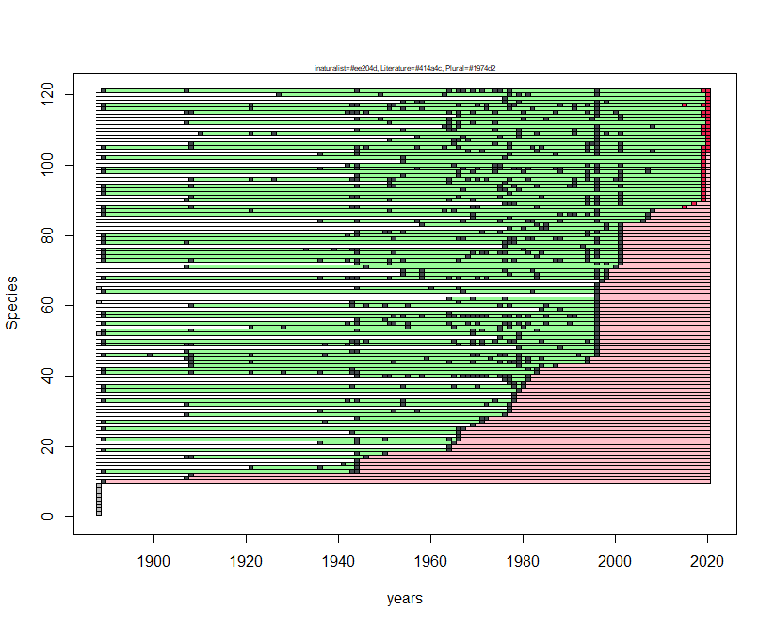
Species N | Species name | first occ. | last occ.
1 | Boloria titania | NA | NA
2 | Satyrium spini | NA | NA
3 | Polyommatus damon | NA | NA
4 | Apatura ilia | NA | NA
5 | Colias hyale | NA | NA
6 | Leptotes pirithous | NA | NA
7 | Hipparchia statilinus | NA | NA
8 | Melitaea aurelia | NA | NA
9 | Erebia styx | NA | NA
10 | Erebia meolans | 1890 | 1890
11 | Brintesia circe | 1908 | 1908
12 | Plebejus argyrognomon | 1909 | 1909
13 | Hamearis lucina | 1890 | 1945
14 | Plebejus idas | 1922 | 1945
15 | Pyrgus armoricanus | 1942 | 1945
16 | Polyommatus dorylas | 1945 | 1945
17 | Carcharodus lavatherae | 1908 | 1947
18 | Limenitis reducta | 1945 | 1951
19 | Melitaea cinxia | 1890 | 1965
20 | Boloria thore | 1965 | 1965
21 | Boloria dia | 1937 | 1966
22 | Colias alfacariensis | 1890 | 1967
23 | Glaucopsyche alexis | 1967 | 1967
24 | Spialia sertorius | 1944 | 1967
25 | Leptidea sinapis | 1890 | 1968
26 | Kretania trappi | 1970 | 1970
27 | Phengaris arion | 1890 | 1972
28 | Pyrgus alveus | 1945 | 1973
29 | Pseudophilotes baton | 1908 | 1977
30 | Erebia pronoe | 1937 | 1978
31 | Favonius quercus | 1978 | 1978
32 | Oeneis glacialis | 1908 | 1978
33 | Polyommatus icarus | 1890 | 1979
34 | Lampides boeticus | 1979 | 1979
35 | Hyponephele lycaon | 1979 | 1979
36 | Erebia epiphron | 1890 | 1980
37 | Aricia agestis | 1890 | 1981
38 | Lopinga achine | 1978 | 1981
39 | Hesperia comma | 1977 | 1982
40 | Pieris bryoniae | 1945 | 1982
41 | Melitaea didyma | 1890 | 1984
42 | Pyronia tithonus | 1890 | 1984
43 | Hipparchia semele | 1909 | 1988
44 | Speyeria aglaja | 1909 | 1995
45 | Hipparchia fagi | 1908 | 1995
46 | Plebejus argus | 1890 | 1997
47 | Carcharodus floccifera | 1908 | 1997
48 | Thymelicus lineola | 1980 | 1997
49 | Lycaena alciphron | 1890 | 1997
50 | Lycaena tityrus | 1890 | 1997
51 | Aricia artaxerxes | 1976 | 1997
52 | Lysandra coridon | 1890 | 1997
53 | Fabriciana adippe | 1890 | 1997
54 | Fabriciana niobe | 1922 | 1997
55 | Melitaea celadussa | 1890 | 1997
56 | Melitaea phoebe | 1945 | 1997
57 | Coenonympha arcania | 1890 | 1997
58 | Erebia ligea | 1890 | 1997
59 | Thecla betulae | 1985 | 1997
60 | Celastrina argiolus | 1909 | 1997
61 | Limenitis camilla | 1944 | 1997
62 | Thymelicus sylvestris | 1965 | 1997
63 | Lycaena hippothoe | 1997 | 1997
64 | Aglais urticae | 1890 | 1997
65 | Erynnis tages | 1945 | 1997
66 | Boloria pales | 1997 | 1997
67 | Parnassius mnemosyne | 1998 | 1998
68 | Pieris rapae | 1890 | 1999
69 | Lasiommata petropolitana | 1955 | 1999
70 | Boloria euphrosyne | 1955 | 1999
71 | Libythea celtis | 1908 | 2001
72 | Ochlodes sylvanus | 1945 | 2002
73 | Papilio machaon | 1890 | 2002
74 | Gonepteryx rhamni | 1890 | 2002
75 | Lycaena virgaureae | 1890 | 2002
76 | Lysandra bellargus | 1890 | 2002
77 | Nymphalis polychloros | 1977 | 2002
78 | Vanessa cardui | 1890 | 2002
79 | Issoria lathonia | 1890 | 2002
80 | Pieris brassicae | 1890 | 2002
81 | Boloria selene | 1945 | 2002
82 | Limenitis populi | 1978 | 2002
83 | Erebia triarius | 1959 | 2002
84 | Erebia tyndarus | 1937 | 2007
85 | Aglais io | 1970 | 2008
86 | Maniola jurtina | 1890 | 2008
87 | Parnassius apollo | 1890 | 2009
88 | Colias crocea | 1890 | 2016
89 | Vanessa atalanta | 1977 | 2018
90 | Heteropterus morpheus | 1908 | 2020
91 | Lycaena phlaeas | 1909 | 2020
92 | Nymphalis antiopa | 1890 | 2020
93 | Erebia euryale | 1890 | 2020
94 | Melanargia galathea | 1890 | 2020
95 | Aphantopus hyperantus | 1952 | 2020
96 | Lasiommata maera | 1909 | 2020
97 | Anthocharis cardamines | 1945 | 2020
98 | Minois dryas | 1890 | 2020
99 | Erebia aethiops | 1890 | 2020
100 | Pararge aegeria | 1943 | 2020
101 | Pyrgus malvoides | 1955 | 2020
102 | Cyaniris semiargus | 1890 | 2020
103 | Erebia montana | 1937 | 2020
104 | Aporia crataegi | 1945 | 2021
105 | Pieris napi | 1890 | 2021
106 | Argynnis paphia | 1909 | 2021
107 | Erebia albergana | 1952 | 2021
108 | Erebia melampus | 1958 | 2021
109 | Coenonympha gardetta | 1911 | 2021
110 | Lasiommata megera | 1945 | 2021
111 | Polygonia c-album | 1964 | 2021
112 | Neptis rivularis | 1908 | 2021
113 | Iphiclides podalirius | 1945 | 2021
114 | Callophrys rubi | 1967 | 2021
115 | Scolitantides orion | 1908 | 2021
116 | Erebia medusa | 1890 | 2021
117 | Coenonympha pamphilus | 1890 | 2021
118 | Carterocephalus palaemon | 1955 | 2021
119 | Satyrium ilicis | 1977 | 2021
120 | Apatura iris | 1928 | 2021
121 | Satyrus ferula | 1890 | 2021

Parco Nazionale del Vesuvio
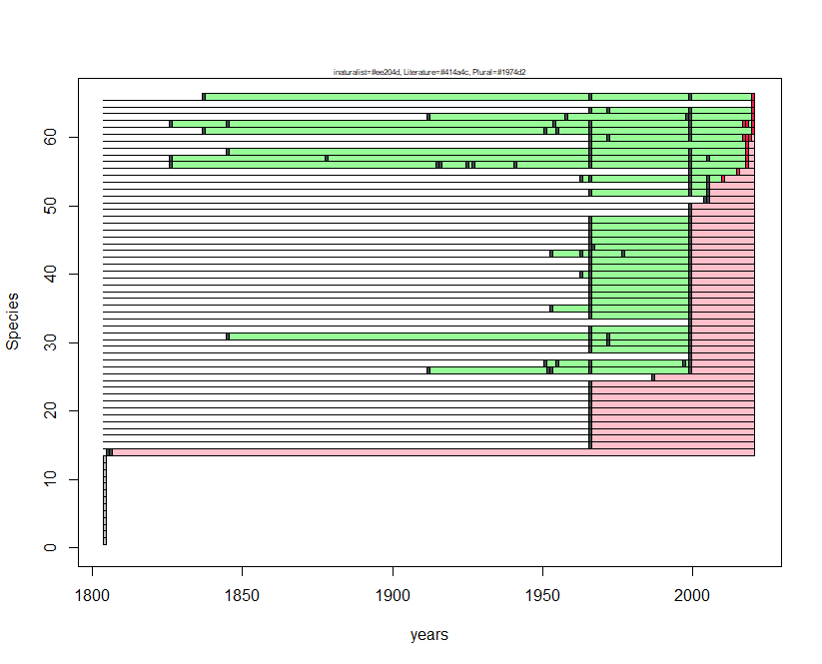
Species N | Species name | first occ. | last occ.
1 | Satyrium spini | NA | NA
2 | Polyommatus amandus | NA | NA
3 | Lysandra bellargus | NA | NA
4 | Polyommatus daphnis | NA | NA
5 | Pyrgus malvoides | NA | NA
6 | Carcharodus alceae | NA | NA
7 | Erynnis tages | NA | NA
8 | Thymelicus sylvestris | NA | NA
9 | Cupido osiris | NA | NA
10 | Plebejus argus | NA | NA
11 | Libythea celtis | NA | NA
12 | Phengaris arion | NA | NA
13 | Melanargia arge | NA | NA
14 | Danaus chrysippus | 1806 | 1807
15 | Hesperia comma | 1967 | 1967
16 | Pyronia cecilia | 1967 | 1967
17 | Hipparchia fagi | 1967 | 1967
18 | Euchloe ausonia | 1967 | 1967
19 | Anthocharis cardamines | 1967 | 1967
20 | Leptidea sinapis | 1967 | 1967
21 | Hipparchia statilinus | 1967 | 1967
22 | Maniola jurtina | 1967 | 1967
23 | Coenonympha pamphilus | 1967 | 1967
24 | Limenitis reducta | 1967 | 1967
25 | Gegenes pumilio | 1988 | 1988
26 | Pieris mannii | 1913 | 2000
27 | Papilio machaon | 1952 | 2000
28 | Plebejus argyrognomon | 2000 | 2000
29 | Melitaea didyma | 1967 | 2000
30 | Polyommatus icarus | 1967 | 2000
31 | Pieris rapae | 1846 | 2000
32 | Spialia sertorius | 1967 | 2000
33 | Thymelicus acteon | 2000 | 2000
34 | Ochlodes sylvanus | 1967 | 2000
35 | Aporia crataegi | 1954 | 2000
36 | Pieris napi | 1967 | 2000
37 | Gonepteryx cleopatra | 1967 | 2000
38 | Gonepteryx rhamni | 1967 | 2000
39 | Satyrium ilicis | 1967 | 2000
40 | Callophrys rubi | 1964 | 2000
41 | Cupido minimus | 1967 | 2000
42 | Celastrina argiolus | 1967 | 2000
43 | Iolana iolas | 1954 | 2000
44 | Aricia agestis | 1967 | 2000
45 | Aglais io | 1967 | 2000
46 | Polygonia egea | 1967 | 2000
47 | Charaxes jasius | 1967 | 2000
48 | Pararge aegeria | 1967 | 2000
49 | Lycaena alciphron | 2000 | 2000
50 | Cyaniris semiargus | 2000 | 2000
51 | Cacyreus marshalli | 2005 | 2006
52 | Melitaea celadussa | 1967 | 2006
53 | Lasiommata maera | 2000 | 2006
54 | Glaucopsyche alexis | 1964 | 2011
55 | Nymphalis polychloros | 2000 | 2016
56 | Pieris brassicae | 1827 | 2019
57 | Vanessa cardui | 1827 | 2019
58 | Pontia edusa | 1846 | 2019
59 | Leptotes pirithous | 1967 | 2019
60 | Vanessa atalanta | 1967 | 2020
61 | Iphiclides podalirius | 1838 | 2021
62 | Lampides boeticus | 1827 | 2021
63 | Lycaena phlaeas | 1913 | 2021
64 | Colias crocea | 1967 | 2021
65 | Issoria lathonia | 2021 | 2021
66 | Lasiommata megera | 1838 | 2021

Parco Nazionale del Golfo di Orosei e del Gennargentu
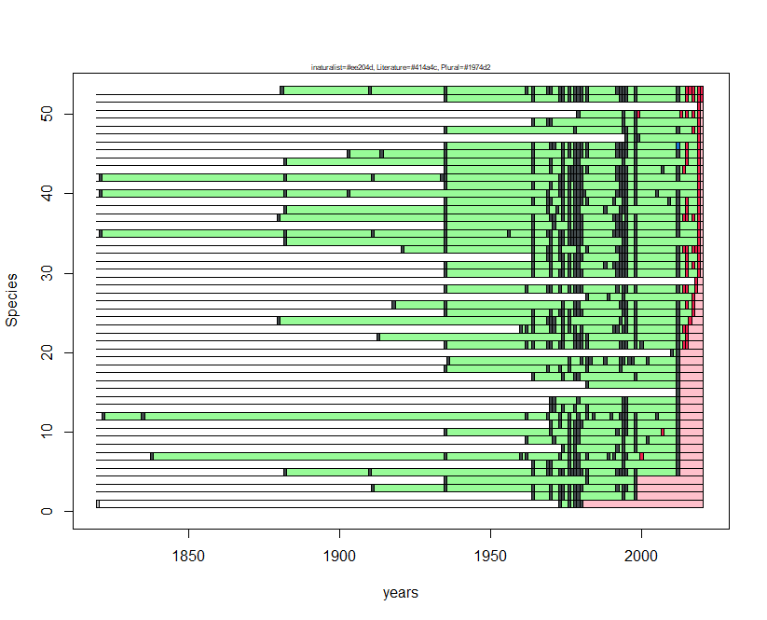
Species N | Species name | first occ. | last occ.
1 | Gonepteryx rhamni | 1974 | 1981
2 | Favonius quercus | 1965 | 1999
3 | Pyronia tithonus | 1912 | 1999
4 | Pyrgus armoricanus | 1936 | 1999
5 | Maniola nurag | 1883 | 2013
6 | Carcharodus alceae | 1965 | 2013
7 | Papilio hospiton | 1839 | 2013
8 | Pieris brassicae | 1975 | 2013
9 | Euchloe insularis | 1963 | 2013
10 | Aglais io | 1936 | 2013
11 | Vanessa atalanta | 1971 | 2013
12 | Aglais ichnusa | 1823 | 2013
13 | Leptidea sinapis | 1971 | 2013
14 | Callophrys rubi | 1971 | 2013
15 | Gegenes pumilio | 2013 | 2013
16 | Anthocharis cardamines | 1983 | 2013
17 | Pontia daplidice | 1965 | 2013
18 | Spialia therapne | 1936 | 2013
19 | Pseudophilotes barbagiae | 1937 | 2013
20 | Thymelicus lineola | 2011 | 2013
21 | Gonepteryx cleopatra | 1936 | 2016
22 | Limenitis reducta | 1914 | 2016
23 | Papilio machaon | 1961 | 2016
24 | Libythea celtis | 1881 | 2017
25 | Polygonia c-album | 1936 | 2018
26 | Nymphalis polychloros | 1919 | 2018
27 | Danaus chrysippus | 1983 | 2018
28 | Vanessa cardui | 1936 | 2019
29 | Cacyreus marshalli | 2019 | 2019
30 | Colias crocea | 1936 | 2020
31 | Polyommatus celina | 1936 | 2020
32 | Argynnis pandora | 1965 | 2020
33 | Lasiommata paramegaera | 1922 | 2020
34 | Brintesia circe | 1883 | 2020
35 | Hipparchia aristaeus | 1822 | 2020
36 | Pieris rapae | 1936 | 2020
37 | Lycaena phlaeas | 1881 | 2020
38 | Plebejus bellieri | 1883 | 2020
39 | Aricia cramera | 1936 | 2020
40 | Fabriciana elisa | 1822 | 2020
41 | Argynnis paphia | 1936 | 2020
42 | Hipparchia neomiris | 1822 | 2020
43 | Maniola jurtina | 1936 | 2020
44 | Pyronia cecilia | 1883 | 2020
45 | Coenonympha pamphilus | 1904 | 2020
46 | Pararge aegeria | 1936 | 2020
47 | Lysandra coridon | 1996 | 2020
48 | Issoria lathonia | 1936 | 2020
49 | Lampides boeticus | 1965 | 2020
50 | Charaxes jasius | 1980 | 2020
51 | Leptotes pirithous | 2020 | 2020
52 | Celastrina argiolus | 1936 | 2021
53 | Coenonympha corinna | 1882 | 2021

Parco Nazionale della Sila
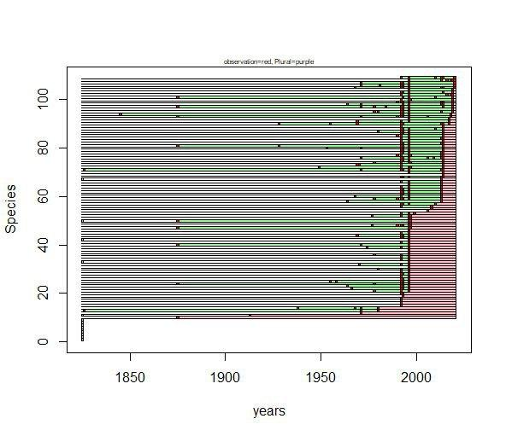
Species N | Species name | first occ. | last occ.
1 | Melanargia russiae | NA | NA
2 | Colias alfacariensis | NA | NA
3 | Aricia artaxerxes | NA | NA
4 | Polygonia egea | NA | NA
5 | Lycaena thersamon | NA | NA
6 | Cupido argiades | NA | NA
7 | Glaucopsyche alexis | NA | NA
8 | Plebejus argyrognomon | NA | NA
9 | Nymphalis antiopa | NA | NA
10 | Pyrgus alveus | 1876 | 1876
11 | Parnassius apollo | 1914 | 1914
12 | Polyommatus escheri | 1972 | 1972
13 | Speyeria aglaja | 1827 | 1981
14 | Brenthis ino | 1939 | 1981
15 | Pyrgus armoricanus | 1993 | 1993
16 | Danaus chrysippus | 1993 | 1993
17 | Melitaea aetherie | 1993 | 1993
18 | Hyponephele lupina | 1993 | 1993
19 | Pyronia tithonus | 1994 | 1994
20 | Gegenes nostrodamus | 1993 | 1994
21 | Erynnis tages | 1979 | 1997
22 | Hesperia comma | 1967 | 1997
23 | Argynnis pandora | 1965 | 1997
24 | Issoria lathonia | 1876 | 1997
25 | Polyommatus dorylas | 1956 | 1997
26 | Aporia crataegi | 1993 | 1997
27 | Pyrgus malvoides | 1993 | 1997
28 | Hipparchia statilinus | 1993 | 1997
29 | Pyrgus onopordi | 1993 | 1997
30 | Carcharodus floccifera | 1981 | 1997
31 | Thymelicus acteon | 1997 | 1997
32 | Anthocharis damone | 1971 | 1997
33 | Gonepteryx cleopatra | 1997 | 1997
34 | Favonius quercus | 1993 | 1997
35 | Satyrium ilicis | 1993 | 1997
36 | Callophrys rubi | 1979 | 1997
37 | Polyommatus thersites | 1997 | 1997
38 | Limenitis reducta | 1997 | 1997
39 | Hipparchia blachieri | 1975 | 1997
40 | Hipparchia fagi | 1876 | 1997
41 | Melanargia arge | 1993 | 1997
42 | Pyronia cecilia | 1997 | 1997
43 | Plebejus idas | 1993 | 1997
44 | Gonepteryx rhamni | 1970 | 1997
45 | Polyommatus daphnis | 1993 | 1997
46 | Muschampia proto | 1997 | 1997
47 | Iphiclides podalirius | 1876 | 1998
48 | Spialia sertorius | 1978 | 1998
49 | Anthocharis cardamines | 1997 | 1998
50 | Thymelicus sylvestris | 1876 | 1998
51 | Gegenes pumilio | 1997 | 1998
52 | Euchloe ausonia | 1978 | 1998
53 | Hipparchia hermione | 1993 | 2000
54 | Leptotes pirithous | 2007 | 2007
55 | Melitaea ornata | 2009 | 2009
56 | Melitaea phoebe | 1993 | 2009
57 | Pieris napi | 1993 | 2011
58 | Fabriciana adippe | 1965 | 2014
59 | Coenonympha pamphilus | 1979 | 2014
60 | Brenthis daphne | 1969 | 2014
61 | Brintesia circe | 1993 | 2014
62 | Lycaena phlaeas | 1993 | 2014
63 | Pontia edusa | 1993 | 2014
64 | Lampides boeticus | 1993 | 2014
65 | Celastrina argiolus | 1997 | 2014
66 | Libythea celtis | 1993 | 2014
67 | Pseudophilotes baton | 2014 | 2014
68 | Pieris brassicae | 1993 | 2015
69 | Phengaris arion | 2015 | 2015
70 | Pieris mannii | 1997 | 2015
71 | Fabriciana niobe | 1827 | 2015
72 | Zerynthia cassandra | 1950 | 2015
73 | Eumedonia eumedon | 1970 | 2015
74 | Leptidea sinapis | 1979 | 2015
75 | Boloria euphrosyne | 1993 | 2015
76 | Aricia agestis | 1972 | 2015
77 | Carcharodus alceae | 1991 | 2015
78 | Lasiommata megera | 1993 | 2015
79 | Parnassius mnemosyne | 1993 | 2015
80 | Lycaena alciphron | 1954 | 2015
81 | Lycaena tityrus | 1876 | 2015
82 | Cyaniris semiargus | 1993 | 2015
83 | Nymphalis polychloros | 1993 | 2015
84 | Vanessa atalanta | 1993 | 2015
85 | Polygonia c-album | 1991 | 2015
86 | Melitaea cinxia | 1993 | 2015
87 | Coenonympha arcania | 1981 | 2015
88 | Lasiommata maera | 1993 | 2015
89 | Cupido minimus | 1993 | 2015
90 | Polyommatus amandus | 1929 | 2018
91 | Pyrgus carthami | 1970 | 2018
92 | Papilio machaon | 1997 | 2018
93 | Maniola jurtina | 1876 | 2019
94 | Polyommatus icarus | 1846 | 2019
95 | Pieris rapae | 1979 | 2020
96 | Plebejus argus | 1993 | 2020
97 | Melanargia galathea | 1876 | 2020
98 | Hipparchia semele | 1965 | 2020
99 | Colias crocea | 1991 | 2020
100 | Thymelicus lineola | 1993 | 2020
101 | Ochlodes sylvanus | 1876 | 2020
102 | Aglais io | 1993 | 2020
103 | Melitaea celadussa | 1993 | 2020
104 | Melitaea trivia | 1997 | 2020
105 | Vanessa cardui | 1969 | 2021
106 | Aglais urticae | 1972 | 2021
107 | Melitaea didyma | 1972 | 2021
108 | Argynnis paphia | 1997 | 2021
109 | Pararge aegeria | 1993 | 2021

Parco Nazionale dell'Isola di Pantelleria
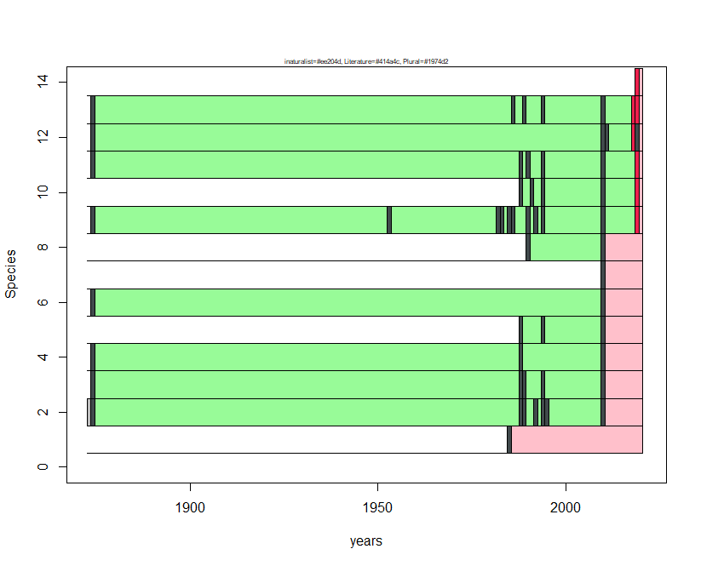
Species N | Species name | first occ. | last occ.
1 | Pontia daplidice | 1986 | 1986
2 | Pieris brassicae | 1875 | 2011
3 | Vanessa atalanta | 1875 | 2011
4 | Colias crocea | 1875 | 2011
5 | Gegenes pumilio | 1989 | 2011
6 | Lycaena phlaeas | 1875 | 2011
7 | Lampides boeticus | 2011 | 2011
8 | Polyommatus celina | 1991 | 2011
9 | Pieris rapae | 1875 | 2020
10 | Leptotes pirithous | 1989 | 2020
11 | Celastrina argiolus | 1875 | 2020
12 | Lasiommata megera | 1875 | 2020
13 | Vanessa cardui | 1875 | 2020
14 | Charaxes jasius | 2020 | 2020

Parco Nazionale dello Stelvio
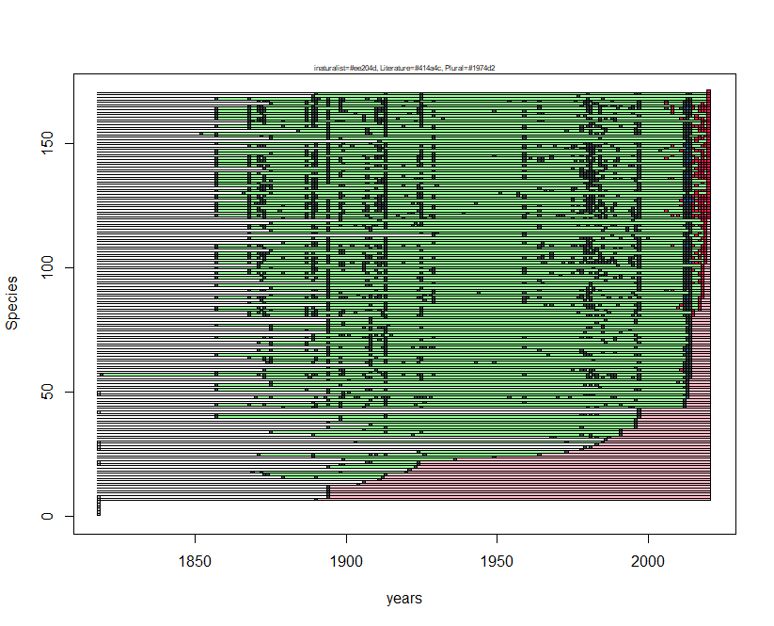
Species N | Species name | first occ. | last occ.
1 | Favonius quercus | NA | NA
2 | Neptis rivularis | NA | NA
3 | Brenthis hecate | NA | NA
4 | Limenitis reducta | NA | NA
5 | Satyrium ilicis | NA | NA
6 | Coenonympha glycerion | NA | NA
7 | Leptotes pirithous | 1891 | 1891
8 | Lopinga achine | 1895 | 1895
9 | Cupido alcetas | 1895 | 1895
10 | Limenitis camilla | 1895 | 1895
11 | Brintesia circe | 1895 | 1895
12 | Carcharodus floccifera | 1895 | 1895
13 | Argynnis pandora | 1905 | 1905
14 | Lycaena dispar | 1907 | 1907
15 | Apatura ilia | 1912 | 1912
16 | Cupido osiris | 1880 | 1913
17 | Erebia meolans | 1874 | 1914
18 | Erebia stiria | 1870 | 1921
19 | Lampides boeticus | 1922 | 1922
20 | Pyronia tithonus | 1895 | 1924
21 | Erebia eriphyle | 1899 | 1925
22 | Plebejus argyrognomon | 1908 | 1925
23 | Hipparchia statilinus | 1900 | 1937
24 | Melitaea asteria | 1890 | 1950
25 | Satyrus ferula | 1872 | 1965
26 | Iolana iolas | 1925 | 1974
27 | Pyrgus onopordi | 1979 | 1979
28 | Hamearis lucina | 1980 | 1982
29 | Pyrgus carlinae | 1984 | 1984
30 | Thecla betulae | 1904 | 1986
31 | Minois dryas | 1987 | 1987
32 | Kretania trappi | 1969 | 1988
33 | Brenthis daphne | 1890 | 1992
34 | Boloria dia | 1876 | 1992
35 | Scolitantides orion | 1907 | 1992
36 | Nymphalis polychloros | 1895 | 1997
37 | Carcharodus alceae | 1909 | 1997
38 | Aphantopus hyperantus | 1895 | 1997
39 | Satyrium pruni | 1899 | 1997
40 | Erebia manto | 1858 | 1998
41 | Melitaea cinxia | 1858 | 1998
42 | Melitaea deione | 1998 | 1998
43 | Erebia nivalis | 1998 | 1998
44 | Polyommatus eros | 1880 | 2013
45 | Fabriciana adippe | 1858 | 2013
46 | Erebia triarius | 1890 | 2013
47 | Coenonympha arcania | 1895 | 2013
48 | Erebia styx | 1871 | 2014
49 | Melitaea celadussa | 1900 | 2014
50 | Hipparchia fagi | 1895 | 2014
51 | Aricia agestis | 1858 | 2014
52 | Polyommatus thersites | 1985 | 2014
53 | Glaucopsyche alexis | 1858 | 2014
54 | Polyommatus damon | 1876 | 2014
55 | Melitaea aurelia | 1895 | 2014
56 | Plebejus idas | 1874 | 2015
57 | Eumedonia eumedon | 1820 | 2015
58 | Gonepteryx rhamni | 1858 | 2015
59 | Erebia pronoe | 1874 | 2015
60 | Pararge aegeria | 1895 | 2015
61 | Pyrgus warrenensis | 1909 | 2015
62 | Pyrgus alveus | 1875 | 2015
63 | Spialia sertorius | 1874 | 2015
64 | Pyrgus andromedae | 1869 | 2015
65 | Colias alfacariensis | 1858 | 2015
66 | Polygonia c-album | 1895 | 2015
67 | Melitaea phoebe | 1872 | 2015
68 | Hyponephele lycaon | 1895 | 2015
69 | Pseudophilotes baton | 1876 | 2015
70 | Colias crocea | 1872 | 2015
71 | Polyommatus daphnis | 1890 | 2015
72 | Melitaea athalia | 1858 | 2015
73 | Chazara briseis | 1890 | 2015
74 | Celastrina argiolus | 1895 | 2015
75 | Leptidea sinapis | 1876 | 2015
76 | Polyommatus dorylas | 1876 | 2015
77 | Satyrium spini | 1858 | 2015
78 | Pyrgus carthami | 1895 | 2015
79 | Lasiommata megera | 1895 | 2015
80 | Pontia edusa | 1909 | 2015
81 | Agriades optilete | 1869 | 2016
82 | Aricia nicias | 1869 | 2016
83 | Papilio machaon | 1858 | 2018
84 | Erynnis tages | 1858 | 2018
85 | Coenonympha pamphilus | 1895 | 2018
86 | Ochlodes sylvanus | 1869 | 2018
87 | Thymelicus lineola | 1873 | 2018
88 | Pontia callidice | 1858 | 2019
89 | Melitaea didyma | 1876 | 2019
90 | Euphydryas intermedia | 1895 | 2019
91 | Oeneis glacialis | 1869 | 2019
92 | Pyrgus malvoides | 1876 | 2019
93 | Maniola jurtina | 1858 | 2019
94 | Thymelicus sylvestris | 1895 | 2019
95 | Pieris napi | 1873 | 2019
96 | Phengaris arion | 1858 | 2019
97 | Nymphalis antiopa | 1873 | 2019
98 | Fabriciana niobe | 1858 | 2019
99 | Boloria thore | 1869 | 2019
100 | Lasiommata petropolitana | 1858 | 2019
101 | Erebia pharte | 1872 | 2019
102 | Parnassius phoebus | 1858 | 2020
103 | Aricia artaxerxes | 1874 | 2020
104 | Lysandra coridon | 1858 | 2020
105 | Pieris brassicae | 1858 | 2020
106 | Pieris bryoniae | 1858 | 2020
107 | Callophrys rubi | 1876 | 2020
108 | Polyommatus icarus | 1858 | 2020
109 | Boloria pales | 1858 | 2020
110 | Erebia aethiops | 1880 | 2020
111 | Anthocharis cardamines | 1895 | 2020
112 | Issoria lathonia | 1869 | 2020
113 | Limenitis populi | 1930 | 2020
114 | Erebia ligea | 1869 | 2020
115 | Lycaena phlaeas | 1876 | 2020
116 | Hipparchia semele | 1869 | 2020
117 | Agriades glandon | 1869 | 2020
118 | Iphiclides podalirius | 1876 | 2020
119 | Apatura iris | 1899 | 2020
120 | Hesperia comma | 1869 | 2021
121 | Parnassius apollo | 1858 | 2021
122 | Colias palaeno | 1869 | 2021
123 | Colias phicomone | 1858 | 2021
124 | Lycaena hippothoe | 1858 | 2021
125 | Lycaena virgaureae | 1858 | 2021
126 | Agriades orbitulus | 1858 | 2021
127 | Aglais urticae | 1869 | 2021
128 | Erebia melampus | 1858 | 2021
129 | Erebia montana | 1858 | 2021
130 | Phengaris alcon | 1867 | 2021
131 | Pieris rapae | 1858 | 2021
132 | Pyrgus cacaliae | 1869 | 2021
133 | Pyrgus serratulae | 1858 | 2021
134 | Lycaena tityrus | 1858 | 2021
135 | Plebejus argus | 1858 | 2021
136 | Cyaniris semiargus | 1858 | 2021
137 | Speyeria aglaja | 1858 | 2021
138 | Boloria euphrosyne | 1858 | 2021
139 | Boloria selene | 1876 | 2021
140 | Aglais io | 1874 | 2021
141 | Euphydryas aurinia | 1858 | 2021
142 | Lasiommata maera | 1858 | 2021
143 | Coenonympha gardetta | 1858 | 2021
144 | Erebia euryale | 1858 | 2021
145 | Erebia epiphron | 1869 | 2021
146 | Erebia medusa | 1858 | 2021
147 | Erebia albergana | 1858 | 2021
148 | Erebia cassioides | 1895 | 2021
149 | Erebia pandrose | 1869 | 2021
150 | Melanargia galathea | 1858 | 2021
151 | Parnassius mnemosyne | 1912 | 2021
152 | Carterocephalus palaemon | 1876 | 2021
153 | Aporia crataegi | 1858 | 2021
154 | Lysandra bellargus | 1853 | 2021
155 | Vanessa atalanta | 1885 | 2021
156 | Argynnis paphia | 1869 | 2021
157 | Boloria titania | 1858 | 2021
158 | Vanessa cardui | 1869 | 2021
159 | Erebia pluto | 1869 | 2021
160 | Euphydryas cynthia | 1858 | 2021
161 | Melitaea diamina | 1858 | 2021
162 | Melitaea varia | 1858 | 2021
163 | Erebia gorge | 1858 | 2021
164 | Erebia tyndarus | 1858 | 2021
165 | Boloria napaea | 1869 | 2021
166 | Cupido minimus | 1876 | 2021
167 | Erebia mnestra | 1872 | 2021
168 | Lycaena alciphron | 1858 | 2021
169 | Brenthis ino | 1890 | 2021
170 | Polyommatus amandus | 1891 | 2021
171 | Pyrgus armoricanus | 2021 | 2021

Parco Nazionale del Pollino
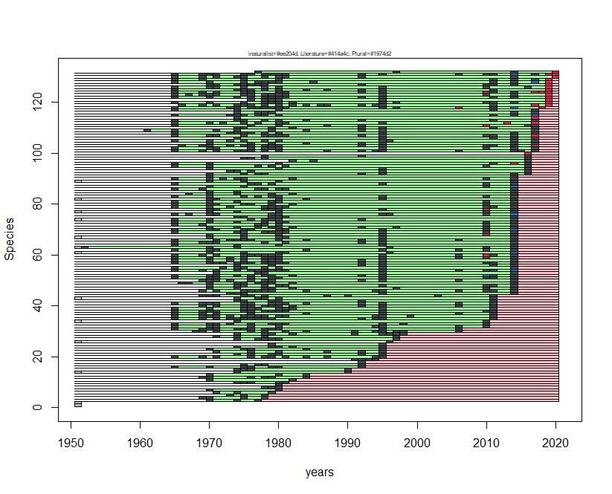
Species N | Species name | first occ. | last occ.
1 | Papilio alexanor | NA | NA
2 | Cacyreus marshalli | NA | NA
3 | Carcharodus lavatherae | 1971 | 1978
4 | Pyrgus alveus | 1970 | 1979
5 | Carcharodus baeticus | 1974 | 1979
6 | Zerynthia cassandra | 1972 | 1980
7 | Satyrium acaciae | 1971 | 1981
8 | Lycaena thersamon | 1979 | 1981
9 | Hyponephele lupina | 1981 | 1981
10 | Nymphalis polychloros | 1975 | 1982
11 | Plebejus argyrognomon | 1971 | 1983
12 | Lycaena hippothoe | 1970 | 1985
13 | Satyrium w-album | 1971 | 1985
14 | Plebejus idas | 1975 | 1991
15 | Erebia gorge | 1975 | 1991
16 | Lycaena tityrus | 1966 | 1993
17 | Chazara briseis | 1976 | 1993
18 | Hipparchia blachieri | 1993 | 1993
19 | Anthocharis damone | 1992 | 1995
20 | Lycaena virgaureae | 1966 | 1996
21 | Favonius quercus | 1975 | 1996
22 | Leptotes pirithous | 1972 | 1996
23 | Aricia artaxerxes | 1971 | 1996
24 | Cupido alcetas | 1975 | 1996
25 | Cupido argiades | 1980 | 1996
26 | Gegenes nostrodamus | 1997 | 1997
27 | Euchloe ausonia | 1975 | 1998
28 | Gegenes pumilio | 1972 | 1998
29 | Anthocharis euphenoides | 1975 | 1999
30 | Polyommatus ripartii | 1969 | 2007
31 | Melanargia russiae | 1966 | 2007
32 | Plebejus argus | 1966 | 2011
33 | Gonepteryx rhamni | 1966 | 2011
34 | Pyrgus sidae | 1975 | 2011
35 | Hyponephele lycaon | 1966 | 2012
36 | Hipparchia hermione | 1966 | 2012
37 | Polyommatus daphnis | 1966 | 2012
38 | Speyeria aglaja | 1966 | 2012
39 | Aglais urticae | 1966 | 2012
40 | Satyrus ferula | 1970 | 2012
41 | Fabriciana niobe | 1966 | 2012
42 | Pyronia tithonus | 1975 | 2012
43 | Polyommatus escheri | 1975 | 2012
44 | Erebia cassioides | 1970 | 2012
45 | Thymelicus acteon | 1974 | 2015
46 | Polyommatus dorylas | 1970 | 2015
47 | Anthocharis cardamines | 1971 | 2015
48 | Erynnis tages | 1971 | 2015
49 | Melanargia arge | 1967 | 2015
50 | Pieris ergane | 1970 | 2015
51 | Colias crocea | 1966 | 2015
52 | Aricia agestis | 1966 | 2015
53 | Polyommatus thersites | 1972 | 2015
54 | Polyommatus icarus | 1966 | 2015
55 | Polygonia egea | 1966 | 2015
56 | Melitaea trivia | 1975 | 2015
57 | Melitaea didyma | 1966 | 2015
58 | Lasiommata megera | 1966 | 2015
59 | Maniola jurtina | 1966 | 2015
60 | Melanargia galathea | 1966 | 2015
61 | Phengaris arion | 1971 | 2015
62 | Pyrgus carthami | 1966 | 2015
63 | Pyrgus malvoides | 1953 | 2015
64 | Gonepteryx cleopatra | 1966 | 2015
65 | Lycaena phlaeas | 1966 | 2015
66 | Pseudophilotes baton | 1966 | 2015
67 | Libythea celtis | 1971 | 2015
68 | Brenthis daphne | 1971 | 2015
69 | Vanessa cardui | 1966 | 2015
70 | Melitaea celadussa | 1966 | 2015
71 | Spialia sertorius | 1971 | 2015
72 | Thymelicus lineola | 1966 | 2015
73 | Aporia crataegi | 1966 | 2015
74 | Pontia edusa | 1966 | 2015
75 | Callophrys rubi | 1975 | 2015
76 | Cyaniris semiargus | 1966 | 2015
77 | Boloria euphrosyne | 1971 | 2015
78 | Coenonympha arcania | 1971 | 2015
79 | Lasiommata maera | 1966 | 2015
80 | Cupido minimus | 1966 | 2015
81 | Melitaea phoebe | 1966 | 2015
82 | Polyommatus amandus | 1971 | 2015
83 | Pararge aegeria | 1966 | 2015
84 | Glaucopsyche alexis | 1968 | 2015
85 | Pyrgus armoricanus | 1971 | 2015
86 | Carcharodus floccifera | 1966 | 2015
87 | Thymelicus sylvestris | 1971 | 2015
88 | Ochlodes sylvanus | 1966 | 2015
89 | Cupido osiris | 1971 | 2015
90 | Melitaea cinxia | 1966 | 2015
91 | Eumedonia eumedon | 1971 | 2015
92 | Satyrium spini | 1971 | 2017
93 | Polyommatus dolus | 1974 | 2017
94 | Lycaena alciphron | 1971 | 2017
95 | Parnassius mnemosyne | 1966 | 2017
96 | Polygonia c-album | 1966 | 2017
97 | Iolana iolas | 1983 | 2017
98 | Coenonympha dorus | 1976 | 2017
99 | Hamearis lucina | 1979 | 2017
100 | Danaus chrysippus | 2017 | 2017
101 | Hipparchia semele | 1966 | 2018
102 | Pieris brassicae | 1966 | 2018
103 | Pieris napi | 1967 | 2018
104 | Celastrina argiolus | 1971 | 2018
105 | Carcharodus alceae | 1966 | 2018
106 | Pieris mannii | 1975 | 2018
107 | Coenonympha pamphilus | 1966 | 2018
108 | Pyronia cecilia | 1966 | 2018
109 | Hipparchia fagi | 1962 | 2018
110 | Hesperia comma | 1975 | 2018
111 | Lampides boeticus | 1966 | 2018
112 | Nymphalis antiopa | 1966 | 2018
113 | Hipparchia statilinus | 1966 | 2018
114 | Pyrgus onopordi | 1975 | 2018
115 | Papilio machaon | 1966 | 2018
116 | Muschampia proto | 1975 | 2018
117 | Fabriciana adippe | 1966 | 2018
118 | Iphiclides podalirius | 1966 | 2019
119 | Lysandra coridon | 1967 | 2020
120 | Leptidea sinapis | 1966 | 2020
121 | Satyrium ilicis | 1977 | 2020
122 | Pieris rapae | 1966 | 2020
123 | Colias alfacariensis | 1966 | 2020
124 | Argynnis paphia | 1966 | 2020
125 | Argynnis pandora | 1966 | 2020
126 | Aglais io | 1966 | 2020
127 | Lysandra bellargus | 1971 | 2020
128 | Vanessa atalanta | 1966 | 2020
129 | Limenitis reducta | 1966 | 2020
130 | Brintesia circe | 1966 | 2021
131 | Issoria lathonia | 1966 | 2021
132 | Euphydryas aurinia | 1978 | 2021

