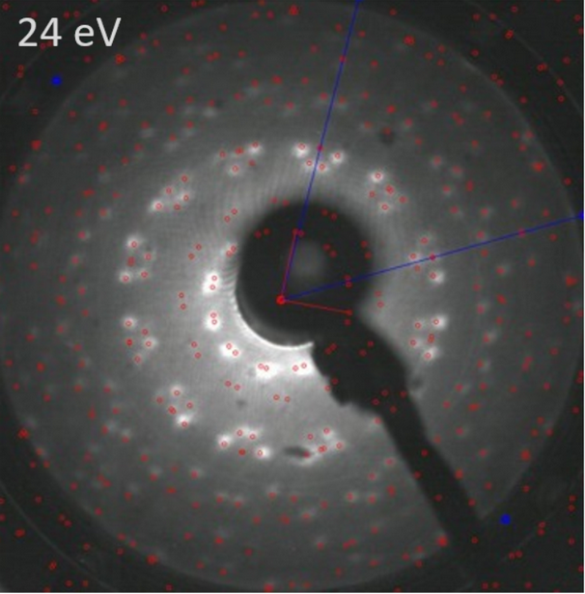

Extended Data Fig. 1: LEED image of a monolayer of CuPc adsorbed on TiSe₂ (E_{kin} = 24 eV). The molecule derived reflexes are marked with red dots and the substrate spots are marked with blue dots. The lines indicate one symmetry set of the respective reciprocal lattices.

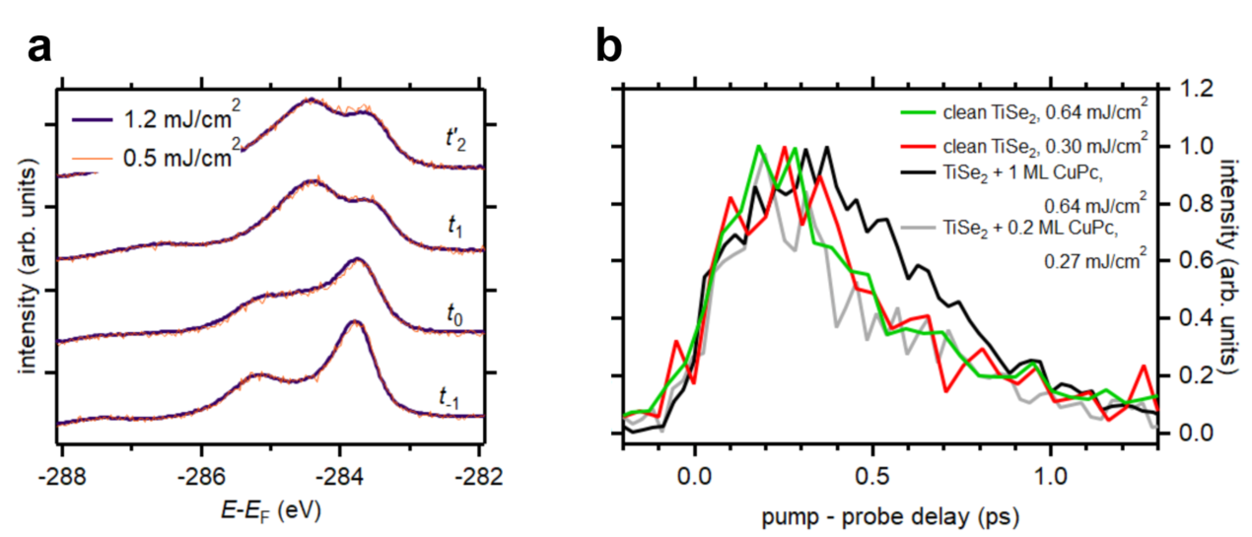
Extended Data Fig. 3: Fluence-dependent dynamics. (a) C 1s core level evolution of TiSe₂ covered by a monolayer CuPc for varying pump laser fluences. (b) Population dynamics of the Ti 3d conduction band for varying pump laser fluence for pristine TiSe₂, TiSe₂ covered by ~0.2 monolayers of CuPc, and TiSe₂ covered by a monolayer of CuPc.

