Supplementary materials
Table S1. The primers and shRNA sequence
 | Gene/shRNA | Sequence
RT-PCR primers | BMI1 | F: 5'-CCAGGGCTTTTCAAAAATGA-3'  R: 5'-CCGATCCAATCTGTTCTGGT-3'
RT-PCR primers | GAPDH | F: 5'-CATGGCCTTCCGTGTTCCTA-3'
RT-PCR primers | GAPDH | R: 5'-CCCTCAGATGCCTGCTTCA-3'
Construction Primers | BMI1-WT | F: 5'-AAAGGTACCATGCATCGAACAACGAGAATC-3'
Construction Primers | BMI1-WT | R: 5'-AAAGCGGCCGCTCAACCAGAAGAAGTTGCTG-3'
Sequences of shRNAs | shBMI1#1 | 5'-CCGGCCTACATTTATACCTGGAGAACTCGAGTTCTCCA GGTATAAATGTAGGTTTTTT-3'
Sequences of shRNAs | shBMI1#2 | 5'-CCGGATTGATGCCACAACCATAATACTCGAGTATTATG GTTGTGGCATCAATTTTTTT-3'
Sequences of shRNAs | shBMI1#3 | 5'-CCGGTAATGGATATTGCCTACATTTCTCGAGAAATGTA GGCAATATCCATTATTTTTT-3'
Sequences of shRNAs | shBMI1#4 | 5'-CCGGCCTAATACTTTCCAGATTGATCTCGAGATCAATC TGGAAAGTATTAGGTTTTTT-3'

Table S2. Expression of BMI1 from TCGA database (tumor and normal samples)
Types |  | Expression (Log2 TPM+1)
 |  | Maximum | Median | Minimum | p value
BLCA(T=407,N=19) |  |  |  |  | P=0.74
 | Normal  Tumor | 5.55  6.46 | 4.63  4.34 | 3.11  1.58
BRCA(T=1092,N=113) |  |  |  |  | P<0.0001
 | Normal  Tumor | 6.17  9.41 | 5.29  5.52 | 3.53  1.92
CESC(T=304,N=3) |  |  |  |  | P=0.89
 | Normal  Tumor | 5.01  6.32 | 4.25  4.10 | 3.09  1.23
CHOL(T=36,N=9) |  |  |  |  | P<0.001
 | Normal  Tumor | 3.68  5.98 | 3.45  4.33 | 3.11  2.91
COAD(T=288,N=41) |  |  |  |  | P<0.0001
 | Normal  Tumor | 5.00  5.65 | 4.05  4.42 | 3.42  2.70
COADREAD(T=380,N=51) |  |  |  |  | P<0.001
 | Normal  Tumor | 5.53  5.65 | 4.14  4.44 | 3.42  1.15
ESCA(T=181,N=13) |  |  |  |  | P<0.05
 | Normal  Tumor | 5.94  7.50 | 4.09  5.05 | 2.98  2.96
GBM(T=153,N=5) |  |  |  |  | P=0.62
 | Normal  Tumor | 5.67  6.31 | 4.76  4.87 | 4.62  2.47
GBMLGG(T=662,N=5) |  |  |  |  | P=0.83
 | Normal  Tumor | 5.67  7.65 | 4.76  5.04 | 4.62  2.47
HNSC(T=518,N=44) |  |  |  |  | P<0.0001
 | Normal  Tumor | 4.58  6.25 | 3.56  4.04 | 1.48  0.52
KICH(T=66,N=129) |  |  |  |  | P<0.0001
 | Normal  Tumor | 6.31  6.04 | 3.67  4.00 | 4.75  2.02
KIPAN(T=884,N=129) |  |  |  |  | P<0.0001
 | Normal  Tumor | 6.31  7.05 | 4.75  4.54 | 3.67  0.72
KIRC(T=530,N=129) |  |  |  |  | P=0.81
 | Normal  Tumor | 6.31  7.05 | 4.75  4.79 | 3.67  1.30
KIRP(T=288,N=129) |  |  |  |  | P<0.0001
 | Normal  Tumor | 6.31  6.82 | 4.75  4.09 | 3.67  0.72
LGG(T=509,N=5) |  |  |  |  | P=0.67
 | Normal  Tumor | 5.67  7.65 | 4.76  5.07 | 4.62  5.06
LIHC(T=369,N=50) |  |  |  |  | P<0.0001
 | Normal  Tumor | 3.98  6.51 | 3.32  4.13 | 1.84  1.21
LUAD(T=513,N=109) |  |  |  |  | P=0.61
 | Normal  Tumor | 5.39  7.39 | 4.67  4.61 | 3.83  2.74
LUSC(T=498,N=109) |  |  |  |  | P=0.33
 | Normal  Tumor | 5.39  6.47 | 4.67  4.60 | 3.83  2.11
PAAD(T=178,N=4) |  |  |  |  | P=0.63
 | Normal  Tumor | 4.94  6.20 | 4.60  4.56 | 4.15  1.49
PRAD(T=495,N=52) |  |  |  |  | P<0.0001
 | Normal  Tumor | 6.12  6.14 | 5.14  4.75 | 3.89  1.81
PCPG(T=177,N=3) |  |  |  |  | P=0.73
 | Normal  Tumor | 5.54  6.33 | 4.28  4.94 | 4.09  2.59
READ(T=92,N=10) |  |  |  |  | P=0.89
 | Normal  Tumor | 5.53  5.41 | 4.43  4.53 | 3.74  1.15
THCA(T=504,N=59) |  |  |  |  | P=0.70
 | Normal  Tumor | 5.29  5.88 | 4.58  4.61 | 2.46  1.06
STAD(T=414,N=36) |  |  |  |  | P<0.0001
 | Normal  Tumor | 5.23  6.95 | 3.95  4.92 | 2.73  2.58
STES(T=595,N=49) |  |  |  |  | P<0.0001
 | Normal  Tumor | 5.94  7.50 | 3.95  4.95 | 2.73  2.58
UCEC(T=180,N=23) |  |  |  |  | P<0.01
 | Normal  Tumor | 5.81  7.01 | 4.77  4.41 | 3.38  0.83
We downloaded a uniformly standardized TCGA pan-cancer dataset from the UCSC platform (https://xenabrowser.net/) from which we extracted the expression data of the ENSG00000168283(BMI1) gene in each sample. We screened the following sample sources: normal solid tissue, primary blood-derived cancer-peripheral blood, and primary tumor. Log2 (x+1) transformation was performed for each expression value. In addition, we also eliminated cancer species with less than three samples from a single cancer species and finally obtained the expression data of 26 cancer species.
R software (version 3.6.4) was used to calculate the differences in expression between normal samples and tumor samples from these 26 tumors, and the unpaired Student's t-test was used for difference significance analysis. Significant upregulation was observed in COAD, COADREAD, BRCA, ESCA, STES, STAD, HNSC, LIHC, and CHOL, and significant downregulation was observed in KIRP, KIPAN, PRAD, UCEC, and KICH (Table S2 and Fig. S1).

Table S3. The expression of miRNA in CC and EC from GEO database
Tumor type | ID-miRNA | logFC | P Value
EC | hsa-miR-203a-3p | 1.988775125 | 7.44E-05
EC | hsa-miR-200c-3p | 1.498389786 | 0.000959606
EC | hsa-miR-218-2-3p | 0.89973922 | 0.014804123
EC | hsa-miR-203b-3p | -0.481367698 | 0.052925929
EC | hsa-miR-203b-5p | 0.60831189 | 0.084313992
EC | hsa-miR-218-5p | 0.638243208 | 0.144961883
EC | hsa-miR-200c-5p | -0.293517585 | 0.360198315
EC | hsa-miR-218-1-3p | 0.304402538 | 0.421690488
EC | hsa-miR-203a-5p | 0.098825395 | 0.82711682
CC | hsa-miR-203 | -0.612882954 | 0.000217822
CC | hsa-miR-200b | -0.321892967 | 0.050496363
CC | hsa-miR-200c | -0.061142565 | 0.711641078
CC | hsa-miR-200a | -0.013161871 | 0.889487753
CC | hsa-miR-218 | -0.008508281 | 0.92049076
We downloaded the EC dataset (GSE112264; Platforms: GPL21263) from the GEO database (http://www.ncbi.nlm.nih.gov/) and extracted miRNA expression data for each sample. The sample sources for screening were as follows: logFoldChange=2; Adjust P = 0.05; ConNum=41, treatNum=50. R software (version 3.6.4) was used to calculate the expression of miRNAs in each EC sample (R program: limma). Differences were analyzed for significance using unpaired Wilcoxon Rank Sum and Signed Rank Tests.
The results showed that hsa-miR-203b-3p and hsa-miR-200c-5p were expressed at low levels in EC, while hsa-miR-203a-3p, hsa-miR-200c-3p, hsa-miR-218-2-3p, hsa-miR-203b-5p, hsa-miR-218-5p, hsa-miR-218-1-3p, and hsa-miR-203a-5p were highly expressed in EC.
Similarly, we downloaded the CC dataset (GSE19611; Platforms: GPL7534) from the GEO database(http://www.ncbi.nlm.nih.gov/) and extracted miRNA expression data for each sample. We screened the samples from the following sources: logFoldChange=2; adjusted P = 0.05; ConNum = 23; TreatNum = 20. The R software (version 3.6.4) was used to calculate the expression of miRNAs in each CC sample (R program: limma). Differences were analyzed for significance using unpaired Wilcoxon Rank Sum and Signed Rank Tests.
The analysis results showed that hsa-miR-203, hsa-miR-200 a/b/c, and hsa-miR-218 were expressed at low levels in CC. Among these, the low expression of hsa-miR-203 in CC was statistically significant.

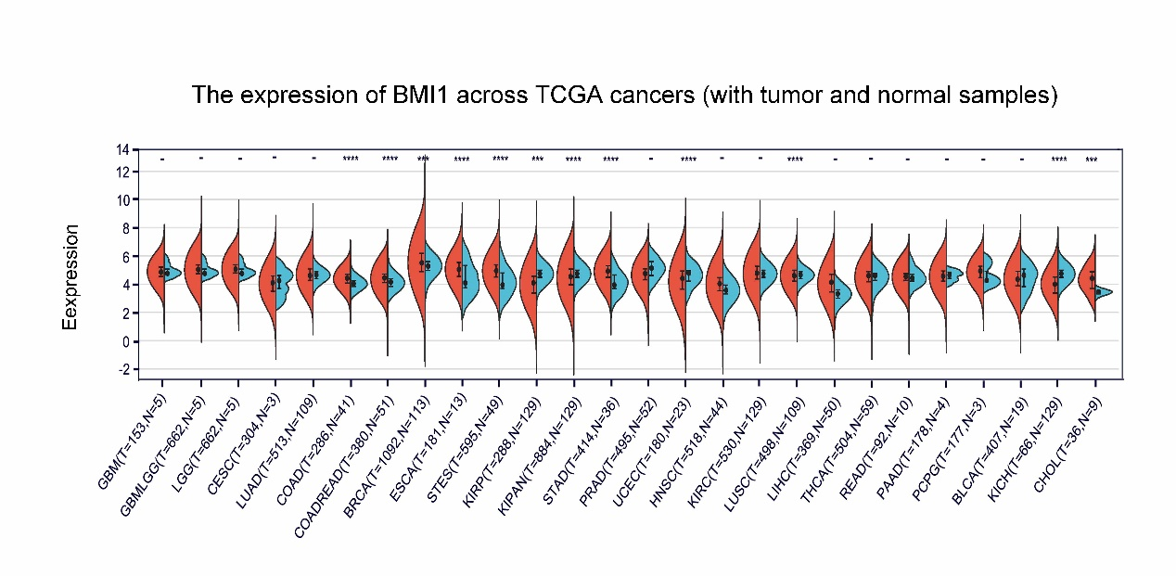
Figure S1. The expression of BMI1 from TCGA database (tumor and normal samples)
(A) The expression of BMI1 in pan-cancer samples from TCGA database. Significant upregulation was observed in COAD, COADREAD, BRCA, ESCA, STES, STAD, HNSC, LIHC, and CHOL, whereas significant downregulation was observed in KIRP, KIPAN, PRAD, UCEC, and KICH.

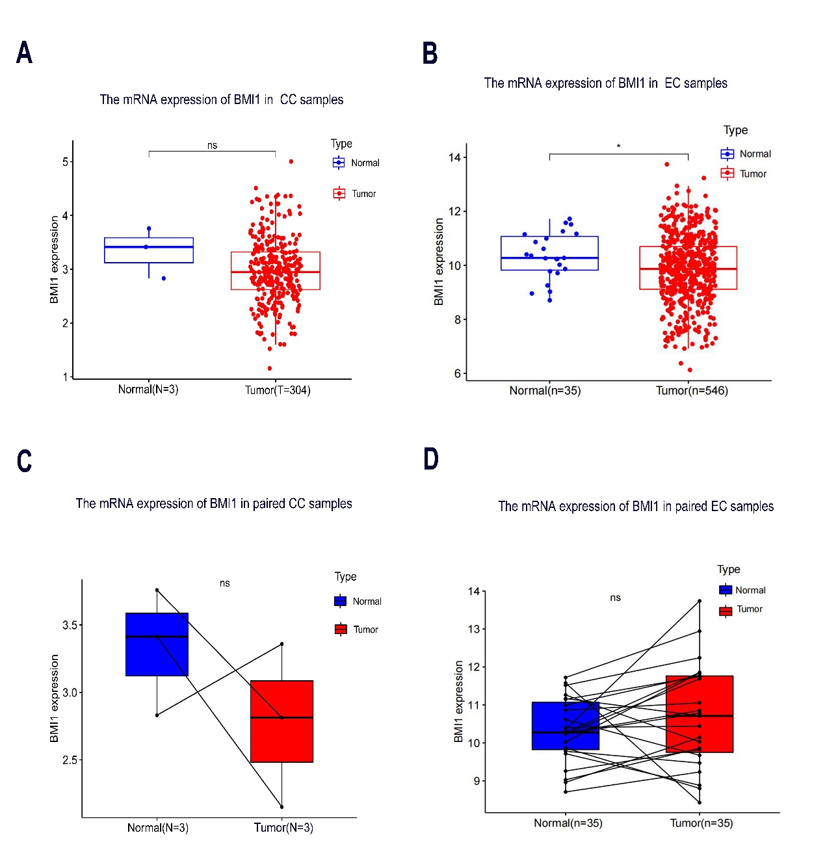

Figure S2. The mRNA expression of BMI1 in CC and EC from TCGA samples
(A) The mRNA expression of BMI1 in all CC samples from TCGA. (B) The mRNA expression of BMI1 in paired CC samples from TCGA. (C) The mRNA expression of BMI1 in all EC samples from TCGA. (D) The mRNA expression of BMI1 in paired EC samples from TCGA.

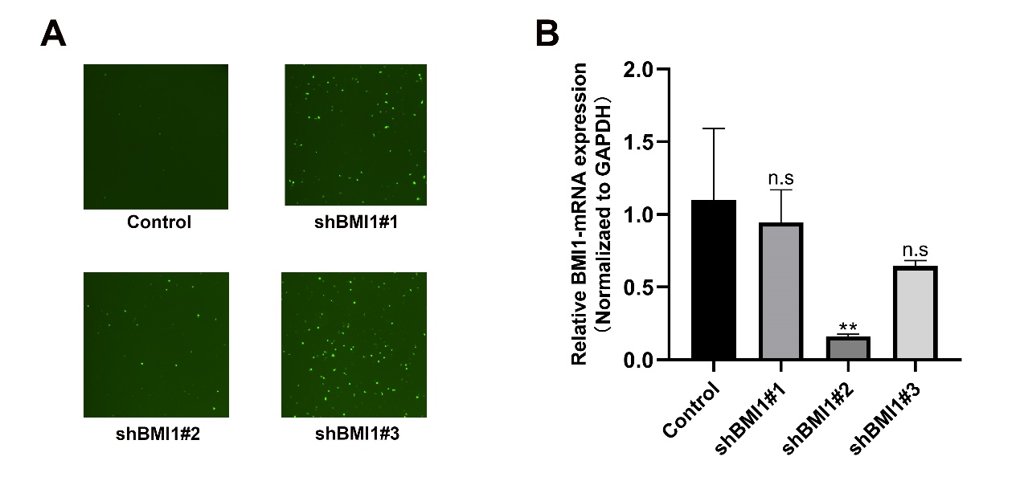
Fig S3. Transfection with shBMI1 plasmids in HEK-293T cells.
(A)The transfection efficiency of shBMI1 under a fluorescent microscope after 24hours of transfection; (B) RT-qPCR measured BMI1 gene mRNA expression in control, shBMI1#1, shBMI1#2 and shBMI1#3 group of HEK-293T cells. Data are shown as means ± SD (n=3). **P < 0.01.

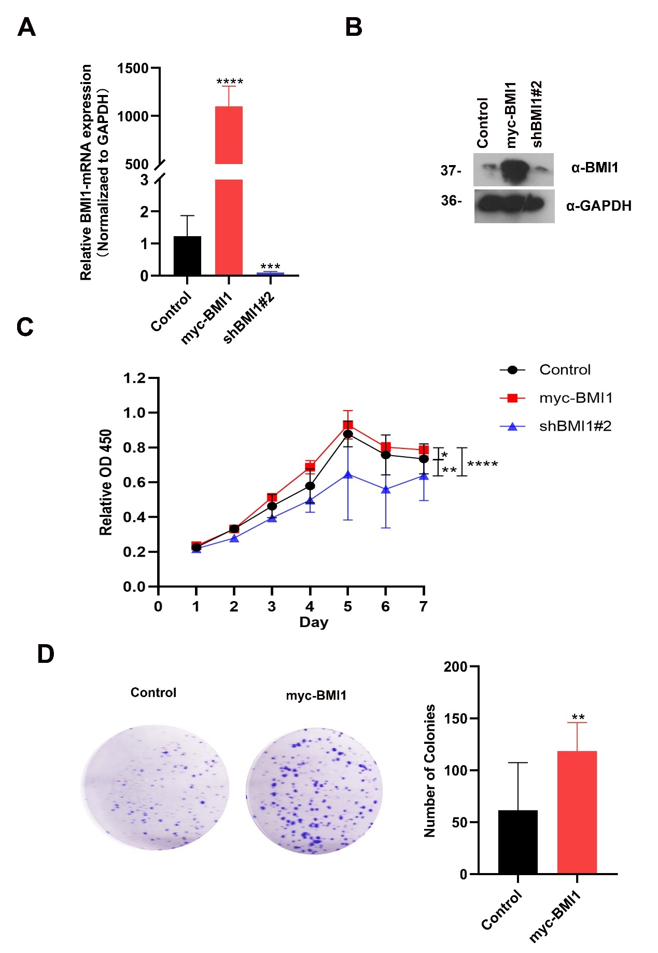
Figure S4 Effect of BMI1 on the growth and proliferation of SPEC-2 endometrial cancer cells
(A) RT-qPCR measured BMI1 gene mRNA expression in control, myc-BMI1 high expression group and shBMI1 knockdown group of SPEC-2 cells, data are shown as means ± SD (n=3). ***P < 0.001.; **** P < 0.0001.*P < 0.05; (B) Western blot of SPEC-2 cells infected with empty plasmids、myc-BMI1 and shBMI1#2 plasmids; (C) Cell proliferation assay of SPEC-2 cells infected with empty plasmids、myc-BMI1 and shBMI1#2 plasmids. *P < 0.05; ** P < 0.01; ****P < 0.0001. (D) Cell colony formation assay of SPEC-2 cells infected with empty plasmids and myc-BMI1 plasmids, all data shown are mean values ± SD (n=3). ** P < 0.01.

