Extended Methods
Selection of Invasive Alien Species of Concern
The EU Regulation 1143/2014, on the prevention and management of the introduction and spread of invasive alien species (https://ec.europa.eu/environment/nature/invasivealien/index_en.htm), establishes a Union List of IAS that, based on available scientific evidence, are likely to have a significant adverse impact on biodiversity or the related ecosystem services, and may also have an adverse impact on human health or the economy. To be included, IAS must have undergone a comprehensive risk assessment by independent experts and reviewed by the EU Scientific Forum. Risk assessments include a description of the adverse impact on biodiversity and related ecosystem services, and we used that information here to assess impacts on Nature’s Contribution to People. In this study, our analysis included all 94 non-marine IAS that have been fully risk assessed and thus identified as priorities for management at the European scale (last accessed August 2022, https://circabc.europa.eu/). This includes 33 terrestrial plants, 31 terrestrial animals, 18 freshwater animals and 12 freshwater plants (Supplementary Table 1). We note that 13 IAS are still under consideration for inclusion in the Union List. However, we took the most inclusive approach in our study in an attempt to maximise the future utility of our analyses.
We retrieved information about impacts on NCP from questions about the impact of each species on ecosystem services. The protocol used to assess the risk associated with invasive species has changed over time, and between taxonomic groups (more details in Supplementary Table 1). When the risk assessment protocol lacked a specific question about ecosystem services, the information was extracted from other related questions, such as impacts on economic interests or biodiversity. The overall magnitude of the risk posed by IAS to ecosystem services was frequently, yet not always, quantified in a Minor to Massive scale (or Low to High, depending on the type of protocol used). To minimise influence of assessor variability, we followed a precautionary approach and categorised impacts as “yes/no”. In doing so, we acknowledge that (1) the magnitude of impacts is highly context-dependent, so that we cannot extrapolate a value to the whole area affected by the species, (2) information provided by the assessors did not always allow for estimating the magnitude of individual impacts, and (3) some IAS are still absent from Europe and there is high uncertainty regarding the magnitude of their potential impacts. Yet we also assumed that the mere presence of a species may impact those NCP that have been reported to be affected elsewhere, which is a conservative, precautionary approach. Supplementary Table 1 lists the 94 IAS investigated in this study, their characteristics, and impacts upon seven NCP.
Supplementary Table 1: Extended List of 94 IAS of European Concern investigated in this study.
https://docs.google.com/spreadsheets/d/1QBBNm6zjyWrP9fEZ4QJDiaUfQP-4WDYqYZBkAlP5kq0/edit?usp=sharing
Species presence and pseudo-absence data
We obtained worldwide occurrence data for the 94 IAS from the Global Biodiversity Information Facility (GBIF, https://www.gbif.org; see Supplementary Table 2 for DOIs). GBIF data downloads included records where the species occurrence status was “present” and whose location included spatial coordinates. These data, delivered in one compressed comma-separated values (CSV) file per species, were then imported into R and cleaned of inaccuracies with the functions ‘coord_incomplete’, ‘coord_imprecise’, ‘coord _impossible’ and ‘coord_unlikely’ from the ‘scrubr’ R package version 0.3.2¹. We further filtered out records whose coordinate uncertainty was higher than 50 km, to minimise spatial error while avoiding a large loss of records. When available, we included additional occurrences from: 1) the European Alien Species Information Network (EASIN; https://easin.jrc.ec.europa.eu/easin; ^{2–5}), 2) several original sources compiled in Gallardo et al.⁶ , and 3) a recent data paper compiling invasive occurrence records from additional sources⁷ (Supplementary Table 2). Records from EASIN and from Ascensão et al.⁷ were available as 10x10 km² grid cells and were converted to the coordinates of their centroids. In total, we gathered 8,829,828 presence records from GBIF (which were reduced to 8,781,484 after cleaning); 145,361 records from EASIN; 17,347 records from Ascensão et al.⁷; and 107,397 records compiled previously by Gallardo et al.⁶ (see Supplementary Table 2 for a breakdown by species).
Supplementary Table 2. Sources of IAS occurrence and total number of records used for modelling the potential distribution of 94 IAS of European concern. https://docs.google.com/spreadsheets/d/1aOQ33RBvhyPKGTa0YIXdhvkJtkpBKMfxUnea8Henxh4/edit?usp=sharing
Species occurrence records were gridded to a 10 arc-minute spatial resolution, which is approximately 11x11 km² at the centroid of Europe, using the 'gridRecords' function of the 'fuzzySim' R package version 3.8 ⁸. This function thins (i.e. rarefies) both presences and pseudo-absences to one maximum point per pixel, which reduces spatial autocorrelation induced by survey bias (e.g. ⁹). Individual maps of occurrences in Europe for the 94 IAS investigated can be consulted in Supplementary Figure 1. The number of analysed IAS per grid cell in Europe is mapped by major taxonomic groups in Supplementary Figure 2.
Supplementary Figure 1. Occurrence of 94 invasive alien species of European concern. This information was used to calibrate species distribution models. Sources of information can be consulted in Supplementary Table 2.
https://drive.google.com/file/d/1FlyVpY86AZMFJPMUDHktbICwr0SmTSXX/view?usp=share_link
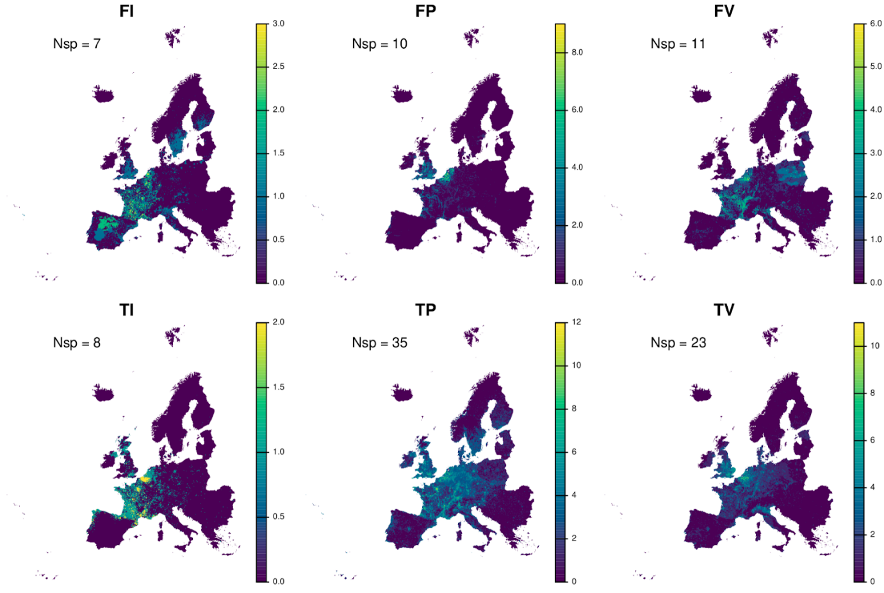
Supplementary Figure 2. Number of analysed species recorded on European 10x10 km² grid cells by major taxonomic groups. FI= freshwater invertebrates, FP= freshwater plants, FV= freshwater vertebrates, TI= terrestrial invertebrates, TP= terrestrial plants, TV= terrestrial vertebrates. Nsp: total number of species in each group. Maps are in Lambert Azimuthal Equal-Area (LAEA) Europe projection.
Pseudo-absences were generated randomly in the same number of each species’ presences, in separate 10-arc-minute pixels and outside the presence pixels, but within a 200-km spatial buffer to avoid non-surveyed regions¹⁰. Buffers and point samples were created, respectively, with the 'buffer’ and ‘spatSample’ functions of the ‘terra' R package version 1.5.21¹¹.
Nature’s Contribution to People
In this study we used proxies for 7 NCP using maps of the provision of ecosystem services recently developed by two major initiatives of the European Environmental Agency (EEA):
- MAES – Mapping and Assessment of Ecosystems and their Services: The state and trends of ecosystems in the European Union (https://biodiversity.europa.eu/ecosystems):
- INCA – Accounting for ecosystems and their services in the European Union (https://ec.europa.eu/environment/nature/capital_accounting/index_en.htm)
The advantage of using EEA data and maps is both methodological and practical. First, MAES and INCA include reports for a total of 9 ecosystem services using a single, comparable methodology based on European data and statistics¹². Second, MAES and INCA maps will support future assessments and policy developments, in particular with respect to the EU Biodiversity Strategy for 2030 and the European Green Deal and are therefore particularly relevant for management. Uncertainties and limitations related to the underpinning data and calculation of each NCP can be consulted in the references listed in Supplementary Table 3.
The selection of NCP for evaluation in this research was conditioned by: (1) the availability of suitable proxies, and (2) the total number of IAS with reported evidence of impacts. This combination led to a total of 7 NCP selected for further investigation (Supplementary Table 3). We discarded crop pollination and climate regulation available through MAES because of the low proportion of the 94 focus IAS that affect these two services (N=7 and 2 respectively). All NCP maps were obtained from the Joint Research Centre (https://data.jrc.ec.europa.eu/dataset, last accessed July 2022).
Supplementary Table 3. Nature’s Contribution to People (NCP) investigated in this study, including information about the spatial proxies used and their metadata. The number of IAS of European concern that have reported negative impacts on each NCP are indicated and can be also consulted in Supplementary Table 1. See more details in the text. NCP numbering refers to the IPBES conceptual framework¹³.
NCP | Proxy | Metadata
NCP 1-Habitat creation and maintenance | Habitat suitability to support species populations | Reference: La Notte et al.¹⁴  Resolution: 10x10 km²  Year: 2012  Units: unitless, from 0 to 100.
NCP7-Regulation of freshwater quality | Nitrogen retention by natural ecosystems | Reference: La Notte et al.¹⁴  Resolution: 30 arcsec  Year: 2012  Units: tonne/ha
NCP 8-Formation and protection of soils | Soil retention | Reference: La Notte et al.¹⁴  Resolution: 100 m²  Year: 2012  Units: % of potential soil erosion that is mitigated by ecosystems. From 0 to 100.
NCP 9-Regulation of hazards and extreme events | Flood control | Reference: Vallecillo et al.¹⁵  Resolution: shapefile (polygons)  Year: 2012  Units: % service provisioning areas upstream. From 0 to 100.
NCP 12-Food and Feed | Ecosystem contribution to crop provision | Reference: Vallecillo et al.¹⁶  Resolution: 1 km²  Year: 2012  Units: tonnes/km³ attributable to the ecosystem contribution
NCP13-Materials | Timber provision | Reference: Vallecillo et al.¹⁴  Year: 2012  Units: m³/year
NCP 16-Physical and psychological experiences | Outdoor Recreation | Reference: Vallecillo et al.¹⁶  Resolution: shapefile (NUTS2)  Year: 2012  Units: % areas for daily recreation per admin unit. From 0 to 100.

Description of proxies used to reflect Nature’s Contribution to People:
Habitat suitability. This map reflects suitable ecological conditions (or suitable habitats) required to support species populations, integrating information about the quality and quantity of different ecosystem types. The habitat suitability indicator is calculated by multiplying the ecological condition of European habitats, to account for habitat degradation, by the relative ecosystem extent per 10x10 km² cell, to account for habitat loss¹⁷. We assume that a high habitat suitability implies a high provision of the NCP Habitat creation and maintenance.
Flood control. Defined here as the regulation of water flow by ecosystems that mitigates or prevents potential damage to economic assets (i.e., infrastructure, agriculture) and human lives¹⁸. This proxy measures the hectares of land benefiting from the flood control provided by ecosystems in a given year. The potential for flood control is higher in forested areas in Europe and reaches lower values in the main agricultural plains with intense human development, e.g., in the east of the UK, southern Spain, the Po plain in Italy and in Romania¹⁵. We assume that a high capacity for flood control implies a high provision of the NCP Regulation of hazards and extreme events.
Nitrogen retention. In large-scale assessments, nitrogen retention has been adopted as a proxy to quantify the service of water purification^{19–21}. One of the reasons for this choice is the widespread problem of excessive nitrogen (and phosphorus) loadings to aquatic ecosystems, which cause the disproportionate growth of algal biomass and consequent hypoxia and collapse of the ecosystem²². Water purification was mapped considering the nitrogen inputs, weather and hydrological conditions of 2012²³. The model considers basin retention (including crop uptake) and river and lake retention. High nitrogen retention can be found in countries with high nitrogen input such as Denmark, Hungary, the Netherlands and Poland, and in northern Italy. We assume that a high nitrogen retention implies a high provision of the NCP Regulation of freshwater quality.
Soil retention. Indicator that reflects the relationship between the capacity of ecosystems to avoid soil erosion and how much soil is retained by vegetation. Soil erosion control is a key regulatory service that refers to the ability of ecosystems to retain soil and minimise natural or induced erosion. We assume that a high capacity to retain soils implies a high provision of the NCP Formation and protection of soils.
Crop provision. Ecosystem contribution to the growth of cultivated crops that can be harvested and used for the production of food, fibre and fuel. The quantification disentangles the yield generated by natural inputs (i.e. sunlight, wind, rainfall, evapotranspiration, soil) from what is generated by human inputs (i.e., planting, irrigation, chemical products). The map represents the percentage of the yield that can be attributed to the ecosystem contribution, and varies from 0, when yield is entirely derived from human inputs, to 1 when no human input is involved. At the EU level, ecosystem contribution to crop provision is about 21% of the total yield value. The rest is due to human inputs. We assume that a high ecosystem contribution to crop provision implies a high provision of the NCP Food and feed.
Timber provision. Ecological contribution to the production of timber that can be harvested and used as raw material¹⁸. This is calculated using the Net Annual Increment of Timber (NAI), which represents the gross annual increment minus losses due to natural tree mortality and the human contribution to timber provision (see more details in¹⁵). We assume that a high production of timber implies a high provision of the NCP Materials.
Outdoor daily recreation. Value of ecosystems with a high potential for daily use for recreation. Daily recreation includes a wide variety of practises including walking, jogging, running, bike riding, picnicking, observing flora and fauna, enjoying the surrounding beauty of the landscape, among a myriad of other possibilities. The map is based on the recreation opportunities spectrum (ROS), which represents a whole range of recreation opportunities categorised as a function of their level of provision and the distance to roads and residential areas. Areas with the highest recreation opportunities are mainly in mountains and close or within natural protected areas. We assume that a high capacity to retain soils implies a high provision of the NCP Formation and protection of soils.
Values of each NCP proxy were averaged over the 10x10 km² reference grid of the European Environment Agency (EEA, https://www.eea.europa.eu/data-and-maps/), using the ‘exact_extract’ function of R package ‘exactextractr’ version 0.6.1²⁴. The maps of all NCP proxies were then rasterized using this grid as a template, so that each pixel exactly matches one EEA grid cell. Values were finally classified into three categories using the upper and lower 20% percentiles: low provisioning (≤ 20% of data), medium provisioning (20-80% of data) and high provisioning (≥ 80% of data) (Supplementary Figure 3). The classification is narrower at the extremes to allow better discrimination of both very low and very high provisioning areas.
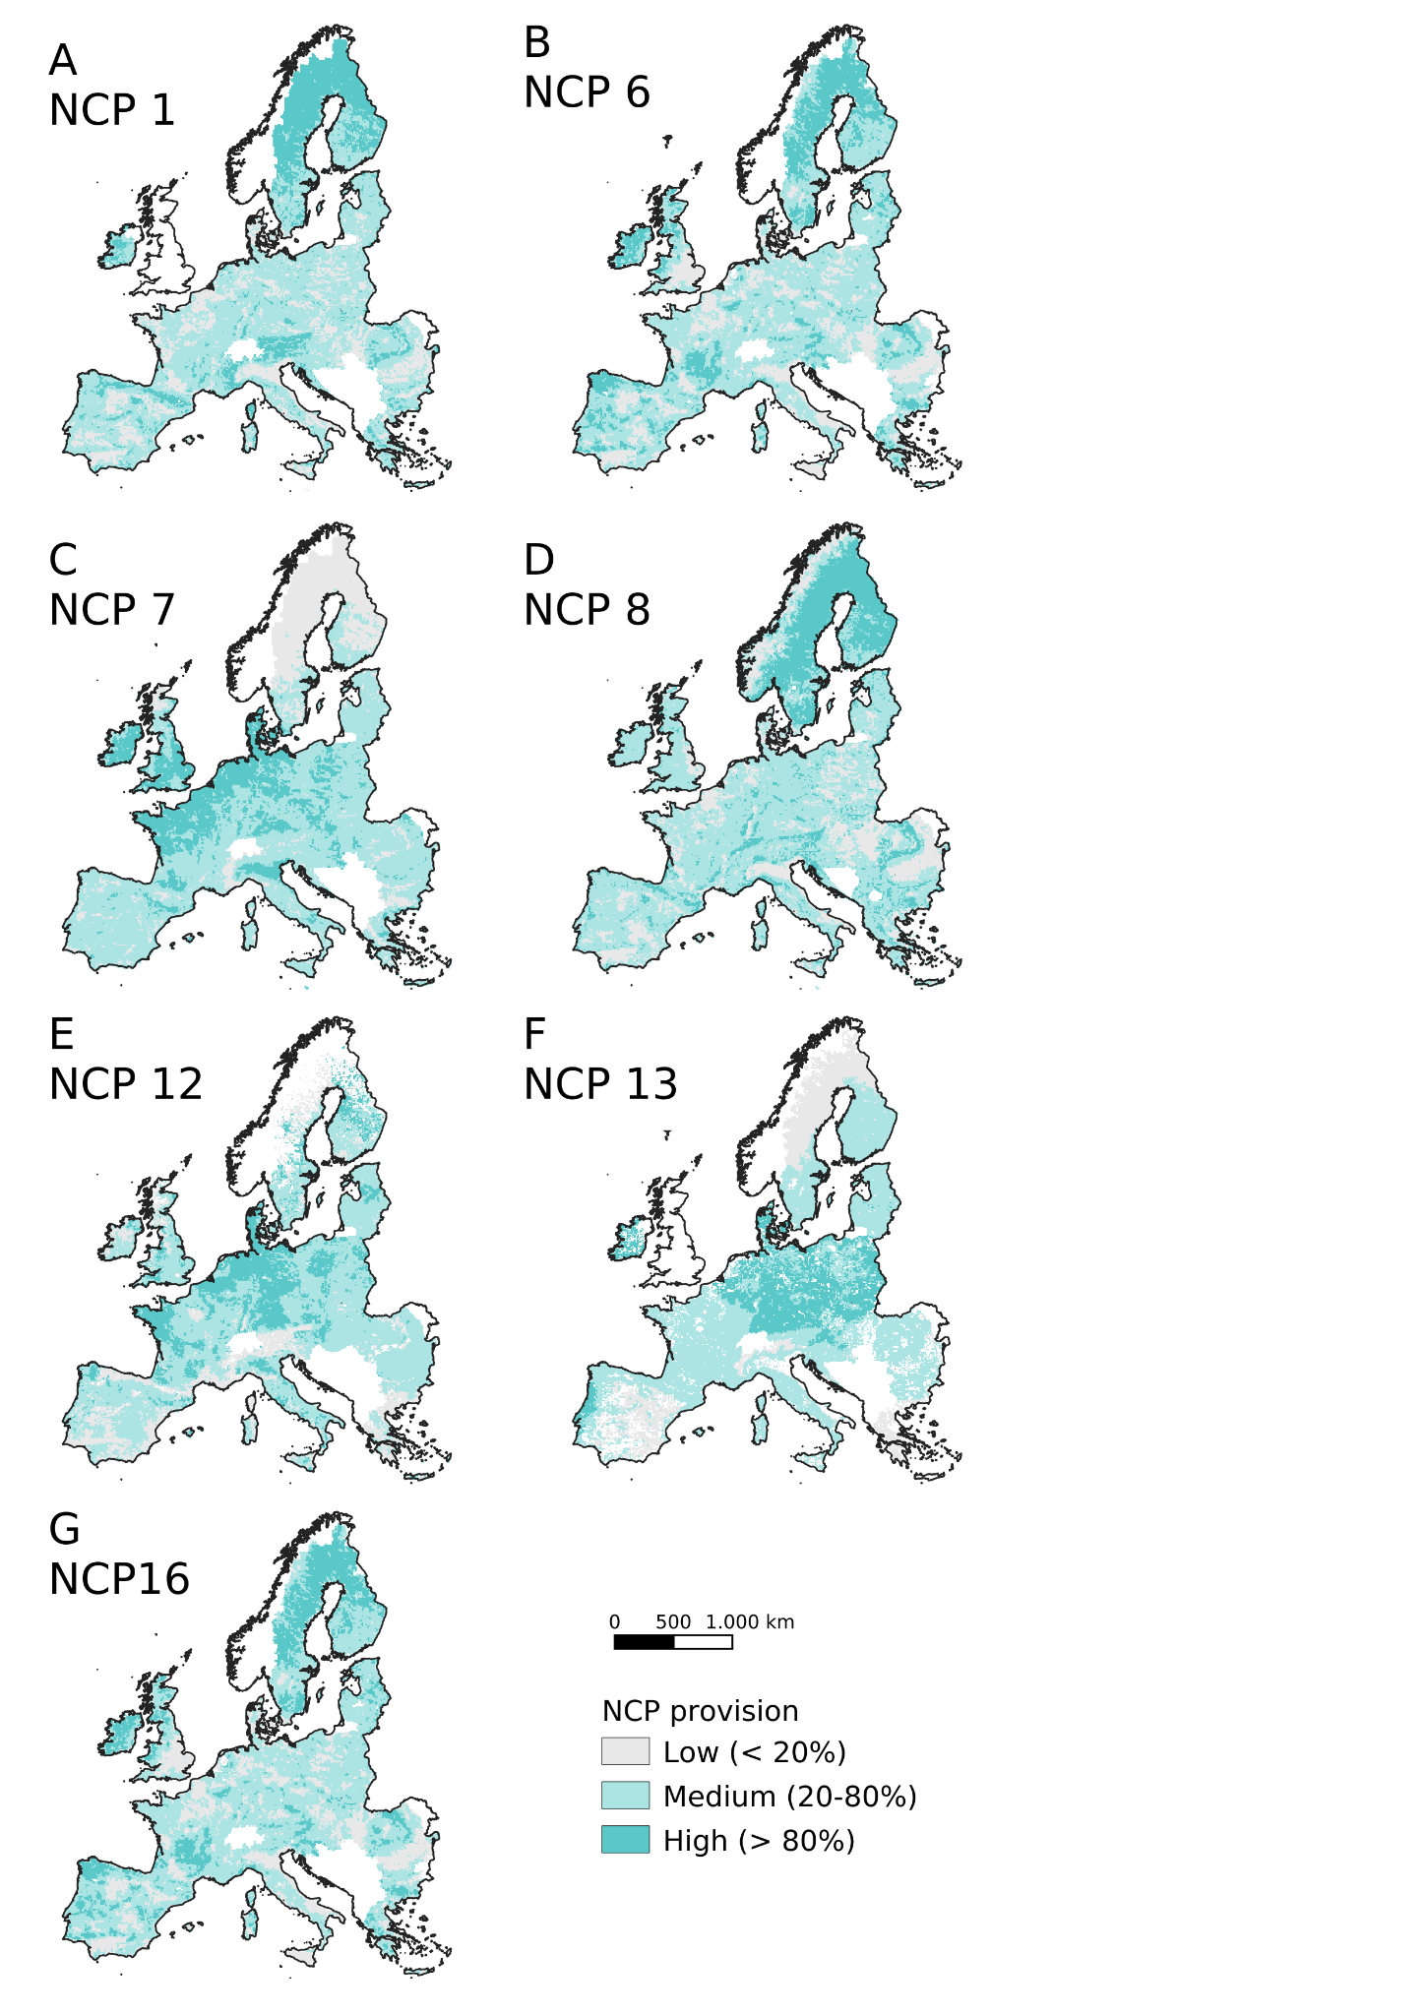
Supplementary Figure 3. Maps of Nature’s Contribution to People reclassified into three quintiles (Low, Medium and High provisioning). Proxies used for each NCP can be consulted in Supplementary Table 3.
Current threat was measured as the total number of IAS that are known to affect a particular NCP. We used Welch one-way ANOVA for unequal variances to test if differences in IAS current threat were significantly different among areas delivering Low, Medium and High NCP. The normality assumption can be relaxed in the case of very large sample sizes, as in this case²⁵. Results from non-normal analysis of variance (Kruskal-Wallis Test) did not differ. We also used post-hoc Tukey HSD tests to explore pairwise comparisons (Supplementary Table 4).
Supplementary Table 4. Analysis of Variance in IAS richness across low, medium and high NCP provisioning areas. Results from Welch One-Way ANOVA with unequal variances across groups. The dependent variable is the observed richness of invasive species affecting each NCP (SR_{ncp1→16}). The independent variable is the NCP provision, a categorical variable with three levels: low, medium and high. Results from a post hoc Tukey HSD Test show pairwise significant differences. “***”= highly significant at p<0.0001; n.s.= not significant at p>0.05.
Formula | One-Way ANOVA Test  F (DF) P-value |  | Tukey HSD Test
SR_{ncp1} ~ NCP1 | 8875.6 (2, 9834.2) | <0.001 (***) | Low-Medium ***  Low-High ***  Medium-High ***
SR_{ncp6} ~ NCP6 | 968.83 (2, 17315) | <0.001 (***) | Low-Medium ***  Low-High ***  Medium-High ***
SR_{ncp7} ~ NCP7 | 1986 (2, 2709.9) | <0.001 (***) | Low-Medium ***  Low-High ***  Medium-High ***
SR_{ncp8} ~ NCP8 | 1589.1 (2, 21318) | <0.001 (***) | Low-Medium ***  Low-High ***  Medium-High ***
SR_{ncp12} ~ NCP12 | 1473.6 (2, 15550) | <0.001 (***) | Low-Medium ***  Low-High ***  Medium-High ***
SR_{ncp13} ~ NCP13 | 500.73 (2, 15395) | <0.001 (***) | Low-Medium ***  Low-High ***  Medium-High n.s.
SR_{ncp16} ~ NCP16 | 1373 (2, 16923) | <0.001 (***) | Low-Medium ***  Low-High ***  Medium-High ***

The calculation of threats depends on the thresholds used to classify sites into Low, Medium and High NCP delivering areas. We therefore performed sensitivity analysis using three alternative breakdowns of NCP values.
Alternative 1: Low (NCP ⋜10%), Medium (10-90% NCP) and High (NCP ⋝90%)
Alternative 2 (selected for this study): Low (NCP ⋜20%), Medium (20-80% NCP) and High (NCP ⋝80%)
Alternative 3: Low (NCP ⋜30%), Medium (30-70% NCP) and High (NCP ⋝70%)
Patterns of IAS threat upon the 7 NCP were consistent along the three alternative thresholds investigated, with the average number of IAS present per category showing a variation of 5.8% (between Alternative 2 and 3) and 6.6% (between Alternative 1 and 2) (Supplementary Figure 4). Differences in IAS current threat among sites providing Low, Medium and High NCP were significant in the three alternatives (Kruskal-Wallis Test, P<0.001 in all cases). The IAS current threat was significantly lower in High provisioning areas for Habitat maintenance, soil erosion, hazard regulation and human experiences. The contrary was observed for water quality, the provisioning of food and materials, in which case there was a higher richness of IAS in High NCP delivering areas.
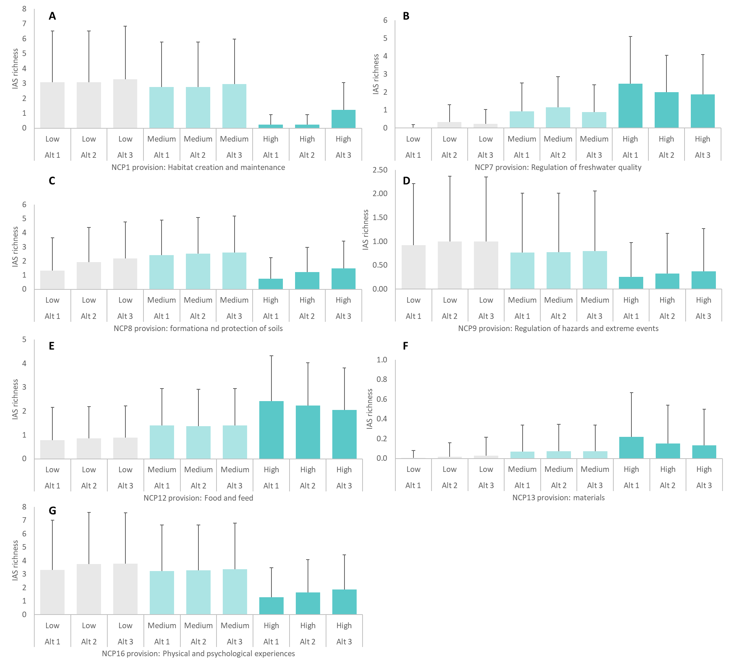
Supplementary Figure 4. Sensitivity analysis using three alternative thresholds to measure the current threat posed by IAS on NCP provision. Bars represent the mean±SD number of invasive alien species know to occur per pixel of 10x10Km² in Europe. Alt 1/2/3 represent the three alternative thresholds to classify NCP provisioning into Low/Medium/High categories.

Predictor variables
We used 21 environmental variables to model the distribution of each species, including accessibility (measured by human travel time²⁶); elevation²⁷; and 19 bioclimatic variables obtained from CHELSA (Climatologies at High resolution for the Earth's Land Surface Areas) version 2.1²⁸. CHELSA variables are based on statistical downscaling of global reanalysis data rather than on a spatial interpolation of (irregularly distributed) weather station data, which visibly improves their accuracy at regional and local scales^{28,29}. All variables were downloaded as raster maps at 30 arc-second resolution (except for elevation, which was available at 1 arc-minute resolution) and aggregated using the 'aggregate' function of R package 'terra' to 10 arc minutes (approximately 11x11 km² in central Europe) to approximately match the spatial resolution of the species occurrence data. Such high resolution is necessary to obtain a continental scale picture that will help us understand and communicate about IAS threats on NCP. Pearson’s correlations among the 21 variables were calculated and then represented graphically using the 'corrplot' R package³⁰ (Supplementary Figure 5).
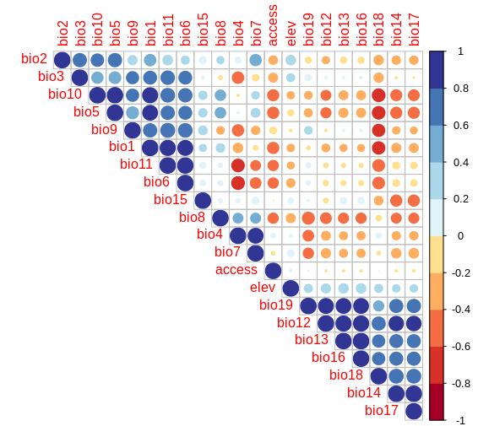
Supplementary Figure 5. Correlations among the 21 candidate variables. access= accessibility, elev= elevation. bio1= mean annual air temperature; bio2= mean diurnal air temperature range; bio3= isothermality; bio4= temperature seasonality; bio5= mean daily maximum air temperature of the warmest month; bio6= mean daily minimum air temperature of the coldest month; bio7= annual range of air temperature; bio8= mean daily mean air temperatures of the wettest quarter; bio9= mean daily mean air temperatures of the driest quarter; bio10= mean daily mean air temperatures of the warmest quarter; bio11= mean daily mean air temperatures of the coldest quarter; bio12= annual precipitation amount; bio13= precipitation amount of the wettest month; bio14= precipitation amount of the driest month; bio15= precipitation seasonality; bio16= mean monthly precipitation amount of the wettest quarter; bio17= mean monthly precipitation amount of the driest quarter; bio18= mean monthly precipitation amount of the warmest quarter; bio19= mean monthly precipitation amount of the coldest quarter.
Modelling IAS potential distribution
Models were built for each species using Bayesian Additive Regression Trees (BART), computed with the 'bart' function of the 'dbarts' R package³¹. BART is a machine-learning technique that has been shown to infer appropriate modelling parameters using the default settings, and to provide accurate predictions without overfitting to noise or to particular cases in the data, thanks to its built-in complexity penalty and its inherent handling of uncertainty^{32,33}. Because BART is robust to the inclusion of redundant variables, we used all predictors in our models³².
To ensure that our choice of modelling method did not bias our results and conclusions, we compared BART predictions to those obtained with three other methods of different complexity, all of which have previously been shown to provide robust results in species distribution modelling: Generalised Linear Models (GLM), computed with the 'glm' function of base R; Generalised Additive Models (GAM), computed with the 'gam' function of the 'gam' R package; and Generalised Boosted Models (GBM, also known as boosted regression trees), computed with the 'gbm' function of the 'gbm' R package.
Models were subjected to five-fold spatial block cross-validation. Unlike conventional random cross-validation, which may underestimate prediction error on spatially structured or clustered data samples³⁴, block cross-validation spatially separates the training and testing data, allowing a more rigorous assessment of model predictive ability, in both nearby and more distant locations³⁵. The study area (i.e. the modelling buffer) of each species was divided into five folds (groups) of spatial blocks, using the ‘spatialBlock’ function of the ‘blockCV’ R package version 2.1.1³⁵. The size of these spatial blocks was set to 200 km, which was considered a reasonable distance beyond which similar presence and prediction patterns are no longer simply due to spatial autocorrelation. Larger block sizes, defined e.g. by the range of spatial autocorrelation in predictor variables³⁵, reduce the environmental representation in model testing blocks, thereby producing unreasonably low evaluation scores³⁴. We modelled the distribution of each species five times, each time leaving out one of the five folds of spatial blocks. Each of these five partial models was then tested on the corresponding reserved fold. Finally, the mean and variance of the model evaluation metrics were assessed across folds. After assessing this cross-validation performance, a final model was computed for each species using the entire dataset.
For the assessment of model performance, we used two threshold-independent evaluation metrics that focus on different but equally important facets of predictive accuracy: 1) the Area Under the receiver operating characteristic Curve (AUC), which measures the overall discrimination power, i.e., the capacity of the model to assign higher predicted values to presence than to absence localities; 2) Miller’s calibration slope (MCS), which measures the reliability of model predictions, i.e., the overall deviation of predicted probabilities from observed occurrence frequencies^{36,37}. An AUC value of 1 indicates perfect discrimination between presences and absences, i.e. that all presences have higher predicted values than any absences. An MCS value of 1 shows that predicted probabilities are directly proportional to observed occurrence frequencies. These metrics were computed with R package ‘modEvA’ version 3.0³⁸.
Results from cross-validation indicated good to excellent performance of distribution models, with an average AUC of 0.86 ± 0.06 and MCS of 1.09 ± 0.18. Limnoperna fortunei was the only species achieving AUC < 0.7, which can be considered poor. Two species obtained MCS slightly above 1.5 (i.e. far from 1). Cross-validation performance indicators (AUC and MCS) for the 94 IAS investigated across the 4 algorithms (BART, GLM, GAM and GBM) can be found in Supplementary Table 5.
Supplementary Table 5. Results of model cross-validation for the 94 IAS investigated. AUC= Area Under the receiver operating characteristic Curve. MCS= Miller’s calibration slope.
https://docs.google.com/spreadsheets/d/1CwFcDgWBe3Cn6qtJjfnuIUsR4B7LkSOktzNfFa0LNDs/edit?usp=sharing
Accessibility, bio6 (temperature of coldest month), bio 13 (precipitation of wettest month), bio 4 (temperature seasonality), and bio 12 (annual precipitation) were among the most important predictors of the distribution of our focus IAS, with slight changes across major taxonomic groups (Supplementary Figure 4). Temperature related predictors (bio 1 to bio 11) contributed 54 ± 6% to the models; whereas the overall contribution of precipitation related predictors (bio 12 to bio 19) was lower, at 36 ± 5%. Considering the high inter-correlation among candidate variables shown in Supplementary Figure 6, identifying the most important predictors of individual IAS requires more detailed investigation that is beyond the scope of this study.

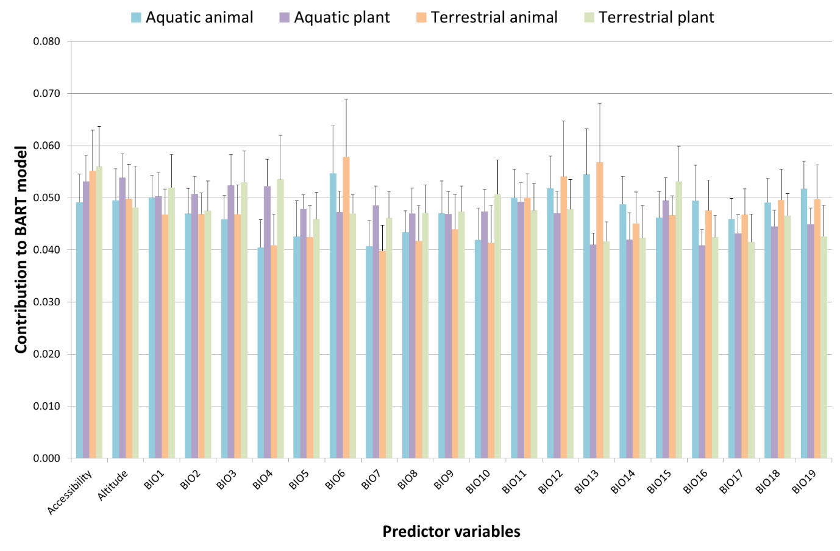
Supplementary Figure 6. Contribution of predictor variables to species distribution models. Values represent the mean and standard deviation across 32 terrestrial plants, 29 terrestrial animals, 20 aquatic animals and 13 aquatic plants.
Distribution models provide the probability of establishment of modelled species, which measures how likely we are to find the species at a given place. Probability therefore depends on how good the environment is at that place and how common the species is across the study area. Independently of the environment, presence probability is higher for species that are more common, so species that (still) have few presences, as is normally the case with recently introduced invasive species, would be underestimated. Compensating for differences in prevalence, favourability is how much the environment favours the presence of each species. At 50% modelled prevalence (i.e. same number of presences and pseudo-absences for each species), presence probability is the same as favourability, thus providing directly comparable predictions across species^{39,40}. In this way, models can be combined in order to predict the number of IAS that could potentially occur in a location^{41,42}. Favourability per species was classified into three categories: 1 (favourability ⋜20%), 2 (20-80% favourability), and 3 (favourability ⋝80%), the latter representing odds more than 4:1 favourable environmentally for species occurrence^{43,44}.
Potential threat is the projected impacts of IAS upon NCP under a worst-case scenario where they are able to fill the most accessible and favourable parts of their ecological niche, under current environmental conditions. At the level of species, we quantified the potential threat as the total surface of Europe (in km²) that shows a very high climate suitability and accessibility (i.e. category 3), and thus could be colonised in the near-future. We compared the current area colonised by each IAS - i.e. where species have been observed presently - (=current threat) with the total area that could potentially be affected - i.e. where the environment is favourable for the species and could be colonised (=potential threat).
Range expansion can be influenced by the threshold used to classify sites as very suitable for invasive species (category 3), so we compared three alternatives:
Alternative 1: favourability ⋝ 90%
Alternative 2: favourability ⋝ 80%
Alternative 3: favourability ⋝ 70%
The total area classified as suitable for IAS increased from Alternative 1 to Alternative 3. In comparison with the total area currently occupied by IAS (corresponding to “Current threat” in Supplementary Figure 7), Alternative 1 results in an average range contraction of 3% for IAS of European concern, which suggests that this option is too conservative when looking at the areas most suitable for invasion. In contrast, Alternative 3 results in a range expansion of 163% on average across the 94 IAS investigated. Under this alternative, the area occupied by IAS in Europe almost triples, which is possible but unrealistic in the near future. At an intermediate level, Alternative 2 results in a range expansion of 77% relative to the area currently invaded. This is considered the most credible option and is therefore used in the main manuscript (Extended Data 2).

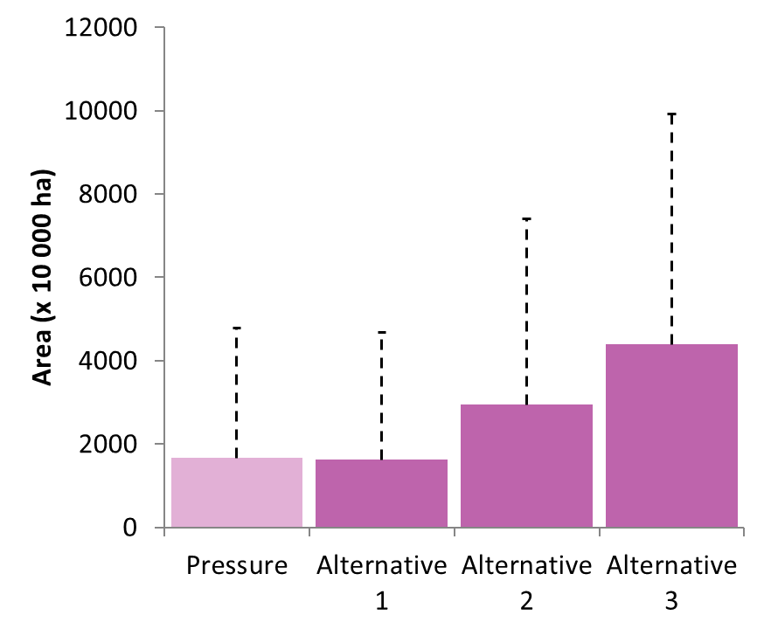
Supplementary Figure 7. Barplot showing the average (+standard deviation) area under current and potential threat by IAS of concern in Europe, using three alternative threat thresholds: favourability ⋝ 0.90, ⋝ 0.80 and ⋝ 0.70 respectively.
Some IAS showed a very high potential for range expansion, particularly when they currently occupy a minimal fraction of their potential niche (e.g. C. candensis, L. getula, S. niger, Extended Data 2). At the other extreme we find IAS with minimal potential for range expansion; this was the case of species that seem to have filled most of their climate niches (e.g. O. jamaicensis, A. syriaca) or that may even lose suitable habitat (e.g. A. triangulatus, L. catesbeianus).
Risks posed by invasive species upon Nature’s Contribution to People
Potential impacts of IAS upon NCP are estimated through the combination of species favourability and the delivery of ecosystem services. Following Pérez et al.⁴⁵, we defined a total of 9 risk categories by combining the provision of NCP (categories L, M and H) with the favourability for invasion per species (categories 1, 2 and 3) (Fig. 3A). This classification allowed us to spatially evaluate changes in the potential impacts of invasive species on the provisioning of ecosystem services. For the analysis, particular emphasis was put on the following categories:
- Coldspots (L1) represent sites where both NCP provisioning and species suitability are low; consequently, IAS impacts are expected to be limited.
- Critical impact (L3) represent sites where NCP provisioning is already low and the probability of invasion is high; consequently, the invader may compromise entirely the provisioning of the NCP e.g. an invasive species that promotes nutrient accumulation in areas with poor capacity for nitrogen retention may lead to a change in the stable state of the ecosystem towards eutrophication.
- Safe provision (H1) represents sites showing high NCP provisioning and low probability of invasion, where no major problems associated with the invader are expected.
- Hotspots (H3) represent sites combining a high delivery of ecosystem services and high probability of invasion. Consequently, this is where we may expect the greatest reduction in the overall provisioning of ecosystem services.
We acknowledge that the mechanisms behind impacts are complex and empirical evidence is scarce, so that NCP may not be affected even if the IAS is present if, for instance, the density of the invader is low or corrective management measures are applied to either limit the abundance of the invader or mitigate its impacts. More empirical evidence about the direct and indirect consequences of IAS upon nature’s contribution to people is therefore needed.
For each of the NCP-IAS combinations evaluated in this study, we extracted the area of Europe classified into the nine categories of threat (Supplementary Table 6). Bar plots displaying the surface of Europe classified into coldspot, safe, critical and hotspot for all IAS affecting each of the 7 NCP investigated can be found in Supplementary Figure 8. Individual maps for all the 269 combinations between 94 IAS and seven NCP are stored in the Figshare data repository (Figshare, DOI: 10.6084/m9.figshare.21739385).
Supplementary Table 6. Potential impact of invasive alien species on Nature’s Contributions to People (NCP). Data indicate the area of Europe classified into 9 categories of risk (Fig. 3A), from Safe to Hotspot. All individual combinations between 94 invasive alien species and 7 NCP that may be potentially affected are shown.
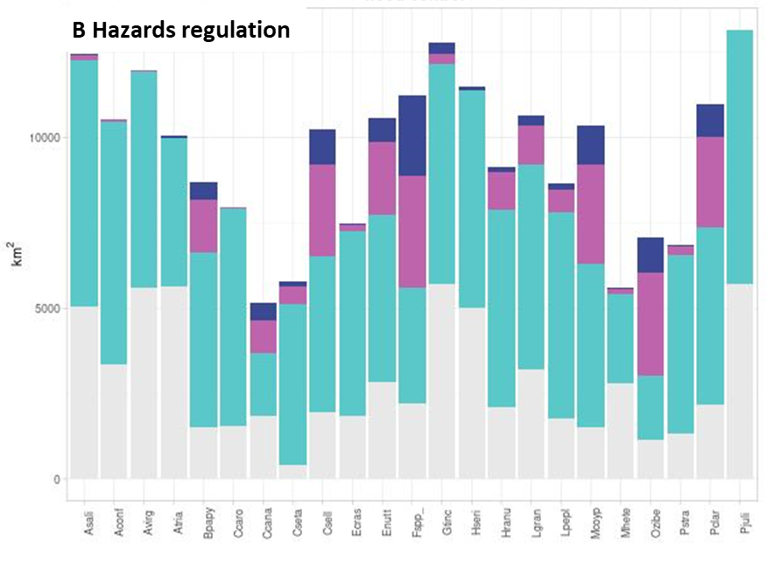
https://docs.google.com/spreadsheets/d/1IO8nDWnujhqvL8m0jpKvj1j6WP-TZKMF4w0F2cl7OQU/edit?usp=sharing
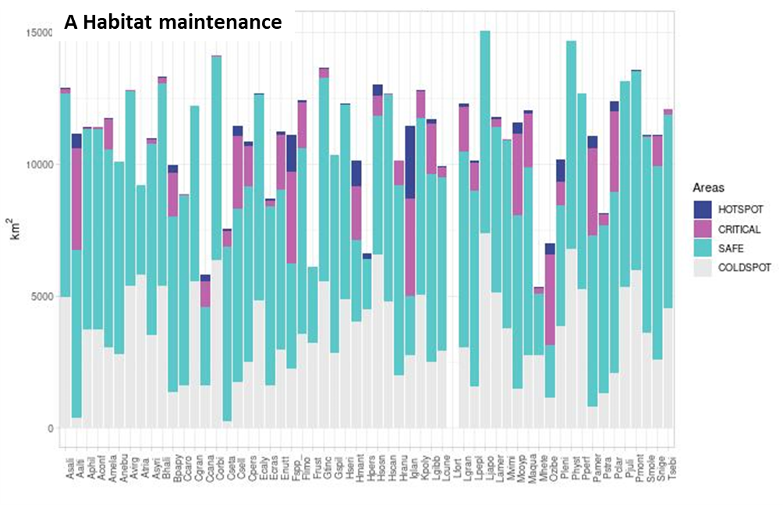
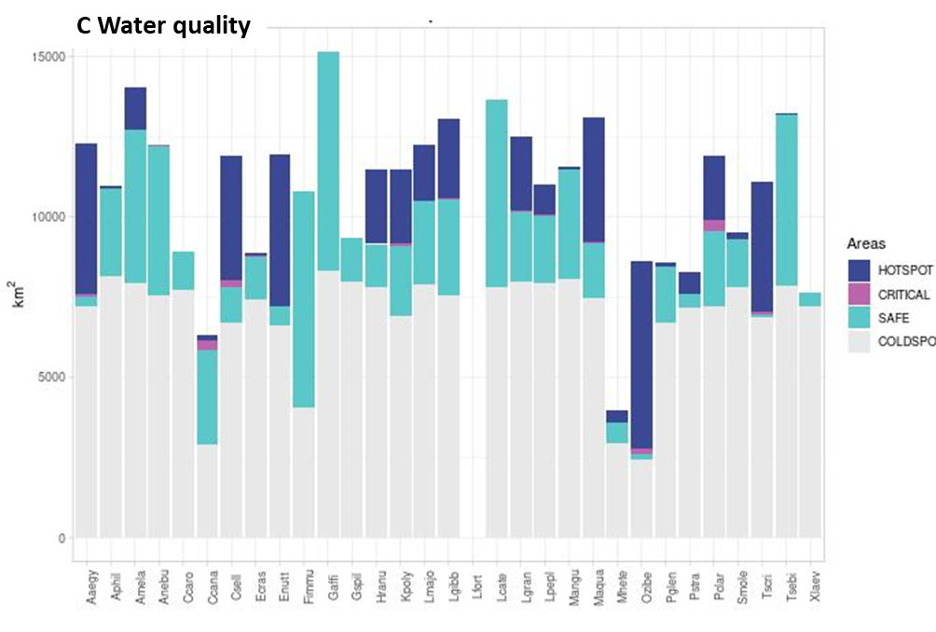
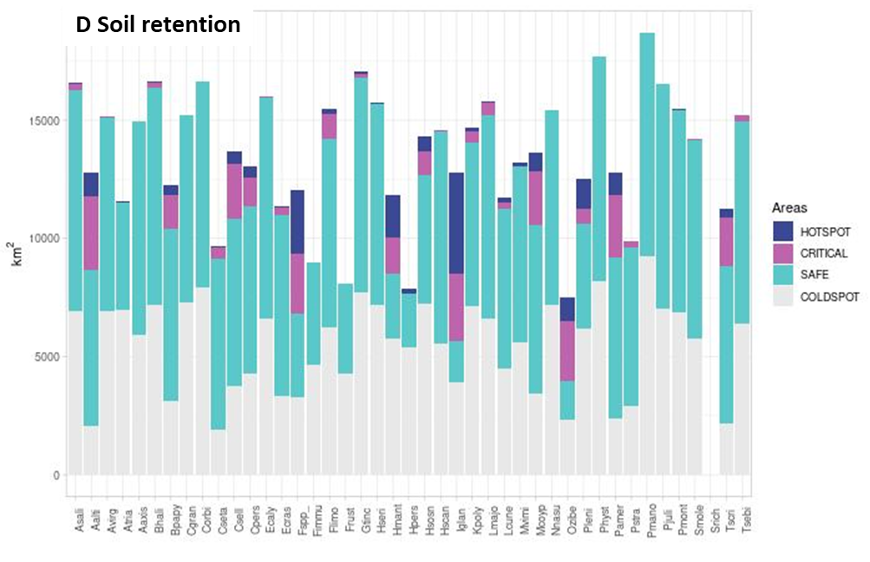
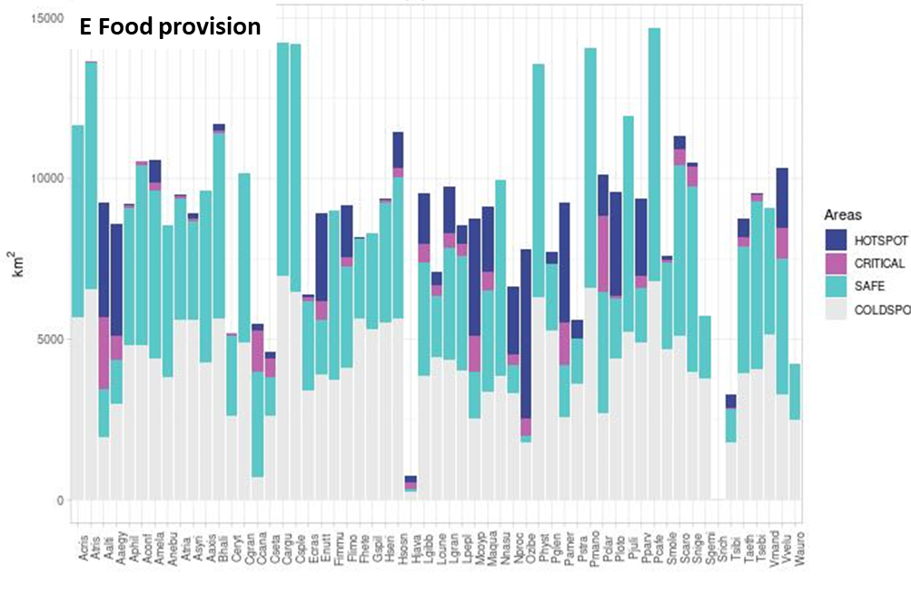
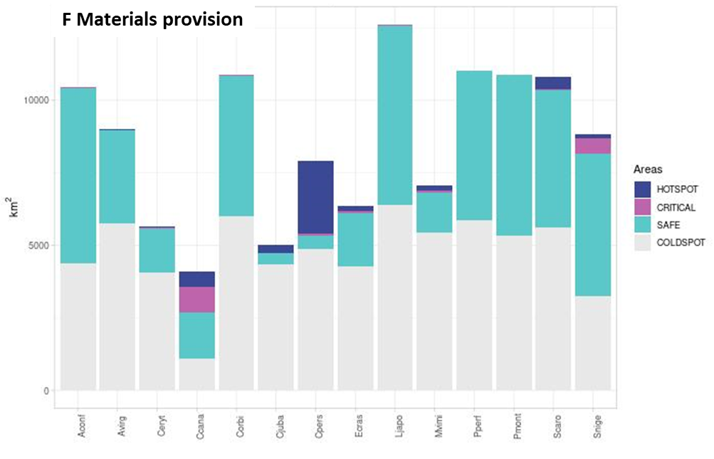
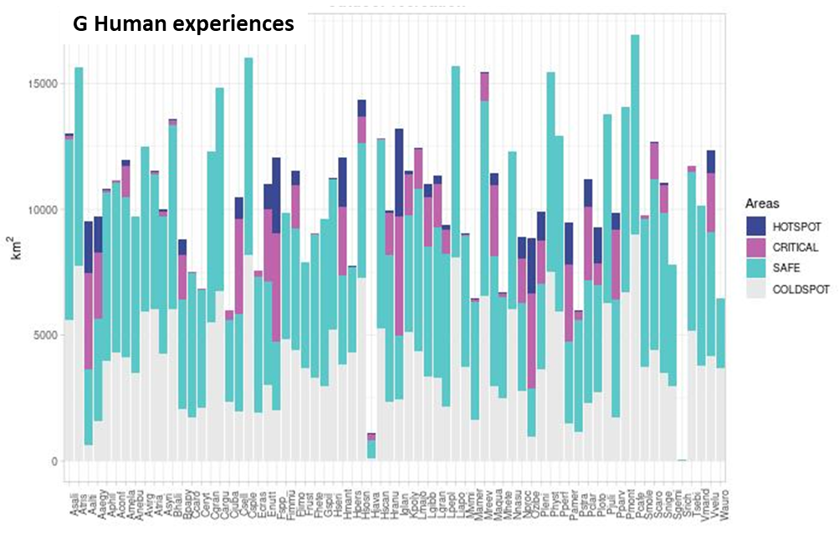
Supplementary Figure 8. Total areas of Europe that are classified into 4 impact categories combining the favourability for IAS and NCP provision. “Critical” represents sites where ecosystem service provision is low and the probability of invasion is high, “Hotspots” represents sites combining a high probability of invasion and a high delivery of ecosystem services. In the x-axis, ID of invasive species with reported evidence of negative impact upon the specific NCP. The full name and characteristics of IAS can be consulted in Supplementary Table 1.
We compared the total area of Europe classified into each of the 9 potential risk categories using three alternative NCP thresholds:
Alternative 1: Low (NCP ⋜10%), Medium (10-90% NCP) and High (NCP ⋝90%)
Alternative 2 (selected for this study): Low (NCP ⋜20%), Medium (20-80% NCP) and High (NCP ⋝80%)
Alternative 3: Low (NCP ⋜30%), Medium (30-70% NCP) and High (NCP ⋝70%)
Patterns were consistent across the three alternatives, although the area of Europe classified in the extreme categories (Low and High) arguably increased from Alternative 1 to 3, simply because a larger percentile of data is considered (Supplementary Figure 10).

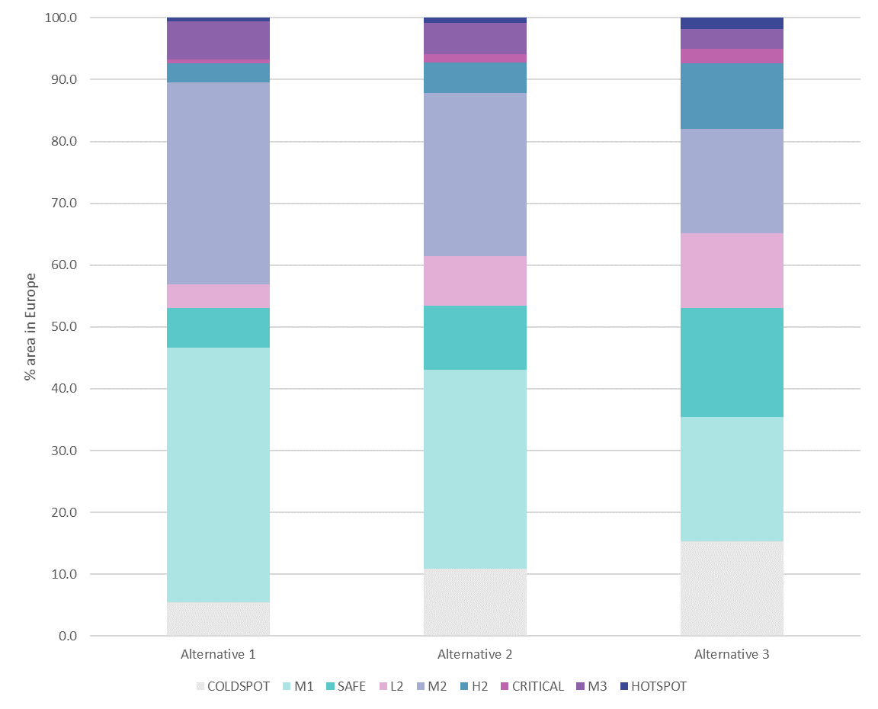
Supplementary Figure 10. Sensitivity analysis of the effects of alternative thresholds used to classify NCP into Low-Medium-High delivering areas. Alternative 2 is used in the main manuscript.

Maps of hotspots and critical areas
We extracted and combined hotspot maps for all IAS affecting each particular NCP to create a density of hotspots map per NCP (Fig. 4). Values range from 0, for areas that are not classified as hotspots for any species, to 100% for areas providing high NCP and favourability for invasion for all IAS that may affect it. We did the same with critical areas to obtain a similar density map allowing the identification of large areas in Europe providing low NCP and high favourability for invasion (Extended Data 3).

References cited in extended methods
1. Chamberlain, S. scrubr: clean biological occurrence records. (2016).
2. Tsiamis, K., Gervasini, E., Deriu, I. & Cardoso, A. C. Updates on the baseline distribution of Invasive Alien Species of Union concern (2019). 15 https://doi.org/10.2760/28412 (2019).
3. Tsiamis, K. et al. Baseline distribution of invasive alien species of Union concern. 96 https//:doi.org/10.2760/772692 (2017).
4. Tsiamis, K. et al. Baseline distribution of species listed in the 1st update of Invasive Alien Species of Union concern. 61 (2019).
5. Tsiamis, K. et al. Baseline distribution of invasive alien species added to the Union list in 2019. 64 https://doi.org/10.2760/68915 (2021).
6. Gallardo, B. et al. Protected areas offer refuge from invasive species spreading under climate change. Glob. Change Biol. 23, 5331–5343 (2017).
7. Ascensão, F. et al. Distribution of alien tetrapods in the Iberian Peninsula. NeoBiota 64, 1–21 (2021).
8. Barbosa, A. M. fuzzySim: applying fuzzy logic to binary similarity indices in ecology. Methods Ecol. Evol. 6, 853–858 (2015).
9. Sillero, N. et al. Want to model a species niche? A step-by-step guideline on correlative ecological niche modelling. Ecol. Model. 456, 109671 (2021).
10. Gallien, L., Douzet, R., Pratte, S., Zimmermann, N. E. & Thuiller, W. Invasive species distribution models – how violating the equilibrium assumption can create new insights. Glob. Ecol. Biogeogr. 21, 1126–1136 (2012).
11. Hijmans, R. J. et al. terra: Spatial Data Analysis. (2023).
12. Maes, J. et al. Mapping and assessment of ecosystems and their services: an EU ecosystem assessment. (Publications Office of the European Union, 2020).
13. Díaz, S. et al. Assessing nature’s contributions to people. Science 359, 270–272 (2018).
14. La Notte, A. et al. Ecosystem Services Accounting – Part III – Pilot accounts for habitat and species maintenance, on-site soil retention and water purification. 234 https://doi.org/0.2760/636621 (2021).
15. Vallecillo, S. et al. Ecosystem services accounting-Part II Pilot accounts for crop and timber provision, global climate regulation and flood control. 165 https://doi.org/10.2760/631588 (2019).
16. Vallecillo, S. et al. Ecosystem services accounting: Part I-Outdoor recreation and crop pollination. 89 https://doi.org/10.2760/619793 (2018).
17. Vallecillo, S. et al. EU-wide methodology to map and assess ecosystem condition: Towards a common approach consistent with a global statistical standard. 144 https://doi.org/10.2760/13048 (2022).
18. Haines-Young, R. & Potschin-Young, M. Revision of the common international classification for ecosystem services (CICES V5. 1): a policy brief. One Ecosyst. 3, e27108 (2018).
19. La Notte, A. et al. An ecological-economic approach to the valuation of ecosystem services to support biodiversity policy. A case study for nitrogen retention by Mediterranean rivers and lakes. Ecol. Indic. 48, 292–302 (2015).
20. Liquete, C. et al. Mapping green infrastructure based on ecosystem services and ecological networks: A Pan-European case study. Environ. Sci. Policy 54, 268–280 (2015).
21. Grizzetti, B. et al. Relationship between ecological condition and ecosystem services in European rivers, lakes and coastal waters. Sci. Total Environ. 671, 452–465 (2019).
22. Howarth, R. et al. Coupled biogeochemical cycles: eutrophication and hypoxia in temperate estuaries and coastal marine ecosystems. Front. Ecol. Environ. 9, 18–26 (2011).
23. Grizzetti, B. et al. How EU policies could reduce nutrient pollution in European inland and coastal waters. Glob. Environ. Change 69, 102281 (2021).
24. Baston, D. Package ‘exactextractr’: Fast Extraction from Raster Datasets using Polygons. (2022).
25. Faraway, J. J. Extending the linear model with R: generalized linear, mixed effects and nonparametric regression models. (Chapman and Hall/CRC, 2016).
26. Weiss, D. J. et al. A global map of travel time to cities to assess inequalities in accessibility in 2015. Nature 533, 333–336 (2018).
27. Amante, C. & Eakins, B. W. ETOPO1 arc-minute global relief model: procedures, data sources and analysis. (2009).
28. Karger, D. N. et al. Climatologies at high resolution for the Earth land surface areas. Sci. Data 4, 170122 (2017).
29. Kusch, E. & Davy, R. KrigR—a tool for downloading and statistically downscaling climate reanalysis data. Environ. Res. Lett. 17, 024005 (2022).
30. Wei, T. et al. Package ‘corrplot’: Visualization of a Correlation Matrix. (2021).
31. Dorie, V. dbarts: Discrete Bayesian Additive Regression Trees Sampler. (2023).
32. Chipman, H. A., George, E. I. & McCulloch, R. E. BART: Bayesian additive regression trees. (2010) doi:10.1214/09-AOAS285.
33. Carlson, C. J. embarcadero: Species distribution modelling with Bayesian additive regression trees in r. Methods Ecol. Evol. 11, 850–858 (2020).
34. Wadoux, A. M.-C., Heuvelink, G. B., De Bruin, S. & Brus, D. J. Spatial cross-validation is not the right way to evaluate map accuracy. Ecol. Model. 457, 109692 (2021).
35. Valavi, R., Elith, J., Lahoz-Monfort, J. & Guillera-Arroita, G. Package ‘blockCV’: Spatial and Environmental Blocking for K-Fold Cross-Validation. (2020).
36. Miller, M. E., Hui, S. L. & Tierney, W. M. Validation techniques for logistic regression models. Stat. Med. 10, 1213–1226 (1991).
37. Wintle, B. A., Elith, J. & Potts, J. M. Fauna habitat modelling and mapping: A review and case study in the Lower Hunter Central Coast region of NSW. Austral Ecol. 30, 719–738 (2005).
38. Barbosa, A. M., Brown, J. A. & Real, R. modEvA–an R package for model evaluation and analysis. (2013).
39. Real, R., Barbosa, A. M. & Vargas, J. M. Obtaining environmental favourability functions from logistic regression. Environ. Ecol. Stat. 13, 237–245 (2006).
40. Acevedo, P. & Real, R. Favourability: concept, distinctive characteristics and potential usefulness. Naturwissenschaften 99, 515–522 (2012).
41. Real, R., Barbosa, A. M. & Bull, J. W. Species distributions, quantum theory, and the enhancement of biodiversity measures. Syst. Biol. 66, 453–462 (2017).
42. Estrada, A., Barbosa, A. M. & Real, R. Changes in potential mammal diversity in national parks and their implications for conservation. Curr. Zool. 64, 671–679 (2018).
43. Muñoz, A.-R. & Real, R. Assessing the potential range expansion of the exotic monk parakeet in Spain. Divers. Distrib. 12, 656–665 (2006).
44. Olivero, J. et al. Recent loss of closed forests is associated with Ebola virus disease outbreaks. Sci. Rep. 7, 1–9 (2017).
45. Pérez, G., Vilà, M. & Gallardo, B. Potential impact of four invasive alien plants on the provision of ecosystem services in Europe under present and future climatic scenarios. Ecosyst. Serv. 56, 101459 (2022).
Data availability
All data utilised in the analysis are open access. Data stored in Figshare DOI: 10.6084/m9.figshare.21739385.

Code availability
Reproducible R code and processed datasets stored in Figshare DOI: 10.6084/m9.figshare.21739385.

