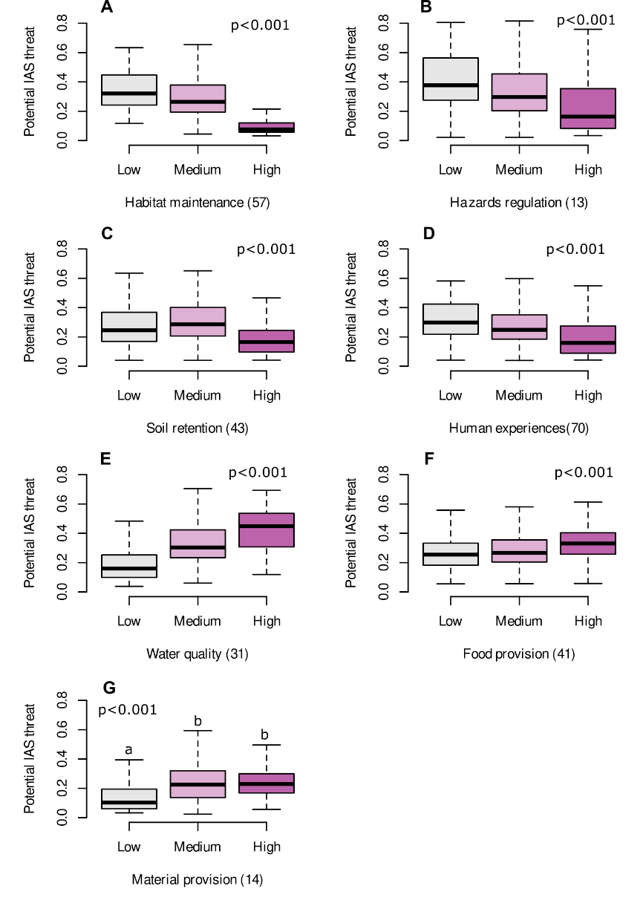
Extended Data 1. Potential threat associated with invasive alien species upon Nature’s Contributions to People. Potential threat is measured as the number of IAS per 10x10 km² cell with high favourability (≥0.80), predicted to occur in areas delivering Low (bottom 20% of NCP values), Medium (20-80%) and High (top 20% of NCP values) contributions to people. Values are rescaled to 0-1 to account for the uneven number of IAS that can affect each NCP individually, indicated in brackets. P-values correspond to Welch one-way ANOVA. Pairwise Tukey HSD post-hoc comparisons were all highly significant except for the NCP material provision (G), for which letters indicate significantly different groups.

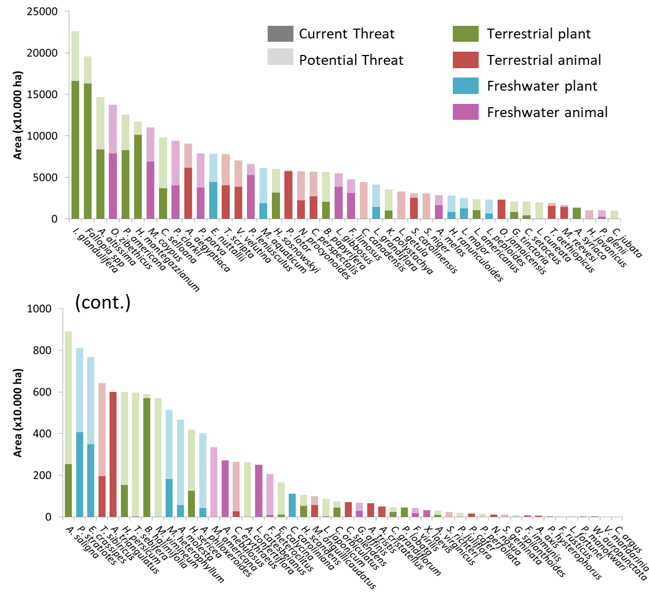
Extended Data 2. Current and potential threat (=range expansion) of 94 invasive alien species of concern in Europe. Colours depict four major groups of organisms: terrestrial plants (green), terrestrial animals (red), freshwater plants (blue) and freshwater animals (pink). In dark shade, the area currently occupied by each species. In light shade, the additional area predicted as favourable for the establishment of the species under current climate and accessibility conditions. Species are ordered decreasingly by the total area under threat (current+potential).
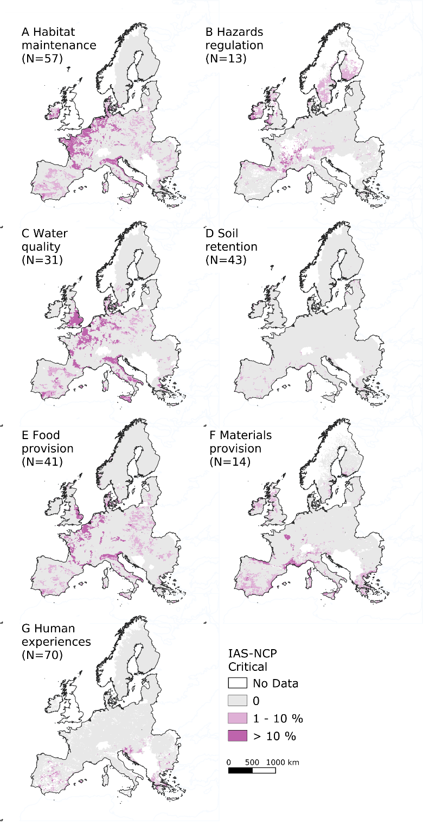
Extended Data 3. Density of critical areas for invasive alien species potential impacts on nature's contribution to people (NCP). Critical areas combine high favourability for invasion and low delivery of NCP. Values represent the % of invasive species known to negatively affect each specific NCP that are either present or likely to be present in the near future in low-NCP provisioning areas. The total number of invasive species of European concern that are known to affect each NCP is indicated in brackets.

