Table 3: Scenarios within the Multi-Criteria Scenario Framework, varying planning criteria identified as ‘critical uncertainties’ for the case study region
Business as usual (BAU) for wind energy and PV
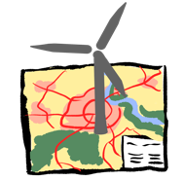 | 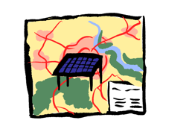 | 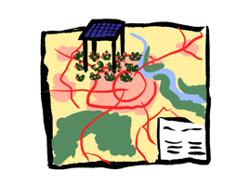
#1 Wind energy under current planning  practice (no bird priority zones) (BAU) | #2 Ground-mounted PV on subsidized areas  (no bird priority zones) (BAU) | #3 Agri-PV on agricultural areas  (no bird priority zones) (BAU)
Planning variants in bird priority zones
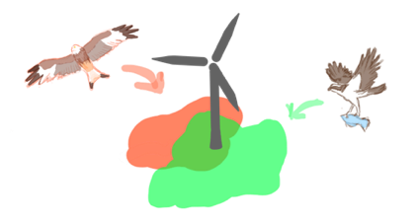 | 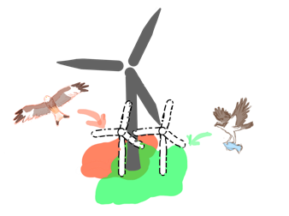 | 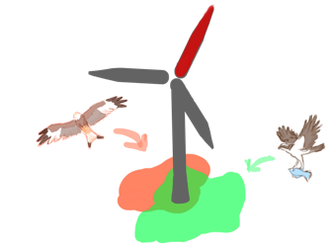
#4 Wind energy in bird priority zones  (A 0% - B 5% - C 10% wind energy in bird priority zones, - D using wind energy areas in bird priority zones based on BAU) | #5 Repowering in bird priority zones  (A 100% - B 200% repowering in bird priority zones) | #6 Retrofitting in bird priority zones  (A 50% retrofitting in bird priority zones)
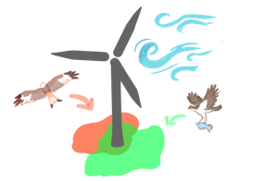 | 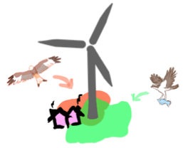 | 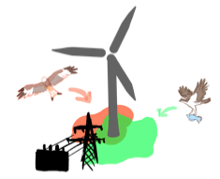
#7 Bird priority zones and efficient areas for  wind energy  (A 10% - B 5% wind energy in bird priority zones) | #8 Bird priority zones and  electricity demand near settlements  (A wind energy within a 1km buffer  around settlements) | #9 Bird priority zones and network efficiency  (A <5km around transformer stations enabling wind energy development)
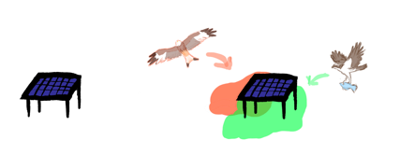 | 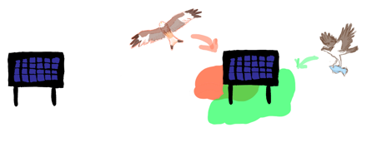 | 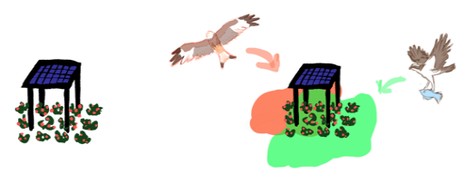
#10 Ground-mounted PV in bird priority zones  (A 0% - B 10% - C 20% PV in bird priority zones) | #11 Vertical PV in bird priority zones  (A 5% - B 10% - C 20% PV in bird priority zones) | #12 Agri-PV on agricultural areas in  bird priority zones  (A 0% - B 10% - C 20% PV in bird priority zones)
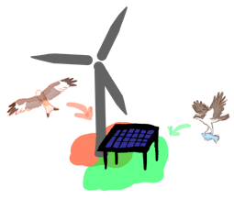 | 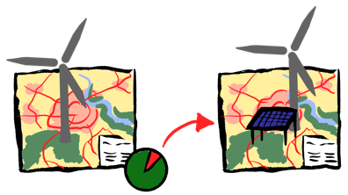
#13 Energy mix of ground-mounted PV and wind energy in bird priority zones (A 10% wind  energy and PV in bird priority zones) | #14 Ground mounted PV to substitute for missing wind energy according to achieved targets with BAU  (A 0% PV and wind energy in bird priority zones)
Planning variants of large-area requiring criteria with fixed bird priority zones
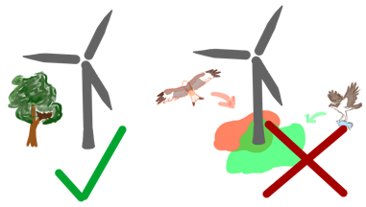 | 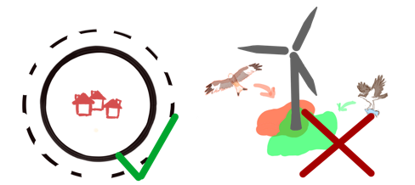 | 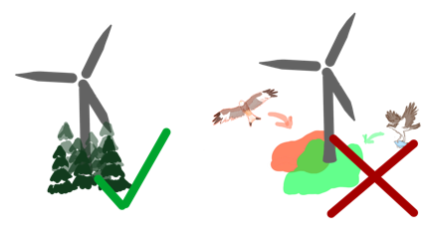
#15 Bird priority zones and no  species-specific buffers  (A no species-specific buffers) | #16 Bird priority zones and smaller buffer  to settlements  (A 800m settlement buffer) | #17 Bird priority zones and  wind energy in forests  (A 4% - B 2% wind energy in forests)
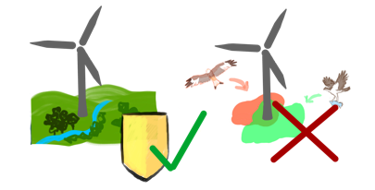 | 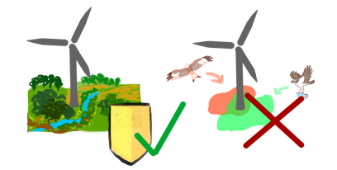 | 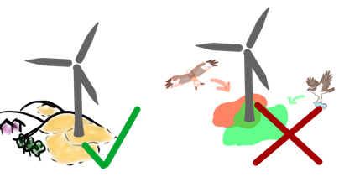
#18 Bird priority zones and  wind energy in landscape protection areas  (A 3% - B 1% wind energy in landscape protection areas) | #19 Bird priority zones and  wind energy in nature park areas  (A 4% - B 2% wind energy in nature park areas) | #20 Bird priority zones and  wind energy in open spaces  (A 4% - B 2% wind energy in open spaces)

