Appendix

Appendix A – Scenario description
Table 6: Scenario description
 | Scenario Title | No.
Business as usual (BAU) planning for wind energy
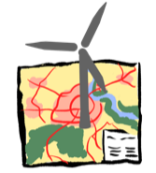 | Wind energy under planning practice and 100% in bird priority zones (BAU)  Wind energy planning is based on the draft regional plan 3.0 for the Havelland-Fläming region, using the current planning concept [78, 125]. Wind energy is developed in modeled bird priority zones as there is no bird priority zone concept in Brandenburg. | #1A
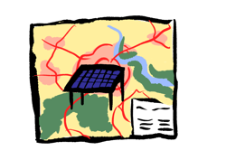 | Ground-mounted PV on subsidized areas and 100% in bird priority zones (BAU)  Ground-mounted PV is being developed on potential, subsidized areas (‘EEG-areas’). PV is developed in bird priority zones as there is no bird priority zone concept in Brandenburg. | #2A
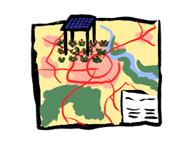 | Agri-PV on agricultural areas (soil ranking number <23) and 100 % in bird priority zones (BAU)  Agri-PV is developed on agricultural areas with a soil number less than 23, i.e. lower-yielding land [115]. Agri-PV systems are located in bird priority zones as there is no bird priority zone concept in Brandenburg. | #3A
Planning variants in bird priority zones
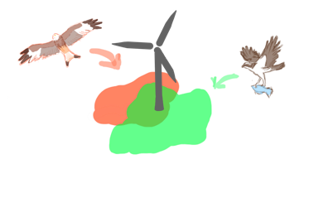 | Wind energy in bird priority zones  To a small extent, wind turbines are allowed to be installed in bird priority zones as is the case in federal states Bavaria, or Hesse. Other federal states exclude wind turbines from being installed in bird priority zones to ensure that bird priority zones can fulfill their function of protecting populations, such as in Saxony Anhalt [79]. Large-scale wind energy development would contradict the species protection objectives of the bird priority zones. Therefore, it is assumed that 0%, 5% and 10% of the area could be used for wind energy development. | #4A-D  A-0%  B-5%  C-10%  D-Wind energy areas
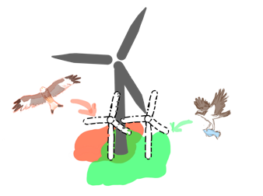 | Repowering in bird priority zones  Dealing with existing turbines in new bird priority zone approaches calls for planning visualization to determine the extent to which repowering can occur. Due to the larger turbine dimensions, a higher capacity can be expected [131]. At the same time, changes in species protection and noise legislation may mean that the same capacity cannot be achieved on the site [178]. Existing turbines are considered older when they were built after 2005 and are 18 years or older. It is therefore assumed that the same capacity could be realized by repowering in bird priority zones (1:1). Alternatively, it is assumed that double the capacity could be realized (2:1). The additional capacity is added to the region’s development potential for wind energy. | #5A-B  A-100%  B-200%
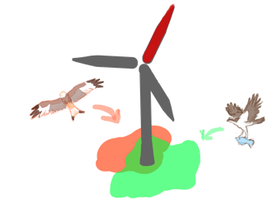 | Retrofitting in bird priority zones  As an alternative to repowering, existing facilities in bird priority zones could be retrofitted, i.e. modernized [133]. A partial retrofit of 50% is considered possible if existing turbines are operated beyond the age of 20 years. | #6A  A-50%
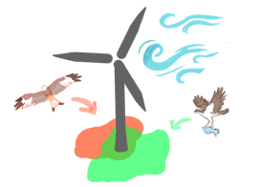 | Bird priority zones and efficient areas for wind energy  Bird priority zones can lead to spatial trade-offs with planning parameters that aim to optimize the energy efficiency of wind energy planning [179, 180]. Bird priority zones may also provide good habitat quality for species in areas where wind speeds are particularly favorable for wind turbines [181, cf. 180]. It is varied how the area impact for wind energy would change if the windiest sites in bird priority zones were used for wind energy at 10% and 5% when the wind speed is greater than 5.5 m/sec [125]. | #7A-B  A-10%  B-5%
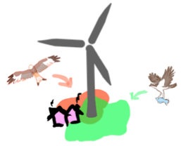 | Bird priority zones and higher electricity demand  Bird priority zones can also be located in areas where there is a higher demand for electricity in the vicinity of settlements. Ideally, it would be sensible to locate wind turbines where there are electricity consumers [182]. It is examined how the area impact for wind energy changes when turbines are installed in bird priority zones near residential areas. A buffer of 800m is assumed to ensure noise protection distances [125]. To ensure proximity to settlements, it is also considered that wind energy can be installed in bird priority zones within a 1km strip. | #8A  A-1km strip
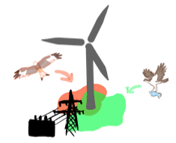 | Bird priority zones and network efficiency  Planning for wind energy would be (cost-)efficient if turbines were located near grid feed-in points, such as transformer stations [180, 179]. These areas may also overlap with bird priority zones. Therefore, it is assumed that wind turbines can be located in bird priority zones if they are less than 5km from 110 kV substations. | #9A  A-<5km
Photovoltaics and planning variants in bird priority zones
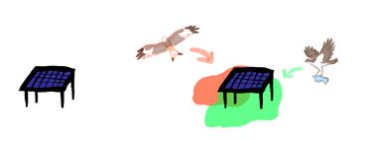 | Ground-mounted PV in bird priority zones  With regard to the share of renewable energy in the energy mix, the extent is examined to which PV can be developed in the region under bird priority zone approaches. Since PV may have a lower spatial trade-off potential in terms of collisions with avifauna compared to wind energy [183–185], a proportionally smaller development in bird priority zones would be possible (0%, 10%, 20%). Habitats could be established, which allows structural richness for species through additional measures [186]. | #10A  A-0%  B-10%  C-20%
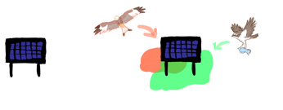 | Vertical PV in bird priority zones  Vertical PV systems can capture sunlight from both east and west [113]. It is assumed that, to a small extent, vertical PV could be installed in areas of bird priority zones. Their characteristics could further reduce trade-offs with birds, especially if the area under the module lines were to be heavily farmed, and now providing a potential habitat for small mammals, such as mouse, for raptors to hunt. The power density per module is lower than for ground-mounted PV [114]. It is assumed that vertical PV could be installed on a small scale in bird priority zones (0%, 10%, 20%). | #11A-C  A-5%  B-10%  C-20%
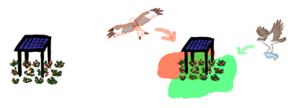 | Agri-PV in bird priority zones  Agri-PV is typically a higher elevation PV system that allows for the cultivation of agricultural crops, such as berries [187, 188, 170]. To minimize the impact on land for food production, it is assumed that agri-PV would be developed on agricultural land with soil rating number of less than 23 [115]. These areas have a lower yield expectation. Therefore, the potential loss of agricultural products such as corn and wheat, which cannot be easily grown under PV modules, is not expected to be too significant. Small thresholds of 0%, 10%, and 20% are assumed to determine whether areas in bird priority zones would also need to be developed with agri-PV to meet energy targets. | #12A-C  A-0%  B-10%  C-20%
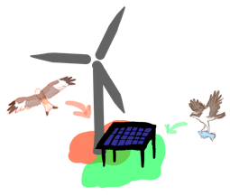 | Energy mix of ground-mounted PV and wind energy in bird priority zones  The concern is whether wind energy and PV together would be necessary in bird priority zones to meet the area and energy targets. To fulfill the conservation mandate of bird priority zones for populations and to resolve species protection conflicts, this can only be a small part. Therefore, for both energy sources, it is assumed that only a lower share of 10% would allow development in bird priority zones. | #13A  A-10%
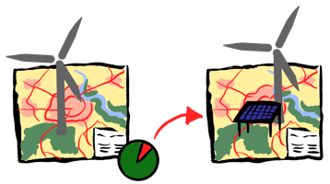 | Ground mounted PV to substitute for missing wind energy according to achieved targets with BAU  The energy mix of renewable energies is addressed, whether, alternatively, sufficient area would be available to additionally cover the deficit with PV, which cannot be achieved with wind energy in BAU of regional planning. In addition to the PV potential that would be required to meet the energy targets for PV, the substitution of energy quantities with PV would have to be realized. To this end, an analysis is made of what the area impact would be if ground-mounted PV were not installed in bird priority zones. | #14A  A-0%
Planning variants of criteria requiring area with fixed bird priority zones
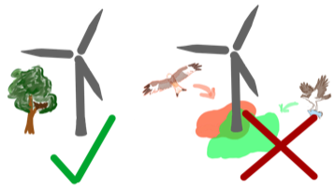 | Bird priority zones and no species-specific buffers  In addition to bird priority zones, there are other land use interests that can take up a larger share of the area. Species-specific buffers, designed to ensure species protection in the permitting process, can account for a significant share of the area [80, 134]. To measure the amount of land left for wind energy if only bird priority zones were used as a planning criterion, the planning for wind turbines without species-specific buffers is shown. | #15A  A-no species-specific buffers
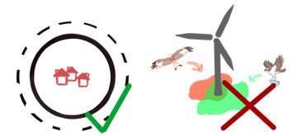 | Bird priority zones and varying buffer to settlements  Settlement buffers exceeding the federal emission protection buffers are often imposed by decision makers to secure the acceptance of wind energy by local residents [134]. The BAU scenario assumes a buffer of about 1000m to residential areas. However, research on acceptance suggests that buffers have little effect on the acceptance of wind energy [189]. It is examined how the area impact for wind energy changes when planning exclusively with the 800m setback based on emission law. | #16A  A-800m
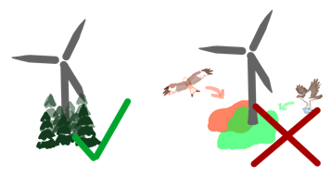 | Bird priority zones and forests  Brandenburg is rich in woodlands [190]. The development of wind energy in forests is controversial due to possible impacts on birds and bats, also for the economic use of the forest [191, 192]. As forest areas make up a larger part of the region, thresholds are examined in terms of their target footprint if wind turbines are additionally installed in forest areas to a certain extent (2%, 4%). The installation of wind energy in deciduous forests is potentially more conflictual than in coniferous forests. Therefore, only coniferous forests are considered. | #17A-B  A-4%  B-2%
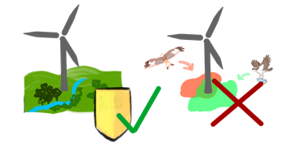 | Bird priority zones and landscape protection areas  Landscape protection areas are intended to preserve the general character of the landscape, also for recreation and tourism. In BAU, landscape protection areas are open to balancing, but have been excluded in the current draft regional plan [125]. Regulations at the federal level envisage opening up landscape protection areas for wind turbines to achieve the spatial targets [193, 194]. Thresholds in this scenario aim to open a small percentage (1%, 3%) of landscape protection areas for wind energy. | #18A-B  A-3%  B-1%
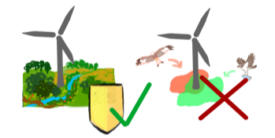 | Bird priority zones and nature park areas  Nature parks are protected, often large landscape areas that have been created through long forms of landscape management. However, they usually combine several other categories of protection. Due to the larger scale of nature parks, the extent to which additional development of wind energy in nature parks can lead to the achievement of spatial targets is examined. | #19A-B  A-4%  B-2%
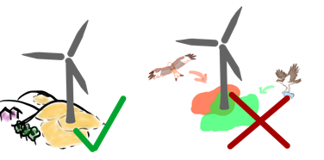 | Bird priority zones and open spaces  The free space network includes those parts of the open space that are of high regional value, and that are connected to each other [125, 78]. Due to its large size, this planning category is examined to determine how small-scale wind energy development in areas for open spaces could lead to the achievement of spatial targets. | #20A-B  A-4%  B-2%

Appendix B - Verifying area usability within overlay analysis
Meeting the renewable energy targets would require opening up some land uses, i.e. planning criteria for the use of wind energy that have previously been excluded in this case study. Since land uses generally overlap, however, the area available for wind energy may ultimately be limited. For example, there could be further protected areas in the landscape (e.g., nature reserves in open spaces). When examining the land uses in this case, it is found that there are some land uses that require a significant amount of land. These uses could therefore present a greater spatial trade-off with wind energy. Environmental and social needs are especially high in the region. These include, in particular, settlement buffers, landscape protection areas, nature parks, open spaces, and coniferous forests (Figure 12).
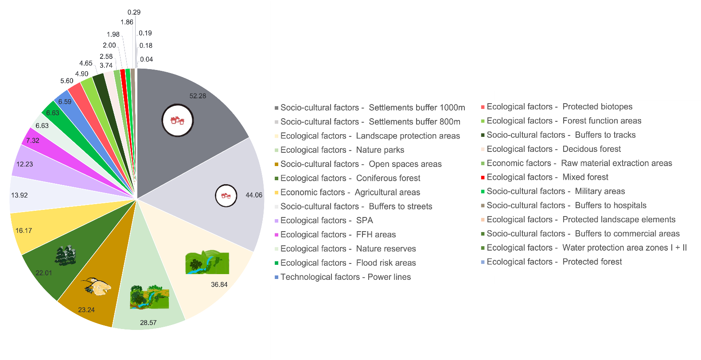
Figure 12: Area sizes of land uses in %, i.e. planning criteria when excluding wind energy in all bird priority zones approaches

It remains to be seen whether some portion of these land uses could actually be used for wind energy. The overlay analysis indicates that, for legal reasons, a share of these land uses cannot actually be made available for wind energy as shown in Figure 13 (see also section 2.2.4.2). Wind energy per se is not possible within 350m of settlements and 1000m of hospitals, nature reserves, military areas, open spaces, airports and ground-mounted PV systems (Figure 13).
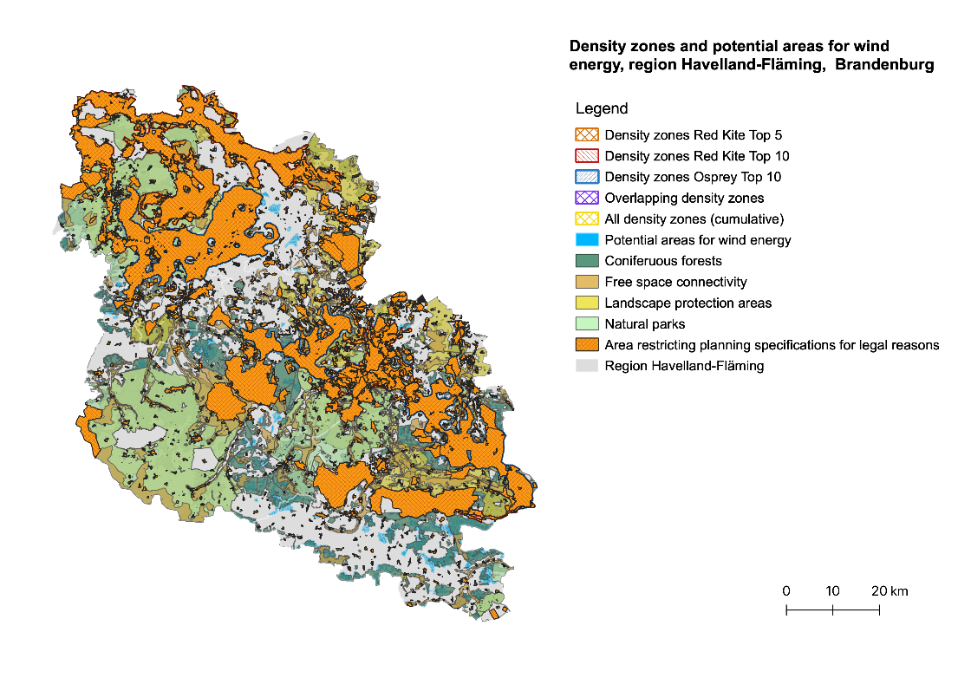
Landscape protection areas
Bird priority zones and area restricting criteria for legal reasons in the region Havelland-Fläming, Brandenburg
Bird priority zones Red Kite Top 10
Bird priority zones Osprey Top 10
All bird priority zones (cumulative)
Overlapping bird priority zones
Bird priority zones Red Kite Top 5
Nature parks
Coniferous forests
Wind energy areas
Open space areas
Area restricting criteria for legal reasons
Region Havelland-Fläming
Figure 13: Bird priority zones and area restricting criteria for legal reasons in the region Havelland-Fläming, Brandenburg (geodata copyright by © GeoBasis-DE / BKG 2022, Regional Planning Authority Havelland-Fläming 2022 (RPG 2022), OSM 2022, Geoportal LGB 2022, MLUK 2022)

In numeric terms, more than half of the land uses are overlaid by protected areas that cannot be made available for wind energy. From that, it would take between 10% and 14% to reach the 2.2% target for wind energy as shown in Figure 14. Specifically, about 10% of the available area would be needed for wind energy use in landscape protection areas. The spatial demand for wind energy in coniferous forests, nature parks and open spaces is even higher at about 14%. This is mainly due to overlaps with nature reserves. Overall, a sufficient amount of land could be made available for wind energy in those land uses, i.e. planning criteria, as they account for a high share of land in the case study (Figure 14).
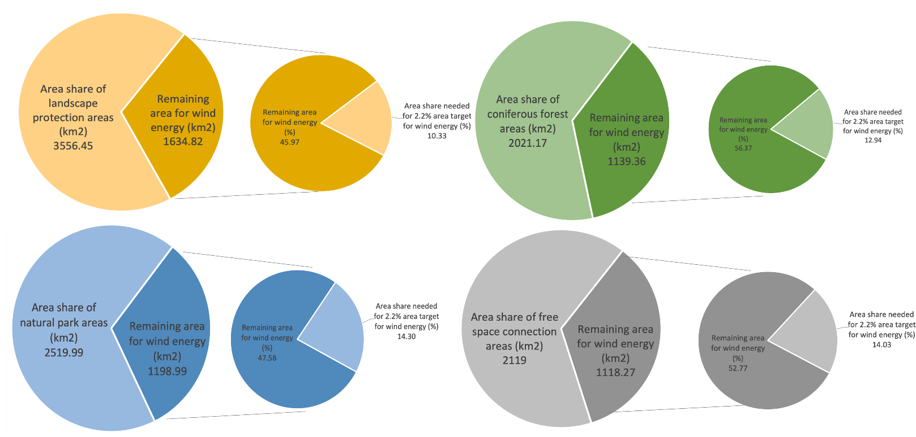
Figure 14: Numerical evaluation of the actually available areas in the land uses, i.e. the planning criteria for wind energy (in percent). The colors are for illustrative purposes only.

As a site potential analysis for ground-mounted PV was already available for this analysis, showing the legally possible areas for PV, an overlay analysis for PV is not necessary here. These are on the one hand potentially subsidized areas (‘EEG areas’) and on the other hand areas on less productive agricultural land [115] (see Supplemental Materials for GIS-Model).

, §37 (1) 96.
§26 (1) BNatSchG
§27 (1) BNatSchG

