Supplement

Supplement 1. DNA-damage in BAL and BW
Supplement 1. DNA damage measured in A: bronchial wash and B: bronchoalveolar lavage following exposure of healthy subjects to wood smoke or filtered air. DNA damage was quantified using the Comet assay and expressed as Olive tail moment. No statistically significant change was seen between the exposures. The red line indicates median value.

Supplement 2. Comet assay from BW and BAL
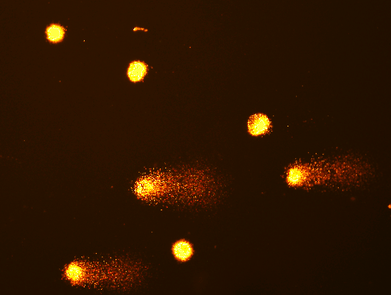

Supplement 2. Comet assay performed on cells from (A) bronchial wash (B) bronchoalveolar lavage.

