Table 1: Data for antipromastigote activity (IC₅₀) testing of the synthesized compounds.
Test compounds | Structure | IC₅₀ Values (µg/mL) | IC50 Values (µM/mL)
9 | 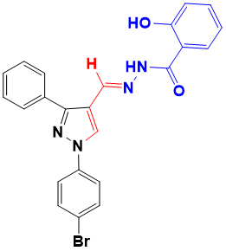 | 0.084 | 0.256
10 | 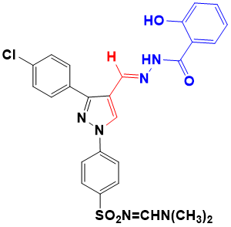 | 0.207 | 0.450
11 | 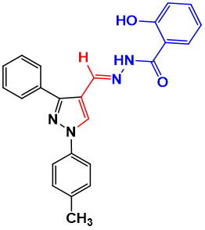 | 5.738 | 10.413
12 | 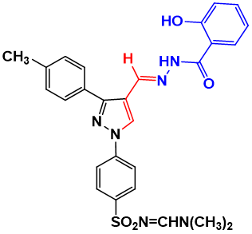 | 0.111 | 0.280
13 | 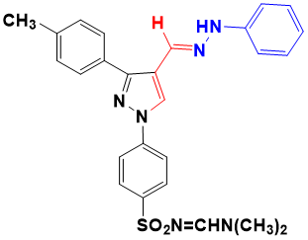 | 0.018 | 0.033
14 | 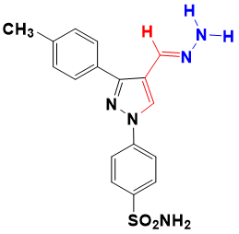 | 3.263 | 6.706
15 | 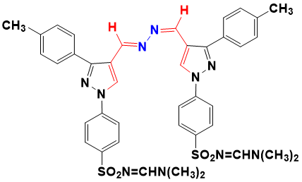 | 0.181 | 0.441
Miltefosine | - | 3.130 | 7.680
Amphotericin B | - | 0.047 | 0.035

