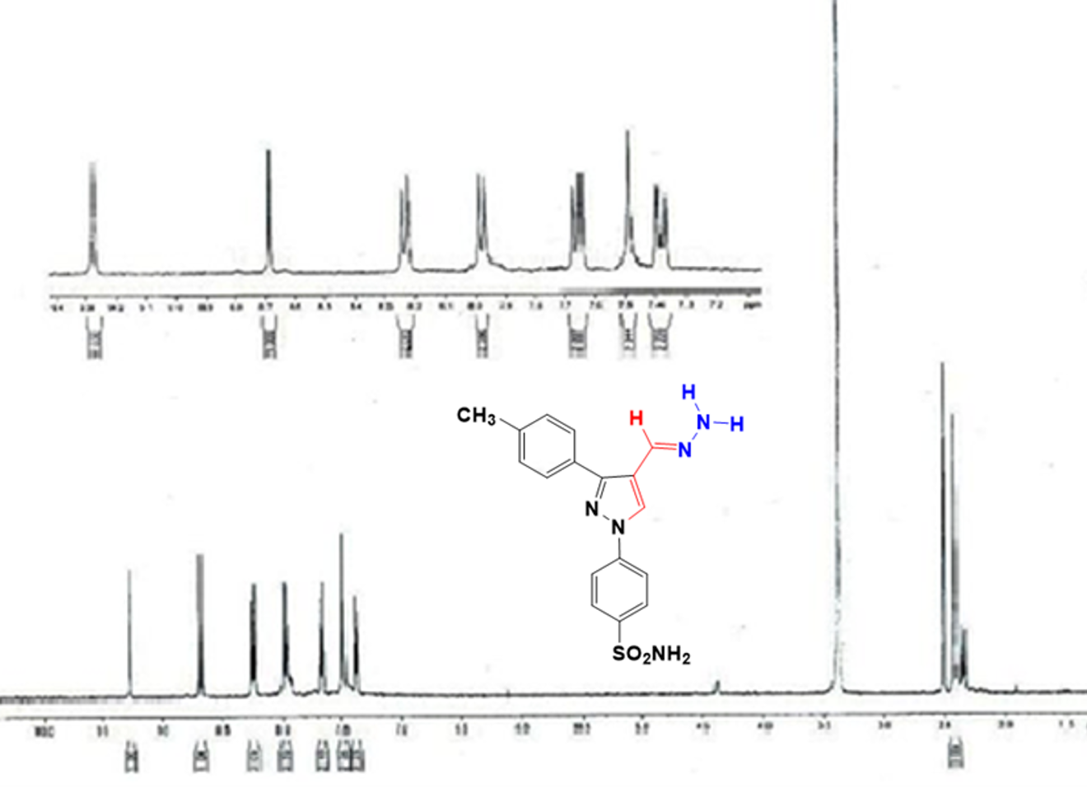
Figure S7: ¹H NMR spectrum of compound 14 in DMSO-d₆.

