Table 2: Antimalarial activity test for the synthesized compounds at a dose of 48.46 µmol/kg*.
Test compounds | Structure | Dose (mg/kg) | % Parasitemia | % Suppression | Mean survival time (day)
9 | 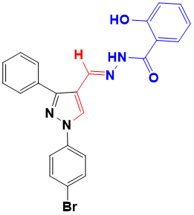 | 17.95 | 34.7 ± 4.1 | 33.3 | 8.6 ± 1.8
10 | 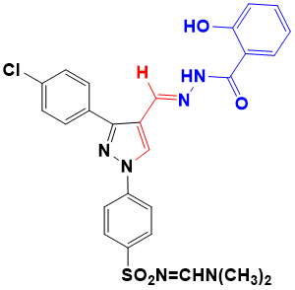 | 18.07 | 33.0 ± 6.7 | 36.5 | 6.8 ± 0.7
11 | 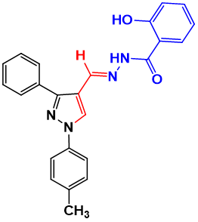 | 19.21 | 30.0 ± 6.7 | 42.3 | 8.7 ± 0.7
12 | 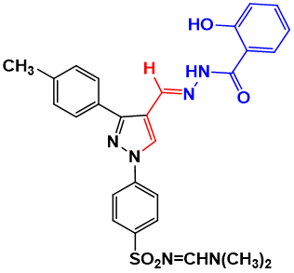 | 20.67 | 67.9 ± 3.7 | -30.5 | 7.8 ± 1.2
13 | 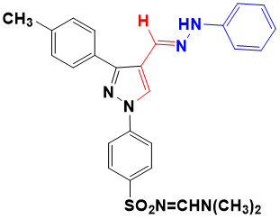 | 17.17 | 24.0 ± 1.7 | 53.9 | 9.5 ± 1.9
14 | 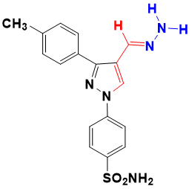 | 17.17 | 15.5 ± 4.1 | 70.2 | 9.0 ± 2.0
15 | 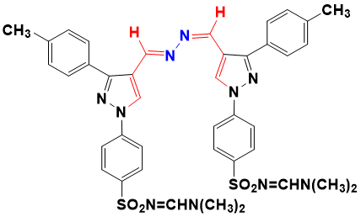 | 18.63 | 5.0 ± 1.4 | 90.4 | 7.7 ± 1.4
NC** | - | 1 mL/100g | 52.0 ± 2.8 | 0.0 | 7.0 ± 1.2
CQ | - | 25 | 0 | 100 | ND
*The equimolar concentration of the synthesized compounds as compared to the reference drug, CQ. **Values are mean ± standard deviations, p ˂ 0.05. NC, negative control; CQ, chloroquine phosphate; ND, no mouse death was recorded during the study period.

