Table 3: CC₅₀ value of compound 13 against normal VERO cells and its selectivity index.

Test compounds | Structure | CC₅₀ (µM) | IC₅₀ (µM) | SI
13 | 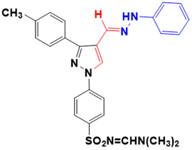 | 117.79 | 0.60442 | 194.88
Miltefosine | - | 99.7 | 7.897 | 12.63
CC₅₀ is the concentration at which 50% of the VERO cells survive and IC₅₀ of antileishmanial activity. SI is the selectivity index, SI = CC₅₀/ IC₅₀.

