Supplementary Table 1. Details of 17 groundnut genotypes used in the study
S.No. | Genotype | Pedigree | Habit Group  SB/VB | Year of Release | Released Institute
1 | TPT 1 | E.C 106983 × 3 | SB | 1989 | RARS, ANGRAU, Tirupati
2 | TPT 2 | GAUG 1 × Nc.Ac.FLA.14 | SB | 1989 | RARS, ANGRAU, Tirupati
3 | TPT 3 | Selection from TMV 10, a Virginia bunch variety with variegated testa | VB | 1991 | RARS, ANGRAU, Tirupati
4 | TAG 24* | TGS 2 × TGE 1 | SB | 1991 | BARC, Mumbai
5 | TPT 4 | JL 24 × Ah316/S | SB | 1995 | RARS, ANGRAU, Tirupati
6 | Narayani | JL 24 × Ah316/S | SB | 2002 | RARS, ANGRAU, Tirupati
7 | Kalahasti | TCG1709 × TCG1518 | SB | 2002 | RARS, ANGRAU, Tirupati
8 | Prasuna | TCG1717 × TCG1518 | SB | 2006 | RARS, ANGRAU, Tirupati
9 | Abhaya | K 134 × TAG 24 | SB | 2006 | RARS, ANGRAU, Tirupati
10 | Greeshma | TIR 46 × JUG 37 | SB | 2009 | RARS, ANGRAU, Tirupati
11 | Rohini | Tirupati 4 × TIR 45 | SB | 2010 | RARS, ANGRAU, Tirupati
12 | Bheema | TAG 24 × TG 19 | SB | 2010 | RARS, ANGRAU, Tirupati
13 | ICGV 00350 | ICGV 87290 × ICGV 87846 | SB | 2011 | RARS, ANGRAU, Tirupati
14 | Dharani | VRI 2 × TCGP 6 | SB | 2012 | RARS, ANGRAU, Tirupati
15 | TCGS 1073 | Narayani × JAL 30 | SB | 2018 | RARS, ANGRAU, Tirupati
16 | TCGS 1157 | TAG 24 × Jyothi | SB | 2018 | RARS, ANGRAU, Tirupati
17 | TCGS 894 | TIR 46 × Kadiri 134 | SB | 2018 | RARS, ANGRAU, Tirupati

RARS, Regional Agricultural Research Station, Tirupati; BARC, Baba Atomic Research Center; SB, Spanish Bunch; VB, Virginia Bunch
*Hybridization between mutant TGS2 obtained by irradiation with gamma rays (200 Gy) and mutant TGE1 obtained by irradiation with X-rays (750 Gy).

Supplementary Table 2. List of Yield and Seed quality governing Gene targeted markers of rice used in the study

S. No. | Trait to be studied in Groundnut | Genes identified to be associated with corresponding trait in Rice | Chr | Marker | Gene Function | Reference
1 | Plant height | sd1/GA20ox2 (semi-dwarfing), LOC_Os01g66100 | 1 | sd1-h | GA20 oxidase-2 (GA20ox-2) | Monna et al., 2002
2 | Plant Architecture | MOC1 (MONOCULM 1), LOC_Os06g40780 | 6 | MOC1 | GRAS family nuclear protein, expresses mainly in axillary buds | Shao et al., 2019
 |  | OsSPL14/WFP/IPA1, LOC_Os08g39890 | 8 | OsSPL14 | squamosa promoter binding protein-like 14, (also known as wealthy farmer's panicle / ideal plant architecture 1 | Mohapatra et al, 2018
 |  | PLANT ARCHITECTURE AND YIELD 1, LOC_Os08g31470 | 8 | PAY1sp6 | peptidase, trypsin-like serine and cysteine proteases | Zhao et al., 2015
3 | Yield Contributing Genes | Gn1a/OsCKX2 (Grain number), LOC_Os01g10110 | 1 | ex Gn1a | Cytokinin oxidase/dehydrogenase regulation of grain production | Kim et al., 2016
 |  | GN2 (GRAINS NUMBER 2), LOC_Os02g56630 | 2 | RM3535 | OsWAK (Wall-associated kinase) receptor-like protein kinase | Chen et al., 2017
 |  | YLD |  | RM223 |  | Haritha et al., 2018
 |  |  |  | HY2-4
 |  | NAL1 / SPIKELET NUMBER (SPIKE), LOC_Os04g52479 | 8 | SPIKE- indel 3 | peptidase, trypsin-like serine and cysteine proteases | Kim et al., 2016
 |  | EP3 (ERECT PANICLE) LOC_Os02g15950 | 2 | S5 803 | putative F-box protein | Piao et al., 2009
 |  | Hybrid sterility, LOC_Os06g11010 | 6 | S5-1 | eukaryotic aspartyl protease domain containing protein, wide compatibility genes, pollination, fertilization, hybrid sterility | Li et al., 2017
 |  | APO1/OsAPO1/ SCM2, LOC_Os06g45460 | 6 | SCM2 indel1 | OsFBX202 - F-box domain containing protein | Kim et al., 2016
 |  | DEP1/DN1/qPE9-1/OsDEP1 (DENSE AND ERECT PANICLE), LOC_Os09g26999 | 9 | exDep1 | PEBP-domain protein | Huang et al., 2009
 |  |  |  | DEP1 indel1
 |  |  |  | DEP1-1 |  | Li et al., 2017
 |  |  |  | Dep1s7 |  | Kim et al., 2016
4 | Seed Quality Genes | GS2/OsGRF4/GL2/ GLW2/LGS1/PT2 (Grain size), LOC_Os02g47280 | 2 | RM3212 | growth-regulating factor 4 | Zhang et al., 2013
 |  | GS3 (Grain size), RAP ID -Os03g0407400) | 3 | RGS1 | transmembrane protein; negative regulator for grain size | Ngangkham et al., 2018
 |  |  |  | SR17 |  | Ngangkham et al., 2018
 |  | GS5/OsSCP26/ SCP26/OsGS5 (Grain size), LOC_Os05g06660 | 5 | C62 |  | Li et al., 2011
 |  |  |  | RM593 |  | Yan et al., 2014
 |  |  |  | GS5 indel 1 |  | Kim et al., 2016
 |  |  |  | RM574 | OsSCP26 - Putative Serine Carboxypeptidase homologue, expressed | Bidanchiet al., 2018
 |  | AP2/EREBP#073, AP2/EREBP73, AP2-3, SSH1, OsSSH1, OsSNB, DLN181, DLN181a, DLN181b, OsDLN181, OsDLN181a, OsDLN181b, SUI4, OsSUI4, SUI4/SNB, LOC_Os07g13170 | 7 | OsSNB2 | APETALA2/ethylene-responsive element binding protein 73, APETALA2-3, suppression of shattering1, DLN repressor 181, DLN motif protein 181 | Ma et al., 2019
 |  | GW2 (Grain weight), LOC_Os02g14720 | 2 | GW2SNP2 | Ring type E-3 ubiquitin ligase | Zhang et al., 2015
 |  |  |  | GW004 |  | Ngangkham et al., 2018
 |  | GW5 /SW5/ GSE5 (Grain width/Seedwidth),LOC_Os05g09520 | 5 | RM3328 |  | Wang et al., 2008
 |  |  |  | RMw513 | Calmodulin binding protein, protein IQ-DOMAIN 14 | Zhao et al., 2015
 |  |  |  | N1212 |  | Y.D. Zhang et al., 2015
 |  | GW7 /GL7/qGW7/ qGL7/ SLG7/Qpy7 (Grain weight), LOC_Os07g41200 | 7 | RM22015 | TONNEAU1-recruiting motif protein/ expressed protein | Bian et al., 2013
 |  | GRAIN LENGTH AND WEIGHT ON CHROMOSOME 7/OsSPL13, LOC_Os07g32170 | 7 | GLW7/OsSPL13/SPL13 | SQUAMOSA PROMOTER-BINDING-LIKE POTEIN 13 | Si et al., 2016
 |  |  |  | RM505 | (qgrl7.1 -Grain Filling/Grain Plumpiness), Grain length | Liu et al., 2017
 |  |  |  | RM21945 |  | Verma et al., 2015
 |  | GW8/ SPL16/ OsSPL16/ SLP1/ qGW8 (Grain weight), LOC_Os08g41940 | 8 | GW8 PRO2 | Squamosa promoter-binding-like protein 16 | Wang et al., 2012
5 | Shelling Percentage | GIF1/OsCIN2/OsGIF1/WB1 (Grain incomplete filling), LOC_Os04g33740 | 4 | exGIF1 | glycosyl hydrolases | Wang et al., 2008
 |  |  |  | RM16942 |  | Wang et al., 2008
6 | Flowering Time | Hd1 (heading date), LOC_Os06g16370 | 6 | Hd1 | CCT/B-box zinc finger protein | Yano et al., 2000
 |  |  |  | Hd1 AGC |  | Gaafar., 2010
 |  | Hd3a (heading date 3a), LOC_Os06g06320. | 6 | Hd3a | OsFTL2 FT-Like2 homologous to Flowering Locus T gene, Phosphatidyl ethanolamine-binding protein | Tsuji et al., 2015
 |  | Hd5/DTH8/Ghd8/ OsHAP3H/LHD1/ EF8/CAR8/OsNF-YB11, LOC_Os08g07740 | 8 | DTH8-INDEL | OsHAP3 SUBUNIT OF A CCAAT-BOX BINDING PROTEIN (a histone-like CCAAT-box binding transcription factor) | Dai et al., 2012
7 | Seed Micronutrient Content | YSL2 (Yellow stripe like),LOC-Os02g43370 | 2 | vf0226164188 | Transposan protein, putative, unclassified, expressed | Indel primers designed in current study using Primer 3 software
 |  |  |  | vf0226169288
 |  |  |  | vf0226164382
 |  | YSL15(Yellow stripe like), LOC-Os02g43410 | 2 | 02g43410 | Iron phytosidarophore transporter
 |  | YSL13 (Yellow stripe like), LOC-Os04g44300 | 4 | 04g44300 | Probable metal nicotianamine transporter
Supplementary Table 3. Rice yield and seed size gene Orthologs found in A. hypogaea genome, chromosome distribution and their location
Rice genes |  |  |  | Rice gene ortholog of A. hypogaea
Gene | Trait Governed | Chr | Gene Function | Arachis Gene | Chr | Gene Function | Chr Start (bp) | Chr End (bp)
Gn1a | Grain number/plant | 1 | Cytokinin oxidase/dehydrogenase | arahy.6Z1DTG | 1 | cytokinin oxidase/dehydrogenase 1 | 94873927 | 94879978
 |  |  |  | arahy.K2AT2P | 1 | cytokinin oxidase/dehydrogenase 1 | 94938761 | 94944365
 |  |  |  | arahy.VUSB1V | 1 | cytokinin oxidase/dehydrogenase 1 | 94901563 | 94906152
 |  |  |  | arahy.ZP1VNA | 1 | cytokinin oxidase/dehydrogenase 1 | 94987985 | 94991588
 |  |  |  | arahy.IXQ7CK | 1 | cytokinin oxidase/dehydrogenase 6 | 95003690 | 95008859
 |  |  |  | arahy.QM99BA | 3 | cytokinin oxidase/dehydrogenase 1 | 41283378 | 41288376
 |  |  |  | arahy.46YZYG | 3 | cytokinin oxidase/dehydrogenase 6 | 9566772 | 9569838
 |  |  |  | arahy.KIE2XR | 4 | cytokinin oxidase/dehydrogenase 1 | 125871002 | 125874225
 |  |  |  | arahy.7YV5MC | 6 | cytokinin oxidase/dehydrogenase 1 | 111030885 | 111036561
 |  |  |  | arahy.E69B57 | 6 | cytokinin oxidase/dehydrogenase 1 | 11209566 | 11212624
 |  |  |  | arahy.T07MCP | 8 | cytokinin oxidase/dehydrogenase 1 | 1358925 | 1361175
 |  |  |  | arahy.MEWG3I | 8 | cytokinin oxidase/dehydrogenase 1 | 1357528 | 1358197
 |  |  |  | arahy.G4U6W9 | 9 | cytokinin oxidase/dehydrogenase 1 | 40418962 | 40420038
 |  |  |  | arahy.IUS8SN | 10 | cytokinin dehydrogenase 5-like | 55673394 | 55676630
 |  |  |  | arahy.HS4ETS | 10 | cytokinin oxidase/dehydrogenase 1 | 97966577 | 97970965
 |  |  |  | arahy.22S773 | 11 | cytokinin oxidase/dehydrogenase 1 | 148802938 | 148806971
 |  |  |  | arahy.G2KK8P | 11 | cytokinin oxidase/dehydrogenase 1 | 148817551 | 148822324
 |  |  |  | arahy.NB98VA | 11 | cytokinin oxidase/dehydrogenase 1 | 148851151 | 148856049
 |  |  |  | arahy.95G8P9 | 11 | cytokinin oxidase/dehydrogenase 1 | 148782971 | 148789346
 |  |  |  | arahy.V0WFIB | 11 | cytokinin oxidase/dehydrogenase 6 | 148856415 | 148857504
 |  |  |  | arahy.VN3YD3 | 11 | cytokinin oxidase/dehydrogenase 6 | 148829475 | 148834413
 |  |  |  | arahy.S7A2EF | 13 | cytokinin oxidase/dehydrogenase 1 | 43008953 | 43014087
 |  |  |  | arahy.0N24AQ | 13 | cytokinin oxidase/dehydrogenase 6 | 12837601 | 12840527
 |  |  |  | arahy.1E8W48 | 16 | cytokinin oxidase/dehydrogenase 1 | 149676810 | 149683529
 |  |  |  | arahy.W51I50 | 16 | cytokinin oxidase/dehydrogenase 1 | 8455010 | 8458111
 |  |  |  | arahy.3XUI20 | 17 | cytokinin oxidase/dehydrogenase 1 | 113055511 | 113057812
 |  |  |  | arahy.SFX2CC | 17 | cytokinin oxidase/dehydrogenase 1 | 113058560 | 113059234
 |  |  |  | arahy.76U9D5 | 20 | cytokinin oxidase/dehydrogenase 1 | 120269882 | 120274721
OsSPL14 | Panicle branching and grain number | 8 | Squamosa promoter binding protein-like 14 | arahy.W5ECAN | 10 | squamosa promoter binding protein-like 14 | 116514813 | 116521071
 |  |  |  | arahy.JYN5FU | 16 | squamosa promoter binding protein-like 14 | 133169240 | 133172520
 |  |  |  | arahy.NWS29J | 20 | squamosa promoter binding protein-like 14 | 143387157 | 143393308
sd1 | Plant height | 1 | Gibberelin 20 oxidase 2-like | arahy.M32WB3 | 2 | gibberellin 20 oxidase 2-like | 96604553 | 96607968
 |  |  |  | arahy.RF8D1A | 2 | gibberellin 20 oxidase 2-like | 97689814 | 97691760
 |  |  |  | arahy.BLJ7SD | 3 | gibberellin 20 oxidase 2-like | 119800329 | 119803558
 |  |  |  | arahy.QH4I6C | 3 | gibberellin 20 oxidase 2-like | 29463351 | 29465950
 |  |  |  | arahy.822FWS | 4 | gibberellin 20 oxidase 2-like | 112865361 | 112867715
 |  |  |  | arahy.2861FR | 5 | gibberellin 20 oxidase 2-like | 111807397 | 111809794
 |  |  |  | arahy.47A3W6 | 5 | gibberellin 20 oxidase 2-like | 579788 | 582139
 |  |  |  | arahy.TS21P9 | 8 | gibberellin 20 oxidase 2-like | 9746064 | 9750980
 |  |  |  | arahy.F7AUT2 | 9 | gibberellin 20 oxidase 2-like | 109934486 | 109936817
 |  |  |  | arahy.R01U6H | 9 | gibberellin 20 oxidase 2-like | 1535948 | 1539001
 |  |  |  | arahy.422KT0 | 10 | gibberellin 20 oxidase 2-like | 30584585 | 30585698
 |  |  |  | arahy.C5YR29 | 12 | gibberellin 20 oxidase 2-like | 113165828 | 113169352
 |  |  |  | arahy.22IVZ0 | 13 | gibberellin 20 oxidase 2-like | 122485223 | 122488173
 |  |  |  | arahy.IXQG45 | 13 | gibberellin 20 oxidase 2-like | 31198647 | 31203055
 |  |  |  | arahy.DP7WE9 | 13 | gibberellin 20 oxidase 2-like | 142327260 | 142328637
 |  |  |  | arahy.D8TDQV | 14 | gibberellin 20 oxidase 2-like | 124190184 | 124192537
 |  |  |  | arahy.JY6JSS | 15 | gibberellin 20 oxidase 2-like | 579788 | 582139
 |  |  |  | arahy.QV02Z8 | 15 | gibberellin 20 oxidase 2-like | 156853124 | 156855627
 |  |  |  | arahy.GH5A87 | 16 | gibberellin 20 oxidase 2-like | 143734566 | 143737125
 |  |  |  | arahy.VJ5WH4 | 16 | gibberellin 20 oxidase 2-like | 146243328 | 146245898
 |  |  |  | arahy.C5TJ0J | 17 | gibberellin 20 oxidase 2-like | 125676721 | 125681049
 |  |  |  | arahy.4TCZ1X | 19 | gibberellin 20 oxidase 2-like | 157818648 | 157820991
 |  |  |  | arahy.K8MVYG | 19 | gibberellin 20 oxidase 2-like | 2104635 | 2107190
GW2 | Grain  width 2 | 2 | E3 ubiquitin-protein ligase | arahy.UI60BE | 1 | E3 ubiquitin ligase | 101931004 | 101933494
 |  |  |  | arahy.YREA25 | 1 | ubiquitin protein ligase 5 | 104264587 | 104269526
 |  |  |  | arahy.U26HEC | 4 | ubiquitin protein ligase 5 | 5984904 | 5992388
 |  |  |  | arahy.FX1Z4A | 4 | E3 ubiquitin protein ligase DRIP2-like | 126580389 | 126596198
 |  |  |  | arahy.T63L49 | 5 | E3 ubiquitin protein ligase RIE1-like isoform X2 | 13316610 | 13325464
 |  |  |  | arahy.W2FENU | 6 | E3 ubiquitin protein ligase DRIP2-like | 3770024 | 3773112
 |  |  |  | arahy.XI1KBX | 6 | E3 ubiquitin protein ligase DRIP2-like | 17376687 | 17383323
 |  |  |  | arahy.TDR434 | 8 | E3 ubiquitin protein ligase DRIP2-like | 48720243 | 48726068
 |  |  |  | arahy.8YHQ6Y | 9 | E3 ubiquitin protein ligase DRIP2-like | 63636794 | 63642334
 |  |  |  | arahy.4JD3YM | 10 | E3 ubiquitin protein ligase RIN2-like isoform X3 | 114640221 | 114649155
 |  |  |  | arahy.SBV9CP | 10 | Ubiquitin ligase SCF complex subunit cullin | 108223218 | 108225243
 |  |  |  | arahy.WNC7YQ | 11 | ubiquitin protein ligase 5 | 136639109 | 136644108
 |  |  |  | arahy.YUC3W2 | 11 | ubiquitin protein ligase 6 | 143758259 | 143768132
 |  |  |  | arahy.G4V0MI | 12 | E3 ubiquitin protein ligase RIN2-like isoform X3 | 99000125 | 99019021
 |  |  |  | arahy.407K2U | 13 | Ubiquitin-protein ligase, putative | 109720105 | 109723214
 |  |  |  | arahy.ULYV8E | 14 | E3 ubiquitin protein ligase DRIP2-like | 141015919 | 141031728
 |  |  |  | arahy.UE6XF8 | 16 | E3 ubiquitin protein ligase DRIP2-like | 19624970 | 19629518
 |  |  |  | arahy.V7CRUC | 19 | E3 ubiquitin protein ligase DRIP2-like | 81155833 | 81161567
 |  |  |  | arahy.V4XZ4Q | 20 | Ubiquitin ligase SCF complex subunit cullin | 133513218 | 133517271
 |  |  |  | arahy.WP6JS3 | 20 | E3 ubiquitin protein ligase RIN2-like isoform X3 | 141428001 | 141437099
GW5 | Grain  width 5 | 5 | Calmodulin binding protein | arahy.SYM6HI | 1 | Calmodulin binding protein-like | 89103228 | 89108389
 |  |  |  | arahy.Z1AXDZ | 1 | Calmodulin-binding protein | 96374961 | 96381971
 |  |  |  | arahy.6IHK1L | 3 | pyruvate dehydrogenase E1 component, alpha subunit | 32586306 | 32589297
 |  |  |  | arahy.9X98AJ | 3 | Calmodulin-binding protein | 32030322 | 32035083
 |  |  |  | arahy.NSK5D4 | 3 | Calmodulin-binding protein | 126802308 | 126807726
 |  |  |  | arahy.PIMJ0B | 3 | Calmodulin binding protein-like | 37863635 | 37866370
 |  |  |  | arahy.1J3RWB | 4 | syntaxin , Calmodulin binding protein-like | 12902798 | 12906511
 |  |  |  | arahy.3F0XG2 | 5 | Calmodulin binding protein-like | 99998934 | 100003978
 |  |  |  | arahy.GM51F1 | 6 | Calmodulin-binding protein | 5720578 | 5724168
 |  |  |  | arahy.KXLH0Y | 6 | Calmodulin-binding protein | 5716176 | 5718770
 |  |  |  | arahy.RSK3K5 | 6 | Calmodulin-binding protein | 5640255 | 5644774
 |  |  |  | arahy.XSRH3V | 6 | Calmodulin-binding protein | 5667015 | 5670778
 |  |  |  | arahy.3T6VK1 | 10 | Calmodulin-binding protein | 3141879 | 3146552
 |  |  |  | arahy.13F19V | 11 | Calmodulin binding protein-like | 113362251 | 113367406
 |  |  |  | arahy.2T4A42 | 11 | Calmodulin-binding protein | 147781024 | 147788544
 |  |  |  | arahy.79N218 | 11 | uncharacterized protein LOC100797598 isoform X2 ; Calmodulin binding protein-like | 137337339 | 137338345
 |  |  |  | arahy.R2NPVK | 12 | Calmodulin-binding protein | 116775765 | 116781461
 |  |  |  | arahy.RV2MLL | 12 | Calmodulin-binding protein | 93486388 | 93487822
 |  |  |  | arahy.5CXD2A | 13 | Calmodulin binding protein-like | 39807302 | 39810048
 |  |  |  | arahy.T2UMYP | 13 | Calmodulin-binding protein | 33908587 | 33913324
 |  |  |  | arahy.GK1SJ0 | 15 | Calmodulin binding protein-like | 144955831 | 144961150
 |  |  |  | arahy.1Y8NUF | 16 | Calmodulin-binding protein; | 16087933 | 16092123
 |  |  |  | arahy.35SLR1 | 16 | Calmodulin-binding protein | 16103209 | 16106002
 |  |  |  | arahy.8I98WG | 16 | Calmodulin binding protein-like | 16112993 | 16116947
 |  |  |  | arahy.FSM3AC | 16 | Calmodulin-binding protein | 16180086 | 16182352
 |  |  |  | arahy.R41K8Z | 16 | Calmodulin-binding protein | 16055140 | 16059198
 |  |  |  | arahy.TZF7UT | 16 | probable protein S-acyltransferase 22-like ; (almodulin binding protein-like | 138639643 | 138642219
 |  |  |  | arahy.LG7ZS8 | 20 | Calmodulin-binding protein | 5451926 | 5456586
GW8 | Grain  width 8 | 8 | Squamosa promoter-binding-like protein 16 | arahy.YYFQ06 | 13 | squamosa promoter-binding-like protein 16-like | 115933761 | 115937461
GS2 | Grain size 2 | 2 | Growth-regulating factor 4 | arahy.KV1X6M | 6 | growth-regulating factor 4 | 66975933 | 66979061
 |  |  |  | arahy.G4PR1G | 16 | growth-regulating factor 4 | 94527987 | 9453117
HD3A | Heading date and Grain yield/plant | 6 | Flowering Locus T gene, Phosphatidylethanolamine-binding protein | arahy.711CF1 | 2 | PEBP (phosphatidylethanolamine-binding protein) | 91056857 | 91058647
 |  |  |  | arahy.9X2P9A | 2 | flowering locus protein T; Phosphatidylethanolamine-binding protein | 556893 | 562588
 |  |  |  | arahy.DYRS20 | 2 | flowering locus protein T; (Phosphatidylethanolamine-binding protein PEBP) | 101515604 | 101518031
 |  |  |  | arahy.I7DBCX | 2 | flowering locus protein T; Phosphatidylethanolamine-binding protein | 563342 | 565188
 |  |  |  | arahy.M4T34S | 2 | PEBP (phosphatidylethanolamine-binding protein) | 91075304 | 91077677
 |  |  |  | arahy.TCE5WS | 3 | flowering locus protein T; Phosphatidylethanolamine-binding protein | 136432462 | 136435303
 |  |  |  | arahy.S8RL65 | 4 | flowering locus protein T; Phosphatidylethanolamine-binding protein | 128475989 | 128479574
 |  |  |  | arahy.V0UB6N | 4 | flowering locus protein T; Phosphatidylethanolamine-binding protein | 128454149 | 128456460
 |  |  |  | arahy.XGVA1E | 4 | flowering locus protein T; Phosphatidylethanolamine-binding protein | 128493080 | 128494201
 |  |  |  | arahy.FFIH3X | 5 | flowering locus protein T; Phosphatidylethanolamine-binding protein | 112576170 | 112577954
 |  |  |  | arahy.T6PK46 | 5 | flowering locus protein T; Phosphatidylethanolamine-binding protein | 100220562 | 100223017
 |  |  |  | arahy.02PX6U | 6 | flowering locus protein T; Phosphatidylethanolamine-binding protein | 71914130 | 71915947
 |  |  |  | arahy.LUT2QN | 6 | flowering locus protein T; Phosphatidylethanolamine-binding protein | 96587319 | 96589586
 |  |  |  | arahy.M2THPA | 6 | flowering locus protein T; Phosphatidylethanolamine-binding protein | 96067127 | 96070620
 |  |  |  | arahy.G6F3P2 | 8 | flowering locus protein T; Phosphatidylethanolamine-binding protein | 463134 | 466222
 |  |  |  | arahy.SB1I92 | 8 | flowering locus protein T; Phosphatidylethanolamine-binding protein | 30510005 | 30511446
 |  |  |  | arahy.IZ8FG5 | 10 | flowering locus protein T; Phosphatidylethanolamine-binding protein | 114868429 | 114870091
 |  |  |  | arahy.VGT3DW | 10 | flowering locus protein T; Phosphatidylethanolamine-binding protein | 3263221 | 3265309
 |  |  |  | arahy.1WC97K | 12 | PEBP (phosphatidylethanolamine-binding protein) | 105768710 | 105770108
 |  |  |  | arahy.BBG51B | 12 | flowering locus protein T; Phosphatidylethanolamine-binding protein | 119113529 | 119115956
 |  |  |  | arahy.SWS1EB | 12 | PEBP (phosphatidylethanolamine-binding protein) | 105751031 | 105752343
 |  |  |  | arahy.PBX2T9 | 13 | flowering locus protein T; Phosphatidylethanolamine-binding protein | 139222068 | 139224866
 |  |  |  | arahy.JQBA31 | 14 | flowering locus protein T; Phosphatidylethanolamine-binding protein | 142928610 | 142929731
 |  |  |  | arahy.L2SG6N | 14 | flowering locus protein T; Phosphatidylethanolamine-binding protein | 142889679 | 142891990
 |  |  |  | arahy.MKP2FL | 14 | flowering locus protein T; Phosphatidylethanolamine-binding protein | 142911519 | 142915104
 |  |  |  | arahy.FW8Z6T | 15 | flowering locus protein T; Phosphatidylethanolamine-binding protein | 144414793 | 144416287
 |  |  |  | arahy.NBC3HK | 15 | flowering locus protein T; Phosphatidylethanolamine-binding protein | 157748194 | 157750008
 |  |  |  | arahy.CIFX90 | 16 | flowering locus protein T; Phosphatidylethanolamine-binding protein | 96936470 | 96938403
 |  |  |  | arahy.EM6VH3 | 16 | flowering locus protein T; Phosphatidylethanolamine-binding protein | 127109490 | 127113119
 |  |  |  | arahy.VQ1Q3Q | 16 | flowering locus protein T; Phosphatidylethanolamine-binding protein | 127276002 | 127278695
 |  |  |  | arahy.4GAQ4U | 17 | flowering locus protein T; Phosphatidylethanolamine-binding protein | 115182498 | 115185383
 |  |  |  | arahy.9K247M | 18 | flowering locus protein T; Phosphatidylethanolamine-binding protein | 6315186 | 6316626
 |  |  |  | arahy.5H2LSK | 19 | flowering locus protein T; Phosphatidylethanolamine-binding protein | 12120552 | 12123149
 |  |  |  | arahy.2I11L4 | 20 | flowering locus protein T; Phosphatidylethanolamine-binding protein | 5682075 | 5684382
 |  |  |  | arahy.E8V3SA | 20 | flowering locus protein T; Phosphatidylethanolamine-binding protein | 141627892 | 141628952

Supplementary Table 4. Collinearity of cereal and legume genomes analysed with genomic sequences of molecular model crops

 | Poaceae
Molecular Model Genomes | Osindica Group | Os Japonica Group |  | Z. mays |  | T. aestivum |  | S. bicolor | Hv subsp. vulgare
Arabidopsis thaliana | Uncovered: 55% Matches: 29% | Uncovered: 48%  Matches: 34% |  | Uncovered: 46% Matches: 35% |  | Uncovered: 48% Matches: 33% |  | Uncovered: 49% Matches: 33% | Uncovered: 50%  Matches: 32%
Oryza sativa Japonica Group | Uncovered: 7% Covered: 93% |  |  | Uncovered: 13% Matches: 68% |  | Uncovered: 9% Matches: 70% |  | Uncovered: 12% Matches: 69% | Uncovered: 14% Matches: 67%
Oryza sativa Indica Group |  | Uncovered: 7%  Covered: 93%
 | Leguminaceae
Molecular Model Genomes | G. max |  | P. vulgaris |  | V. radiata var. radiata |  | Vigna angularis
Arabidopsis thaliana | Uncovered: 27%  Matches: 49% |  | Uncovered: 25% Matches: 50% |  | Uncovered: 26%  Matches: 49% |  | Uncovered: 27% Matches: 49%
Oryza sativa Japonica Group | Uncovered: 38%  Matches: 41% |  | Uncovered: 41% Matches: 38% |  | Uncovered: 36%  Matches: 42% |  | Uncovered: 45% Matches: 36%
Source: http://plants.ensembl.org/compara_analyses

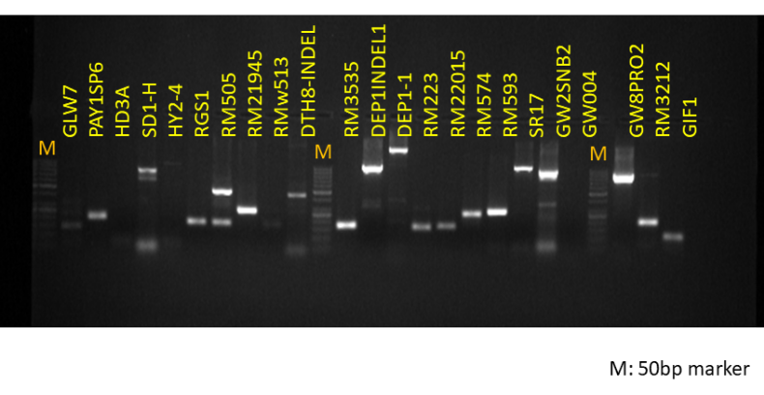
S. Fig.1.Representative gel image showing standardization of markers with rice genotype, a cultivated popular rice variety NLR 34449 (Nellore Mashuri) at 58°C annealing temperature
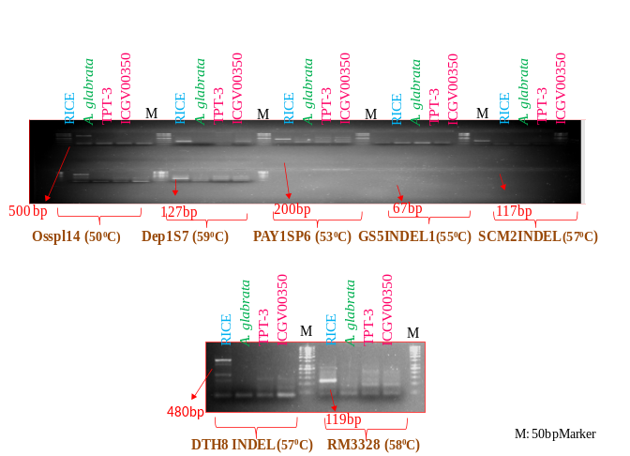
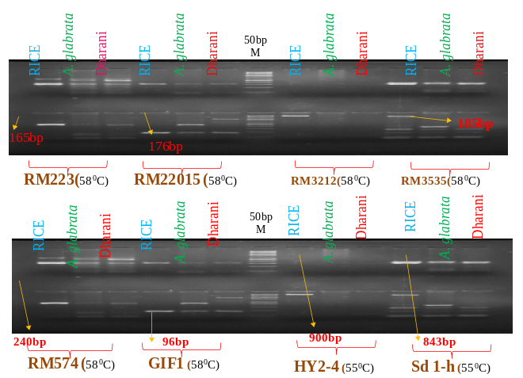

S. Fig. 2.Standardization of chosen set of markers with groundnut genotypes

Rice: cultivated popular rice variety NLR 34449 (Nellore Mashuri), Wild genotype of groundnut: Arachisglabrata, Dharani: cultivated popular groundnut variety released from ANGRAU

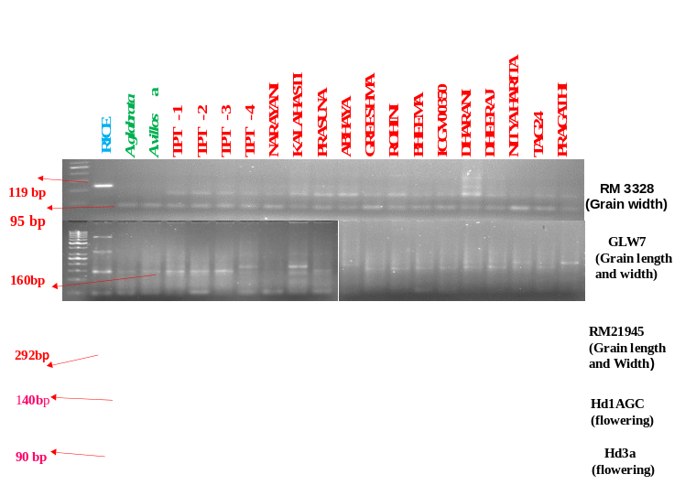

S. Fig 3. Gel image showing rice Seed weight and Flowering markers amplified at low intensity in groundnut
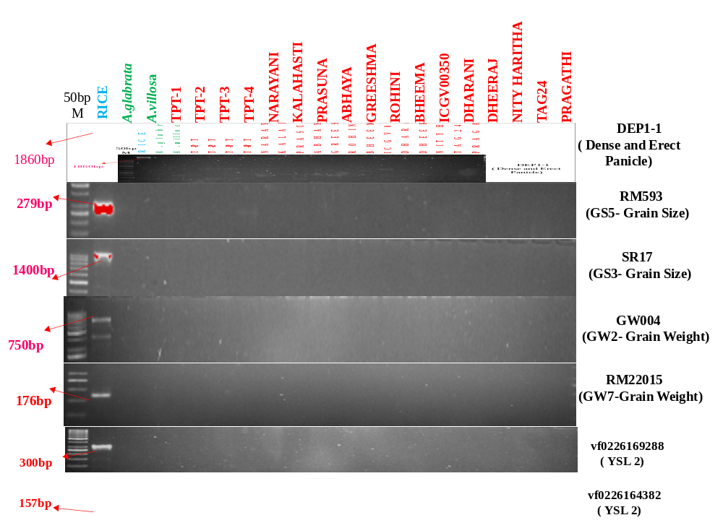

S. Fig 4. Gel images showing rice gene tagged markers amplified only in rice genome

