Table S1. For each simulation, list of the variable parameters are listed below.
No. | L (m) | W (m) | f_{C} (Hz) | Δσ (MPa) | Dm (m) | V_{R} (m/s) | X_{nuc} (m) | Y_{nuc} (m)
1 | 10640 | 2765 | 0.245 | 3.9 | 1.4346 | 2689.88 | 56.50% | 72.60%
2 | 9485 | 2450 | 0.275 | 5.5 | 1.8162 | 2698.52 | 57.20% | 68.70%
3 | 9345 | 2415 | 0.27 | 5.2 | 1.8701 | 2609.45 | 51.70% | 80.40%
4 | 8855 | 2310 | 0.313 | 8.1 | 2.0633 | 2868.37 | 76.50% | 70.40%
5 | 9170 | 2380 | 0.332 | 9.6 | 1.9338 | 3141.02 | 30.80% | 82.90%
6 | 8400 | 2170 | 0.305 | 7.5 | 2.3154 | 2646.68 | 78.10% | 78.80%
7 | 9030 | 2345 | 0.299 | 7.1 | 1.9931 | 2791.18 | 37.90% | 72.00%
8 | 7840 | 2030 | 0.377 | 14 | 2.6518 | 3055.09 | 14.00% | 66.70%
9 | 7910 | 2065 | 0.357 | 12 | 2.5838 | 2918.4 | 24.20% | 71.90%
10 | 9205 | 2380 | 0.275 | 5.5 | 1.9264 | 2617.64 | 17.10% | 81.10%
11 | 10115 | 2625 | 0.275 | 5.5 | 1.5895 | 2875.12 | 89.40% | 60.90%
12 | 7630 | 1995 | 0.346 | 11 | 2.7726 | 2732.15 | 74.80% | 77.60%
13 | 10640 | 2765 | 0.26 | 4.6 | 1.4346 | 2852.92 | 81.80% | 66.90%
14 | 10395 | 2695 | 0.26 | 4.6 | 1.5065 | 2787.97 | 17.30% | 70.20%
15 | 8260 | 2135 | 0.361 | 12 | 2.3932 | 3079.57 | 60.50% | 88.50%
16 | 9905 | 2555 | 0.292 | 6.6 | 1.6677 | 2991.95 | 47.20% | 88.80%
17 | 8050 | 2100 | 0.376 | 14 | 2.4966 | 3131.72 | 82.90% | 83.50%
18 | 9555 | 2485 | 0.273 | 5.3 | 1.7775 | 2691.66 | 12.00% | 60.70%
19 | 8435 | 2170 | 0.332 | 9.7 | 2.3058 | 2893.99 | 87.80% | 77.20%
20 | 10185 | 2660 | 0.285 | 6.1 | 1.5578 | 2998.69 | 20.80% | 73.40%
21 | 7525 | 1960 | 0.389 | 15 | 2.8615 | 3023.51 | 15.20% | 79.30%
22 | 8120 | 2100 | 0.341 | 10 | 2.475 | 2857.38 | 74.40% | 66.40%
23 | 10255 | 2660 | 0.29 | 6.4 | 1.5472 | 3070.56 | 38.10% | 75.80%
24 | 8785 | 2275 | 0.311 | 8 | 2.1117 | 2824.91 | 80.90% | 84.00%
25 | 10045 | 2625 | 0.291 | 6.5 | 1.6006 | 3017.36 | 26.00% | 62.90%
26 | 8435 | 2170 | 0.357 | 12 | 2.3058 | 3106.25 | 11.10% | 63.20%
27 | 8085 | 2100 | 0.368 | 13 | 2.4858 | 3075.37 | 58.70% | 66.10%
28 | 8715 | 2275 | 0.312 | 8 | 2.1287 | 2808.95 | 67.90% | 88.20%
29 | 9415 | 2450 | 0.282 | 5.9 | 1.8297 | 2744.67 | 39.40% | 89.00%
30 | 7560 | 1960 | 0.382 | 14 | 2.8483 | 2984.52 | 28.30% | 85.80%
31 | 9835 | 2555 | 0.295 | 6.8 | 1.6795 | 3001.3 | 29.70% | 76.90%
32 | 8085 | 2100 | 0.371 | 13 | 2.4858 | 3097.45 | 71.30% | 85.50%
33 | 10920 | 2835 | 0.26 | 4.6 | 1.3633 | 2931.19 | 46.30% | 63.40%
34 | 8680 | 2240 | 0.294 | 6.7 | 2.1706 | 2637.16 | 64.10% | 69.10%
35 | 7665 | 1995 | 0.366 | 13 | 2.76 | 2901.54 | 42.80% | 78.50%
36 | 7630 | 1960 | 0.34 | 10 | 2.8221 | 2675.65 | 70.20% | 86.60%
37 | 7700 | 1995 | 0.386 | 15 | 2.7474 | 3066.99 | 79.40% | 62.20%
38 | 7770 | 2030 | 0.388 | 15 | 2.6757 | 3115.41 | 63.30% | 62.40%
39 | 9590 | 2485 | 0.263 | 4.8 | 1.771 | 2604.39 | 31.80% | 76.30%
40 | 8470 | 2205 | 0.334 | 9.9 | 2.2598 | 2923.75 | 44.70% | 65.40%
41 | 7910 | 2065 | 0.343 | 10 | 2.5838 | 2806.11 | 19.90% | 80.60%
42 | 8505 | 2205 | 0.331 | 9.6 | 2.2505 | 2909.17 | 26.70% | 62.00%
43 | 8540 | 2205 | 0.313 | 8.1 | 2.2413 | 2760.34 | 65.40% | 74.10%
44 | 8155 | 2100 | 0.33 | 9.5 | 2.4644 | 2780.58 | 62.20% | 81.40%
45 | 9485 | 2450 | 0.304 | 7.4 | 1.8162 | 2980.86 | 45.20% | 68.40%
46 | 8330 | 2170 | 0.361 | 12 | 2.3348 | 3104.84 | 77.80% | 84.10%
47 | 9205 | 2380 | 0.33 | 9.5 | 1.9264 | 3134.55 | 58.90% | 86.80%
48 | 8155 | 2100 | 0.351 | 11 | 2.4644 | 2955.92 | 28.90% | 70.60%
49 | 7805 | 2030 | 0.333 | 9.7 | 2.6637 | 2682.89 | 53.30% | 85.80%
50 | 10850 | 2800 | 0.265 | 4.9 | 1.3892 | 2965.84 | 85.40% | 67.70%
51 | 9730 | 2520 | 0.283 | 6 | 1.7213 | 2842.62 | 19.20% | 63.80%
52 | 7595 | 1960 | 0.348 | 11 | 2.8351 | 2727.68 | 83.70% | 82.00%
53 | 7875 | 2030 | 0.332 | 9.7 | 2.64 | 2701.23 | 30.90% | 89.90%
54 | 8365 | 2170 | 0.34 | 10 | 2.325 | 2941.15 | 33.10% | 65.90%
55 | 7875 | 2030 | 0.341 | 10 | 2.64 | 2776.66 | 36.00% | 60.20%
56 | 7840 | 2030 | 0.372 | 13 | 2.6518 | 3012.09 | 18.10% | 67.80%
57 | 7665 | 1995 | 0.394 | 16 | 2.76 | 3118.37 | 86.60% | 89.30%
58 | 8750 | 2275 | 0.293 | 6.6 | 2.1202 | 2644.74 | 87.30% | 78.90%
59 | 10395 | 2695 | 0.28 | 5.8 | 1.5065 | 3009.48 | 67.20% | 79.70%
60 | 8960 | 2310 | 0.288 | 6.3 | 2.0391 | 2667.95 | 12.80% | 61.40%
61 | 8855 | 2310 | 0.301 | 7.2 | 2.0633 | 2750.35 | 71.60% | 71.30%
62 | 8295 | 2170 | 0.345 | 10 | 2.3447 | 2959.27 | 79.90% | 87.40%
63 | 7980 | 2065 | 0.336 | 10 | 2.5611 | 2769.92 | 88.50% | 72.40%
64 | 9310 | 2415 | 0.272 | 5.3 | 1.8771 | 2618.74 | 51.50% | 76.00%
65 | 8505 | 2205 | 0.338 | 10 | 2.2505 | 2973.68 | 24.70% | 84.40%
66 | 8190 | 2135 | 0.342 | 10 | 2.4137 | 2898.81 | 10.60% | 64.60%
67 | 9275 | 2415 | 0.318 | 8.5 | 1.8842 | 3043.23 | 60.40% | 87.60%
68 | 8295 | 2135 | 0.361 | 12 | 2.3831 | 3088.06 | 36.50% | 68.60%
69 | 8890 | 2310 | 0.283 | 6 | 2.0552 | 2595.8 | 42.10% | 78.20%
70 | 7700 | 1995 | 0.382 | 14 | 2.7474 | 3036.38 | 73.60% | 63.90%
71 | 7525 | 1960 | 0.35 | 11 | 2.8615 | 2722.89 | 34.80% | 79.90%
72 | 7490 | 1960 | 0.343 | 10 | 2.8749 | 2659.44 | 23.20% | 89.60%
73 | 7595 | 1960 | 0.335 | 10 | 2.8351 | 2627.78 | 39.80% | 77.80%
74 | 10535 | 2730 | 0.284 | 6.1 | 1.4674 | 3091.84 | 55.90% | 69.60%
75 | 7945 | 2065 | 0.316 | 8.3 | 2.5724 | 2590.26 | 21.50% | 73.90%
76 | 8925 | 2310 | 0.289 | 6.4 | 2.0471 | 2663.26 | 50.20% | 73.70%
77 | 7735 | 1995 | 0.365 | 12 | 2.735 | 2912.62 | 82.40% | 82.20%
78 | 8715 | 2275 | 0.306 | 7.6 | 2.1287 | 2754.59 | 61.40% | 71.60%
79 | 7490 | 1960 | 0.381 | 14 | 2.8749 | 2946.83 | 55.40% | 65.60%
80 | 9380 | 2415 | 0.293 | 6.6 | 1.8631 | 2836.32 | 35.10% | 70.90%
81 | 7770 | 1995 | 0.339 | 10 | 2.7227 | 2717.62 | 72.60% | 74.90%
82 | 9975 | 2590 | 0.271 | 5.3 | 1.6336 | 2795.62 | 64.60% | 74.50%
83 | 9835 | 2555 | 0.289 | 6.4 | 1.6795 | 2937.66 | 66.70% | 67.30%
84 | 9660 | 2520 | 0.305 | 7.5 | 1.7337 | 3047.65 | 27.40% | 75.40%
85 | 10500 | 2730 | 0.266 | 4.9 | 1.4723 | 2882.73 | 40.60% | 73.10%
86 | 10745 | 2800 | 0.258 | 4.5 | 1.4028 | 2864.79 | 49.60% | 82.50%
87 | 8645 | 2240 | 0.332 | 9.7 | 2.1794 | 2967.9 | 69.60% | 86.10%
88 | 8575 | 2240 | 0.312 | 8 | 2.1972 | 2763.96 | 76.30% | 69.40%
89 | 9100 | 2380 | 0.3 | 7.1 | 1.9487 | 2817.42 | 41.20% | 64.30%
90 | 8995 | 2345 | 0.326 | 9.2 | 2.0008 | 3033.22 | 49.10% | 87.10%
91 | 10290 | 2660 | 0.257 | 4.5 | 1.5419 | 2734.45 | 16.30% | 75.10%
92 | 8225 | 2135 | 0.31 | 7.8 | 2.4034 | 2630.3 | 54.50% | 85.20%
93 | 9730 | 2520 | 0.305 | 7.5 | 1.7213 | 3060.91 | 69.00% | 60.60%
94 | 8225 | 2135 | 0.319 | 8.6 | 2.4034 | 2709.09 | 52.70% | 61.60%
95 | 8015 | 2065 | 0.377 | 14 | 2.55 | 3123.32 | 14.50% | 83.30%
96 | 8015 | 2065 | 0.32 | 8.7 | 2.55 | 2651.28 | 22.60% | 81.80%
97 | 8610 | 2240 | 0.318 | 8.5 | 2.1883 | 2829.9 | 43.70% | 84.60%
98 | 9975 | 2590 | 0.276 | 5.6 | 1.6336 | 2846.65 | 48.00% | 65.00%
99 | 9065 | 2345 | 0.302 | 7.2 | 1.9854 | 2823.07 | 33.90% | 76.70%
100 | 7805 | 2030 | 0.358 | 12 | 2.6637 | 2889.63 | 84.50% | 81.00%

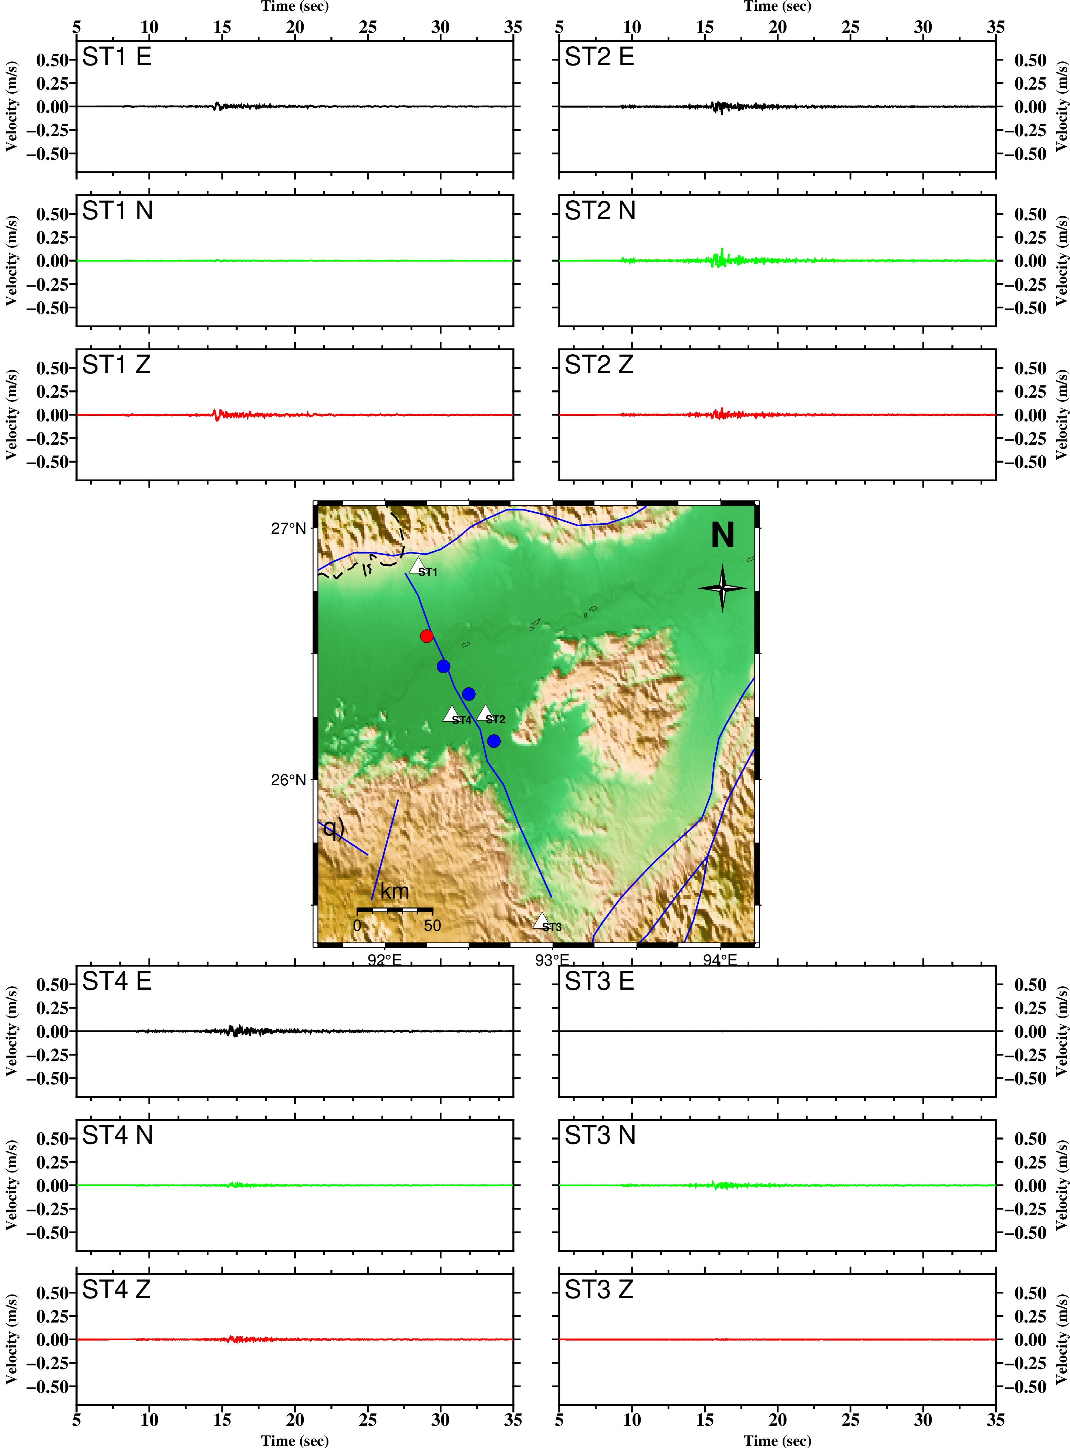
Figure S1. Simulated time histories of velocity along E-, N- and Z-direction generated by the event represent by red circle. The location of the four stations (viz. ST1, ST2, ST3 and ST4) are indicated by white triangle. The blue circles represent the remaining three scenarios. [M_{W} 6.0, Depth 18km]

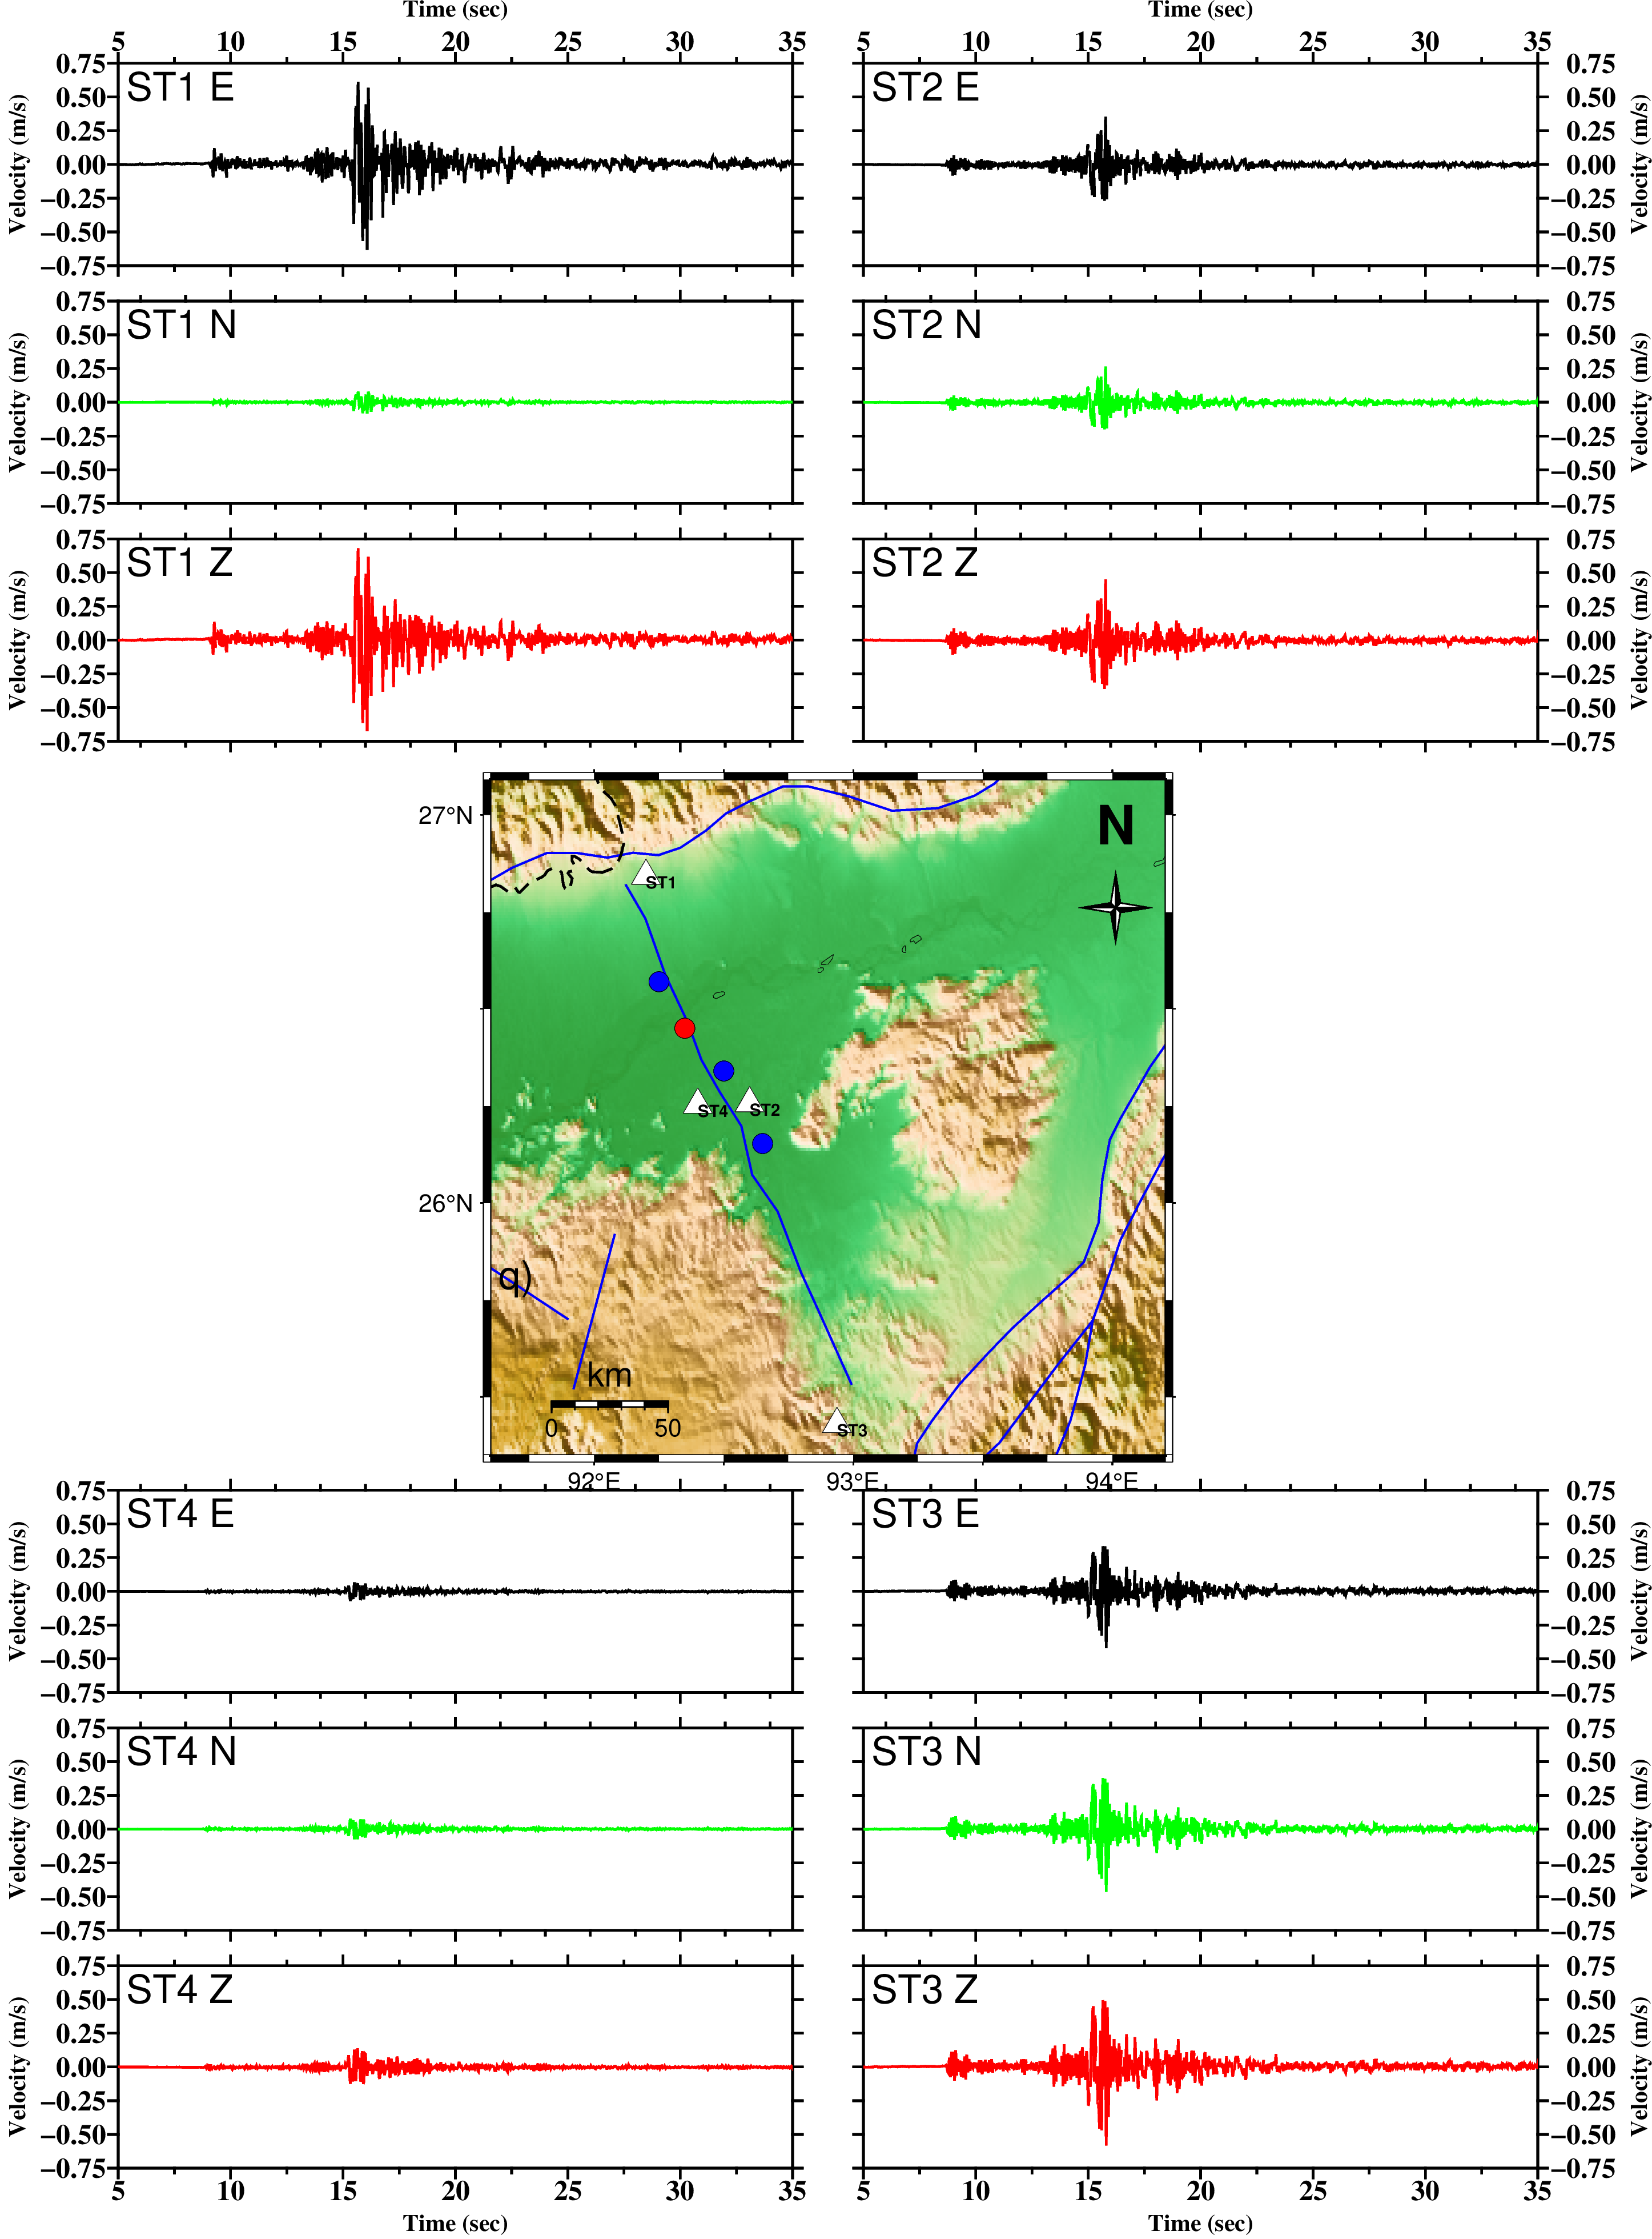
Figure S2. Same as Figure S1, but for different event. [M_{W} 6.0, Depth 14km]
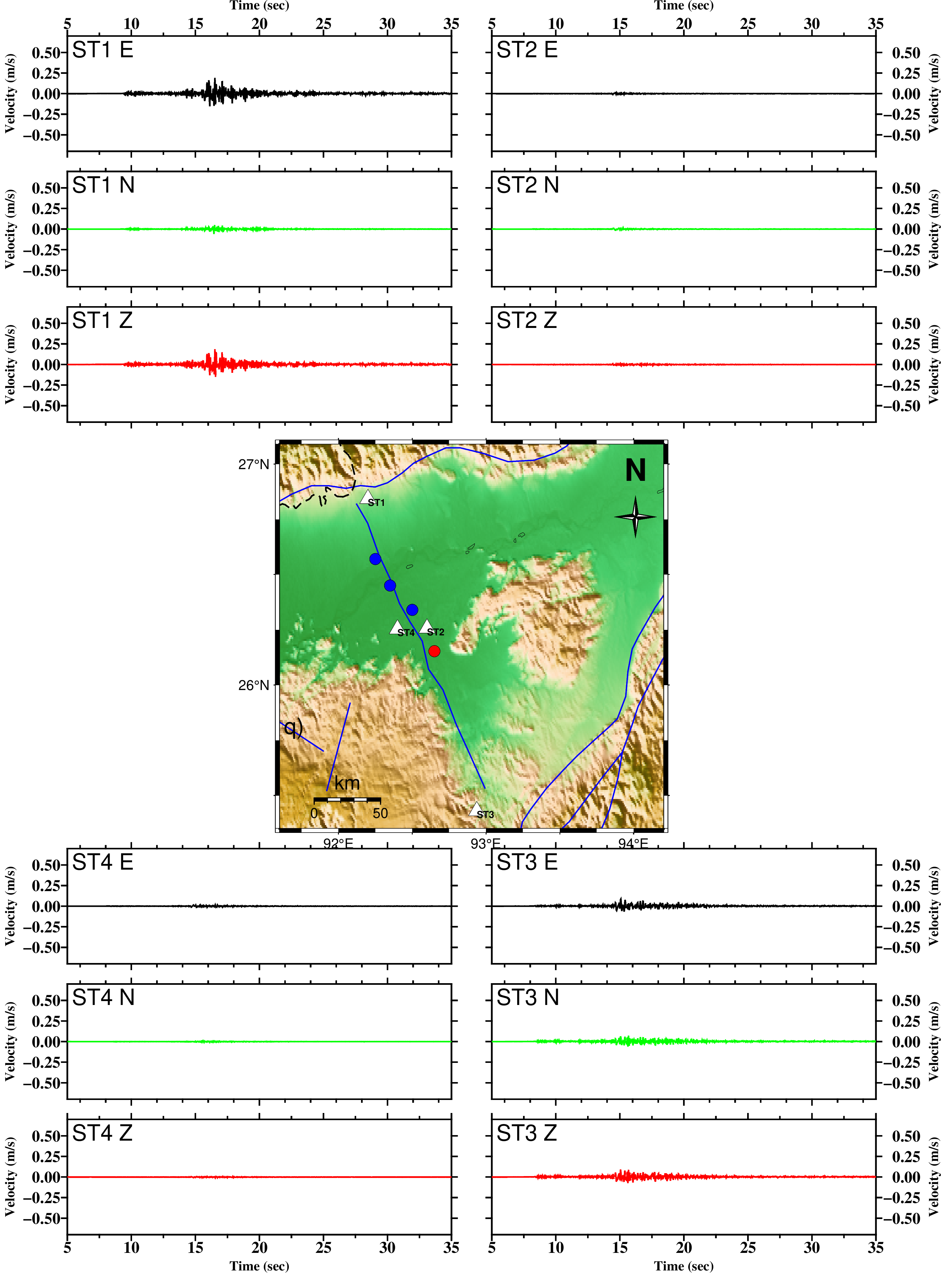
Figure S3. Same as Figure S1, but for different event. [M_{W} 6.0, Depth 17km]

