Archives of Microbiology

Supplementary Materials

Aliilewinella sediminis gen. nov. sp. nov., isolated from the coastal sediment, and reclassification of some Lewinella species as the members of the genus Alilewinella
Ya-Jing Zhang^{1#}, Chu-Xuan Ji^{1#}, Fan Li¹, Yan-Lin Zhong¹, Ya Gong^{1, 2, *} and Zong-Jun Du^{1, 2, *}
¹Marine College, Shandong University, Weihai, Shandong, 264209, PR China
²State key Laboratory of Microbial Technology, Shandong University, Qingdao, Shandong, 266237, PR China
#Ya-Jing Zhang and Chu-Xuan Ji contributed equally to this work. #

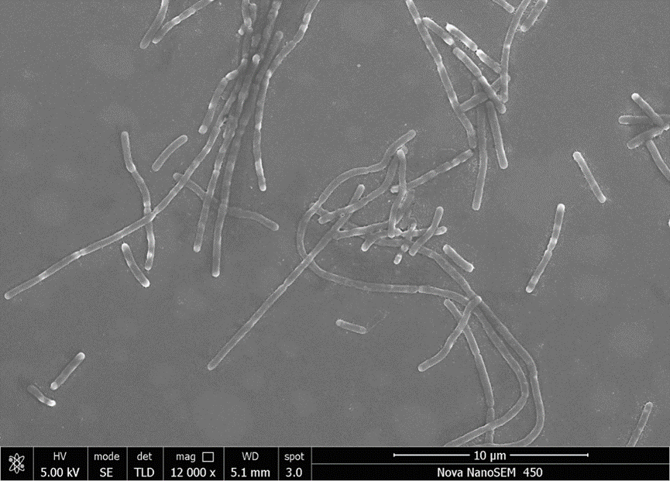
Supplementary Fig S1. Scanning electron micrograph of cells of strain W8^{T}. Cells were grown on marine agar 2216 at 28 °C for 3 days. Bar, 10 µm.

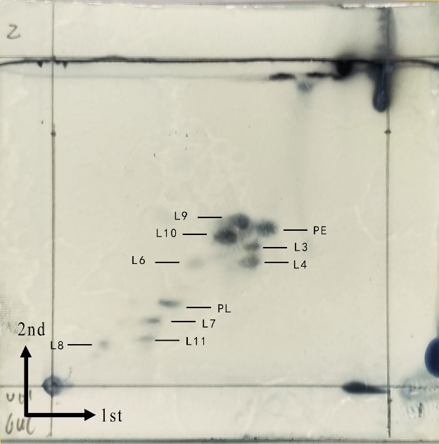
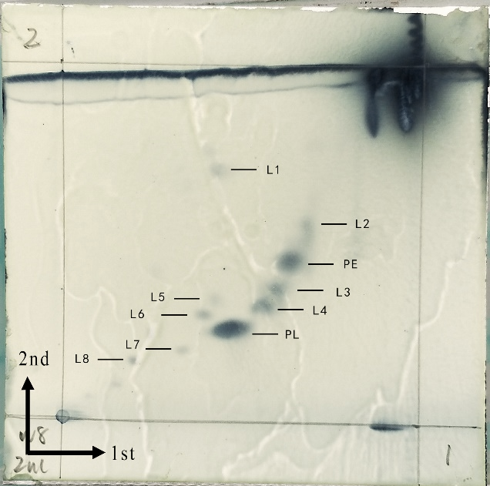

(a) (b)
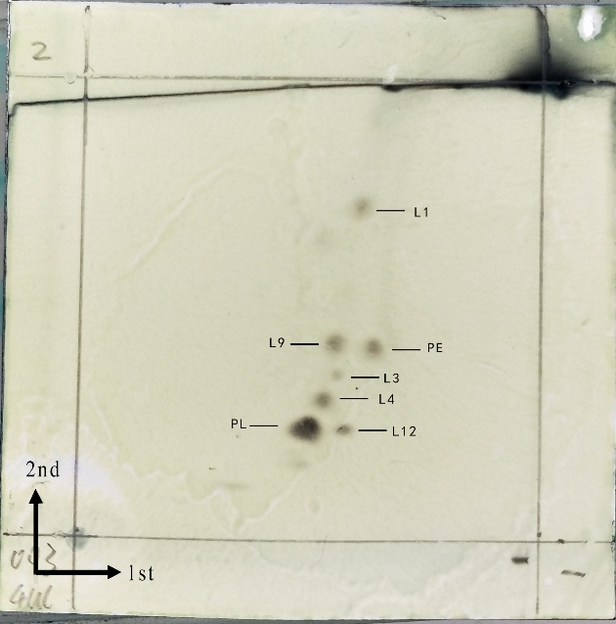
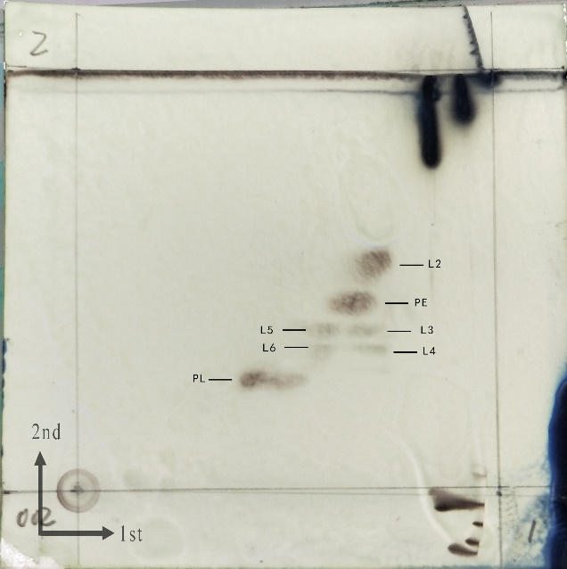

(c) (d)
Supplementary Fig S2. Two-dimensional TLC plate images of lipids of strain W8^{T} and three related strains. Strains: a, W8^{T}; b, L. cohaerens NBRC 102661^{T}; c, L. agarilytica KCTC 12774^{T}; d, L. lacunae KCTC 42187^{T}. All lipids were shown on the plate after 5 % molybdatophosphoric acid was sprayed. PE, phosphatidylethanolamine; PL, phospholipid; L, lipid.

Table S1. The ANI index and dDDH values between the strain W8^{T} and the related type strains in family Lewinellaceae.
Species- strain | ANIm | is DDH
2 | 71.09 | 18.8
3 | 72.25 | 19.2
4 | 70.92 | 18.9
5 | 72.27 | 19.7
6 | 71.02 | 19.0
7 | 70.56 | 18.3
8 | 71.83 | 19.1
9 | 71.5 | 18.4
10 | 71.04 | 19.9
11 | 66.38 | 36.7
Strains: 1, W8^{T}; 2, L. agarilytica KCTC 12774^{T}; 3, L. lacunae KCTC 42187^{T}; 4, L. persica T-3^{T}; 5, L. marina MKG-38^{T}; 6, L. xylanilytica 13-9-B8^{T}; 7, L. antarctica IMCC3223^{T}; 8, L. litorea HSMS-39^{T}; 9, L. aquimaris HDW-36^{T}; 10, L. aurantiaca SSH13^{T}; 11, L. cohaerens NBRC 102661^{T}. The ANI values and dDDH values were significantly lower than the threshold for species boundaries (94-96 % of ANI and 70 % of dDDH).

Table S2. The AAI values between the strain W8^{T} and the related type strains in family Lewinellaceae.
AAI | 2 | 3 | 4 | 5 | 6 | 7 | 8 | 9 | 10 | 11
1 | 66.6 | 66.8 | 65.7 | 64.7 | 62.7 | 63.0 | 62.4 | 67.74 | 69.08 | 51.8
2 |  | 69.0 | 70.5 | 63.9 | 62.1 | 65.5 | 63.9 | 67.36 | 72.79 | 51.4
3 |  |  | 68.7 | 64.3 | 62.9 | 65.1 | 64.2 | 67.61 | 70.62 | 51.4
4 |  |  |  | 63.5 | 61.7 | 64.9 | 63.3 | 67.08 | 75.04 | 51.4
5 |  |  |  |  | 74.7 | 62.3 | 85.8 | 76.5 | 66.78 | 52.4
6 |  |  |  |  |  | 61.0 | 75.1 | 74.86 | 65.82 | 50.9
7 |  |  |  |  |  |  | 62.0 | 66.02 | 68.92 | 50.5
8 |  |  |  |  |  |  |  | 76.61 | 66.71 | 52.1
9 |  |  |  |  |  |  |  |  | 66.94 | 58.74
10 |  |  |  |  |  |  |  |  |  | 58.37
11
Strains: 1, W8^{T}; 2, L. agarilytica KCTC 12774^{T}; 3, L. lacunae KCTC 42187^{T}; 4, L. persica T-3^{T}; 5, L. marina MKG-38^{T}; 6, L. xylanilytica 13-9-B8^{T}; 7, L. antarctica IMCC3223^{T}; 8, L. litorea HSMS-39^{T}; 9, L. aquimaris HDW-36^{T}; 10, L. aurantiaca SSH13^{T}; 11, L. cohaerens NBRC 102661^{T}; Values (≥ 60.0 %) are highlighted in bold.

Table S3. The POCP values between the strain W8^{T} and the related type strains in family Lewinellaceae.
POCP | 2 | 3 | 4 | 5 | 6 | 7 | 8 | 9 | 10 | 11
1 | 65.5 | 63.2 | 63.7 | 59.8 | 57.2 | 56.4 | 60.1 | 58.83 | 61.85 | 42.6
2 |  | 64.3 | 66.7 | 60.3 | 56.8 | 59.0 | 59.7 | 60.27 | 69.78 | 41.5
3 |  |  | 62.4 | 59.3 | 57.2 | 58.3 | 59.9 | 57.75 | 62.67 | 40.6
4 |  |  |  | 57.0 | 55.1 | 57.7 | 56.8 | 57.08 | 66.48 | 42.2
5 |  |  |  |  | 74.7 | 61.7 | 89.7 | 81.44 | 59.89 | 41.6
6 |  |  |  |  |  | 59.2 | 75.4 | 73.1 | 56.81 | 39.0
7 |  |  |  |  |  |  | 62.0 | 61.33 | 58.75 | 39.2
8 |  |  |  |  |  |  |  | 80.32 | 59 | 41.1
9 |  |  |  |  |  |  |  |  | 60.57 | 40.36
10 |  |  |  |  |  |  |  |  |  | 41.21
11
Strains: 1, W8^{T}; 2, L. agarilytica KCTC 12774^{T}; 3, L. lacunae KCTC 42187^{T}; 4, L. persica T-3^{T}; 5, L. marina MKG-38^{T}; 6, L. xylanilytica 13-9-B8^{T}; 7, L. antarctica IMCC3223^{T}; 8, L. litorea HSMS-39^{T}; 9, L. aquimaris HDW-36^{T}; 10, L. aurantiaca SSH13^{T}; 11, L. cohaerens NBRC 102661^{T}; Values (≥ 50.0 %) are highlighted in bold.

Table S4. Fatty acid composition (%) of strain W8^{T} and its closely related strains.
Fatty acid | 1 | 2 | 3 | 4
Straight chain
C_{14:0} | tr | tr | 1.2 | 1.1
C_{16:0} | 4.5 | 3.2 | 18.0 | 11.8
C_{17:0} | tr | 1.1 | tr | 1.3
C_{18:0} | tr | tr | 1.9 | 2.2
Unsaturated
C_{15:1}ω6c | 5.0 | - | 4.3 | 4.5
C_{17:1}ω6c | 7.8 | - | 4.6 | 6.2
C_{17:1}ω8c | 1.8 | - | tr | tr
Branched
iso-C_{14:0} | - | 1.1 | - | -
iso-C_{15:0} | 17.3 | 38.1 | 18.5 | 21.4
iso-C_{16:0} | tr | 2.5 | tr | -
iso-C_{17:0} | 2.0 | 3.0 | 1.2 | 2.8
iso-C_{15:1} F | 4.1 | 24.1 | 2.3 | 1.0
iso-C_{16:1} G | tr | 1.4 | tr | tr
iso-C_{16:1} H | 2.4 | - | - | -
Hydroxy
C_{16:0} 3-OH | tr | tr | 2.4 | tr
C_{17:0} 3-OH | 1.9 | 2.6 | 1.8 | 1.9
iso-C_{15:0} 3-OH | 2.4 | 3.0 | 1.6 | 2.0
iso-C_{17:0} 3-OH | 11.8 | 10.8 | 4.5 | 8.7
*Summed feature
2 | - | tr | 1.0 | tr
3 | 20.6 | tr | 28.7 | 19.9
9 | 11.1 | tr | 2.3 | 9.6
Strains: 1, W8^{T}; 2, L. cohaerens NBRC 102661^{T}; 3, L. agarilytica KCTC 12774^{T}; 4, L. lacunae KCTC 42187^{T}. TR, traces (<1.0 %); −, not detected. Fatty acids amounting (<1.0 %) are not shown, dominant fatty acids (≥10.0 %) are highlighted in bold. All data from the present study. *Summed features represent groups of two or three fatty acids that could not be separated by gas–liquid chromatography with the MIDI system. Summed Feature 2, iso-C_{16:1} I/C_{14:0} 3-OH; Summed Feature 3, C_{16:1}ω7c/C_{16:1}ω6c; Summed Feature 8, C_{18:1}ω7c/C_{16:1}ω6c; Summed Feature 9, C_{16:0} 10-methyl/iso-C_{17:1}ω9c.

