Supplementary Information

Active site tuning based on pseudo-binary alloys for low-temperature acetylene semihydrogenation

Ma et al.

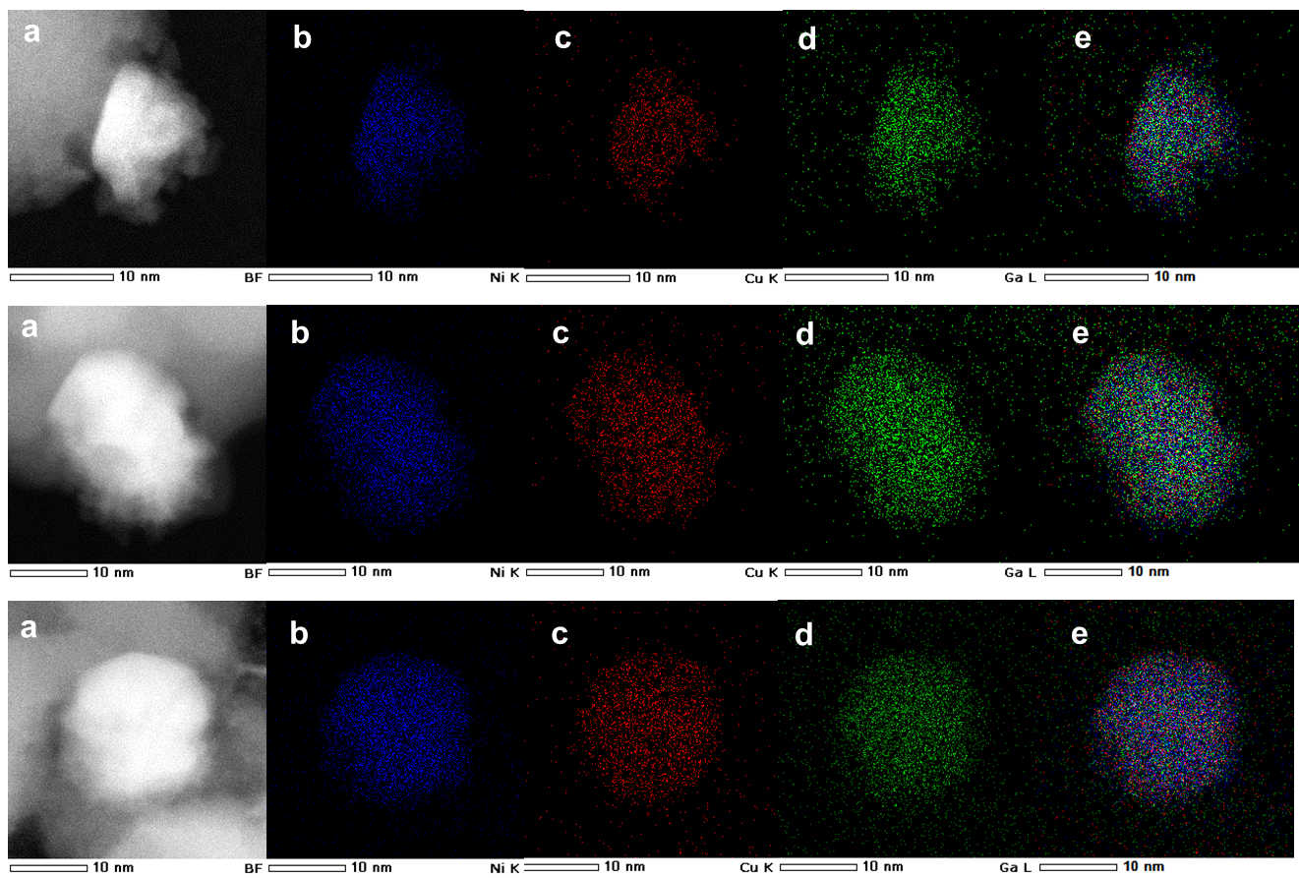
Supplementary Figure 1. a HAADF–STEM image and the corresponding elemental maps for b Ni, c Cu, d Ga, e Ni+Cu+Ga (magnified for a few particles) for (Ni_{0.8}Cu_{0.2})₃Ga/TiO₂.

Supplementary Table 1. Particle size of (Ni_{0.8}Cu_{0.2})₃Ga/TiO₂, (Ni_{0.8}Cu_{0.2})₃Ga/SiO₂ and Ni₃Ga/TiO₂ calculated according to Scherrer equation.
catalysts | Scherrer  constant | half with  / degree | center  / degree | crystallite  size / nm
(Ni_{0.8}Cu_{0.2})₃Ga/TiO₂ | 0.849 | 0.76 | 43.52 | 10.6
Ni₃Ga/TiO₂ | 0.849 | 1.03 | 43.74 | 7.8
(Ni_{0.8}Cu_{0.2})₃Ga/SiO₂ | 0.849 | 1.60 | 43.74 | 5.1

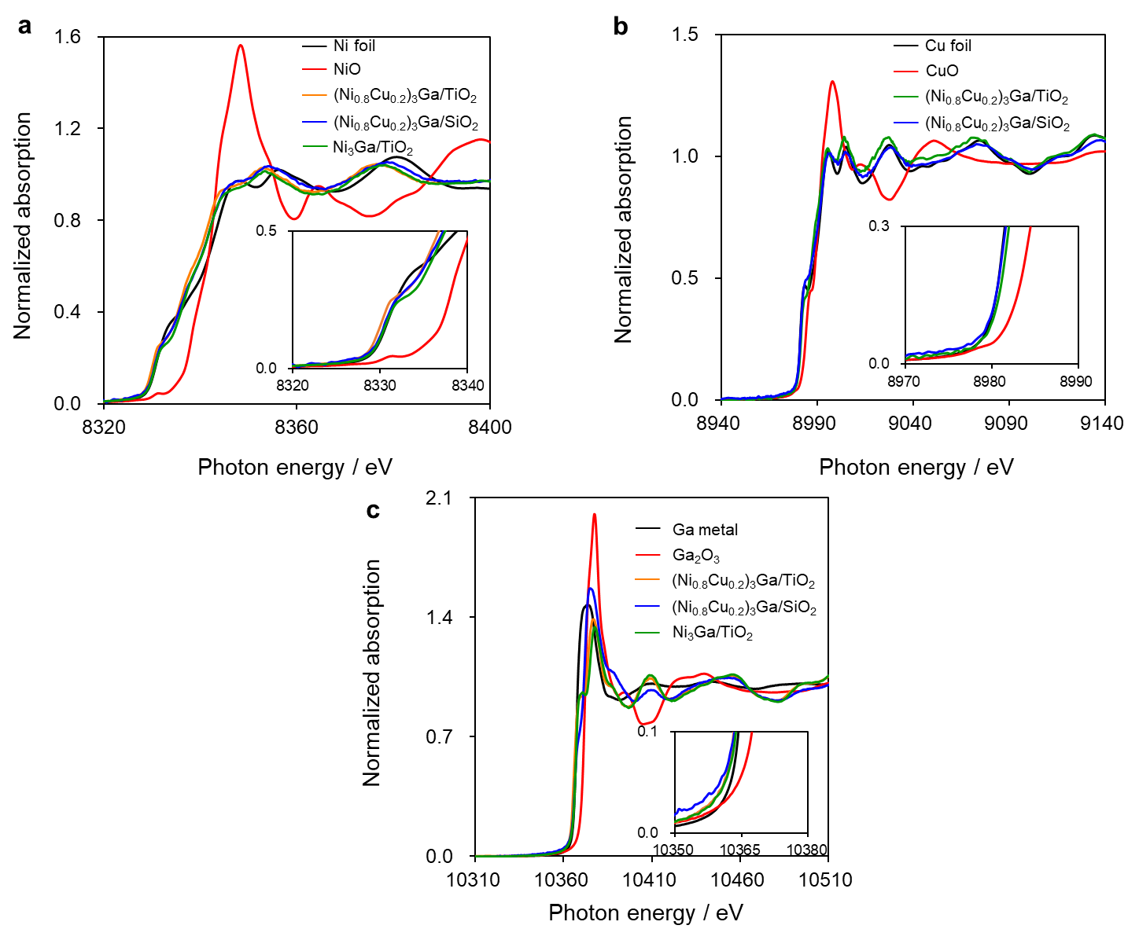
Supplementary Figure 2. a Ni, b Cu, and c Ga K-edge XANES spectra of over (Ni_{0.8}Cu_{0.2})₃Ga/TiO₂, (Ni_{0.8}Cu_{0.2})₃Ga/SiO₂, Ni₃Ga/TiO₂ and reference compounds.

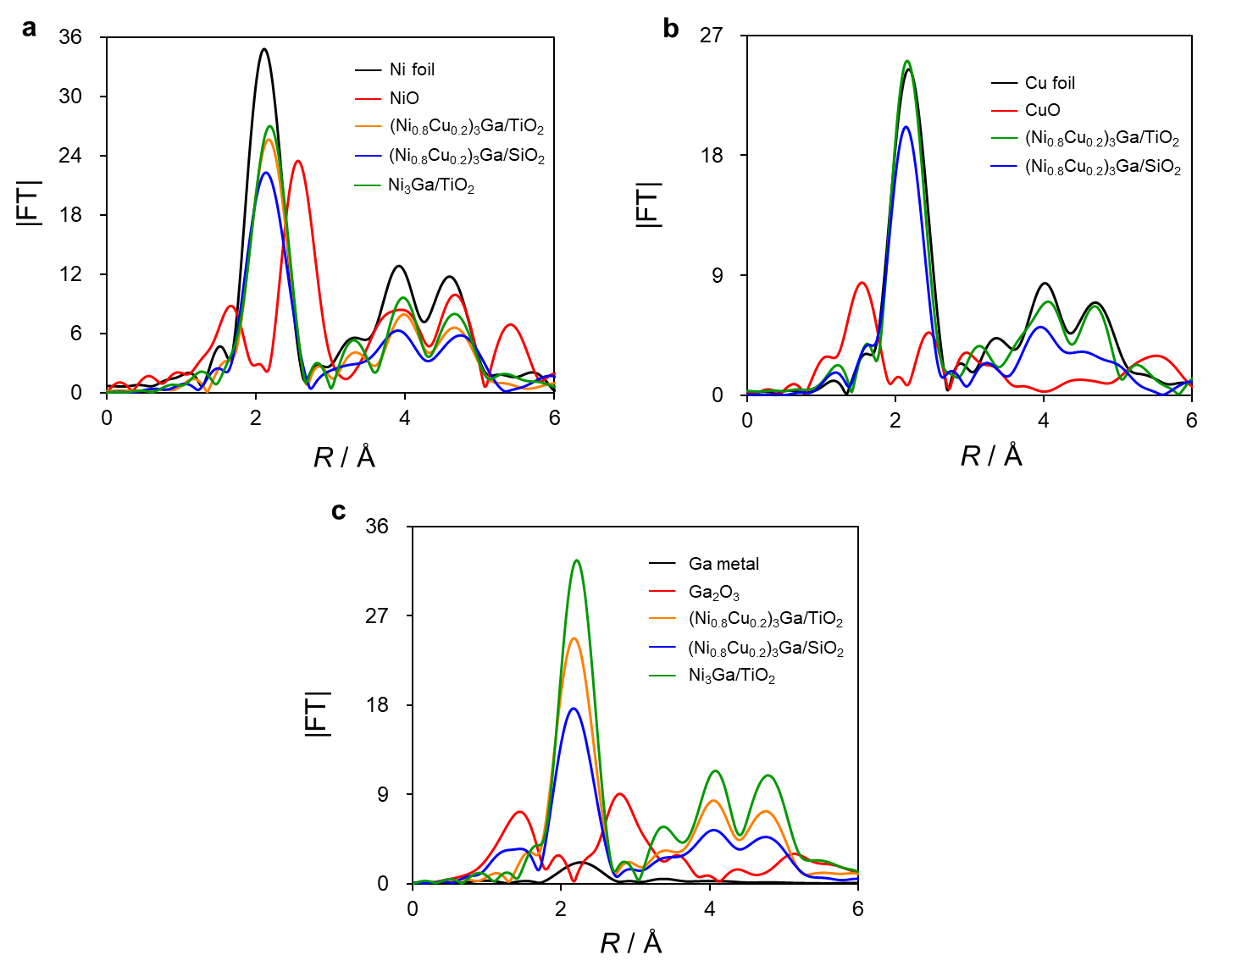
Supplementary Figure 3. Fourier-transforms of EXAFS in a Ni, b Cu, and c Ga K-edge over (Ni_{0.8}Cu_{0.2})₃Ga/TiO₂, (Ni_{0.8}Cu_{0.2})₃Ga/SiO₂, Ni₃Ga/TiO₂. and reference compounds.

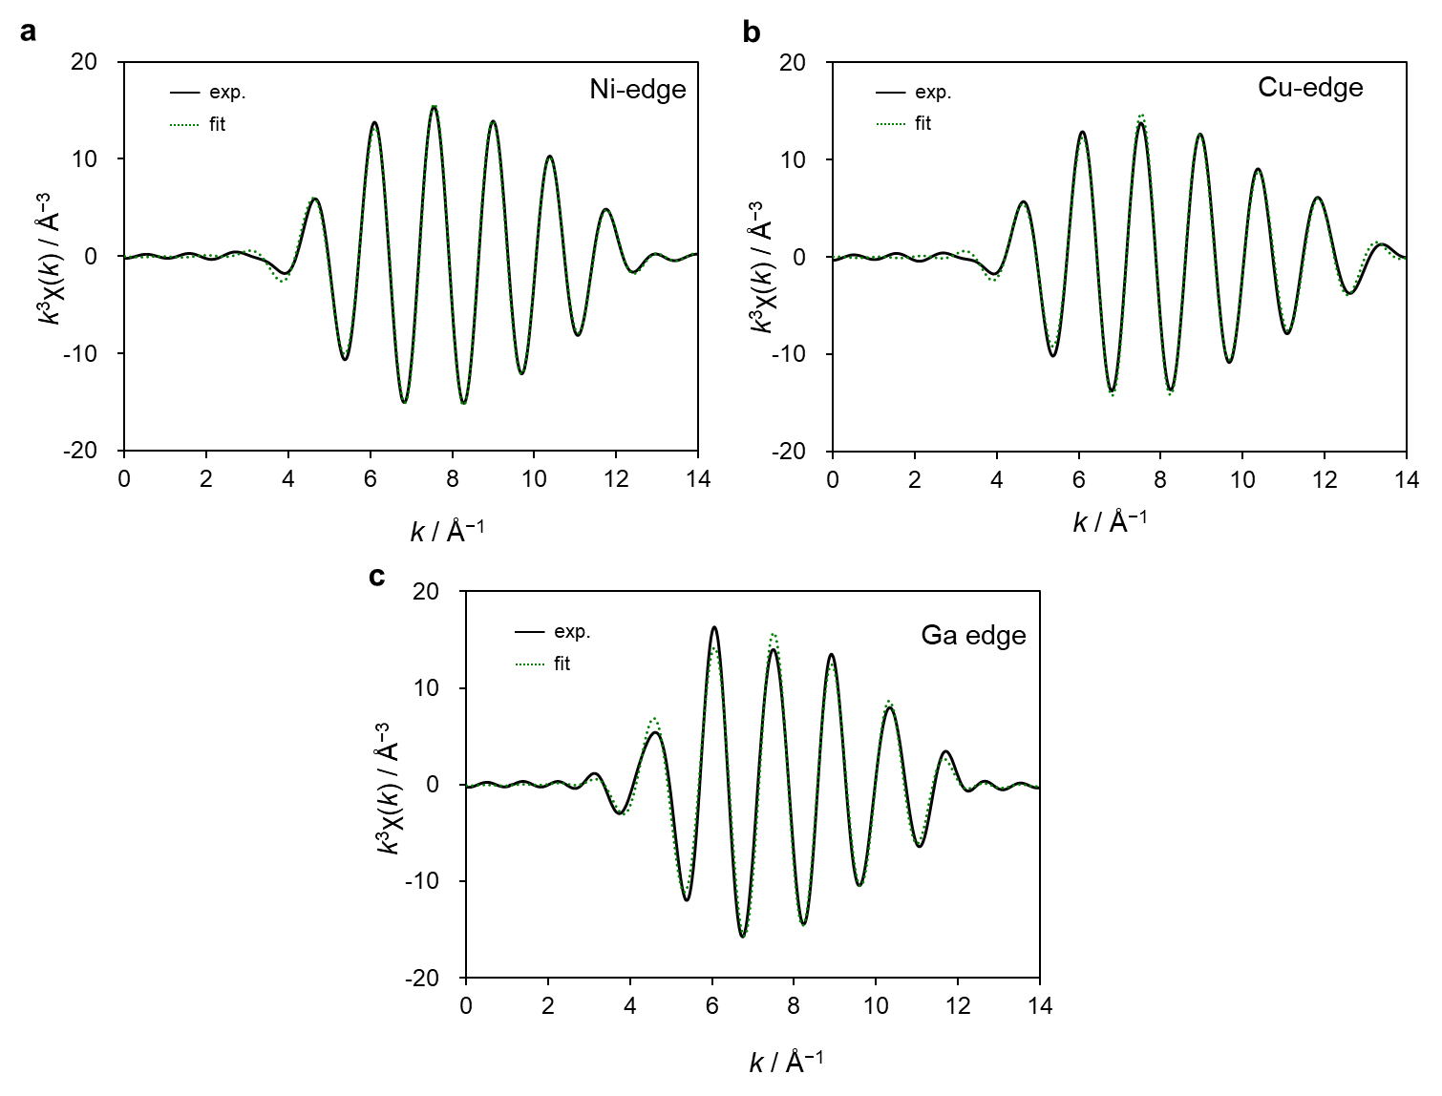
Supplementary Figure 4. Curve-fitting results of a Ni b Cu and c Ga K-edge k³-weighted EXAFS of (Ni_{0.8}Cu_{0.2})₃Ga/TiO₂. Solid and dashed lines indicate the results of simulation and experiment, respectively.

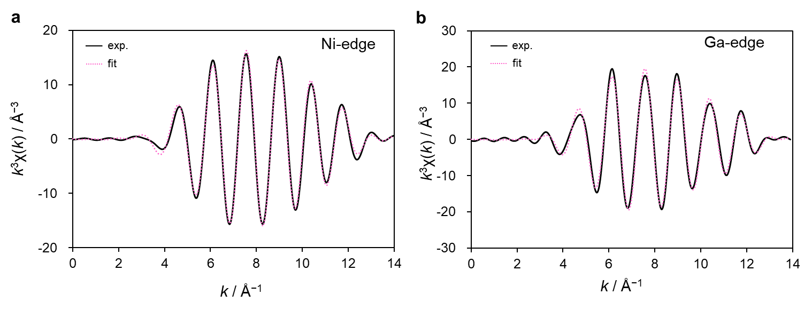
Supplementary Figure 5. Curve-fitting results of a Ni and b Ga K-edge k³-weighted EXAFS of Ni₃Ga/TiO₂. Solid and dashed lines indicate the results of simulation and experiment, respectively.
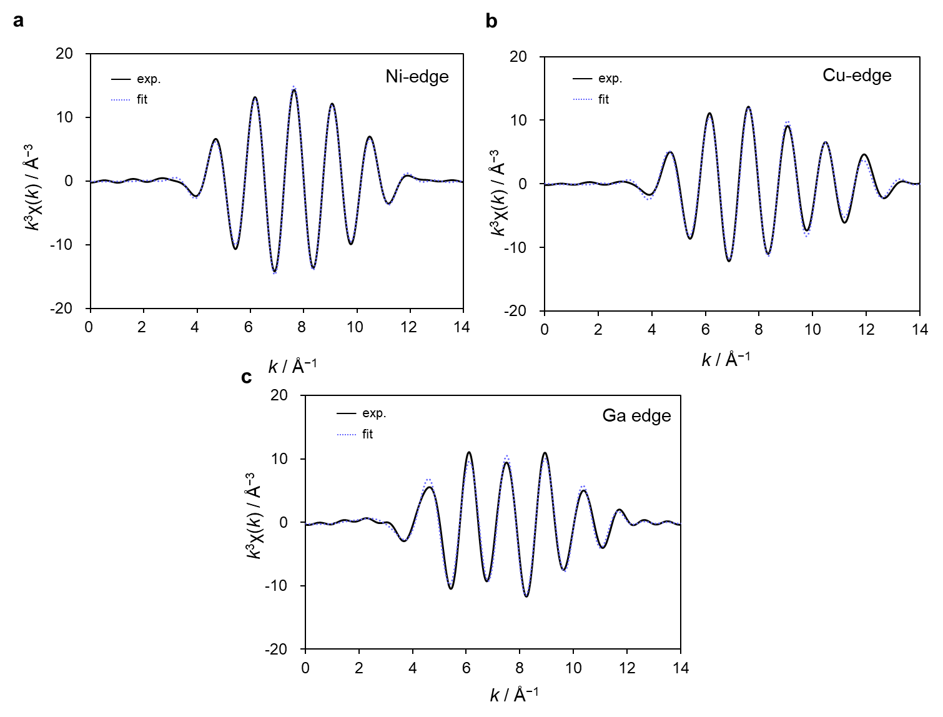
Supplementary Figure 6. Curve-fitting results of a Ni b Cu and c Ga K-edge k³-weighted EXAFS of (Ni_{0.8}Cu_{0.2})₃Ga/SiO₂. Solid and dashed lines indicate the results of simulation and experiment, respectively.

Supplementary Table 2. Summary of the EXAFS curve fitting for (Ni_{0.8}Cu_{0.2})₃Ga/TiO₂, (Ni_{0.8}Cu_{0.2})₃Ga/SiO₂, Ni₃Ga/TiO₂ catalysts and reference.

Sample | Edge | Shell | S_{o}² | CN | r (Å) | ∆E_{o} (eV) | σ² (Å²) | R-factor
Ni foil | Ni k | Ni-Ni | 0.846 | 12 | 2.48±0.01 | 5.43±0.7 | 0.00621 | 0.003
Cu foil | Cu k | Cu-Cu | 0.918 | 12 | 2.54±0.02 | 6.26±0.9 | 0.0088 | 0.005
Ga₂O₃ | Ga k | Ga-O | 1.316 | 3 | 1.91±0.09 | 6.84±1.8 | 0.00657 | 0.014
Ga₂O₃ | Ga k | Ga-O | 1.316 | 1 | 2.12±0.25 | 6.84±1.8 | 0.00361 | 0.014
Ga₂O₃ | Ga k | Ga-Ga | 1.316 | 2 | 3.05±0.01 | 6.84±1.8 | 0.00338 | 0.014
(Ni_{0.8}Cu_{0.2})₃Ga/TiO₂ | Ni k | Ni-Ga | 0.846 | 3.50±0.99 | 2.46±0.07 | 5.40±1.5 | 0.00415 | 0.003
(Ni_{0.8}Cu_{0.2})₃Ga/TiO₂ | Ni k | Ni-Ni(Cu) | 0.846 | 7.00±0.99 | 2.58±0.08 | 5.40±1.5 | 0.00472 | 0.003
(Ni_{0.8}Cu_{0.2})₃Ga/TiO₂ | Cu k | Cu-Ga | 0.918 | 2.79±0.48 | 2.49±0.04 | 2.81±1.8 | 0.00275 | 0.008
(Ni_{0.8}Cu_{0.2})₃Ga/TiO₂ | Cu k | Cu-Cu(Ni) | 0.918 | 8.38±0.48 | 2.60±0.04 | 2.81±1.8 | 0.00799 | 0.008
(Ni_{0.8}Cu_{0.2})₃Ga/TiO₂ | Ga k | Ga-O | 1.316 | 2.11±0.29 | 2.03±0.20 | 0.65±1.7 | 0.0698 | 0.005
(Ni_{0.8}Cu_{0.2})₃Ga/TiO₂ | Ga k | Ga-Ni(Cu) | 1.316 | 8.46±0.28 | 2.54±0.00 | 0.65±1.7 | 0.00914 | 0.005
(Ni_{0.8}Cu_{0.2})₃Ga/SiO₂ | Ni k | Ni-Ga | 0.846 | 3.29±0.64 | 2.43±0.11 | 4.51±1.1 | 0.00185 | 0.018
(Ni_{0.8}Cu_{0.2})₃Ga/SiO₂ | Ni k | Ni-Ni(Cu) | 0.846 | 6.58±0.64 | 2.57±0.04 | 4.51±1.1 | 0.00323 | 0.018
(Ni_{0.8}Cu_{0.2})₃Ga/SiO₂ | Cu k | Cu-Ga | 0.918 | 3.59±0.93 | 2.29±0.24 | 9.38±2.3 | 0.02631 | 0.01
(Ni_{0.8}Cu_{0.2})₃Ga/SiO₂ | Cu k | Cu-Cu(Ni) | 0.918 | 10.8±0.93 | 2.50±0.05 | 9.38±2.3 | 0.00953 | 0.01
(Ni_{0.8}Cu_{0.2})₃Ga/SiO₂ | Ga k | Ga-O | 1.316 | 1.47±0.20 | 1.81±0.01 | 1.91±1.6 | 0.00796 | 0.02
(Ni_{0.8}Cu_{0.2})₃Ga/SiO₂ | Ga k | Ga-Ni(Cu) | 1.316 | 5.89±0.20 | 2.54±0.00 | 1.91±1.6 | 0.00897 | 0.02
Ni₃Ga/TiO₂ | Ni k | Ni-Ga | 0.846 | 3.51±1.22 | 2.45±0.09 | 6.27±1.9 | 0.00421 | 0.006
Ni₃Ga/TiO₂ | Ni k | Ni-Ni | 0.846 | 7.03±1.23 | 2.57±0.04 | 6.27±1.9 | 0.00389 | 0.006
Ni₃Ga/TiO₂ | Ga k | Ga-O | 1.316 | 2.28±1.10 | 1.79±0.04 | 5.20±1.5 | 0.13945 | 0.021
Ni₃Ga/TiO₂ | Ga k | Ga-Ni | 1.316 | 9.11±1.12 | 2.53±0.00 | 5.20±1.5 | 0.00811 | 0.021

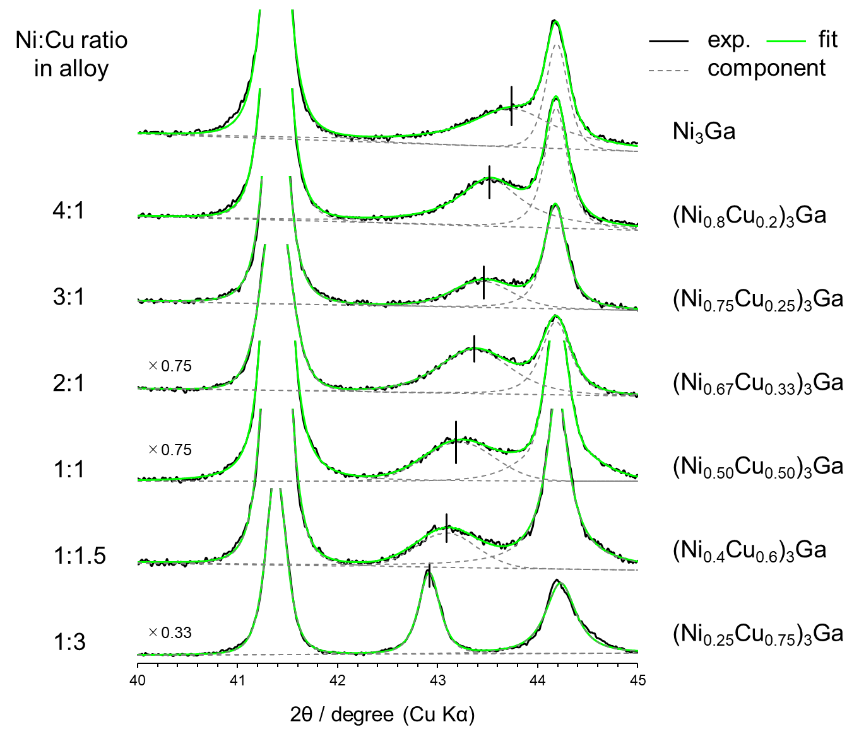
Supplementary Figure 7. XRD analysis for (Ni_{1-x}Cu_{x})₃Ga/TiO₂ (x = 0, 0.2, 0.25, 0.33, 0.5, 0.6, 0.75) catalysts. Vertical solid lines indicate the diffraction angles of the corresponding (Ni_{1-x}Cu_{x})₃Ga phases.

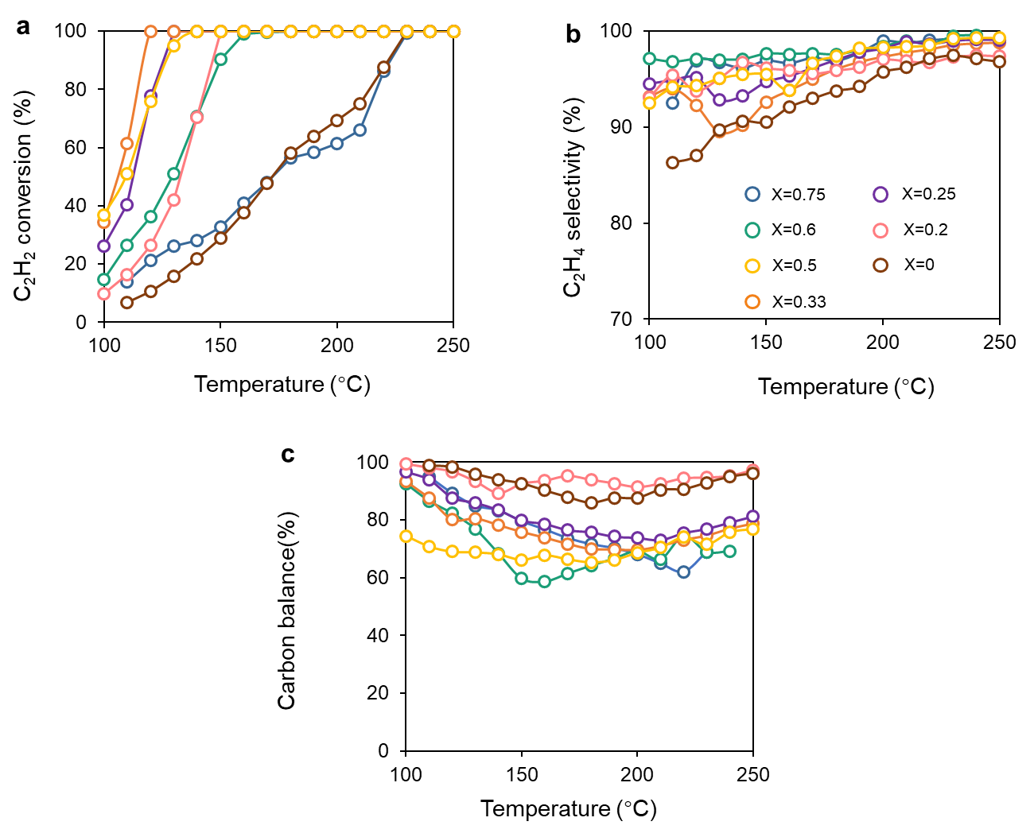
Supplementary Figure 8. a C₂H₂ conversion, b C₂H₄ selectivity and c carbon balance as a function of reaction temperature over (Ni_{1-x}Cu_{x})₃Ga/TiO₂.

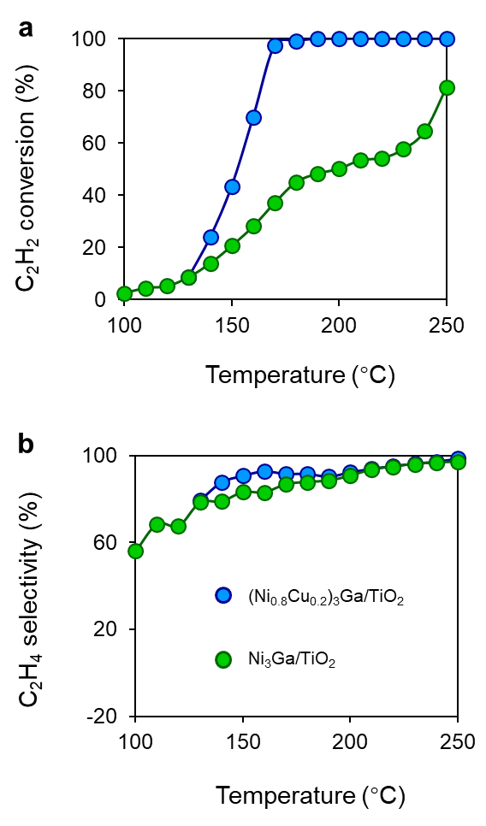
Supplementary Figure 9. a C₂H₂ conversion and b C₂H₄ selectivity as a function of reaction temperature in the presence of ethylene (C₂H₂:H₂:He:C₂H₄ = 1:10:39:5 mLmin⁻¹) over (Ni_{0.8}Cu_{0.2})₃Ga/TiO₂ and Ni₃Ga/TiO₂.

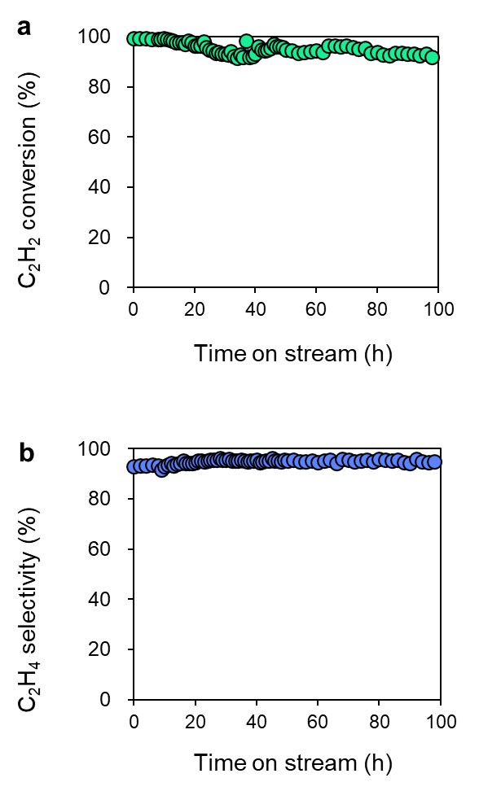
Supplementary Figure 10. Long-term stability test using (Ni_{0.8}Cu_{0.2})₃Ga/TiO₂ in the presence of excess ethylene at 180°C. a C₂H₂ conversion and b C₂H₄ selectivity.

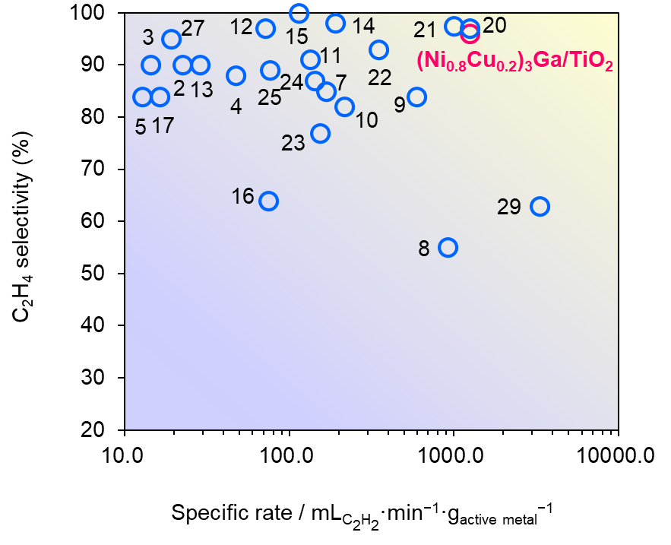

Supplementary Figure 11. Relationship between the specific activity and ethylene selectivity at high acetylene conversion (>80%) for 3d transition metal-based catalysts that were reported in literature and developed in this study. Numbers correspond to the entries in Supplementary Table 3.

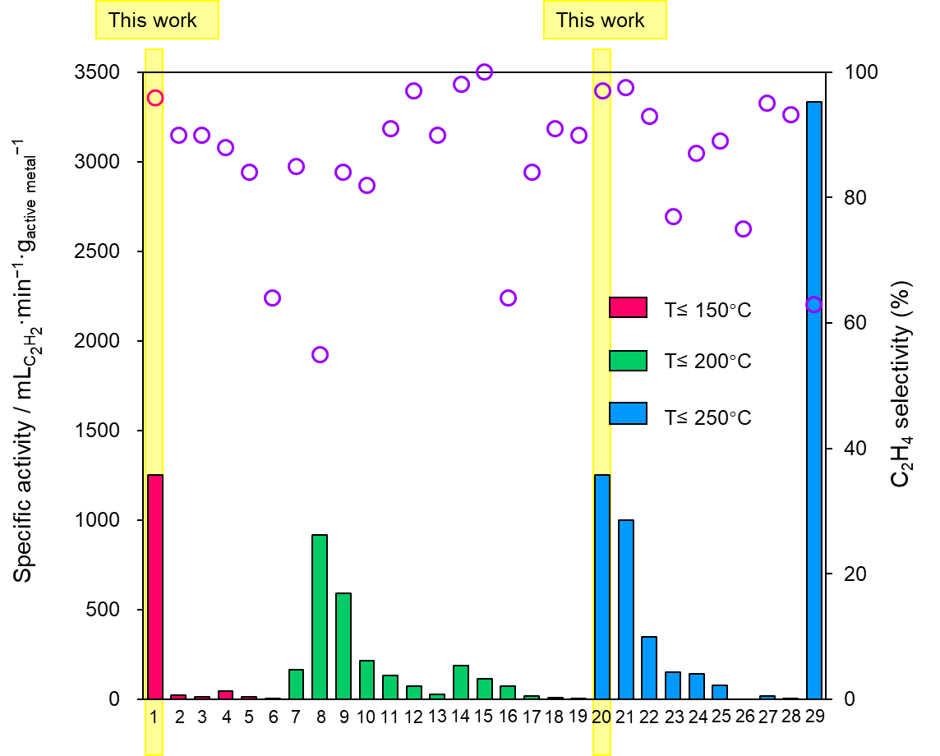

Supplementary Figure 12. Relationship between the specific activity and ethylene selectivity at high acetylene conversion (>80%) at different reaction temperature for 3d transition metal-based catalysts that were reported in literature and developed in this study. Numbers correspond to the entries in Supplementary Table 3.

Supplementary Table 3. Summary of reaction conditions and catalytic performances in acetylene semihydrogenation using 3d transition metal-based catalysts that were reported in literature and developed in this study.
entry | catalyst | loading  (wt%) | amount  / mg | C₂H₂ flow  /mLmin⁻¹ | C₂H₂ : H₂ : C₂H₄ | total flow  /mLmin⁻¹ | GHSV /  mLg⁻¹h⁻¹ | conv.  (%) | sel.  (%) | temp.  / °C | specific rate /  mL_{C2H2}min⁻¹g_{M}⁻¹ | Operation time (h) | ref
1 | (Ni_{0.8}Cu_{0.2})₃Ga/TiO₂ | 1 | 80 | 1 | 1 : 10 : 0 | 50 | 37500 | 100 | 96 | 150 | 1250.0 | 60 | This work
2 | Ni₃GaC_{0.5}/MgAl LDH | 14.88 | 150 | 0.5 | 0.5:2.5:10 | 100 | 40000 | 100 | 90 | 110 | 22.4 | 36 | ¹
3 | Ni₁MoS/Al₂O₃ | 3.5 | 500 | 0.2475 | 1:20:0 | 165 | 19800 | 100 | 90 | 125 | 14.1 | 16 | ²
4 | NiCu/MgAl-MMO | 9.58 | 100 | 0.558 | 1 : 2 : 103 | 166 | 100500 | 81 | 88 | 140 | 47.2 | 36 | ³
5 | Cu(OH)₂ | 78.9 | 100 | 1 | 1 : 9 : 0 | 10 | 6000 | 100 | 84 | 110 | 12.7 | 250 | ⁴
6 | Cu₂O | 88.8 | 100 | 0.045 | 1 : 22 : 197 | 10 | 6000 | 100 | 64 | 120 | 0.5 | 100 | ⁵
7 | Ni₃ZnC_{0.7}/C | 12 | 50 | 1 | 1:15:0 | 100 | 120000 | 100 | 85 | 165 | 166.7 | 10 | ⁶
8 | AgNi_{0.5}/SiO₂ | 1.09 | 30 | 0.3 | 1:20:0 | 30 | 60000 | 100 | 55 | 180 | 917.4 | 24 | ⁷
9 | Ni/g-C₃N₄-T | 1 | 50 | 0.3 | 1:10:20 | 30 | 36000 | 99 | 84 | 175 | 594.0 | 20 | ⁸
10 | NiGa/MgAl-LDH | 10 | 50 | 1.2 | 1 : 10 : 20 | 120 | 144000 | 90 | 82 | 190 | 216.0 | 24 | ⁹
11 | 0.5Cu/Al₂O₃ | 0.5 | 300 | 0.2 | 1 : 10 : 50 | 20 | 4000 | 100 | 91 | 188 | 133.3 | 40 | ¹⁰
12 | Na-Ni/CHA | 3.5 | 200 | 0.5 | 1 : 16 : 0 | 50 | 15000 | 100 | 97 | 170 | 71.4 | 20 | ¹¹
13 | Ni₁Cu₂/g-C₃N₄ | 3.5 | 150 | 0.15 | 1 : 10 : 50 | 30 | 12000 | 100 | 90 | 160 | 28.6 | 400 | ¹²
14 | Cu₁/ND | 0.25 | 200 | 0.1 | 1 : 10 : 20 | 10 | 3000 | 95 | 98 | 200 | 190.0 | 60 | ¹³
15 | Ni–CeO₂ | 1.54 | 200 | 0.35 | 1 : 70 : 4 | 70 | 21000 | 100 | 100 | 200 | 113.6 | 3 | ¹⁴
16 | Ni₆In/SiO₂ | 8 | 500 | 3 | 1 : 10 : 0 | 300 | 36000 | 100 | 64 | 200 | 75.0 | 35 | ¹⁵
17 | Al₁₃Fe₄ | 38.9 | 20 | 0.15 | 1 : 10 : 100 | 30 | 90000 | 85 | 84 | 200 | 16.4 | 14 | ¹⁶
18 | Ni-SAs/N-C | 5.67 | 400 | 0.2 | 1 : 20 : 100 | 40 | 6000 | 96 | 91 | 200 | 8.5 | 18 | ¹⁷
19 | Co₂FeGe | 47.8 | 400 | 0.03 | 1 : 400 : 100 | 30 | 4500 | 91 | 90 | 200 | 0.1 |  | ¹⁸
20 | Ni₃Ga/TiO₂ | 1 | 80 | 1 | 2 : 10 : 0 | 50 | 37500 | 100 | 97 | 230 | 1250.0 | 1 | This work
21 | NiCuFeGaGe/SiO₂ | 1 | 100 | 1 | 1 : 10 : 0 | 50 | 30000 | 100 | 98 | 220 | 1000.0 | 28 | ¹⁹
22 | NiCu/ZrO₂ | 4.6 | 25 | 0.4 | 1:10:20 | 40 | 96000 | 100 | 93 | 220 | 347.8 | 15 | ²⁰
23 | Ni₃Ga/MgAl₂O₄ | 2 | 100 | 0.33 | 1 : 20 : 100 | 67 | 144000 | 92 | 77 | 220 | 153.3 | 24 | ²¹
24 | Ni/MCM-41 | 25 | 100 | 3.7 | 1 : 2 : 0 | 66.6 | 40000 | 96 | 87 | 240 | 142.2 | 10 | ²²
25 | Ni₃Ge/MCM-41 | 3.2 | 1500 | 3.9 | 1 : 2.1 : 0 | 29 | 1160 | 94 | 89 | 250 | 76.4 |  | ²³
26 | Cu_{2.75}Ni_{0.25}Fe | - | 150 | 0.63 | 1.5:4.5:8.1 | 42 | 16800 | 100 | 75 | 250 |  | 30 | ²⁴
27 | Cu/Fe_{0.16}MgO_{x} | 18.0 | 200 | 0.69 | 1 :100 : 3 | 209 | 62700 | 100 | 95 | 215 | 19.2 | 40 | ²⁵
28 | NiSb/MgAl LDH | 8.58 | 300 | 0.15 | 0.5:2.5:30 | 30 | 6000 | 100 | 93.2 | 260 | 5.8 | 48 | ²⁶
29 | NiCu_{0.125}/MCM-41 | 1 | 100 | 3.3 | 1 : 3 : 0 | 13.3 | 8000 | 100 | 63 | 250 | 3333.3 | 9 | ²⁷
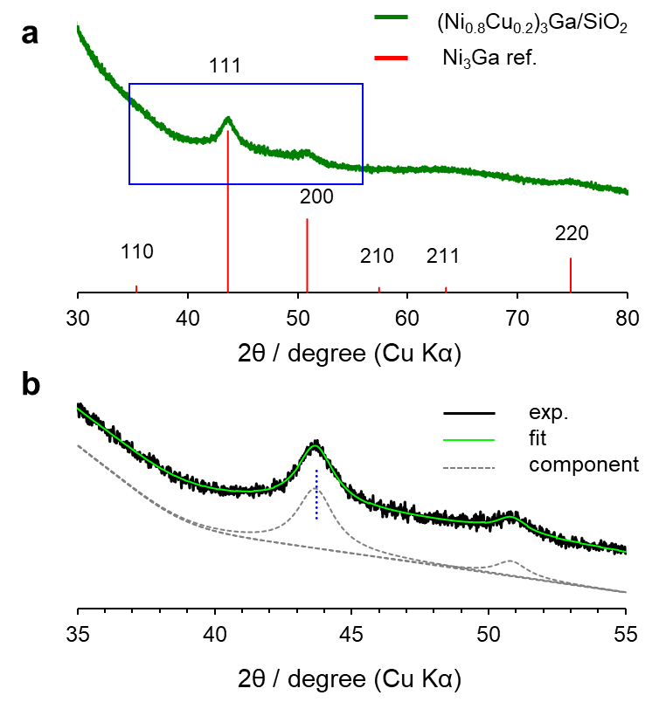

Supplementary Figure 13. a XRD pattern of (Ni_{0.8}Cu_{0.2})₃Ga/SiO₂ and b its magnification indicated as the bule square. The center of 111 diffraction was at 43.72° (blue dotted line), which agreed with that of (Ni_{0.8}Cu_{0.2})₃Ga/TiO₂ (43.74°).
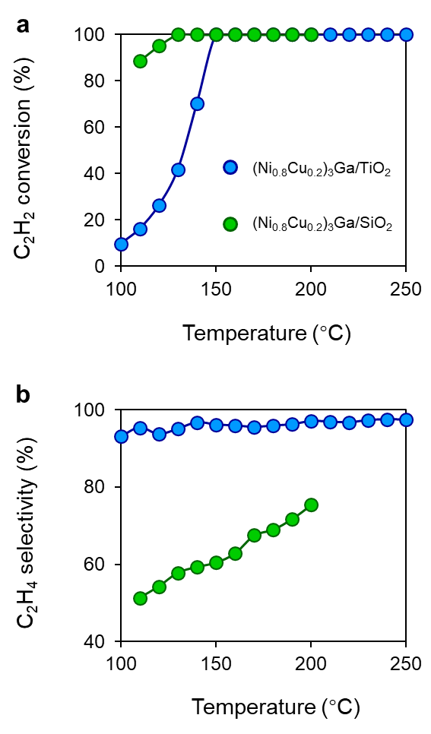
Supplementary Figure 14. a C₂H₂ conversion and b C₂H₄ selectivity as a function of reaction temperature in the absence of ethylene (C₂H₂:H₂:He = 1:10:39 mLmin⁻¹) over (Ni_{0.8}Cu_{0.2})₃Ga/TiO₂ and (Ni_{0.8}Cu_{0.2})₃Ga/SiO₂.
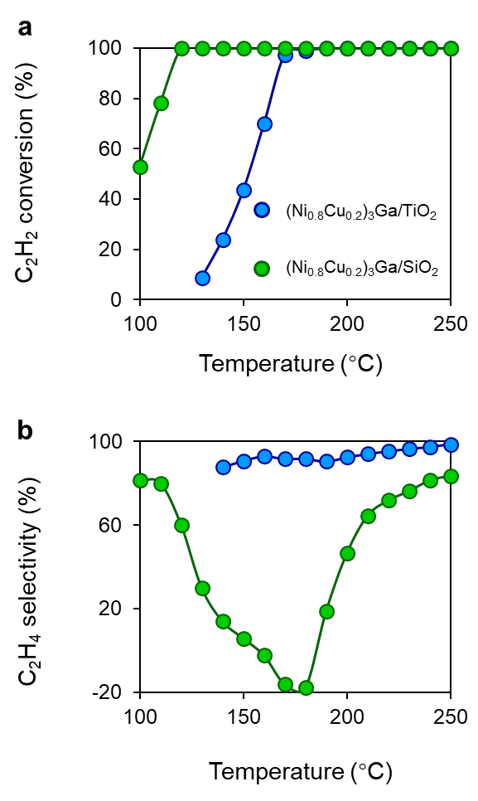
Supplementary Figure 15. a C₂H₂ conversion and b C₂H₄ selectivity as a function of reaction temperature in the presence of ethylene (C₂H₂:H₂:He:C₂H₄ = 1:10:39:5 mLmin⁻¹) over (Ni_{0.8}Cu_{0.2})₃Ga/TiO₂ and (Ni_{0.8}Cu_{0.2})₃Ga/SiO₂.
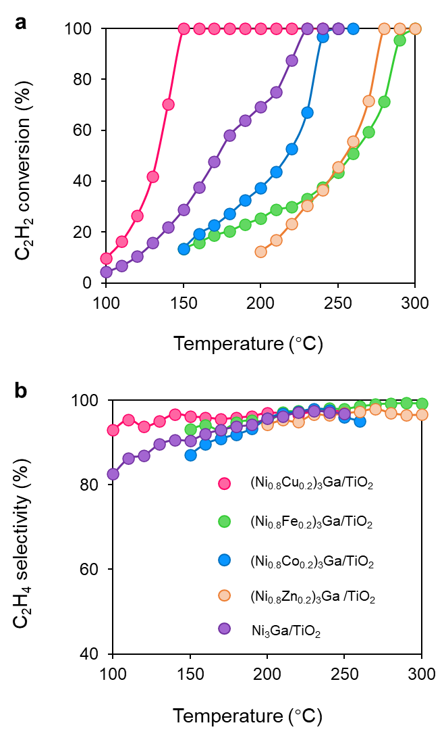

Supplementary Figure 16. a C₂H₂ conversion and b C₂H₄ selectivity as a function of reaction temperature over (Ni_{0.8}M_{0.2})₃Ga/TiO₂ (M = Cu, Fe, Co, Zn) and Ni₃Ga/TiO₂.

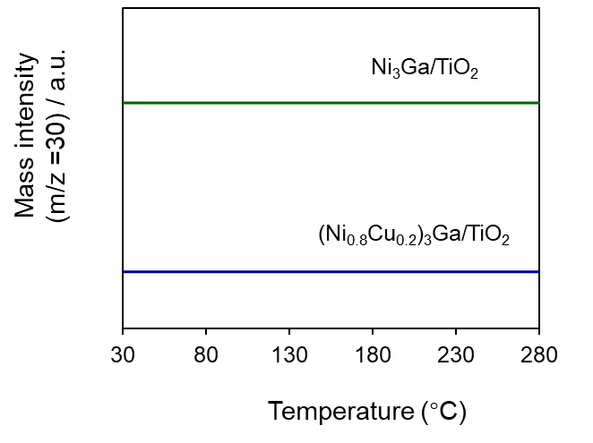

Supplementary Figure 17. Ethylene temperature programmed surface reaction profiles (TPSR) of the (Ni_{0.8}Cu_{0.2})₃Ga/TiO₂ and Ni₃Ga/TiO₂ catalysts for ethylene hydrogenation.

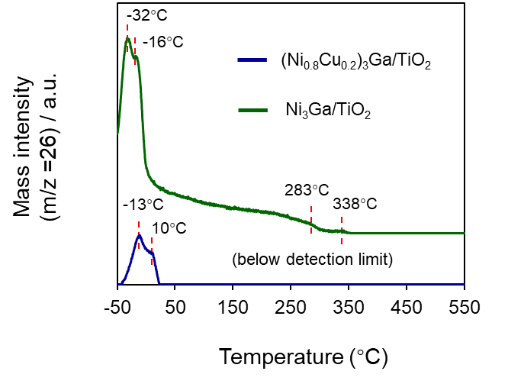

Supplementary Figure 18. C₂H₂-TPD profiles of the (Ni_{0.8}Cu_{0.2})₃Ga/TiO₂ and Ni₃Ga/TiO₂ catalysts.

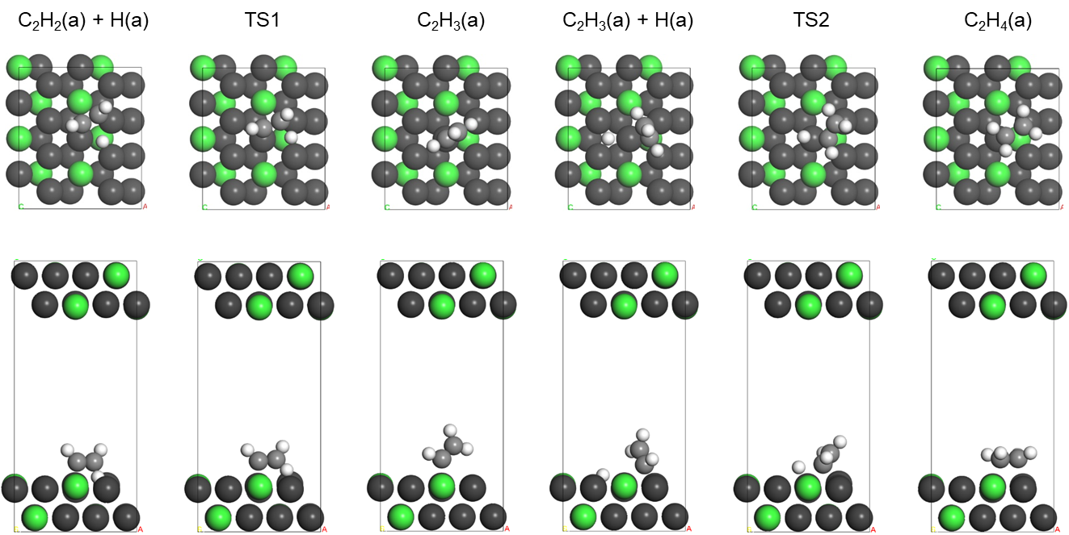

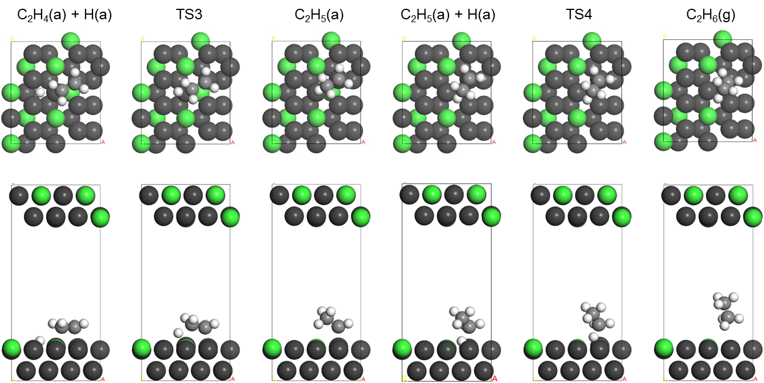

Supplementary Figure 19. Optimized structures of the slab and adsorbates in acetylene hydrogenation to ethane over Ni₃Ga(111).

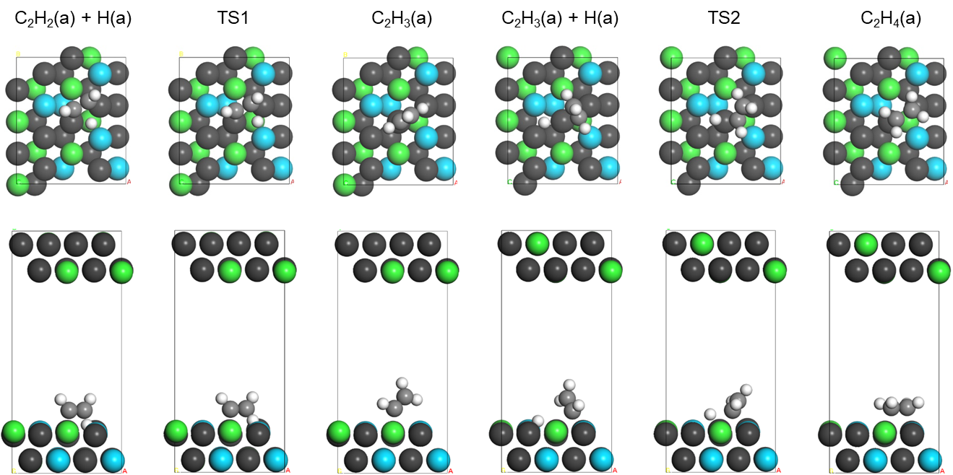

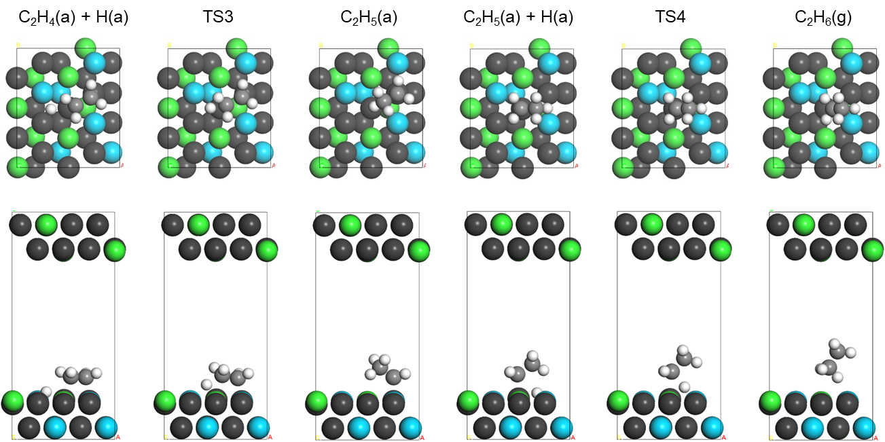

Supplementary Figure 20. Optimized structures of the slab and adsorbates in acetylene hydrogenation to ethane over (Ni_{0.8}Cu_{0.2})₃Ga(111).

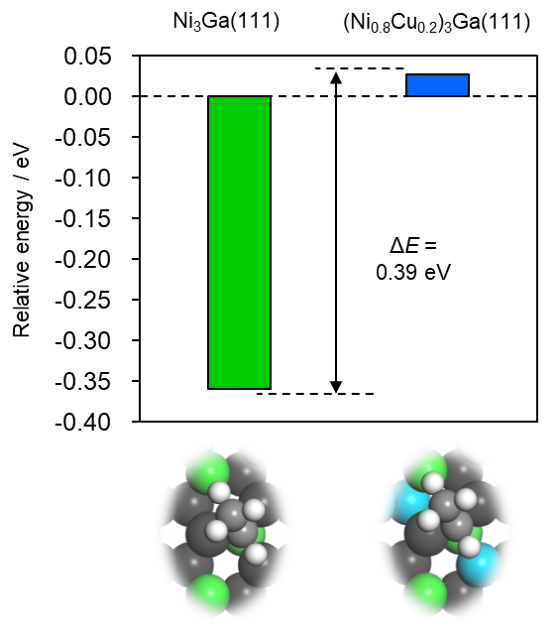
Supplementary Figure 21. Relative energy of ethylidene intermediate on Ni₃Ga(111) and (Ni_{0.8}Cu_{0.2})₃Ga(111). Sum of gas phase C₂H₆ and the clean slab was set to zero in energy as in Figure 3a.

Supplementary references
1. Ge, X. et al. Enhanced acetylene semi-hydrogenation on a subsurface carbon tailored Ni-Ga intermetallic catalyst. J. Mater. Chem. A 19722–19731 (2022).
2. Fu, B. et al. Highly Selective and Stable Isolated Non-Noble Metal Atom Catalysts for Selective Hydrogenation of Acetylene. ACS Catal. 12, 607–615 (2022).
3. Liu, Y. et al. Layered double hydroxide-derived Ni-Cu nanoalloy catalysts for semi-hydrogenation of alkynes: Improvement of selectivity and anti-coking ability via alloying of Ni and Cu. J. Catal. 359, 251–260 (2018).
4. Lu, C., Zeng, A., Wang, Y. & Wang, A. Copper-Based Catalysts for Selective Hydrogenation of Acetylene Derived from Cu(OH)₂. ACS Omega 6, 3363–3371 (2021).
5. Lu, C., Wang, Y., Zhang, R., Wang, B. & Wang, A. Preparation of an Unsupported Copper-Based Catalyst for Selective Hydrogenation of Acetylene from Cu₂O Nanocubes. ACS Appl. Mater. Interfaces 12, 46027–46036 (2020).
6. Wang, Y., Liu, B., Lan, X. & Wang, T. Subsurface Carbon as a Selectivity Promotor to Enhance Catalytic Performance in Acetylene Semihydrogenation. ACS Catal. 11, 10257–10266 (2021).
7. Liu, H. et al. Effect of IB-metal on Ni/SiO₂ catalyst for selective hydrogenation of acetylene. Chinese J. Catal. 41, 1099–1108 (2020).
8. Zhou, H. et al. Sulfur-Doped g-C₃N₄-Supported Ni Species with a Wide Temperature Window for Acetylene Semihydrogenation. ACS Sustain. Chem. Eng. 10, 4849–4861 (2022).
9. Cao, Y. et al. Adsorption Site Regulation to Guide Atomic Design of Ni–Ga Catalysts for Acetylene Semi‐Hydrogenation. Angew. Chemie 132, 11744–11749 (2020).
10. Shi, X. et al. Copper Catalysts in Semihydrogenation of Acetylene: From Single Atoms to Nanoparticles. ACS Catal. 10, 3495–3504 (2020).
11. Chai, Y. et al. Acetylene-Selective Hydrogenation Catalyzed by Cationic Nickel Confined in Zeolite. J. Am. Chem. Soc. 141, 9920–9927 (2019).
12. Gu, J. et al. Synergizing metal–support interactions and spatial confinement boosts dynamics of atomic nickel for hydrogenations. Nat. Nanotechnol. 16, 1141–1149 (2021).
13. Huang, F. et al. Anchoring Cu₁ species over nanodiamond-graphene for semi-hydrogenation of acetylene. Nat. Commun. 10, 4431 (2019).
14. Riley, C. et al. Synthesis of Nickel-Doped Ceria Catalysts for Selective Acetylene Hydrogenation. ChemCatChem 11, 1526–1533 (2019).
15. Chen, Y. & Chen, J. Selective hydrogenation of acetylene on SiO₂ supported Ni-In bimetallic catalysts: Promotional effect of In. Appl. Surf. Sci. 387, 16–27 (2016).
16. Armbrüster, M. et al. Al₁₃Fe₄ as a low-cost alternative for palladium in heterogeneous hydrogenation. Nat. Mater. 11, 690–693 (2012).
17. Dai, X. et al. Single Ni sites distributed on N-doped carbon for selective hydrogenation of acetylene. Chem. Commun. 53, 11568–11571 (2017).
18. Kojima, T., Kameoka, S., Fujii, S., Ueda, S. & Tsai, A. P. Catalysis-tunable Heusler alloys in selective hydrogenation of alkynes: A new potential for old materials. Sci. Adv. 4, (2018).
19. Ma, J., Xing, F., Nakaya, Y., Shimizu, K. ichi & Furukawa, S. Nickel-Based High-Entropy Intermetallic as a Highly Active and Selective Catalyst for Acetylene Semihydrogenation. Angew. Chemie - Int. Ed. 61, (2022).
20. Li, Z. et al. Unveiling the origin of enhanced catalytic performance of NiCu alloy for semi-hydrogenation of acetylene. Chem. Eng. J. 450, 138244 (2022).
21. Liu, Y. et al. Intermetallic NixMy(M = Ga and Sn) Nanocrystals: A Non-precious Metal Catalyst for Semi-Hydrogenation of Alkynes. Adv. Mater. 28, 4747–4754 (2016).
22. Zhao, J. et al. Preparation of MCM-41 supported nickel NPs for the high-efficiency semi-hydrogenation of acetylene. New J. Chem. 45, 1054–1062 (2021).
23. Komatsu, T., Kishi, T. & Gorai, T. Preparation and catalytic properties of uniform particles of Ni₃Ge intermetallic compound formed inside the mesopores of MCM-41. J. Catal. 259, 174–182 (2008).
24. Bridier, B. & Pérez-Ramírez, J. Coperative effects in ternary Cu-Ni-Fe catalysts lead to enhanced alkene selectivity in alkyne hydrogenation. J. Am. Chem. Soc. 132, 4321–4327 (2010).
25. Fu, F. et al. Interfacial Bifunctional Effect Promoted Non-Noble Cu/Fe_{y}MgO_{x} Catalysts for Selective Hydrogenation of Acetylene. ACS Catal. 11, 11117–11128 (2021).
26. Ge, X. et al. Mechanism driven design of trimer Ni₁Sb₂ site delivering superior hydrogenation selectivity to ethylene. Nat. Commun. 13, 5534 (2022).
27. Zhou, S., Kang, L., Zhou, X., Xu, Z. & Zhu, M. Pure acetylene semihydrogenation over Ni–Cu bimetallic catalysts: Effect of the Cu/Ni ratio on catalytic performance. Nanomaterials 10, 509 (2020).

