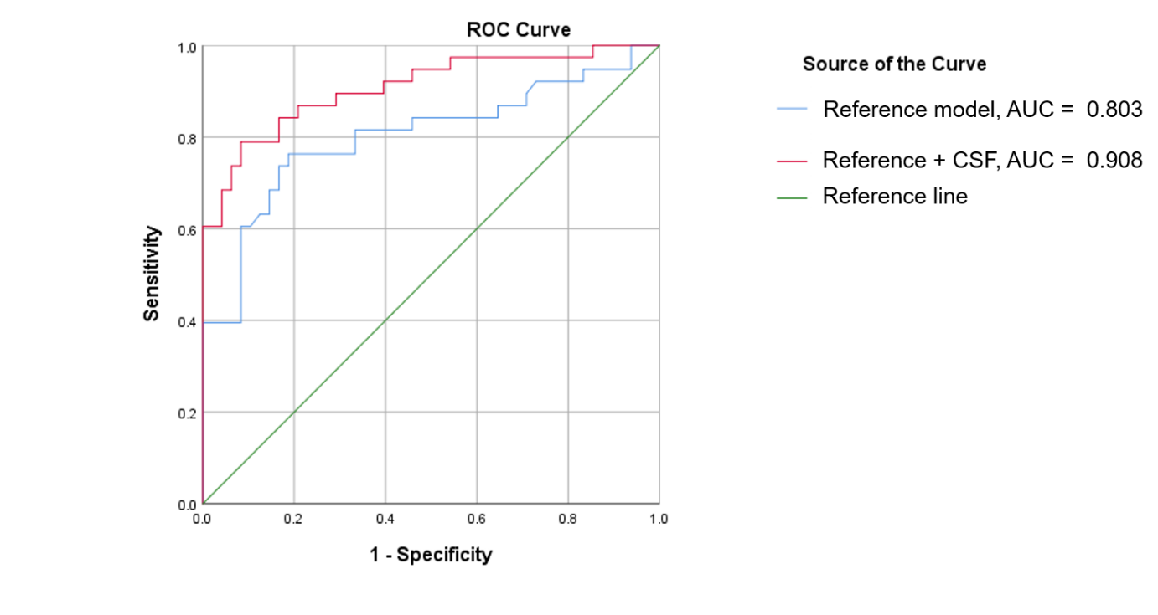

Supplementary Figure 1: Predictive model of the presence of neuropsychiatric symptoms. Probabilities derived from a binary logistic regression model using demographic and clinical factors as a primary block and four neuroinflammatory cerebrospinal fluid markers (sICAM-1, IP-10, IL-8 and CRP) as a secondary block shown as a ROC curve. AUC = Area under the Curve.

