Supporting Information for
Bamboo fiber-derived bifunctional electrocatalyst for rechargeable Zn-Air batteries

Jian Yu, Zehong Chen, Linxin Zhong, Wu Yang, Tingzhen Li, Yongfa Huang, Yujia Wei, and Xinwen Peng∗

State Key Laboratory of Pulp and Paper Engineering, South China University of Technology, Guangzhou, 510641, China.
* Corresponding author. E-mail: fexwpeng@scut.edu.cn (X. Peng)

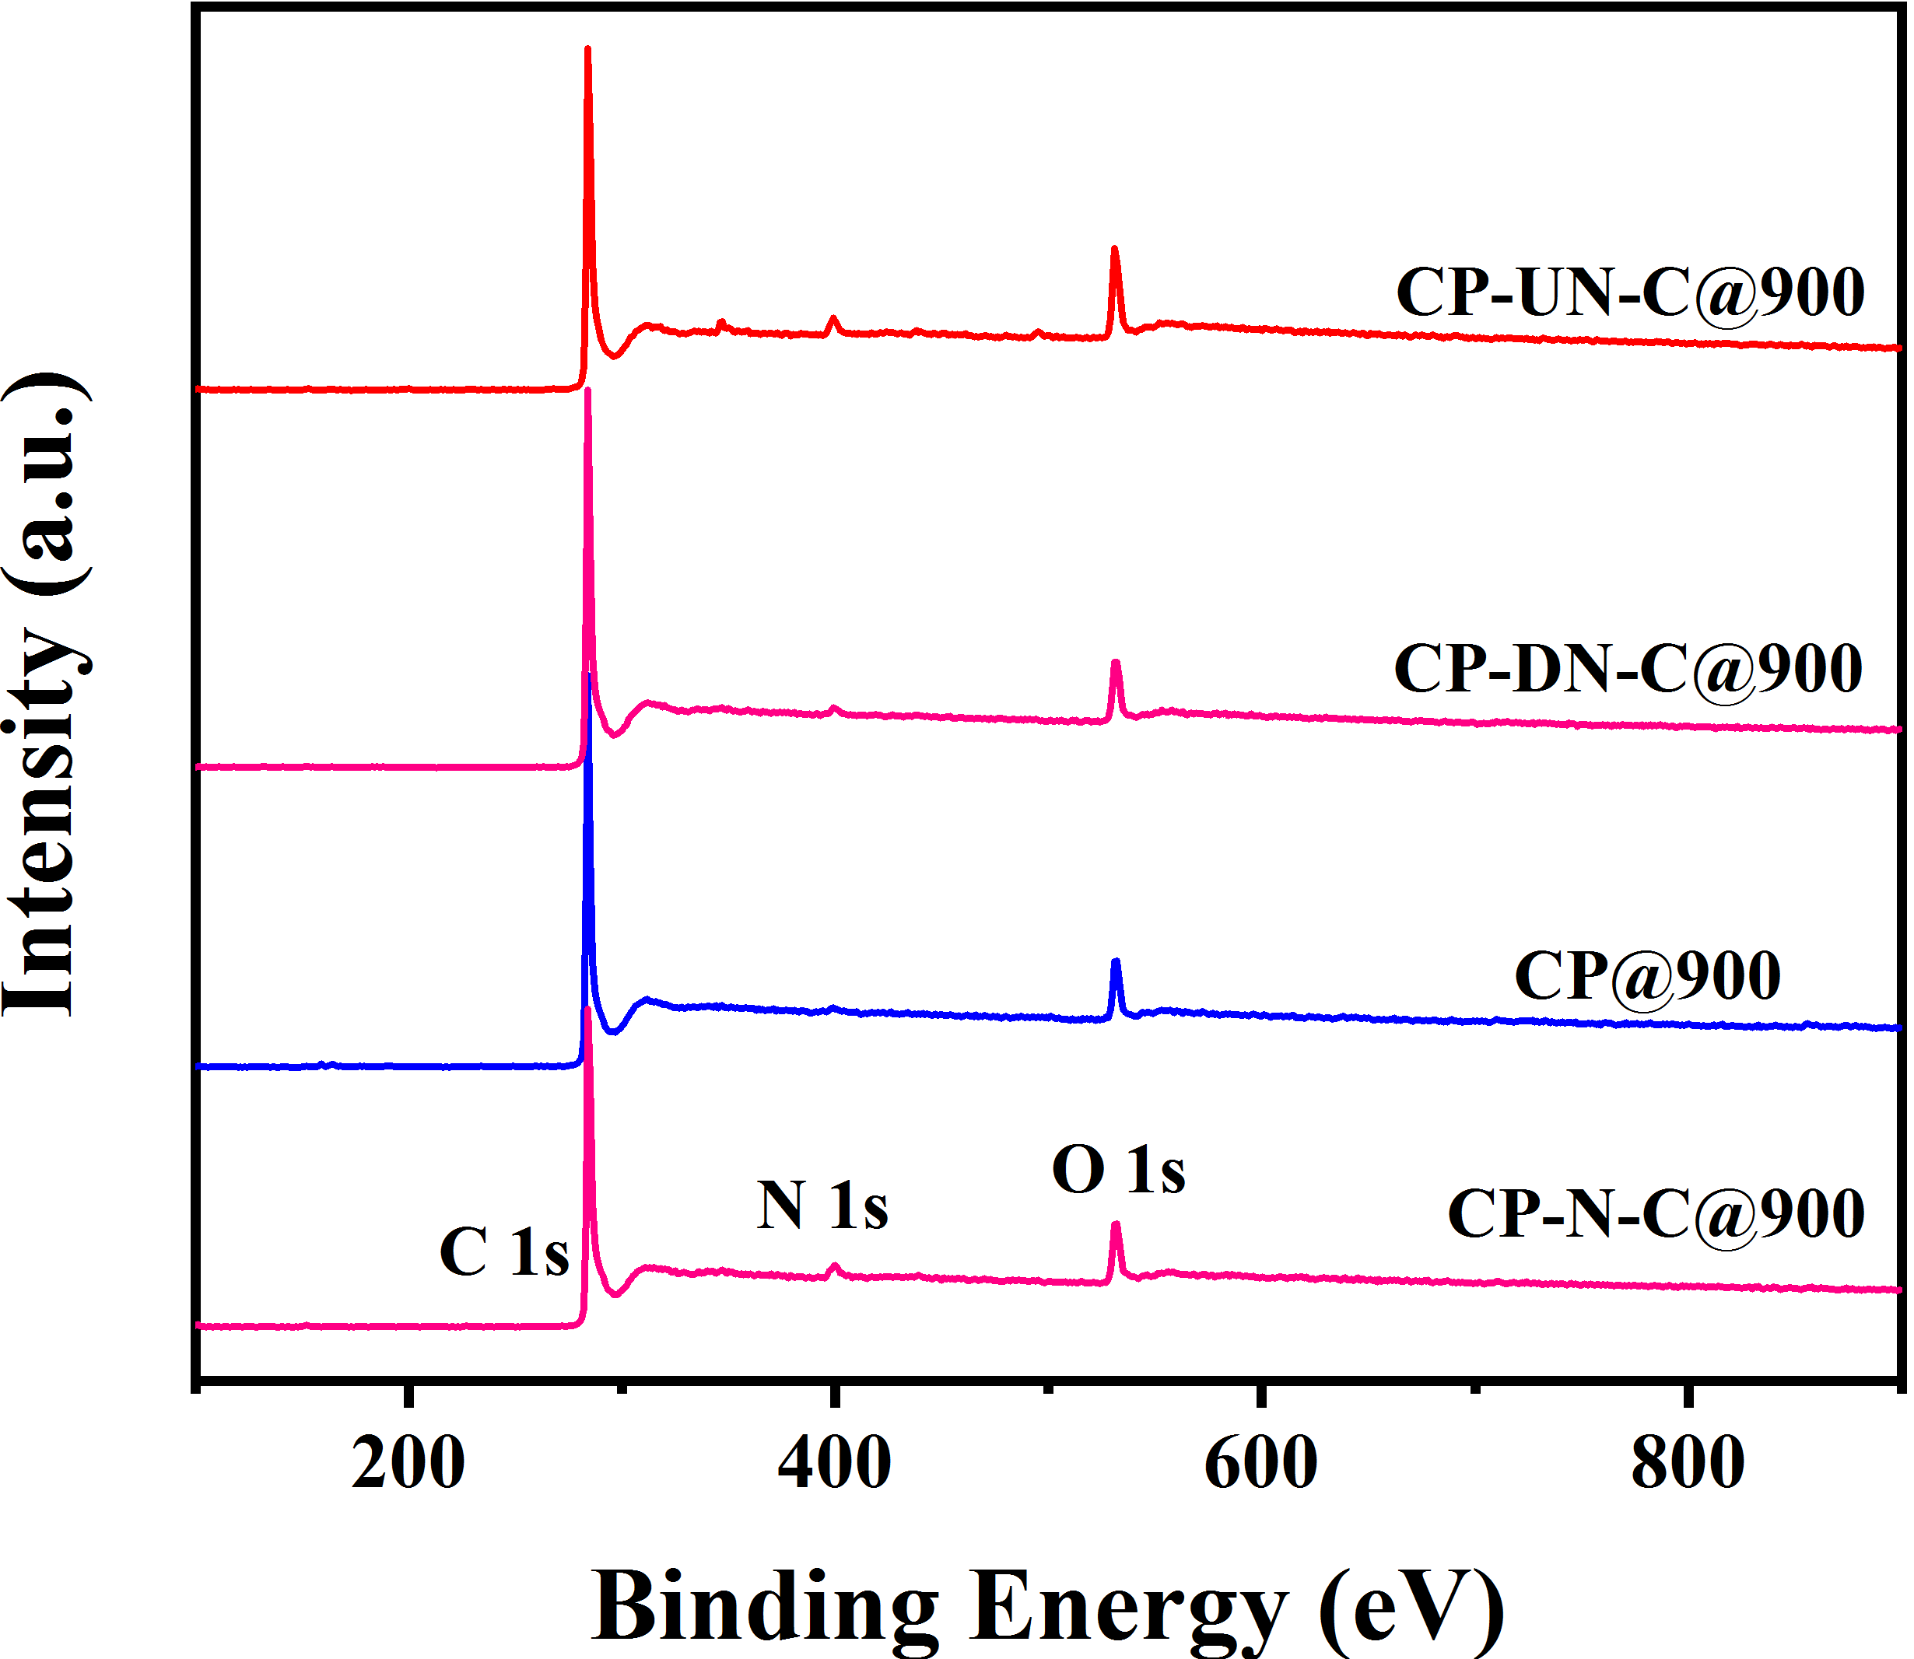
Fig. S1 The XPS survey spectra of CP@900, CP-N-C@900, CP-UN-C@900 and CP-DN-C@900.

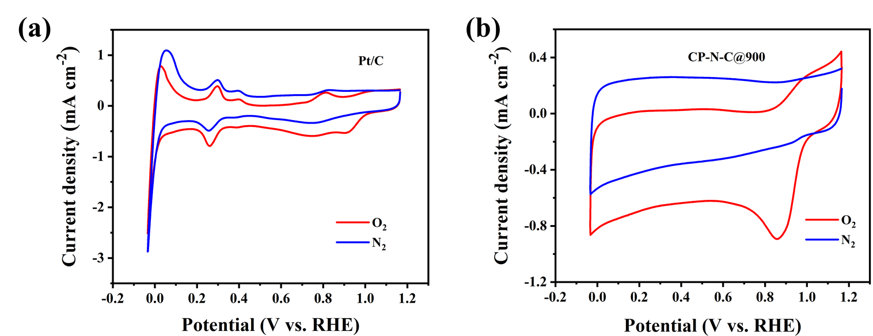
Fig. S2 CV curves of (a) Pt/C and (b) CP-N-C@900 under O₂ and N₂ saturation.

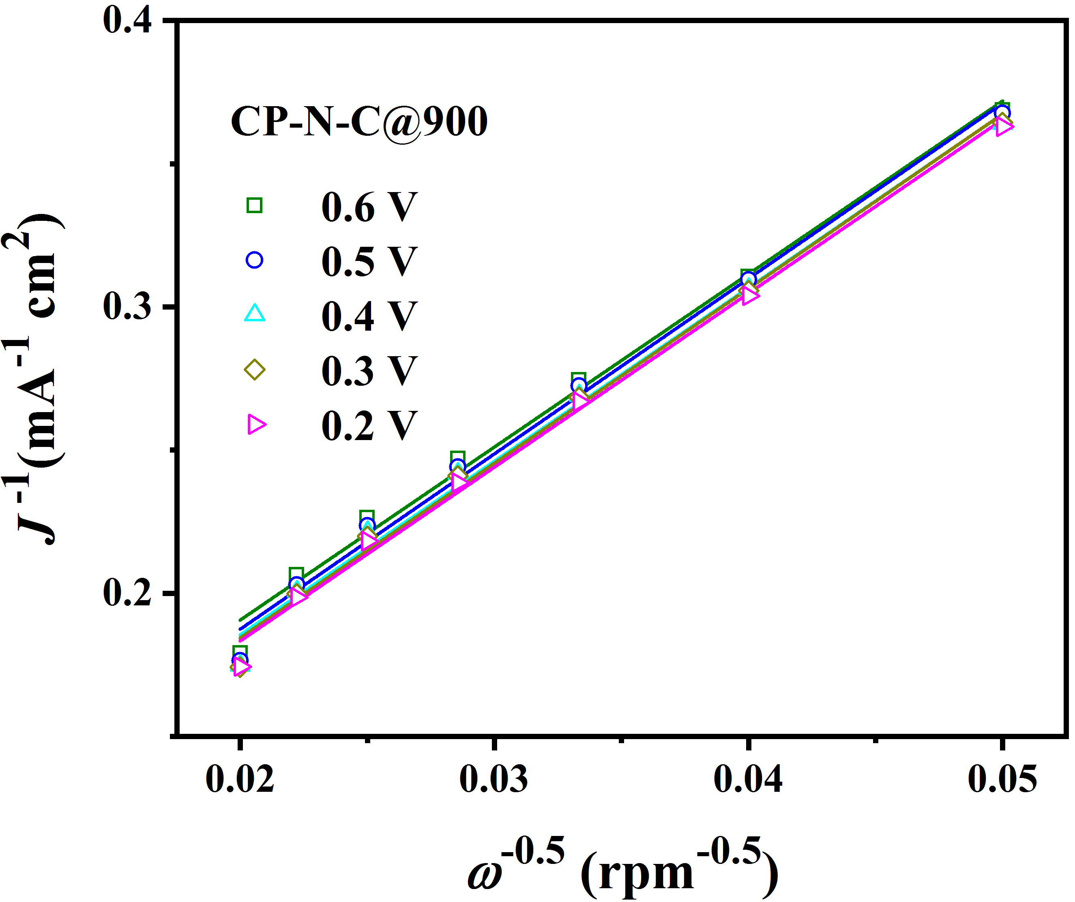
Fig. S3 The Koutecky-Levich plots at different potentials.

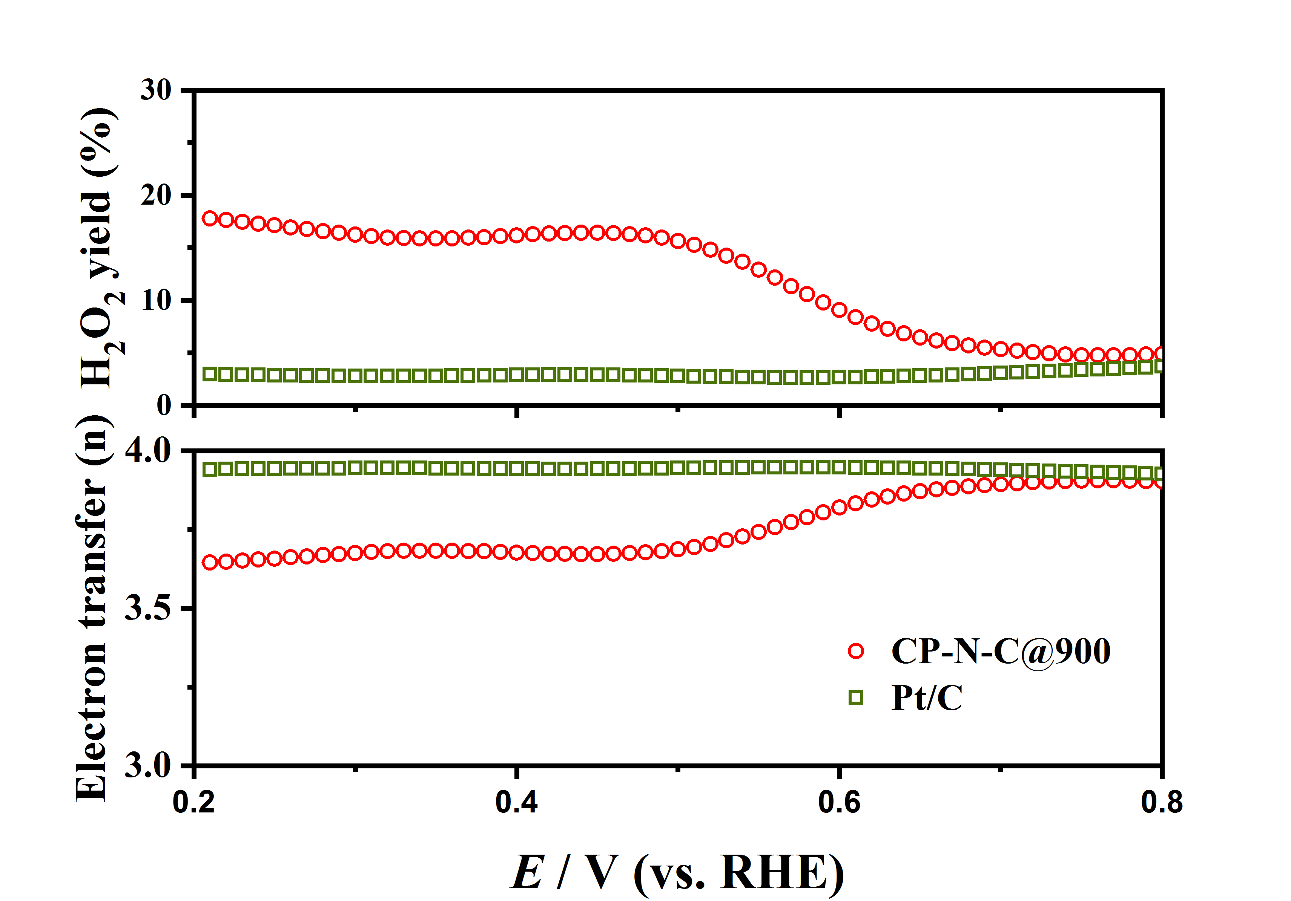
Fig. S4 Electron transfers and H₂O₂ yields of CP-N-C@900 and Pt/C.

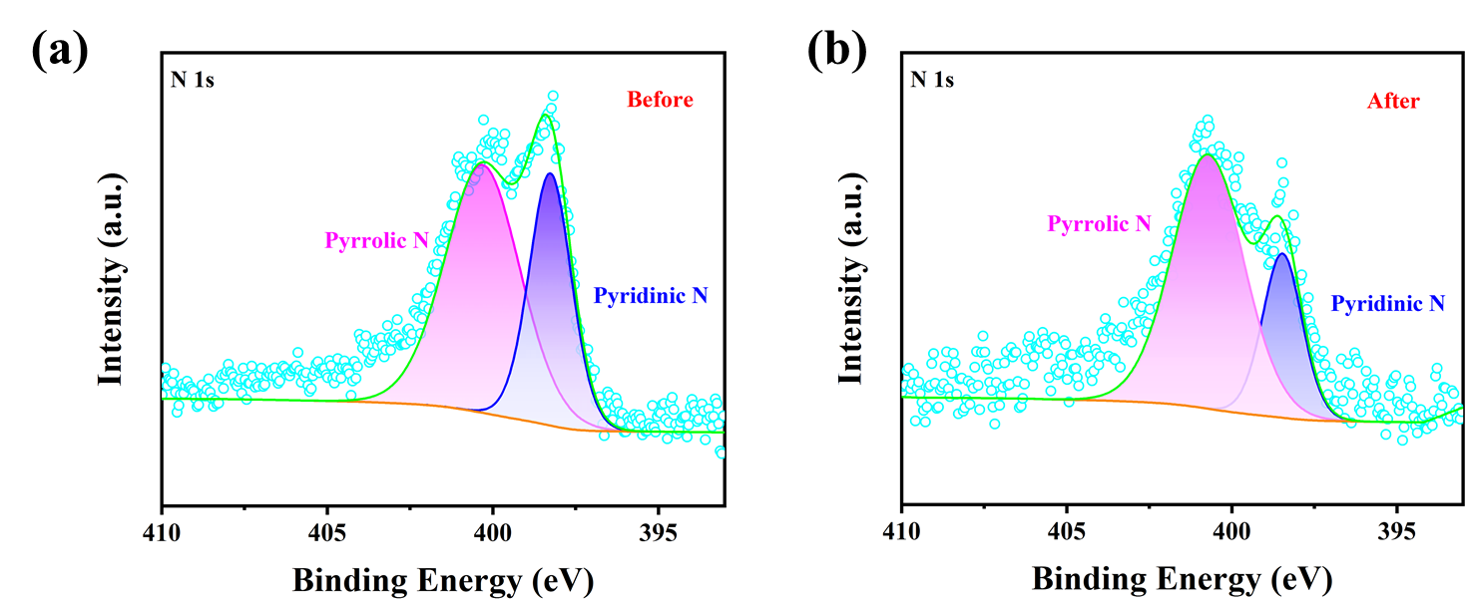
Fig. S5 Deconvoluted N 1s spectra of CP-N-C@900 before (a) and after (b) the ORR durable test.

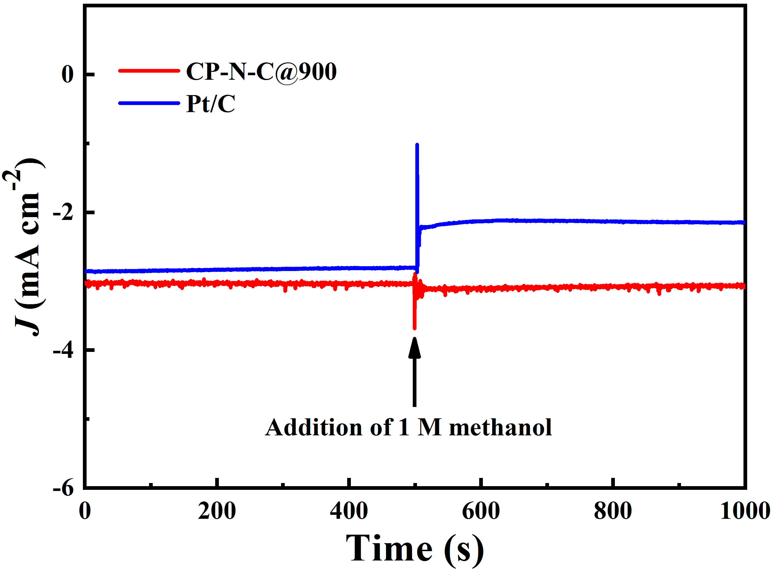
Fig. S6 Methanol tolerance measurements of Pt/C and CP-N-C@900 at the same condition, with the addition of 1 M methanol at 500 s

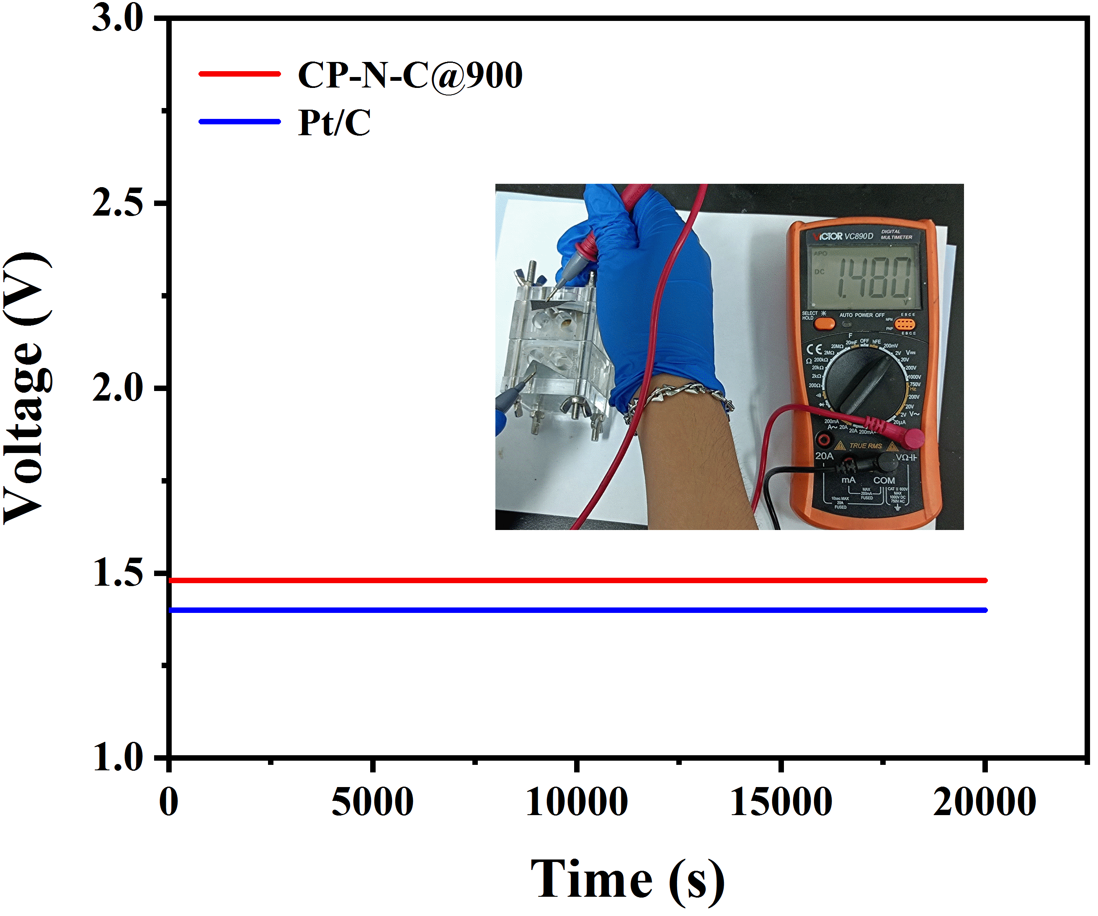
Fig. S7 The open circuit voltages of CP-N-C@900-based and Pt/C-based liquid ZAB (Inset: the open circuit voltage of CP-N-C@900-based ZAB).

Table. S1 The element contents obtained by elemental analysis.
Samples | C (wt%) | N (wt%) | O (wt%)
CP@900 | 94.1 | 0 | 5.9
CP-N-C@900 | 83.2 | 8.6 | 8.2
CP-UN-C@900 | 88.2 | 6.3 | 5.5
CP-DN-C@900 | 86.9 | 5.8 | 7.3

Table. S2 Specific surface areas and the element contents obtained by XPS of the electrocatalysts.
Samples | Specific surface area (m² g⁻¹) | The element content obtained by XPS (atom%)
Samples | Specific surface area (m² g⁻¹) | C | N | O
CP@900 | 825.4 | 94.6 | 0 | 5.3
CP-N-C@900 | 1109.23 | 88.57 | 3.62 | 7.81
CP-UN-C@900 | 1028.65 | 90.61 | 2.57 | 6.82
CP-DN-C@900 | 1265.27 | 86.63 | 2.49 | 10.88

Table. S3 Summary of the catalytic activities of the reported electrocatalysts in 0.1 M KOH.
Catalysts | E_{onset}  (V vs. RHE) |  | E_{1/2}  (V vs. RHE) |  | E _{j=10}  (V) | ΔE  (E _{j=10}-  E_{1/2}) (V)
CP-N-C@900 | 1.00 | 0.86 |  | 1.65 |  |  | 0.79
10 wt% Pt/C | 0.98 | 0.837 |  | — |  |  | —
RuO₂ | — | — |  | 1.54 |  |  | —
S, S′-CNT _{1000 °C} | 0.87 | 0.79 |  | 1.58 |  |  | 0.79
NGM | 0.89 | 0.77 |  | 1.67 |  |  | 0.90
N-GRW | 0.92 | 0.84 |  | 1.59 |  |  | 0.75
HPNC-2 | 0.96 | 0.86 |  | — |  |  | —
N-GDY-900 | 1.01 | 0.83 |  | 1.796 |  |  | 0.966
MCAC | 0.87 | 0.8 |  | 1.56 |  |  | 0.76
Fe@C–NG/NCNTs | 0.93 | 0.84 |  | 1.68 |  |  | 0.84
Co-POC | — | 0.83 |  | 1.70 |  |  | 0.87
MnCo₂O₄/N-rGO | 0.89 | 0.82 |  | 1.73 |  |  | 0.91
Co@NPC-800 | 0.89 | 0.70 |  | 1.68 |  |  | 0.98

References
El-Sawy A. M, Mosa I. M, Su D, Guild C. J, Khalid S, Joesten R, Rusling J. F, Suib S. L (2016) Controlling the active sites of sulfur-doped carbon nanotube-graphene nanolobes for highly efficient oxygen evolution and reduction catalysis. Adv Energy Mater 6 (5):1501966. https://doi.org/10.1002/aenm.201501966
Ge X, Liu Y, Goh F. W, Hor T. S, Zong Y, Xiao P, Zhang Z, Lim S. H, Li B, Wang X, Liu Z (2014) Dual-phase spinel MnCo₂O₄ and spinel MnCo₂O₄/nanocarbon hybrids for electrocatalytic oxygen reduction and evolution. ACS Appl Mater Interfaces 6 (15):12684-12691. https://doi.org/10.1021/am502675c
Li B. Q, Zhao C. X, Chen S, Liu J. N, Chen X, Song L, Zhang Q (2019) Framework-porphyrin-derived single-atom bifunctional oxygen electrocatalysts and their applications in Zn-air batteries. Adv Mater 31 (19):1900592. https://doi.org/10.1002/adma.201900592
Lu H.-S, Zhang H, Liu R, Zhang X, Zhao H, Wang G (2017) Macroscale cobalt-MOFs derived metallic Co nanoparticles embedded in N-doped porous carbon layers as efficient oxygen electrocatalysts. App Surf Sci 392:402-409. https://doi.org/10.1016/j.apsusc.2016.09.045
Lu T, Hu X, He J, Li R, Gao J, Lv Q, Yang Z, Cui S, Huang C (2021) Aqueous/solid state Zn-air batteries based on N doped graphdiyne as efficient metal-free bifunctional catalyst. Nano Energy 85:106024. https://doi.org/10.1016/j.nanoen.2021.106024
Liu H, He G, Liu X, Zhu Y, Eigler S, Han L (2021) Ion-induced formation of hierarchical porous nitrogen-doped carbon materials with enhanced oxygen reduction. ChemCatChem 13 (13):3112-3118. https://doi.org/10.1002/cctc.202002045
Liu J, Wang C, Song Y, Zhang S, Zhang Z, He L, Du M (2021) Two-dimensional triazine-based porous framework as a novel metal-free bifunctional electrocatalyst for zinc-air batty. J Colloid Interface Sci 591:253-263. https://doi.org/10.1016/j.jcis.2021.02.007
Tang C, Wang H. F, Chen X, Li B. Q, Hou T. Z, Zhang B, Zhang Q, Titirici M. M, Wei F. (2016) Topological defects in metal-free nanocarbon for oxygen electrocatalysis. Adv Mater 28 (32):6845-6851. https://doi.org/10.1002/adma.201601406
Wang Q, Lei Y, Chen Z, Wu N, Wang Y, Wang B, Wang Y (2018) Fe/Fe₃C@C nanoparticles encapsulated in N-doped graphene–CNTs framework as an efficient bifunctional oxygen electrocatalyst for robust rechargeable Zn–air batteries. J Mater Chem A 6 (2):516-526. https://doi.org/10.1039/c7ta08423d
Yang H. B, Miao J, Hung S.-F, Chen J, Tao H. B, Wang X, Zhang L, Chen R, Gao J, Chen H. M (2016) Identification of catalytic sites for oxygen reduction and oxygen evolution in N-doped graphene materials: Development of highly efficient metal-free bifunctional electrocatalyst. Sci Adv 2 (4):1501122. https://doi.org/10.1126/sciadv.1501122

∗ Corresponding author. E-mail address: fexwpeng@scut.edu.cn (X. Peng)

