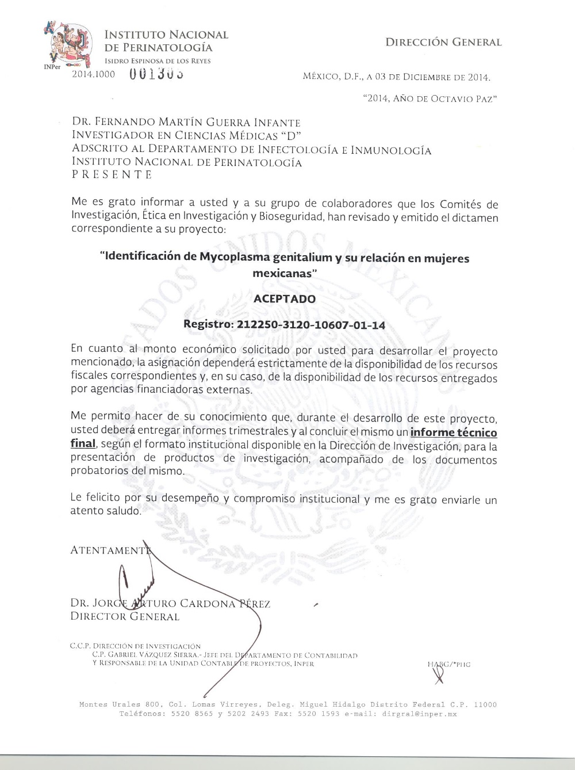
Appendix 2 The Ethics Committee of the National Institute of Perinatology "Isidro Espinosa de Los Reyes" (INPer) approved this research, following the ethical standards established in the Declaration of Helsinki. INPer registration number 212250-3120-10607-01-14.

