SUPPLEMENTARY FIGURES

Supplementary Figure 1.

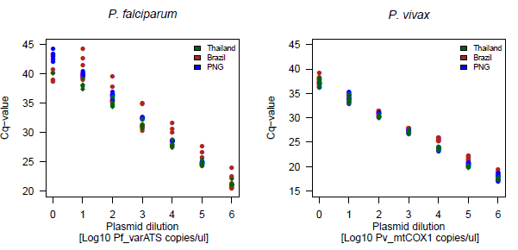
Fig. S1: Comparison of Pf_varATS and Pv_mtCOX1 plasmid standards across the 3 study sites.

Supplementary Figure 2.
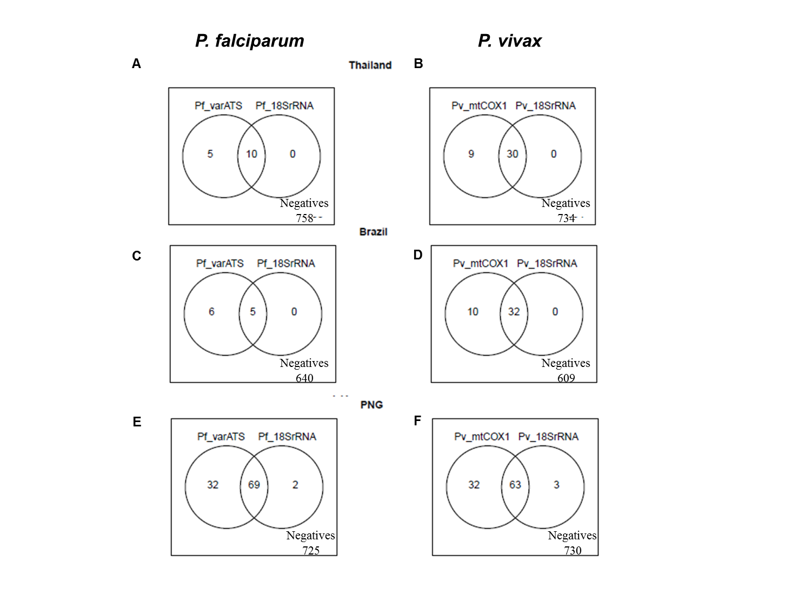
Fig. S2: Venn diagrams of P. falciparum and P. vivax positivity by ultra-sensitive and standard 18SrRNA qPCR.

Supplementary Figure 3.
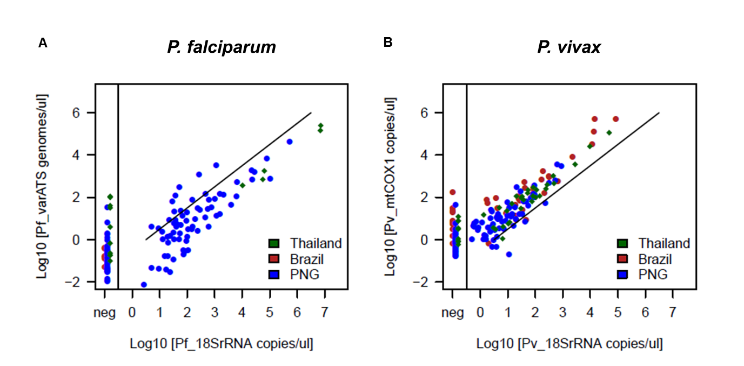
Fig. S3: Correlation of P. falciparum (A) and P. vivax (B) densities between ultra-sensitive and standard 18srRNA qPCR. Spearman’s correlation coefficient was assessed on log₁₀-transformed parasite densities for P. falciparum: rho(PNG) = 0.74, P. vivax: rho (PNG) =0.80 , rho(Brazil)=0.85, rho(Thailand)=0.94. Because of only few Pf-positives in the data sets from Thailand and Brazil, the correlation between assays was not assessed for these study sites. Black line denotes perfect correlation (r=1).

Supplementary Figure 4.

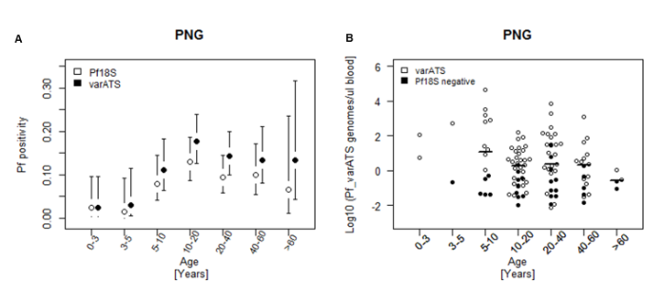
Fig. S4: Age trends in P. falciparum positivity rates (A) and parasite densities (B) in PNG. Pf positivity by Pf_18SrRNA qPCR (white circles) and Pf_varATS us-qPCR (black circles) stratified by age group. Black vertical lines in panel A denote 95% confidence interval. Panel B represents Pf_varATS copy numbers per age group. Median copy numbers are denoted (horizontal lines).

