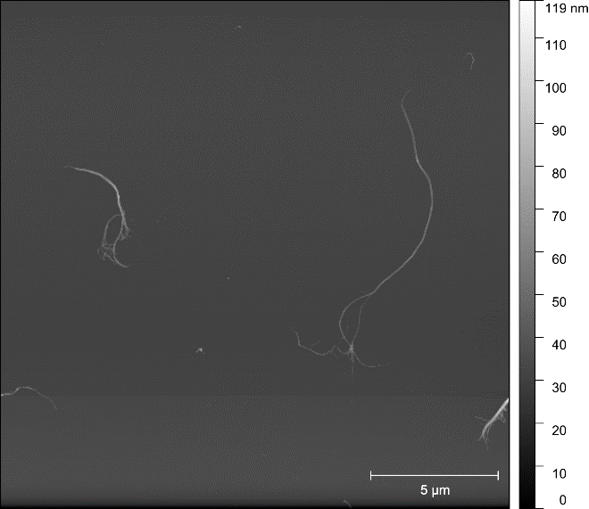 | 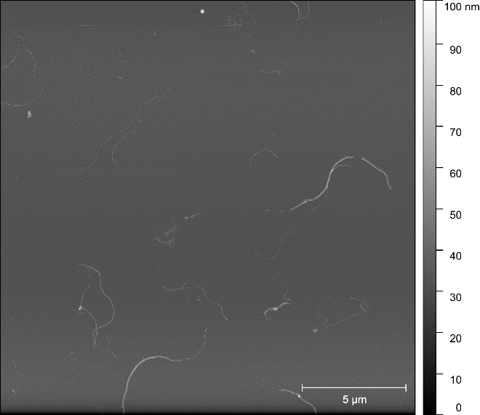
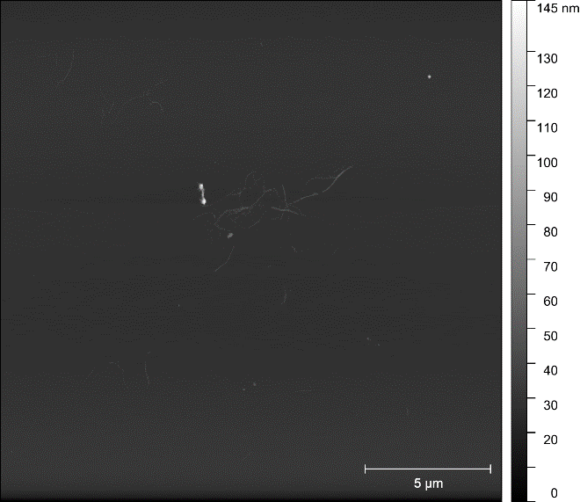 | 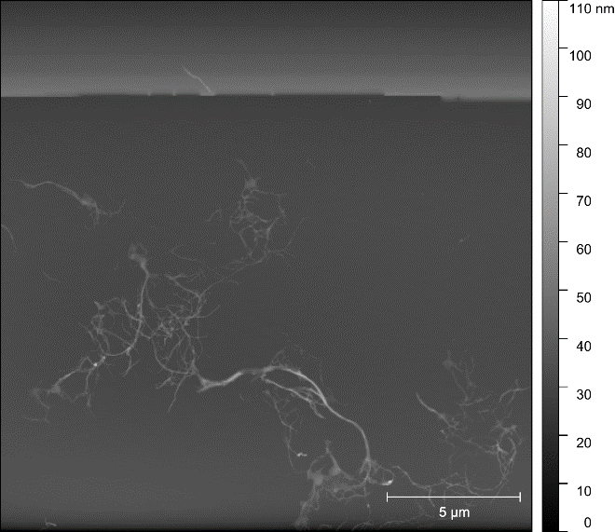
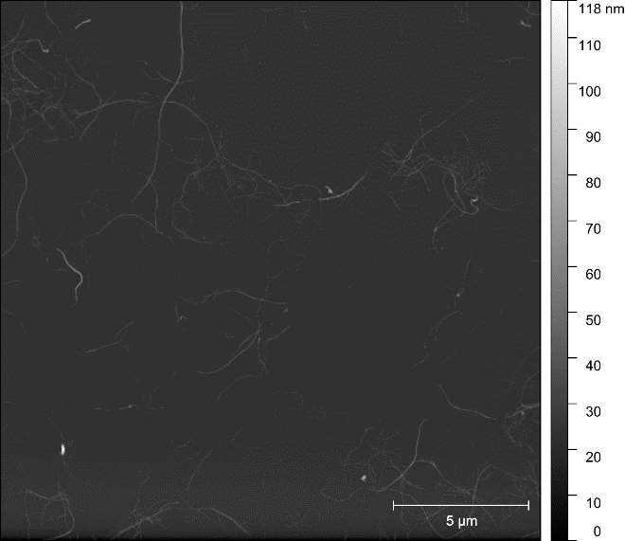 | 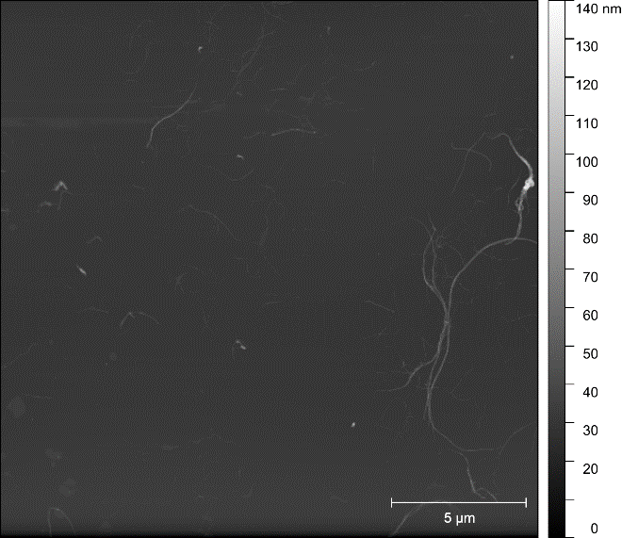
SI 1: Characteristic AFM Images of the (top) DH6, (middle) DH6W6, and (bottom) DH6W6F3 samples.

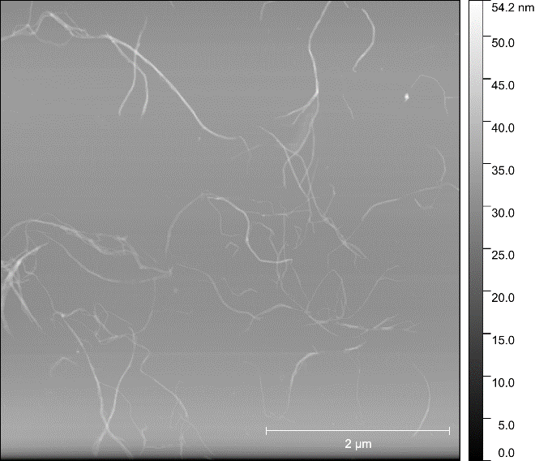
SI 2: A higher resolution AFM image of the DH6W6F3 sample.

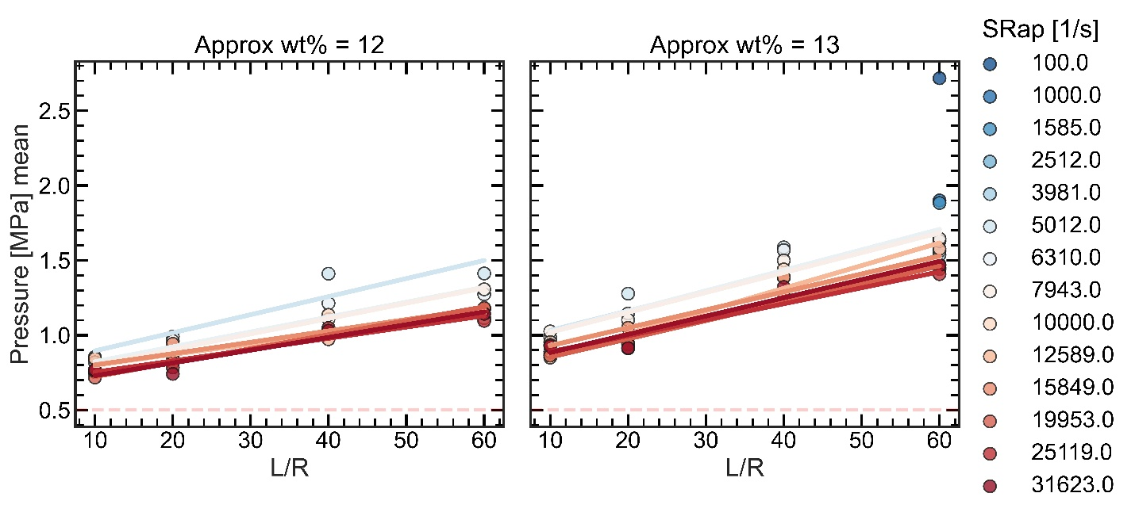
SI 3: Bagley plots for the 12 and 13 NFC wt% samples. Lower shear rates (blues) show higher mean pressures than the higher shear rates (reds). Solid lines illustrate linear regression fits for a given shear rate. The red dashed line illustrates the lower limit of the pressure transducer, for reference.

