Supplementary material 2

Focus Group 1

The Concept of and Thoughts of Wellbeing
- Wellbeing tracking behaviour – Do you currently track your wellbeing?

- Frequency of thoughts concerning one’s wellbeing - How often do you think about your wellbeing?

- Thoughts on effect of tracking on improvement of wellbeing – Do you think that monitoring your level of well-being can allow you to improve it?

- Importance of wellbeing tracking – How important is it for you to be able to track and improve your wellbeing?

University and your wellbeing
- Perception of University’s consideration of staff and students’ wellbeing - Do you think that the University cares about your wellbeing?

- Thoughts on University using remote wellbeing services – Would you be comfortable with the university tracking your wellbeing using remote services?

Wellbeing tracking: Data collection, methods, frequency, and analysis
- Method of data entry into remote wellbeing service– Would you prefer to the wellbeing tracker to reply on user-input or automatically derived (e.g. using sensors)?

- Form of data collection – How would you like the information about your wellbeing to be collected?

- Frequency of data collection – How often would you like the required information should be tracked and collected?

Evaluating Wellbeing monitoring and support services
- Assumed usefulness of remote wellbeing services – Do you think remote services for monitoring and support wellbeing are useful?

- Confidence with the use of AI to track wellbeing – How comfortable are you with the use of artificial intelligence to monitor your wellbeing?

Wearable Devices
- Preference for wellbeing app connected to other applications or devices – Would you like the wellbeing tracker device to be able to couple to other types of devices or applications?

Wellbeing tracking; duration, reasons, and reservations
- Preferred duration for wellbeing tracking – Over how long would you be interested in tracking your wellbeing?

Word Cloud Responses:
Word cloud representation of written responses for the first focus group cohort.
Note: Word size reflects the frequency in the responses provided by the participants, orientation and distance between words are random.
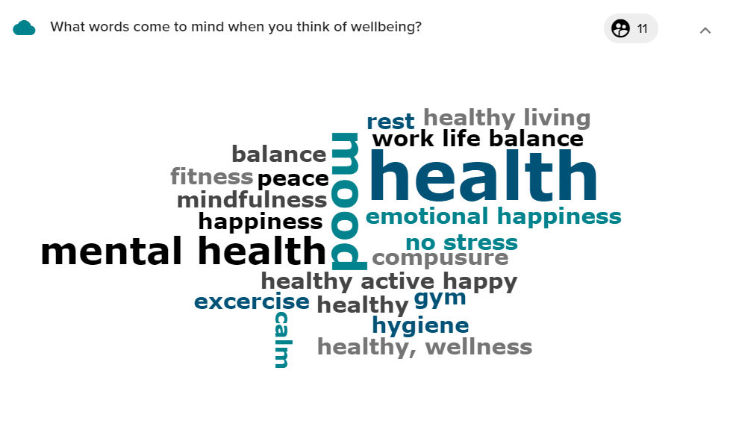
- What words come to mind when you think of wellbeing?

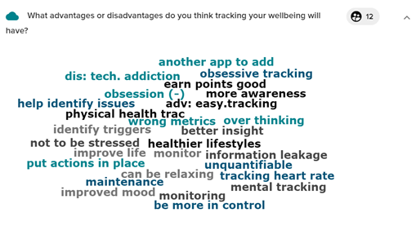
- What advantages and disadvantages do you think tracking your wellbeing will have?

- What kind of information, physiological or otherwise, do you think can provide information about one’s wellbeing?
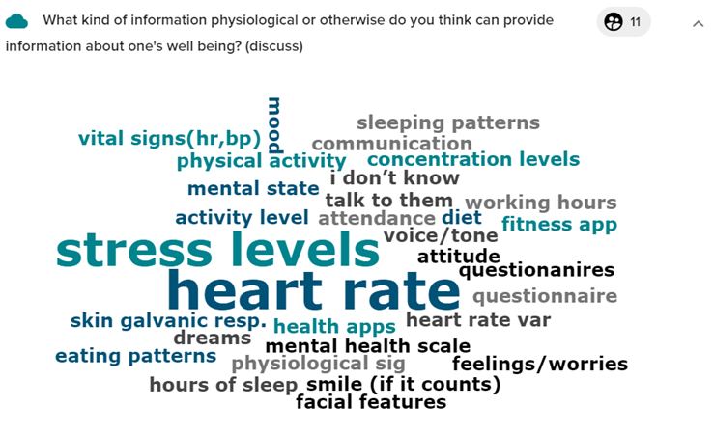

- What kind of measurable outcome would you like to benefit from a wellbeing monitoring device?
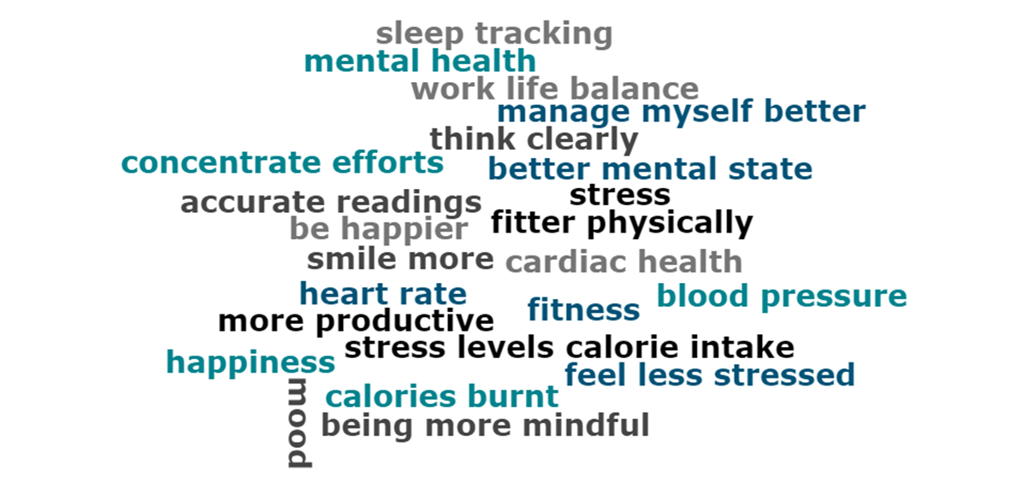

Focus Group 2

The Concept of and Thoughts of Wellbeing
- Wellbeing tracking behaviour – Do you currently track your wellbeing?

- Frequency of thoughts concerning one’s wellbeing - How often do you think about your wellbeing?

- Thoughts on effect of tracking on improvement of wellbeing – Do you think that monitoring your level of well-being can allow you to improve it?

- Importance of wellbeing tracking – How important is it for you to be able to track and improve your wellbeing?

University and your wellbeing
- Perception of University’s consideration of staff and students’ wellbeing - Do you think that the University cares about your wellbeing?

- Thoughts on University using remote wellbeing services – Would you be comfortable with the university tracking your wellbeing using remote services?

Wellbeing tracking: Data collection, methods, frequency, and analysis
- Method of data entry into remote wellbeing service– Would you prefer to the wellbeing tracker to reply on user-input or automatically derived (e.g using sensors)?

- Method of receiving suggestions and data collection – How would you like to receive the suggestions of implementations to improve your wellbeing and like your information to be collected?

- Frequency of data collection – How often would you like the required information should be tracked and collected?

Evaluating Wellbeing monitoring and support services
- Assumed usefulness of remote wellbeing services – Do you think remote services for monitoring and support wellbeing are useful?

- Confidence with the use of AI to track wellbeing – How comfortable are you with the use of artificial intelligence to monitor your wellbeing?

Wearable Devices
- Preference for wellbeing app connected to other applications or devices – Would you like the wellbeing tracker device to be able to couple to other types of devices or applications?

Wellbeing tracking; duration, reasons, and reservations
- Preferred duration for wellbeing tracking – Over how long would you be interested in tracking your wellbeing?

Word Cloud Responses:
Word cloud representation of written responses for the second focus group cohort.
Note: Word size reflects the frequency in the responses provided by the participants, orientation and distance between words are random.
- What words come to mind when you think of wellbeing?

- what advantages and disadvantages do you think tracking your wellbeing will have?
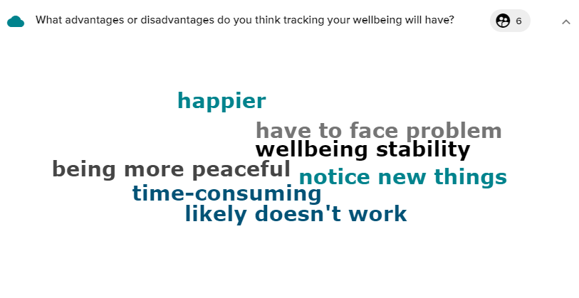

- What kind of information, physiological or otherwise, do you think can provide information about one’s wellbeing?
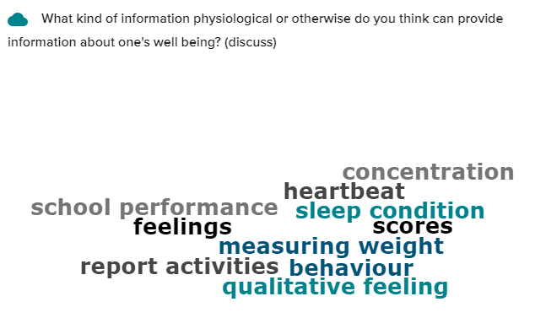
- What kind of measurable outcome would you like to benefit from a wellbeing monitoring device?
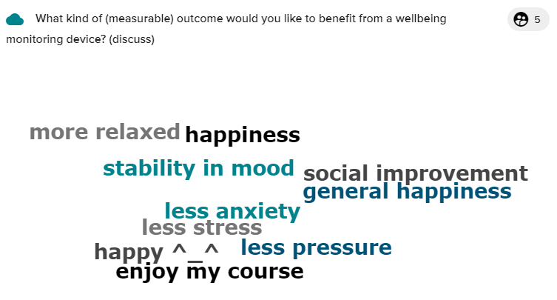

This question was added only in the second focus group.
This question was added only in the second focus group.
This question was only part of the first focus group.
This question was only part of the first focus group.
This question was only part of the first focus group.
This question was only part of the first focus group.

