Suppressive action of nesfatin-1 and nesfatin-1-like peptide on cortisol synthesis in adrenal cortex cells
Authors:
Atefeh Nasri¹, Jade Sands¹, Suraj Unniappan^{1*}

Institutional affiliations:
¹Laboratory of Integrative Neuroendocrinology, Department of Veterinary Biomedical Sciences, Western College of Veterinary Medicine, University of Saskatchewan, Saskatoon, Saskatchewan S7V 1H2, Canada
*Corresponding author

Supplementary Material
Table S1. The list of primer forward and reverse sequences and their annealing temperature
Figure S1. The expression of MC2R in H295R cells incubated with ACTH at different time points
Figure S2. Full size Western blot gel images shown in Figure 5

Table S1. The list of primer forward and reverse sequences and their annealing temperature
Gene | Accession no. | Primer sequence (5′−3′) |  | Tem (°C)
Gene | Accession no. | Forward | Reverse | Tem (°C)
HM-STAR | NM_000349.3 | CTCTCTACTCGGTTCTCGGC | AGCCCTCTTGGTTGCTAAGG | 59.3
HM-CYP11A1 | KU178011.1 | GGTGACAATGGCTGGCTAAAC | GTTGCCGAGCTTCTCCCTGTAA | 60.5
HM-CYP17A1 | NM_000102.4 | TGGCTCTCTTGCTGCTTACC | ACGAACCGAATAGATGGGGC | 60
HM-CYP21 | XM_047443023.1 | GCAGACCTGAGCCACTTACC | CACAGAACTCCTGGGTCAGC | 60
HM-CYP11B1 | NM_000497.4 | AGGAGACCTTGCGGCTCTAC | GAGTAGAGGAACACGCGCA | 60.6
HM-CYP11B2 | AH001448.2 | TTGTTCAAGCAGCGAGTGTTG | GCATCCTCGGGACCTTCTC | 59.5
HM-HSD3β | NM_001166120.2 | CCACACCGCCTGTATCATTG | CCCGGCTACCTCTATGCTAC | 59.6
HM-ACTβ | HQ154074.1 | TCCACGAAACTACATTCAATTCCA | ACAGAGTACTTGCGCTCAGGA | 60
HM-GAPDH | NM_001357943.2 | TGCACCACCAACTGCTTAGC | GGCATGGACTGTGGTCATGAG | 61
HM-NUCB1 | XM_017026845.2 | GACCCTCAGAACCAGCATACA | CTCCCAGTGACTCCAGATAACG | 60
HM-NUCB2 | XM_047426994.1 | AGTAGATGAGGTGGAGGACCA | TAGGCACAGCTTCAAGAGCA | 59
MS-Star | L36062.2 | TCACTTGGCTGCTCAGTATTGAC | GCGATAGGACCTGGTTGATGA | 60
MS-Cyp21 | NM_009995.2 | GGTTCCAGGAAGCGATCTG | CAACTAGGGCTAGCAGCATC | 57
MS-Cyp11a1 | NM_001346787.1 | GACCTGGAAGGACCATGCA | TGGGTGTACTCATCAGCTTTATTGA | 59.3
MS-Cyp11b1 | NM_001033229.3 | CGCTGCAAATCCTCAGAAGG | ACATTGAGGACTGTCCCAGCA | 60.1
MS-Cyp11b2 | NM_009991.4 | TGGCATTGTGGCGGAACTAA | AAGGGGATTGCTGTCGTGTC | 60.4
MS-Hsd3β | XM_006501036.3 | CTTTTCAGCCACCACCATCT | GGTCTGTCCTTCCCAGTGAT | 58.5
MS-Mc2r | NM_001301372.1 | CACACCAATGACACCGCAAG | CACAGCCAGGAGGACAATCA | 60
MS- Pcsk1/3 | NM_013628 | AGGTCGAGTCTAGCTGGTGT | TGCTCCATGGCTCAAAACCT | 60
MS-Pcsk2 | NM_008792 | CAGCTGGCGTGTTTGCATTA | AATTCCAGGCCAACCCCATT | 60
MS-Crhr1 | AB375515.1 | CCTCCAGGATCAGCAGTGTG | GTGTTGTAGCGGACACCGTA | 60
MS-Nucb1 | XM_006540696.4 | CACGGGCCTGTACTACCAC | TTGGCTCAGCTTTCCACTCT | 60
MS-Nucb2 | XR_004934144.1 | AACACGAGCGGAGAGAGTAT | AGGGTCCAATCCATCAGTCT | 60
MS-Actβ | BC138614 | CCACTGCCGCATCCTCCTCC | CTCGTTGCCAATAGTGATGAC | 60
MS-Gapdh | XM_036165840 | GACATCAAGAAGGTGGTG | ATACCAGGAAATGAGCTTGACAAA | 59

Figure S1. The expression of MC2R in H295R cells incubated with ACTH at 6, 12 and 24 h. The results presented are pooled from 3 independent studies with at least triplicates for each treatment. Asterisks show statistical differences between experimental and control groups.

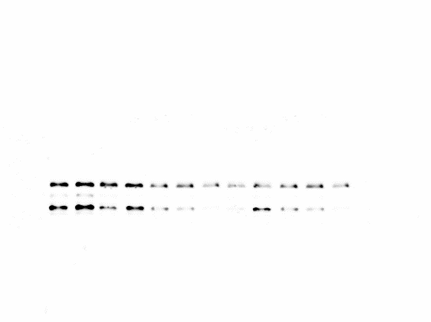
H295R cells
C NLP NESF-1
C NLP NESF-1
C NLP NESF-1
37KD

50KD

T-CREB
43kD
P-CREB
43kD
Beta-ACTIN
45kD

Figure S2. Full size Western blot gel images shown in Figure 5 of the manuscripts. The areas within the dark rectangles were cropped and shown in Figure 5. The protein ladder used to size the bands are shown in the upper right image.

