Fig S1: Chromatograms for Method B from a different laboratory. From top to bottom: IA and IB (zoom) -radiochromatogram of the test sample of [¹⁷⁷Lu]Lu-PSMA I&T; II- UV 200 nm chromatogram of the radioactive test sample; III- mixture of PSMA I&T and ^{nat}Lu-PSMA I&T UV 200 nm
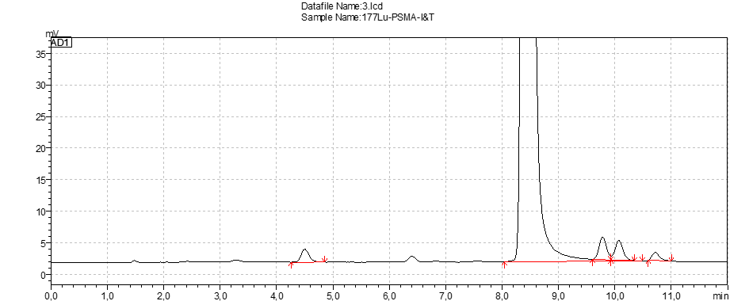
[Radio]
I A
[Radio]
I B
[UV 200nm]
II
[UV 200 nm]
III

Validation data for Method B from a different laboratory
Criteria | Validation parameter | Method | No of repetitions | Aceptance Criteria | Found  Method B  Lab No. 2
Identity | Accuracy | Retention time [¹⁷⁷Lu]Lu-PSMA I&T | 6 | sd (%)<1% | 0.08%  (Rt 8.44min)
Identity | Accuracy | Retention time ^{nat}Lu-PSMA I&T | 6 | sd (%)<1% | 0.08%  (Rt 8.34min)
Identity | Accuracy | Retention time PSMA I&T | 6 | sd (%)<1% | 0.08%  (Rt 7.61min)
Identity | Specificity | Retention time [¹⁷⁷Lu]Lu-PSMA I&T vs ^{nat}Lu-PSMA I&T | 6 | deviation < 0.5 min | 0.1 min
Radiochemical purity | Specificity | Resolution PSMA I&T vs ^{nat}Lu-PSMA I&T | 6 | Resolution >2 | 3.1
Radiochemical purity | Precision | RSD of peak areas of [¹⁷⁷Lu]Lu-PSMA I&T | 6 | sd (%)≤2% | 1.6%
Chemical purity - content | Precision | Sum of the peak areas of PSMA-I&T + Lu-PSMA-I&T | 6 | sd (%)≤2% | 1.8%

Fig S2: Chromatograms for PSMA I&T. From top to bottom: I-Radiochromatogram of a test sample of [¹⁷⁷Lu]Lu-PSMA I&T with a radiochemical purity of about 96% 4 hr post preparation ; II- ^{nat}Lu-PSMA I&T UV 220 nm 50µl/mL irradiated with 500Gy; I- ^{nat}Lu-PSMA I&T UV 220 nm 50µl/withourt irradiation
Peak labels: 1: main radiochemical impurity; 2: [¹⁷⁷Lu]Lu-PSMA I&T; 3: impurity of ^{nat}Lu-PSMA I&T collected for MALDI-TOF MS; 4: ^{nat}Lu-PSMA I&T.

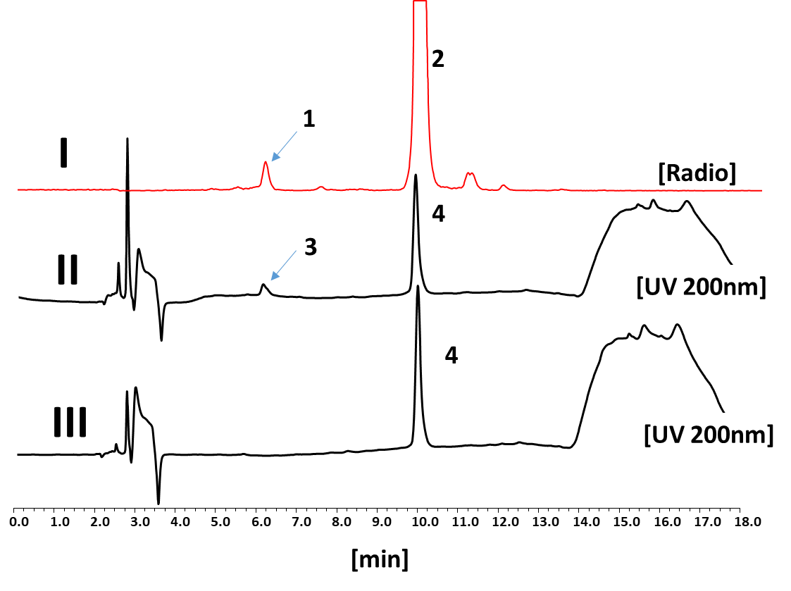

Fig S3: MALDI-TOF MS of impurity collected after irradiation of ^{nat}Lu-PSMA I&T at 500 Gy (Peak 3 according to figure S2).
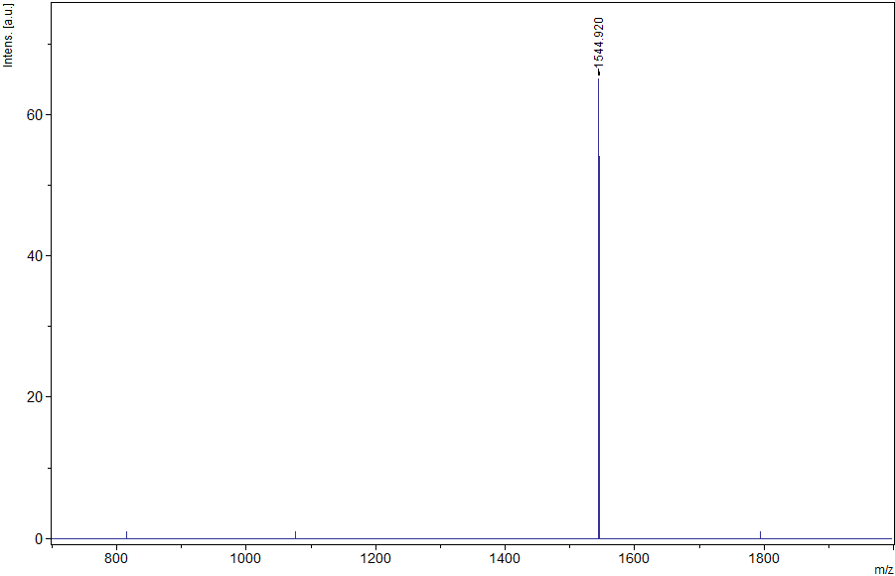
Figure S4: Representative TLC Chromatograms for [¹⁷⁷Lu]Lu-Chloride solution, [¹⁷⁷Lu]Lu-colloid (neutralized [¹⁷⁷Lu]Lu-Chloride solution), [¹⁷⁷Lu]Lu-DTPA and the test solution [¹⁷⁷Lu]Lu-PSMA I&T in TLC system 1 (left) and system 2 (right).
[¹⁷⁷Lu]Lu-Chloride solution
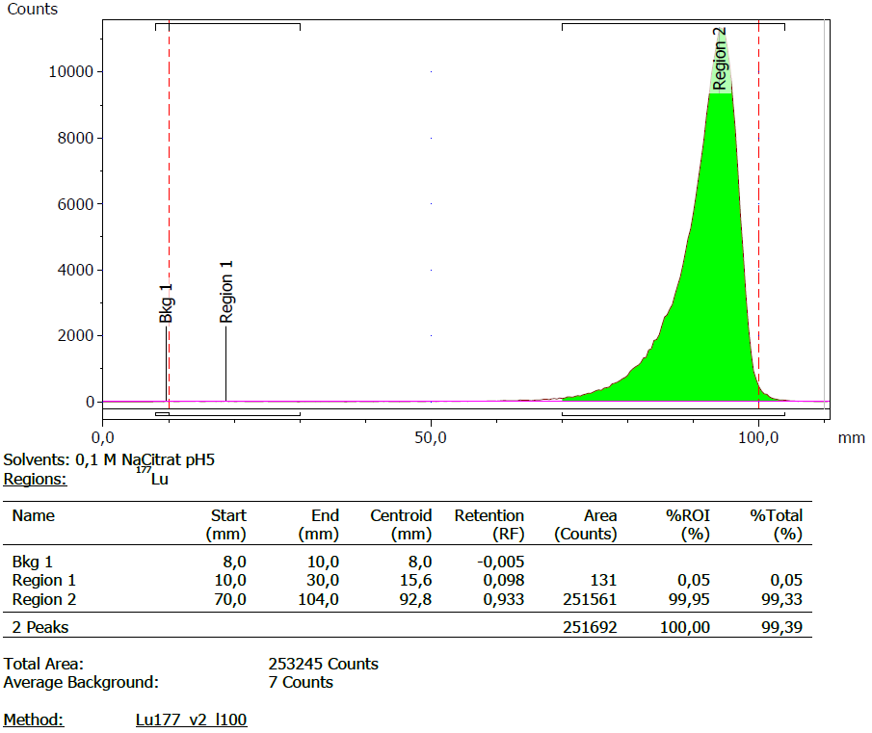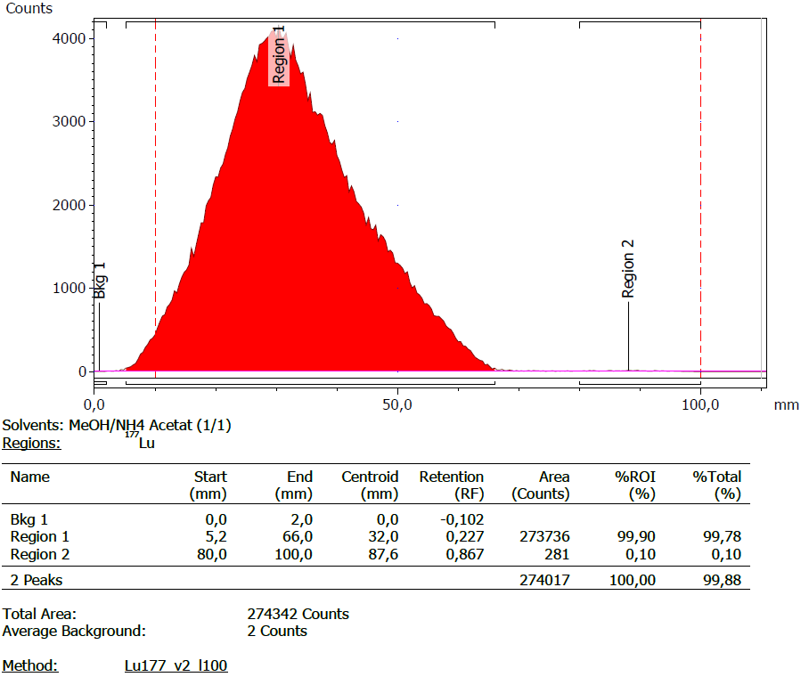
[¹⁷⁷Lu]Lu-colloid (neutralized [¹⁷⁷Lu]Lu-Chloride solution)
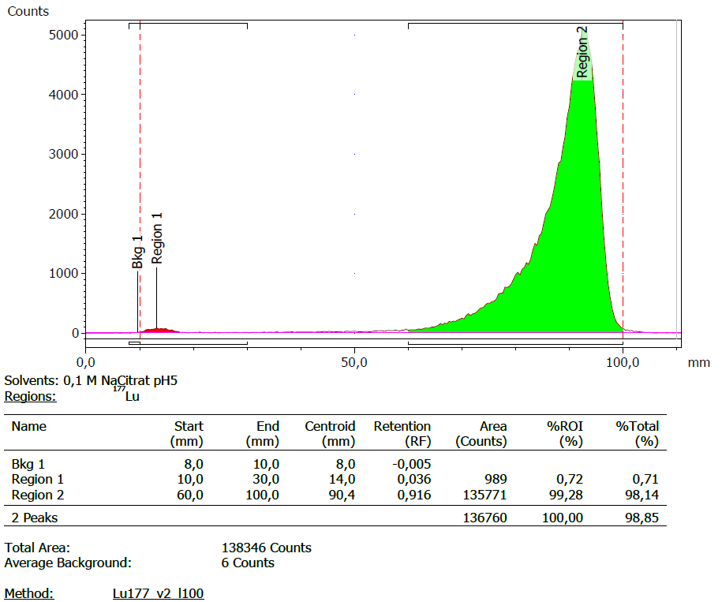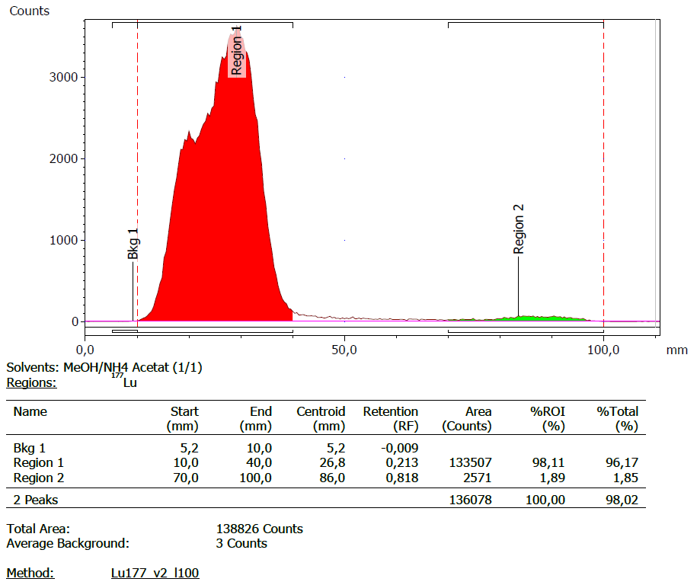
[¹⁷⁷Lu]Lu-DTPA
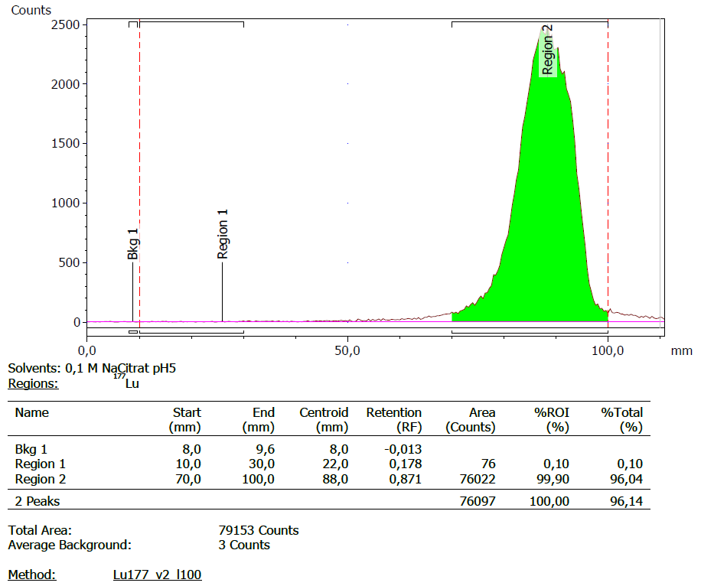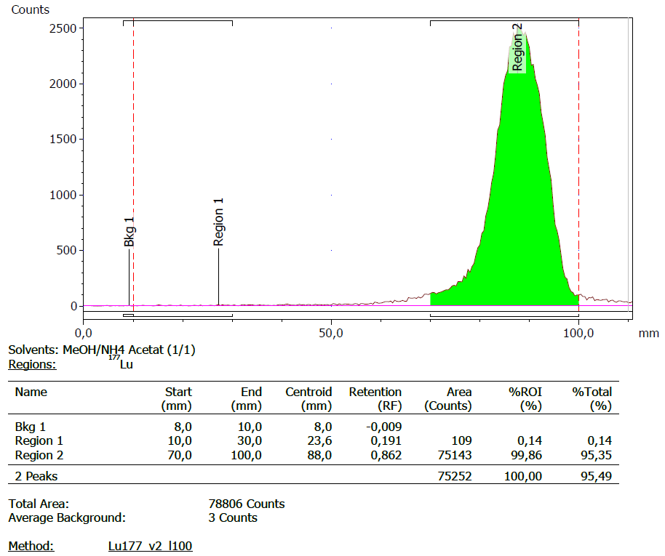
test solution [¹⁷⁷Lu]Lu-PSMA I&T
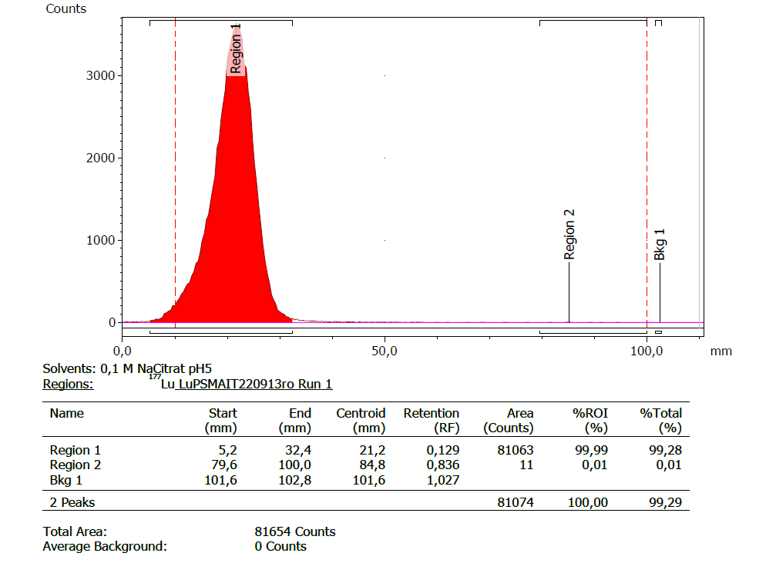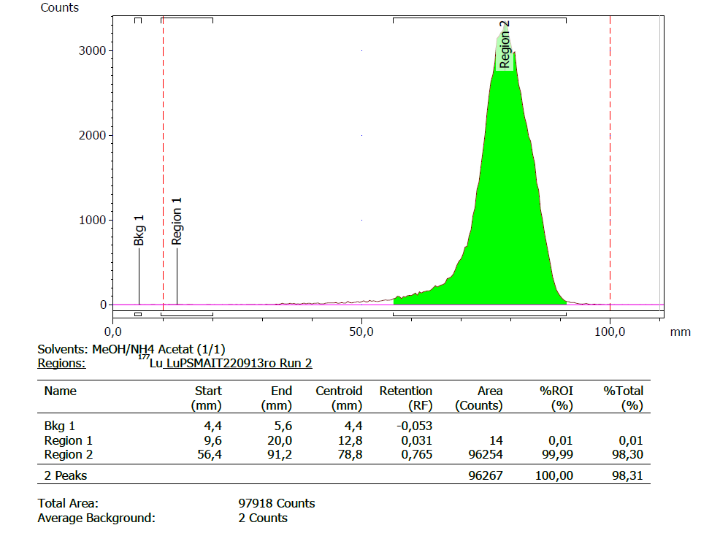

Figure S5: UV/Vis absorption spectrum of PSMA I&T.
