Supplementary Information
Title: Sialyltransferase7A promotes cardiomyocyte ferroptosis induced by sorafenib through increase in HIF-1ɑ expression

Table S1. Primary antibodies used in Western blot experiments.
Antibody | Clonality | Dilution | Source | Catalog no.
GPX4 | monoclonal | 1:1000 | Abcam | ab125066
SLC7a11 | polyclonal | 1:800 | Proteintech | 26864-1-AP
Siat7A | polyclonal | 1:1000 | Proteintech | 15363-1-AP
HIF-1α | polyclonal | 1:1000 | Proteintech | 20960-1-AP
ANP | polyclonal | 1:800 | Proteintech | 27426-1-AP
α-actinin | polyclonal | 1:1000 | Proteintech | 11313-2-AP
Nrf2 | polyclonal | 1:1000 | Proteintech | 16396-1-AP

Table S2. Primers used for Real-time PCR
Gene | Primer sequence
Rat-GPX4 | F:5- TTGCAGCCGGCTACAATGTC-3
 | F:5- CCACGCAGCCGTTCTTATCA -3
Rat- SLC7A11 | F:5- TGCTGCCTACACAAAGACGTT -3
 | R:5- CGCCTTGCCCTTTAAGTATTCACC -3
Rat-Siat7A | F:5- GAGCCAAGCACAAGGGTTTC-3
 | R:5- GTGGGTGTCAGGGTCACGAT-3
Rat-HIF-1α | F:5- TCTAGTGAACAGGATGGAATGGAG -3
 | R:5- TCGTAACTGGTCAGCTGTGGTAA -3
Rat-18s ribosomal RNA | F:5- TGAGGCCATGATTAAGAGGG -3
 | R:5- AGTCGGCATCGTTTATGGTC-3
Rat-α-sketetal actin | F:5- CACGGACGTGAAGCCTCACT -3
(α-actinin) | R:5- AGAGCCGTTGTCACACACAAGA -3
Rat-ANP | F:5- AGAGCGGACTAGGCTGCAACA -3
 | R:5- TCAGTGGCAATGCGACCAA -3

Detailed Methods
Animals and treated
About the dose of sorafenib animal model: some studies have found that the dose of 20-30mg/kg/d can induce cardiac toxicity in rats, such as cardiac hypertrophy and hypertension, so the dose of this study is 30mg/kg/d [1, 2] .

Results
Figure 2. Uncropped immunoblot membranes (Detection of GPX4, SLC7a11 and myocardial injury markers in rats in sorafenib group.)
After treatment with sorafenib to induce cardiotoxicity, we observed that the levels of GPX4 and SLC7 were lower than those in the control group. The index of myocardial injury Siat7A,hif was higher than that of the control group.

A
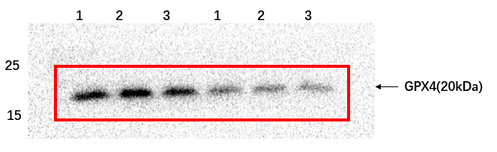
B
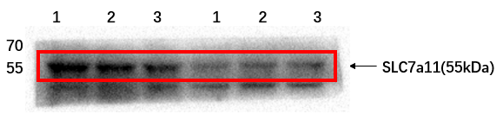
C
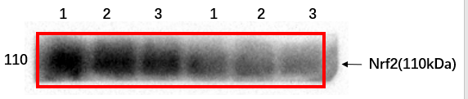
D
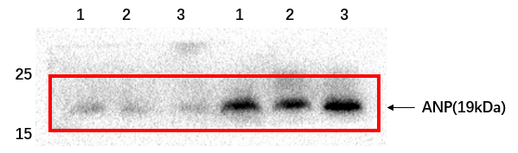
E
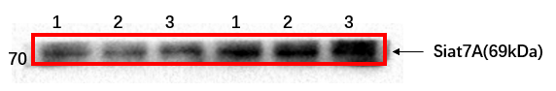
F
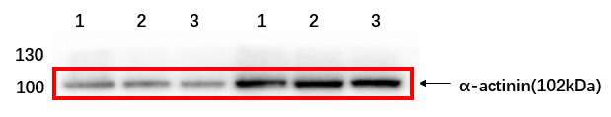
G
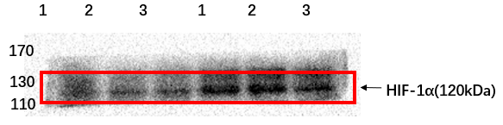
H
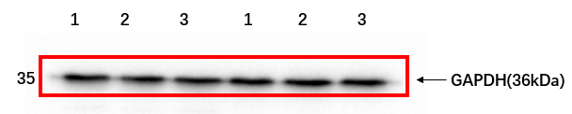

Fig. 2. Immunoblot membranes. A. glutathione peroxidase 4 (GPX4). B. Solute carrier family 7 member 11 (SLC7A11/xCT). C. Nuclear factor-erythroid 2-related factor 2 (Nrf2). D. atrial natriuretic peptide (ANP). E. Sialyltransferase7A(Siat7A). F. α-sketetal actin(α-actinin). G. hypoxia-inducible factor 1α(HIF-1α). H. Internal reference gene GAPDH. N=6(1,2,3 – different rats).

Fig. 3. Uncropped immunoblot membranes (Detection of Gpx4, SLC7a11 and myocardial injury markers after treatment of AC16 with different concentrations of sorafenib.)
After the treatment of AC16 cells with different concentrations of sorafenib, we observed that the levels of Gpx4 and SLC7 were lower than those of the control group, and the myocardial damage index Siat7A and HIF were higher than those of the control group, with a trend of concentration.

A
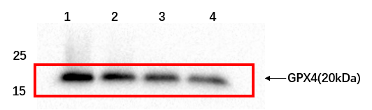
B
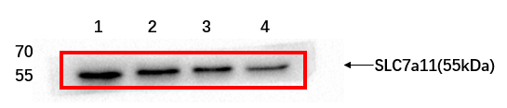
C
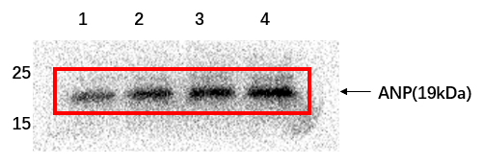
D
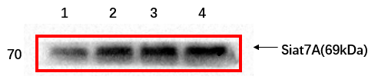
E
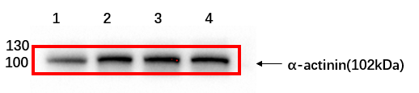
F
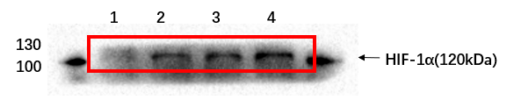
G
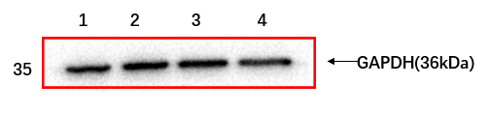
Fig.3. Immunoblot membranes. A. glutathione peroxidase 4 (GPX4). B. Solute carrier family 7 member 11 (SLC7A11/xCT). C. Nuclear factor-erythroid 2-related factor 2 (Nrf2). D. atrial natriuretic peptide (ANP). E. Sialyltransferase7A(Siat7A). F. α-sketetal actin(α-actinin). G. hypoxia-inducible factor 1α(HIF-1α). N=6(1,2,3,4 – different concentration of Sorafenib).

Fig. 4. Siat7A knockdown inhibits cardiomyocyte ferroptosis by regulating HIF-1α
We transferred shRNA Siat7A into cultured AC16 cells, using 25 μ M SOR stimulated transfected cells. Compared with the cells transfected with shRNA NC plasmid, the expression of siat7a was significantly down-regulated after shRNA siat7a was transfected, and the expression level of ferritosis markers GPX4 and SLC7A11 protein was increased, and HIF-1 α Protein, cardiac hypertrophy marker ANP and α-actinin decreased.

A
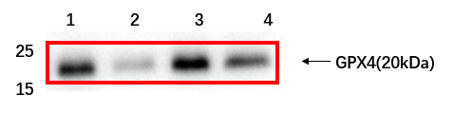
B
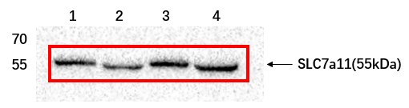
C
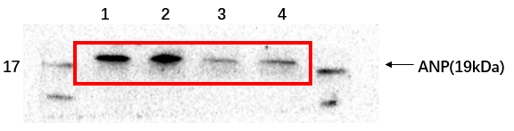
D
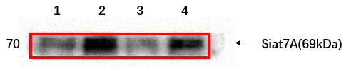
E
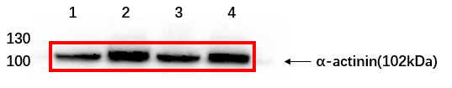
F
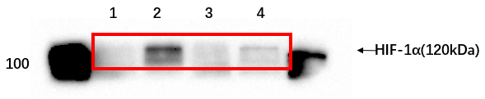
G
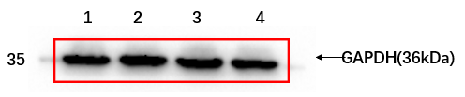
Fig. 4. Immunoblot membranes. A. glutathione peroxidase 4 (GPX4). B. Solute carrier family 7 member 11 (SLC7A11/xCT). C. atrial natriuretic peptide (ANP). D. Sialyltransferase7A(Siat7A). E. α-sketetal actin(α-actinin). F. hypoxia-inducible factor 1α(HIF-1α). The first channel is NC group, the second channel is sorafenib-treated NC cell group, the third channel is ShSiat7a control group treated with DMSO, and the fourth channel is sorafenib-treated ShSiat7a cell group(N=6).

Fig. 5. The upregulation of Siat7A expression aggravates cardiomyocytes ferroptosis.
In vitro, the overexpression of Siat7A significantly increased the level of Siat7A protein, the expression levels of HIF-1α protein and cardiac hypertrophy markers ANP and α-actinin increased, while the expression levels of ferroptosis markers GPX4 and SLC7A11 decreased. The results suggest that ferroptosis increases and myocardial hypertrophy increases.
A
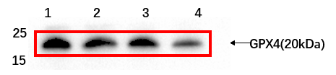
B
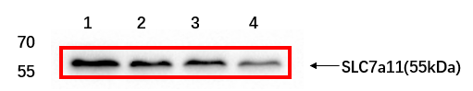
C
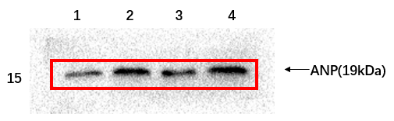
D
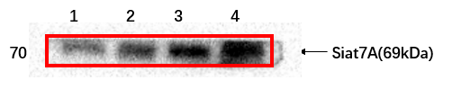
E
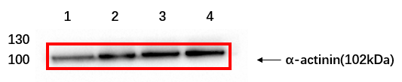
F
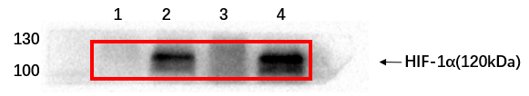
G
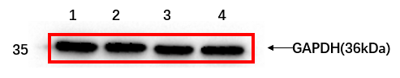
Fig. 5. Immunoblot membranes. A. glutathione peroxidase 4 (GPX4). B. Solute carrier family 7 member 11 (SLC7A11/xCT). C. atrial natriuretic peptide (ANP). D. Sialyltransferase7A(Siat7A). E. α-sketetal actin(α-actinin). F. hypoxia-inducible factor 1α(HIF-1α). The first channel is NC group, the second channel is sorafenib-treated NC cell group, the third channel is OvershSiat7a control group treated with DMSO, and the fourth channel is sorafenib-treated OvershSiat7a cell group(N=6).

1. Duran, J.M., et al., Sorafenib cardiotoxicity increases mortality after myocardial infarction. Circ Res, 2014. 114(11): p. 1700-1712.
2. Abdelgalil, A.A., et al., The protective effect of losartan against sorafenib induced cardiotoxicity: Ex-vivo isolated heart and metabolites profiling studies in rat. Eur J Pharmacol, 2020. 882: p. 173229.

