Journal title: Plant and Soil

Root Architecture Parameters and Rhizosphere Biology in fourteen Winter Wheat Varieties Released in Chile between 1965 and 2020

Paula Paz-Vidal¹, Dalma Castillo-Rosales², María Dolores López³, Iván Matus Tejos², Felipe Noriega³ and Mauricio Schoebitz^{1*}

¹Department of Soil Science and Natural Resources, Faculty of Agronomy, Universidad de Concepción, P.O. Box 160 C, Campus Concepción, Chile.
²Instituto de Investigaciones Agropecuarias INIA-Quilamapu, Programa de Mejoramiento Genético de trigo. Avenida Vicente Méndez 515, Chillán 3800062, Chile.
³Department of Plant Production, Faculty of Agronomy, Universidad de Concepción, Campus Concepción, Chile.
*corresponding author: mschoebitz@udec.cl
Tel. +56 4121446

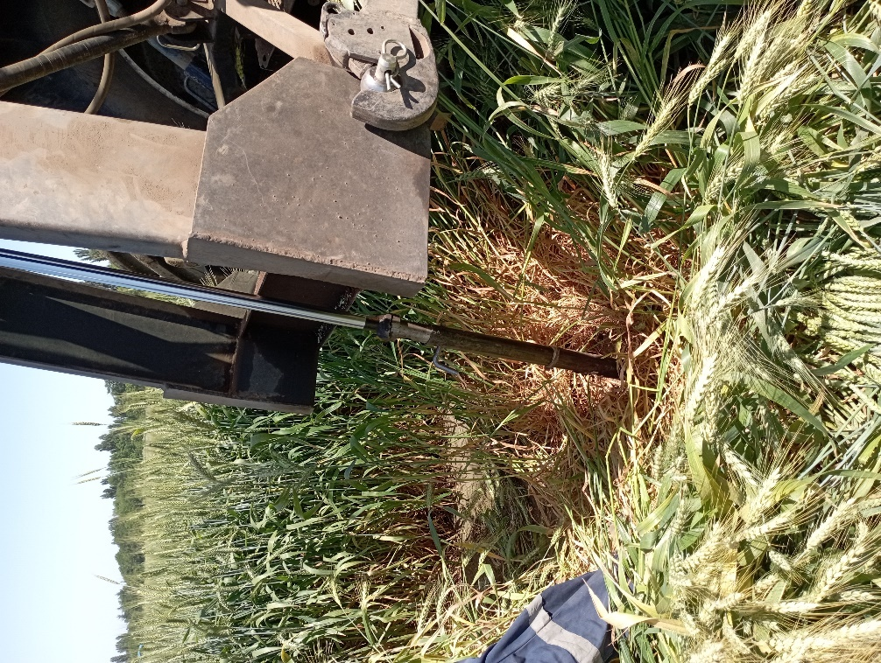

Fig. S1. Soil samples obtained from the central rows of each plot using a hydraulic sampler tube mounted on a tractor with a diameter of 3.5 cm and capable of reaching a depth of 60 cm.

Fig. S2 Scanning of complete root systems in the anthesis phase Druchamp (1965) variety.
Fig. S3 Scanning of complete root systems in the anthesis phase Melifen (1974) variety.
Fig. S4 Scanning of complete root systems in the anthesis phase Manquefen (1977) variety
Fig. S5. Scanning of complete root systems in the anthesis phase Talafen (1982) variety.
Fig. S6. Scanning of complete root systems in the anthesis phase Laurel (1987) variety.
Fig. S7. Scanning of complete root systems in the anthesis phase Lautaro (1990) variety.
Fig. S8. Scanning of complete root systems in the anthesis phase Tukan (1993) variety.
Fig. S9. Scanning of complete root systems in the anthesis phase Kumpa (2002) variety.
Fig. S10. Scanning of complete root systems in the anthesis phase Bicentenario (2010) variety.
Fig. S11. Scanning of complete root systems in the anthesis phase Maxwell (2012) variety.
Fig. S12. Scanning of complete root systems in the anthesis phase Pionero (2013) variety.
Fig. S13. Scanning of complete root systems in the anthesis phase Rocky (2015) variety.
Fig. S14. Scanning of complete root systems in the anthesis phase Kiron (2017) variety.

Fig. S15. Scanning of complete root systems in the anthesis phase Chevignon (2020) variety.

